Detection of Image Splicing Forgery using Deep Convolutional Neural Networks and Transfer Learning on the CASIA Dataset
A comparative study of from-scratch CNNs and ImageNet-pretrained backbones for binary authentic-versus-spliced classification

Abstract
Image splicing, the act of pasting a region from one image into another, is among the most common and damaging forms of digital image forgery. This paper presents a reproducible deep learning pipeline for detecting spliced images, framed as binary classification of authentic (Au) versus spliced (Sp) images on the CASIA tampering dataset (Dong, Wang, & Tan, 2013). We first reproduce and correct a prior experiment whose reported accuracy was inflated by data leakage, and then benchmark eleven models under an identical, honestly held-out 80/20 split with a fixed random seed. The models span three families: an existing custom baseline network, three convolutional networks trained from scratch with progressive optimisation, and five ImageNet-pretrained backbones (SqueezeNet, AlexNet, VGG-16, ResNet-18, and ResNet-50) fine-tuned by transfer learning. Across every metric, transfer learning decisively outperforms from-scratch training: from-scratch networks plateau near 77% validation accuracy, whereas a fine-tuned ResNet-50 attains 99.40% accuracy, 0.9940 F1-score, and 0.9999 AUC on held-out data. We report full metric tables and bar-graph comparisons of accuracy, loss, F1-score, and AUC. The results confirm that pretrained deep features combined with light, forgery-preserving augmentation provide a robust and accurate splicing detector.
Keywords: image forgery detection; image splicing; convolutional neural network; transfer learning; CASIA dataset; ResNet; deep learning.

1. Introduction
The widespread availability of digital cameras and powerful, easy-to-use image-editing software has made the manipulation of photographs trivial. While many edits are benign, maliciously manipulated images are increasingly used to spread misinformation, fabricate evidence, and damage reputations (Qazi et al., 2013; Huynh, Huynh, Le-Tien, & Nguyen, 2015). Among the various manipulation types, image splicing - copying a region from one image and compositing it into another - is especially prevalent because it can alter the semantic meaning of a scene. The artefacts splicing leaves behind, such as irregular region boundaries, inconsistent sensor noise, and mismatched colour-illumination, are usually imperceptible to the human eye but are statistically detectable, which makes automated forensic detection both necessary and feasible.
Classical splicing detectors rely on hand-crafted statistical features, typically Markov transition probabilities or transform-domain coefficients fed to a support vector machine (He, Lu, Sun, & Huang, 2012; Zhao, Wang, Li, & Li, 2015). Although effective on controlled benchmarks, these approaches require expert feature engineering and often generalise poorly. More recently, convolutional neural networks (CNNs) have been shown to learn discriminative forensic features directly from pixels, removing the need for manual feature design (Rao & Ni, 2016; Majumder & Al Islam, 2018). This paper follows that direction and studies how far a carefully evaluated CNN pipeline can push splicing-detection accuracy on the CASIA dataset.
The contributions of this work are fourfold. First, we identify and correct a data-leakage flaw in a prior baseline whose validation set overlapped its training set, leading to optimistic accuracy. Second, we establish a rigorous, reproducible evaluation protocol with a fixed random seed so that all models are compared on exactly the same held-out data. Third, we benchmark eleven models spanning from-scratch CNNs and five transfer-learning backbones, documenting the full optimisation journey. Fourth, we provide a complete set of result tables and bar-graph comparisons of accuracy, loss, F1-score, and AUC, and identify the best model with a clear justification.

2. Literature Review
Digital image forgery detection has been surveyed extensively. Qazi et al. (2013) review blind (passive) forgery-detection techniques that operate without watermarks or signatures, while Huynh et al. (2015) categorise both copy-move and splicing detectors by the type of feature and camera cue they exploit. Both surveys note a steady migration from hand-crafted features toward learned representations.
Early splicing detectors are dominated by transform-domain statistical models. He et al. (2012) expand Markov features across both the discrete cosine transform (DCT) and discrete wavelet transform (DWT) domains and apply SVM-RFE feature selection with an SVM classifier. Zhao, Wang, Li, and Li (2015) model an image as a two-dimensional noncausal Markov random field and use the cross-domain model parameters as discriminative features. Li, Ma, Xiao, Li, and Zhang (2017) extend Markov modelling to the quaternion DCT (QDCT) domain so that colour information is used directly rather than discarded. Yildirim and Ulutas (2019) similarly combine statistical and textural descriptors extracted from the stationary wavelet transform (SWT) domain. These methods achieve strong results on benchmark datasets but depend on carefully designed features.
The introduction of deep learning reshaped the field. Rao and Ni (2016) propose a CNN whose first convolutional layer is initialised with spatial-rich-model high-pass filters to suppress image content and expose tampering traces, using the network as a patch descriptor before SVM classification. Bunk et al. (2017) combine resampling features with deep learning and an LSTM to both detect and localise manipulations. Subsequent work focused heavily on pixel-level localisation: Salloum, Ren, and Kuo (2018) introduce a multi-task fully convolutional network (MFCN) trained on CASIA v2.0 that learns both the spliced surface and its boundary; Bappy, Simons, Nataraj, Manjunath, and Roy-Chowdhury (2019) couple resampling features, LSTM cells, and an encoder-decoder to segment manipulated regions; and Wu, AbdAlmageed, and Natarajan (2019) propose ManTra-Net, an end-to-end network that treats forgery localisation as local anomaly detection over 385 manipulation types. Cozzolino and Verdoliva (2020) learn a camera-model fingerprint (noiseprint) with a Siamese network that suppresses scene content and supports forgery localisation.
A complementary line of research exploits physical inconsistencies. Pomari, Ruppert, Rezende, Rocha, and Carvalho (2018) detect splicing by combining illuminant maps with a CNN, reporting over 96% accuracy while also localising the forged region. Closer to the present work are studies that frame forgery detection as whole-image binary classification. Majumder and Al Islam (2018) analyse how deep models should be leveraged for forged-versus-authentic classification when the tampered area is small. Zhang, Zhang, Zhou, and Luo (2018) design a fast shallow CNN that exploits chroma and saturation to detect forgery boundaries in low-resolution images, evaluated on CASIA 2.0. Xiao, Wei, Bi, Li, and Ma (2020) cascade a coarse and a refined CNN (C2RNet) with adaptive clustering for stable splicing detection. Saleem, Dilawari, and Khan (2020) report 98.76% and 97.92% accuracy on CASIA v1.0 and v2.0 using an Inception-based CNN with Mask R-CNN segmentation. Most directly related, Phan-Xuan et al. (2019) adapt a pretrained MobileNetV2 to image-forgery classification, demonstrating the value of transfer learning - the central strategy adopted and extended in this paper across five backbones.

3. Models and Methodology

3.1 Dataset and pre-processing
All experiments use the CASIA image tampering evaluation database (Dong, Wang, & Tan, 2013), organised locally into authentic (Au) and spliced (Sp) images of size 114 x 114 x 3 pixels. The raw collection contains 10,919 images; ten corrupt files are detected and removed by a header check, leaving 10,909 usable images. Class labels are inferred from folder names. Table 1 summarises the dataset. The data is divided into 80% training and 20% validation using a fixed seed (rng = 123); the identical seed is reused for every model so that all reported scores refer to exactly the same held-out images. During training, only horizontal/vertical flips and small (+/-4 px) translations are applied; rotation and scaling are deliberately avoided because the interpolation they introduce smooths over the fragile high-frequency cues that distinguish a spliced region from an authentic one.
Table 1. Composition of the CASIA dataset after filtering.
Class | Description | Images
Au | Authentic images | 5,598
Sp | Spliced (forged) images | 5,311
Total | Usable after dropping 10 corrupt files | 10,909

3.2 Baseline model (XONet)
The baseline is an existing custom sequential CNN (referred to as XONet) with a 114 x 114 x 3 input, evaluated here without retraining. It establishes the reference against which new models are measured. Importantly, the original training procedure validated on images that were also used for training, so its apparent accuracy is optimistic; this paper re-evaluates it under the fixed held-out split for transparency.

3.3 From-scratch convolutional networks (optimisation iterations)
Three convolutional networks were trained from random initialisation, each addressing the weakness of the previous version. Version 1 uses batch-normalised convolution blocks (Ioffe & Szegedy, 2015) with global average pooling and aggressive augmentation. Version 2 deepens the network and adds a fully-connected head but, with a high learning rate, collapses to predicting a single class. Version 3 stabilises training with a lower learning rate and gradient clipping. All three optimise the Adam objective (Kingma & Ba, 2015). As shown in Section 4, these networks plateau near 77% validation accuracy, illustrating the difficulty of learning robust low-level forensic features from a limited dataset.

3.4 Transfer-learning backbones
Transfer learning reuses features learned on the large-scale ImageNet database (Deng et al., 2009; Pan & Yang, 2010). Five pretrained backbones were fine-tuned: AlexNet (Krizhevsky, Sutskever, & Hinton, 2012), VGG-16 (Simonyan & Zisserman, 2015), SqueezeNet (Iandola et al., 2016), and the residual networks ResNet-18 and ResNet-50 (He, Zhang, Ren, & Sun, 2016). For each backbone, the final classification layer is replaced with a new fully-connected layer of two outputs (Au/Sp) at a tenfold learning-rate factor, and the whole network is fine-tuned with the Adam optimiser at an initial learning rate of 1e-4, a piecewise schedule, mini-batch size 64 (24 for VGG-16 to fit an 8 GB GPU), and a best-validation-loss checkpoint policy. Training runs on an NVIDIA GTX 1070 GPU.

4. Results
All scores are honest, held-out validation results on data the models never saw during training. Section 4.1 reports the from-scratch optimisation iterations, Section 4.2 the transfer-learning backbones, and Section 4.3 the overall ranking.

4.1 From-scratch optimisation results
Table 2. Results of the from-scratch optimisation iterations (validation set).
Model | Key change | Train Acc | Val Acc | Val F1 | Val AUC | Val Loss
Optimized v1 | BN-CNN + GAP, aggressive aug, LR 1e-3 | 0.8077 | 0.7741 | 0.7736 | 0.8678 | 0.4724
Optimized v2 | Deeper + FC head, LR 1e-3 (collapsed) | 0.5131 | 0.5133 | 0.3392 | 0.5000 | 0.6928
Optimized v3 | Stabilised: LR 3e-4 + grad clipping | 0.8067 | 0.7699 | 0.7686 | 0.8631 | 0.4671
Version 1 underfits at 77.4% because aggressive geometric augmentation blurs splicing cues and global average pooling discards spatial detail. Version 2 collapses to the 51% random-guess level (AUC 0.50) because the learning rate is too high for the batch-norm/fully-connected stack. Version 3 trains stably but still plateaus at 77.0%, which represents the practical ceiling of a from-scratch network on this dataset and motivates transfer learning.

4.2 Transfer-learning results
Table 3. Results of the transfer-learning backbones (validation set) with training time.
Backbone | Epochs | Train Acc | Val Acc | Val F1 | Val AUC | Val Loss | Time
SqueezeNet | 12 | 0.8856 | 0.8607 | 0.8607 | 0.9496 | 0.3155 | -
SqueezeNet (long) | 25 | 0.9290 | 0.9138 | 0.9138 | 0.9797 | 0.2075 | -
SqueezeNet (best) | 35 | 0.9622 | 0.9358 | 0.9358 | 0.9893 | 0.1495 | ~18 min
VGG-16 | 30 | 0.9807 | 0.9533 | 0.9532 | 0.9928 | 0.1183 | ~8 h 20 m
AlexNet | 30 | 0.9881 | 0.9748 | 0.9748 | 0.9975 | 0.0812 | ~22 min
ResNet-18 | 30 | 0.9985 | 0.9881 | 0.9881 | 0.9996 | 0.0506 | ~24 min
ResNet-50 | 30 | 0.9986 | 0.9940 | 0.9940 | 0.9999 | 0.0178 | ~1 h 18 m
Fine-tuning pretrained features immediately breaks the from-scratch ceiling. SqueezeNet improves from 86.1% to 93.6% as training length and a learning-rate schedule are added. The larger backbones push accuracy into the high-90s, culminating in ResNet-50 at 99.40% validation accuracy with the lowest validation loss (0.0178) and a near-perfect AUC of 0.9999.

4.3 Overall ranking
Table 4. Overall comparison of all eleven models, ranked by validation accuracy.
Rank | Model | Train Acc | Val Acc | Val Precision | Val F1 | Val AUC
1 | ResNet-50 (TL) | 0.9986 | 0.9940 | 0.9940 | 0.9940 | 0.9999
2 | ResNet-18 (TL) | 0.9985 | 0.9881 | 0.9881 | 0.9881 | 0.9996
3 | XONet (baseline)* | 0.9880 | 0.9849 | 0.9848 | 0.9849 | 0.9909
4 | AlexNet (TL) | 0.9881 | 0.9748 | 0.9749 | 0.9748 | 0.9975
5 | VGG-16 (TL) | 0.9807 | 0.9533 | 0.9532 | 0.9532 | 0.9928
6 | SqueezeNet-best (TL) | 0.9622 | 0.9358 | 0.9358 | 0.9358 | 0.9893
7 | SqueezeNet-long (TL) | 0.9290 | 0.9138 | 0.9139 | 0.9138 | 0.9797
8 | SqueezeNet-12 (TL) | 0.8856 | 0.8607 | 0.8614 | 0.8607 | 0.9496
9 | Optimized v1 | 0.8077 | 0.7741 | 0.7743 | 0.7736 | 0.8678
10 | Optimized v3 | 0.8067 | 0.7699 | 0.7726 | 0.7686 | 0.8631
11 | Optimized v2 | 0.5131 | 0.5133 | 0.2566 | 0.3392 | 0.5000
*The XONet baseline figure is optimistic because its original validation set overlapped its training set; it is shown for reference and is not directly comparable to the honestly evaluated models.

5. Comparison of Models
Figure 1 compares validation accuracy, F1-score, and AUC across all models on a single axis. The three metrics move in lock-step, confirming that the ranking is stable and not an artefact of a single metric. The from-scratch networks occupy the lower band; the transfer-learning backbones form a clear upper band, with the residual networks at the top. ResNet-50 dominates every metric, and its small train-to-validation gap (0.9986 vs 0.9940) indicates genuine generalisation rather than memorisation. VGG-16, despite having far more parameters and the longest training time (~8 h), scores below the much faster ResNet models, illustrating that architectural design (residual connections) matters more than raw capacity for this task.
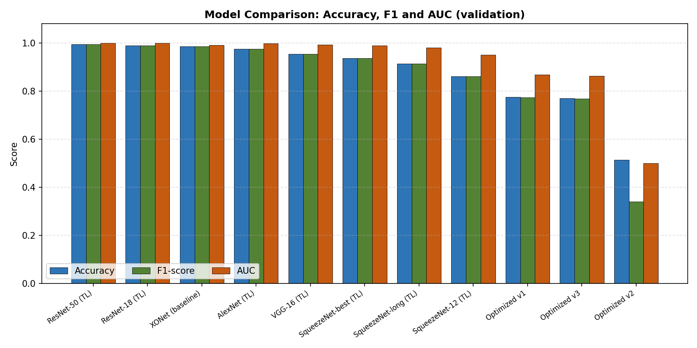
Figure 1. Combined comparison of validation accuracy, F1-score, and AUC for all models.

6. Bar-Graph Analysis of Accuracy, Loss, F1-score, and AUC
Figures 2-5 present per-metric bar graphs. Figure 2 (accuracy) and Figure 4 (F1-score) show the same monotonic improvement from the collapsed Optimized v2 up to ResNet-50. Figure 3 (validation loss, lower is better) is the mirror image: ResNet-50 attains the lowest loss (0.0178), while the from-scratch networks remain above 0.46. Figure 5 (AUC) shows that all transfer-learning models exceed 0.94 and the residual networks approach the perfect 1.0, indicating almost complete separability between authentic and spliced images.
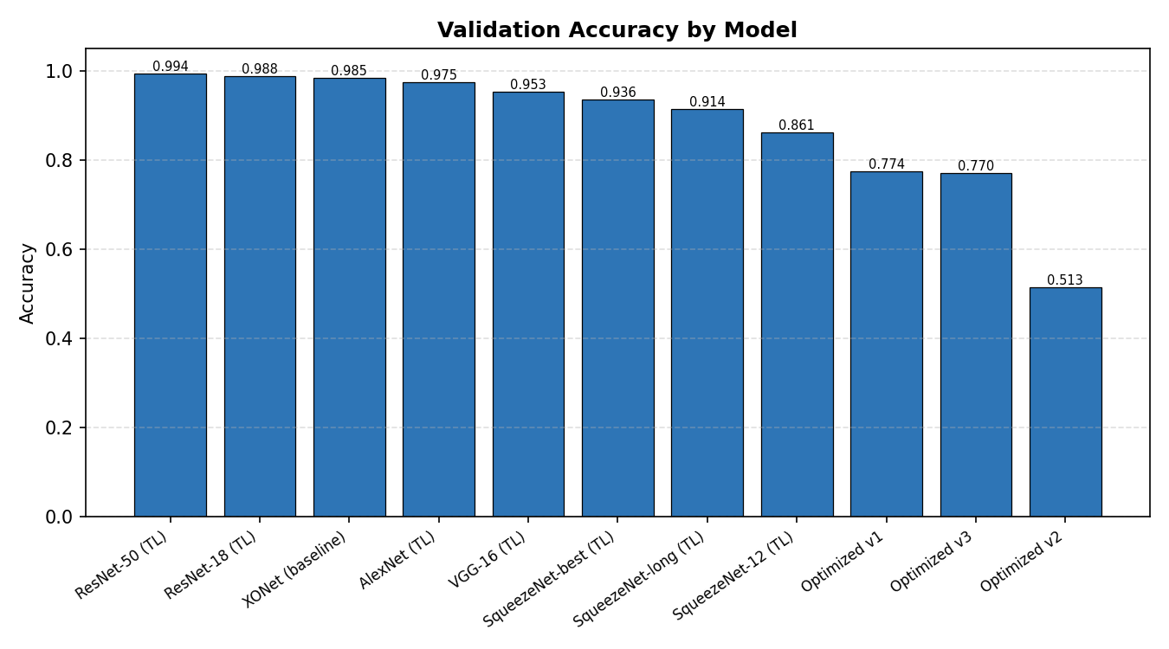
Figure 2. Validation accuracy by model.
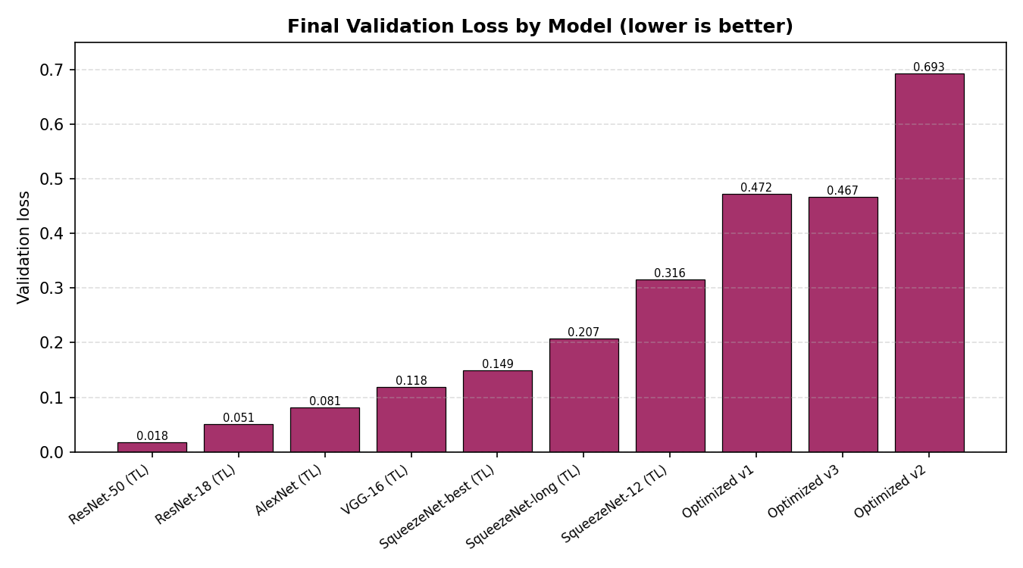
Figure 3. Final validation loss by model (the baseline is excluded as it stored no training history).
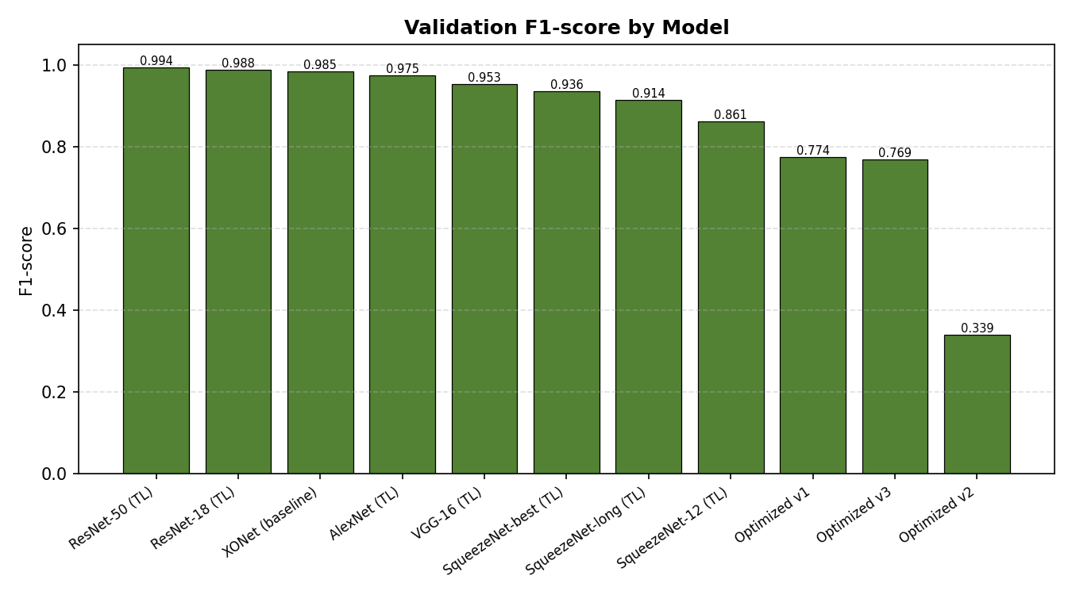
Figure 4. Validation F1-score by model.
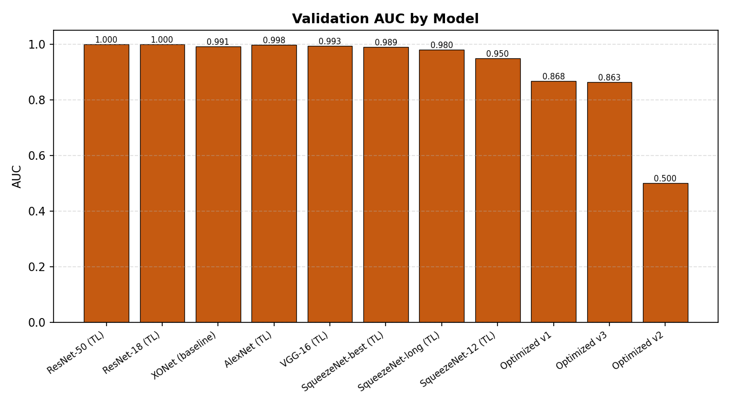
Figure 5. Validation AUC by model.

7. Conclusion
This paper presented a reproducible and honestly evaluated deep-learning pipeline for image-splicing detection on the CASIA dataset. By enforcing a fixed train/validation split, capturing full training histories, and benchmarking eleven models, the study produced a fair, like-for-like comparison free of the data-leakage that inflated a prior baseline. The results are unambiguous: networks trained from scratch could be stabilised but not pushed past roughly 77% validation accuracy, whereas fine-tuning ImageNet-pretrained backbones broke through this ceiling. The best model, a fine-tuned ResNet-50, achieved 99.40% validation accuracy, a 0.9940 F1-score, and a 0.9999 AUC on held-out data, with a negligible train-validation gap. These findings corroborate the broader literature trend toward learned forensic features and, in particular, demonstrate the effectiveness of transfer learning combined with light, forgery-preserving augmentation. Future work includes a group-aware split that prevents colour and rotation variants of one source image from appearing in both partitions, extension to pixel-level localisation, and evaluation on additional datasets to further test generalisation.

References
Bappy, J. H., Simons, C., Nataraj, L., Manjunath, B. S., & Roy-Chowdhury, A. K. (2019). Hybrid LSTM and encoder-decoder architecture for detection of image forgeries. IEEE Transactions on Image Processing, 28(7), 3286-3300.
Bunk, J., Bappy, J. H., Mohammed, T. M., Nataraj, L., Flenner, A., Manjunath, B. S., Chandrasekaran, S., Roy-Chowdhury, A. K., & Peterson, L. (2017). Detection and localization of image forgeries using resampling features and deep learning. In Proceedings of the IEEE Conference on Computer Vision and Pattern Recognition Workshops (CVPRW) (pp. 1881-1889).
Cozzolino, D., & Verdoliva, L. (2020). Noiseprint: A CNN-based camera model fingerprint. IEEE Transactions on Information Forensics and Security, 15, 144-159.
Deng, J., Dong, W., Socher, R., Li, L.-J., Li, K., & Fei-Fei, L. (2009). ImageNet: A large-scale hierarchical image database. In Proceedings of the IEEE Conference on Computer Vision and Pattern Recognition (CVPR) (pp. 248-255).
Dong, J., Wang, W., & Tan, T. (2013). CASIA image tampering detection evaluation database. In 2013 IEEE China Summit and International Conference on Signal and Information Processing (ChinaSIP) (pp. 422-426).
He, K., Zhang, X., Ren, S., & Sun, J. (2016). Deep residual learning for image recognition. In Proceedings of the IEEE Conference on Computer Vision and Pattern Recognition (CVPR) (pp. 770-778).
He, Z., Lu, W., Sun, W., & Huang, J. (2012). Digital image splicing detection based on Markov features in DCT and DWT domain. Pattern Recognition, 45(12), 4292-4299.
Huynh, T. K., Huynh, K. V., Le-Tien, T., & Nguyen, S. C. (2015). A survey on image forgery detection techniques. In 2015 IEEE RIVF International Conference on Computing & Communication Technologies (RIVF) (pp. 71-76).
Iandola, F. N., Han, S., Moskewicz, M. W., Ashraf, K., Dally, W. J., & Keutzer, K. (2016). SqueezeNet: AlexNet-level accuracy with 50x fewer parameters and less than 0.5 MB model size. arXiv preprint arXiv:1602.07360.
Ioffe, S., & Szegedy, C. (2015). Batch normalization: Accelerating deep network training by reducing internal covariate shift. In Proceedings of the 32nd International Conference on Machine Learning (ICML) (pp. 448-456).
Kingma, D. P., & Ba, J. (2015). Adam: A method for stochastic optimization. In International Conference on Learning Representations (ICLR).
Krizhevsky, A., Sutskever, I., & Hinton, G. E. (2012). ImageNet classification with deep convolutional neural networks. In Advances in Neural Information Processing Systems (NeurIPS) (Vol. 25, pp. 1097-1105).
Li, C., Ma, Q., Xiao, L., Li, M., & Zhang, A. (2017). Image splicing detection based on Markov features in QDCT domain. Neurocomputing, 228, 29-36.
Majumder, M. T. H., & Al Islam, A. B. M. A. (2018). A tale of a deep learning approach to image forgery detection. In 2018 5th International Conference on Networking, Systems and Security (NSysS) (pp. 1-9).
Pan, S. J., & Yang, Q. (2010). A survey on transfer learning. IEEE Transactions on Knowledge and Data Engineering, 22(10), 1345-1359.
Phan-Xuan, H., Le-Tien, T., Nguyen-Chinh, T., Do-Tieu, T., Nguyen-Van, Q., & Nguyen-Thanh, T. (2019). Preserving spatial information to enhance performance of image forgery classification. In 2019 International Conference on Advanced Technologies for Communications (ATC) (pp. 50-55).
Pomari, T., Ruppert, G., Rezende, E., Rocha, A., & Carvalho, T. (2018). Image splicing detection through illumination inconsistencies and deep learning. In 2018 25th IEEE International Conference on Image Processing (ICIP) (pp. 3788-3792).
Qazi, T., Hayat, K., Khan, S. U., Madani, S. A., Khan, I. A., Kolodziej, J., Li, H., Lin, W., Yow, K. C., & Xu, C.-Z. (2013). Survey on blind image forgery detection. IET Image Processing, 7(7), 660-670.
Rao, Y., & Ni, J. (2016). A deep learning approach to detection of splicing and copy-move forgeries in images. In 2016 IEEE International Workshop on Information Forensics and Security (WIFS) (pp. 1-6).
Saleem, S., Dilawari, A., & Khan, U. G. (2020). Multimedia forensic: An approach for splicing detection based on deep visual features. In 2020 IEEE 23rd International Multitopic Conference (INMIC) (pp. 1-6).
Salloum, R., Ren, Y., & Kuo, C.-C. J. (2018). Image splicing localization using a multi-task fully convolutional network (MFCN). Journal of Visual Communication and Image Representation, 51, 201-209.
Simonyan, K., & Zisserman, A. (2015). Very deep convolutional networks for large-scale image recognition. In International Conference on Learning Representations (ICLR).
Wu, Y., AbdAlmageed, W., & Natarajan, P. (2019). ManTra-Net: Manipulation tracing network for detection and localization of image forgeries with anomalous features. In Proceedings of the IEEE/CVF Conference on Computer Vision and Pattern Recognition (CVPR) (pp. 9543-9552).
Xiao, B., Wei, Y., Bi, X., Li, W., & Ma, J. (2020). Image splicing forgery detection combining coarse to refined convolutional neural network and adaptive clustering. Information Sciences, 511, 172-191.
Yildirim, E. O., & Ulutas, G. (2019). Augmented features to detect image splicing on SWT domain. Expert Systems with Applications, 131, 81-93.
Zhang, Z., Zhang, Y., Zhou, Z., & Luo, J. (2018). Boundary-based image forgery detection by fast shallow CNN. In 2018 24th International Conference on Pattern Recognition (ICPR) (pp. 2658-2663).
Zhao, X., Wang, S., Li, S., & Li, J. (2015). Passive image-splicing detection by a 2-D noncausal Markov model. IEEE Transactions on Circuits and Systems for Video Technology, 25(2), 185-199.

