Geometrical attack detection and localization using Machine Learning and Color illumination technique
Abhishek Thakurª, Neeru Jindal^{b}*
abDepartment of Electonics and Communication, Thapar Institute of Engineering and Information Technology, Patiala, Punjab, India.
(Send 7 August 201e8)

Nowadays billions of users are using social media for sharing personal images and useful information as part of communication. They share billions of digital images on social media, onlooker easily download and manipulate image content in order to make an illegal advantage or to make false propaganda. Digital image tempering is now a very easy task with the help of editing software. These images are not considered in courts of law as evidence without reliable forensic analysis. The most common forgeries are copy-move and splicing. It became very important to detect the realness and reliability of digital images which cause a grave threat to the society. In this paper, we find copy move forgery, splicing forgery classification and localization on various geometrical attacks. Machine learning with Deep learning algorithm is used to classify image is forged or not and which type of forgery is present. In this technique convolution neural network is used to classify the categories. Color illumination technique is used for localization of forged patch on copy move forged images with various geometrical attacks. In this technique Color Illumination, SLICO, SIFT, Block Matching, Morphological operation and SVM is used to detect forged object. Experiments are performed on various public datasets such as COMFOD, CASIA-1, CASIA-2 and DVMM. Various geometrical attacks such as JPEG, scaling and rotation are detected on COMFOD dataset.

Keywords: Image Forensics (IF); Machine Learning (ML); Deep Learning (DL); Convolution Neural Network (CNN); Color Illumination (CI); Copy-move Forgery (CMF); Splicing Forgery (SF)

- Introduction
The use of digital images on social media has increased in modern society due to the low-cost digital cameras. These images are downloaded and modified by onlookers with user friendly software. It becomes very easy to modify these images and create false propaganda. These images cannot be accepted in courts of law as proof without trustworthy forensic investigation. The detection and localization of these types of forgery is a vital problem. Therefore, forensic investigation of images is an active area of research. The most common type of image forgeries is copy move and splicing.
Copy-move forgery and splicing forgery is the most difficult type of digital image forgeries to detect. Copy move forgery and splicing uses a region in the image with the same properties and features of the other image regions to hide or duplicate some objects in the image. [1] Bashar et al., 2010 used DWT and KPCA on overlapping blocks of grayscale image to extract features. Lexicographical sorting is applied to label similar

*Corresponding author. Email: neeru.jindal@thapar.edu

© 2018 Australian Academy of Forensic Sciences

blocks for copy-move forgery detection. This algorithm detects forgery when post-processing operations such as rendering, rotation (30°, 60°, 90°, 135°, 135°, 180°), ﬂipping (HF, VF) and noise is used. This algorithm is not able to detect forgery when scaling, shearing and rotation (at arbitrary angles) are applied as post processing operations. [2] Amerinie et al., 2011 used SIFT algorithm to detect forgery on MICC-F220 dataset. This algorithm achieved avg. acc. 73.36%, avg. TPR 93%, and avg. FPR 8%. This method has poor performance on detecting small region forgeries. [3] Huang et al., 2011 used DCT on each overlapping block to extract features. Truncation is applied to reduce the dimension of the features vector. Feature vectors are lexicographically sorted and duplicated blocks are then compared to detect forgery in DVMM datasets. The achieved avg. acc. on this dataset is 90%, avg. TPR is 85%, and avg. FPR is 0.18%. [4] Muhammad et al., 2012 evaluated CASIA TIDE V1.0 and V2.0. In this algorithm, the input image is decomposed into LL1 and HH1 sub-bands. Then the LL1 and HH1 sub-bands are divided into overlapping blocks and the similarity between blocks is calculated. These blocks are sorted based on high similarity using LL1 sub-bands and high dissimilarity using HH1 sub-bands. The matched pairs are obtained from the sorted list using thresholding. The CASIA algorithm is evaluated and achieved avg. acc. 79.9%. [5] Shabanifard et al., 2013 divide each input image of R, G and B components into blocks of dimension 60 × 60. Pixel pair histogram and its binary form are generated for each block. Fourier transformation is applied on pixel pair histograms and its binary form to generate polar coordinates. Features were extracted using Zernike moments and phase component. Finally, support vector machine is used for classiﬁcation. This algorithm is evaluated on UCID dataset and achieved avg. acc. 95%, avg. TPR 99.5%, and avg. FPR 5%. This algorithm is insensitive to post-processing operations such as contrast and not robust against geometric transformations such as rotation, scaling. [6] Hussain et al., 2013 converted input image into YCbCr colour space. Multi-resolution WLD descriptor is applied on chrominance components to extract features. SVM is used for classiﬁcation. CASIA TIDE V1.0 and V2.0 dataset is used for classification, the avg. acc. 93.33%, avg. TPR 91%, avg. FPR 0.88% is achieved. For rotation attack the acc. is 77.4% and for splicing attack the acc. is 85%. [7] Carvalho et al., 2013 applied Illuminant estimators on input images to estimate illumination variation. Texture and edge features are extracted from estimated illumination variations, which are then passed to SVM for decision-making. It is a signiﬁcant advancement in the exploitation of illuminant color as a forensic cue. Sensitive to geometric transformations. The DOS-I dataset is evaluated and find Avg. Acc 86%. [8] Chen et al., 2015 used Convolution Neural Network model with additional ﬁlter layer. Features are represented and learned automatically. The CASIA TIDE V1.0 CASIA TIDE V2.0 DVMM dataset is evaluated and find avg. acc. 96.8%. In the rotation attack the avg. acc. is 93.22%, in scaling attack acc. is 94.68%, in no transform the acc. is 94.89% and in deforming the acc. is 95.59%. [10] Muhammad et al., 2014 used SPT together with LBP to extract texture from chrominance channels of each block of given image. Suitable features are selected using local learning based (LLB) method. Finally, SVM is used for classiﬁcation. From the study they veriﬁed that the chrominance channels are better option than the luminance channel for forgery detection.
The rest of this paper is organized as follows. In section two proposed technique for copy-move forgery and splicing classification and localization is covered. In section three copy- move forgery attacks (Jpeg, Scale and Rotation) detection and localization is covered. Section four concludes the paper by highlighting the salient features of CNN and Color Illumination methods.
- Forgery Classification and Localization
Copy move forgery is the type of forgery in which one part of the image is copied and pasted on the other part of the same image to duplicate or hide information. The main reason to create copy-move forgery is to hide useful information and create false propaganda. Image splicing is the type of forgery in which two images are merged into single image. In this type of image forgery objects are collected from more than one image.

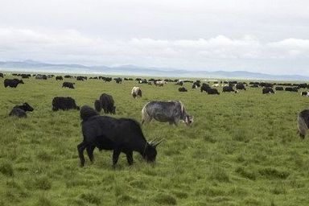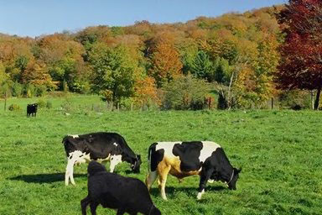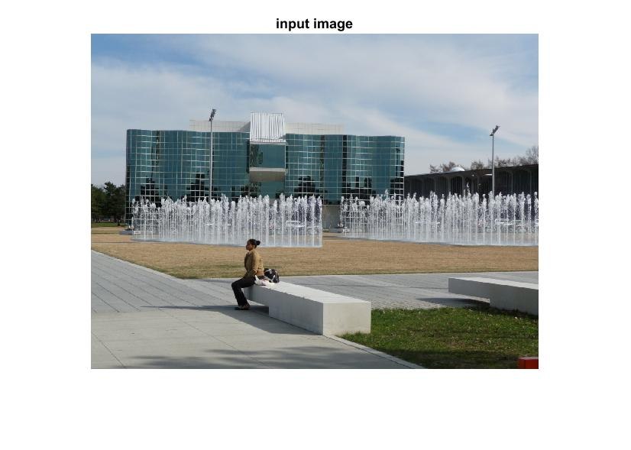
- (b) (c) (d)

Figure 1. Original images (a, b). Spliced image (c). Copy-move image (d).
Figure 1. shows the splicing forgery in (c) and copy move forgery in (d). Some part of the original images (b) is copied and pasted in figure (a) which give the spliced image in image (c). In figure (d) some part of the image is copied and pasted in the same image.
  - Forgery classification algorithm
In this paper the emphasis is given on copy move, splicing image forgery detection and localization under various geometrical attacks using machine learning and color illumination method.
The major steps of the proposed forgery classification algorithm to classify copy-move and splicing forgery are given below.
- Image preprocessing: In this step all the images are resized and labeled into proper size (116×116×3). Color illumination is applied on all the images. This step transforming an RGB image into identical blocks and illuminant maps, in order to detect sharp edges and traces in geometrical attacks.
- Prepare Training and Validation Dataset: First step is to create two categories such as Forged and Authentic. In these two categories copy move and spliced images are placed. The CASIA-1, CASIA-2, DVMM, COMOFOD dataset of copy move and splicing are taken for experiment. All these datasets are arranged in proper size and labels. In the second step color information and category labels are extracted to generate training and validation dataset. This dataset is divided into Authentic and Forged Categories (80% for Training and 20% for validation)
- Setup of the CNN: To create Convolution Neural Network (CNN) input layer is taken with no data augmentation. First convolutional layer has a bank of filters, padding of 4 pixels, ReLU layer, max pooling layer with 5x5 spatial pooling area and Stride of 2 pixels. These layers create CNN model for training.
- Setup of the Deep CNN: Deep Convolution Neural Network (DCNN) is nothing but multiple layers are added with existing CNN. In this step multiple convolution layers, ReLU layers and max pooling layers added that has a 5x5 spatial pooling area and a stride of 2 pixels. This step down samples the data dimensions.
- Setup of the Fully Connected Layers: Output categories decide the number of neuron. In this experiment two categories are classified so we add a fully connected layer with 2 output neurons, soft max loss layer and classification layer. All the network weights are tuned to minimize the loss over this categorical distribution in training.
- Train the Model: The DCNN model is trained with the given dataset using training options. This training option consists of parameters such as stochastic gradient descent with momentum, initial learn rate, learn rate schedule, piecewise, learn rate drop factor, learn rate drop period, L2 regularization, maximum size of epochs, minimum batch size and verbose. These parameters are tuned to get good accuracy. The DCNN model is trained with these parameters.

1. Preprocessing: Resize images, Apply Color Illumination to Training Dataset
2. Prepare Training and Validation Dataset: Get color information; Get category labels; Generate training and validation set; Load Image Dataset with Authentic and Forged Categories (80% for Training and 20% for validation)

3. Setup of the CNN: Input layer with no data augmentation; First convolutional layer has a bank of filters; Padding of 4 pixels, ReLU layer; Max pooling layer with 5x5 spatial pooling area; Stride of 2 pixels.

4. Setup of the Deep CNN: Add multiple convolution layers, ReLU layers and Max Pooling Layers that has a 5x5 spatial pooling area and a stride of 2 pixels. This step down samples the data dimensions.

5. Setup of the Fully Connected Layers: Add a fully connected layer with 2 output neurons; Soft Max loss layer and classification layer. All the network weights are tuned to minimize the loss over this categorical distribution in training.
6. Train the Model: Training Options (stochastic gradient descent with momentum, 0.9, Initial Learn Rate, 0.001, Learn Rate Schedule, piecewise, Learn Rate Drop Factor, 0.25, Learn Rate Drop Period, 20, L2 Regularization, 0.004, Max Epochs, 60, Min Batch Size, 20, Verbose, true)
7. Validate the Model: Validate the model on 20% unseen images.
8. Classify correct categories as Authentic and forged

Forged

Authentic

Figure 3. Forgery detection and localization general framework.
- Validate the Model: The trained model is validated with 20% of unseen images. These images are not present in the training phase. All these images are new for the model. This step is very important because if the model is trained with 100% accuracy and in the validation step it show 50% accuracy then model is under fit. If the accuracy is 50% in training and in the validation step it shows 100% accuracy, then the model is over fit. To overcome this problem equal proportion of each category images should be given to train the model.
- Classify correct categories as Authentic and forged: The classification output is shown in figure 2. In this image the trained model prediction shows forged and authentic classification.
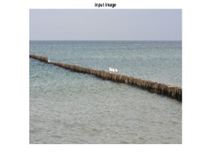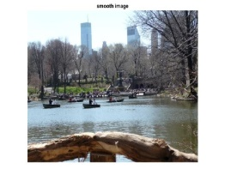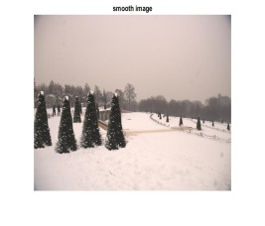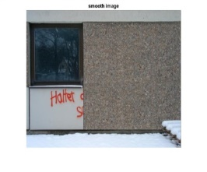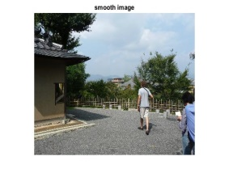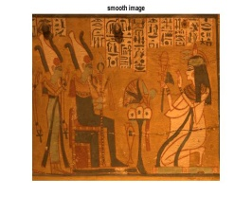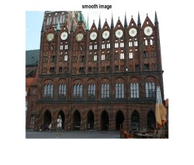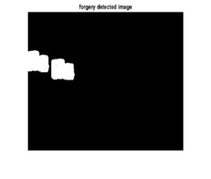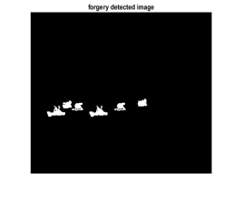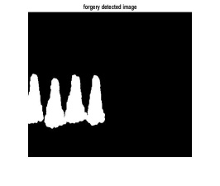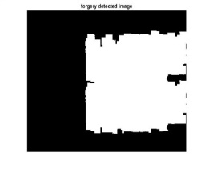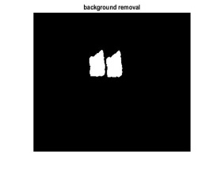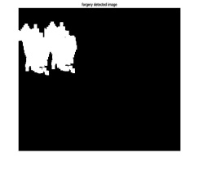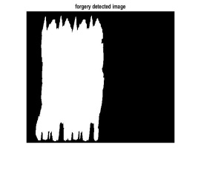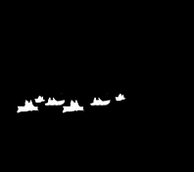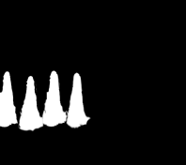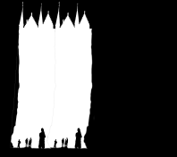

The training of the DCNN network is performed with the help of training parameters. The description of the fifteen layer DCNN model is shown in table 1.

Table 1 DCNN model training parameters
Sr. No. | Layer Abb. | Layer Name | Layer Discriptions
1 | Imageinput | Image Input | 116x116x3 images with 'zerocenter' normalization
2 | conv_1 | Convolution | 32 5x5x3 convolutions with stride [1 1] and padding [4 4 4 4]
3 | relu_1 | ReLU | ReLU
4 | maxpool_1 | Max Pooling | 5x5 max pooling with stride [2 2] and padding [0 0 0 0]
5 | conv_2 | Convolution | 64 5x5x32 convolutions with stride [1 1] and padding [4 4 4 4]
6 | relu_2 | ReLU | ReLU
7 | maxpool_2 | Max Pooling | 5x5 max pooling with stride [2 2] and padding [0 0 0 0]
8 | conv_3 | Convolution | 64 5x5x64 convolutions with stride [1 1] and padding [2 2 2 2]
9 | relu_3 | ReLU | ReLU
10 | maxpool_3 | Max Pooling | 3x3 max pooling with stride [2 2] and padding [0 0 0 0]
11 | fc_1 | Fully Connected | 2 fully connected layer
12 | relu_4 | ReLU | ReLU
13 | fc_2 | Fully Connected | 2 fully connected layer
14 | Softmax | Softmax | softmax
15 | classoutput | Classification Output | Cross entropy ex with classes 'Au' and 'Sp'

Table 2 CASIA-1 Training
Epoch | Iteration | Time Elapsed  (Seconds) | Accuracy
1 | 1 | 2.27 | 50
50 | 550 | 291.18 | 85
100 | 1100 | 582.36 | 100
150 | 1650 | 878.15 | 100
200 | 2200 | 1172.63 | 100

Figure 2 The graph of CASIA-1 Training
Performance on validation set 0.9667
We have 2/66 wrong classifications ans = 0.9858

CASIA_arc 100

Table 3 CASIA-1_arc_Au100_Sp100 Transfer Learning Training

Epoch | Iteration | Time Elapsed  (Seconds) | Accuracy
1 | 1 | 0.9 | 100
50 | 250 | 131.56 | 100
100 | 500 | 262.76 | 100
150 | 750 | 394.25 | 100
200 | 1000 | 525.6 | 100
Figure 3 The graph of CASIA-1 Training

Performance on validation set 1.0000
We have 0/30 wrong classifications ans = 1
Au 7437
Sp 1638
Table 4 CASIA-1_Au7437_Sp1638 all Transfer Learning Training
Epoch | Iteration | Time Elapsed  (Seconds) | Accuracy
1 | 1 | 1.86 | 25
50 | 22650 | 11850.86 | 95
100 | 44850 | 23513.76 | 100
150 | 67950 | 35634.77 | 100
200 | 90600 | 47624.14 | 100
Figure 4 The graph of CASIA-1_Au7437_Sp1638 all Training

Performance on validation set 0.9767
We have 79/2722 wrong classifications ans = 0.9793

Au 800
Sp 921

Table 5 CASIA-1_Au800_Sp921 Transfer Learning Training
Epoch | Iteration | Time Elapsed  (Seconds) | Accuracy
1 | 1 | 2.88 | 50
50 | 4300 | 2242.4 | 55
100 | 8600 | 4491.44 | 85
150 | 12900 | 6749.11 | 90
200 | 17200 | 9028.58 | 90
Figure 5 The graph of CASIA-1_Au800_Sp921 all Training

Performance on validation set 0.9726
We have 15/516 wrong classifications ans = 0.9735
CASIA-2

TransferLearning3
Au 100
Sp 120

Table 6 CASIA-2_Au100_Sp120 Transfer Learning Training
Epoch | Iteration | Time Elapsed  (Seconds) | Accuracy
1 | 1 | 2.27 | 50
50 | 550 | 291.18 | 85
100 | 1100 | 582.36 | 100
150 | 1650 | 878.15 | 100
200 | 2200 | 1172.63 | 100
Figure 6 The graph of CASIA-2_Au100_Sp120 all Training

Performance on validation set 0.9667
We have 2/66 wrong classifications ans =0.9858

Au 7437
Sp 1638

Table 7 CASIA-2_Au7437_Sp1638 Transfer Learning Training
Epoch | Iteration | Time Elapsed  (Seconds) | Accuracy
1 | 1 | 1.86 | 25
50 | 22650 | 11850.86 | 95
100 | 45300 | 23749.78 | 100
150 | 67950 | 35634.77 | 100
200 | 90600 | 47624.14 | 100
Figure 7 The graph of CASIA-2, Au7437, Sp1638 all Training

Performance on validation set 0.9767
We have 79/2722 wrong classifications ans = 0.9793
  - Forgery Localization

- Prepare Transfer Learning Dataset: Get color information; Get category labels; Generate training and validation set; Load Image Dataset with Copy Move and Spliced Categories (80% for Training and 20% for validation)
- Repeat steps 3, 4, 5, 6, 7: In these steps all the process remains same as shown in Flow chart 1. After these steps our system correctly classifies the type of forgery.
9. Prepare Transfer Learning Dataset: Get color information; Get category labels; Generate training and validation set; Load Image Dataset with Copy Move and Spliced Categories (80% for Training and 20% for validation)

10. Repeat steps 3, 4, 5, 6, 7: In these steps all the process remains same as show in Flow chart 1. After these steps our system correctly classify type of forgery.
12. Setup of the Feature Extraction: SLICO, Block Feature Extraction using SIFT Algorithm, Correlation Coefficient Map generation and Block Matching Threshold Calculation, Matched Blocks Location and Feature Points Labeling
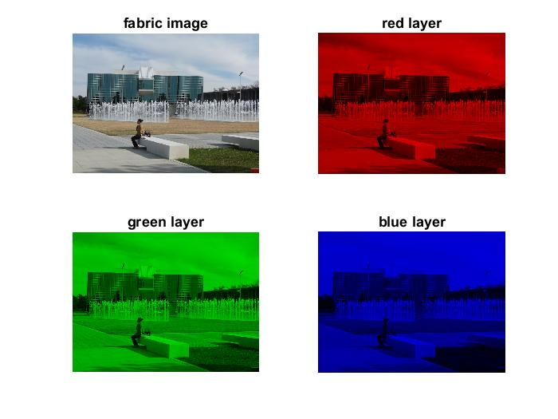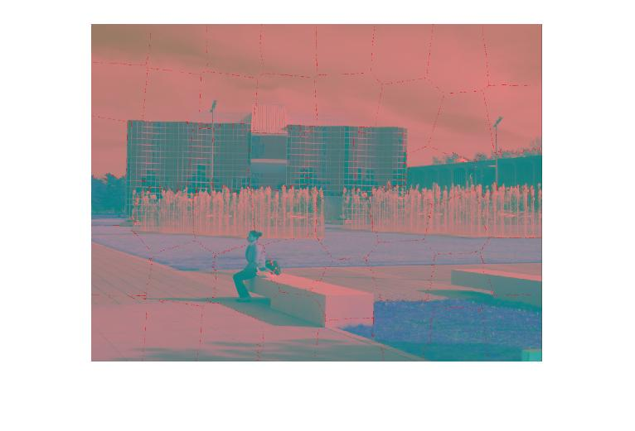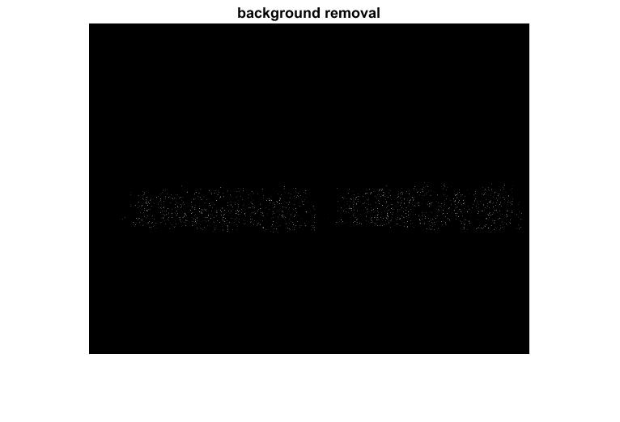 (a) (b) (c) (d)
13. Setup of the Correct Feature boundaries: Local Color Feature Extraction, Use SVM to classify correct feature boundaries, Detected Forgery Regions

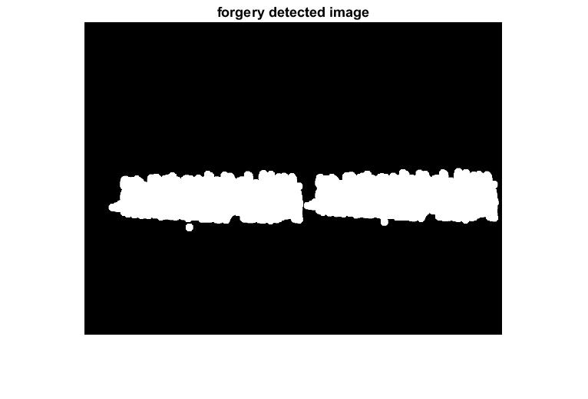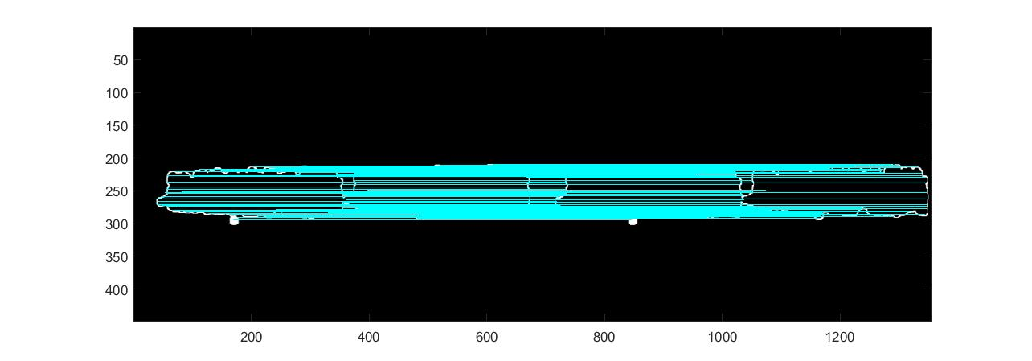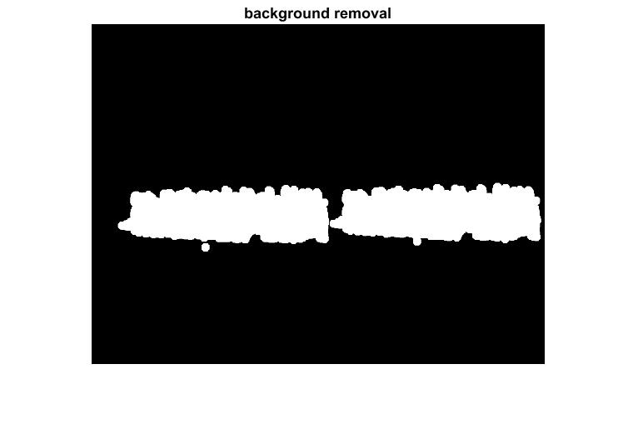
(e) (f) (g)
11. DCNN Classify correct categories as Spliced and Copy Move images.

Copy Move

Spliced
Forged Images Dataset

- DCNN Classify correct categories as Spliced and Copy Move images.
- Feature extraction: The goal of feature extraction is to compute the speciﬁc representation of the data that can highlight relevant data. The dimension of the feature space constructed by the feature extraction techniques may be prohibitive, can involve redundant information and can cause the efﬁciency of a classiﬁer to deteriorate. The feature selection procedure is then utilized to reduce system complexity and time complexity by eliminating the insigniﬁcant features before classiﬁcation.
- Classiﬁer selection and modelling: An appropriate classiﬁer is selected or designed and is then developed on the training set of images. During the training phase the parameters of a classiﬁer are tuned. The purpose of classiﬁer is to discriminate the given images and form them into two categories: original and cast images. Various classiﬁers have been employed such as SVM12–14,16–18, Naïve Bayes19 and Artiﬁcial Neural Network (ANN) 20 to solve the forgery detection problem. the forgery detection problem. According to the steps described above, the commonly used structure of a blind copy-move and splicing forgery detection system for digital images is given in Figure 5. Setup of the Correct Feature boundaries: Local Color Feature Extraction, Use SVM to classify correct feature boundaries, Detected Forgery Regions

Figure 2. Image forgery detection techniques classiﬁcation.

    - Detection (b) Localization

- Experimental Results on Forgery Detection and Localization

Copy-move forgery is the most difficult type of digital image forgeries to detect. It uses a region in the same image with the same properties and features of the other image regions to hide or duplicate some objects in the image. We will concentrate on copy-move forgery detection due to its widespread use and the difficulty of its detection.
There are two main goals of any forgery detection algorithm; firstly, reducing complexity represented in execution time, and Secondly, increasing the algorithm accuracy against different processing operations used in copy-move forgery.

- Classiﬁcation: The purpose.
dfvgfgv

- Classiﬁcation: The purpose.
dsf

- Classiﬁcation: The purpose.
Dfg

In that respect are main steps which any copy-move forgery detection algorithm does. First, grayscale conversion is given by mixing the red, immature, and blue channels to operate in a sort of a grayscale image. The second division operation is executed based on two types of classification; pixel-based type and block-based type [11]. Third, image processing transformations are applied to extract the image characteristics. A descriptor or classifier is applied to calculate the feature vectors as noise distribution, color, light, shadow, resolutions, or borders. Lastly, a lexographical representation is used as a map to test the image feature vectors to compare values and match the very ones. The block diagram in Figure 5 shows the copy-move operation methodology.
Copy-move forgery detection algorithms are separated into different families based on the image processing operation performed after division [3]. In the following part, we will discuss each family, and the earlier techniques used and comparing between the best techniques in each household.

Spliced Image Dataset

Prepare Training and Validation Dataset: Get color information; Get category labels; Generate training and validation set; Load Image Dataset with Authentic and Forged Categories (80% for Training and 20% for validation)

Setup of the CNN: Input layer with no data augmentation; First convolutional layer has a bank of filters; Padding of 4 pixels, ReLU layer; Max pooling layer with 5x5 spatial pooling area; Stride of 2 pixels.

Setup of the Deep CNN: Add multiple convolution layers, ReLU layers and Max Pooling Layers that has a 5x5 spatial pooling area and a stride of 2 pixels. This step down samples the data dimensions.

Setup of the Fully Connected Layers: Add a fully connected layer with 2 output neurons; Soft Max loss layer and classification layer. All the network weights are tuned to minimize the loss over this categorical distribution in training.

Train the Model: Training Options (stochastic gradient descent with momentum, 0.9, Initial Learn Rate, 0.001, Learn Rate Schedule, piecewise, Learn Rate Drop Factor, 0.25, Learn Rate Drop Period, 20, L2 Regularization, 0.004, Max Epochs, 60, Min Batch Size, 20, Verbose, true)

Validate the Model: Validate the model on 20% not seen images.

Classify correct categories: classify Authentic and forged images.

Authentic
Forged

  - Other algorithms
An automatic method was introduced in Ref.68 to identify spliced forgery based on the human visual system, in which visual salience and ﬁxation is used to extract characteristics. A meta-classiﬁer is used to Sort out whether an image is authentic or forged; its Accuracy was 89%. The method offered a convenient means to localize forged regions. Nevertheless, this technique was not robust to blur.
Hussain et al. 13 investigated the effect of two state-of-the-art local texture descriptors, multi-scale WLD and multi-scale LBP, for getting a robust scheme for detecting splicing for gery. The answers showed that the multi-WLD based method is robust for detecting splice forgery.
The methods discussed in this category have some limitations, for example the detection methods fail when blurring is applied to hide the sharp edges after splicing. Moreover most of the techniques cannot detect and localize minor spliced forgeries.

- The province of the art (2010–2015)
State-of-the-art copy-move and splicing forgery detection algorithms are reported in Tables 1 and 2 with their potencies and restrictions. Their strengths and limitations. The methods have been prese Taken down in chronological order. These tables present a brief description of each method, the data- base used for valuation, performance and limitations for easy comparison.
Estimating the color of the illuminant from a single image is an under constrained problem. Hence, each algorithm has to rely on certain assumptions to make the problem tractable. Depending on how well the assumptions are fulfilled in the actual image, the estimate is closer or less close to the ground truth. Operating on image regions instead of full images naturally makes the problem harder, and hence the local estimation errors larger.
Several research groups investigate color constancy in a broader, computer vision, context. There, the task is to be able to color-normalize an image as if it were taken under a canonical white illuminant. For image forensics, the goal is slightly different. We do not aim to get accurate information that is close to the true illuminant. Instead, the aim is to expose inconsistencies in the local color distribution of an image. Although the absolute estimation errors per segment may still be considerable, the forensic application shifts the focus to _relative_ errors between super pixels in the image. In the line of this thought, we proposed color constancy operators as statistical descriptors for image in homogeneities in our 2010 Information Hiding paper "Scene Illumination as an Indicator of Image Manipulation". In this paper, we consider inconsistencies of local illuminators applied on segmentations of full images.
From a theoretical viewpoint, it is advantageous to consider only image regions that consist of approximately the same underlying material. Hence, in our 2013 TIFS paper "Exposing Digital Image Forgeries by Illumination Color Classification", we limited the investigation on comparing descriptors on face regions of the image. Tiago Carvalho greatly extended this thought by devising a machine-learning approach for automatically classifying spliced scenes of faces.

- Experimental Results
Table 1. Precision, Recall and F1 comparison at image level of Proposed scheme, Adaptive Blocking using the Hybrid Method with existing methods.

 | Bravo [30] | Wang [28] | SIFT [31 | SURF [33] | Pun [26] Fixed | Pun [26] Adap. | Pro.
P | 87.27 | 92.31 | 88.37 | 90.49 | 95.92 | 96 | 97.25
R | 100 | 100 | 79.17 | 89.58 | 97.92 | 100 | 100
F1 | 93.2 | 96 | 83.52 | 90.53 | 96.91 | 97.96 | 98.53

Detection results under JPEG attacks
A total of 48 images of high resolution are tested in this experiment when tampered parts are distorted by JPEG transform. The testing of proposed hybrid technique is done using the forged regions that were distorted by JPEG transform. All these 48 pictures with various JPEG compression stances varying from 100 to 20, by incrementing values 10 times, are evaluated and computed the detected forgery results. Avg. Precision=71.44%; Avg. Recall=58.44%; Avg. F1=63.77%.
J-30 J-40 J-50 J-60 J-70 J-80 J-90
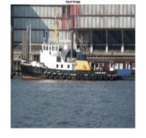



Fig. 17: Shows forged images with 20, 50, 90 and 100 JPEG compression (top row); Pixel level forgery detection results of the corresponding JPEG compression at in middle row (left most image with JPEG compression of 20, 50, 90 and 100); Ground truth images of the corresponding JPEG compression at in bottom row (left most image with JPEG compression of 20, 50, 90 and 100) .

Fig.17 shows pixel level tampering detection outcomes for JPEG compression at 20, 50, 90 and 100. The average precision, average recall and average F1 value are calculated at pixel level. The Avg. Precision=71.44%; Avg. Recall=58.44%; Avg. F1=63.77% is obtained. The graphs are plotted in Fig. 18 (a) for comparison of precision, recall and F1 value with state of the art techniques from table 1. These graphs show better performance results in comparison with existing techniques.

Fig. 18: (a) Shows Graphical representation of Precision, Recall and F1 comparison of Proposed scheme Adaptive Blocking using the Hybrid Method with existing methods at the image level from Table 4. (b), (c) and (d) Pixel level forgery detection results Avg. Precision=71.44%; Avg. Recall=58.44%; Avg. F1=63.77% for JPEG compression at 100 to 20, in steps of −10.

Detection results under SCALE transforms
The proposed hybrid technique tested when forged regions are distorted by JPEF transform. In this experiment 48 images with different JPEG compression level from S-910 to S-1090, in steps of −20 are evaluated and find out the pixel level forgery detection results Avg. Precision=71.44%; Avg. Recall=58.44%; Avg. F1=63.77%.

S-91 S-93 S-95 S-97 S-99 S-101 S-103 S-105 S-107 S-109
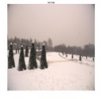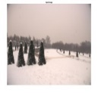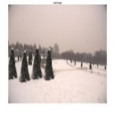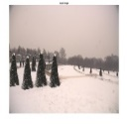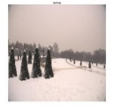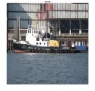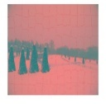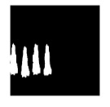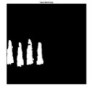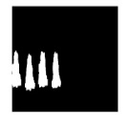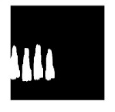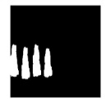
Fig. 19: Shows forged images with 20, 50, 90 and 100 JPEG compression (top row); Pixel level forgery detection results of the corresponding JPEG compression at in middle row (left most image with JPEG compression of 20, 50, 90 and 100); Ground truth images of the corresponding JPEG compression at in bottom row (left most image with JPEG compression of 20, 50, 90 and 100) .

Fig.19 shows pixel level forgery detection results for JPEG compression at 20, 50, 90 and 100. The average precision, average recall and average F1 value are calculated at pixel level. The Avg. Precision=71.44%; Avg. Recall=58.44%; Avg. F1=63.77% is obtained. The graphs are plotted in Fig. 13 (a) for comparison of precision, recall and F1 value with state of the art techniques from table 4. These graphs show better performance results in comparison with existing techniques.

Fig. 20: (a) Shows Graphical representation of Precision, Recall and F1 comparison of Proposed scheme Adaptive Blocking using the Hybrid Method with existing methods at the image level from Table 4. (b), (c) and (d) Pixel level forgery detection results Avg. Precision=71.44%; Avg. Recall=58.44%; Avg. F1=63.77% for JPEG compression at 100 to 20, in steps of −10.

Detection results under Rotation transforms
The proposed hybrid technique tested when forged regions are distorted by JPEF transform. In this experiment 48 images with different JPEG compression level from 100 to 20, in steps of −10 are evaluated and find out the pixel level forgery detection results Avg. Precision=71.44%; Avg. Recall=58.44%; Avg. F1=63.77%.
R-2 R-4 R-6 R-8 R-10
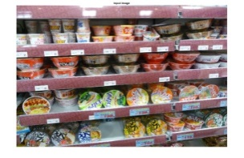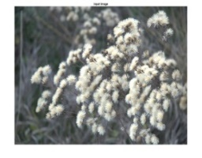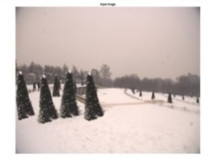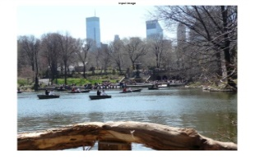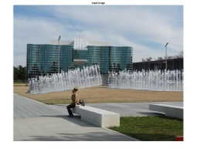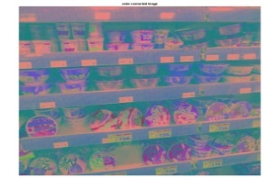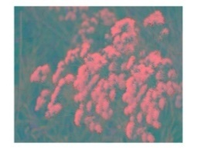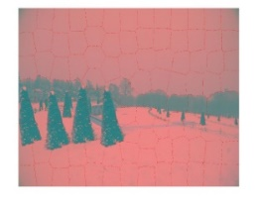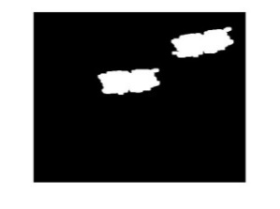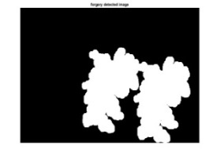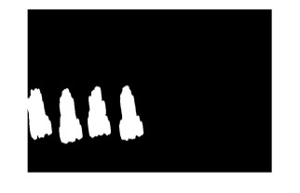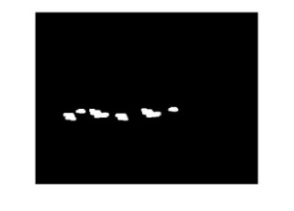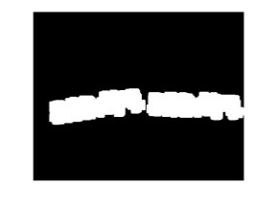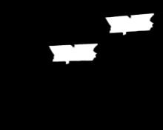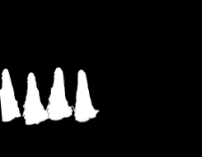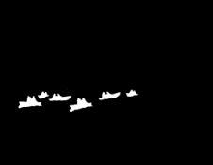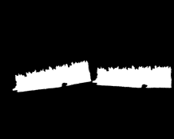

Fig. 21: Shows forged images with 20, 50, 90 and 100 JPEG compression (top row); Pixel level forgery detection results of the corresponding JPEG compression at in middle row (left most image with JPEG compression of 20, 50, 90 and 100); Ground truth images of the corresponding JPEG compression at in bottom row (left most image with JPEG compression of 20, 50, 90 and 100) .

Fig. 21 shows pixel level forgery detection results for JPEG compression at 20, 50, 90 and 100. The average precision, average recall and average F1 value are calculated at pixel level. The Avg. Precision=71.44%; Avg. Recall=58.44%; Avg. F1=63.77% is obtained. The graphs are plotted in Fig. 22 (a) for comparison of precision, recall and F1 value with state of the art techniques from table 4. These graphs show better performance results in comparison with existing techniques.
Fig. 22: (a) Shows Graphical representation of Precision, Recall and F1 comparison of Proposed scheme Adaptive Blocking using the Hybrid Method with existing methods at the image level from Table 4. (b), (c) and (d) Pixel level forgery detection results Avg. Precision=71.44%; Avg. Recall=58.44%; Avg. F1=63.77% for JPEG compression at 100 to 20, in steps of −10.

Fig. 22 (a) shows a graphical representation of Precision, Recall and F1 comparison of Proposed scheme Adaptive Blocking using the Hybrid Method with state of the art methods at the image level from table 4. Fig.13 (b), (c) and (d) shows the CMFD results at the pixel level under JPEG attacks. In these graphs, the results with dark brown color, pronounced as ‘Proposed’ represents the results with Color Illumination method. The results with purple color, pronounced as ‘RSIFT’ represent the results with Fixed Size Blocking. The results with blue color, pronounced as ‘SIFT’ and brown color, pronounced as ‘SURF’ represents the results of the key point based methods SIFT [31], and SURF [33]. The green color, pronounced as ‘Bravo’ and yellow color, pronounced as ‘Circle’ indicates block based methods, results [28], and [30]. As Fig. 22 shows the comparison graph of proposed hybrid algorithm gives better results as compared to the existing methods.

- Conclusions and directions for the future
A concise survey of the copy-move and splicing forgery detection methods can assist researchers to explore new challenges in the ﬁeld. In this report, we have discussed in detail two popular types of image forgeries (copy-move and splicing) and provided the critical analysis of the state-of-the-art methods developed to find and localize copy- move and splicing forgeries.
Many techniques have been broken by researchers that detect and localize copy- move and splicing forgeries. Nevertheless, these methods are not robust, because they do not interpret the structural changes that properly occurred in images after tampering either by copy-move or splicing. The existing forgery detection approaches are facing the following subjects.

  - Copy-move forgery detection techniques
Copy-move forgery is one of the most commonly used forgery techniques to tamper with images. Although many papers have been published suggesting different detection techniques, the following are the major challenges which have not been overcome yet.

    - Benchmarking and standard datasets

An image dataset is fundamental for training, testing and evaluation of any forgery detection algorithm. Several datasets are available for the research community80–84, but there are even some unresolved events that cry for a benchmark dataset. For example, experi- ments invOven observing the impact of geometric transformations requires a dataset of copy-move forged images that are molded by using all types of geometric transfor- mations. Furthermore, a dataset based on the sate-of-the-art copy-move forgery creation techniques is necessary. Thus, further effort on creating and standardizing the additional benchmark dataset is called for.

    - Performance measurement and evaluation

Most of the proposed copy-move forgery detection techniques do not provide achievable performance in terms of accuracy and false alert rates. To further reﬁne these methods, analytical results have to be deﬁned clearly, and appropriate evaluation metrics have to be planned.

ge database and NRCS Photo Gallery
  - Validity

A successful copy-move forgery detection method must be robust against post-pro- ceasing operations. Nevertheless, as even so no method achieved 100% robustness against post- processing operations. In addition, selection of block size poses a problem. If it is considered too small, false positives appear and if considered too large, some forged areas go under- examined. Besides, the feature extraction and selection is manual and has to be wisely set to avoid false positives.

  - Image splicing forgery detection techniques
Now, image splicing forgery is very common and it is easy to create fake pho- tographs and misuse them. Hence, it is necessary to distinguish this sort of image manipu- lation for authenticating images. The existing image splicing detection methods work well, with certain data sets but not in cosmopolitan. The existing methods of detecting image splicing are facing the following challenges.

    - Benchmarking and standard datasets

A dataset based on the image splicing forgery creation technique is necessary to evaluate any image spliced forgery detection method. Further effort is so needed in developing and standardizing the additional benchmark dataset, because only limited datasets are available for evaluation of spliced forgery detection methods.

    - Performance measurement and evaluation

Image splicing is based on multiple images, there is a need to deﬁne separate met- rises for evaluation of algorithms based on lighting inconsistencies, color ﬁlter array and inter-pixel correlation and chromatic distortion.

    - Validity

We studied several methods suggested in the literature to detect image Composi- tion. Most of the existing methods require human interpretation to describe the results and are not automated. Most of the image splicing detection algorithms have a low accuracy if strong post-processing operations such as edge blurring, adding noise, and lossy compression is applied after tempering. So, this ﬁeld is still growing and a lot of research is demanded to make digital forensics more promising.

  - Conclusions and future directions
Deep learning^{85–88} frameworks are able to learn feature representations and perform classiﬁcations automatically. Deep representations involve multiple layers of hidden variables, which allow a combinatorial sharing of statistical strength. Moved by how human brains process information, researchers have explored deep, multi-layer neural networks, such as Deep Boltzmann Machines89, Deep Auto encoders90, and Convolu- tone Neural Networks (CNN) 91–93.ion Neural Networks (CNN)^{91–93}. These methods have shown impressive performance in Artiﬁcial Intelligence (AI) tasks such as object recognition⁹³, natural language pro- cessing⁹⁴ and several other applications. The telling view of deep theory is that it

Figure 6. The proposed framework for copy-move and splicing forgery detection based on deep learning.
Input

Output (Authentic/Forged)
Convolution Layer
Pooling Layer
Fully Conn. Layer
Classification Layer

Can be applied to automatically determine relevant and discriminating features. In forgery detection, the main challenge is to interpret the structural changes taking place in an icon due to counterfeit, and deep learning theory, if applied in an intelligent fashion, can help to automatically model such changes.
To classify whether an image is authentic or forged, a universal and automatic approach can be developed using CNN, as depicted in Figure 6. CNN is a kind of neural networK that shares weights among neurons in the same stratum. CNN is good at Discov- Erin spatially local correlation by enforcing a local connectivity pattern between neo- runs of contiguous strata. CNN combines image segmentation, feature extraction and the classiﬁcation process in one trainable module. CNN takes a two dimensional (2D) raw image with minimal pre-processing and retains the 2D topology throughout its preparation. Classiﬁcation is performed during training and, at the conclusion of training, the learned weights help to separate the input image accurately.

References
- Bashar M, Noda K, Ohnishi N, Mori K. Exploring duplicated regions in natural images, In IEEE Transactions on Image Processing; 2010.
- Amerini I, Ballan L, Caldelli R, Del Bimbo A, Del Tongo L, Serra G. Copy-move forgery detection and localization by means of robust clustering with J-linkage. Signal Process: Image Commun. 2013;28:659–669.
- Huang Y, Lu W, Sun W, Long D. Improved DCT-based detection of copy-move forgery in images. Forensic Sci Int. 2011;206:178–184.
- Muhammad G, Hussain M, Bebis G. Passive copy move image forgery detection using undecimated dyadic wavelet transform. Digital Invest. 2012;9:49–57.
- Shabanifard M, Shayesteh M, Akhaee A. Forensic detection of image manipulation using the Zernike moments and pixel-pair histogram. IET Image Process. 2013;7:817–828.
- Hussain M, Saleh SQ, Aboalsamh H, Muhammad G, Bebis G. Comparison between WLD and LBP descriptors for non-intrusive image forgery detection. In IEEE international symposium on innovations in intelligent systems and applications (INISTA); 2014; Alberobello, Italy; 197–204.
- Carvalho, T.J., Riess, C., Angelopoulou, E., Pedrini, H., & Rocha, A. (2013). Exposing Digital Image Forgeries by Illumination Color Classification. IEEE Transactions on Information Forensics and Security, 8, 1182-1194.
- Chen J, Kang X, Liu Y, Wang ZJ. Median ﬁltering forensics based on convolutional neural networks. IEEE Signal Process Lett. 2015;22:1849–1853.
- Asghar K., Habib Z., Hussain M. (2016): Copy-move and splicing image forgery detection and localization techniques: a review. Australian Journal of Forensic Sciences, DOI: 10.1080/00450618.2016.1153711
- Amerinia I., Uricchioa T., Ballana L., Caldellia R. Localization of JPEG double compression through multi-domain convolutional neural networks. arXiv:1706.01788v1 [cs.MM] 6 Jun 2017
- Mauro B., Luca B., Nicolò B., Paolo B., Andrea C., Marco M., Benedetta T., Stefano T. Aligned and Non-Aligned Double JPEG Detection Using Convolutional Neural Networks. arXiv:1708.00930v1 [cs.CR] 2 Aug 2017
- Wybren v.d. M., Kim-Kwang R. C., Nhien-An L. K., M-Tahar K. Investigation and Automating Extraction of Thumbnails Produced by Image Viewers. (2017) IEEE Trustcom/BigDataSE/ICESS (2017): 1076-1081.
- Chen, B., Haodong Li., and Weiqi L. Image Processing Operations Identification via Convolutional Neural Network. CoRR abs/1709.02908 (2017).
- Wang, H., Wang, HX., Sun, XM. A passive authentication scheme for copy-move forgery based on package clustering algorithm. Multimed Tools Appl (2017) 76: 12627. https://doi.org/10.1007/s11042-016-3687-5
- Chitra G., and Bhuma V. Digital Image Forgery detection using color Illumination and Decision Tree Classification. (2014).
- Sridevi M., Mala C., Sanyam S. Comparative Study of Image Forgery and Copy-Move Techniques. In: Wyld D., Zizka J., Nagamalai D. (eds) Advances in Computer Science, Engineering & Applications. Advances in Intelligent and Soft Computing, (2012). vol 166. Springer, Berlin, Heidelberg
- W. Fan, S. Agarwal, and H. Farid, Rebroadcast attacks: defenses, reattacks, and redefenses, In Proc. of the European Signal Processing Conference (EUSIPCO), Rome, Italy, IEEE, 2018.
- Khalid M. Hosny, Hanaa M. Hamza & Nabil A. Lashin (2018): Copy-move forgery detection of duplicated objects using accurate PCET moments and morphological operators, The Imaging Science Journal, DOI: 10.1080/13682199.2018.1461345
- Agarwal, S., W. Fan and hany. farid. “A Diverse Large-scale Dataset for Evaluating Rebroadcast Attacks.” (2018).
- C. Pun, X. Yuan and X. Bi. Image Forgery Detection Using Adaptive Oversegmentation and Feature Point Matching. in IEEE Transactions on Information Forensics and Security, vol. 10, no. 8, pp. 1705-1716, Aug. 2015.
- Janowczyk A, Madabhushi A. Deep learning for digital pathology image analysis: A comprehensive tutorial with selected use cases. J Pathol Inform 2016;7:29
- Sunil K., and Swati N. Key-point based copy-move forgery detection in digital images, Journal of Statistics and Management Systems, (2017). 20:4, 611-621, DOI: 10.1080/09720510.2017.1395181
- Prakash, C.S., Kumar, A., Maheshkar, S. An integrated method of copy-move and splicing for image forgery detection. Multimed Tools Appl (2018). https://doi.org/10.1007/s11042-018-5899-3

