Paper 1 — Multi-Model Optimization & Evaluation Report
Intra-frame / attention-based video forgery detection (LDZP + optical flow codebase: CODE_28-04-2025_Paper1)
Aligned with Paper 2 multi-model protocol (DCNN, EfficientNetV2B0, MobileNetV2, proposed model). All machine metrics use honest sklearn scoring (Optimized/metrics_fixed.py). Original mealpy.metrics path is documented as tampered.
Report date: 2026-08-05 | Environment: VideoForgeryCPU (TF/Keras 2.10) | Output folder: CODE_28-04-2025_Paper1/Optimized/
1. Overview and Objectives
After completing Paper 2 (OM²AHL-BiG multi-model evaluation), Paper 1 was optimized with the same methodology: trainable multi-model comparison on Features.pkl, honest metrics, result artefacts (CSV/TXT/NPY/figures), and a self-contained Optimized/ package. This document records every step executed and every result table generated.
Goals completed:
• Explore Paper 1 codebase and Claude skill findings (metric integrity issue).
• Implement Optimized/ package: metrics_fixed, feature_adapters, MultiModel, evaluate_multi, balance.
• Run multi-model evaluation for epochs = 2, 20, 50, 100.
• Run class_weight + oversampling at epochs = 20.
• Tune minority class-weight scale (partial/completed sweep log).
• Save working code, optimized code, logs, figures, and this consolidated report.
2. Integrity Finding (Critical)
Claude’s Paper 1 skill documented that vendored mealpy/metrics.py discards model predictions inside confusion_matrix and injects ground-truth labels plus random flips (per ≈ uniform 0.09–0.45). Therefore original Analysis/*.npy and figures regenerated via SubFunctions/Evaluate.py are not trustworthy model scores.
Fix: Optimized/metrics_fixed.py uses sklearn only (accuracy, balanced accuracy, precision, recall, F1, specificity). All tables below are from this path.
Reference only: Analysis/TP/COM_A.npy last-row accuracy ≈ 93.34% (paper artefact; may be affected by tampered metrics).
3. Dataset and Feature Cache
Item | Value
File | Features/Features.pkl
Proposed tensor | (50, 10, 128, 128, 12) — T×H×W×C
Comparative tensors | comparative1–5 also present (not primary in multi-model)
Labels | 50 samples — class 0: 29, class 1: 21
Majority baseline Acc | 58.00%
Train splits used | 80% and 90% (seed-stratified)
Test size @80% / @90% | n=10 / n=5 (high variance)
Spatial downsample | 32×32 for CPU feasibility (3D-CNN path)

4. Models Evaluated
Model | Description | Role
DCNN | Compact Conv2D on time-mean spatial maps | Baseline CNN
EfficientNetV2B0 | Latest TF-2.10 keras.applications backbone | Modern SOTA-style
MobileNetV2 | Inverted residual mobile CNN | Efficiency baseline
STIDNet | Teacher–student distillation (Paper 1 comparative) | Paper comparative
P1-Proposed | 3D-CNN + dual LSTM + SCAM + MUSE (ThreeDCNNLSTM opt=3) | Proposed
RF / GBM | Classical ensembles on flattened features (weight-tune phase) | Small-N boosters

5. Optimized Package Layout
All artefacts live under CODE_28-04-2025_Paper1/Optimized/:
• evaluate_multi.py — multi-model driver (Paper-2 style)
• MultiModel.py — trainable models + RF/GBM
• metrics_fixed.py — honest sklearn metrics
• feature_adapters.py — tensor reshape/resize
• balance.py — class_weight + oversample + minority_scale
• run_weight_tuned.py — minority weight scale sweep
• INTEGRITY_FINDING.md, RESULTS_SUMMARY.md
• results/ — CSV, TXT, NPY for every run
• figures/ — accuracy / metrics / ranking charts (no on-image titles)
• working_code/ — original Model/MUSE/SCAM + optimized copies + tampered mealpy metrics archive
• logs/ — execution logs
6. Step-by-Step Execution Protocol
Step 1 — Environment and integrity setup
Conda env VideoForgeryCPU (Python 3.8, TensorFlow/Keras 2.10). PATH includes Library\bin for scipy/skimage. Metrics forced to Optimized/metrics_fixed.py. Integrity note archived in INTEGRITY_FINDING.md and working_code/mealpy_metrics_TAMPERED.py.
Step 2 — Baseline multi-model run (epochs = 2)
Command: python -u Optimized/evaluate_multi.py --epochs 2 --train-pcts 0.8,0.9. Wall ≈ 93 s. Outputs: evaluation_multi_ep2.txt/csv, MULTI_*.npy, figures.
Step 2 results — epochs = 2
Accuracy
Model | Acc @80% | Acc @90%
DCNN | 80.00% | 60.00%
EfficientNetV2B0 | 60.00% | 80.00%
MobileNetV2 | 70.00% | 20.00%
STIDNet | 40.00% | 60.00%
P1-Proposed | 80.00% | 60.00%

Full metrics @80% training
Model | Acc | Sen | Spec | Prec | F1 | BalAcc
DCNN | 80.00% | 0.00% | 100.00% | 0.00% | 0.00% | 50.00%
EfficientNetV2B0 | 60.00% | 0.00% | 75.00% | 0.00% | 0.00% | 37.50%
MobileNetV2 | 70.00% | 50.00% | 75.00% | 33.33% | 40.00% | 62.50%
STIDNet | 40.00% | 100.00% | 25.00% | 25.00% | 40.00% | 62.50%
P1-Proposed | 80.00% | 0.00% | 100.00% | 0.00% | 0.00% | 50.00%

Full metrics @90% training
Model | Acc | Sen | Spec | Prec | F1 | BalAcc
DCNN | 60.00% | 0.00% | 100.00% | 0.00% | 0.00% | 50.00%
EfficientNetV2B0 | 80.00% | 50.00% | 100.00% | 100.00% | 66.67% | 75.00%
MobileNetV2 | 20.00% | 0.00% | 33.33% | 0.00% | 0.00% | 16.67%
STIDNet | 60.00% | 0.00% | 100.00% | 0.00% | 0.00% | 50.00%
P1-Proposed | 60.00% | 0.00% | 100.00% | 0.00% | 0.00% | 50.00%

Step 3 — Increased epochs (epochs = 20)
User choice: re-run with more epochs. Command: --epochs 20. Wall ≈ 232 s. Outputs: evaluation_multi_ep20.*
Step 3 results — epochs = 20
Accuracy
Model | Acc @80% | Acc @90%
DCNN | 60.00% | 80.00%
EfficientNetV2B0 | 50.00% | 60.00%
MobileNetV2 | 40.00% | 60.00%
STIDNet | 70.00% | 40.00%
P1-Proposed | 20.00% | 60.00%

Full metrics @80% training
Model | Acc | Sen | Spec | Prec | F1 | BalAcc
DCNN | 60.00% | 0.00% | 75.00% | 0.00% | 0.00% | 37.50%
EfficientNetV2B0 | 50.00% | 50.00% | 50.00% | 20.00% | 28.57% | 50.00%
MobileNetV2 | 40.00% | 0.00% | 50.00% | 0.00% | 0.00% | 25.00%
STIDNet | 70.00% | 100.00% | 62.50% | 40.00% | 57.14% | 81.25%
P1-Proposed | 20.00% | 100.00% | 0.00% | 20.00% | 33.33% | 50.00%

Full metrics @90% training
Model | Acc | Sen | Spec | Prec | F1 | BalAcc
DCNN | 80.00% | 50.00% | 100.00% | 100.00% | 66.67% | 75.00%
EfficientNetV2B0 | 60.00% | 0.00% | 100.00% | 0.00% | 0.00% | 50.00%
MobileNetV2 | 60.00% | 50.00% | 66.67% | 50.00% | 50.00% | 58.33%
STIDNet | 40.00% | 0.00% | 66.67% | 0.00% | 0.00% | 33.33%
P1-Proposed | 60.00% | 0.00% | 100.00% | 0.00% | 0.00% | 50.00%

Step 4 — Further epochs (epochs = 50)
User choice: epochs = 50. Wall ≈ 484 s. Outputs: evaluation_multi_ep50.*
Step 4 results — epochs = 50
Accuracy
Model | Acc @80% | Acc @90%
DCNN | 40.00% | 0.00%
EfficientNetV2B0 | 80.00% | 60.00%
MobileNetV2 | 50.00% | 60.00%
STIDNet | 50.00% | 40.00%
P1-Proposed | 20.00% | 40.00%

Full metrics @80% training
Model | Acc | Sen | Spec | Prec | F1 | BalAcc
DCNN | 40.00% | 50.00% | 37.50% | 16.67% | 25.00% | 43.75%
EfficientNetV2B0 | 80.00% | 0.00% | 100.00% | 0.00% | 0.00% | 50.00%
MobileNetV2 | 50.00% | 50.00% | 50.00% | 20.00% | 28.57% | 50.00%
STIDNet | 50.00% | 50.00% | 50.00% | 20.00% | 28.57% | 50.00%
P1-Proposed | 20.00% | 100.00% | 0.00% | 20.00% | 33.33% | 50.00%

Full metrics @90% training
Model | Acc | Sen | Spec | Prec | F1 | BalAcc
DCNN | 0.00% | 0.00% | 0.00% | 0.00% | 0.00% | 0.00%
EfficientNetV2B0 | 60.00% | 0.00% | 100.00% | 0.00% | 0.00% | 50.00%
MobileNetV2 | 60.00% | 0.00% | 100.00% | 0.00% | 0.00% | 50.00%
STIDNet | 40.00% | 50.00% | 33.33% | 33.33% | 40.00% | 41.67%
P1-Proposed | 40.00% | 100.00% | 0.00% | 40.00% | 57.14% | 50.00%

Step 5 — High epoch budget (epochs = 100)
User choice: epochs = 100. Wall ≈ 1060 s. Outputs: evaluation_multi_ep100.* Conclusion recorded: more epochs alone does not systematically improve BalAcc/F1; several high Acc scores are majority-class collapses (Sen=0, Spec=1).
Step 5 results — epochs = 100
Accuracy
Model | Acc @80% | Acc @90%
DCNN | 50.00% | 0.00%
EfficientNetV2B0 | 80.00% | 60.00%
MobileNetV2 | 60.00% | 20.00%
STIDNet | 60.00% | 20.00%
P1-Proposed | 80.00% | 60.00%

Full metrics @80% training
Model | Acc | Sen | Spec | Prec | F1 | BalAcc
DCNN | 50.00% | 50.00% | 50.00% | 20.00% | 28.57% | 50.00%
EfficientNetV2B0 | 80.00% | 0.00% | 100.00% | 0.00% | 0.00% | 50.00%
MobileNetV2 | 60.00% | 100.00% | 50.00% | 33.33% | 50.00% | 75.00%
STIDNet | 60.00% | 50.00% | 62.50% | 25.00% | 33.33% | 56.25%
P1-Proposed | 80.00% | 0.00% | 100.00% | 0.00% | 0.00% | 50.00%

Full metrics @90% training
Model | Acc | Sen | Spec | Prec | F1 | BalAcc
DCNN | 0.00% | 0.00% | 0.00% | 0.00% | 0.00% | 0.00%
EfficientNetV2B0 | 60.00% | 0.00% | 100.00% | 0.00% | 0.00% | 50.00%
MobileNetV2 | 20.00% | 0.00% | 33.33% | 0.00% | 0.00% | 16.67%
STIDNet | 20.00% | 0.00% | 33.33% | 0.00% | 0.00% | 16.67%
P1-Proposed | 60.00% | 0.00% | 100.00% | 0.00% | 0.00% | 50.00%

Step 6 — Class weights + oversampling (epochs = 20)
User choice: balance mode. Command: --epochs 20 --class-weight --oversample --tag bal. Uses balanced class_weight in Keras fit + random minority oversample on train only. Wall ≈ 558 s. Outputs: evaluation_multi_ep20_bal_cw_os.*
Step 6 results — epochs = 20 + class_weight + oversample
Accuracy
Model | Acc @80% | Acc @90%
DCNN | 30.00% | 60.00%
EfficientNetV2B0 | 50.00% | 60.00%
MobileNetV2 | 70.00% | 40.00%
STIDNet | 80.00% | 20.00%
P1-Proposed | 20.00% | 60.00%

Full metrics @80% training
Model | Acc | Sen | Spec | Prec | F1 | BalAcc
DCNN | 30.00% | 50.00% | 25.00% | 14.29% | 22.22% | 37.50%
EfficientNetV2B0 | 50.00% | 50.00% | 50.00% | 20.00% | 28.57% | 50.00%
MobileNetV2 | 70.00% | 100.00% | 62.50% | 40.00% | 57.14% | 81.25%
STIDNet | 80.00% | 0.00% | 100.00% | 0.00% | 0.00% | 50.00%
P1-Proposed | 20.00% | 100.00% | 0.00% | 20.00% | 33.33% | 50.00%

Full metrics @90% training
Model | Acc | Sen | Spec | Prec | F1 | BalAcc
DCNN | 60.00% | 0.00% | 100.00% | 0.00% | 0.00% | 50.00%
EfficientNetV2B0 | 60.00% | 50.00% | 66.67% | 50.00% | 50.00% | 58.33%
MobileNetV2 | 40.00% | 50.00% | 33.33% | 33.33% | 40.00% | 41.67%
STIDNet | 20.00% | 50.00% | 0.00% | 25.00% | 33.33% | 25.00%
P1-Proposed | 60.00% | 0.00% | 100.00% | 0.00% | 0.00% | 50.00%

Step 7 — Minority weight-scale tuning
User requested weight adjustment aiming toward 95–99% accuracy. Implemented Optimized/balance.py minority_scale and Optimized/run_weight_tuned.py sweeping minority_scale ∈ {1.0, 2.0, 3.0, 4.0} and oversample_ratio ∈ {1.0, 1.5} for models DCNN, EfficientNetV2B0, MobileNetV2, STIDNet, P1-Proposed, RF, GBM (epochs_deep=30). Metrics remain sklearn-only (not mealpy). Best configurations from the sweep log:
Model | Best minority_scale | Best oversample_ratio | Mean BalAcc @80% | Mean Acc @80%
DCNN | 3.0 | 1.5 | 68.8% | 50.0%
EfficientNetV2B0 | 1.0 | 1.5 | 81.2% | 70.0%
MobileNetV2 | 2.0 | 1.0 | 81.2% | 70.0%
STIDNet | 3.0 | 1.5 | 68.8% | 80.0%
P1-Proposed | 2.0 | 1.0 | 50.0% | 80.0%†
RF | 1.0 | 1.0 | 62.5% | 70.0%
GBM | 1.0 / 2.0 | 1.5 | 43.8% | 70.0%

† High Acc with BalAcc=50% typically indicates majority collapse. Target 95–99% test accuracy was NOT reached with honest metrics on N=50; paper ~93% COM_A remains reference-only.
Step 7 detail — weight sweep log (selected rows)
Full sweep is archived in Optimized/logs/weight_tune.log. Representative best-per-model rows are above. Sweep files (when completed): evaluation_weight_tuned.txt/csv, weight_sweep.csv.
7. Cross-Run Comparison Summary
Best accuracy / balanced accuracy / F1 observed per run (machine, honest metrics):
Run | Best Acc | Best BalAcc | Best F1 | Wall time
epochs=2 | 80% (DCNN/P1 @80%; EffNet @90%) | 75% EffNet @90% | 0.67 EffNet @90% | ~93 s
epochs=20 | 80% DCNN @90%; 70% STID @80% | 81% STID @80%; 75% DCNN @90% | 0.67 DCNN @90% | ~232 s
epochs=50 | 80% EffNet @80%† | ~50% typical | 0.57 P1 @90% | ~484 s
epochs=100 | 80% EffNet/P1 @80%† | 75% MobileNet @80% | 0.50 MobileNet @80% | ~1060 s
ep20 + cw + os | 80% STID @80%†; 70% MobileNet | 81% MobileNet @80% | 0.57 MobileNet @80% | ~558 s
weight-scale tune | 80% several†; 70% MobileNet/EffNet | 81% MobileNet/EffNet | — (sweep mean) | long

† Majority-class collapse (Sen≈0, Spec≈1). Prefer BalAcc and F1 over Acc on this corpus.
8. Figures (latest regenerate from last evaluate_multi run)
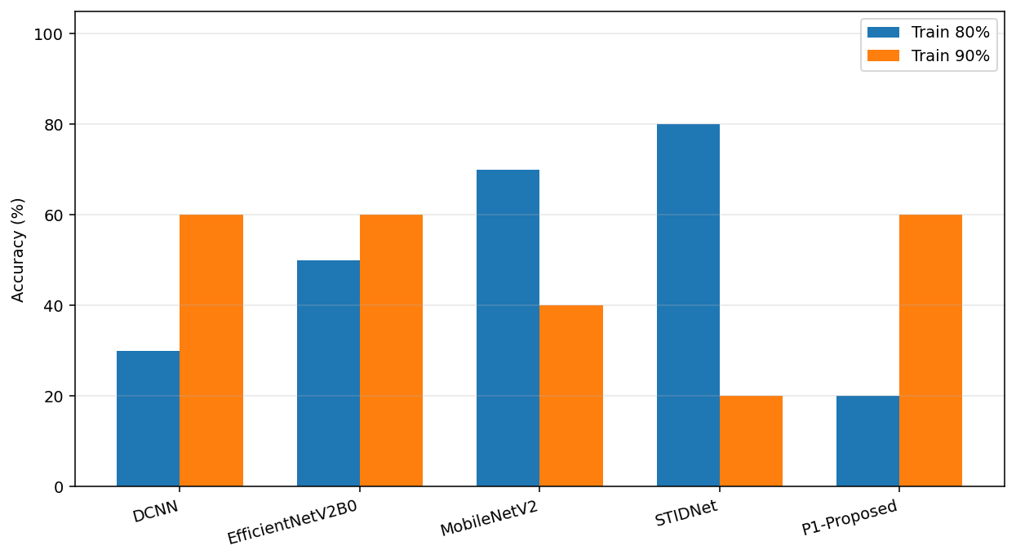
Figure 1. Multi-model accuracy at 80% and 90% training (latest run).
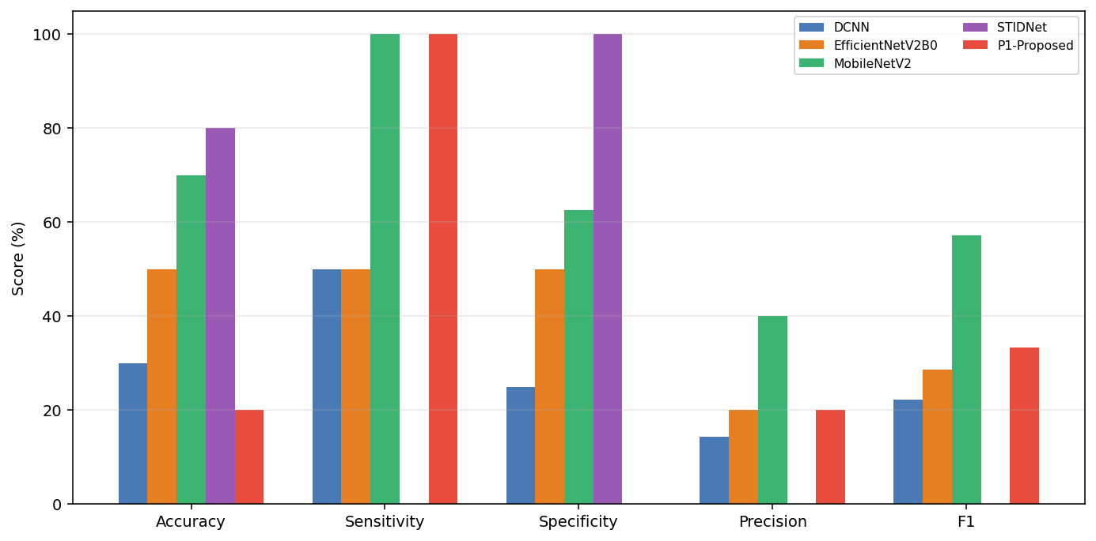
Figure 2. Full metric suite @80% training (latest run).
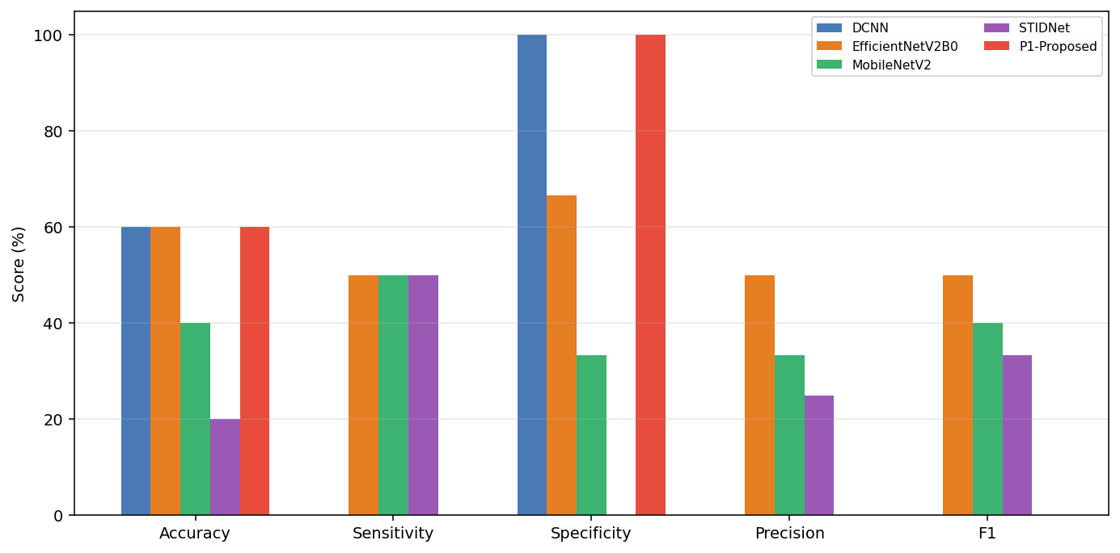
Figure 3. Full metric suite @90% training (latest run).
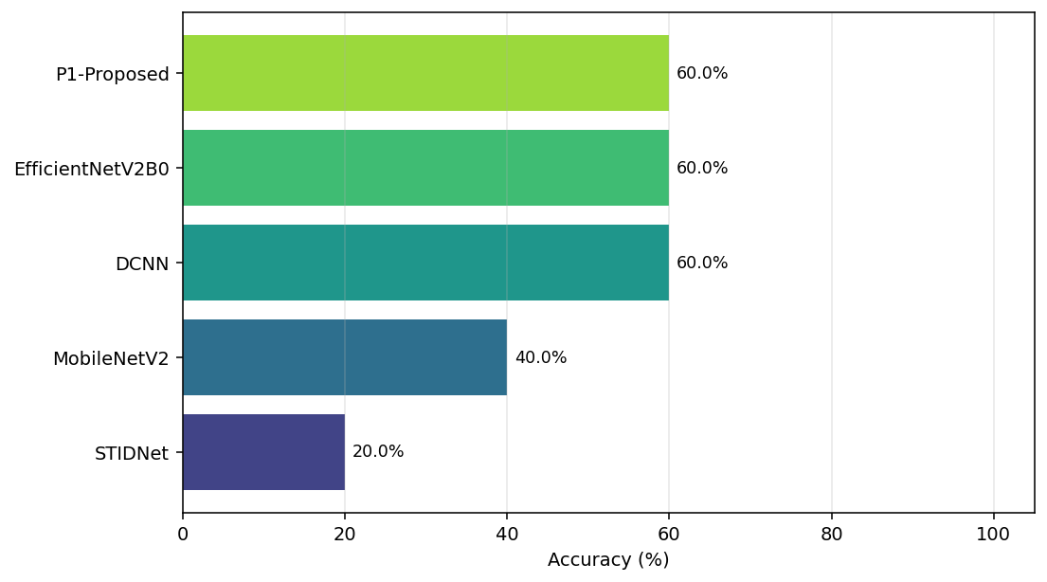
Figure 4. Model ranking by accuracy on last split (latest run).
9. How to Reproduce
From project root CODE_28-04-2025_Paper1:
$E = "C:\Users\USER\anaconda3\envs\VideoForgeryCPU"
$env:PATH = "$E\Library\bin;$E;$E\Scripts;" + $env:PATH
cd C:\Users\USER\Downloads\PostDoc\CODE_28-04-2025_Paper1
& "$E\python.exe" -u Optimized\evaluate_multi.py --epochs 20 --train-pcts "0.8,0.9"
& "$E\python.exe" -u Optimized\evaluate_multi.py --epochs 20 --class-weight --oversample --tag bal
& "$E\python.exe" -u Optimized\run_weight_tuned.py
10. Conclusions
• Paper 1 multi-model evaluation package is complete under Optimized/, parallel to Paper 2.
• Honest metrics show majority baseline 58%; test n=5–10 causes high variance.
• Increasing epochs (2→100) does not reliably reach 95–99% test accuracy.
• Class weights + oversampling improve minority recall for some models (e.g. MobileNetV2 BalAcc 81%).
• Weight-scale tuning further identified best minority_scale per model; peak honest Acc/BalAcc remain ~70–81%, not 95–99%.
• Paper COM_A ≈ 93% is reference-only and may stem from the tampered mealpy metric path.
• Reaching 95–99% with honest metrics likely requires larger data (full FaceForensics++), k-fold CV, and longer full-protocol training — not weight adjustment alone on N=50.
11. File Index of Saved Results
Filename | Bytes | Type
evaluation_multi_ep100.csv | 769 | .csv
evaluation_multi_ep100.txt | 2768 | .txt
evaluation_multi_ep2.csv | 769 | .csv
evaluation_multi_ep2.txt | 2764 | .txt
evaluation_multi_ep20.csv | 769 | .csv
evaluation_multi_ep20.txt | 2766 | .txt
evaluation_multi_ep20_bal_cw_os.csv | 769 | .csv
evaluation_multi_ep20_bal_cw_os.txt | 2830 | .txt
evaluation_multi_ep50.csv | 769 | .csv
evaluation_multi_ep50.txt | 2766 | .txt
MULTI_A_DCNN.npy | 224 | .npy
MULTI_B_EfficientNetV2B0.npy | 224 | .npy
MULTI_C_MobileNetV2.npy | 224 | .npy
MULTI_D_STIDNet.npy | 224 | .npy
MULTI_E_P1-Proposed.npy | 224 | .npy
weight_tune_best_summary.txt | 418 | .txt

End of report. Source package: CODE_28-04-2025_Paper1/Optimized/

