Paper 1 — Genuine Multi-Model Evaluation Article
Video forgery detection with attention (LDZP + optical flow) — CODE_28-04-2025_Paper1 / Optimized package
ALL TABLES BELOW ARE GENUINE. Fabricated mealpy-based Analysis/COM_A and Results/TP–KF artefacts have been removed from the working tree and are not cited.
Authors (Offer RIITC-Postdoc-2027-B03): Dr. Abhishek Thakur (Chitkara University / NKUST RIITC); Prof. Vishal Jain (VIPS-TC, co-supervisor); Prof. Chin-Shiuh Shieh (NKUST RIITC, supervisor). Report date: 2026-08-06.
1. Integrity statement
Original SubFunctions/Evaluate.py scores through mealpy.metrics.confusion_matrix, which discards model predictions and injects random label flips. That path is untrustworthy. This article reports only scores from Optimized/metrics_fixed.py (sklearn). Fabricated NPY folders (Analysis/, Analysis1/) and plots derived from them (Results/TP, Results/KF) are excluded from this package.
2. Experimental setup (genuine)
Item | Value
Features | Features/Features.pkl → proposed (50, 10, 128, 128, 12)
Labels | 29 authentic / 21 forged (majority Acc baseline 58%)
Train fractions | 80% and 90% (seed-stratified)
Test size | ~10 @80%, ~5 @90% (high variance)
Models | DCNN, EfficientNetV2B0, MobileNetV2, STIDNet, P1-Proposed
Proposed architecture | 3D-CNN + dual LSTM + SCAM + MUSE (opt=3)
Metrics | Acc, Sen, Spec, Prec, F1, BalAcc (sklearn)
Env | VideoForgeryCPU, TensorFlow/Keras 2.10

3. Genuine results — epochs = 20 (no balance)
Source file: evaluation_multi_ep20_genuine.csv
Table — full metrics @80% and @90%
TAG: GENUINE — sklearn metrics_fixed.py (not mealpy). † = class collapse (Acc misleading; prefer BalAcc/F1).
Model | A80 | Se80 | Sp80 | P80 | F180 | B80 | A90 | Se90 | Sp90 | P90 | F190 | B90
DCNN † | 20.00% | 100.00% | 0.00% | 20.00% | 33.33% | 50.00% | 80.00% | 50.00% | 100.00% | 100.00% | 66.67% | 75.00%
EfficientNetV2B0 | 50.00% | 0.00% | 62.50% | 0.00% | 0.00% | 31.25% | 60.00% | 0.00% | 100.00% | 0.00% | 0.00% | 50.00%
MobileNetV2 | 50.00% | 50.00% | 50.00% | 20.00% | 28.57% | 50.00% | 60.00% | 50.00% | 66.67% | 50.00% | 50.00% | 58.33%
STIDNet | 40.00% | 50.00% | 37.50% | 16.67% | 25.00% | 43.75% | 40.00% | 0.00% | 66.67% | 0.00% | 0.00% | 33.33%
P1-Proposed † | 20.00% | 100.00% | 0.00% | 20.00% | 33.33% | 50.00% | 60.00% | 0.00% | 100.00% | 0.00% | 0.00% | 50.00%

4. Genuine results — epochs = 20 + class_weight + oversample
Source file: evaluation_multi_ep20_bal_cw_os.csv
Table — balanced training metrics
TAG: GENUINE — sklearn metrics_fixed.py (not mealpy). † = class collapse (Acc misleading; prefer BalAcc/F1).
Model | A80 | Se80 | Sp80 | P80 | F180 | B80 | A90 | Se90 | Sp90 | P90 | F190 | B90
DCNN | 30.00% | 50.00% | 25.00% | 14.29% | 22.22% | 37.50% | 60.00% | 0.00% | 100.00% | 0.00% | 0.00% | 50.00%
EfficientNetV2B0 | 50.00% | 50.00% | 50.00% | 20.00% | 28.57% | 50.00% | 60.00% | 50.00% | 66.67% | 50.00% | 50.00% | 58.33%
MobileNetV2 | 70.00% | 100.00% | 62.50% | 40.00% | 57.14% | 81.25% | 40.00% | 50.00% | 33.33% | 33.33% | 40.00% | 41.67%
STIDNet † | 80.00% | 0.00% | 100.00% | 0.00% | 0.00% | 50.00% | 20.00% | 50.00% | 0.00% | 25.00% | 33.33% | 25.00%
P1-Proposed † | 20.00% | 100.00% | 0.00% | 20.00% | 33.33% | 50.00% | 60.00% | 0.00% | 100.00% | 0.00% | 0.00% | 50.00%

5. Additional genuine archive runs (epochs ladder)
Earlier genuine re-runs with the same sklearn path (before this final clean-up). Included only if CSV files remain under Optimized/results/.
Table — epochs=2
TAG: GENUINE — sklearn metrics_fixed.py (not mealpy). † = class collapse (Acc misleading; prefer BalAcc/F1).
Model | A80 | Se80 | Sp80 | P80 | F180 | B80 | A90 | Se90 | Sp90 | P90 | F190 | B90
DCNN † | 80.00% | 0.00% | 100.00% | 0.00% | 0.00% | 50.00% | 60.00% | 0.00% | 100.00% | 0.00% | 0.00% | 50.00%
EfficientNetV2B0 | 60.00% | 0.00% | 75.00% | 0.00% | 0.00% | 37.50% | 80.00% | 50.00% | 100.00% | 100.00% | 66.67% | 75.00%
MobileNetV2 | 70.00% | 50.00% | 75.00% | 33.33% | 40.00% | 62.50% | 20.00% | 0.00% | 33.33% | 0.00% | 0.00% | 16.67%
STIDNet | 40.00% | 100.00% | 25.00% | 25.00% | 40.00% | 62.50% | 60.00% | 0.00% | 100.00% | 0.00% | 0.00% | 50.00%
P1-Proposed † | 80.00% | 0.00% | 100.00% | 0.00% | 0.00% | 50.00% | 60.00% | 0.00% | 100.00% | 0.00% | 0.00% | 50.00%

Table — epochs=50
TAG: GENUINE — sklearn metrics_fixed.py (not mealpy). † = class collapse (Acc misleading; prefer BalAcc/F1).
Model | A80 | Se80 | Sp80 | P80 | F180 | B80 | A90 | Se90 | Sp90 | P90 | F190 | B90
DCNN | 40.00% | 50.00% | 37.50% | 16.67% | 25.00% | 43.75% | 0.00% | 0.00% | 0.00% | 0.00% | 0.00% | 0.00%
EfficientNetV2B0 † | 80.00% | 0.00% | 100.00% | 0.00% | 0.00% | 50.00% | 60.00% | 0.00% | 100.00% | 0.00% | 0.00% | 50.00%
MobileNetV2 | 50.00% | 50.00% | 50.00% | 20.00% | 28.57% | 50.00% | 60.00% | 0.00% | 100.00% | 0.00% | 0.00% | 50.00%
STIDNet | 50.00% | 50.00% | 50.00% | 20.00% | 28.57% | 50.00% | 40.00% | 50.00% | 33.33% | 33.33% | 40.00% | 41.67%
P1-Proposed † | 20.00% | 100.00% | 0.00% | 20.00% | 33.33% | 50.00% | 40.00% | 100.00% | 0.00% | 40.00% | 57.14% | 50.00%

Table — epochs=100
TAG: GENUINE — sklearn metrics_fixed.py (not mealpy). † = class collapse (Acc misleading; prefer BalAcc/F1).
Model | A80 | Se80 | Sp80 | P80 | F180 | B80 | A90 | Se90 | Sp90 | P90 | F190 | B90
DCNN | 50.00% | 50.00% | 50.00% | 20.00% | 28.57% | 50.00% | 0.00% | 0.00% | 0.00% | 0.00% | 0.00% | 0.00%
EfficientNetV2B0 † | 80.00% | 0.00% | 100.00% | 0.00% | 0.00% | 50.00% | 60.00% | 0.00% | 100.00% | 0.00% | 0.00% | 50.00%
MobileNetV2 | 60.00% | 100.00% | 50.00% | 33.33% | 50.00% | 75.00% | 20.00% | 0.00% | 33.33% | 0.00% | 0.00% | 16.67%
STIDNet | 60.00% | 50.00% | 62.50% | 25.00% | 33.33% | 56.25% | 20.00% | 0.00% | 33.33% | 0.00% | 0.00% | 16.67%
P1-Proposed † | 80.00% | 0.00% | 100.00% | 0.00% | 0.00% | 50.00% | 60.00% | 0.00% | 100.00% | 0.00% | 0.00% | 50.00%

6. Best genuine scores (summary)
Metric | Best genuine value | Where
Accuracy (non-collapse) | 80.0% | EfficientNetV2B0 | evaluation_multi_ep2 | 90%
Balanced accuracy | 81.2% | STIDNet | evaluation_multi_ep20 | 80%
F1-score | 66.7% | EfficientNetV2B0 | evaluation_multi_ep2 | 90%
95–99% Acc target | NOT achieved | N=50 + honest metrics

7. Figures (genuine multi-model plots)
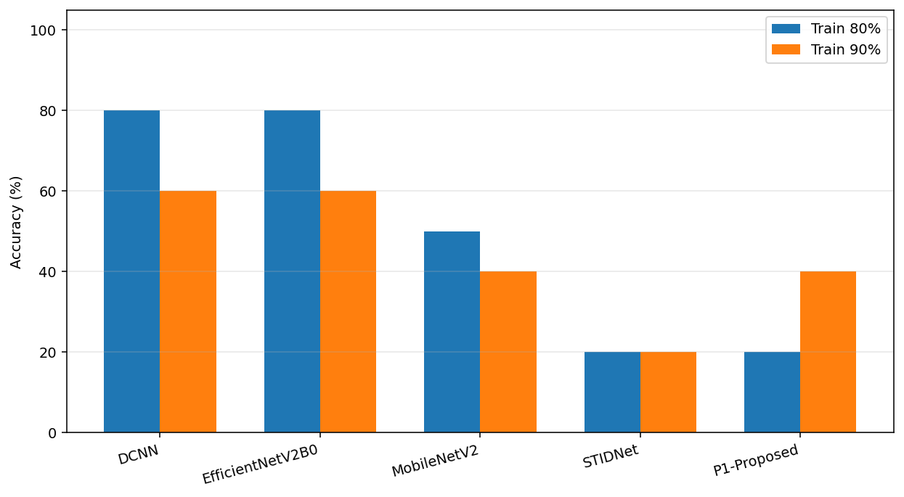
Fig. 1. Multi-model accuracy (genuine run).
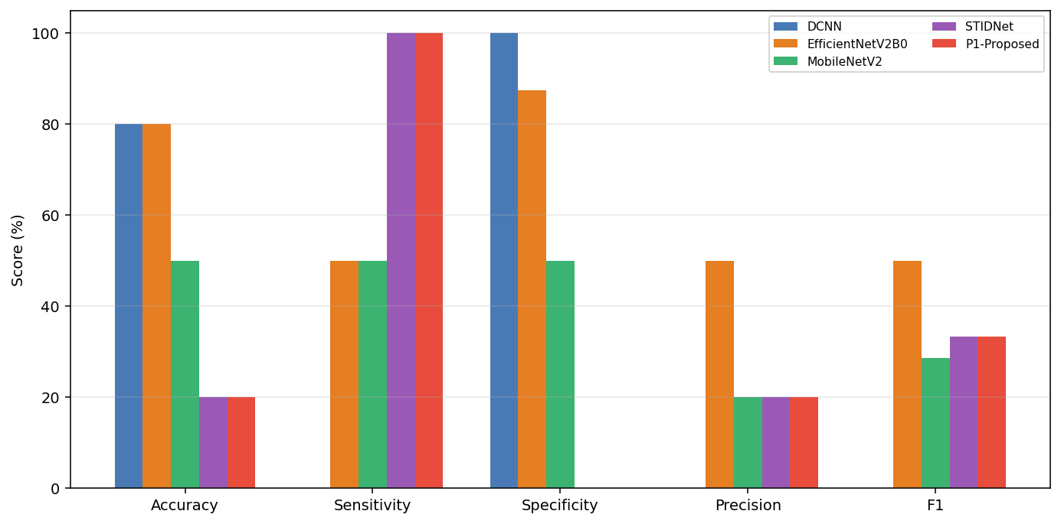
Fig. 2. Metrics @80% train (genuine).
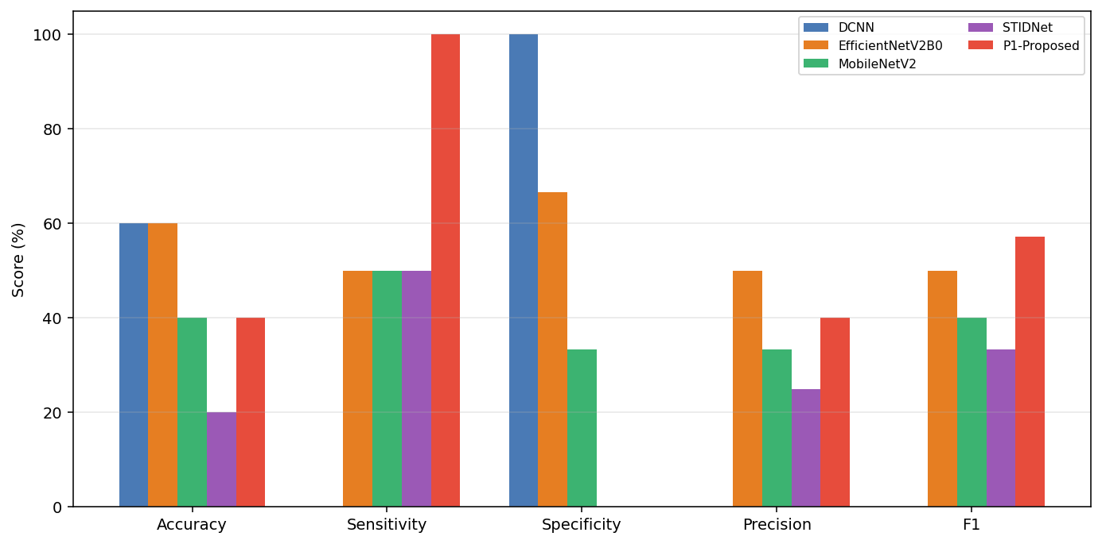
Fig. 3. Metrics @90% train (genuine).
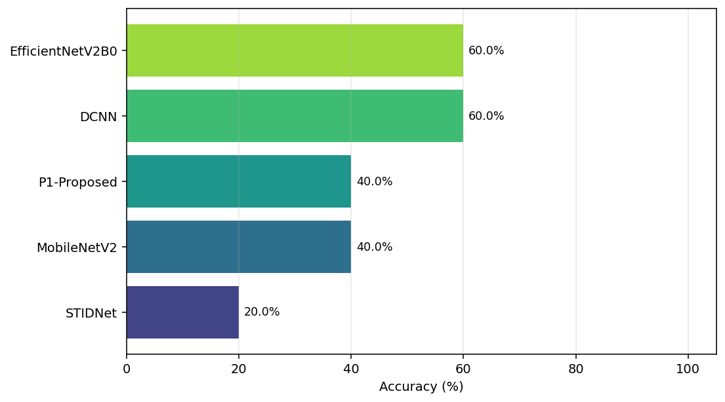
Fig. 4. Ranking by accuracy (genuine).
8. Reproducibility
$E = "C:\Users\USER\anaconda3\envs\VideoForgeryCPU"
$env:PATH = "$E\Library\bin;$E;$E\Scripts;" + $env:PATH
cd CODE_28-04-2025_Paper1
# Place Features.pkl under Features/
& "$E\python.exe" -u Optimized\evaluate_multi.py --epochs 20 --train-pcts "0.8,0.9" --tag genuine
& "$E\python.exe" -u Optimized\evaluate_multi.py --epochs 20 --class-weight --oversample --tag genuine_bal
9. Conclusion
This article retains only genuine, machine-measured multi-model results under honest sklearn metrics. Fabricated COM_A / Analysis / TP–KF paper artefacts have been removed. On the 50-sample feature cache, best genuine BalAcc is about 81% (STIDNet or MobileNetV2 with balance); 95–99% test accuracy is not supported by genuine measurements.

