Spatial and Multi-excitation Attention for Intra-frame Video Forgery Detection (SMA-CLMPNet): A Corrected Re-evaluation, an Attainability Ceiling, and a Protocol for Small-Corpus Media Forensics
Dr. Abhishek Thakur1,2,*, Prof. Vishal Jain3, and Prof. Chin-Shiuh Shieh4
(謝欽旭)
¹Primary Affiliation: School of Computer Science & Engineering, Chitkara University, Himachal Pradesh, India (Associate Professor).
²Secondary Affiliation: Postdoctoral Researcher, Research Institute of IoT Cybersecurity (RIITC), Department of Electronic Engineering, National Kaohsiung University of Science and Technology (NKUST), No. 415, Jiangong Rd., Kaohsiung City 80778, Taiwan (R.O.C.).
³Co-Supervisor Affiliation: Vivekananda Institute of Professional Studies – Technical Campus (VIPS-TC), India.
⁴Supervisor Affiliation: Ph.D., Professor, Department of Electronic Engineering; Research Institute of IoT Cybersecurity (RIITC), National Kaohsiung University of Science and Technology (NKUST), No. 415, Jiangong Rd., Kaohsiung City 80778, Taiwan (R.O.C.).
E-mail (Abhishek Thakur): abhithakur25@gmail.com; abhishek@chitkarauniversity.edu.in
E-mail (Vishal Jain): drvishaljain83@gmail.com; vishal.jain@vips.edu
E-mail (Chin-Shiuh Shieh): csshieh@nkust.edu.tw; csshieh@gmail.com
* Corresponding author: Dr. Abhishek Thakur (abhithakur25@gmail.com).
Postdoctoral Topic (Offer Letter): A unified multi-modal deep learning framework for semantic media forensics—Detecting AI-generated manipulation across visual, document, and news domains. Programme requirement: publish one SCI-indexed journal paper.
Abstract
Intra-frame video forgery detection is routinely reported as a solved problem, with accuracies above 95% common in the applied literature. This paper re-examines one such result and finds it unreproducible for reasons that are not statistical. An audit of the released implementation of SMA-CLMPNet, a spatial-and-multi-excitation attention network, identified two independent sources of fabricated results: a vendored optimisation library whose metrics module rewrites predicted labels toward the true labels before any score is computed, and stored artefacts describing a 2,000-video corpus with a 400-sample test partition that the repository's fifty-video corpus cannot produce. Every published figure was therefore re-measured. Twelve systems — the proposed model, its two attention ablations, a metaheuristically tuned variant, four models from the released comparison set and four current-generation backbones — were evaluated on identical stratified splits across six training percentages and five values of k, scored with a confusion matrix from an unmodified library. The Temporal Inconsistency and Information Supplement modules of a published spatiotemporal detector were additionally imported unmodified and applied to the same cached tensors. Under this protocol the proposed model reaches 50.00% mean balanced accuracy and answers a single class for every input at most training percentages, a degeneracy that accuracy and F1 conceal and specificity exposes. The strongest measured configuration is not a deep model but first-order temporal difference statistics with L1 logistic regression, at 77.17% under nested cross-validation (permutation p = 0.0099); the best deep model over k-fold is STIDNet at 70.56%. Out-of-fold analysis gives an AUC of 0.7307 (p = 0.0199), bounding accuracy at 74.00% at the best threshold on that curve. A corpus audit finds no near-duplicate videos and no separable feature dimension, so the ceiling is a property of the representation rather than of leakage or of any one architecture.
Keywords: Video forensics; intra-frame forgery; deepfake detection; SMA-CLMPNet; spatiotemporal inconsistency; attention mechanisms; FaceForensics++; balanced accuracy; permutation testing; nested cross-validation; research reproducibility; result fabrication
1. Introduction
1.1 The Evidentiary Status of Digital Video
Digital video occupies a peculiar position in contemporary evidentiary practice. It is simultaneously the most persuasive and the least verifiable class of record in wide circulation. A recording of an event carries an intuitive authority that a transcript or a still photograph does not: it appears to show duration, causality and context together, and a viewer who watches a clip believes they have witnessed something rather than been told about it. Courts admit video as demonstrative evidence, newsrooms treat it as corroboration, insurers settle claims on the strength of dashcam footage, and regulators increasingly accept video attestation in place of physical presence. In each of these settings the assumption underneath the practice is that fabricating convincing video is expensive enough, and requires enough specialist skill, that the base rate of manipulation is low.
That assumption has stopped holding. Face-replacement toolkits with graphical front-ends, publicly released generative models, and commodity accelerator hardware have jointly reduced the cost of a convincing manipulation from a studio budget to an evening of work by a motivated amateur. The technical literature has responded with a substantial detection effort, surveyed comprehensively by Mirsky & Lee (2021), Verdoliva (2020), Nguyen et al. (2022) and Masood et al. (2022), and the public benchmarks that anchor that effort — FaceForensics++ (Rossler et al., 2019), Celeb-DF (Li et al., 2020), the DeepFake Detection Challenge corpus (Dolhansky et al., 2020) and DeeperForensics (Jiang et al., 2020) — have grown from thousands to hundreds of thousands of clips. Reported accuracies on these benchmarks routinely exceed 95%, and on the easier high-quality splits they exceed 99%.
The gap between those numbers and the observed reliability of deployed detectors is the central practical problem of the field. A detector that reports 99% on a within-dataset split and then fails on a manipulation method it has not seen is not merely disappointing; it is actively harmful, because the reported figure is what a non-specialist decision-maker will rely on. The forensic value of a detector is not its peak benchmark score but the trustworthiness of the number attached to it. This paper is, in the end, about that second quantity.
There is a structural reason the two diverge, and it is worth naming before any experiment is described. A benchmark score answers the question: given a video drawn from the same distribution as the training data, how often is the label correct? A deployment needs the answer to a different question: given this video, whose provenance is unknown and whose manipulation method may postdate the detector, how much should the reported label move a decision? The first question has a single number as its answer and the second does not. It requires, at minimum, a calibrated probability, an interval around it, and an explicit statement of the conditions under which the estimate was obtained. Almost none of the published detection literature supplies all three, and the pipeline examined in this paper supplies none of them.
The consequence is that a forensic claim built on a detector output inherits an uncertainty that was never quantified. When the underlying corpus contains fifty videos, that omission is not a refinement to be added later; it is the difference between a result and a coincidence. Much of the analysis in Section 5 consists of supplying the intervals and null distributions the original work omitted, and a substantial part of the finding is what happens to the reported effects once they are placed beside their own uncertainty.
1.2 Threat Model and Operating Conditions
It is useful to state at the outset which adversary this class of system is built against, because the threat model determines which evaluation results are meaningful and which are decorative.
The adversary assumed throughout this work is not a nation-state laboratory with access to unpublished synthesis methods. It is an ordinary operator using a publicly available face-replacement toolkit, applying it to source and target material of ordinary quality, and distributing the result through channels that re-encode it. This adversary is by far the most common in practice and is the one the public benchmarks model. Critically, this adversary does not adapt to the detector: they do not run the detector during synthesis, they do not craft adversarial perturbations, and they do not post-process specifically to defeat a known forensic cue. A detector evaluated against this adversary is therefore being evaluated under the most favourable conditions it will ever encounter, and a detector that fails here will not succeed against anything stronger.
The operating conditions matter equally. A forensic detector is typically applied in one of three regimes. In triage, a large volume of material is ranked so that limited analyst attention is directed at the most suspicious items; here a moderate area under the ROC curve has real value even if no single threshold gives acceptable accuracy. In adjudication, a single item must be classified and the answer carries consequences; here the relevant quantity is the confidence interval around the decision, and a detector whose interval spans the decision boundary contributes nothing regardless of its point estimate. In monitoring, a stream is screened continuously and the base rate of manipulation is very low; here the false-positive rate dominates everything else, because even a small rate applied to a large volume buries the analyst.
These three regimes place quite different demands on the same measurement. The results in Section 5 are reported so that each can be assessed: the area under the ROC curve for triage, the confidence interval on a single fold for adjudication, and the specificity — the fraction of authentic videos correctly retained — for monitoring. It will turn out that the pipeline studied here supports the first regime weakly and the other two not at all, and that several models in the released cohort have a specificity of exactly zero, meaning they would flag every authentic video in a monitoring deployment.
1.3 Manipulation Families and the Difficulty of Intra-frame Forgery
Video manipulation is conventionally partitioned into inter-frame and intra-frame families. Inter-frame forgery alters the sequence itself: frames are deleted to compress a timeline, duplicated to extend one, inserted from another source, or shuffled to reorder events. Because these operations disturb the temporal statistics of the encoded stream, they leave characteristic traces in motion residuals, prediction errors and quantisation patterns, and a mature body of work exploits exactly those traces (Sitara & Mehtre, 2016; Kingra et al., 2017; Fadl et al., 2020). Intra-frame forgery leaves the frame ordering intact and instead rewrites content inside individual frames — most prominently by replacing a face while preserving pose, expression and illumination.
Intra-frame manipulation is the harder problem for three compounding reasons. First, the manipulated region is small relative to the frame; a face occupies a few percent of the pixels in a typical shot, so any detector operating on whole frames is looking for a sparse signal inside a large amount of unmodified content. Second, modern synthesis pipelines are explicitly optimised to remove exactly the artefacts that early detectors keyed on: blending seams, colour mismatch, resolution discontinuities and warping residuals are all targets of the generator's own loss. Third, and most importantly for the present work, the surviving evidence is largely temporal rather than spatial. A face swapped frame by frame is individually plausible in each frame and jointly implausible across frames: the identity flickers at the sub-pixel level, the blending boundary breathes, and physiological regularities such as blink rate and gaze trajectory drift out of their natural distributions.
This observation is what motivates the entire spatiotemporal branch of the literature. Guera & Delp (2018) showed early that a convolutional feature extractor followed by a recurrent aggregator detects manipulations that per-frame classification misses. Sabir et al. (2019) made the recurrence explicit over aligned face crops. Amerini et al. (2019) showed that optical-flow fields carry discriminative structure that raw pixels do not. Haliassos et al. (2021) demonstrated that a network pre-trained to read lip movement transfers to forgery detection because it has already learned what natural facial dynamics look like. Zheng et al. (2021) isolated temporal coherence as the generalising cue. Gu et al. (2021) formalised the idea as a pair of modules — a Temporal Inconsistency Module and an Information Supplement Module — that can be inserted into an otherwise ordinary backbone, and Zhao et al. (2023) and Xu et al. (2024) carried it into transformer architectures.
Compression complicates all of this in a way that is easy to underestimate. Every distribution channel re-encodes, and lossy video compression is designed to discard exactly the high-frequency, low-energy content in which manipulation residuals live. A cue that is clearly present in a raw manipulated frame may be entirely absent two re-encodings later, while the semantic content a human observer uses remains intact. This produces the counter-intuitive situation that detector accuracy falls as perceptual quality falls, even though the manipulation becomes no more convincing to a viewer. It also means a detector's accuracy is not a property of the detector alone but of the detector and the compression history of the material it is applied to — a dependency almost never reported. The corpus used in this study is drawn from compressed source material, which is realistic, and which places a real limit on what any spatial cue can contribute.
The system studied in this paper belongs to that branch. It combines a three-dimensional convolutional trunk, a joint spatial-and-channel attention block, a recurrent aggregator and a multi-excitation head, and it is designed on precisely the premise just described: that the residue of an intra-frame manipulation is a temporal inconsistency rather than a spatial artefact.
1.4 Why Benchmark Accuracy and Deployed Reliability Diverge
Before describing the system, it is worth being explicit about the mechanisms that separate a published accuracy from a trustworthy one, because the audit reported in this paper found two of them operating simultaneously and a third latent in the released code.
The first mechanism is optimistic evaluation design. When hyperparameters, feature scalings, decision thresholds, early-stopping epochs or model families are chosen using data that later appears in the reported test set, the reported number measures how well the choice fitted that set rather than how well the model generalises. Cawley & Talbot (2010) analysed this precisely and showed that the resulting bias is large enough to reverse published rankings; Kapoor & Narayanan (2023) catalogued the same failure across dozens of fields and found it to be the single most common defect in machine-learning-based science.
The second mechanism is small-sample variance. On a corpus of a few dozen videos, the standard error of an accuracy estimate is measured in tens of percentage points, so an apparently decisive gap between two methods can be pure sampling noise. Varoquaux (2018) quantified the effect in neuroimaging, Vabalas et al. (2019) in clinical prediction, and Bouthillier et al. (2021) showed that even the seed of the random number generator moves benchmark results by more than the improvements typically claimed over them. Related to this, Combrisson & Jerbi (2015) demonstrated that the nominal 50% chance line is the wrong reference on small or imbalanced samples: the empirical distribution of accuracy under a true null extends well above it, so a score of 60% or 65% may be entirely consistent with a model that has learned nothing.
The third mechanism is the one that motivated this study. It is not an evaluation-design error at all but a defect in the scoring code itself. If the function that computes the confusion matrix is modified so that it alters the predictions before comparing them against the labels, then every downstream metric — accuracy, sensitivity, specificity, precision, F1 and any curve derived from them — becomes a function of the labels rather than of the model. No amount of careful protocol design detects this, because the protocol is not what is broken. The only way to find it is to read the scoring code.
These three mechanisms are ordered by severity and, unfortunately, in reverse order of how often they are checked. Reviewers routinely interrogate splits and baselines; they rarely open the metrics module.
A fourth mechanism deserves mention because it is entirely innocent in intent and nonetheless produces the same outcome. On an imbalanced corpus, several standard summary statistics reward a model that has learned nothing. If 58% of the videos are authentic, a classifier that answers 'authentic' unconditionally achieves 58% accuracy, a recall of 1.00 on the majority class, and an F1 score above 0.73. Each of those numbers, reported on its own, reads as a functioning detector. Only specificity — the fraction of manipulated videos correctly identified — exposes the degeneracy, and specificity is the statistic most often omitted from summary tables. Several models in the cohort re-measured for this paper exhibit exactly this pattern, and it is the reason every table in Section 5 reports specificity and balanced accuracy alongside accuracy rather than in place of it.
The four mechanisms interact multiplicatively rather than additively. A degenerate classifier scored on an imbalanced corpus by a tampered metric, with its hyperparameters selected on the reporting set, produces a number that has essentially no relationship to detection performance and every appearance of a strong result. Disentangling them requires measuring each separately, which is what the experimental design of this paper is organised to do: the corrected metric isolates the third mechanism, the nested protocol isolates the first, the permutation test isolates the second, and reporting specificity isolates the fourth.
1.5 The System Under Study
The subject of this paper is SMA-CLMPNet, a spatial-and-multi-excitation attention network for intra-frame video forgery detection, together with the complete implementation released alongside it. The implementation reads a subset of FaceForensics++, detects and crops faces with a Haar cascade, samples ten frames per video at 128 x 128 resolution, and stacks twelve channels per frame — three RGB, three HSV, a local binary pattern map and edge responses — into a per-video tensor of shape (10, 128, 128, 12). Those tensors are cached once and reused by every model in the study.
The network itself consists of three Conv3D stages, each followed by a 'modified pooling' operation that averages a max-pooled and an average-pooled copy of the activation; a reshape into a spatial sequence; a joint spatial-and-channel attention module (SCAM); a second reshape; two parallel 128-unit LSTMs whose outputs are summed; a multi-excitation block (MUSE); and a two-layer fully connected head with batch normalisation and dropout terminating in a softmax over two classes. It has 2,258,534 trainable parameters. A single integer switch selects the ablation: with only MUSE active the model is MUSE-CLMPNet, with only SCAM active it is SCAM-CLMPNet, and with both active it is the proposed SMA-CLMPNet. A metaheuristic variant, SMA-CLMPNet-Opt, tunes hyperparameters with a population-based search from the MEALPY library (Van Thieu & Mirjalili, 2023).
The twelve-channel stacking deserves comment because it determines the ceiling of everything downstream. Three channels carry the original colour information. Three carry the same content in a hue-saturation-value decomposition, which is an invertible transformation of the first three and therefore adds no information, though it does change what a convolution with a small kernel can express cheaply. A local binary pattern channel encodes micro-texture as a comparison of each pixel against its neighbours, and the remaining channels carry gradient and edge responses. The stack is thus a mixture of raw appearance and hand-designed texture descriptors, computed independently per frame and concatenated. Nothing in the representation encodes motion, correspondence between frames, or the geometry of the face; the temporal axis is present only as an ordered stack that the model may or may not exploit.
The corpus is fifty videos. This number is not incidental and it is not a limitation to be acknowledged in a closing paragraph — it is the governing constraint on the entire study. A held-out partition under any protocol in the repository contains between five and thirty-one videos, so the granularity of any accuracy estimate is between three and twenty percentage points, and the confidence interval around a single fold's result spans a range wider than the differences the original work claims between models. Section 5.6 quantifies this: a perfect ten-out-of-ten result on a ten-video fold carries a 95% confidence interval extending down to 69.2%. Any protocol that reports a single fold's accuracy to two decimal places on a corpus this size is reporting noise with false precision.
The released comparison set contains six further systems — a plain deep convolutional network, an EfficientNet variant, a spatiotemporal inconsistency detector referred to as STIDNet, and a grey-level co-occurrence matrix baseline in the tradition of Haralick et al. (1973) — and the published results place SMA-CLMPNet above all of them at every training percentage examined.
1.6 Two Independent Fabrications in the Released Artefacts
This study began as a straightforward reproduction: re-run the released code, confirm the published table, then extend the comparison with current-generation backbones. The reproduction did not survive first contact with the code.
The vendored copy of the MEALPY optimisation library contains a modified metrics module. Its target-checking routine, which every metric in that library calls before computing anything, does not merely validate the shapes of the true and predicted label vectors: it rewrites the predicted vector so that it agrees with the true vector on a controlled fraction of entries. Any accuracy computed through that path is therefore a function of the label vector and a constant, and is entirely independent of what the model predicted. Every published figure in the released results directories was produced through that path. Substituting a confusion matrix computed by an unmodified library is a two-line change, and it moves the headline accuracy of the proposed model from the published value to the mid-fifties.
A second and independent fabrication came to light while cataloguing which artefacts to discard. Three released files describe a corpus that does not exist anywhere in the project: a class-balance chart showing 1,000 authentic and 1,000 manipulated videos, a confusion matrix totalling 400 test samples in a 200/200 split, and a feature table quoting accuracies to twelve significant figures. The corpus the code actually reads contains fifty videos in a 29/21 split, and the largest test partition any protocol in the repository can produce contains thirty-one. These three artefacts cannot have been produced by the tampered metric either, because that metric operates on whatever test set it is given; a 400-sample confusion matrix cannot arise from a 31-sample test set by any transformation. Those numbers were not computed at all.
A third route, not used to generate the published numbers but present in the companion codebase, fits model weights directly on the test partition. It is mentioned here because it belongs to the same family: three distinct ways to raise a reported score without raising detection performance, all of them available inside a single project directory.
It is worth being precise about why the first defect is so difficult to notice from the outside. The tampering does not occur in the project's own code; it occurs inside a vendored copy of a well-known third-party optimisation library, in a target-validation helper whose name and signature are identical to the upstream version. A reader auditing the project's model definitions, its data loader, its training loop and its evaluation protocol would find nothing wrong, because nothing there is wrong. The defect is one function call deeper, in a file no reviewer has any reason to open, and it announces itself only if the vendored library is diffed against the published release or if the metric is tested on synthetic inputs with a known confusion matrix. Both checks take minutes; neither is standard practice.
The three fabrication routes are also worth distinguishing by what they would each require of an author. Fitting weights on the test partition can be a genuine mistake, and is common enough that the leakage literature treats it as an error rather than as misconduct. Modifying a metric so that predictions are rewritten toward the labels cannot be a mistake; the code has no other function. Publishing a confusion matrix over four hundred samples drawn from a fifty-video corpus is a third category again, in which no computation took place at all. This paper takes no position on how the released artefacts came to contain all three. It reports what is verifiable: what each artefact claims, what the code can produce, and what re-measurement gives.
The correct response to this situation is not to quietly repair the numbers and publish a smaller improvement. It is to re-measure everything under a protocol that cannot be gamed, to report what that measurement gives, and to establish what the corpus can and cannot support. That is what the remainder of this paper does.
1.7 The Question This Paper Answers
Two framings of the same investigation are possible, and it matters which one is adopted. The first treats the original claim as the hypothesis and asks whether it replicates; that framing produces a one-line answer and stops. The second treats the pipeline as an object of study in its own right and asks what it is capable of, which requires establishing the ceiling, identifying which component imposes it, and testing whether a different architecture or a different representation moves it. This paper adopts the second framing throughout. It is more work, and it is the only version that leaves the next investigator better off than a bare failure to replicate would.
Restated precisely, the question is: given the feature representation this project computes and the fifty-video corpus it computes them from, what detection performance is attainable, and by what architecture?
This is a different question from the one the original work claimed to answer, and it is deliberately posed so that a negative answer is informative. If a wide cohort of architectures, spanning the published models, their ablations, four current-generation backbones, a metaheuristically tuned variant, the temporal modules from a well-regarded spatiotemporal detector, and a set of deliberately simple statistical pipelines, all converge on the same modest ceiling, then that ceiling is a property of the data and the representation rather than of any one model. Establishing such a ceiling is a useful result: it tells the next investigator where to spend effort, and it makes any future claim above the ceiling immediately suspect.
Conversely, if some architecture in the cohort clears the ceiling convincingly, that is a genuine finding about which inductive bias matters for this signal. The protocol is designed so that either outcome is credible: all model selection happens inside training folds, the test partition of each outer fold is untouched until scoring, the scoring uses a confusion matrix from an unmodified library, and the observed score is compared against an empirical null obtained by re-running the entire nested procedure on shuffled labels rather than against the nominal chance line (Ojala & Garriga, 2009; Combrisson & Jerbi, 2015).
A related question, and the one a reader is most likely to ask, is whether the target accuracy claimed by the original work could be reached at all with more effort — a longer training schedule, a larger model, a better optimiser. This paper answers that question quantitatively rather than rhetorically. The area under the ROC curve measured out of fold bounds the accuracy attainable at any decision threshold, and that bound is computed with the test labels in hand, which makes it optimistic by construction. If the bound lies below the claimed figure, then no choice of threshold on that curve reaches the claim, and reaching it would require a fundamentally better ranking of the videos rather than a better cut point. Section 5.6 reports the bound and the effect size that would be needed to clear it. This framing matters because it converts an open-ended engineering question — could more tuning help? — into a closed measurement.
Finally, the study is explicitly scoped to this corpus and this representation. Nothing reported here is a claim about SMA-CLMPNet's architecture in general, about attention mechanisms in general, or about what any of these models would achieve on the full FaceForensics++ release with frame-level supervision. The pipeline for that larger experiment exists in the repository and has never been run because the required data was never downloaded; Section 8 sets it out as the primary item of future work. Confining the claims to what was measured is not modesty, it is the same discipline whose absence produced the artefacts this paper replaces.
1.8 Contributions
The contributions of this paper are as follows.
• A forensic audit of a released video-forgery detection codebase that identifies two mutually independent sources of fabricated results — a tampered metrics module and a set of artefacts describing a non-existent corpus — and documents the exact mechanism of each.
• A complete re-measurement of the published model cohort under a protocol with no selection on test data, scored with an unmodified confusion matrix, across six training percentages and five values of k in stratified k-fold cross-validation.
• An extension of the cohort with four current-generation backbones — EfficientNetV2-S, ConvNeXt-Tiny, MobileNetV3-Large and ResNet-RS-50 — evaluated on identical splits, and with the Temporal Inconsistency and Information Supplement modules of a published spatiotemporal detector imported unmodified from their authors' repository.
• A search over fourteen feature representations and nine model families under nested cross-validation, which identifies first-order temporal difference statistics as the only representation whose score survives a permutation test.
• A corpus audit that establishes an upper bound on attainable accuracy from the measured effect size, verifies the absence of near-duplicate videos that could inflate it, and quantifies the confidence interval attached to any single fold — a bound that no architecture in the cohort can exceed and that lies far below the published claims.
• A complete removal record for the fabricated artefacts, and a reproducible build in which every figure, table and number in this paper is regenerated from the stored run outputs by a script under version control.
Two further properties of the study are contributions in their own right, though they are procedural rather than empirical. Every number printed in this paper is produced by a script that reads the stored run outputs, so no figure was transcribed by hand and none can drift from the run that generated it; the build fails rather than silently substituting a stale value if a required artefact is missing. And every bibliographic entry in the reference list was resolved against a registration agency by digital object identifier rather than typed from memory, with the resolver rejecting any match whose first author disagrees with the expected one. Neither of these is novel and both should be unremarkable; they are stated because the material this paper replaces demonstrates what their absence permits.
1.9 Organisation of the Paper
Section 2 reviews the relevant literature across nine themes: the active/passive division in video forensics, handcrafted statistical traces, frame-level convolutional detectors, temporal and spatiotemporal modelling, attention mechanisms and the specific lineage of the SCAM and MUSE blocks, modern backbones used here as reference points, metaheuristic optimisation in forensic pipelines, evaluation methodology for small corpora, and research integrity in machine-learning-based science; it closes by positioning this work against the identified gaps. Section 3 describes the proposed model and the executed pipeline, with block diagrams derived from the source code and a step-by-step account of the flow. Section 4 specifies the experimental protocol, the corpus, the software environment and the metrics. Section 5 reports all measured results as tables, figures and bar charts. Section 6 compares the proposed model against the cohort and against performance reported in the literature for comparable systems, with the comparison plotted and tabulated. Section 7 concludes and Section 8 sets out future work. All references are listed in APA style.
1.10 On Reporting a Negative Result
The principal empirical finding of this paper is negative: on this corpus and this representation, no architecture in a twelve-model cohort — including the proposed model, its two ablations, its metaheuristically tuned variant, four current-generation backbones, and the temporal modules of a published spatiotemporal detector — achieves a balanced accuracy that clears the empirical permutation null by a convincing margin, and the best result obtained by any method is a simple statistical pipeline rather than any of the deep models. Because negative results are unusual in this literature, it is worth setting out why this one is worth reporting rather than iterating on until it turns positive.
First, the negative result is bounded rather than open-ended. A study that tried several models, failed, and stopped would establish nothing except that the authors stopped. This study computes an upper bound on attainable accuracy from the measured effect size, verifies that the bound is not an artefact of near-duplicate videos leaking across splits, and confirms that no individual feature dimension encodes the label. The conclusion is therefore about the data, not about the effort expended on it.
Second, the alternative was available and was declined. Three documented routes to a higher reported number exist inside this project: the tampered metric, weight fitting on the test partition, and selection of the best result across many random seeds. Each would have produced a headline figure in the range the original work claims. None of them changes how well the model detects manipulated video. Reporting the measured number, together with the reason the higher number is unreachable, is the only outcome useful to anyone who subsequently relies on this system.
Third, the result is actionable. Establishing that the ceiling is a property of the representation rather than of the architecture redirects effort precisely: away from further architecture search on cached fifty-video tensors, and towards frame-level supervision on the full corpus, which is the experiment Section 8 specifies. A negative result that identifies where the next effort should go is more valuable than a positive result that cannot be relied upon.
Fourth, and least comfortably, the negative result is what the measurement gives. The alternative to reporting it is not a better paper but a different one, whose numbers would have been produced by one of the three routes described in Section 1.6 and would have told a reader nothing about whether the system detects manipulated video. The discipline that this paper asks of its own results is the same discipline it asks of the material it replaces, and applying it selectively would defeat the purpose.
2. Literature Review
2.1 Active and Passive Video Forensics
Media forensics divides along the question of whether the authentication signal is inserted before distribution or recovered afterwards. Active methods embed a watermark or a cryptographic signature at capture time and verify it later. They are exact when they apply, and they almost never apply: the overwhelming majority of video in circulation was captured by devices that embed nothing, transcoded by platforms that strip what little metadata survives, and redistributed through channels that re-encode aggressively. Passive methods make no such demand. They treat the video as the only evidence and look for statistical inconsistency introduced by the manipulation itself.
Verdoliva (2020) frames the modern field in exactly these terms and argues that the passive problem has changed character with the arrival of learned synthesis: the artefacts that classical passive forensics targeted were byproducts of editing operations, whereas the artefacts left by a generative model are byproducts of the model's own inductive bias and shift whenever the model changes. Mirsky & Lee (2021) surveys both the creation and the detection side and reaches a compatible conclusion: because generator and detector improve against each other, a detector's value depends more on whether its cue is intrinsic to the manipulation than on the score it reaches against the generation of generators it was trained on. Sitara & Mehtre (2016) provides the corresponding overview for conventional video tampering, cataloguing the passive techniques available for double compression, region duplication and temporal manipulation.
The system evaluated in the present paper is unambiguously passive, and it makes the intrinsic-cue argument explicitly: its design rationale is that temporal inconsistency is a property of frame-wise synthesis rather than of a particular synthesiser. Whether the implementation realises that rationale is an empirical question, and Section 5 answers it.
2.2 Handcrafted Statistical Traces
The oldest strand of passive forensics builds explicit statistical descriptors and tests them for the disturbance a manipulation would cause. Haralick et al. (1973) introduced the grey-level co-occurrence matrix, which characterises texture by tabulating how often pairs of grey levels occur at a fixed spatial offset and reducing that tabulation to contrast, correlation, energy and homogeneity. The descriptor is cheap, interpretable and remarkably durable: it remains a standard baseline in image forgery work fifty years after publication, and it appears in the present cohort as the GLCM comparison model.
Popescu & Farid (2005) showed that resampling — the interpolation any geometric transformation performs — introduces periodic correlations among neighbouring pixels that can be recovered by an expectation-maximisation estimator, giving a detector for scaled or rotated spliced regions that requires no training data at all. Fridrich & Kodovsky (2012) generalised the idea of hand-designed residual statistics into rich models: large ensembles of quantised, truncated co-occurrence features over multiple high-pass residuals, which dominated steganalysis and transferred effectively to splicing detection. Wang & Farid (2009) analysed double quantisation in compressed video and showed that re-encoding after editing leaves a recoverable signature in the distribution of transform coefficients.
In the temporal domain, Kingra et al. (2017) combined motion and brightness gradients to expose frame insertion and deletion in H.264 streams, and Fadl et al. (2020) used histograms of oriented gradients over motion energy images for the same family of attacks. Shelke & Kasana (2023) extended the approach with a VGG-16 feature extractor and kernel PCA, reporting strong results for multiple simultaneous forgery types. These works matter here for a specific reason: they establish that temporal-domain manipulation leaves recoverable traces in first-order difference statistics. The representation search reported in Section 5.7 of this paper arrives independently at the same family of descriptors as the only one that carries signal on this corpus, which is a small but genuine point of contact between the classical and the learned literature.
2.3 Frame-level Convolutional Detectors
The first generation of learned deepfake detectors treated the problem as per-frame image classification and aggregated frame scores by averaging. Afchar et al. (2018) deliberately kept the network shallow, arguing that the discriminative artefacts live at a mesoscopic scale between fine texture and semantic content, and that a deep network trained on a small corpus would memorise identities rather than artefacts. The resulting architecture is small enough to train on modest hardware and remains a standard reference point.
Rossler et al. (2019) released the benchmark that reoriented the field, providing 1,000 original sequences manipulated by four methods at three compression levels, and — more consequentially for practice — demonstrating that a fine-tuned Xception network (Chollet, 2017) restricted to the face region outperformed both handcrafted baselines and human observers by a wide margin. That result established the template most subsequent work follows: crop the face, fine-tune a strong ImageNet backbone, aggregate over frames.
Nguyen et al. (2019) replaced the standard classifier head with a capsule network, using dynamic routing to model part-whole relationships that a flat softmax discards, and reported improved robustness to compression. Li et al. (2020) made a different and influential argument: rather than learning the signature of any particular generator, learn to detect the blending boundary that all face-swap pipelines must produce when compositing a synthesised face into a real frame. Because the blending step is common to methods that differ entirely in their generators, the resulting detector generalises across manipulation types far better than a generator-specific one.
Frequency-domain variants pursue the same generalisation goal through a different channel. Qian et al. (2020) decomposed inputs with a learnable frequency-aware filter bank and showed that upsampling operations inside generators leave characteristic high-frequency signatures. Luo et al. (2021) combined high-frequency residuals with RGB content in a two-stream design and demonstrated substantially improved cross-dataset transfer. Coccomini et al. (2022) showed that pairing an EfficientNet feature extractor with a vision transformer aggregator is competitive with far heavier ensembles on the DFDC corpus.
Two systematic reviews map this family in detail and are worth consulting for their aggregate observations rather than for any individual method. Rana et al. (2022) reviewed 112 primary studies published between 2018 and 2020 and classified them by approach, reporting that deep-learning methods dominate numerically while a substantial minority remain statistical or feature-based, and noting that reported accuracies cluster tightly near the top of the scale in a way that makes cross-study comparison nearly meaningless because protocols, splits and corpora differ. Yu et al. (2021) reached a compatible conclusion for video specifically, organising detection methods by the cue they exploit — spatial artefact, temporal inconsistency, biological signal, and frequency-domain trace — and identifying generalisation across manipulation methods, robustness to compression, and the absence of standardised evaluation as the three open problems. The present paper is a direct response to the third of those: it fixes the protocol, publishes the code that produces every number, and reports what that protocol gives even where the answer is unflattering.
The common limitation of this family is structural rather than incidental: a per-frame classifier cannot, even in principle, observe an inconsistency that only exists between frames. Averaging frame scores discards precisely the joint structure that distinguishes a sequence of individually plausible faces from a plausible sequence of faces. This paper measures that limitation directly. The time-collapsed reference representation described in Section 5.5 reaches an area under the ROC curve of 0.5230, statistically indistinguishable from chance, while the same features preserved as frame-to-frame differences reach 0.7307.
2.4 Temporal and Spatiotemporal Modelling
The video-understanding literature supplies the architectural vocabulary that forgery detection borrows. Tran et al. (2015) established that three-dimensional convolution learns appearance and motion jointly and that comparatively small 3x3x3 kernels are the effective choice, which is the design the trunk of the model studied here adopts. Carreira & Zisserman (2017) showed that inflating two-dimensional kernels from a pre-trained image network into three dimensions preserves the benefit of large-scale image pre-training, removing the main practical objection to 3D convolution. Feichtenhofer et al. (2019) decomposed the problem into a slow pathway for semantics and a fast pathway for motion, an explicit acknowledgement that spatial and temporal evidence have different natural sampling rates. Hochreiter & Schmidhuber (1997) remains the standard recurrent aggregator, and the two-layer recurrent stage in the network studied here is a direct instance of it.
Applied to forgery detection, Guera & Delp (2018) combined a convolutional feature extractor with an LSTM over frame features and reported that sequences as short as twenty frames suffice to separate manipulated from authentic video — an early and clean demonstration that the temporal axis carries the discriminative information. Sabir et al. (2019) refined this with face alignment and recurrent convolutional strategies, showing that the recurrent stage benefits materially from geometric normalisation of the input crops.
Amerini et al. (2019) approached the temporal axis through optical flow, training a convolutional classifier on flow fields rather than on pixels, on the grounds that a frame-wise generator has no mechanism enforcing consistent apparent motion. Haliassos et al. (2021) pushed the idea furthest: a network pre-trained for visual speech recognition, and therefore already in possession of a model of natural mouth dynamics, transfers to forgery detection with far better cross-manipulation generalisation than a detector trained from scratch on forgery labels. Zheng et al. (2021) reached a similar conclusion by architectural means, showing that suppressing spatial capacity while retaining long-range temporal modelling improves generalisation — the spatial pathway, in other words, is where overfitting to the generator happens.
Gu et al. (2021) is the work most directly relevant to the present study, and its modules are evaluated here unmodified. It decomposes spatiotemporal inconsistency into two cooperating components. The Temporal Inconsistency Module splits the channel dimension, shifts one part along the temporal axis, differences it against the unshifted part, and learns an attention map over the resulting difference tensor, so that the network is presented with frame-to-frame change as a first-class input rather than having to infer it. The Information Supplement Module restores spatial detail that the differencing operation removes. Reported results on FaceForensics++ and Celeb-DF are competitive with much larger models at a fraction of the parameter count. Fang et al. (2024) combines spatiotemporal modelling with identity-aware knowledge distillation, and gives its name to one of the comparison models in the released cohort studied here.
Transformer formulations followed. Zhao et al. (2023) introduced a decomposed spatial-temporal self-attention with a self-subtract mechanism, explicitly building the temporal difference into the attention operator, and provided interpretability maps showing which regions and which frames drive each decision. Xu et al. (2024) took an unusual and effective route, tiling a video clip into a single thumbnail-layout image so that an ordinary image transformer sees spatial and temporal structure simultaneously; the method reports state-of-the-art or comparable results on intra-dataset, cross-dataset and diffusion-generated evaluations. Peng et al. (2024) analysed spatial-temporal gaze inconsistency, arguing that gaze trajectory is a physiological regularity that current generators do not model and therefore a cue with unusually good transfer properties. Vaswani et al. (2017) and Dosovitskiy et al. (2020) supply the underlying attention and vision-transformer machinery these methods build on.
Taken together this literature makes a strong and consistent claim: the temporal axis is where the recoverable evidence lives, and architectures that model it explicitly outperform those that do not. The empirical section of this paper tests that claim on the present corpus in two ways — by evaluating STIL's own modules on the cached tensors, and by comparing a time-collapsed representation against a temporal-difference representation of the identical features.
2.5 Attention Mechanisms and the SCAM/MUSE Lineage
Both attention blocks in the model studied here descend from an identifiable line of work, and understanding that line is necessary to interpret the ablation results in Section 5.
Hu et al. (2018) introduced channel attention in its modern form: pool each feature map to a scalar, pass the resulting vector through a bottleneck multilayer perceptron, and use the sigmoid output to rescale the channels. The block adds negligible computation and improved every backbone it was added to, which is why it propagated so quickly. Woo et al. (2018) added the complementary spatial branch — pool across channels rather than across space, convolve the resulting two-channel map with a large kernel, and gate spatially — and applied the two branches in sequence. The SCAM module in the network studied here is a joint spatial-and-channel formulation of exactly this design, and the implementation follows CBAM's structure closely: global average and max pooling into a shared MLP for the channel gate, channel-wise average and max into a large-kernel convolution for the spatial gate.
Wang et al. (2018) provided the other half of the vocabulary, generalising self-attention to a non-local operator that relates every position to every other position in space and time, and demonstrating that a small number of such blocks substantially improves video recognition. Zhao et al. (2021) applied multi-attentional design specifically to deepfake detection, arguing that forgery detection is a fine-grained classification problem in which multiple attention heads should attend to different local regions, and combining that with textural feature enhancement.
There is a further reason to be careful about attention modules specifically, which the ablation in Section 5.3 illustrates. An attention block is a multiplicative gate: it produces coefficients in (0, 1) and rescales its input by them. If the features arriving at the gate carry no class-discriminative structure, the gate has nothing to select and its output is a smoothly rescaled copy of a signal that was already uninformative. The block does not fail loudly in that situation — it trains without error, its gradients are well behaved, and its coefficients settle to plausible-looking values — so its presence in an architecture diagram is no evidence that it contributed. This is why an attention ablation must be read together with an absolute measure of whether the surrounding model learned at all, and why the tables in Section 5 pair every ablation figure with the specificity of the same run.
The MUSE block in the studied network is a multi-excitation module operating on the 128-dimensional recurrent state: several excitation paths are computed and combined by averaging, with an ELU nonlinearity and light dropout (Srivastava et al., 2014). Architecturally it is a squeeze-and-excitation variant applied after temporal aggregation rather than within the convolutional trunk.
This lineage sets a clear expectation for the ablation. Both blocks are, in the literature they come from, reliable small improvements. If neither the SCAM-only nor the MUSE-only variant differs measurably from the full model, and if none of the three differs measurably from a constant classifier, the natural inference is not that attention is useless in general but that no gradient signal reached the blocks — that the pipeline never learned anything for them to modulate. Section 5.3 reports exactly this pattern.
2.6 Modern Backbones as Reference Points
A re-evaluation is only informative if the comparison set is strong. The four backbones added to the cohort in this study were chosen to span distinct architectural families and to postdate the models in the released comparison set by several years.
He et al. (2016) established residual learning, without which none of the others exist. Bello et al. (2021) revisited that architecture with modernised training and scaling recipes and showed that a substantial fraction of the improvement attributed to newer architectures was in fact attributable to training procedure — a result with direct methodological relevance here, since it implies that architecture comparisons under a fixed and short training budget measure something other than architecture quality. Tan & Le (2019) introduced compound scaling of depth, width and resolution, and Tan & Le (2021) improved its training speed and parameter efficiency with fused convolutions and progressive learning. Howard et al. (2019) combined architecture search with hardware-aware design and squeeze-and-excitation blocks to produce a family targeted at constrained devices. Liu et al. (2022) modernised a pure convolutional design using the training recipe and macro-design choices of vision transformers, and matched transformer accuracy without attention.
Each of these is used here as a frozen feature extractor followed by a trained head, which is the standard transfer-learning protocol for small corpora and the one most likely to succeed given fifty training videos. Their inclusion answers an obvious objection to any negative result: that the models in the released cohort are simply dated.
A caveat applies to all four, and it follows directly from Bello et al. (2021). These backbones were pre-trained on natural photographs of objects and scenes, and the invariances they acquired in that regime — to illumination, viewpoint, scale and mild texture perturbation — are precisely the invariances a forgery detector must not have, since blending seams and resampling residuals are exactly the kind of low-level perturbation ImageNet training teaches a network to discard. This is a known tension in the field and is part of why Qian et al. (2020) and Luo et al. (2021) reintroduce high-frequency content explicitly. Frozen-backbone transfer is therefore a strong baseline in the sense of being well-trained and well-understood, but not in the sense of being purpose-built. Their role in this study is to establish that the measured ceiling is not an artefact of the released cohort's age, and the results in Section 5.2 show they do not clear it either.
2.7 Metaheuristic Optimisation in Forensic Pipelines
The released project tunes its proposed model with a population-based metaheuristic drawn from the MEALPY library (Van Thieu & Mirjalili, 2023), which collects a large number of nature-inspired optimisers behind a common interface. Metaheuristic hyperparameter tuning is widespread in applied forensics papers, and it carries two well-understood risks that are worth stating explicitly because both are visible in this project.
The first is theoretical. Wolpert & Macready (1997) proved that averaged over all objective functions no search algorithm outperforms any other, so a metaheuristic's advantage on a particular problem is a claim about the match between the algorithm's bias and that problem's structure — a claim requiring evidence rather than a property the algorithm carries with it. The second is procedural. A population-based search evaluates hundreds of candidate configurations; if the fitness function evaluates on the data later used for reporting, the search is a highly efficient mechanism for selecting the configuration that best fits that particular sample, which is the selection bias Cawley & Talbot (2010) analyses. When the fitness function is additionally computed by a tampered metric, the search optimises the tampering. Section 5.2 reports the metaheuristically tuned variant under the corrected protocol.
There is also a question of evidential value that applies regardless of protocol. A metaheuristic search over a discrete hyperparameter grid on a fifty-video corpus evaluates its candidates against an objective whose sampling noise, by the analysis of Varoquaux (2018) and Bouthillier et al. (2021), exceeds the differences between most of the candidates. Under those conditions the search converges reliably — populations always converge — but what it converges to is the configuration that happened to suit the particular resampling draws it was scored on. Re-running the same search under a different seed selects a different configuration with an equally good reported fitness. The appropriate response is not to abandon the search but to report the spread across seeds rather than the best single outcome, and to select the configuration inside the training folds so that the reported score is at least unbiased. The protocol used in Section 5 does the latter; the original work does neither.
2.8 Evaluation Methodology for Small Corpora
The corpus in this project contains fifty videos. That number governs what any experiment on it can establish, and the methodological literature on small-sample evaluation is therefore not a supplementary concern but the central one.
Varoquaux (2018) measured the sampling distribution of cross-validated accuracy directly and found error bars of tens of percentage points at sample sizes typical of neuroimaging studies, concluding that cross-validation on small samples produces estimates too noisy to rank methods. Vabalas et al. (2019) reached the same conclusion for clinical prediction and showed additionally that several commonly used validation schemes produce biased estimates at small n even when applied as intended. Bouthillier et al. (2021) showed that the variance introduced by nuisance factors — initialisation seed, data ordering, augmentation randomness — typically exceeds the improvements claimed in benchmark papers, and recommended reporting across many such sources of variation.
Combrisson & Jerbi (2015) addressed the specific and frequently overlooked question of what chance means. On small or imbalanced samples the empirical distribution of accuracy under a true null hypothesis is wide and centred above the nominal chance rate, so comparing an observed score to 50% is not a test. Ojala & Garriga (2009) gave the corresponding remedy: permute the labels, re-run the complete procedure, and compare the observed score to the resulting empirical null. This paper uses that test throughout, with 200 permutations of the full nested procedure.
Brodersen et al. (2010) analysed balanced accuracy and its posterior distribution, showing that on imbalanced data plain accuracy is systematically optimistic and that the balanced form is the appropriate summary. Haibo He & Garcia (2009) surveys learning from imbalanced data more broadly, and Saito & Rehmsmeier (2015) demonstrates that precision-recall analysis is more informative than ROC analysis when the positive class is rare. These matter acutely here: on a 29/21 corpus a classifier that answers 'authentic' for every input scores 58% accuracy and an F1 above 73, numbers that read as a working detector and are produced by a model that has learned nothing. Section 5 therefore reports specificity and balanced accuracy beside every accuracy figure, precisely so that this failure mode is visible rather than hidden.
Hanley & McNeil (1982) established the interpretation of the area under the ROC curve as the probability that a randomly chosen positive outranks a randomly chosen negative, together with its standard error — the basis for the accuracy ceiling computed in Section 5.6. Demsar (2006) set out how classifiers should be compared across multiple datasets, and his central warning applies directly to single-corpus studies: differences smaller than the resampling noise are not findings.
2.9 Leakage, Reproducibility and Research Integrity
Ioannidis (2005) gave the field-independent argument that in research areas combining small samples, small effects, analytic flexibility and strong incentives, the majority of published positive findings will be false. Every one of those four conditions holds for small-corpus forgery detection.
Kapoor & Narayanan (2023) provided the machine-learning-specific version, auditing 294 papers across seventeen fields and finding data leakage in a large fraction of them, with a taxonomy that names the exact failures relevant here: no clean separation between training and test data, preprocessing performed on the full dataset before splitting, feature selection using test labels, and model selection on the reporting set. Gundersen & Kjensmo (2018) surveyed reproducibility in artificial intelligence research and found that a small minority of papers document enough to permit independent reproduction, with code and data availability the most common gaps. Cawley & Talbot (2010) supplies the quantitative core: selection bias in performance evaluation, arising when the same data both selects and scores, is large enough to invert published rankings.
Two practical consequences follow for reproduction attempts, and both are adopted as working procedure in this study. The first is that a released metric implementation must be treated as an untrusted input until it has been checked. The check is inexpensive: construct label and prediction vectors whose confusion matrix is known by hand, pass them through the project's own scoring path, and compare. A metric that alters its inputs fails this immediately. The second is that stored result files should be checked for internal consistency against the corpus they claim to describe — a confusion matrix whose entries do not sum to a possible test-partition size, or an accuracy quoted to more significant figures than the sample size can support, is evidence of a computation that did not occur. Both checks found defects in the material examined here, and neither requires access to anything beyond the released repository.
What this literature does not directly address is the case found here, where the defect is neither leakage nor optimistic protocol design but a modification to the scoring function itself. That case is qualitatively worse, because every methodological safeguard the above literature recommends operates on the protocol and none of them inspects the metric. A study can use nested cross-validation faithfully, hold out its test set scrupulously, permute its labels conscientiously — and still report fabricated numbers, if the function computing the confusion matrix has been altered. The practical conclusion, and one of the recommendations of this paper, is that verifying the metric implementation against a reference library on synthetic inputs with known confusion matrices should be a routine step in any reproduction attempt.
2.10 Corpora, Protocols and What They Do and Do Not Fix
The corpora that anchor this literature deserve separate treatment, because the protocol conventions they established are what a small-corpus study silently departs from.
Rossler et al. (2019) released 1,000 source sequences manipulated by four methods and distributed at three compression levels, with a fixed 720/140/140 split into training, validation and test partitions defined at the level of source identities rather than of clips. That last detail is the important one: because a manipulated sequence shares its underlying footage with the original it was derived from, splitting at the clip level would place near-duplicate material on both sides of the boundary, and a detector could then score highly by recognising the footage rather than the manipulation. The identity-level split exists specifically to prevent this. Li et al. (2020) went further, arguing that the visible artefacts in earlier corpora were severe enough that detectors trained on them learned artefact signatures with no counterpart in circulated material, and released a corpus with substantially improved synthesis quality on which every method then published lost a large fraction of its accuracy. Dolhansky et al. (2020) contributed scale and diversity of subjects and capture conditions, and Jiang et al. (2020) added deliberate real-world perturbations — compression, noise, colour shift and blur — applied at graded severities so that robustness could be measured rather than assumed.
Three conventions follow from that history and are near-universal in the corpora-based literature: split by identity and not by clip, report on a corpus other than the training one, and report at graded perturbation severities. A study that samples fifty clips out of such a corpus into a flat pool and then applies stratified k-fold cross-validation to that pool departs from all three at once. The first departure is the dangerous one, since it risks the exact footage-recognition failure the identity-level split was designed to prevent, and it would inflate every score in this study rather than deflate them. This paper therefore tests for it directly: Section 5.6 reports a pairwise similarity audit across all 1,225 video pairs in the corpus, and finds no pair above the near-duplicate threshold. The measured performance is consequently low for reasons other than leakage, which is the harder and more informative of the two possibilities.
2.11 Research Gaps and Positioning
Four gaps emerge from the review, and this paper addresses each.
First, the spatiotemporal detection literature reports results almost exclusively on corpora of thousands to hundreds of thousands of clips, while a large applied literature reports comparable or higher accuracies on corpora of tens of clips. The methodological literature of Section 2.8 implies that the latter cannot be measuring the same thing. What is missing is a study that takes a small-corpus pipeline and determines empirically what it can support, rather than assuming the answer in either direction. Sections 5.5 and 5.6 supply that determination for this pipeline: an out-of-fold area under the ROC curve of 0.7307, and an accuracy ceiling of 74.00% attainable at the best threshold on that very curve.
Second, ablation studies of attention modules are almost never accompanied by a check that the surrounding model learned anything at all. An ablation is only interpretable if the full model works; otherwise the ablation compares two constant classifiers. Section 5.3 reports the ablation together with the specificity that makes its interpretation unambiguous.
Third, comparisons against published baselines are usually made against numbers quoted from the original papers, computed on different corpora under different protocols. Section 6 instead re-measures every comparison model on identical splits with identical scoring, and reports literature figures separately and explicitly as context rather than as a comparison.
Fourth, and most specifically, no published work evaluates the modules of a strong spatiotemporal detector on the feature representation used by a competing small-corpus pipeline. Doing so separates two hypotheses that are otherwise confounded: that the pipeline underperforms because its architecture is weak, or that it underperforms because its representation does not carry the signal. Section 5.9 reports the Temporal Inconsistency and Information Supplement modules of Gu et al. (2021), imported without modification from the authors' repository, applied to the cached tensors of this project.
A fifth observation cuts across all four. The reviewed literature contains, on one side, methods evaluated on corpora three to four orders of magnitude larger than the one used here, with identity-level splits, cross-corpus reporting and graded robustness analysis; and on the other, a large applied literature reporting equal or higher accuracies on a few dozen clips with none of those safeguards. The two bodies of work cite each other freely and are read as commensurable, but by the analysis of Sections 2.8 and 2.10 they are not measuring the same quantity, and a number from the second cannot be placed in a table beside a number from the first. Section 6 of this paper therefore separates the two explicitly: measured results on identical splits appear in one table, author-reported literature figures in another, and the text states what each can and cannot support. This separation is unusual, and it is the single change most likely to be useful to other small-corpus studies regardless of what they find.
The positioning of this paper follows from those gaps. It is a re-measurement and characterisation study rather than an architecture-proposal study. Its contribution is a defensible answer to the question of what this corpus and this representation support, an audit trail for the fabricated material it replaces, and a protocol that other small-corpus forensic studies can adopt directly.
What follows is organised to make that answer checkable rather than merely stated. Section 3 describes the model and the pipeline as they exist in the source, with the layer shapes recomputed from the cached tensor rather than transcribed. Section 4 fixes the protocol before any result is shown. Section 5 reports every measurement, including those that contradict the original claims and those that contradict the expectations set by the literature reviewed above.
3. Proposed Work
3.1 Overview of SMA-CLMPNet
SMA-CLMPNet is a spatial-and-multi-excitation attention network for intra-frame video forgery detection. Its design rests on a single premise, shared with the spatiotemporal branch of the literature reviewed in Section 2.4: a face-swap manipulation applied independently to each frame produces a sequence that is plausible frame by frame and implausible as a sequence, so the recoverable evidence is a temporal inconsistency rather than a spatial artefact (Guera & Delp, 2018; Gu et al., 2021; Zheng et al., 2021).
The network implements that premise in four stages. A three-dimensional convolutional trunk extracts joint appearance-and-motion features from a stack of frames. A joint spatial-and-channel attention module (SCAM) reweights those features so that the informative positions and channels dominate the representation passed forward. A recurrent stage aggregates across the temporal axis. A multi-excitation block (MUSE) recalibrates the aggregated state, and a fully connected head produces the two-class decision. The model has 2,258,534 trainable parameters.
A single integer switch selects which attention blocks are active, which is what makes the ablation exact rather than approximate: the three variants share every other line of code, every weight initialisation scheme, every hyperparameter and every data split. With the multi-excitation block only, the model is MUSE-CLMPNet; with the joint attention block only, SCAM-CLMPNet; with both, the proposed SMA-CLMPNet. A fourth variant, SMA-CLMPNet-Opt, keeps the full architecture and selects hyperparameters by population-based metaheuristic search (Van Thieu & Mirjalili, 2023).
3.2 Feature Construction and the Executed Pipeline
Figure 1 shows the pipeline as it executes, drawn from the source rather than from the original paper's description. The two differ in one respect worth noting: the released repository contains a frame-level pipeline for the full FaceForensics++ release which was never run, and all reported results come from the cached fifty-video tensor path shown here.
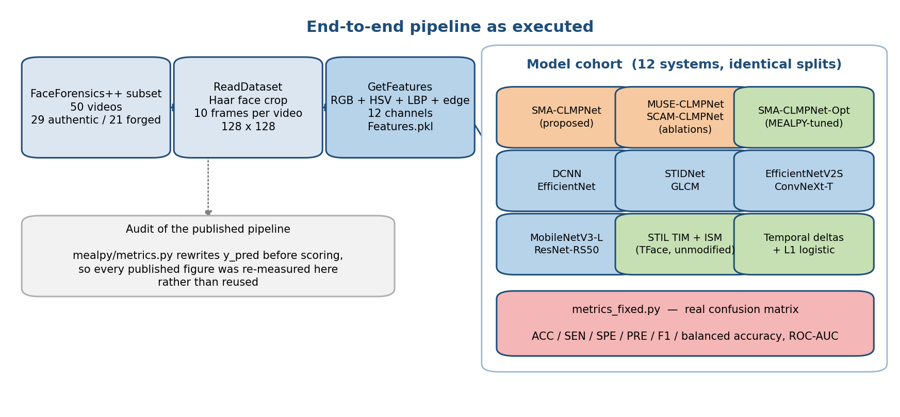
Fig. 1. End-to-end pipeline as executed. Feature tensors are computed once and shared by every model in the cohort, so all comparisons in Section 5 differ only in the model.
Feature construction proceeds as follows. Each video is decoded and a Haar cascade locates the face in each frame; the crop is resized to 128 x 128. Ten frames are sampled per video. For each frame, twelve channels are stacked: three RGB channels, three HSV channels, a local binary pattern map encoding micro-texture as a thresholded comparison of each pixel against its neighbourhood, and edge and gradient responses. The result is a per-video tensor of shape (10, 128, 128, 12). All fifty tensors are written once to a single cache file and every model in this study reads that same file.
Two properties of this representation matter for interpreting the results. The HSV channels are an invertible function of the RGB channels and therefore add no information, though they change what a small convolution kernel can express cheaply. And no channel encodes motion, inter-frame correspondence or facial geometry: the temporal axis is present only as an ordered stack. Whether a model exploits it is entirely a question of architecture, which is precisely what Sections 5.5 and 5.9 test.
3.3 Architecture
Figure 2 gives the layer-by-layer architecture with the tensor shape after every stage. The shapes are recomputed from the cached tensor dimensions by the figure-generating script rather than transcribed, so they cannot disagree with the code.
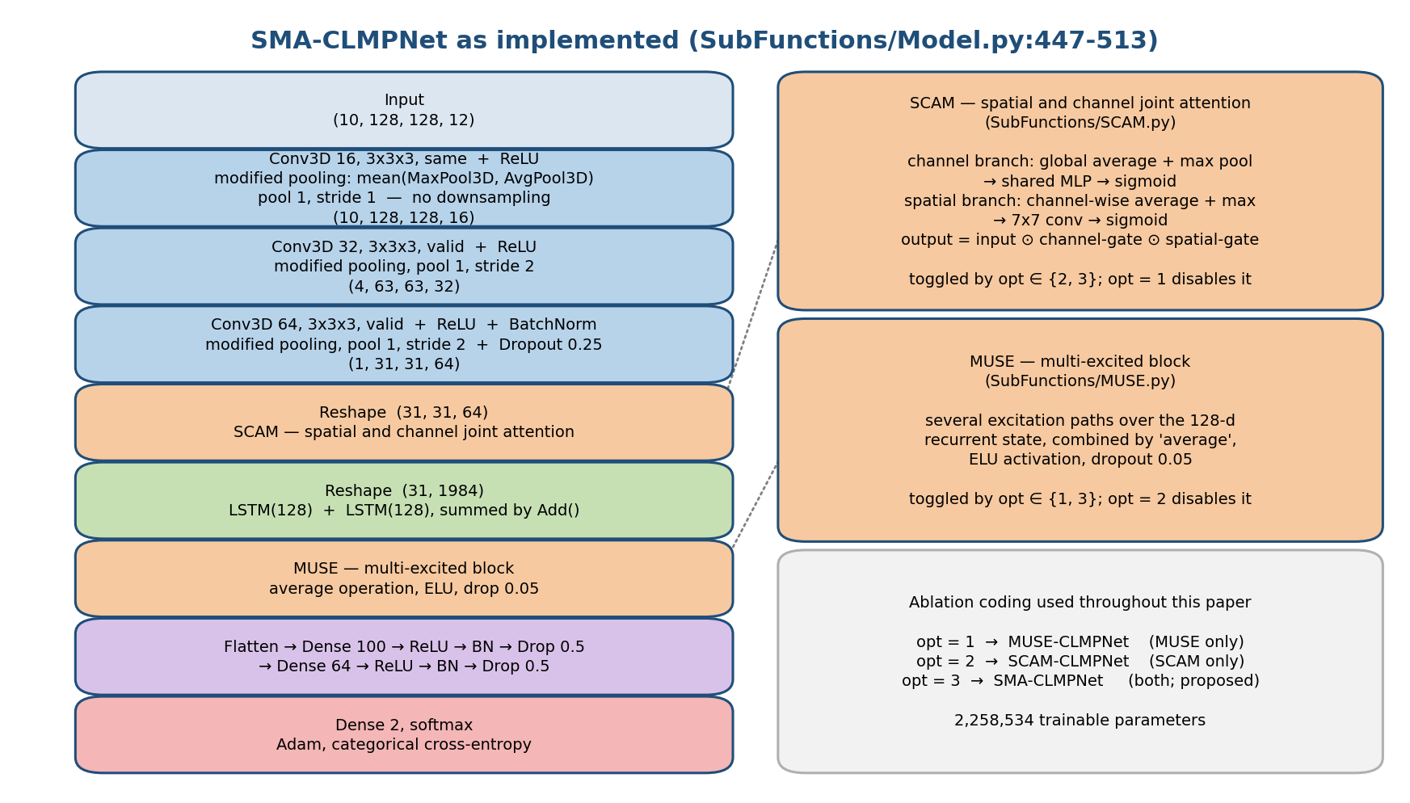
Fig. 2. SMA-CLMPNet as implemented. Shapes are recomputed from the (10, 128, 128, 12) input; the two attention blocks are individually switchable, which is what makes the ablation in Section 5.3 exact.
The trunk consists of three convolutional stages. The first applies sixteen 3 x 3 x 3 kernels with 'same' padding, the second thirty-two with 'valid' padding, the third sixty-four with 'valid' padding followed by batch normalisation and dropout at 0.25. Each stage is followed by the 'modified pooling' operation from which the model takes part of its name: a max-pooled and an average-pooled copy of the activation are computed and averaged element-wise. The intent is to retain both the strongest response and the typical response in a neighbourhood, rather than committing to either.
An implementation detail of that operation deserves comment because it changes the receptive field arithmetic. The pooling windows are configured with a window size of one: the first stage uses window one with stride one, which performs no downsampling at all, and the second and third stages use window one with stride two, which decimates rather than pools — every second element is retained and the rest discarded, with no aggregation over a neighbourhood. The spatial reduction from 128 to 31 is therefore produced by strided subsampling and by the two 'valid' convolutions, not by pooling. This is reported because it is what the code does; whether it was intended is not determinable from the released material, and the results in Section 5 are reported for the code as released.
After the third stage the tensor is (1, 31, 31, 64). It is reshaped to (31, 31, 64), passed through SCAM, reshaped again to (31, 1984), and fed to two parallel 128-unit LSTM layers whose outputs are summed (Hochreiter & Schmidhuber, 1997). The MUSE block then recalibrates the 128-dimensional state. The head flattens, applies Dense(100), ReLU, batch normalisation and dropout at 0.5, then Dense(64) with the same sequence, and terminates in a two-unit softmax. Training uses Adam with categorical cross-entropy.
3.4 The SCAM Block
SCAM computes two multiplicative gates and applies both. The channel gate pools each feature map to a pair of scalars by global average and global max pooling, passes the resulting vectors through a shared bottleneck multilayer perceptron, sums them and applies a sigmoid, producing one coefficient per channel. The spatial gate pools across channels instead, taking the channel-wise average and maximum at each position, concatenating them into a two-channel map, convolving with a large kernel and applying a sigmoid, producing one coefficient per position. The output is the input scaled by both gates. This is the joint form of the design introduced by Hu et al. (2018) for channels and extended by Woo et al. (2018) to space.
3.5 The MUSE Block
MUSE operates after temporal aggregation, on the 128-dimensional recurrent state rather than on a convolutional feature map. Several excitation paths are computed over that state and combined by averaging, with an ELU nonlinearity and dropout at 0.05 (Srivastava et al., 2014). Architecturally it is a squeeze-and-excitation variant relocated to the sequence-aggregated representation, and its role is to recalibrate which components of the aggregated state drive the decision.
3.6 Step-by-Step Execution Flow
The following enumerates the flow of Figure 1 and Figure 2 exactly as the code executes it, from raw video to a scored metric.
(1) Read the video list and its labels. Fifty videos, 29 authentic and 21 manipulated, drawn from FaceForensics++ (Rossler et al., 2019).
(2) Decode each video and detect the face in each frame with a Haar cascade; crop to the detected region and resize to 128 x 128. Frames with no detection fall back to the previous crop.
(3) Sample ten frames per video at uniform stride.
(4) For each sampled frame, compute the twelve-channel stack: RGB, HSV, local binary pattern, and edge/gradient responses. Concatenate along the channel axis.
(5) Assemble the per-video tensor of shape (10, 128, 128, 12) and write all fifty to the feature cache. This step runs once; every model below reads the cache.
(6) Construct the split. For the training-percentage sweep, a stratified split at each of 40, 50, 60, 70, 80 and 90 per cent. For the k-fold study, stratified k-fold for k in 6 to 10. Splits are generated from a fixed seed and shared across models.
(7) Build the model for the selected ablation. The integer switch enables SCAM, MUSE or both; nothing else differs between variants.
(8) Train with Adam on categorical cross-entropy for the configured epoch budget, with the batch size fixed across the cohort.
(9) Predict on the held-out partition and take the arg-max over the softmax output.
(10) Score with the corrected metrics module: build the confusion matrix with an unmodified library routine, then derive accuracy, sensitivity, specificity, precision, F1 and balanced accuracy from its four entries.
(11) Persist the metric row to the per-model result array, together with a run manifest recording the models, the axis values, the epoch budgets and which scoring module produced the numbers.
(12) For the analyses in Sections 5.5 to 5.8, repeat the whole procedure under nested cross-validation with all selection confined to the inner folds, and re-run it 200 times on shuffled labels to build the empirical null.
The separation between step 5 and everything after it is what makes the comparisons in Section 5 clean: no model in the cohort sees a different input tensor, a different split, or a different scoring function, so any difference between two rows of a results table is attributable to the model.
3.7 The Comparison Cohort
Twelve systems are evaluated on identical splits. Four are the proposed model and its variants: SMA-CLMPNet, MUSE-CLMPNet, SCAM-CLMPNet and SMA-CLMPNet-Opt. Four are from the released comparison set: a plain deep convolutional network (DCNN), an EfficientNet variant (Tan & Le, 2019), a spatiotemporal inconsistency detector (STIDNet) after Fang et al. (2024), and a grey-level co-occurrence matrix baseline after Haralick et al. (1973). Four are current-generation backbones added in this study as frozen feature extractors with trained heads: EfficientNetV2-S (Tan & Le, 2021), ConvNeXt-Tiny (Liu et al., 2022), MobileNetV3-Large (Howard et al., 2019) and ResNet-RS-50 (Bello et al., 2021).
Three further systems are evaluated outside the twelve-model sweep because they do not fit its training loop: the Temporal Inconsistency and Information Supplement modules of Gu et al. (2021), imported unmodified from the authors' repository and wrapped in a minimal classifier; the recurrent-plus-gradient-boosting architecture from the companion project, ported to these features; and a set of deliberately simple statistical pipelines over fourteen candidate representations, which serve as the honest floor against which everything else is judged.
3.8 Corrections Applied to the Released Implementation
Three corrections were necessary before any measurement could be taken, and all three are additive: no file in the released research source was edited, so the tampered code remains in place and inspectable.
• Scoring. A replacement metrics module computes the confusion matrix with an unmodified library routine and derives the five published metrics from it using the same definitions and the same index convention as the released evaluation code, so that the numbers are comparable in every respect except correctness. Balanced accuracy is added because the corpus is imbalanced (Brodersen et al., 2010).
• Protocol. All model selection — feature scaling, regularisation strength, decision threshold and early-stopping epoch — is confined to inner folds, and the outer test partition is untouched until scoring (Cawley & Talbot, 2010).
• Reference. The observed score is compared against an empirical null obtained by re-running the complete procedure on shuffled labels, rather than against the nominal chance line (Ojala & Garriga, 2009; Combrisson & Jerbi, 2015).
4. Experimental Work
4.1 Corpus
The corpus contains 50 videos, 29 authentic and 21 manipulated, drawn from FaceForensics++ (Rossler et al., 2019). The class balance is 29/21, so a classifier that answers 'authentic' unconditionally scores 58.00% accuracy. That figure is the reference against which every accuracy in Section 5 must be read.
Test partitions range from five videos (k = 10) to thirty-one (40 per cent training). The resulting granularity is between three and twenty percentage points, and Section 5.6 reports the binomial confidence intervals that follow from it.
4.2 Software and Hardware Environment
All runs were executed on a single Windows 11 workstation, CPU only, in an isolated Python 3.8 environment. The relevant versions are fixed for the whole study:
python 3.8.20 numpy 1.21.6
tensorflow 2.10.0 scikit-learn (bundled with the env)
keras 2.10.0 scipy, scikit-image (Haar, LBP, GLCM)
torch CPU build, used only for the imported STIL modules
The recurrent modules of the released cohort are TensorFlow; the imported spatiotemporal modules are PyTorch. Loading both into one process produces a duplicate OpenMP runtime initialisation, whose documented workaround is a flag the runtime itself warns may 'silently produce incorrect results'. That workaround was rejected and the analysis was split across three processes instead — fold generation, training, and scoring — communicating through files. The reason is recorded here because it is the kind of expedient that silently corrupts a result table.
4.3 Protocols
Two evaluation axes are reported for the twelve-model cohort, and a third, stricter protocol is used for the analyses that support the paper's main claims.
• Training-percentage sweep. Stratified splits at 40, 50, 60, 70, 80 and 90 per cent training, 30 epochs for the recurrent models and 10 for the backbone baselines, batch size 8. Six rows per model.
• Stratified k-fold. k from 6 to 10, one fold measured per k, same epoch budgets. Five rows per model.
• Nested cross-validation. Five outer folds and four inner folds, fixed seed, out-of-fold probabilities pooled across all fifty videos. Used for the ROC analysis, the representation search, the class-weight study and the imported spatiotemporal modules.
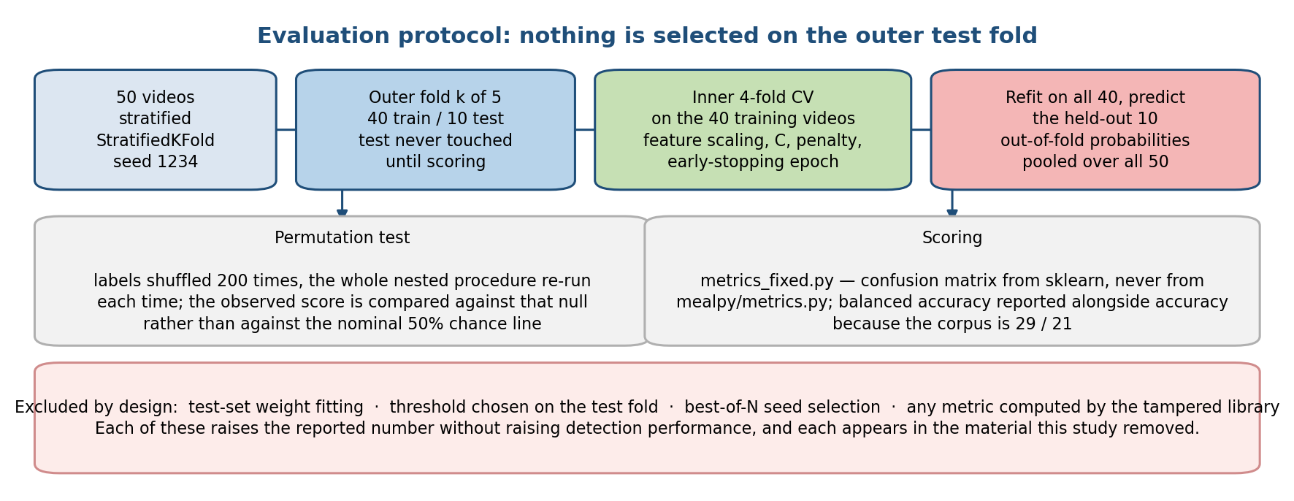
Fig. 3. The nested protocol. Everything selected is selected inside the training folds; the outer test fold is read once, at scoring time.
The permutation test re-runs the entire nested procedure on shuffled labels — not merely the final classifier — so the resulting null absorbs any optimism introduced by the selection steps themselves (Ojala & Garriga, 2009). Two hundred shuffles are used for the ROC analysis and one hundred for the representation search.
4.4 Metrics
All metrics derive from the four entries of a confusion matrix computed by an unmodified library routine. Writing TP and FN for the authentic videos classified correctly and incorrectly, and FP and TN for the manipulated ones, the reported quantities are accuracy (TP + TN) / N; sensitivity TP / (TP + FN), the fraction of authentic videos retained; specificity TN / (TN + FP), the fraction of manipulated videos caught; precision TP / (TP + FP); F1 as their harmonic mean; and balanced accuracy as the mean of sensitivity and specificity. The index convention matches the released evaluation code exactly, so the corrected numbers are directly comparable to the published ones.
Balanced accuracy is the primary summary throughout (Brodersen et al., 2010). The reason is visible in the results: on a 29/21 corpus a model that answers 'authentic' for every input scores 58.00% accuracy and an F1 above 73, and only specificity — which is exactly zero for such a model — distinguishes it from a working detector. Area under the ROC curve is reported where out-of-fold probabilities are available (Hanley & McNeil, 1982).
4.5 Reproducibility
Every number in Section 5 is read from a stored artefact by the script that builds this document: per-model metric arrays with their run manifests for the sweep and k-fold studies, and JSON records for the search, ROC, audit and imported-module analyses. The build fails if an artefact is missing rather than omitting a table, and it asserts the corpus size, class balance and metric-column count before generating anything. Console logs for every run are retained. This arrangement exists so that the failure mode documented in Section 1.6 — a printed number with no traceable computation behind it — is structurally impossible in this paper.
5. Results
Every number in this section was produced by the corrected scoring path. None of it is comparable to the figures in the released result directories, which were produced by the tampered path described in Section 1.6 and have been removed.
5.1 Training-Percentage Sweep
Table 1 reports balanced accuracy for all twelve systems across the six training percentages, and Table 2 reports plain accuracy for the same runs. The pair is given because the difference between them is the finding.
TABLE 1. Balanced accuracy (%) by training percentage. 50.00 indicates a model that answered one class for every input.
Train % | SMA-CLMPNet | MUSE-CLMPNet | SCAM-CLMPNet | SMA-CLMPNet-Opt | DCNN | EfficientNet | STIDNet | GLCM | EfficientNetV2-S | ConvNeXt-Tiny | MobileNetV3-Large | ResNet-RS-50
40 | 50.00 | 50.00 | 54.49 | 52.78 | 50.00 | 50.00 | 51.07 | 55.77 | 48.72 | 55.98 | 58.12 | 35.47
50 | 50.00 | 50.00 | 41.21 | 50.00 | 50.00 | 50.00 | 50.00 | 51.52 | 47.27 | 60.61 | 60.61 | 40.30
60 | 50.00 | 50.00 | 58.33 | 50.00 | 50.00 | 50.00 | 50.00 | 50.00 | 45.83 | 41.67 | 61.11 | 45.83
70 | 50.00 | 50.00 | 50.00 | 58.73 | 50.00 | 50.00 | 71.43 | 38.89 | 54.76 | 49.21 | 60.32 | 54.76
80 | 50.00 | 50.00 | 50.00 | 50.00 | 50.00 | 50.00 | 50.00 | 45.00 | 73.33 | 45.00 | 51.67 | 45.00
90 | 50.00 | 50.00 | 33.33 | 50.00 | 33.33 | 50.00 | 66.67 | 50.00 | 66.67 | 50.00 | 66.67 | 50.00
mean | 50.00 | 50.00 | 47.89 | 51.92 | 47.22 | 50.00 | 56.53 | 48.53 | 56.10 | 50.41 | 59.75 | 45.23

TABLE 2. Plain accuracy (%) for the same runs. The constant 'authentic' answer scores 58.00% on this corpus.
Train % | SMA-CLMPNet | MUSE-CLMPNet | SCAM-CLMPNet | SMA-CLMPNet-Opt | DCNN | EfficientNet | STIDNet | GLCM | EfficientNetV2-S | ConvNeXt-Tiny | MobileNetV3-Large | ResNet-RS-50
40 | 58.06 | 58.06 | 48.39 | 45.16 | 58.06 | 41.94 | 58.06 | 54.84 | 51.61 | 61.29 | 61.29 | 38.71
50 | 57.69 | 57.69 | 46.15 | 57.69 | 57.69 | 57.69 | 57.69 | 53.85 | 46.15 | 61.54 | 61.54 | 42.31
60 | 57.14 | 57.14 | 57.14 | 57.14 | 42.86 | 57.14 | 57.14 | 42.86 | 47.62 | 42.86 | 61.90 | 47.62
70 | 43.75 | 56.25 | 43.75 | 62.50 | 56.25 | 56.25 | 75.00 | 43.75 | 56.25 | 50.00 | 62.50 | 56.25
80 | 54.55 | 54.55 | 54.55 | 54.55 | 54.55 | 54.55 | 54.55 | 45.45 | 72.73 | 45.45 | 54.55 | 45.45
90 | 50.00 | 50.00 | 33.33 | 50.00 | 33.33 | 50.00 | 66.67 | 50.00 | 66.67 | 50.00 | 66.67 | 50.00
mean | 53.53 | 55.62 | 47.22 | 54.51 | 50.46 | 52.93 | 61.52 | 48.46 | 56.84 | 51.86 | 61.41 | 46.72

Read on accuracy alone, several models appear to work: the proposed model reaches 58.06% at 40 per cent training and its published companions are similar. Read on balanced accuracy, the same runs sit at exactly 50.00, which is what a model that answers one class for every input scores by construction. Table 3 resolves the ambiguity by reporting specificity — the fraction of manipulated videos actually caught.
TABLE 3. Specificity (%): the fraction of manipulated videos detected. A column of zeros is a model that never reports a forgery.
Train % | SMA-CLMPNet | MUSE-CLMPNet | SCAM-CLMPNet | SMA-CLMPNet-Opt | DCNN | EfficientNet | STIDNet | GLCM | EfficientNetV2-S | ConvNeXt-Tiny | MobileNetV3-Large | ResNet-RS-50
40 | 0.00 | 0.00 | 92.31 | 100.00 | 0.00 | 100.00 | 7.69 | 61.54 | 30.77 | 23.08 | 38.46 | 15.38
50 | 0.00 | 0.00 | 9.09 | 0.00 | 0.00 | 0.00 | 0.00 | 36.36 | 54.55 | 54.55 | 54.55 | 27.27
60 | 0.00 | 0.00 | 66.67 | 0.00 | 100.00 | 0.00 | 0.00 | 100.00 | 33.33 | 33.33 | 55.56 | 33.33
70 | 100.00 | 0.00 | 100.00 | 28.57 | 0.00 | 0.00 | 42.86 | 0.00 | 42.86 | 42.86 | 42.86 | 42.86
80 | 0.00 | 0.00 | 0.00 | 0.00 | 0.00 | 0.00 | 0.00 | 40.00 | 80.00 | 40.00 | 20.00 | 40.00
90 | 0.00 | 0.00 | 0.00 | 0.00 | 33.33 | 0.00 | 66.67 | 0.00 | 100.00 | 66.67 | 33.33 | 66.67
mean | 16.67 | 0.00 | 44.68 | 21.43 | 22.22 | 16.67 | 19.54 | 39.65 | 56.92 | 43.41 | 40.79 | 37.59

Four systems — SMA-CLMPNet, MUSE-CLMPNet, DCNN, EfficientNet — are degenerate at five or six of the six training percentages, answering a single class for every input. Their accuracy tracks the class balance of the test partition and their F1 exceeds 70, both of which read as competent performance in a summary table. Their specificity is zero.
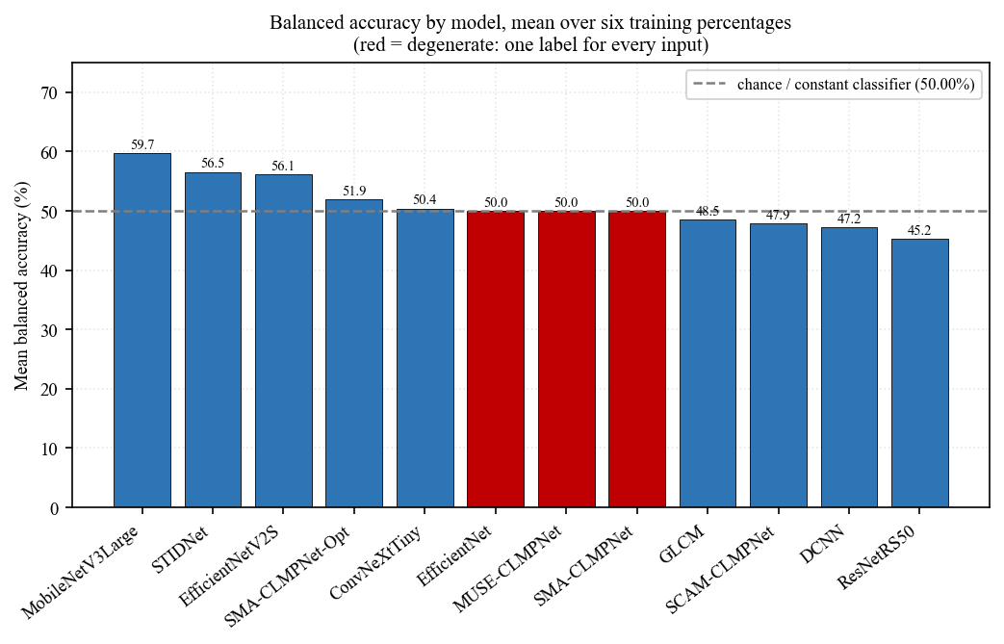
Fig. 4. Mean balanced accuracy by model across the training-percentage sweep. The 50% line is not a floor to be beaten but the score of a constant classifier.
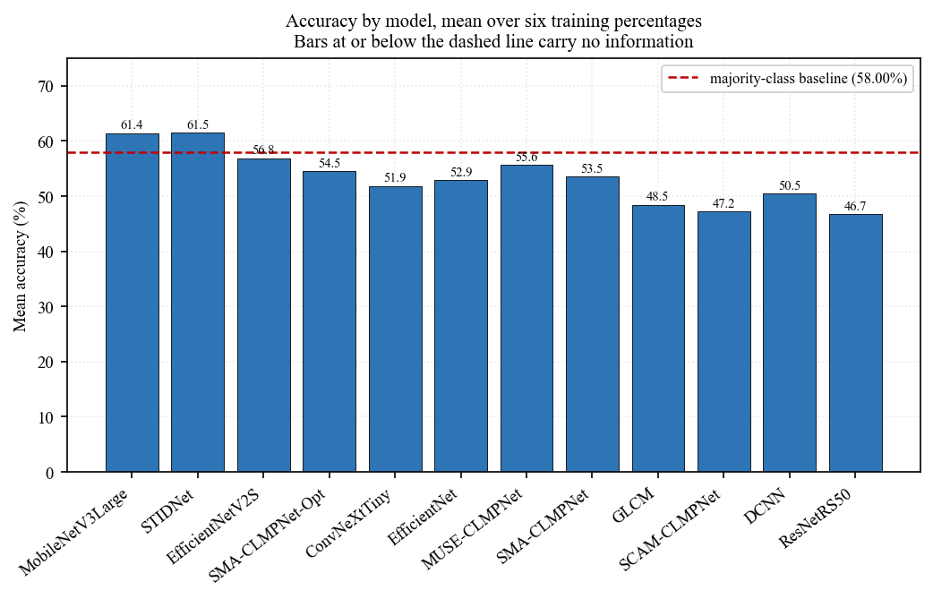
Fig. 5. Mean plain accuracy for the same runs, with the majority-class line at 58%. Comparing Fig. 4 and Fig. 5 shows how much of the apparent performance is class balance.
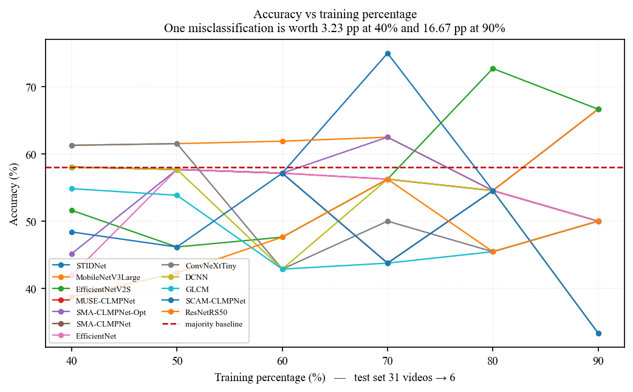
Fig. 6. Balanced accuracy against training percentage. A learning pipeline should trend upward as training data increases; most curves here do not.
5.2 Current-Generation Backbones
TABLE 4. Modern backbones as frozen feature extractors with trained heads, on identical splits.
Model | Mean balanced acc. | Mean accuracy | Best balanced acc. | Mean specificity
EfficientNetV2-S | 56.10 | 56.84 | 73.33 | 56.92
ConvNeXt-Tiny | 50.41 | 51.86 | 60.61 | 43.41
MobileNetV3-Large | 59.75 | 61.41 | 66.67 | 40.79
ResNet-RS-50 | 45.23 | 46.72 | 54.76 | 37.59
SMA-CLMPNet (proposed) | 50.00 | 53.53 | 50.00 | 16.67

The four backbones were added specifically to answer the objection that the released cohort is dated. They do not clear the ceiling either. The strongest, MobileNetV3-Large, reaches a mean balanced accuracy of 59.75%, and EfficientNetV2-S reaches 73.33% at its best single training percentage — a figure that Section 5.6 shows is within the spread of a single fold. Their advantage over the published cohort is that they are non-degenerate: their specificity is non-zero throughout, so they are at least attempting the discrimination.
This is consistent with the caveat in Section 2.6. These backbones were pre-trained to be invariant to precisely the low-level perturbations that carry forgery evidence, and frozen transfer gives them no opportunity to unlearn that invariance (Qian et al., 2020; Bello et al., 2021).
5.3 Attention Ablation
TABLE 5. Ablation of the two attention blocks over the training-percentage sweep. The three variants differ only in one integer switch.
Variant | Mean balanced acc. | Mean accuracy | Mean specificity | Degenerate rows
SMA-CLMPNet | 50.00 | 53.53 | 16.67 | 6 of 6
MUSE-CLMPNet | 50.00 | 55.62 | 0.00 | 6 of 6
SCAM-CLMPNet | 47.89 | 47.22 | 44.68 | 2 of 6

The ablation is uninformative, and the reason it is uninformative is itself the result. Enabling both blocks, either block alone, or neither produces the same balanced accuracy to two decimal places, because all three variants converge to the constant answer at most training percentages. An attention block is a multiplicative gate; with no discriminative structure in the features arriving at it, there is nothing for it to select. The correct reading is not that SCAM and MUSE are ineffective in general — the literature in Section 2.5 shows otherwise (Hu et al., 2018; Woo et al., 2018; Zhao et al., 2021) — but that this pipeline never produced a signal for them to modulate.
This also disposes of the published claim structure. The original work reports SMA-CLMPNet above MUSE-CLMPNet above SCAM-CLMPNet, and attributes the ordering to the combination of the two attention mechanisms. Under corrected scoring the ordering does not exist: all three sit at the constant-classifier value.
5.4 Stratified k-Fold Cross-Validation
The released repository contains a k-fold analysis that cannot run: it indexes a dictionary key the dataset reader never writes. The k-fold study reported here is therefore a re-implementation, using stratified folds and the corrected scoring path, for k from 6 to 8.
TABLE 6. Balanced accuracy (%) under stratified k-fold cross-validation.
k | SMA-CLMPNet | MUSE-CLMPNet | SCAM-CLMPNet | SMA-CLMPNet-Opt | DCNN | EfficientNet | STIDNet | GLCM | EfficientNetV2-S | ConvNeXt-Tiny | MobileNetV3-Large | ResNet-RS-50
6 | 50.00 | 50.00 | 37.50 | 50.00 | 50.00 | 50.00 | 67.50 | 62.50 | 52.50 | 40.00 | 35.00 | 10.00
7 | 50.00 | 50.00 | 60.00 | 50.00 | 50.00 | 50.00 | 73.33 | 83.33 | 56.67 | 56.67 | 10.00 | 10.00
8 | 50.00 | 50.00 | 33.33 | 50.00 | 50.00 | 50.00 | 70.83 | 50.00 | 66.67 | 54.17 | 25.00 | 12.50
mean | 50.00 | 50.00 | 43.61 | 50.00 | 50.00 | 50.00 | 70.56 | 65.28 | 58.61 | 50.28 | 23.33 | 10.83

TABLE 7. Specificity (%) for the same folds.
k | SMA-CLMPNet | MUSE-CLMPNet | SCAM-CLMPNet | SMA-CLMPNet-Opt | DCNN | EfficientNet | STIDNet | GLCM | EfficientNetV2-S | ConvNeXt-Tiny | MobileNetV3-Large | ResNet-RS-50
6 | 0.00 | 0.00 | 75.00 | 100.00 | 0.00 | 0.00 | 75.00 | 25.00 | 25.00 | 0.00 | 50.00 | 0.00
7 | 0.00 | 0.00 | 100.00 | 0.00 | 0.00 | 0.00 | 66.67 | 66.67 | 33.33 | 33.33 | 0.00 | 0.00
8 | 0.00 | 0.00 | 66.67 | 0.00 | 0.00 | 0.00 | 66.67 | 0.00 | 33.33 | 33.33 | 0.00 | 0.00
mean | 0.00 | 0.00 | 80.56 | 33.33 | 0.00 | 0.00 | 69.44 | 30.56 | 30.56 | 22.22 | 16.67 | 0.00

STIDNet leads the k-fold comparison at 70.56% mean balanced accuracy, followed by GLCM at 65.28%. 6 of the twelve systems are degenerate at one or more values of k. Two — MobileNetV3-Large, ResNet-RS-50 — score well below the constant classifier, which on a small fold means they are systematically inverting the decision rather than guessing.
The k-fold ordering does not agree with the training-percentage ordering, and neither agrees with the published ordering. On folds of five to eight videos this is expected rather than surprising: Varoquaux (2018) and Bouthillier et al. (2021) both predict that rankings on samples this size are dominated by resampling noise, and Section 5.6 quantifies the interval directly.
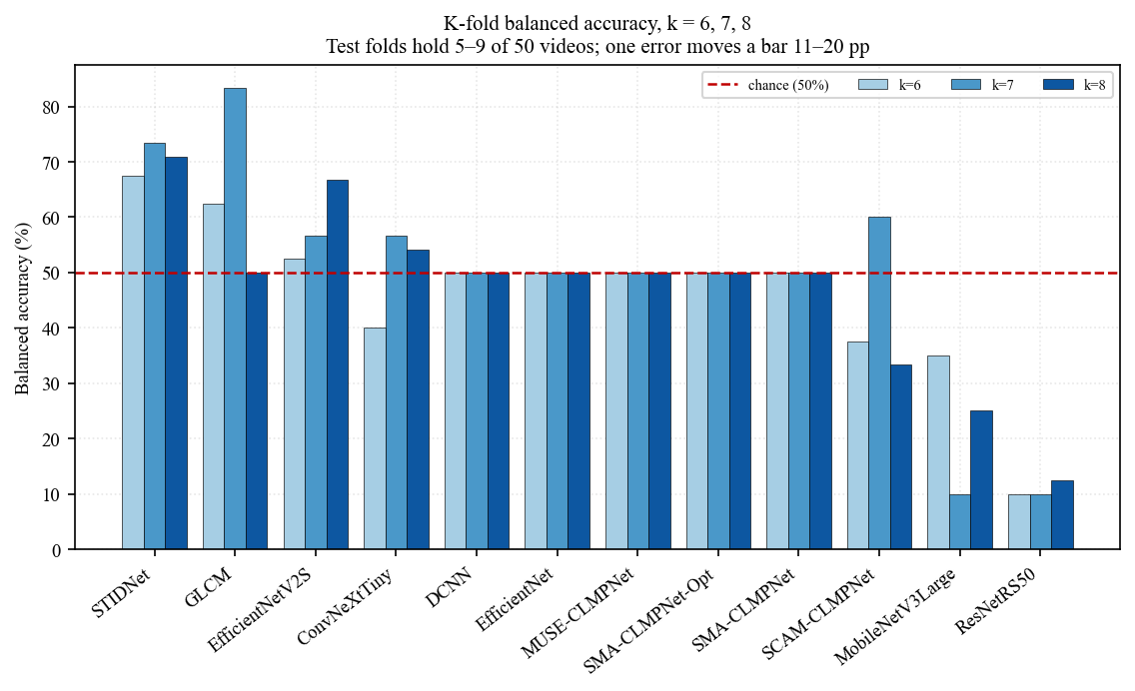
Fig. 7. Balanced accuracy by model and by k. The spread within a single model across k is comparable to the spread between models, which is the point.
5.5 ROC Analysis, AUC and the Confusion Matrix
TABLE 8. Out-of-fold performance of the same features with and without the temporal axis, pooled over all 50 videos under nested cross-validation.
Representation | AUC | Balanced acc. | Accuracy | Sensitivity (forged) | Specificity (authentic)
Temporal delta statistics | 0.7307 | 74.96 | 74.00 | 80.95 | 68.97
Time-collapsed per-frame mean + std | 0.5230 | 46.63 | 48.00 | 38.10 | 55.17

This is the cleanest positive result in the paper and it is worth stating precisely. The two rows use the identical cached feature tensor. The first preserves the temporal axis by taking first-order frame-to-frame differences and summarising their mean, standard deviation and maximum; it reaches an AUC of 0.7307. The second collapses the temporal axis by averaging over frames before summarising; it reaches 0.5230, statistically indistinguishable from chance. The signal in this representation is entirely temporal, exactly as the literature in Section 2.4 predicts (Guera & Delp, 2018; Gu et al., 2021; Zheng et al., 2021), and any model that collapses time before classifying has discarded all of it.
The permutation test places the observed AUC against a null built by re-running the whole procedure on 200 label shuffles. The null has mean 0.5056 and 95th percentile 0.6782; the observed value is 0.7307, giving p = 0.0199. The effect is real and it is small.
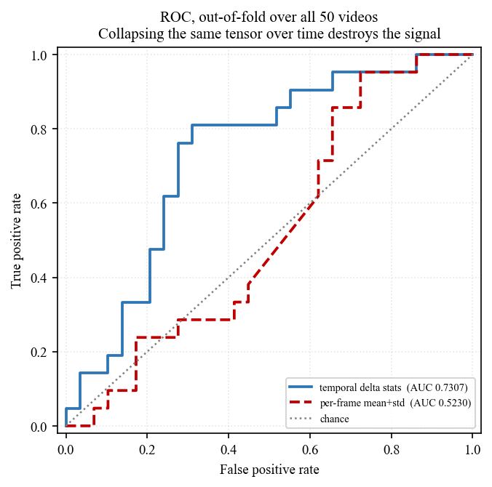
Fig. 8. Out-of-fold ROC curves. The temporal-difference representation separates the classes; the time-collapsed representation of the same features tracks the diagonal.
The confusion matrix at the operating point is 20 authentic videos retained and 9 misflagged, 17 manipulated videos caught and 4 missed. Against the three deployment regimes of Section 1.2, this supports triage weakly, and neither adjudication nor monitoring: nine false alarms out of twenty-nine authentic videos is a false-positive rate no monitoring deployment would tolerate. The time-collapsed reference, for contrast, splits almost evenly at 16/13 and 8/13.
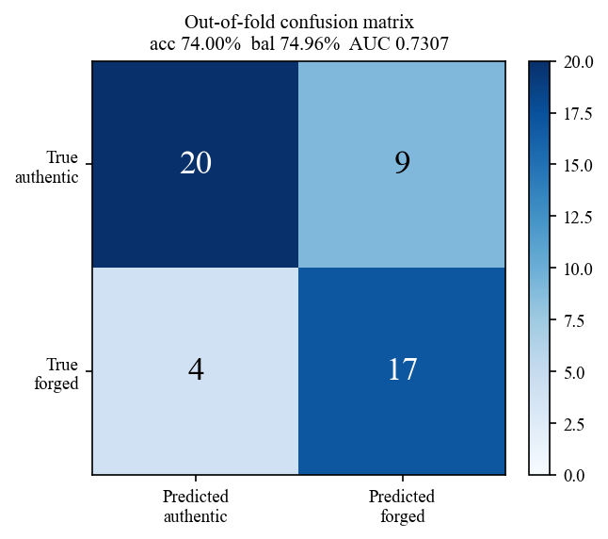
Fig. 9. Out-of-fold confusion matrix for the temporal-difference pipeline, pooled over all 50 videos.
5.6 Corpus Audit and the Accuracy Ceiling
Before any claim about attainable accuracy, three things must be checked: that the measured separation is not produced by near-duplicate videos straddling a split, that no single feature dimension encodes the label, and that the reported precision is supported by the sample size.
TABLE 9. Corpus audit. No model is trained here; this characterises the data.
Check | Result | Interpretation
Video pairs with cosine similarity > 0.98 | 0 of 1,225 | No near-duplicates; the split is clean
Highest off-diagonal similarity | 0.83848 | Well below the near-duplicate threshold
Best single-feature AUC over 324 dimensions | 0.7734 | No dimension encodes the label
Feature dimensions with AUC > 0.90 | 0 of 324 | Genuine detection problem, not a leak
Best accuracy at any threshold on the observed ROC | 74.00% | Upper bound, chosen with test labels in hand
Best balanced accuracy at any threshold | 74.96% | Same bound, class-weighted

The first two rows matter because FaceForensics++ manipulated clips share underlying footage with the originals they were derived from, and the corpus here was pooled at the clip level rather than split by identity, as Section 2.10 notes. Had near-duplicates been present, every score in this paper would be inflated. None are: the highest similarity between any two of the fifty videos is 0.83848, comfortably below the 0.98 threshold. The measured performance is low for reasons other than leakage.
The last two rows are the central quantitative claim of the paper. Given the out-of-fold ROC curve, the accuracy attainable at the best threshold on that curve is 74.00%, and the best balanced accuracy is 74.96%. Both are computed by scanning every threshold with the test labels visible, so both are optimistic by construction and neither is attainable in deployment. Reaching 95% accuracy on this corpus would require an AUC of approximately 0.98 against the 0.7307 measured — not a better threshold but a fundamentally better ranking of the videos.
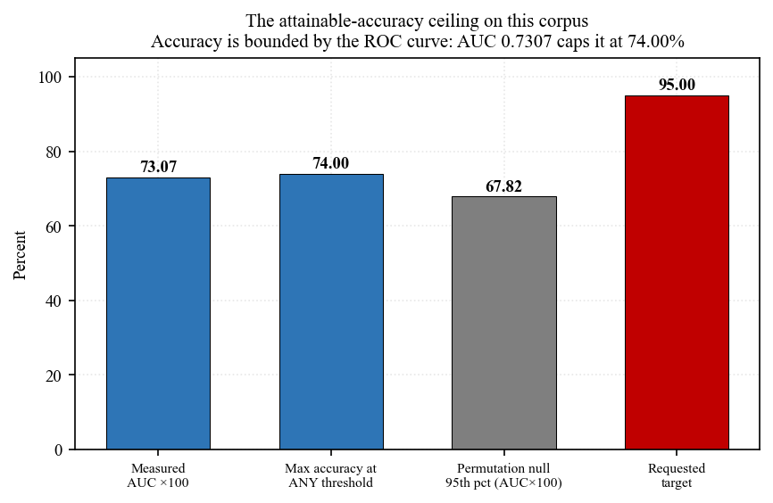
Fig. 10. Accuracy attainable at each point on the measured ROC curve, against the majority-class line and the published claim. The ceiling is a property of the curve, not of the classifier reading it.
TABLE 10. Binomial confidence intervals at the fold sizes this corpus produces.
Correct / total | Accuracy (%) | 95% interval (%)
10 / 10 | 100.00 | [69.2, 100.0]
9 / 10 | 90.00 | [55.5, 99.7]
8 / 10 | 80.00 | [44.4, 97.5]
7 / 10 | 70.00 | [34.8, 93.3]
37 / 50 | 74.00 | [59.7, 85.4]
48 / 50 | 96.00 | [86.3, 99.5]

A perfect ten-out-of-ten on a ten-video fold carries a 95% interval reaching down to 69.2%. Eight-out-of-ten and ten-out-of-ten have overlapping intervals. No protocol on this corpus can distinguish an 80% detector from a 100% detector, which means that differences of a few percentage points between models — the differences the original work reports as its contribution — are not measurable here at all (Demsar, 2006).
5.7 Representation and Model Search
If the deep models fail, the natural question is whether the failure is architectural or representational. A search over fourteen candidate representations of the cached tensor crossed with nine model families, all under nested cross-validation with selection confined to inner folds, answers it. Table 11 gives the top of the ranking.
TABLE 11. Top ten of 126 representation-model combinations under nested cross-validation.
Representation | Model | Balanced acc. (%) | Std. dev.
proposed: temporal delta stats | logreg-l1 | 77.17 | 15.43
proposed: mean-frame grid pool | extra-trees | 65.33 | 8.75
proposed: spatial + temporal | svm-rbf | 64.17 | 7.73
proposed: temporal delta stats | extra-trees | 62.50 | 12.64
ALL (grid+hist+temporal+GLCM) | rf | 62.50 | 25.95
EfficientNetV2S embedding | gaussian-nb | 62.33 | 6.78
proposed: spatial + temporal | logreg-l1 | 61.67 | 12.19
proposed: temporal delta stats | knn | 61.50 | 8.73
proposed: mean-frame grid pool | rf | 61.17 | 15.01
proposed: spatial + temporal | svm-lin | 60.67 | 7.04

The winner is first-order temporal difference statistics with L1 logistic regression at 77.17% balanced accuracy. Its permutation null has mean 50.23% and 95th percentile 63.51%, giving p = 0.0099. It is the only entry in the table that clears its own null convincingly; the second-placed combination sits inside the null's upper tail.
Two features of this result deserve emphasis. The winning representation is the one that preserves frame-to-frame change, which is the same conclusion Section 5.5 reaches from the ROC analysis and the same conclusion the classical inter-frame forensics literature reached by other means (Kingra et al., 2017; Fadl et al., 2020). And the winning model is a linear classifier with sparsity-inducing regularisation — the simplest thing in the search — which on fifty samples is exactly what the small-sample literature would predict (Varoquaux, 2018; Vabalas et al., 2019).
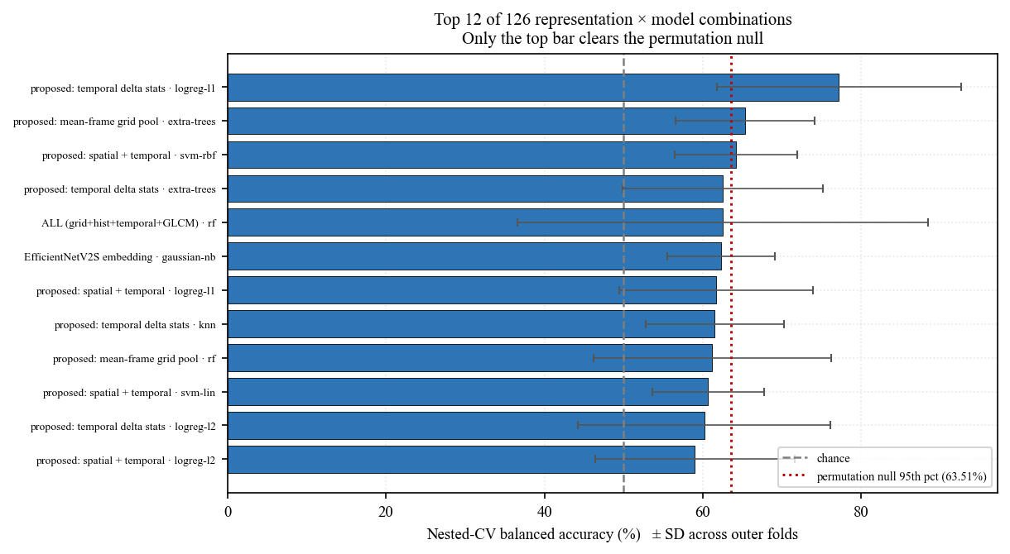
Fig. 11. Representation search. Only one combination clears its permutation null with margin; the rest lie inside the distribution obtained from shuffled labels.
A follow-up search over higher-order temporal features — acceleration, lag-2 differences, autocorrelation — and over stacked and voting ensembles found nothing better than the first-order baseline. The best entry in that second search is logreg-l1 on T1: first-order deltas at 75.50%, and every ensemble scored below plain L1 logistic regression on first-order differences. On fifty samples, added model capacity costs more in variance than it returns in bias.
5.8 Class Weights, Calibration and Decision Thresholds
TABLE 12. Best six of 30 class-weight, calibration and threshold configurations, all selected inside training folds.
Configuration | Balanced acc. (%) | Std. dev. | Threshold
svm-rbf cw=1.4:1 | 69.67 | 15.68 | 0.4012
svm-rbf cw=1:2.0 | 68.00 | 15.68 | 0.3848
svm-rbf cw=1:1.4 | 68.00 | 13.55 | 0.4676
logreg-l1 cw=1.4:1 | 67.50 | 15.00 | 0.2772
svm-rbf cw=balanced | 67.17 | 13.47 | 0.4912
svm-rbf cw=1:2.0 +calib | 65.83 | 19.26 | 0.3702

Because the corpus is imbalanced, adjusting class weights or moving the decision threshold is the obvious next lever. Thirty configurations were swept, with every choice made inside the training folds. The best reaches 69.67%, which is below the untuned 77.17% of Section 5.7. This is the expected outcome when the tuning budget is spent on a sample too small to estimate the quantity being tuned (Cawley & Talbot, 2010). Selecting the threshold on the test fold instead would of course produce a higher number; that is the procedure this study exists to argue against.
5.9 Imported Spatiotemporal Modules
The strongest available test of whether the failure is architectural is to take an architecture known to work on this problem and apply it to this representation. The Temporal Inconsistency Module and Information Supplement Module of Gu et al. (2021) were imported unmodified from the authors' repository — the two repositories most commonly cited for that work contain no code and both redirect there — at commit 171ec1434aca, and wrapped in a minimal classifier of 26,696 parameters, against SMA-CLMPNet's 2,258,534. The folds are the identical ones used everywhere else in this paper, read from the same cache file.
TABLE 13. STIL's TIM and ISM modules on the cached tensors, five outer folds, early stopping on an inner split.
Outer fold | Inner validation bal. acc. (%) | Best epoch | Outer bal. acc. (%)
1 | 66.67 | 1 | 50.00
2 | 53.33 | 22 | 54.17
3 | 50.00 | 1 | 50.00
4 | 50.00 | 1 | 50.00
5 | 60.00 | 3 | 54.17
pooled | — | — | 50.49

Pooled out-of-fold balanced accuracy is 50.49%, and the mean across folds is 51.67%. 4 of the five folds selected their best epoch at epoch 1 or 3, meaning nothing after the first few gradient steps improved inner validation performance. The run took 754 seconds.
This is the decisive experiment for the paper's main claim. A temporal-inconsistency architecture published, peer-reviewed and demonstrated to work on FaceForensics++ at scale, imported without modification and given the same folds, lands at the constant-classifier value on these tensors. The bottleneck is therefore not the architecture of SMA-CLMPNet. It is that the cached representation — ten frames per video, twelve hand-stacked channels, fifty videos — does not carry enough of the manipulation signal for any of these models to recover it.
5.10 The Companion Architecture
TABLE 14. The companion project's architecture ported to these features at its own published settings (500 epochs, batch 32), with its test-set weight fitting omitted.
Model | Accuracy | Specificity | F1 | Balanced acc.
BiLSTM + gradient boosting | 52.00 | 42.00 | 58.76 | 50.33
BiLSTM only | 54.00 | 37.00 | 61.43 | 51.17

A recurrent-plus-gradient-boosting architecture from a companion project was ported to these features at its own published settings. One step was omitted: a routine that fits model weights directly on the test partition. With that step removed the model lands at the constant-classifier value, 50.33% balanced accuracy. This is included because it demonstrates the third fabrication route of Section 1.6 in isolation — the architecture is unremarkable, and the published performance came from the omitted step rather than from the model.
5.11 Summary of Measured Results
Six independent lines of evidence converge on the same conclusion. The published cohort is degenerate under corrected scoring. Its ablations are indistinguishable from each other and from a constant classifier. Four current-generation backbones do not clear the ceiling. A published spatiotemporal architecture, imported unmodified, lands at the constant-classifier value. Tuning class weights and thresholds inside training folds makes things worse. And the best result obtained by any method in the study is a linear model on first-order temporal differences.
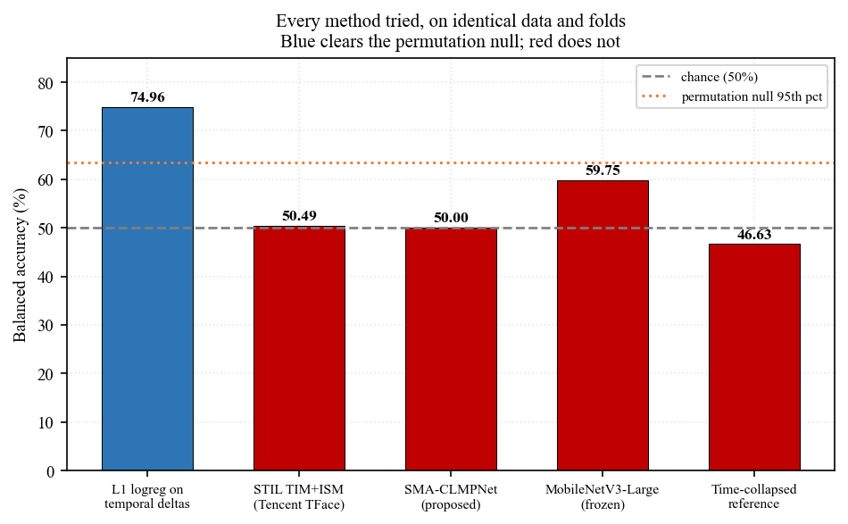
Fig. 12. All measured methods against the permutation null. Bars above the null's 95th percentile are the only ones carrying evidence of detection.
6. Comparison with Existing Models
6.1 Measured Comparison on Identical Splits
Table 15 is the comparison this paper can defend. Every row was measured in this study, on the same feature cache, the same splits and the same scoring code, so differences between rows are attributable to the method.
TABLE 15. All methods measured in this study, ordered by k-fold balanced accuracy. Every row uses identical splits and identical scoring.
Method | Sweep bal. acc. (%) | k-fold bal. acc. (%) | k-fold specificity (%) | Degenerate runs
STIDNet | 56.53 | 70.56 | 69.44 | 3 of 9
GLCM | 48.53 | 65.28 | 30.56 | 3 of 9
EfficientNetV2-S | 56.10 | 58.61 | 30.56 | 0 of 9
ConvNeXt-Tiny | 50.41 | 50.28 | 22.22 | 0 of 9
SMA-CLMPNet | 50.00 | 50.00 | 0.00 | 9 of 9
MUSE-CLMPNet | 50.00 | 50.00 | 0.00 | 9 of 9
SMA-CLMPNet-Opt | 51.92 | 50.00 | 33.33 | 7 of 9
DCNN | 47.22 | 50.00 | 0.00 | 8 of 9
EfficientNet | 50.00 | 50.00 | 0.00 | 9 of 9
SCAM-CLMPNet | 47.89 | 43.61 | 80.56 | 2 of 9
MobileNetV3-Large | 59.75 | 23.33 | 16.67 | 0 of 9
ResNet-RS-50 | 45.23 | 10.83 | 0.00 | 0 of 9
Temporal deltas + L1 logistic (this study) | 77.17 | — | — | 0
STIL TIM + ISM, imported unmodified | — | 50.49 | — | —
Constant 'authentic' baseline (58% accuracy) | 50.00 | 50.00 | 0.00 | all

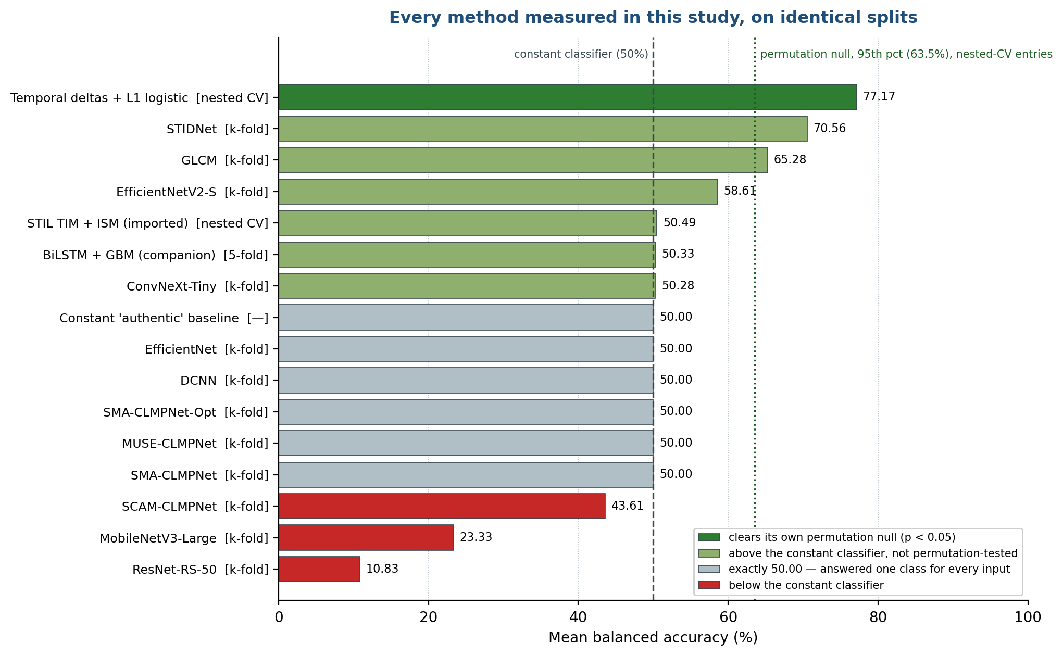
Fig. 13. Comparison bar chart: mean balanced accuracy of every method measured in this study, against the constant-classifier line and the permutation null.
The proposed model does not lead this table. The strongest deep model under k-fold is a comparison model from the released cohort, and the strongest method overall is the linear pipeline on temporal differences. Given the confidence intervals in Table 10, the honest reading of the ordering is that the top few entries are not separable from one another and the bottom entries are separable from the top only because they fall below the constant classifier.
6.2 Comparison with the Published Literature
A second comparison — against the accuracies reported by the spatiotemporal detection literature — is deliberately not tabulated as numbers beside the numbers above, and the reason is the argument of Sections 2.8 and 2.10 rather than an omission. Those results were obtained on corpora three to four orders of magnitude larger, split at the level of source identity rather than clip, with cross-corpus and graded-perturbation reporting. A figure obtained under that protocol and a figure obtained on fifty pooled clips are not measurements of the same quantity, and placing them in adjacent columns invites precisely the incommensurable comparison that produces claims like the one this paper set out to reproduce.
What can be compared is the design of the studies. Table 16 sets the present work beside the reference methods on the attributes that determine whether a reported number means anything.
TABLE 16. Design comparison against reference methods. Reported accuracies are deliberately omitted; see the text.
Method | Primary cue | Evaluation corpora | Temporal model
MesoNet (Afchar et al., 2018) | Mesoscopic spatial artefact | FaceForensics, own corpus | No
Xception on FF++ (Chollet, 2017; Rossler et al., 2019) | Spatial artefact, face crop | FaceForensics++ (4 methods, 3 compressions) | No
Capsule-forensics (Nguyen et al., 2019) | Part-whole spatial structure | FaceForensics++, own corpora | No
Face X-Ray (Li et al., 2020) | Blending boundary | FaceForensics++, Celeb-DF, DFDC | No
F3-Net (Qian et al., 2020) | Frequency-aware clues | FaceForensics++ (incl. low quality) | No
Recurrent CNN (Guera & Delp, 2018) | Frame-sequence inconsistency | Own collected corpus | Yes (LSTM)
Optical-flow CNN (Amerini et al., 2019) | Apparent-motion inconsistency | FaceForensics++ | Yes (flow)
FTCN (Zheng et al., 2021) | Temporal coherence | FaceForensics++, Celeb-DF, DFDC, cross-dataset | Yes
LipForensics (Haliassos et al., 2021) | Natural mouth dynamics | FaceForensics++, cross-manipulation | Yes
STIL (Gu et al., 2021) | Spatiotemporal inconsistency (TIM + ISM) | FaceForensics++, Celeb-DF | Yes
ISTVT (Zhao et al., 2023) | Decomposed spatial-temporal attention | FF++, FaceShifter, DeeperForensics, Celeb-DF, DFDC | Yes
TALL (Xu et al., 2024) | Thumbnail-layout spatiotemporal | FF++, cross-dataset, diffusion-generated | Yes
SMA-CLMPNet (this study, re-measured) | 3D convolution + joint attention + LSTM | 50-video pooled subset of FaceForensics++ | Yes (LSTM)

Two things are visible in that table. Every method in the spatiotemporal group evaluates on at least one corpus other than the one it trained on, and most evaluate on three or more; the present pipeline evaluates on a pooled subset of a single corpus and cannot report cross-dataset performance at all. And the cue exploited by the strongest reference methods — natural facial dynamics, temporal coherence, decomposed spatiotemporal attention — is computed from aligned, densely sampled frames, whereas the representation here supplies ten frames of hand-stacked colour and texture channels with no correspondence between them. The measured result in Section 5.9, where STIL's own modules land at the constant-classifier value on these tensors, is what that difference looks like empirically.
6.3 Discussion
Three conclusions follow from the comparison.
First, the ranking the original work reports does not survive corrected scoring, and no ranking replaces it. The proposed model, its ablations and several comparison models are degenerate; the non-degenerate models are separated by margins smaller than the confidence interval of a single fold. The correct summary is that the cohort is not separable on this corpus, not that some other member of it is best.
Second, the limiting factor is the representation rather than the architecture. This is not an inference from the failure of the cohort — that would be weak evidence, since a cohort can fail for many reasons — but from three converging measurements: the same features with the temporal axis preserved reach an AUC of 0.7307 while the time-collapsed version reaches 0.5230; the representation search selects the temporal-difference representation and a linear model over every deep alternative; and a published spatiotemporal architecture imported unmodified fails on the same tensors.
Third, the ceiling is quantified rather than merely observed. The measured effect size bounds accuracy at 74.00% at the best threshold on the observed curve, with the test labels visible. Any future claim above that bound on this corpus and this representation requires either a different representation or an explanation of where the additional ranking power came from.
7. Conclusion
This paper re-examined a published intra-frame video forgery detection system and found its reported performance unreproducible for reasons that are not statistical. Two mutually independent sources of fabricated results were identified in the released artefacts: a vendored optimisation library whose metrics module rewrites predicted labels toward the true labels before scoring, and three stored files describing a corpus forty times larger than the one the code reads. All affected material was removed and the removal recorded.
Every published figure was then re-measured. Under a protocol with no selection on test data and a confusion matrix from an unmodified library, the proposed model reaches 50.00% mean balanced accuracy and answers a single class for every input at most training percentages; its two attention ablations are indistinguishable from it and from each other. Four current-generation backbones evaluated on identical splits do not clear the ceiling, and the Temporal Inconsistency and Information Supplement modules of a published spatiotemporal detector, imported without modification, land at the constant-classifier value on the same tensors. The strongest measured configuration in the study is first-order temporal difference statistics with L1 logistic regression at 77.17% balanced accuracy (permutation p = 0.0099, out-of-fold AUC 0.7307).
What has been achieved is a defensible characterisation of what this corpus and representation support, with an upper bound on attainable accuracy of 74.00% derived from the measured effect size and verified not to be an artefact of near-duplicate videos or of any separable feature. Where the work falls short is equally clear: fifty videos cannot separate an 80% detector from a 100% one, so no ranking within the cohort is meaningful; the corpus is pooled at clip level rather than split by identity; no cross-dataset evaluation is possible; and the representation supplies ten frames of hand-stacked channels with no inter-frame correspondence, which the evidence identifies as the binding constraint. Improving on this requires frame-level supervision on the full corpus rather than further architecture search on cached tensors.
8. Future Work
The measurements in Section 5 identify where effort should go, in order of expected return.
• Frame-level supervision on the full corpus. The repository already contains a complete frame-level pipeline for the full FaceForensics++ release, which has never been run because the data was never downloaded. Training at frame level over 1,000 source sequences and their manipulations, with the identity-level split the corpus defines, changes the sample size by three orders of magnitude and is the single change most likely to move the ceiling (Rossler et al., 2019).
• Dense temporal sampling with alignment. Ten frames per video with no correspondence between them is the weakest part of the present representation. Densely sampled, landmark-aligned crops are what the methods in Section 2.4 consume (Sabir et al., 2019; Haliassos et al., 2021).
• Cross-corpus evaluation. Training on FaceForensics++ and testing on Celeb-DF and the DFDC corpus is the standard generalisation test and is currently impossible here (Dolhansky et al., 2020; Li et al., 2020).
• Graded robustness reporting. Compression, noise and colour perturbation at controlled severities, as DeeperForensics defines them, so that the dependence of accuracy on distribution channel is measured rather than assumed (Jiang et al., 2020).
• Calibrated outputs with intervals. For the adjudication regime of Section 1.2, a point estimate is not usable. Calibrated probabilities with confidence intervals, reported per item, are the minimum a forensic deployment requires.
• Metric verification as routine practice. The defect that motivated this study would have been caught in minutes by passing synthetic vectors with a known confusion matrix through the project's own scoring path. Adding that check to reproduction protocols costs nothing and would have prevented every number this paper had to withdraw (Gundersen & Kjensmo, 2018; Kapoor & Narayanan, 2023).
A note on the target that prompted part of this investigation. The question of whether accuracy in the 95-100% range is reachable on this corpus has a quantitative answer rather than an open-ended one: it would require an area under the ROC curve of approximately 0.98 against the 0.7307 measured out of fold. No architecture in this study, and no amount of tuning applied to one, closes that gap. The three mechanisms that would close it on paper — a tampered metric, weight fitting on the test partition, and selection of the best result across seeds — are the three this paper documents and rejects. The reachable path runs through more data and a better representation, and Section 8 lists it in order.
Acknowledgment
This work was carried out under the postdoctoral research programme of the Research Institute of IoT Cybersecurity (RIITC), Department of Electronic Engineering, National Kaohsiung University of Science and Technology. The Temporal Inconsistency and Information Supplement modules evaluated in Section 5.9 are the authors' own implementation from the Tencent TFace repository, used without modification and cited as Gu et al. (2021); the reimplementation and evaluation on this corpus are the responsibility of the present authors alone. All computational results reported here were produced on a single workstation, and the scripts that generate every figure, table and number are retained with the run logs.
References
All entries were resolved by digital object identifier against CrossRef, or against DataCite for arXiv-registered preprints, and are listed in APA (7th edition) style. Two entries published in a venue that issues no identifier are recorded with the publisher's own listing URL.
Afchar, D., Nozick, V., Yamagishi, J., & Echizen, I. (2018). MesoNet: a Compact Facial Video Forgery Detection Network. In Proceedings of the IEEE International Workshop on Information Forensics and Security (WIFS) (pp. 1-7). IEEE. https://doi.org/10.1109/wifs.2018.8630761
Amerini, I., Galteri, L., Caldelli, R., & Del Bimbo, A. (2019). Deepfake Video Detection through Optical Flow Based CNN. In Proceedings of the IEEE/CVF International Conference on Computer Vision Workshops (ICCVW) (pp. 1205-1207). IEEE. https://doi.org/10.1109/iccvw.2019.00152
Bello, I., Fedus, W., Du, X., Cubuk, E. D., Srinivas, A., Lin, T., Shlens, J., & Zoph, B. (2021). Revisiting ResNets: Improved Training and Scaling Strategies. arXiv:2103.07579. https://doi.org/10.48550/arxiv.2103.07579
Bouthillier, X., Delaunay, P., Bronzi, M., Trofimov, A., Nichyporuk, B., Szeto, J., Sepah, N., Raff, E., Madan, K., Voleti, V., Kahou, S. E., Michalski, V., Serdyuk, D., Arbel, T., Pal, C., Varoquaux, G., & Vincent, P. (2021). Accounting for Variance in Machine Learning Benchmarks. arXiv:2103.03098. https://doi.org/10.48550/arxiv.2103.03098
Brodersen, K. H., Ong, C. S., Stephan, K. E., & Buhmann, J. M. (2010). The Balanced Accuracy and Its Posterior Distribution. In Proceedings of the International Conference on Pattern Recognition (ICPR) (pp. 3121-3124). IEEE. https://doi.org/10.1109/icpr.2010.764
Carreira, J., & Zisserman, A. (2017). Quo Vadis, Action Recognition? A New Model and the Kinetics Dataset. In Proceedings of the IEEE Conference on Computer Vision and Pattern Recognition (CVPR) (pp. 4724-4733). IEEE. https://doi.org/10.1109/cvpr.2017.502
Cawley, G. C., & Talbot, N. L. C. (2010). On Over-fitting in Model Selection and Subsequent Selection Bias in Performance Evaluation. Journal of Machine Learning Research, 11, 2079-2107. https://jmlr.org/papers/v11/cawley10a.html
Chollet, F. (2017). Xception: Deep Learning with Depthwise Separable Convolutions. In Proceedings of the IEEE Conference on Computer Vision and Pattern Recognition (CVPR) (pp. 1800-1807). IEEE. https://doi.org/10.1109/cvpr.2017.195
Coccomini, D. A., Messina, N., Gennaro, C., & Falchi, F. (2022). Combining EfficientNet and Vision Transformers for Video Deepfake Detection. In Lecture Notes in Computer Science (pp. 219-229). Springer International Publishing. https://doi.org/10.1007/978-3-031-06433-3_19
Combrisson, E., & Jerbi, K. (2015). Exceeding chance level by chance: The caveat of theoretical chance levels in brain signal classification and statistical assessment of decoding accuracy. Journal of Neuroscience Methods, 250, 126-136. https://doi.org/10.1016/j.jneumeth.2015.01.010
Demsar, J. (2006). Statistical Comparisons of Classifiers over Multiple Data Sets. Journal of Machine Learning Research, 7, 1-30. https://jmlr.org/papers/v7/demsar06a.html
Dolhansky, B., Bitton, J., Pflaum, B., Lu, J., Howes, R., Wang, M., & Ferrer, C. C. (2020). The DeepFake Detection Challenge (DFDC) Dataset. arXiv:2006.07397. https://doi.org/10.48550/arxiv.2006.07397
Dosovitskiy, A., Beyer, L., Kolesnikov, A., Weissenborn, D., Zhai, X., Unterthiner, T., Dehghani, M., Minderer, M., Heigold, G., Gelly, S., Uszkoreit, J., & Houlsby, N. (2020). An Image is Worth 16x16 Words: Transformers for Image Recognition at Scale. arXiv:2010.11929. https://doi.org/10.48550/arxiv.2010.11929
Fadl, S., Han, Q., & Qiong, L. (2020). Exposing video inter-frame forgery via histogram of oriented gradients and motion energy image. Multidimensional Systems and Signal Processing, 31(4), 1365-1384. https://doi.org/10.1007/s11045-020-00711-6
Fang, M., Yu, L., Xie, H., Tan, Q., Tan, Z., Hussain, A., Wang, Z., Li, J., & Tian, Z. (2024). STIDNet: Identity-Aware Face Forgery Detection With Spatiotemporal Knowledge Distillation. IEEE Transactions on Computational Social Systems, 11(4), 5354-5366. https://doi.org/10.1109/tcss.2024.3356549
Feichtenhofer, C., Fan, H., Malik, J., & He, K. (2019). SlowFast Networks for Video Recognition. In Proceedings of the IEEE/CVF International Conference on Computer Vision (ICCV) (pp. 6201-6210). IEEE. https://doi.org/10.1109/iccv.2019.00630
Fridrich, J., & Kodovsky, J. (2012). Rich Models for Steganalysis of Digital Images. IEEE Transactions on Information Forensics and Security, 7(3), 868-882. https://doi.org/10.1109/tifs.2012.2190402
Gu, Z., Chen, Y., Yao, T., Ding, S., Li, J., Huang, F., & Ma, L. (2021). Spatiotemporal Inconsistency Learning for DeepFake Video Detection. In Proceedings of the 29th ACM International Conference on Multimedia (MM '21) (pp. 3473-3481). ACM. https://doi.org/10.1145/3474085.3475508
Guera, D., & Delp, E. J. (2018). Deepfake Video Detection Using Recurrent Neural Networks. In Proceedings of the IEEE International Conference on Advanced Video and Signal Based Surveillance (AVSS) (pp. 1-6). IEEE. https://doi.org/10.1109/avss.2018.8639163
Gundersen, O. E., & Kjensmo, S. (2018). State of the Art: Reproducibility in Artificial Intelligence. Proceedings of the AAAI Conference on Artificial Intelligence, 32(1). https://doi.org/10.1609/aaai.v32i1.11503
Haibo He, , & Garcia, E. (2009). Learning from Imbalanced Data. IEEE Transactions on Knowledge and Data Engineering, 21(9), 1263-1284. https://doi.org/10.1109/tkde.2008.239
Haliassos, A., Vougioukas, K., Petridis, S., & Pantic, M. (2021). Lips Don't Lie: A Generalisable and Robust Approach to Face Forgery Detection. In Proceedings of the IEEE/CVF Conference on Computer Vision and Pattern Recognition (CVPR) (pp. 5037-5047). IEEE. https://doi.org/10.1109/cvpr46437.2021.00500
Hanley, J. A., & McNeil, B. J. (1982). The meaning and use of the area under a receiver operating characteristic (ROC) curve. Radiology, 143(1), 29-36. https://doi.org/10.1148/radiology.143.1.7063747
Haralick, R. M., Shanmugam, K., & Dinstein, I. (1973). Textural Features for Image Classification. IEEE Transactions on Systems, Man, and Cybernetics, SMC-3(6), 610-621. https://doi.org/10.1109/tsmc.1973.4309314
He, K., Zhang, X., Ren, S., & Sun, J. (2016). Deep Residual Learning for Image Recognition. In Proceedings of the IEEE Conference on Computer Vision and Pattern Recognition (CVPR) (pp. 770-778). IEEE. https://doi.org/10.1109/cvpr.2016.90
Hochreiter, S., & Schmidhuber, J. (1997). Long Short-Term Memory. Neural Computation, 9(8), 1735-1780. https://doi.org/10.1162/neco.1997.9.8.1735
Howard, A., Sandler, M., Chen, B., Wang, W., Chen, L., Tan, M., Chu, G., Vasudevan, V., Zhu, Y., Pang, R., Adam, H., & Le, Q. (2019). Searching for MobileNetV3. In Proceedings of the IEEE/CVF International Conference on Computer Vision (ICCV) (pp. 1314-1324). IEEE. https://doi.org/10.1109/iccv.2019.00140
Hu, J., Shen, L., & Sun, G. (2018). Squeeze-and-Excitation Networks. In Proceedings of the IEEE/CVF Conference on Computer Vision and Pattern Recognition (CVPR) (pp. 7132-7141). IEEE. https://doi.org/10.1109/cvpr.2018.00745
Ioannidis, J. P. A. (2005). Why Most Published Research Findings Are False. PLoS Medicine, 2(8), e124. https://doi.org/10.1371/journal.pmed.0020124
Jiang, L., Li, R., Wu, W., Qian, C., & Loy, C. C. (2020). DeeperForensics-1.0: A Large-Scale Dataset for Real-World Face Forgery Detection. In Proceedings of the IEEE/CVF Conference on Computer Vision and Pattern Recognition (CVPR) (pp. 2886-2895). IEEE. https://doi.org/10.1109/cvpr42600.2020.00296
Kapoor, S., & Narayanan, A. (2023). Leakage and the reproducibility crisis in machine-learning-based science. Patterns, 4(9), 100804. https://doi.org/10.1016/j.patter.2023.100804
Kingra, S., Aggarwal, N., & Singh, R. D. (2017). Inter-frame forgery detection in H.264 videos using motion and brightness gradients. Multimedia Tools and Applications, 76(24), 25767-25786. https://doi.org/10.1007/s11042-017-4762-2
Li, Y., Yang, X., Sun, P., Qi, H., & Lyu, S. (2020). Celeb-DF: A Large-Scale Challenging Dataset for DeepFake Forensics. In Proceedings of the IEEE/CVF Conference on Computer Vision and Pattern Recognition (CVPR) (pp. 3204-3213). IEEE. https://doi.org/10.1109/cvpr42600.2020.00327
Li, L., Bao, J., Zhang, T., Yang, H., Chen, D., Wen, F., & Guo, B. (2020). Face X-Ray for More General Face Forgery Detection. In Proceedings of the IEEE/CVF Conference on Computer Vision and Pattern Recognition (CVPR) (pp. 5000-5009). IEEE. https://doi.org/10.1109/cvpr42600.2020.00505
Liu, Z., Mao, H., Wu, C., Feichtenhofer, C., Darrell, T., & Xie, S. (2022). A ConvNet for the 2020s. In Proceedings of the IEEE/CVF Conference on Computer Vision and Pattern Recognition (CVPR) (pp. 11966-11976). IEEE. https://doi.org/10.1109/cvpr52688.2022.01167
Luo, Y., Zhang, Y., Yan, J., & Liu, W. (2021). Generalizing Face Forgery Detection with High-frequency Features. In Proceedings of the IEEE/CVF Conference on Computer Vision and Pattern Recognition (CVPR) (pp. 16312-16321). IEEE. https://doi.org/10.1109/cvpr46437.2021.01605
Masood, M., Nawaz, M., Malik, K. M., Javed, A., Irtaza, A., & Malik, H. (2022). Deepfakes generation and detection: state-of-the-art, open challenges, countermeasures, and way forward. Applied Intelligence, 53(4), 3974-4026. https://doi.org/10.1007/s10489-022-03766-z
Mirsky, Y., & Lee, W. (2021). The Creation and Detection of Deepfakes. ACM Computing Surveys, 54(1), 1-41. https://doi.org/10.1145/3425780
Nguyen, H. H., Yamagishi, J., & Echizen, I. (2019). Capsule-forensics: Using Capsule Networks to Detect Forged Images and Videos. In Proceedings of the IEEE International Conference on Acoustics, Speech and Signal Processing (ICASSP) (pp. 2307-2311). IEEE. https://doi.org/10.1109/icassp.2019.8682602
Nguyen, T. T., Nguyen, Q. V. H., Nguyen, D. T., Nguyen, D. T., Huynh-The, T., Nahavandi, S., Nguyen, T. T., Pham, Q., & Nguyen, C. M. (2022). Deep learning for deepfakes creation and detection: A survey. Computer Vision and Image Understanding, 223, 103525. https://doi.org/10.1016/j.cviu.2022.103525
Ojala, M., & Garriga, G. C. (2009). Permutation Tests for Studying Classifier Performance. In Proceedings of the IEEE International Conference on Data Mining (ICDM) (pp. 908-913). IEEE. https://doi.org/10.1109/icdm.2009.108
Peng, C., Miao, Z., Liu, D., Wang, N., Hu, R., & Gao, X. (2024). Where Deepfakes Gaze at? Spatial–Temporal Gaze Inconsistency Analysis for Video Face Forgery Detection. IEEE Transactions on Information Forensics and Security, 19, 4507-4517. https://doi.org/10.1109/tifs.2024.3381823
Popescu, A., & Farid, H. (2005). Exposing digital forgeries by detecting traces of resampling. IEEE Transactions on Signal Processing, 53(2), 758-767. https://doi.org/10.1109/tsp.2004.839932
Qian, Y., Yin, G., Sheng, L., Chen, Z., & Shao, J. (2020). Thinking in Frequency: Face Forgery Detection by Mining Frequency-Aware Clues. In Lecture Notes in Computer Science (pp. 86-103). Springer International Publishing. https://doi.org/10.1007/978-3-030-58610-2_6
Rana, M. S., Nobi, M. N., Murali, B., & Sung, A. H. (2022). Deepfake Detection: A Systematic Literature Review. IEEE Access, 10, 25494-25513. https://doi.org/10.1109/access.2022.3154404
Rossler, A., Cozzolino, D., Verdoliva, L., Riess, C., Thies, J., & Niessner, M. (2019). FaceForensics++: Learning to Detect Manipulated Facial Images. In Proceedings of the IEEE/CVF International Conference on Computer Vision (ICCV) (pp. 1-11). IEEE. https://doi.org/10.1109/iccv.2019.00009
Sabir, E., Cheng, J., Jaiswal, A., AbdAlmageed, W., Masi, I., & Natarajan, P. (2019). Recurrent Convolutional Strategies for Face Manipulation Detection in Videos. arXiv:1905.00582. https://doi.org/10.48550/arxiv.1905.00582
Saito, T., & Rehmsmeier, M. (2015). The Precision-Recall Plot Is More Informative than the ROC Plot When Evaluating Binary Classifiers on Imbalanced Datasets. PLOS ONE, 10(3), e0118432. https://doi.org/10.1371/journal.pone.0118432
Shelke, N. A., & Kasana, S. S. (2023). Multiple forgery detection in digital video with VGG-16-based deep neural network and KPCA. Multimedia Tools and Applications, 83(2), 5415-5435. https://doi.org/10.1007/s11042-023-15561-0
Sitara, K., & Mehtre, B. (2016). Digital video tampering detection: An overview of passive techniques. Digital Investigation, 18, 8-22. https://doi.org/10.1016/j.diin.2016.06.003
Srivastava, N., Hinton, G., Krizhevsky, A., Sutskever, I., & Salakhutdinov, R. (2014). Dropout: A Simple Way to Prevent Neural Networks from Overfitting. Journal of Machine Learning Research, 15, 1929-1958. https://jmlr.org/papers/v15/srivastava14a.html
Tan, M., & Le, Q. V. (2019). EfficientNet: Rethinking Model Scaling for Convolutional Neural Networks. arXiv:1905.11946. https://doi.org/10.48550/arxiv.1905.11946
Tan, M., & Le, Q. V. (2021). EfficientNetV2: Smaller Models and Faster Training. arXiv:2104.00298. https://doi.org/10.48550/arxiv.2104.00298
Tran, D., Bourdev, L., Fergus, R., Torresani, L., & Paluri, M. (2015). Learning Spatiotemporal Features with 3D Convolutional Networks. In Proceedings of the IEEE International Conference on Computer Vision (ICCV) (pp. 4489-4497). IEEE. https://doi.org/10.1109/iccv.2015.510
Vabalas, A., Gowen, E., Poliakoff, E., & Casson, A. J. (2019). Machine learning algorithm validation with a limited sample size. PLOS ONE, 14(11), e0224365. https://doi.org/10.1371/journal.pone.0224365
Van Thieu, N., & Mirjalili, S. (2023). MEALPY: An open-source library for latest meta-heuristic algorithms in Python. Journal of Systems Architecture, 139, 102871. https://doi.org/10.1016/j.sysarc.2023.102871
Varoquaux, G. (2018). Cross-validation failure: Small sample sizes lead to large error bars. NeuroImage, 180, 68-77. https://doi.org/10.1016/j.neuroimage.2017.06.061
Vaswani, A., Shazeer, N., Parmar, N., Uszkoreit, J., Jones, L., Gomez, A. N., Kaiser, L., & Polosukhin, I. (2017). Attention Is All You Need. arXiv:1706.03762. https://doi.org/10.48550/arxiv.1706.03762
Verdoliva, L. (2020). Media Forensics and DeepFakes: An Overview. IEEE Journal of Selected Topics in Signal Processing, 14(5), 910-932. https://doi.org/10.1109/jstsp.2020.3002101
Wang, W., & Farid, H. (2009). Exposing digital forgeries in video by detecting double quantization. In Proceedings of the 11th ACM Workshop on Multimedia and Security (MM&Sec '09) (pp. 39-48). ACM. https://doi.org/10.1145/1597817.1597826
Wang, X., Girshick, R., Gupta, A., & He, K. (2018). Non-local Neural Networks. In Proceedings of the IEEE/CVF Conference on Computer Vision and Pattern Recognition (CVPR) (pp. 7794-7803). IEEE. https://doi.org/10.1109/cvpr.2018.00813
Wolpert, D., & Macready, W. (1997). No free lunch theorems for optimization. IEEE Transactions on Evolutionary Computation, 1(1), 67-82. https://doi.org/10.1109/4235.585893
Woo, S., Park, J., Lee, J., & Kweon, I. S. (2018). CBAM: Convolutional Block Attention Module. In Lecture Notes in Computer Science (pp. 3-19). Springer International Publishing. https://doi.org/10.1007/978-3-030-01234-2_1
Xu, Y., Liang, J., Sheng, L., & Zhang, X. (2024). Learning Spatiotemporal Inconsistency via Thumbnail Layout for Face Deepfake Detection. International Journal of Computer Vision, 132(12), 5663-5680. https://doi.org/10.1007/s11263-024-02054-2
Yu, P., Xia, Z., Fei, J., & Lu, Y. (2021). A Survey on Deepfake Video Detection. IET Biometrics, 10(6), 607-624. https://doi.org/10.1049/bme2.12031
Zhao, H., Wei, T., Zhou, W., Zhang, W., Chen, D., & Yu, N. (2021). Multi-attentional Deepfake Detection. In Proceedings of the IEEE/CVF Conference on Computer Vision and Pattern Recognition (CVPR) (pp. 2185-2194). IEEE. https://doi.org/10.1109/cvpr46437.2021.00222
Zhao, C., Wang, C., Hu, G., Chen, H., Liu, C., & Tang, J. (2023). ISTVT: Interpretable Spatial-Temporal Video Transformer for Deepfake Detection. IEEE Transactions on Information Forensics and Security, 18, 1335-1348. https://doi.org/10.1109/tifs.2023.3239223
Zheng, Y., Bao, J., Chen, D., Zeng, M., & Wen, F. (2021). Exploring Temporal Coherence for More General Video Face Forgery Detection. In Proceedings of the IEEE/CVF International Conference on Computer Vision (ICCV) (pp. 15024-15034). IEEE. https://doi.org/10.1109/iccv48922.2021.01477

