BCSE307 – Compiler Design | Project Review 3
WattWise
Compiler-Assisted Energy Profiling and Optimization
Final Report: Demonstration, Evaluation and Project Completion Review
Item | Details
Course Code / Title | BCSE307 – Compiler Design
Team Number | A35
Project ID and Title | Project ID – WattWise: Compiler-Assisted Energy Profiling and Optimization
Review Date | dd Month yyyy
Faculty / Evaluator | Faculty name
Source repository | https://github.com/abhithapliyal05/WattWise

Team members
Name | Register number
Abhyuday Thapliyal | 24BCT0204
Arhat Gupta | 24BDS0195
Anaya Singh | 24BCI0077
Keshav Biyani | 24BCE0344

Originality declaration
We declare that this report and the accompanying software are the work of the team named above, with the third-party code, libraries, tools and assistance acknowledged in the Acknowledgements section and in the references. We have not included confidential credentials, personal data or unapproved copyrighted material.

Team leader signature: ______________________ | Date: ______________________

Contents
Acknowledgements and use of third-party resources 3
Abstract 4
1. Introduction and Motivation 5
2. Problem Statement, Objectives, Scope and Limitations 5
2.1 Problem statement 5
2.2 Objectives and compliance 5
2.3 Scope 6
2.4 Limitations in brief 6
3. Background and Related Work 6
3.1 Software energy models 6
3.2 Hardware energy counters 6
3.3 Compiler analysis and optimisation 6
3.4 Static frequency estimation and profile guidance 6
3.5 Differential testing 7
3.6 Positioning 7
4. Requirements and Technology Stack 7
5. System Design 8
5.1 Architecture and data flow 8
5.2 Modules and interfaces 8
5.3 Core data structures 9
5.4 Design decisions 9
5.5 Command-line interface 9
6. Algorithms and Methodology 10
6.1 Lexical analysis 10
6.2 Parsing 10
6.3 Semantic analysis 10
6.4 Intermediate code 10
6.5 Control-flow graph, dominators, loops and liveness 10
6.6 Energy model 11
6.7 Execution frequency 11
6.8 Aggregation and the hot set 12
6.9 Optimisation passes 12
6.10 Verification 13
7. Implementation Details 14
7.1 Code organisation 14
7.2 Build process 14
7.3 The interpreter 14
7.4 Continuous integration 14
7.5 Web interface 14
8. Testing Strategy and Test Cases 16
8.1 Layers of testing 16
8.2 Representative test cases 17
8.3 Boundary, failure and stress cases 17
8.4 Regression and what the tests caught 17
9. Results and Evaluation 18
9.1 Correctness 18
9.2 Optimisation effectiveness 18
9.3 What the Review 3 passes add 19
9.4 Static estimate against measured counts 20
9.5 Cost of the analysis 21
9.6 Threats to validity 21
10. Error Handling, Limitations and Known Issues 22
10.1 Error handling 22
10.2 Limitations and known issues 22
11. Member-wise Contribution 22
12. Conclusion and Future Work 23
12.1 What was achieved 23
12.2 What we learned 23
12.3 Future work 23
13. References 24
Appendix A. User Manual 25
A.1 Build and run 25
A.2 Web interface 25
A.3 Tests 25
Appendix B. Sample Runs 25
B.1 IR and control-flow graph of hoist.cpp 25
B.2 Optimised IR of hoist.cpp 26
B.3 Text report for hoist.cpp with --opt 26
B.4 Optimisation log for redundant.cpp 27
Appendix C. Complete Test Table 28
C.1 Invalid programs 28
C.2 Differential suite 29
C.3 Unit test cases 29
Appendix D. Grammar of the Accepted Subset 30
Appendix E. Intermediate Representation 30
Appendix F. Contribution Log (to be completed) 31
Appendix G. Evaluator-Selected Test Record 31

Acknowledgements and use of third-party resources
We thank faculty name for guidance throughout the course project. The following external resources are used and acknowledged:
- Catch2 v3.5.4 (Boost Software License), vendored in third_party/ and used only by the unit tests.
- GCC / g++ (used as the independent correctness oracle and as the build compiler), CMake, Ninja, Node.js and Express (web interface), and GitHub Actions (continuous integration).
- The instruction-level energy-modelling literature (Tiwari et al.; Steinke et al.), from which the relative ordering of the cost table is taken. The constants themselves are the team's own and are not copied from those papers.
- The Dragon Book and Muchnick's textbook for the textbook formulations of dominators, natural loops, liveness and the classical optimisations.

AI assistance
Confirm this paragraph against your course's policy on AI assistance before submitting. Parts of this project were developed with the assistance of an AI coding assistant (Anthropic's Claude, used through Claude Code). It was used for: the redundant-load and dead-code elimination passes and their unit tests; extending common-subexpression elimination to extended basic blocks; the redundant.cpp benchmark; the web interface (server and browser front end); a continuous-integration fix; documentation updates; and drafting this report. Every number in this report was produced by running the code in this repository, and the team remains responsible for the content.

Abstract
Energy use has become a design constraint for software, yet most programmers cannot see which parts of a program are expensive without running it on instrumented hardware. WattWise is a small compiler for a restricted subset of C++17 that estimates where a program spends energy and rewrites the hottest code to spend less. It lowers source code to three-address code, builds a control-flow graph with dominators, natural loops and liveness, and prices every instruction with a documented, overridable table of per-operation costs in model picojoules. Execution frequencies come either from a static estimator based on loop induction variables and the call graph, or from an IR interpreter that counts real executions; the tool compares the two rankings. Energy is aggregated per block, loop, function, source line and operation class, and the lines covering 90% of the total form the hot set. Five profile-directed passes (strength reduction, common-subexpression elimination over extended basic blocks, loop-invariant code motion, redundant-load elimination and dead-code elimination) rewrite only that hot code, and the interpreter then checks that the program's output is unchanged. Every accepted program is also valid C++, so g++ serves as an independent oracle. Across 15 benchmarks the passes reduce estimated energy by 10.7% on average (12.8% under measured execution counts) and by up to 58.6%. All 35 differential tests, 33 invalid-program tests and 58 unit tests pass, and continuous integration is green. The static estimator ranks hotspots well (the top block is correct on 14 of 15 programs) but misjudges magnitude when loop bounds are unknown, and the cost model is relative rather than calibrated to hardware.

1. Introduction and Motivation
Software runs on batteries and in data centres, and the energy it uses is shaped by decisions made long before the program executes: which algorithm is chosen, how loops are written, and which instructions the compiler finally emits. Compilers already transform programs to make them faster or smaller. Energy-aware compilation applies the same machinery with a different objective: find the code that costs the most energy and make it cheaper without changing what the program computes.
The practical difficulty is visibility. A programmer who asks "where does this program spend its energy, and what would change that?" has two poor options. Measuring real hardware needs instrumented machines, reports totals over a time window rather than per source line, and is hard to repeat. Instruction-level energy models attribute cost per instruction, but a model on its own does not tell a programmer which lines to change, and a model with no way to apply and check the changes stops short of being useful.
WattWise closes that loop in a form small enough to read end to end. It accepts a subset of C++, compiles it to an intermediate representation, estimates the energy of every basic block, loop, function and source line, ranks the hotspots, rewrites the hot code with classical optimisations, re-estimates, and verifies by execution that the optimised program prints the same output. Because the accepted language is real C++, every test program can also be compiled with g++ and compared, which turns the compiler into its own best test subject.
The intended beneficiaries are students and instructors, for whom every classical compiler phase is present and inspectable in about four thousand lines of C++, and developers who want a fast, repeatable way to compare how code variants rank in energy before measuring on a device. The project touches most of the course: lexical analysis, parsing with error recovery, semantic analysis, intermediate code generation, control-flow and data-flow analysis, and code optimisation, together with the engineering needed to test a compiler convincingly.

2. Problem Statement, Objectives, Scope and Limitations

2.1 Problem statement
Given a program in a restricted subset of C++, estimate how much energy each part of it uses under a documented cost model, identify the parts that matter, transform them to use less, and demonstrate that the transformation preserves the program's observable behaviour.

2.2 Objectives and compliance
Drafting note, delete before submission: the objectives below were reconstructed from the repository README and docs. Replace or reconcile them with the objective list approved at Reviews 1 and 2.
Table 1. Objective-compliance matrix.
ID | Objective | Status | Evidence
O1 | Accept a small subset of C++ that is itself valid C++, so g++ can act as an oracle. | Met | Subset grammar in Appendix D. All 35 valid programs match g++ (Section 9.1).
O2 | A complete front end with error recovery and located diagnostics. | Met | 33 of 33 invalid programs rejected in the expected phase (Appendix C).
O3 | Three-address IR, control-flow graph, dominators, natural loops and liveness. | Met | 8 IR and CFG unit tests; dumps in Appendix B.
O4 | A documented, overridable instruction-level cost model. | Met | Table 7 and the --costs FILE option.
O5 | Static and dynamic execution frequencies, with a cross-check between them. | Met | Top block agrees on 14 of 15 programs (Section 9.4).
O6 | Energy ranking by block, loop, function, source line and operation class. | Met | Text, JSON and Graphviz reports; web interface.
O7 | Energy-directed optimisation passes. | Met | 26 rewrites over 15 benchmarks; mean static reduction 10.7%.
O8 | Optimisation must never change program output. | Met | Verification oracle in the CLI; 35 of 35 differential tests.
O9 | A usable interface for demonstration. | Met | Command line and browser interface (Section 7.5).
O10 | Calibrate the cost table against hardware energy counters. | Not attempted | Future work (Section 12).

2.3 Scope
In scope: int, double, bool and void; one-dimensional arrays; global and local scalars; functions with scalar parameters, including recursion; if, while, for; compound assignment and increment as statements; cout output. Out of scope: classes, templates, pointers and references, multi-dimensional arrays, array parameters, switch, break and continue, input, threads, the standard library containers and floating-point formats other than double. These exclusions are deliberate: they remove aliasing and side effects inside expressions, which keeps every optimisation in this report easy to state and to prove safe.

2.4 Limitations in brief
The cost model is a relative table, not a hardware measurement. The static frequency estimator is exact only for loops with constant start, step and bound. The optimiser has five passes and does not forward values across loop iterations. Section 10 gives the full list and Section 12 the plan for addressing it.

3. Background and Related Work

3.1 Software energy models
Tiwari, Malik and Wolfe [1] measured the current drawn by individual instructions and by pairs of instructions on real processors and built an instruction-level model from those measurements, with a base cost per instruction plus an inter-instruction overhead. Steinke et al. [2] refined this style of model and used it to guide software optimisations. These works establish the idea WattWise relies on: the energy of a program can be estimated as the sum over executed instructions of a per-instruction cost, and the useful property of such a table is its ordering (memory accesses and divisions cost far more than additions and moves).

3.2 Hardware energy counters
Modern processors expose energy estimates through interfaces such as Intel RAPL [3], which report energy per package, core or memory domain over a time window. They are well suited to measuring whole-run totals on a real machine. They do not attribute energy to individual instructions or source lines, and on some processors the values are themselves model-based estimates. WattWise does not read them; Section 12 describes how they could be used to calibrate its cost table.

3.3 Compiler analysis and optimisation
Dominators, natural loops, liveness, loop-invariant code motion, common-subexpression elimination, strength reduction and dead-code elimination are standard material [4], [5]. WattWise implements the textbook formulations and adds the policy layer that is specific to energy: the passes act only on the code that the energy analysis marks hot.

3.4 Static frequency estimation and profile guidance
Optimisers need to know how often code runs. Profile-guided optimisation measures this with instrumented runs. Static alternatives predict branch outcomes and loop counts from program structure [6], [7]. WattWise supports both: a deliberately simple static estimator, and exact counts from its own interpreter, so that the two can be compared on every program.

3.5 Differential testing
Differential testing runs one input through independent implementations and flags any disagreement [8]. Because every WattWise-accepted program is valid C++, g++ is an independent implementation of the same language, and the project tests itself against it.

3.6 Positioning
Table 2. How the approaches compare. The WattWise row describes this project, not a measured comparison with the others.
Approach | Needs hardware | Attributes energy to source lines | Rewrites the code | Checks the rewrite
Hardware counters (RAPL, power meters) | Yes | No (time windows) | No | No
Instruction-level model [1], [2] | For calibration | Possible in principle | Not by itself | Not by itself
Profile-guided optimisation | No | No (optimises for speed) | Yes | By the compiler's own testing
WattWise | No | Yes, from a relative model | Yes, hot code only | Yes, by execution against g++ and the interpreter
We do not claim a new energy model. The contribution is integration and inspectability: one small, readable toolchain in which the cost model, the frequency estimate, the ranking, the rewriting and the verification are all visible and testable.

4. Requirements and Technology Stack
Table 3. Software, hardware and data used.
Item | Choice | Notes
Implementation language | C++17 | No third-party runtime dependencies in the compiler.
Compilers | g++ 13.2.0 (MSYS2 UCRT64) and GCC 13.3.0 | Development on Windows 11; CI on Ubuntu 24.04. The README states g++ 11 or clang 14 as the minimum.
Build system | CMake 3.16 or newer, Ninja | CMake 4.3.0 used. Warnings: -Wall -Wextra -Wpedantic.
Unit tests | Catch2 3.5.4 (amalgamated) | Vendored in third_party/.
Other tests | Bash scripts, g++ as oracle | scripts/difftest.sh, scripts/invalidtest.sh.
Continuous integration | GitHub Actions | Configure, build and ctest on every push.
Web interface | Node.js 18+ (v24.14.1 used), Express 4.22.3 | Plain HTML, CSS and JavaScript; no framework and no CDN.
Test programs | 15 benchmarks, 20 valid programs, 33 invalid programs | All in the repository (benchmarks/, tests/).
Repository | https://github.com/abhithapliyal05/WattWise | Branch main.

5. System Design

5.1 Architecture and data flow
WattWise is a pipeline. The front end (M1) turns text into a typed syntax tree. The middle end (M2) lowers it to three-address code and builds the control-flow graph. The analysis stage (M3) combines a frequency source with the cost model to produce an energy report and a hot set. The optimiser rewrites the hot code, and the verifier re-analyses the result and runs both versions to confirm the output is unchanged. All of this lives in one static library, wattwise_core; the command-line tool, the unit tests and the web server all use the same code.
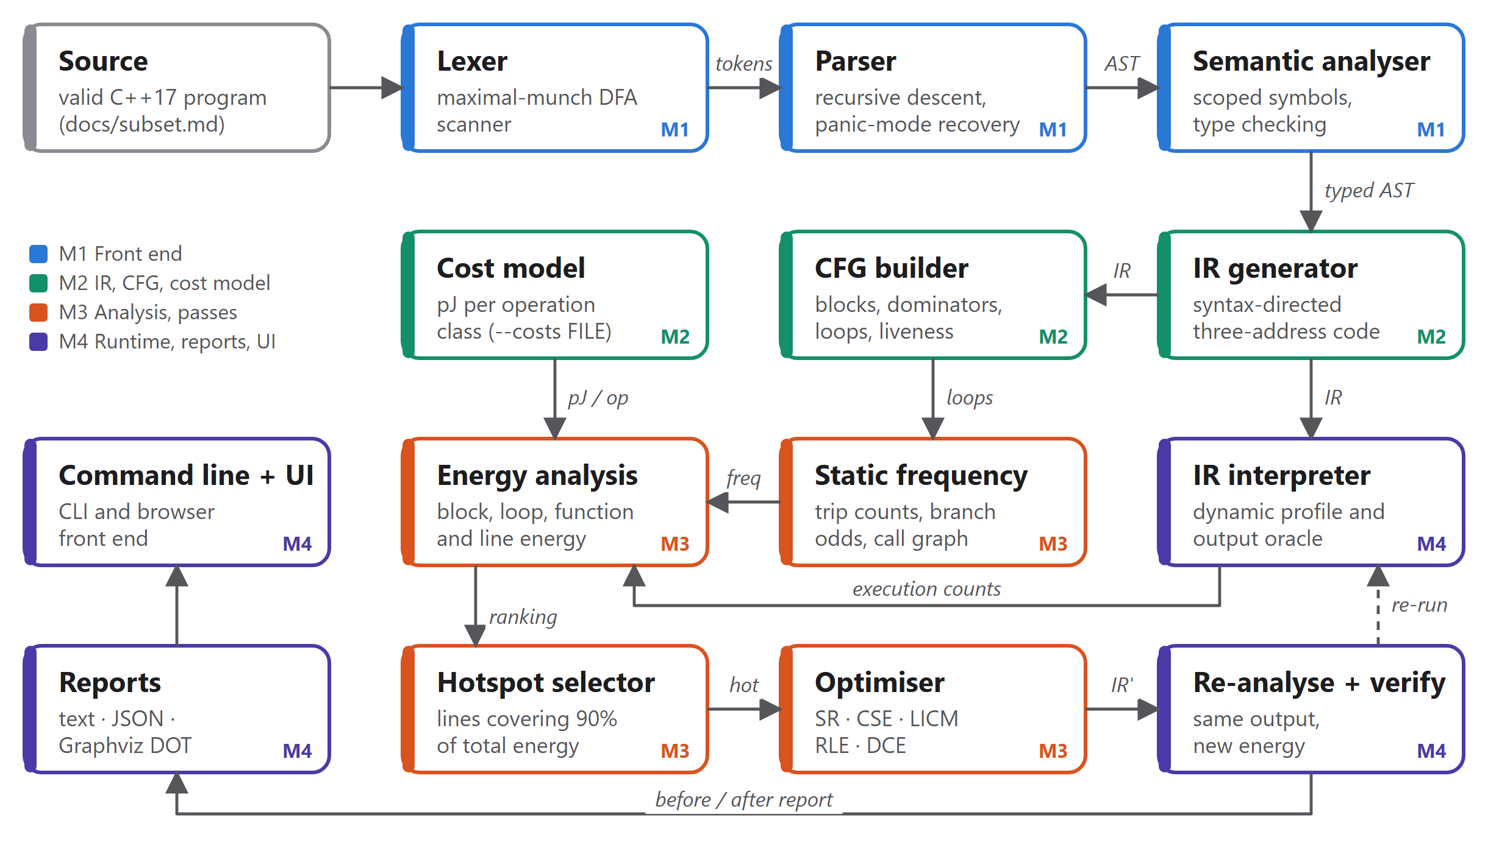
Figure 1. WattWise pipeline. Colours mark the module groups from the project README (M1 to M4).

5.2 Modules and interfaces
Table 4. Modules, files and interfaces. Line counts include headers.
Module | Files | Input → output | Group | Lines
Lexer | lexer.cpp | Source text → tokens | M1 | 264
Parser | parser.cpp, ast.hpp | Tokens → AST | M1 | 559
Semantic analysis | semantic.cpp | AST → annotated AST, diagnostics | M1 | 485
Common types | common.cpp/.hpp | Diagnostics, CompileError | M1 | 65
IR and generator | ir.cpp, irgen.cpp | Annotated AST → quadruples | M2 | 655
CFG | cfg.cpp | Quadruples → blocks, dominators, loops, liveness | M2 | 219
Cost model | energy_model.cpp | Quad → pJ per execution | M2 | 96
Frequency estimation | frequency.cpp | CFG → block and call frequencies | M3·M4 | 229
Energy analysis | analysis.cpp | Frequencies + costs → energy report, hot set | M3 | 226
Optimisation passes | optimize/*.cpp | IR + hot set → rewritten IR | M3 | 581
Interpreter and profiler | interpreter.cpp | IR → output, exit code, per-quad counts | M4 | 325
Reports and CLI | report.cpp, main.cpp | Report → text, JSON, DOT; command line | M4 | 428
Total |  |  |  | 4,132

5.3 Core data structures
- Token and AST. A token carries its kind, lexeme, literal value and line and column. AST nodes are annotated by semantic analysis with types, constant values and unique names (shadowed locals become x.1, x.2).
- Quad and Operand. The IR is a flat vector of quadruples (op, dst, a, b, c) with a source line per quad. Operands are variables, temporaries, integer or double constants, labels, functions or strings. Arrays are named objects accessed only by Load and Store.
- Block, Loop and CFG. A block is a range of quads with successor and predecessor lists. A loop records its header, member blocks, latches, exiting blocks, nesting depth and parent. The CFG holds the dominator relation as a bit matrix.
- EnergyReport. Energy per block, loop, function, source line and operation class, in a form that the text, JSON and DOT renderers share.
- HotSet and PassStats. The set of hot lines and loops that restricts the optimiser, and a per-pass change count with one log line per rewrite.

5.4 Design decisions
Table 5. Key design decisions and why they were taken.
Decision | Rationale
Accept only real C++ | g++ becomes a free, independent oracle for differential testing. This replaced the custom language proposed at Review 1.
Quadruple IR with a source line on every quad | Per-line energy attribution is then a by-product of the analysis, with no extra bookkeeping.
Cost model separate from the analysis | The table can be replaced from a file (--costs) without touching code, which is the hook for calibration.
Profile-directed passes | Only the lines covering 90% of the energy are rewritten, so effort goes where it can matter and cold code is left alone.
The interpreter is both profiler and oracle | One component supplies exact execution counts and the output used to check every optimisation.
No pointers or array parameters | Distinct arrays cannot alias, which is what makes redundant-load elimination sound without a separate alias analysis.
The web interface wraps the CLI | The browser tool exercises the same code path as the tests, and the JSON report is the only contract between them.

5.5 Command-line interface
Table 6. Command-line options and exit codes.
Option | Effect
--static, --dynamic, --both | Static estimate (default), measured profile, or both with a hotspot-agreement line.
--opt[=LIST], --opt-all | Run passes (sr,cse,licm,rle,dce or all), re-profile and verify. --opt-all treats every line as hot.
--coverage X | Hot set = lines covering fraction X of energy (default 0.90).
--costs FILE | Override any entry of the cost table.
--ir, --ir-opt, --cfg, --tokens, --ast | Print the internal representations.
--dot DIR, --json FILE | Write Graphviz CFGs shaded by energy; write a machine-readable report.
--run, --run-opt | Execute the (optimised) IR and print only the program output.
Exit codes | 0 success; 1 compile error; 2 runtime error; 3 optimisation changed the output; 64 usage error.

6. Algorithms and Methodology

6.1 Lexical analysis
The scanner is hand-written and uses maximal munch: each branch of the scan loop is the deterministic automaton for one token class (identifiers and keywords, integer and floating-point numbers with exponents, string and character literals, comments, and one- or two-character operators). It reports an unterminated string or comment, an invalid escape, an integer literal that overflows 32 bits and any unknown character, each with a line and column. Preprocessor lines are skipped. Time is linear in the input.

6.2 Parsing
The parser is recursive descent with one function per non-terminal of the grammar in Appendix D. Operator precedence follows C++ and is encoded by the nesting of the expression functions (||, &&, equality, relational, additive, multiplicative, unary, postfix). On a syntax error it records the diagnostic, skips to the next ; or } (panic mode) and continues, so several errors are reported in one run. A set of keywords that belong to C++ but not to the subset (class, switch, template, cin, and others) produces a specific "outside the subset" message rather than a generic one.

6.3 Semantic analysis
A stack of scopes forms the symbol table, searched from the innermost outwards. The pass resolves every name, gives shadowed locals unique names, folds const scalars, and checks types and context: implicit int, double and bool conversions; % on integers only; assignment to arrays and constants; calls with the wrong number of arguments; use before declaration; void used as a value; division by a constant zero; a constant array index that is out of bounds; array sizes that are not constants; and a missing main. All errors of the phase are collected before it stops.

6.4 Intermediate code
Code generation is syntax-directed (Dragon Book, chapter 6). Logical && and || become short-circuit control flow. Array reads and writes are explicit Load and Store quads so that memory traffic is visible to the cost model. An assignment retargets the quad that produced the value, so x = a + b is one quad rather than two. Implicit conversions become I2D and D2I. Listing 1 shows the IR of the hoist benchmark, whose loop recomputes n * 2 + n / 2 on every iteration.
func main() -> int
n = 1000
i = 0
L1:
t1 = i < n
iffalse t1 goto L2
t2 = n * 2
t3 = n / 2
t4 = t2 + t3
@a[i] = t4
i = i + 1
goto L1
...

Listing 1. Three-address code for benchmarks/hoist.cpp.

6.5 Control-flow graph, dominators, loops and liveness
Leaders are the first quad, every label, and every quad after a jump or return; a block runs from one leader to the next. Edges follow the branch targets, and reachability is found by search from the entry. Dominators are computed by the iterative data-flow method on a bit matrix: the entry is dominated only by itself, and every other block starts dominated by all blocks and is repeatedly intersected over its predecessors until nothing changes. A back-edge is an edge n → h where h dominates n; the natural loop is h plus every block that can reach n without passing through h. Loops are sorted innermost first and nested by strict containment. Liveness is the standard backward data flow, with in[B] = use[B] ∪ (out[B] − def[B]). The cost of the dominator step is the number of iterations times the edges times the blocks, which is small for the program sizes in scope.

6.6 Energy model
The energy of a program is the sum, over basic blocks, of the block's execution frequency times the cost of the quads it contains:
E = Σ_{blocks b} freq(b) × Σ_{q ∈ b} cost(category(q))
Each quad maps to a category (for example mem.load, int.div, branch.cond), and each category has a cost in model picojoules (Table 7). The values encode an ordering, memory ≫ divide > multiply > ALU > move > branch, taken from the instruction-level literature [1], [2]. They are relative, not measured joules: they are meant to rank code and compare variants. Any entry can be overridden from a text file with --costs.
Table 7. Default cost table (model pJ per execution).
Category | Cost | Operations
mem.load | 10.0 | Load: array read, including address generation
mem.store | 12.0 | Store
int.alu | 1.0 | Integer add, subtract, negate, not, comparisons
int.shift | 1.0 | Shl
int.mul | 3.0 | Integer multiply
int.div | 18.0 | Integer divide and modulo (multi-cycle)
fp.alu / fp.mul / fp.div | 2.5 / 3.5 / 14.0 | Double add and compare / multiply / divide
convert | 2.0 | Int to double and back
move | 0.8 | Copy
branch.uncond / branch.cond | 0.6 / 0.9 | Jump / conditional jump
call / ret / param | 6.0 / 4.0 / 0.8 | Call overhead
io | 0.0 | Output (out of scope)

6.7 Execution frequency

Static estimate
For a function invoked once, a block b is estimated to run freq(b) = Π over loops L containing b of (trip(L) + [b is the header of L]) × p(b). The trip count is derived from the loop's induction variable: the header must end in a comparison iv op bound, iv must be a local updated exactly once in the loop by a constant step, and the start and bound must be known constants (including const globals and locals assigned once). With constants, the count is exact; for example i from 0 step 1 vs 1000 gives 1,000. If only the bound is known (a triangular inner loop whose start is another loop's variable) the estimate is bound / 2. Otherwise a default of 10 is used. The branch probability p(b) is 1 if b dominates every latch of its innermost loop (or every return, outside loops) and 0.5 otherwise. Function invocation counts are propagated over the call graph from main in topological order, and recursive functions are multiplied by a factor of 10 because their depth is unknown.

Dynamic profile
The interpreter executes the IR and counts how often every quad runs. The frequencies are then exact for the program's single, deterministic run, and a loop's average trip count is the number of back-edge traversals divided by the number of times the loop is entered. With --both the tool reports both estimates and whether their top-three hotspots agree.

6.8 Aggregation and the hot set
Block energy is the sum of cost(q) × executions(q) over the block. Loop energy is the sum over its blocks and so includes inner loops. Function energy is the sum over its own blocks, and callee cost appears through the callee's invocation count. Energy is also bucketed by source line and by operation class, and the lists are sorted to give the rankings. The hot set is selected greedily: lines are taken in decreasing order of energy until their running total reaches the coverage fraction (default 0.90) of the program total, and a loop is hot if its inclusive energy is at least 1 − coverage of the total.

6.9 Optimisation passes
Every pass rewrites only quads on hot lines (or hot loops). Each states its legality conditions below; none changes the program's observable behaviour.

Strength reduction (SR)
Rewrites x * 2^k to x << k for integers, x * 2.0 to x + x and x / 2^k to a multiplication by an exact power-of-two reciprocal for doubles, removes identities (x * 1, x / 1, x + 0, x - 0) and folds operations on two integer constants with 32-bit wrap-around (never dividing by zero). Integer division by a power of two is deliberately not turned into a shift: for negative operands C++ truncates toward zero while an arithmetic shift rounds toward negative infinity.

Common-subexpression elimination (CSE)
A value-numbering pass over extended basic blocks. Within a block, t2 = a op b is removed when an earlier t1 = a op b is still available, meaning neither operand has been redefined since; uses of t2 are renamed to t1. A block with exactly one predecessor, reached by a forward edge, inherits that predecessor's available set, so the scope is a tree of blocks; at joins and loop headers the set starts empty. Calls kill expressions on global variables. This is safe because both temporaries have a single definition and the first definition dominates the second. Loads are not handled here.

Loop-invariant code motion (LICM)
For each hot natural loop, innermost first, an instruction d = a op b is hoisted into a new pre-header when it is pure and cannot trap (integer division only by a constant other than 0 and −1), every operand is a constant or has no definition inside the loop (or is itself hoisted), and either d is a single-definition temporary, or it is a local defined once in the loop that is not live on entry to the header and that is either defined in a block dominating every exit or dead at every exit. The last condition keeps zero-trip loops correct. Jumps from outside the loop are redirected to the pre-header, and the process repeats until no more code moves. Figure 2 shows the effect on hoist.

Redundant-load elimination (RLE)
The pass tracks which array elements currently have a known copy in a scalar name or constant, as a map from (array, index operand) to a value operand. A load adds its destination; a store adds its stored value, which gives store-to-load forwarding. A later load of the same array and index operand is then redundant: it becomes a move, or, when both the destination and the value are single-definition temporaries or constants, it disappears and its uses are renamed. An entry is dropped when its index or value operand is redefined; a store drops every entry of the same array except entries whose constant index provably differs; a call drops all global-array entries and entries that use global scalars. Because the subset has no pointers or array parameters, distinct arrays never alias, so nothing else can invalidate an entry. The scope is the extended basic block, as for CSE. A removed load cannot hide a runtime error, because an identical load with the same index executed earlier on the same path.

Dead-code elimination (DCE)
Three clean-ups. Unreachable blocks are deleted; they execute zero times, so this does not change energy and it is applied to every function. A dead assignment, one whose result is a local or temporary that is not live afterwards, is deleted, repeatedly, so whole chains disappear; only hot lines are touched. Self-moves are deleted. Removable operations are the pure ones (a conversion from double to int is excluded), loads, double division, and integer division or modulo by a constant other than 0 and −1. A dead load can only trap on a bad index; WattWise optimises a program only after a run of the original has completed without a runtime error, and the subset has no input, so the removed load never trapped. Stores, calls, output, branches and anything that defines a global are never removed.

Pass order
The default order is sr, cse, licm, cse, rle, dce. Strength reduction runs first so that later passes see the simplified operations. CSE unifies index temporaries so that RLE's keys match across the compare-and-swap blocks of a sort. LICM follows, and the second CSE removes duplicates it exposes. RLE turns the redundant loads into moves, and DCE runs last to remove whatever the earlier passes left dead.
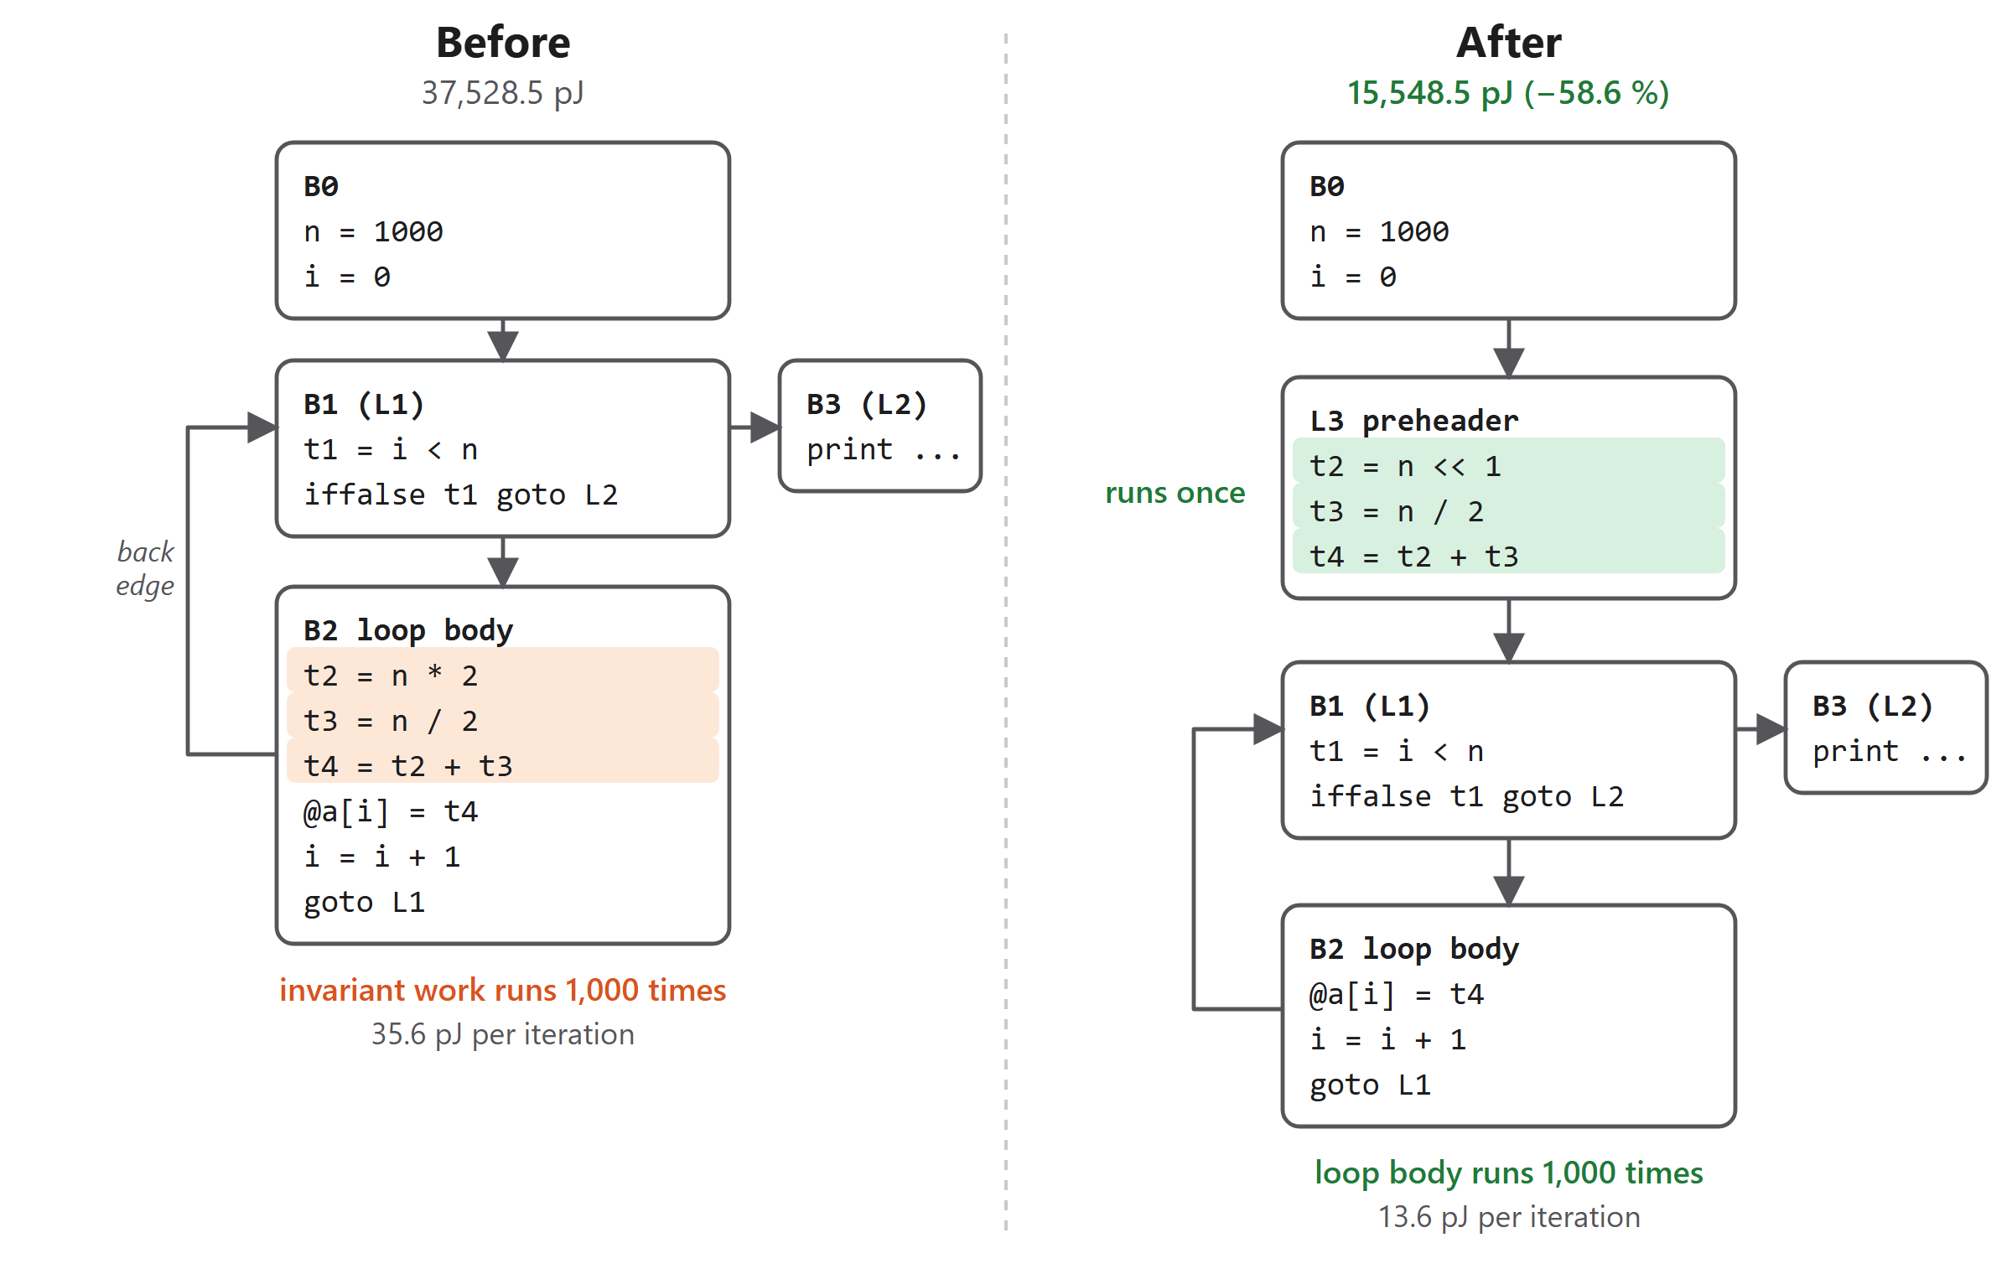
Figure 2. Loop-invariant code motion on benchmarks/hoist.cpp. The three invariant quads move into a pre-header and strength reduction turns the multiply into a shift.

6.10 Verification
Optimisation works on a copy of the IR. The CLI first interprets the original (a failure here stops with exit code 2), applies the passes, re-analyses, interprets the optimised IR and compares the output text and exit code. A difference is reported and the process exits with code 3. Separately, scripts/difftest.sh compares g++, the unoptimised IR and the IR optimised with every pass on every line (Section 8).
Table 8. Asymptotic cost of each stage, for n quads, b blocks and e edges.
Stage | Cost | Stage | Cost
Lexing, parsing, semantic analysis | O(n) | Dominators | O(iterations × e × b)
IR generation | O(n) | Natural loops | O(b × e)
Static frequency | O(b + loops × n) | Energy aggregation | O(n)
Strength reduction | O(n) | CSE | O(n log n)
RLE | O(n × tracked entries) | DCE | O(n × rounds)
LICM | O(rounds × loops × n) | Interpreter | O(executed quads)

7. Implementation Details

7.1 Code organisation
The repository is organised by purpose: src/ and include/wattwise/ for the compiler (4,132 lines), src/optimize/ for the five passes, tests/unit/ for the Catch2 tests (713 lines), tests/valid/ and tests/invalid/ for the test programs, benchmarks/ for the 15 benchmarks with golden outputs, scripts/ for the two test drivers, docs/ for the grammar, cost model and IR format, and webapp/ for the browser interface (1,750 lines of JavaScript, HTML and CSS).

7.2 Build process
cmake -S . -B build -DWATTWISE_TESTS=ON
cmake --build build -j
ctest --test-dir build --output-on-failure # unit + differential + invalid

CMake builds three targets: the wattwise_core library, the wattwise command, and wattwise_tests, which links the same library. Compilation uses -Wall -Wextra -Wpedantic and the build is warning-free.

7.3 The interpreter
The interpreter resolves variable names to slots and array names to indices once, then executes quads from a flat vector, incrementing a per-quad counter on each step. Integers are 32-bit with wrap-around. It traps on integer division or modulo by zero, an out-of-range array index, a double-to-int conversion out of range, a step count above 2,000,000,000 (a likely infinite loop), a call depth above 10,000, and running off the end of a function, and it reports each with the function name. Those traps are what make the dynamic mode a trustworthy oracle: unlike a native binary, a bad index fails deterministically with a clear message.

7.4 Continuous integration
A GitHub Actions workflow configures, builds and runs ctest on Ubuntu 24.04 with GCC 13.3.0 on every push. The latest run on the final commit (ea51e67) passed all three suites. The first CI runs had failed before executing any test, because the two test scripts had been committed from Windows without the executable bit; the fix is described in Section 8.4.

7.5 Web interface
The browser interface lets a user paste or load a program, choose whether to optimise and whether to run a dynamic profile, and read the report. A small Express server exposes three endpoints: GET /api/benchmarks and GET /api/benchmarks/:name (the name is validated against a pattern to prevent path traversal) and POST /api/analyze, which writes the source to a temporary file, runs wattwise with --json through execFile (no shell) under a 10-second timeout, removes the temporary files and returns the exit code, the text report and the parsed JSON.
The front end is a single page with no framework and no external requests. It leads with one headline number and a verified-output badge, then shows the before/after energy by operation class, the hotspot and loop tables (with trip counts labelled exact, approximate or guess), and the list of rewrites. Motion uses physically derived spring easing, only transform and opacity are animated, and reduced-motion, reduced-transparency and high-contrast preferences are honoured. A draggable divider resizes the source and report panes with rubber-banding at the limits. It also handles the case where an optimisation changed the output (exit code 3) by showing the numbers together with a warning.
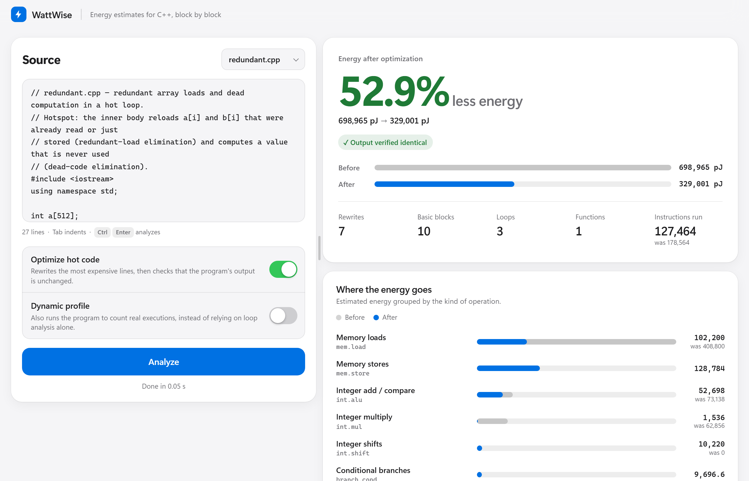
Figure 3. The web interface after analysing redundant.cpp with optimisation on.
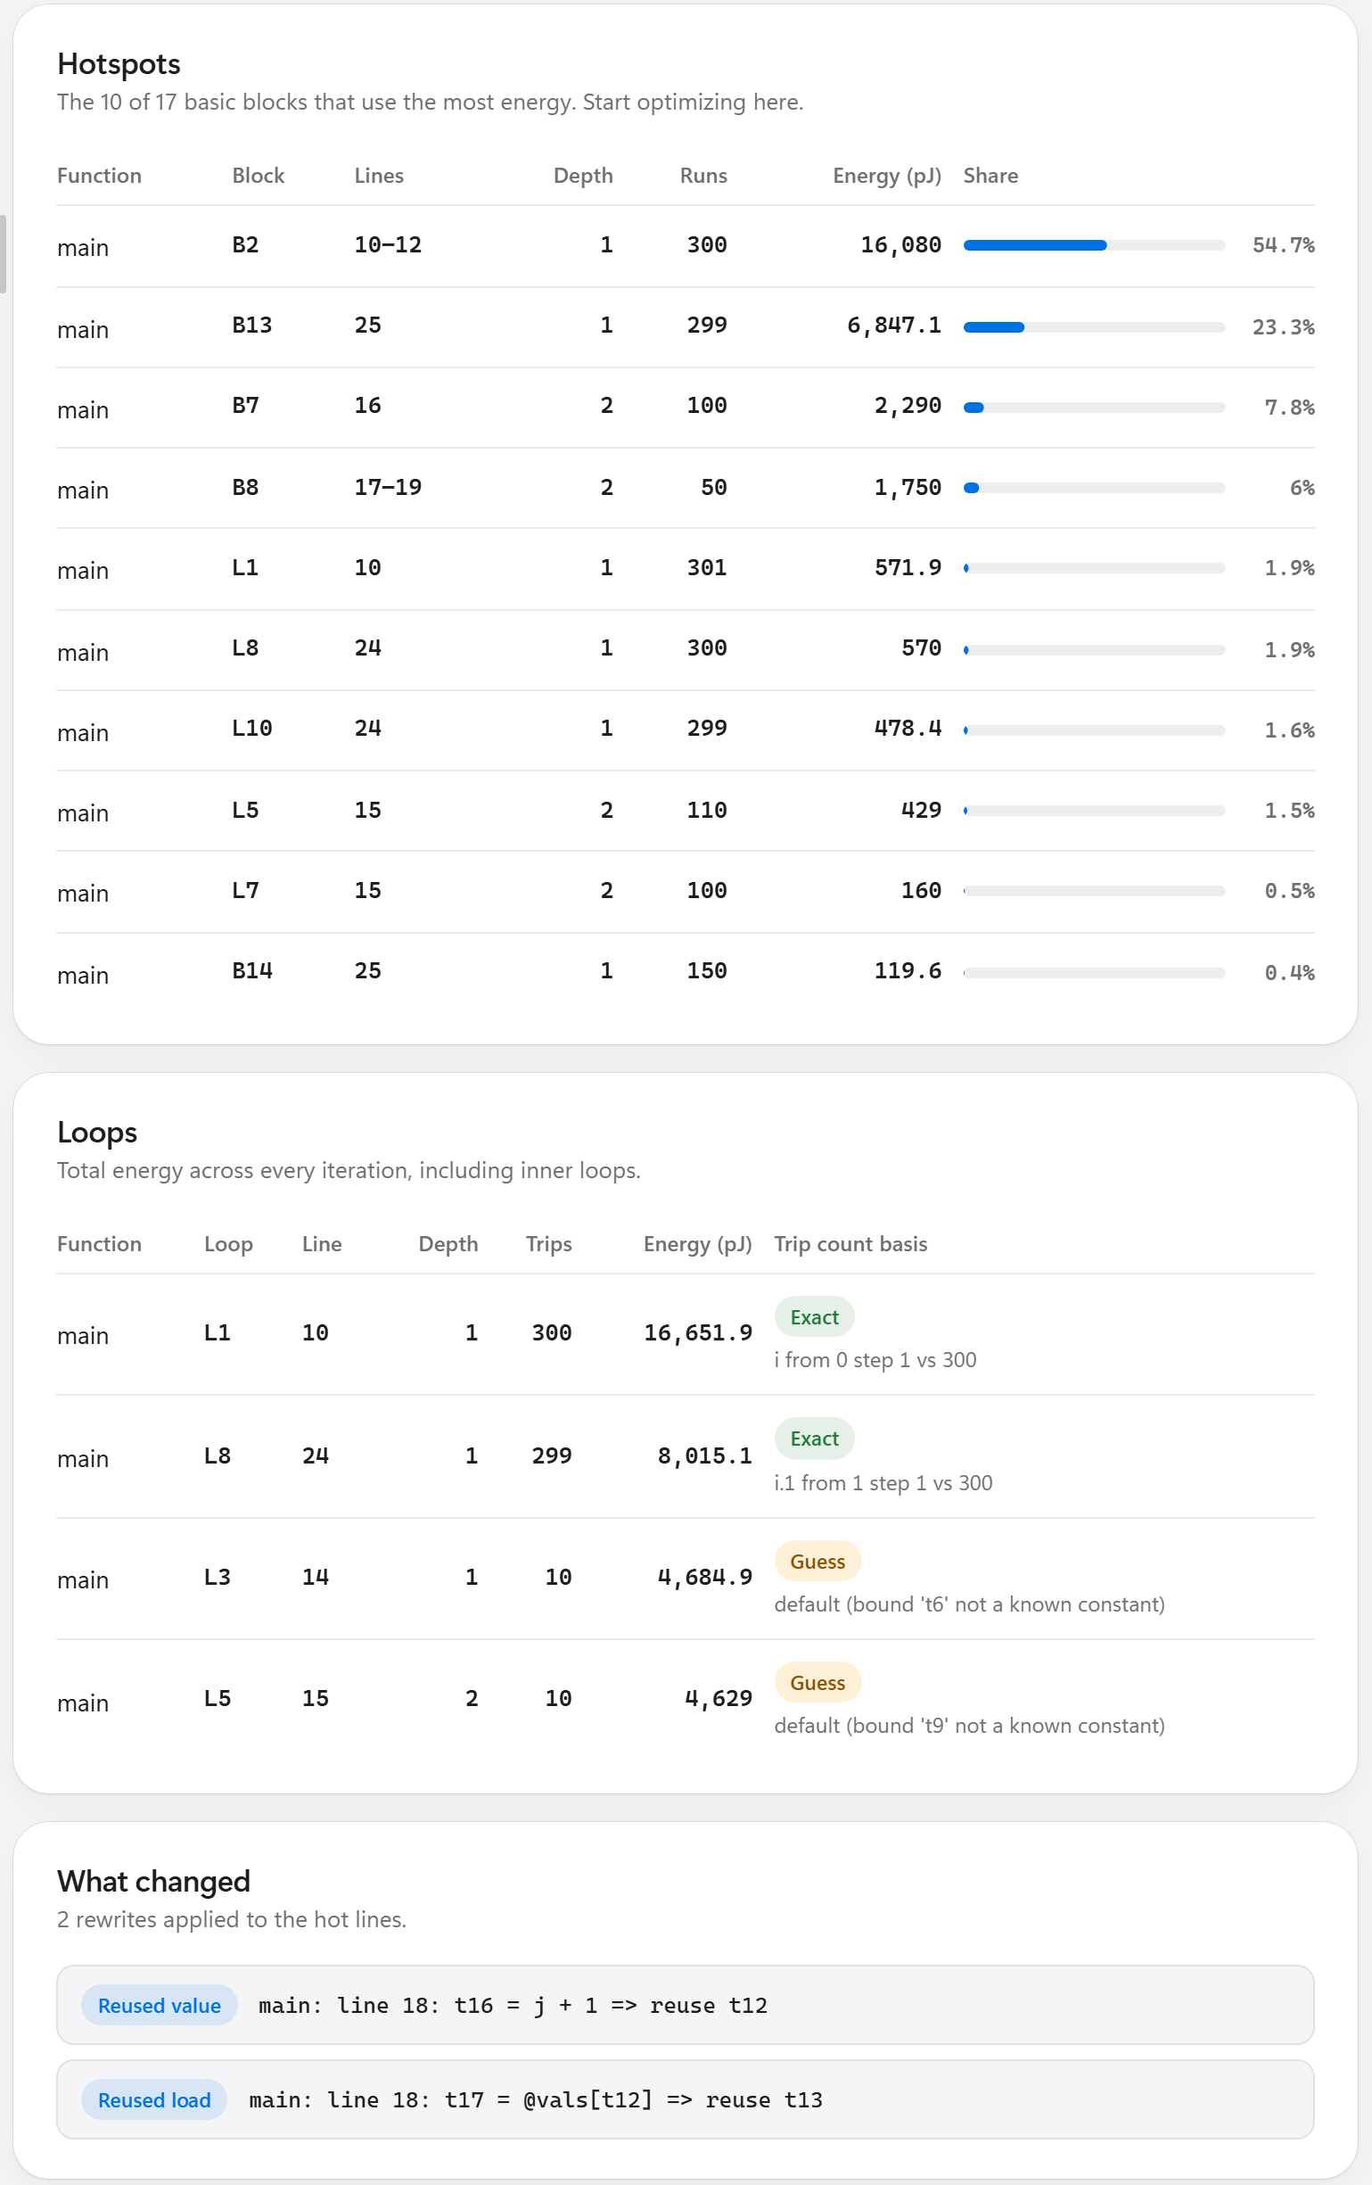 | 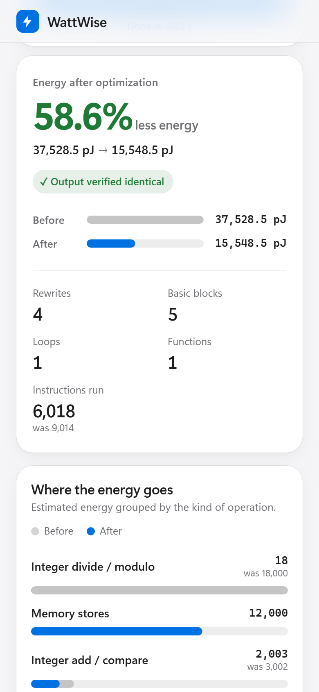
Figure 4. Left: hotspot and loop tables and the list of rewrites for bubble_sort. Right: the phone-width layout.
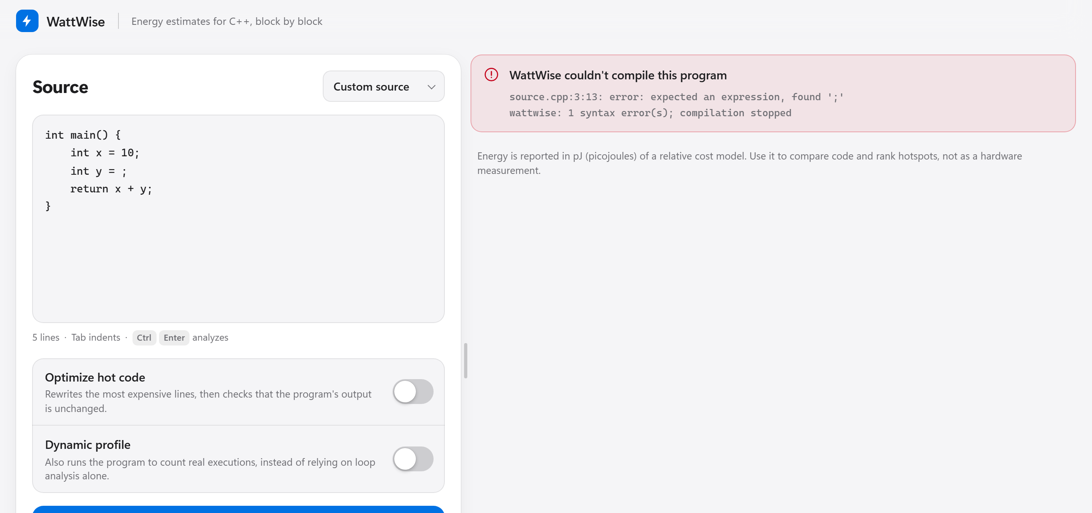
Figure 5. A compile error is shown with a plain title and the compiler's located message.

8. Testing Strategy and Test Cases

8.1 Layers of testing
Table 9. Test layers and results on the final commit.
Layer | What it checks | Size | Result
Unit tests (Catch2) | Lexer, parser, semantic analysis, IR, CFG, energy model and every pass in isolation. | 58 cases, 220 assertions | All pass
Invalid programs | Each phase rejects bad input with the right diagnostic phase, exit code 1, and no crash. | 33 programs: 9 lexical, 10 syntax, 14 semantic | 33 of 33
Differential | g++, unoptimised IR and fully optimised IR give the same output and exit code. | 35 programs: 15 benchmarks and 20 others | 35 of 35
Continuous integration | The same suites on a clean Ubuntu 24.04 machine with GCC 13.3.0. | Every push | Passing
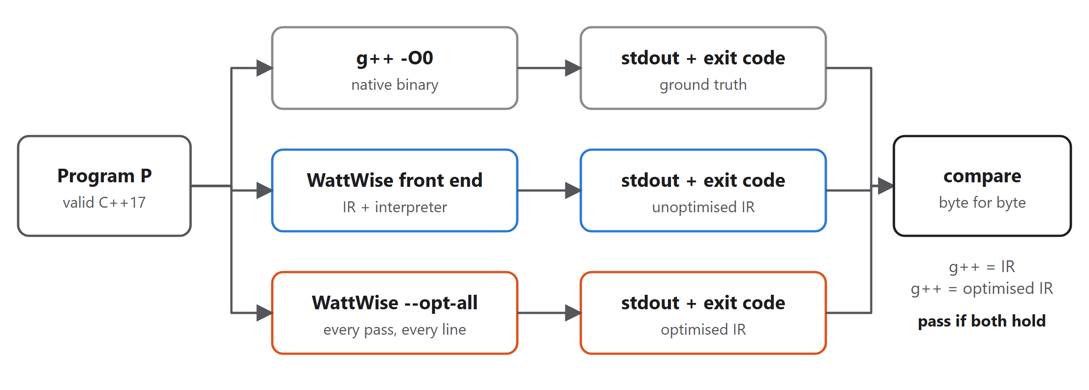
Figure 6. Differential testing. The optimised run applies every pass to every line, the strictest setting.
The differential suite uses --opt-all, which treats every line as hot, so it exercises the passes far more aggressively than a normal run does. The three-way comparison separates fault locations: a mismatch between g++ and the unoptimised IR points to the front end, IR generator or interpreter, and a mismatch between the unoptimised and optimised IR points to a pass.

8.2 Representative test cases
Table 10. Selected test cases with expected and observed results.
# | Test (input) | Expected | Observed
1 | Lexical: unterminated string literal | Lexical error, exit 1 | 4:22: error: unterminated string literal; exit 1
2 | Syntax: missing ; after a declaration | Syntax error, exit 1 | 2:24: error: expected ';' after declaration, found 'return'; exit 1
3 | Semantic: use of an undeclared name | Semantic error, exit 1 | 2:21: error: use of undeclared identifier 'y'; exit 1
4 | Boundary: 10 / 0 (g++ accepts it) | Rejected by a subset rule | 2:27: error: division by constant zero; exit 1
5 | Failure: a[i] with i = 10, size 4, run with --dynamic | Runtime error, exit 2 | array index 10 out of bounds (size 4); exit 2. A native g++ binary gives undefined behaviour.
6 | Program returning 42 (exit_code.cpp) | Same exit code in all three runs | g++, IR and optimised IR all exit 42
7 | SR on negative operands: -7*4, -7/2, -7%2 | -28 -3 -1 (C++ semantics) | Identical after the pass
8 | LICM: 10 / z inside a loop that runs zero times | No trap; output 0 | Output 0; division not hoisted
9 | RLE: store to the same array between two loads, index aliasing and not | 6 99 and 6 6 | Both as expected; second load kept
10 | RLE: call between loads of a global and a local array | Global reload kept, local reload removed | Output 1 50 2 2; one load removed
11 | DCE: dead int u = 10 / z with z = 0 | Still traps | Interpreter still fails after the pass
12 | DCE: code after return, with an empty hot set | Unreachable code removed; exit code kept | Code removed; exit code 3
13 | Cold code under profile direction (empty hot set) | No rewrite | 0 changes
14 | redundant.cpp with --opt | Output identical; energy falls | total=3049800 unchanged; −52.9%

8.3 Boundary, failure and stress cases
Boundary cases include zero-trip loops, negative integer arithmetic, loops with unknown bounds, recursion, empty hot sets and arrays whose index is a constant at the edge of the array. Failure cases are the thirty-three invalid programs plus runtime traps. Stress is bounded by the interpreter's limits (2×10⁹ steps, depth 10,000); the longest benchmark executes 2.5 million IR instructions (collatz), and the whole pipeline takes a mean of 15 ms per benchmark (Section 9.5).

8.4 Regression and what the tests caught
- Mutation check. To confirm the RLE tests can fail, the store-invalidation rule was disabled on purpose. Three assertions failed, including a wrong program output, and the rule was restored.
- Continuous integration. The first three CI runs failed before running any test because difftest.sh and invalidtest.sh had mode 100644. The fix was a mode-only change (100644 to 100755); the next run passed all three suites.
- Environment. On Windows the .sh scripts cannot be started by ctest directly, and when run from Git Bash every invocation of the binary failed with "command not found" (exit 127) until the MSYS2 toolchain directory was placed first on PATH, which points to a conflicting runtime library earlier on the default PATH.

9. Results and Evaluation

9.1 Correctness
All 35 valid programs produce the same output and exit code under g++, the unoptimised IR and the IR optimised with every pass on every line. All 33 invalid programs are rejected in the expected phase, none crashes the compiler, and fifteen of them are accepted by g++ 13.2 (-fsyntax-only) and rejected here by design, either as subset rules or because g++ only warns. All 58 unit tests pass. Every one of the 15 normal optimisation runs finished with the verification line reporting identical output and exit code 0.

9.2 Optimisation effectiveness
Table 11 lists the result for each benchmark. The static columns use the default profile-directed run; the dynamic column repeats it using the interpreter's measured counts, so its numbers are exact with respect to the cost model. The last two columns give the IR instructions the interpreter executed before and after, and the number of rewrites by pass (SR, CSE, LICM, RLE, DCE).
Table 11. Results per benchmark, sorted by static reduction. Energy in model pJ.
Benchmark | Blocks / loops | Static before | Static after | Static Δ | Dynamic Δ | IR instructions run | Rewrites by pass
hoist | 4 / 1 | 37,529 | 15,549 | 58.6% | 58.6% | 9,014 → 6,018 | 1/0/3/0/0
redundant | 10 / 3 | 698,965 | 329,001 | 52.9% | 52.9% | 178,564 → 127,464 | 1/0/0/2/4
binsearch | 20 / 3 | 2,619,900 | 2,119,900 | 19.1% | 18.9% | 973,850 → 922,105 | 0/0/0/1/0
stencil | 16 / 5 | 67,610 | 60,202 | 11.0% | 15.2% | 498,493 → 457,736 | 1/0/4/0/0
matmul | 19 / 6 | 548,832 | 505,128 | 8.0% | 8.0% | 197,713 → 183,361 | 0/2/2/0/0
histogram | 17 / 2 | 2,757,160 | 2,577,160 | 6.5% | 7.7% | 479,924 → 469,847 | 0/1/0/0/0
integrate | 5 / 1 | 806,060 | 786,059 | 2.5% | 2.5% | 340,017 → 340,017 | 1/0/0/0/0
bubble_sort | 17 / 4 | 29,932 | 29,382 | 1.8% | 24.4% | 729,972 → 684,400 | 0/1/0/1/0
poly_eval | 15 / 4 | 397,248 | 397,248 | 0.0% | 3.9% | 150,812 → 150,812 | 0/0/0/0/0
collatz | 13 / 2 | 1,099,740 | 1,099,740 | 0.0% | 0.0% | 2,484,409 → 2,484,409 | 1/0/0/0/0
fib_recursive | 7 / 1 | 2,916 | 2,916 | 0.0% | 0.0% | 247,889 → 247,889 | 0/0/0/0/0
gcd_lcm | 12 / 3 | 869,420 | 869,420 | 0.0% | 0.0% | 154,022 → 154,022 | 0/0/0/0/0
prefix_sum | 12 / 3 | 419,300 | 419,300 | 0.0% | 0.0% | 126,230 → 126,230 | 0/0/0/0/0
sieve | 9 / 2 | 1,916,910 | 1,916,910 | 0.0% | 0.0% | 406,485 → 406,485 | 0/0/0/0/0
triangular | 14 / 3 | 2,361,170 | 2,361,170 | 0.0% | 0.0% | 1,167,002 → 1,167,002 | 0/0/0/0/0
Across all 15 benchmarks the mean static reduction is 10.7% and the mean dynamic reduction 12.8%; 8 programs improve under the static model and 9 under measured counts. The largest gains are on hoist (58.6%, loop-invariant work), redundant (52.9%, repeated loads and dead code) and binsearch (19.1%, a repeated load of the middle element). Seven programs are unchanged. For prefix_sum the reason is that its redundancy is loop-carried (pre[i] = pre[i-1] + … reads a value stored under a different index on the previous iteration), which the extended-block RLE does not forward; sieve only stores. The remaining zeros have not been analysed individually; for each of them the current passes find no change that lowers the estimated energy of the hot lines.
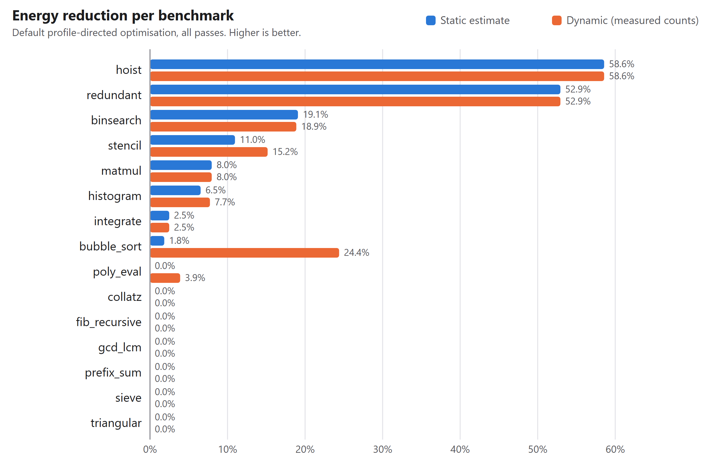
Figure 7. Energy reduction for each benchmark, static estimate against measured counts.

9.3 What the Review 3 passes add
At the start of the Review 3 work the optimiser had strength reduction, block-local CSE and LICM. On the 14 benchmarks that existed then, it improved 5 of 14 programs with a mean static reduction of 6.2%. With redundant-load and dead-code elimination, and with CSE extended to extended basic blocks, the same 14 programs now give 7 of 14 improved and a mean of 7.7% (9.9% under measured counts). Figure 8 isolates the contribution by running the older pass list (sr,cse,licm,cse, here already using the extended-block CSE) against the full list.
Table 12. Summary before and after the Review 3 passes.
Measure | Start of Review 3 work (14 programs) | Final, same 14 programs | Final, all 15 programs
Mean static reduction | 6.2% | 7.7% | 10.7%
Programs improved (static) | 5 of 14 | 7 of 14 | 8 of 15
Mean dynamic reduction | not recorded | 9.9% | 12.8%
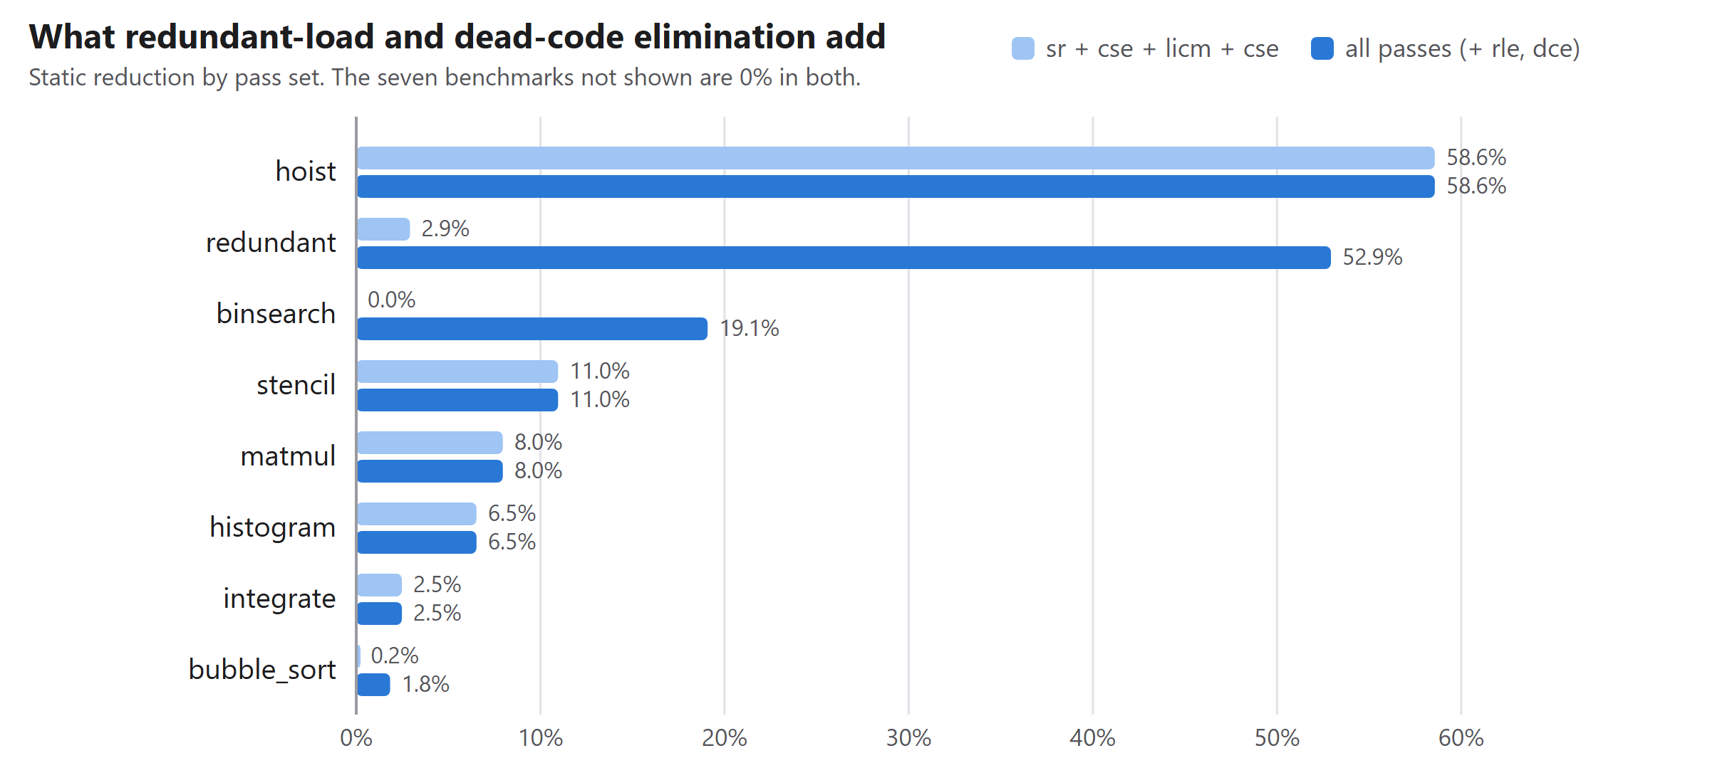
Figure 8. Static reduction with the older pass list and with all five passes. The seven programs not shown are 0% in both.
The largest change is on redundant, which rises from 2.9% to 52.9% once RLE and DCE are added, and on binsearch, which rises from 0% to 19.1%. Figure 9 shows why for redundant: memory-load energy falls from 408,800 to 102,200 pJ, integer-multiply energy from 62,856 to 1,536 pJ because a dead chain is removed, and register-move energy rises from 19 to 8,195 pJ because each removed load leaves a cheap move behind. The optimiser has traded expensive operations for cheap ones, as intended.
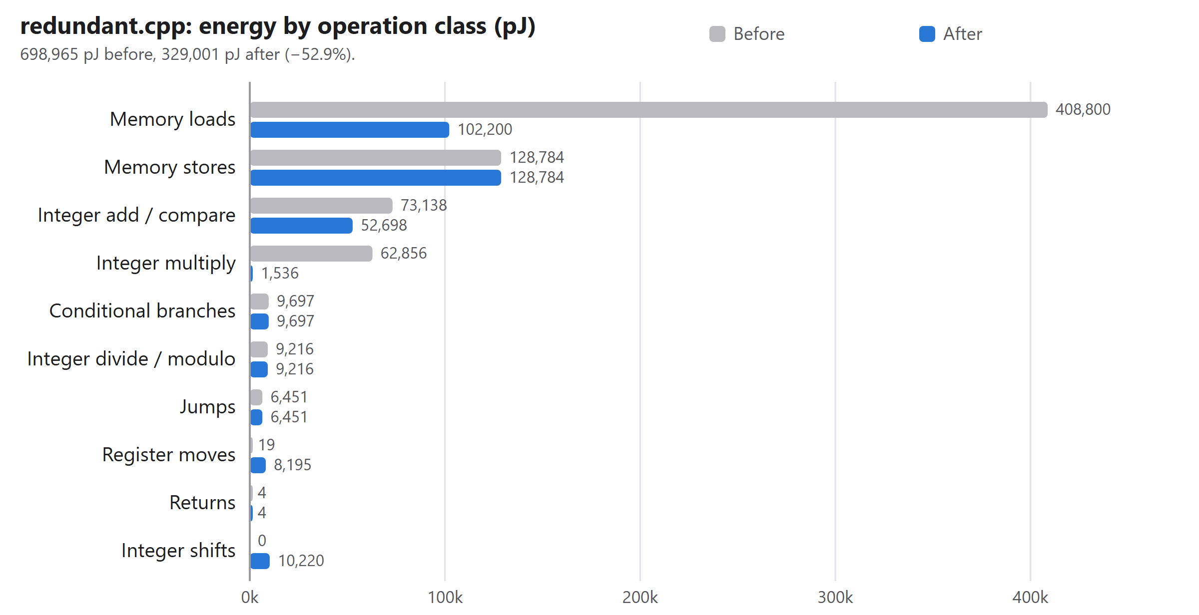
Figure 9. Energy by operation class for redundant.cpp before and after optimisation.

9.4 Static estimate against measured counts
With --both the tool reports whether the static and dynamic rankings agree. They agree closely on which block is hottest: the top block is the same on 14 of 15 programs and the full top-three set matches on 12 of 15. The exceptions are bubble_sort (top block differs, one of three in common), poly_eval and stencil (two of three in common). The ranking, which is what drives hot-set selection, is therefore reliable on this benchmark set.
The magnitude is a different matter. Figure 10 divides the measured total by the static total. Where every loop bound is a constant (hoist, integrate, matmul, redundant) the two are identical to three significant figures. Where a bound is unknown the static estimator falls back to a default trip count of 10 and its error is large: it is 78 times too low for bubble_sort (inner bound n - 1 - pass), 172 times too low for fib_recursive (recursion is weighted ×10 rather than by true depth), 30 times too low for stencil, and 7.3 times too low for collatz (a data-dependent loop). It can also be too high, as for gcd_lcm (0.41×) and sieve (0.45×).
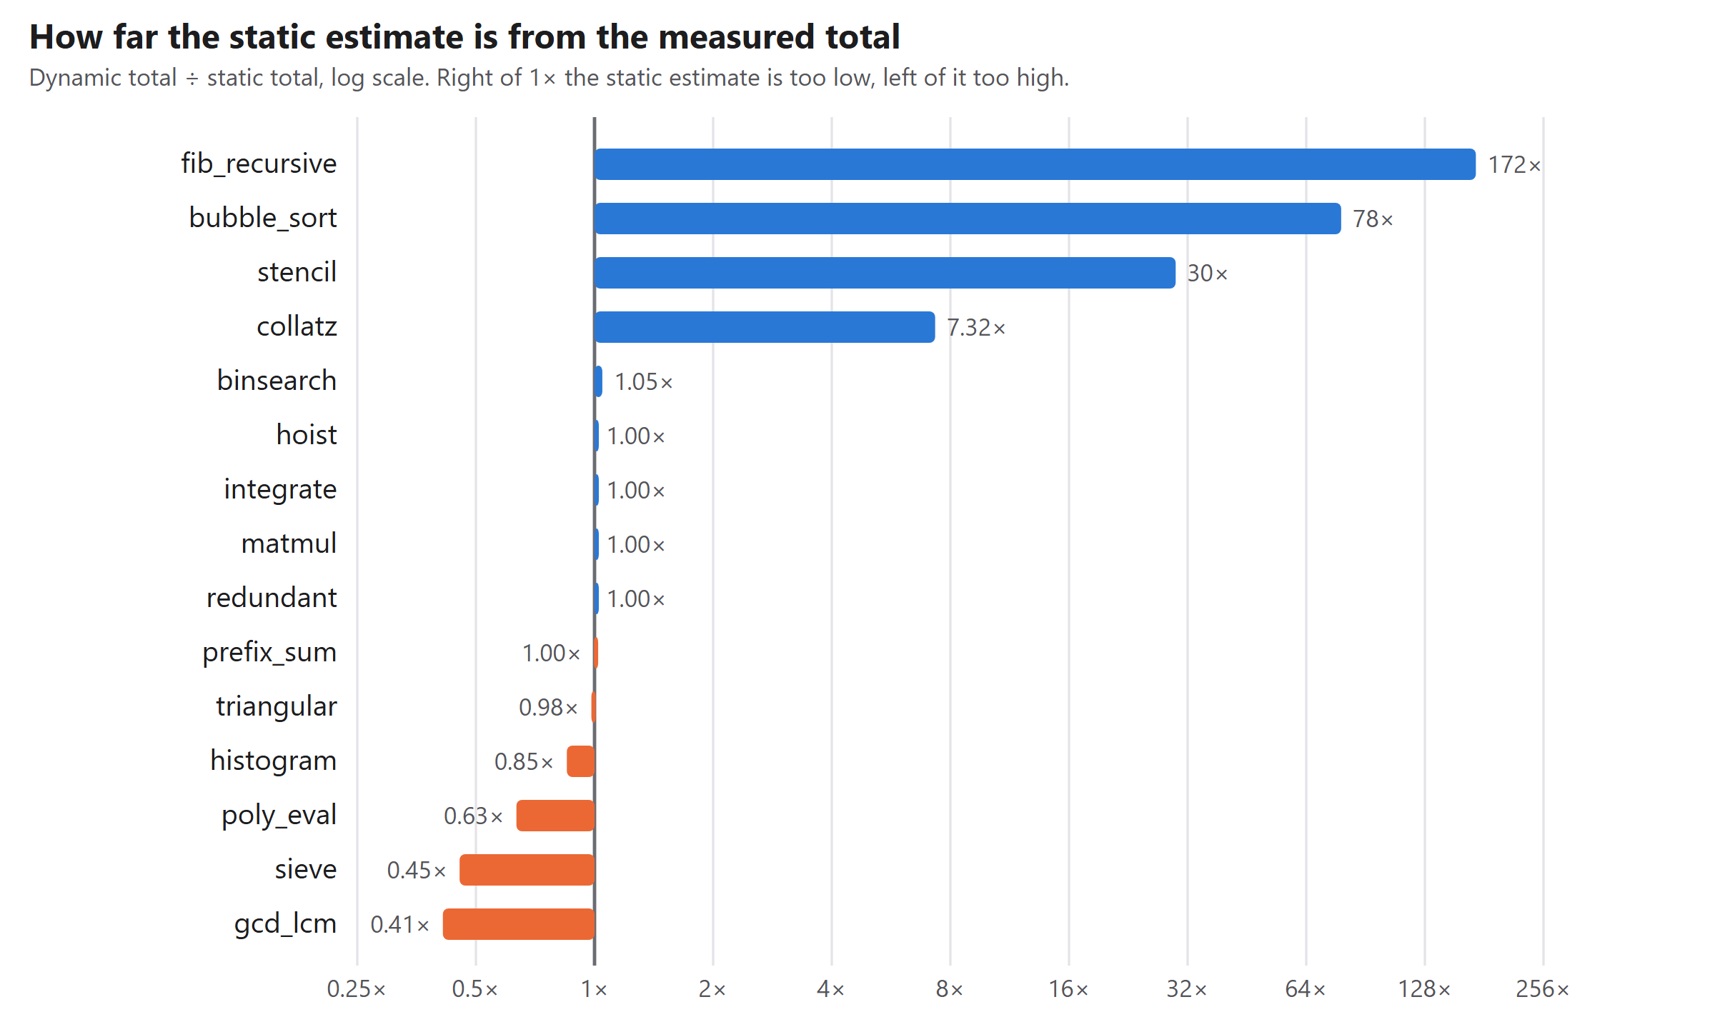
Figure 10. Measured total divided by static total on a logarithmic scale.
This has a visible consequence for optimisation. The static model credits bubble_sort with a 1.8% reduction, but under measured counts the same kind of rewrite saves 24.4%: the swap block (lines 17 to 19) is estimated to run 50 times statically and is measured at 22,786 executions, about 456 times more. Likewise poly_eval shows 0% statically and 3.9% dynamically. Its hot set depends on the frequencies: with measured counts it reaches main lines 30 and 31, where x / 4.0 appears twice, so strength reduction rewrites both to x * 0.25 and CSE then reuses one of them; with static frequencies those lines fall below the 90% cutoff and are left alone. The practical advice is to use the static mode to rank and the dynamic mode to size the benefit.

9.5 Cost of the analysis
Running the full pipeline on a benchmark, including parsing, IR generation, analysis, all five passes and two interpreter runs, took a mean of 15 ms and at most 27 ms per program on the development machine (wall time of the process, including start-up). The interpreter is the dominant cost. At these sizes analysis time is not a concern.

9.6 Threats to validity
- The model is relative. Percentages are reductions in model picojoules. They say which variant is cheaper under the model, not how many joules a device would save.
- No microarchitecture. A load costs the same whether it would hit in cache or miss. Real energy savings from removing a load depend on where it would have been served.
- Benchmark selection. The 15 programs were written by the team, several (hoist, redundant) to exhibit a specific transformation, so the mean reduction is not a prediction for arbitrary code.
- One machine. Timing figures come from one Windows development machine.

10. Error Handling, Limitations and Known Issues

10.1 Error handling
Table 13. Error classes, diagnostics and exit codes.
Class | Examples | Behaviour | Exit
Lexical | Unknown character, unterminated string or comment, bad escape, integer overflow | Located message; all lexical errors reported; compilation stops | 1
Syntax | Missing ; or brace, dangling operator, else without if, features outside the subset | Panic-mode recovery; several errors per run; specific message for excluded C++ | 1
Semantic | Undeclared or redeclared name, type misuse, wrong argument count, constant division by zero, constant index out of bounds | All errors of the phase reported | 1
Runtime | Index out of bounds, division by zero, step limit, recursion depth | Function name and cause; program output printed so far | 2
Verification | Optimised output differs from the original | Report printed; web interface warns | 3
Usage | Unknown option, missing value or file | Usage text | 64

10.2 Limitations and known issues
- Relative cost model. The constants encode an ordering from the literature and are not calibrated to any processor. There is no cache, pipeline, branch-prediction or frequency-scaling model.
- Static frequency estimation. Exact only for loops with constant start, step and bound. Elsewhere it guesses (default trip count 10, branch probability 0.5, recursion ×10) and can be wrong by two orders of magnitude (Section 9.4).
- Optimiser scope. Five passes. RLE and CSE work within extended basic blocks and do not forward values across loop iterations; there is no copy or constant propagation and no dead-store elimination. Seven of the 15 benchmarks are unchanged.
- Language subset. No pointers, classes, templates, multi-dimensional arrays, array parameters, input or concurrency. The tool cannot be pointed at arbitrary real-world C++.
- Web server. Intended for local use. It limits request size and run time but does not sandbox the analysed program beyond the interpreter's step and depth limits, and it has no authentication; it should not be exposed to untrusted users.
- Windows testing. ctest cannot start the .sh test drivers directly on Windows; they must be run from Git Bash with the MSYS2 toolchain first on PATH (Section 8.4). The CI environment is Linux.

11. Member-wise Contribution
The project README assigns each member one module group. The matrix below follows that assignment; the evidence column is to be completed with each member's own commits, pull requests, tests and demonstration artefacts, because the evaluator may inspect the repository history to confirm these claims.
Drafting note, delete before submission: at the time of writing the repository history shows commits from a single account. Link each member's own commits, pull requests and test artefacts below before the review.
Table 14. Final contribution matrix.
Member | Primary technical ownership | Final deliverable produced | Evidence / commit / test | Integration / support | Viva module
Abhyuday Thapliyal (24BCT0204) | M1: lexer, parser, semantic analysis, subset definition | Front end; docs/subset.md; invalid-program suite | commits / PRs | integration role | Front end
Arhat Gupta (24BDS0195) | M2: IR, IR generation, CFG, cost model | IR, dominators, loops, liveness; docs/cost_model.md, docs/ir_format.md | commits / PRs | integration role | IR, CFG, cost model
Anaya Singh (24BCI0077) | M3: analysis, hot-set selection, optimisation passes, static frequency | Energy analysis; SR, CSE, LICM, RLE, DCE | commits / PRs | integration role | Analysis and passes
Keshav Biyani (24BCE0344) | M4: interpreter, reporting, CLI, benchmarks, CI | Interpreter and profiler; text, JSON and DOT reports; CI; test drivers | commits / PRs | integration role | Runtime, testing, release

12. Conclusion and Future Work

12.1 What was achieved
WattWise meets its core objectives. It compiles a subset of C++ to a readable IR, builds the control-flow structures a classical optimiser needs, estimates energy per block, loop, line and operation class under a documented cost model, ranks the hotspots with both a static estimator and exact counts, rewrites the hot code with five passes, and verifies each rewrite by execution. The result is 10.7% mean reduction in estimated energy over 15 benchmarks (12.8% under measured counts), up to 58.6%, with all differential, invalid-program and unit tests passing and continuous integration green.

12.2 What we learned
- A cheap static estimator is good at ranking and poor at magnitude; the right use is to rank statically and size the benefit dynamically.
- An execution oracle changes how optimisations are written: a pass that miscompiles is caught by the next test run instead of by inspection. The mutation check showed the tests can fail.
- Excluding pointers and array parameters from the language bought a simple and sound redundant-load elimination; the cost is generality.
- Small engineering details decide whether a project is reproducible: a missing executable bit failed every CI run until it was found.

12.3 Future work
- Calibrate the cost table with hardware counters. On an Intel Linux machine, RAPL could be read around micro-benchmarks that isolate one operation class at a time, with frequency pinned, and the per-operation energies fed to --costs. This would replace the ordering taken from the literature with measured constants for one processor. It would not by itself add cache or pipeline effects, which need a memory-hierarchy model.
- Forward values across loop iterations (scalar replacement) so that prefix_sum-style recurrences stop reloading what the previous iteration stored.
- More passes: copy and constant propagation, dead-store elimination.
- Better static estimates: symbolic loop bounds, and branch heuristics in the style of Ball and Larus [6], to reduce the gap shown in Figure 10.
- A cache model, so that a load's cost depends on locality.
- A wider language: multi-dimensional arrays, and pointers with an alias analysis.
Further-development potential. The most defensible outward-facing contribution is as a teaching tool: a complete, inspectable compiler with an energy model and a verification oracle in four thousand lines. A short paper on the gap between static and measured frequency estimation, using the benchmark results here, would be a modest but honest research contribution once the cost model is calibrated.

13. References
[1] V. Tiwari, S. Malik and A. Wolfe, "Power analysis of embedded software: a first step towards software power minimization," IEEE Transactions on VLSI Systems, vol. 2, no. 4, 1994.
[2] S. Steinke, M. Knauer, L. Wehmeyer and P. Marwedel, "An accurate and fine grain instruction-level energy model supporting software optimizations," Proc. PATMOS, 2001.
[3] H. David, E. Gorbatov, U. R. Hanebutte, R. Khanna and C. Le, "RAPL: memory power estimation and capping," Proc. ACM/IEEE ISLPED, 2010.
[4] A. V. Aho, M. S. Lam, R. Sethi and J. D. Ullman, Compilers: Principles, Techniques, and Tools, 2nd ed., Addison-Wesley, 2006.
[5] S. S. Muchnick, Advanced Compiler Design and Implementation, Morgan Kaufmann, 1997.
[6] T. Ball and J. R. Larus, "Branch prediction for free," Proc. ACM PLDI, 1993.
[7] Y. Wu and J. R. Larus, "Static branch frequency and program profile analysis," Proc. IEEE/ACM MICRO-27, 1994.
[8] W. M. McKeeman, "Differential testing for software," Digital Technical Journal, vol. 10, no. 1, 1998.
[9] Catch2 test framework, v3.5.4. https://github.com/catchorg/Catch2
[10] WattWise source repository. https://github.com/abhithapliyal05/WattWise
Verify each citation's details against the source before submission.

Appendix A. User Manual

A.1 Build and run
Requirements: a C++17 compiler (g++ 11 or newer, or clang 14 or newer) and CMake 3.16 or newer. Node.js 18 or newer is needed only for the web interface.
cmake -S . -B build -DWATTWISE_TESTS=ON
cmake --build build -j

build/wattwise benchmarks/hoist.cpp # static energy report
build/wattwise benchmarks/hoist.cpp --both # static, dynamic, hotspot agreement
build/wattwise benchmarks/hoist.cpp --opt # optimise hot code, re-profile, verify
build/wattwise benchmarks/hoist.cpp --ir --cfg # inspect IR and CFG
build/wattwise benchmarks/matmul.cpp --dot out/ # Graphviz energy heat map
build/wattwise benchmarks/hoist.cpp --opt --json r.json

On Windows with MSYS2, use -G Ninja -DCMAKE_CXX_COMPILER=<path to g++.exe> and run the shell scripts from Git Bash with the MSYS2 ucrt64/bin directory first on PATH.

A.2 Web interface
cd webapp
npm install
npm start # then open http://localhost:5173

Paste a program or pick a sample, switch on Optimize hot code and, if wanted, Dynamic profile, and press Analyze (or Ctrl+Enter). The example buttons on the empty screen load a sample and analyse it with optimisation on. The divider between the two panes can be dragged or moved with the arrow keys.

A.3 Tests
ctest --test-dir build --output-on-failure
scripts/difftest.sh build/wattwise # g++ vs IR vs optimised IR
scripts/invalidtest.sh build/wattwise # every invalid program must be rejected

Appendix B. Sample Runs

B.1 IR and control-flow graph of hoist.cpp
func main() -> int
n = 1000
i = 0
L1:
t1 = i < n
iffalse t1 goto L2
t2 = n * 2
t3 = n / 2
t4 = t2 + t3
@a[i] = t4
i = i + 1
goto L1
L2:
t6 = @a[0]
print t6
print " "
t7 = n - 1
t8 = @a[t7]
print t8
print endl
return 0
end

func main: 4 blocks, 1 loop(s)
B0 quads [0,2) depth 0 -> B1
B1 (L1) quads [2,5) depth 1 -> B2 B3
B2 quads [5,11) depth 1 -> B1
B3 (L2) quads [11,20) depth 0 ->
loop header B1 depth 1 blocks {B1,B2} latches {B2}

B.2 Optimised IR of hoist.cpp
func main() -> int
n = 1000
i = 0
L3:
t2 = n << 1
t3 = n / 2
t4 = t2 + t3
L1:
t1 = i < n
iffalse t1 goto L2
@a[i] = t4
i = i + 1
goto L1
L2:
t6 = @a[0]
print t6
print " "
t7 = n - 1
t8 = @a[t7]
print t8
print endl
return 0
end

Verification: optimised program output IDENTICAL (9014 -> 6018 IR instructions executed)

B.3 Text report for hoist.cpp with --opt
WattWise energy report — benchmarks\hoist.cpp [static estimate]
Total estimated energy: 37,528.5 pJ (model units; relative, not absolute joules)

Top basic blocks (hotspots)
# function block lines depth executions pJ/exec energy pJ share
1 main B2 11-13 1 1,000 35.6 35,600.0 94.9%
2 main L1 11 1 1,001 1.9 1,901.9 5.1%
3 main L2 15-16 0 1 25.0 25.0 0.1%
4 main B0 9-10 0 1 1.6 1.6 0.0%

Loops (inclusive energy)
function header line depth trip energy pJ share trip-count source
main L1 11 1 1,000.0 37,501.9 99.9% i from 0 step 1 vs 1000

Functions (exclusive energy)
main calls 1 37,528.5 100.0%

Energy by operation class
int.div 18,000.0 48.0%
mem.store 12,000.0 32.0%
int.alu 3,002.0 8.0%
int.mul 3,000.0 8.0%
branch.cond 900.9 2.4%
branch.uncond 600.0 1.6%
mem.load 20.0 0.1%
ret 4.0 0.0%
move 1.6 0.0%

Hottest source lines
main:12 34,000.0 90.6%
main:11 2,501.9 6.7%
main:13 1,000.0 2.7%
main:15 21.0 0.1%
main:16 4.0 0.0%
main:9 0.8 0.0%
main:10 0.8 0.0%

Optimisation (profile-directed: hot lines/loops only, static model)
strength-reduction 1 change(s)
main: line 12: t2 = n * 2 => t2 = n << 1
local-cse 0 change(s)
licm 3 change(s)
main: line 12: hoisted 't2 = n << 1' out of loop L1 into L3
main: line 12: hoisted 't3 = n / 2' out of loop L1 into L3
main: line 12: hoisted 't4 = t2 + t3' out of loop L1 into L3
local-cse 0 change(s)
redundant-load-elim 0 change(s)
dead-code-elim 0 change(s)

function before pJ after pJ delta
main 37,528.5 15,548.5 -58.6%
TOTAL 37,528.5 15,548.5 -58.6%

Verification: optimised program output IDENTICAL (9014 -> 6018 IR instructions executed)

B.4 Optimisation log for redundant.cpp
Optimisation (profile-directed: hot lines/loops only, static model)
strength-reduction 1 change(s)
main: line 19: y = t10 * 2 => y = t10 << 1
local-cse 0 change(s)
licm 0 change(s)
local-cse 0 change(s)
redundant-load-elim 2 change(s)
main: line 17: t8 = @a[i.1] => reuse t7
main: line 19: t10 = @b[i.1] => reuse x
dead-code-elim 4 change(s)
main: line 20: removed dead 'dead = t14 + y'
main: line 20: removed dead 't14 = t13 * 5'
main: line 20: removed dead 't13 = @a[t12]'
main: line 20: removed dead 't12 = i.1 - 1'

function before pJ after pJ delta
main 698,965.0 329,001.0 -52.9%
TOTAL 698,965.0 329,001.0 -52.9%

Verification: optimised program output IDENTICAL (178564 -> 127464 IR instructions executed)

Appendix C. Complete Test Table

C.1 Invalid programs
Table 15. The 33 invalid programs: expected phase, observed phase, exit code, and whether g++ 13.2 accepts the program.
Program | Expected | Observed | Exit | g++ -fsyntax-only
lex_bad_char | lexical | lexical | 1 | rejects
lex_bad_escape | lexical | lexical | 1 | accepts (subset rule or warning only)
lex_bitwise_and | lexical | lexical | 1 | accepts (subset rule or warning only)
lex_cin_unsupported | lexical | lexical | 1 | accepts (subset rule or warning only)
lex_int_overflow | lexical | lexical | 1 | accepts (subset rule or warning only)
lex_shift_right | lexical | lexical | 1 | accepts (subset rule or warning only)
lex_ternary_unsupported | lexical | lexical | 1 | accepts (subset rule or warning only)
lex_unterminated_comment | lexical | lexical | 1 | rejects
lex_unterminated_string | lexical | lexical | 1 | rejects
sem_arg_count | semantic | semantic | 1 | rejects
sem_assign_array | semantic | semantic | 1 | rejects
sem_const_assign | semantic | semantic | 1 | rejects
sem_div_zero | semantic | semantic | 1 | accepts (subset rule or warning only)
sem_index_oob | semantic | semantic | 1 | accepts (subset rule or warning only)
sem_mod_double | semantic | semantic | 1 | rejects
sem_no_main | semantic | semantic | 1 | accepts (subset rule or warning only)
sem_nonconst_array_size | semantic | semantic | 1 | accepts (subset rule or warning only)
sem_redeclared | semantic | semantic | 1 | rejects
sem_return_value_void | semantic | semantic | 1 | rejects
sem_subscript_scalar | semantic | semantic | 1 | rejects
sem_undeclared | semantic | semantic | 1 | rejects
sem_use_before_decl | semantic | semantic | 1 | rejects
sem_void_value | semantic | semantic | 1 | rejects
syn_array_param_unsupported | syntax | syntax | 1 | accepts (subset rule or warning only)
syn_class_unsupported | syntax | syntax | 1 | accepts (subset rule or warning only)
syn_dangling_operator | syntax | syntax | 1 | rejects
syn_else_without_if | syntax | syntax | 1 | rejects
syn_missing_brace | syntax | syntax | 1 | rejects
syn_missing_paren | syntax | syntax | 1 | rejects
syn_missing_semi | syntax | syntax | 1 | rejects
syn_struct_unsupported | syntax | syntax | 1 | accepts (subset rule or warning only)
syn_switch_unsupported | syntax | syntax | 1 | accepts (subset rule or warning only)
syn_template_unsupported | syntax | syntax | 1 | accepts (subset rule or warning only)

C.2 Differential suite
Table 16. The 35 valid programs: exit code under g++, and agreement of the unoptimised and fully optimised IR with g++.
Program | g++ exit | IR | Opt. IR | Program | g++ exit | IR | Opt. IR
binsearch | 0 | ok | ok | bool_logic | 0 | ok | ok
bubble_sort | 0 | ok | ok | compound_assign | 0 | ok | ok
collatz | 0 | ok | ok | const_folding | 0 | ok | ok
fib_recursive | 0 | ok | ok | double_array | 0 | ok | ok
gcd_lcm | 0 | ok | ok | euler_sum | 0 | ok | ok
histogram | 0 | ok | ok | exit_code | 42 | ok | ok
hoist | 0 | ok | ok | for_nested | 0 | ok | ok
integrate | 0 | ok | ok | global_arrays | 0 | ok | ok
matmul | 0 | ok | ok | incdec | 0 | ok | ok
poly_eval | 0 | ok | ok | mixed_conversion | 0 | ok | ok
prefix_sum | 0 | ok | ok | nested_if | 0 | ok | ok
redundant | 0 | ok | ok | print_formats | 0 | ok | ok
sieve | 0 | ok | ok | recursion_ackermann | 0 | ok | ok
stencil | 0 | ok | ok | recursion_power | 0 | ok | ok
triangular | 0 | ok | ok | scopes_shadow | 0 | ok | ok
arith_double | 0 | ok | ok | void_function | 0 | ok | ok
arith_int | 0 | ok | ok | while_collatz | 0 | ok | ok
array_init_list | 0 | ok | ok

C.3 Unit test cases
Table 17. The 58 Catch2 test cases.
# | Test case | # | Test case
1 | strength reduction: x*2 -> x<<1, algebraic identities | 30 | unknown bound falls back to the default trip count
2 | strength reduction preserves negative-number semantics of multiply | 31 | static energy equals Σ cost × freq and sorts hotspots
3 | local CSE removes a repeated expression | 32 | dynamic profile agrees with static on a counted loop
4 | CSE respects kills: redefined operand blocks reuse | 33 | selectHot covers the requested fraction
5 | LICM hoists an invariant into a preheader | 34 | assignment of a binary expression is a single quad
6 | LICM does not hoist a possibly-trapping division out of a zero-trip loop | 35 | mixed arithmetic inserts I2D conversion
7 | LICM does not hoist a variant expression | 36 | short-circuit && does not evaluate its RHS
8 | cold code is not transformed under profile direction | 37 | CFG blocks partition the function
9 | RLE: a repeated load of the same element is removed | 38 | entry dominates every reachable block
10 | RLE: a load right after a store reuses the stored value | 39 | nested natural loops are found, inner first
11 | RLE: a store to the same array invalidates earlier loads, aliasing or not | 40 | liveness: loop-carried variable is live into the header
12 | RLE: redefining the index invalidates the entry | 41 | IR interpreter matches expected semantics
13 | RLE: a call invalidates global arrays but not local arrays | 42 | runtime errors are caught, not crashes
14 | RLE: entries flow into a single-predecessor block but not across a join | 43 | minimal and full-featured programs are accepted
15 | CSE then RLE removes the reloads of a compare-and-swap | 44 | operator precedence follows C++
16 | DCE removes an unused computation and the chain feeding it | 45 | syntax errors
17 | DCE keeps a value that is used | 46 | constructs outside the subset are rejected clearly
18 | DCE never removes global writes or array stores | 47 | panic-mode recovery reports several syntax errors
19 | DCE keeps a division that may trap | 48 | semantic errors
20 | DCE removes a dead load | 49 | shadowing inner scopes gets unique IR names
21 | DCE deletes unreachable code even when nothing is hot | 50 | narrowing double->int produces a warning, not an error
22 | DCE leaves cold dead assignments alone | 51 | keywords, identifiers and punctuation
23 | optimize() accepts rle and dce and rejects unknown names | 52 | maximal munch on multi-character operators
24 | full pipeline with RLE and DCE preserves output and lowers energy | 53 | float literals with fraction and exponent
25 | full pipeline preserves output and never increases energy | 54 | string escapes are unescaped
26 | default cost table encodes memory >> ALU ordering | 55 | comments and preprocessor lines are skipped
27 | quad categories | 56 | line and column tracking
28 | cost file overrides entries | 57 | lexical errors are reported
29 | exact trip count from constant bounds | 58 | multiple lexical errors are collected

Appendix D. Grammar of the Accepted Subset
program = { top_decl } ;
top_decl = "using" "namespace" "std" ";"
| var_decl ";"
| func_def ;
func_def = type IDENT "(" [ params | "void" ] ")" block ;
params = type IDENT { "," type IDENT } ; (* scalars only *)
type = "int" | "double" | "bool" | "void" ;
var_decl = [ "const" ] type declarator { "," declarator } ;
declarator = IDENT [ "[" expr "]" ] [ "=" ( expr | "{" [ expr { "," expr } ] "}" ) ] ;

block = "{" { var_decl ";" | stmt } "}" ;
stmt = block | ";"
| "if" "(" expr ")" stmt [ "else" stmt ]
| "while" "(" expr ")" stmt
| "for" "(" [ for_init ] ";" [ expr ] ";" [ simple ] ")" stmt
| "return" [ expr ] ";"
| print ";"
| simple ";" ;
for_init = var_decl | simple ; (* one declarator *)
simple = lvalue assign_op expr
| lvalue ( "++" | "--" ) | ( "++" | "--" ) lvalue
| call ;
assign_op = "=" | "+=" | "-=" | "*=" | "/=" | "%=" ;
print = [ "std" "::" ] "cout" "<<" item { "<<" item } ;
item = STRING | CHAR | [ "std" "::" ] "endl" | additive ;

expr = or_expr ;
or_expr = and_expr { "||" and_expr } ;
and_expr = equality { "&&" equality } ;
equality = relational { ( "==" | "!=" ) relational } ;
relational = additive { ( "<" | "<=" | ">" | ">=" ) additive } ;
additive = multiplicative { ( "+" | "-" ) multiplicative } ;
multiplicative = unary { ( "*" | "/" | "%" ) unary } ;
unary = ( "-" | "+" | "!" ) unary | postfix ;
postfix = INT | FLOAT | "true" | "false" | "(" expr ")"
| IDENT [ "(" [ expr { "," expr } ] ")" | "[" expr "]" ] ;
lvalue = IDENT [ "[" expr "]" ] ;

Appendix E. Intermediate Representation
Quadruples dst = a op b, one per source-level operation. Names are x (local, shadowed locals become x.1), @g (global), tN (temporary) and LN (label). Every quad carries its source line.
Table 18. IR forms.
Form | Operations
dst = a op b | Add Sub Mul Div Mod Shl Lt Le Gt Ge Eq Ne
dst = op a | Neg Not Copy I2D D2I
dst = a[b] and a[b] = c | Load and Store
L:, goto L, iffalse a goto L | Label, Jmp, JmpF
param a, dst = call f, n, return a | Param, Call, Ret
print a, print "s", print endl | Print, PrintS, PrintNL

Appendix F. Contribution Log (to be completed)
Table 19. Dated log of technical work. Add rows for each member.
Date | Member | Work item | Evidence (commit, PR, test)
date | name | work item | link
date | name | work item | link
date | name | work item | link
date | name | work item | link
date | name | work item | link
date | name | work item | link
date | name | work item | link
date | name | work item | link

Appendix G. Evaluator-Selected Test Record
To be filled in during the viva (Review 3 guidelines, section 8.1).
Table 20. Evaluator-selected tests.
Test / scenario | Expected behaviour | Observed output / evidence | Result / remarks
1. Evaluator-selected input
2. Boundary or failure condition
3. Rebuild / reproducibility check

