PROJECT SYNOPSIS
SMART CANTEEN MANAGEMENT SYSTEM

Maa Pateshwari Devi Rajkiya Engineering College, Gonda (REC Gonda)
Session: 2025-26

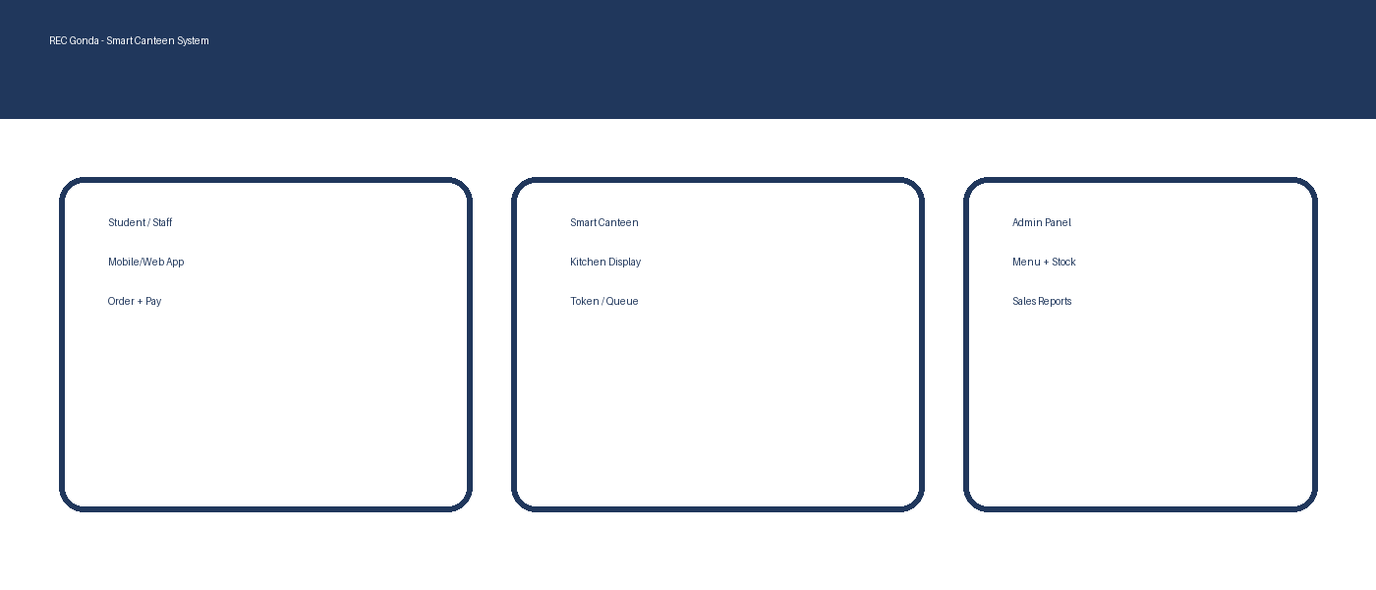

1. Introduction
The Smart Canteen Management System is a web/mobile based solution proposed for Maa Pateshwari Devi Rajkiya Engineering College, Gonda (REC Gonda) to digitize canteen operations. The system provides an online menu, pre-ordering, cashless payment, kitchen order management, and real-time status updates. It reduces crowding at the counter, saves time for students and staff, and provides transparency in sales and inventory.

2. Problem Statement
In traditional canteen work-flow, students stand in long queues, orders are written manually, and payment is mostly cash-based. This causes order mistakes, delays, peak-time congestion, and difficulty in tracking daily sales and stock. A smart system is required to automate ordering and improve service speed and accuracy.

3. Objectives
- Provide digital menu with item availability and prices.
- Enable students/staff to place orders using Mobile/Web app or kiosk.
- Support cashless payment (UPI/Wallet) and token generation.
- Send order to kitchen in real-time and show preparation status.
- Reduce queue time and crowd near the canteen counter.
- Allow admin to manage menu, categories, offers and inventory.
- Generate sales, order and stock reports for decision-making.

4. Scope of the Project
The proposed system covers end-to-end canteen ordering and management inside REC Gonda campus. It supports three user roles: Customer (Student/Staff), Canteen Staff (Kitchen/Counter), and Admin. The project scope includes online ordering, payment, kitchen display, and reporting. Future scope includes hostel mess integration, RFID/ID-card payment, and campus-wide delivery counters.

5. Proposed System Overview
The system is divided into three main components:
- Customer App/Website: Browse menu, add items to cart, place order, pay, and track status.
- Kitchen/Counter Panel: Receive orders, update preparation status, and mark delivered.
- Admin Panel: Manage items, stock, users, offers, and reports.

6. System Architecture Diagram
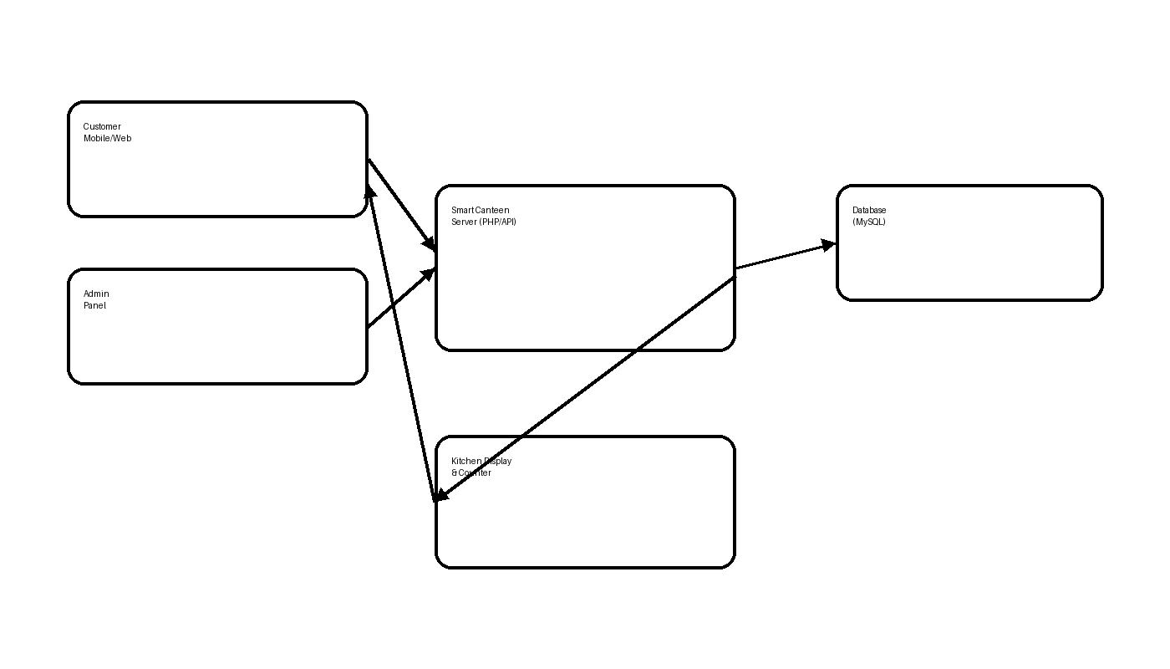

7. Data Flow Diagram (Level-0)
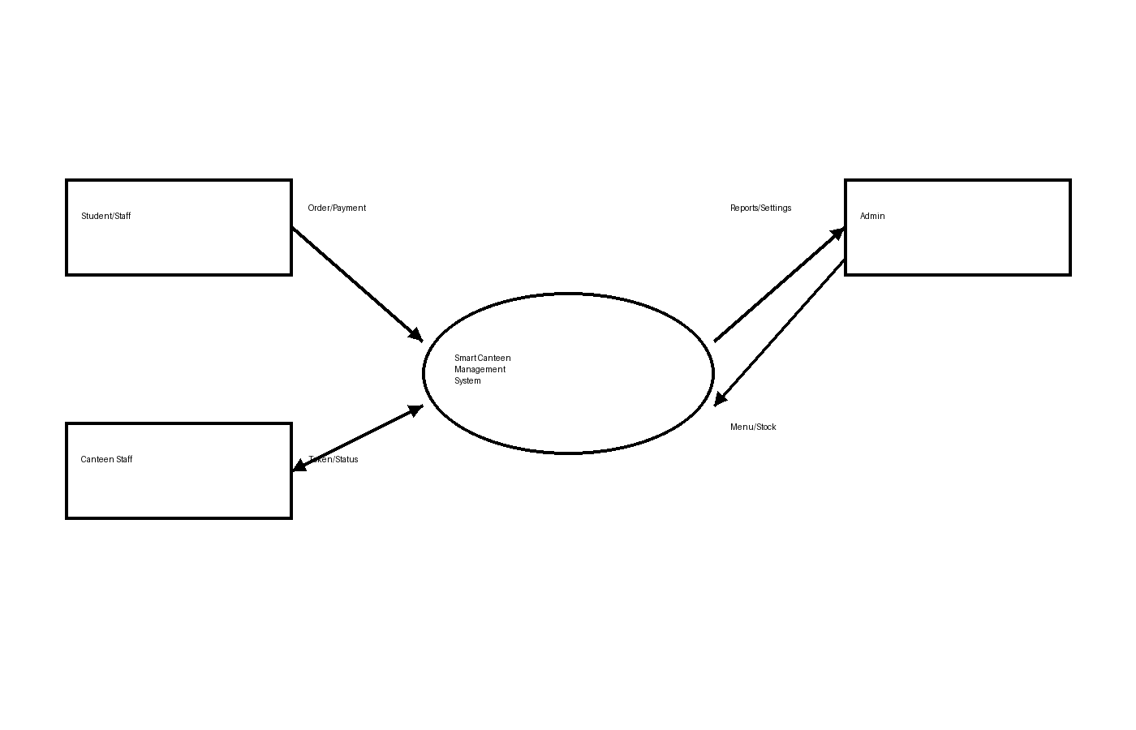

8. Module Description

8.1 Customer Module
- Registration/Login (College email/phone).
- View digital menu with categories.
- Add to cart and place order.
- Online payment (UPI).
- Get token number and live order status.
- View order history and feedback.

8.2 Canteen Staff Module
- Kitchen dashboard: new orders list.
- Update order status: Accepted -> Preparing -> Ready.
- Counter delivery: verify token and mark delivered.

8.3 Admin Module
- Manage categories and food items (CRUD).
- Manage prices, combos, and availability.
- Inventory/stock update and low-stock alerts.
- User management and role control.
- Sales analytics: daily/weekly/monthly reports.

9. Database Design (Proposed Tables)
The following tables are proposed for MySQL database:
Table | Important Fields | Purpose
users | user_id, name, role, phone, email, password | Store student/staff/admin accounts
categories | cat_id, cat_name | Menu categories
items | item_id, cat_id, item_name, price, is_available | Food items
orders | order_id, user_id, order_time, total_amt, status | Order master
order_items | id, order_id, item_id, qty, amount | Order details
payments | pay_id, order_id, method, txn_ref, pay_status | Payment record
inventory | inv_id, item_id, stock_qty, updated_at | Stock tracking

10. Tools & Technologies Used
- Frontend: HTML5, CSS3, JavaScript, Bootstrap
- Backend: PHP (REST APIs)
- Database: MySQL
- Server: Apache (XAMPP/WAMP)
- Payment: UPI QR / payment gateway integration (optional)
- Hardware (optional): Kitchen display screen / token display / QR stand

11. Hardware & Software Requirements

Hardware
- Computer/Laptop (i3 or above)
- 4GB RAM or more
- Internet/Wi-Fi in campus
- Android phones for users (optional kiosk)

Software
- Windows 10/11
- XAMPP (Apache + MySQL + PHP)
- VS Code / Notepad++
- Browser: Chrome/Edge

12. Advantages of Proposed System
- Saves time by reducing queues.
- Less order mistakes due to digital order ticket.
- Cashless payments increase transparency.
- Real-time stock & sales tracking.
- Better customer experience and faster service.

13. Conclusion
Smart Canteen Management System will help REC Gonda to provide faster and more organized food service inside campus. It will improve operational efficiency for canteen staff and provide a smooth ordering experience for students and staff. The system also supports analytics and inventory control, which is difficult in manual systems.

14. Future Enhancements
- Student ID/RFID based payment.
- Hostel mess menu integration.
- AI based demand prediction for inventory planning.
- Delivery counter wise distribution to avoid crowd.
- Push notifications via WhatsApp/SMS.

References
- REC Gonda official website: https://recgonda.ac.in/
- IJSRED paper: “SMART CANTEEN MANAGEMENT SYSTEM” (overview of smart canteen concept).
- University of Peradeniya project page: Smart Canteen Management System (features and concepts).

