Nature of Invention: Process design

**Applicant:** **BCG**

**Inventors:** **Mudit Bhanwar , Aakash Saran**

**Chemical Formula: C11H24O3**

**Chemical Name: Ethyl-hexyl-glycerine**

**Process Title: Production of Ethylhexylglycerine from 2-ethylhexanol , epichlorohydrin , sodium hydroxide and water .**

**Process Description:**

1. Give the block diagram for the feasible process (as determined in market analysis report). List all unit operations and process conditions.

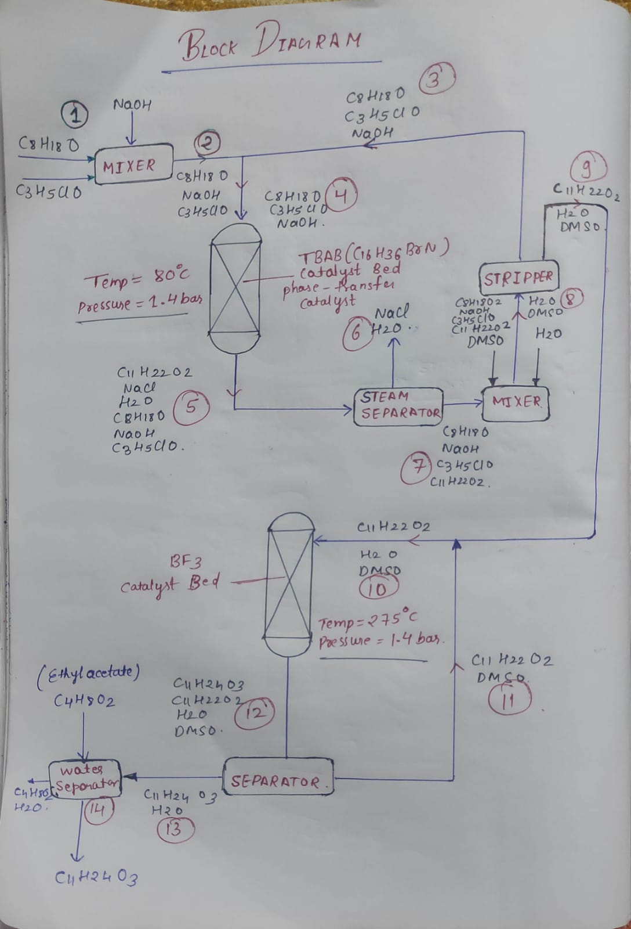

1. Give the material balance for a scaled-up process plant with capacity of 1000 kg/day. (If needed, simplify the calculations by stating assumptions)

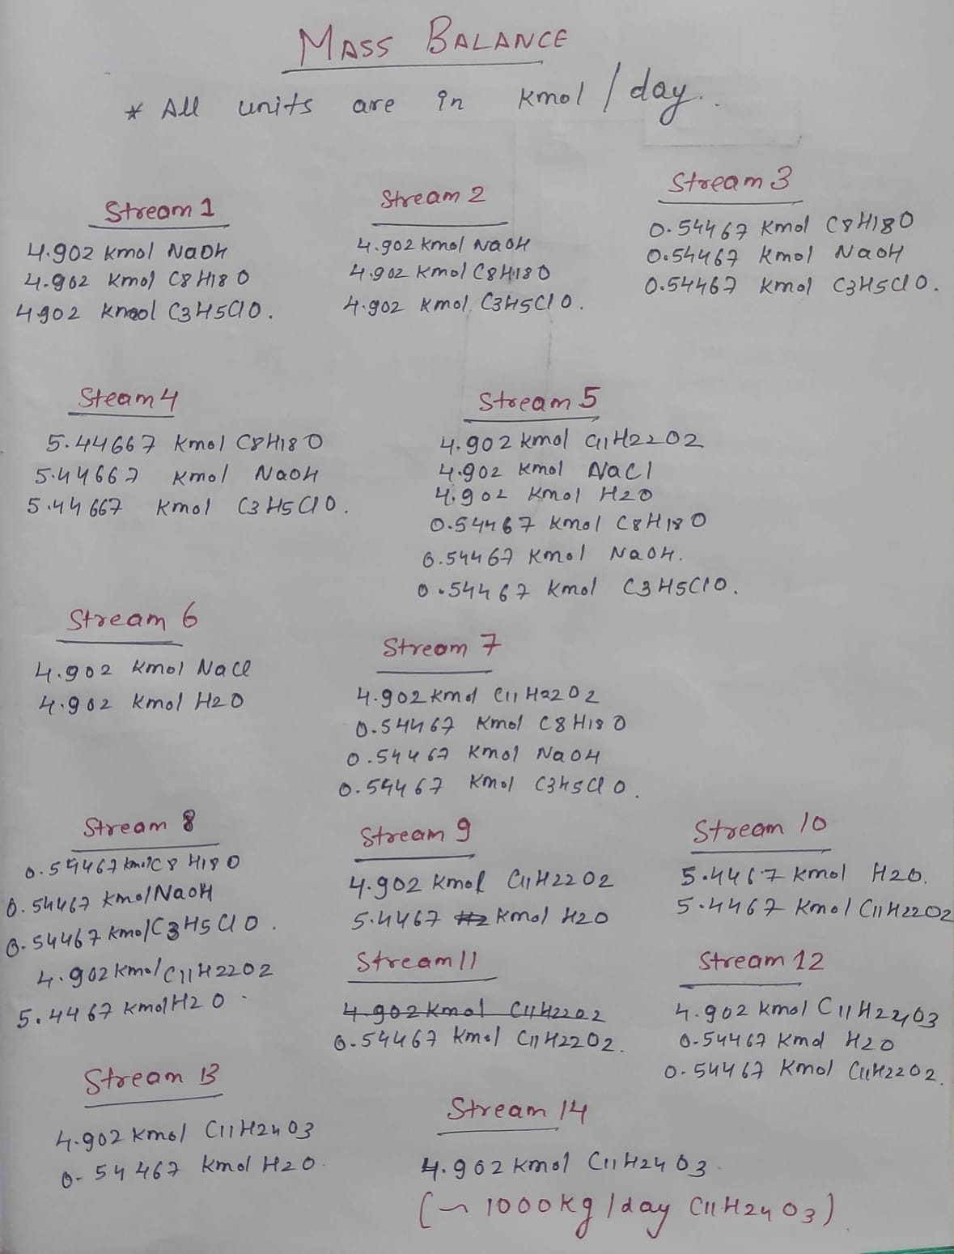

1. List the capacity of reactors needed and evaluate the cost. Use Glass lined Carbon steel (GS lined CS) as the material of construction (MOC). Use the pressure according to reaction conditions. You will use only 70% of the total volume. If you design a 1000 L reactor, you can only fill 700 L reaction mixture.

Number of Reactors required (capacity = 500L) = 2

Number of Mixers (capacity = 500L) = 2

Number of Separator and Strippers (capacity = 500L) = 4

Total cost = 8*33500/4=67000

**TOTAL FIXED COST = $67,000**

**Capital cost (only for the reactor):**

**example:**

|  |  |  |  |  |
| --- | --- | --- | --- | --- |
| **Equipment** | **Design Capacity (L)** | **No. of units** | **Cost/unit ($ for year 2014)** | **Total Cost ($ for year 2014)** |
| Reactor 1  (Jacketed reactor, agitated, Carbon steel, atm. pressure) | 2000 | 1 | 33,500 | 33,500 |
|  |  |  |  |  |

**References:** Provide reference for a research paper or an actual patent.

1. <http://www.matche.com/equipcost/Reactor.html>

**List the contributions of each author:**

* Mudit Bhanwar and Aakash Saran designed the block diagram and the unit operations for the process and determined the unit operations required .
* Mudit Bhanwar and Aakash Saran did the mass balanced and determined the reaction conditions .
* Priyanka calculated the reactor costs .

**Sign the pdf and upload.**

|  |  |  |
| --- | --- | --- |
| Name | Roll No | Signature |
| ABHINABA MUKHERJEE | 210028 |  |
| MUDIT BHANWAR | 210637 |  |
| PRIYANKA | 210733 |  |
| AAKASH SARAN | 210009 |  |
| Fourth author Name (if any) |  |  |
| Fifth author Name, Roll No & signature (if any) |  |  |
| Sixth author Name (if any) |  |  |