Nature of Invention: Process design

**Applicant:** BCG

**Inventors:** Naman Goyal, Avi Gupta and Priyanka

**Chemical Formula:** C14H14O3

**Chemical Name:** (S)-6-Methoxy-α-methyl-2-naphthaleneacetic acid

**Process Title:** Production of Naproxen from Methoxy Napthylene

**Process Description:**

1. **Block Diagram:**

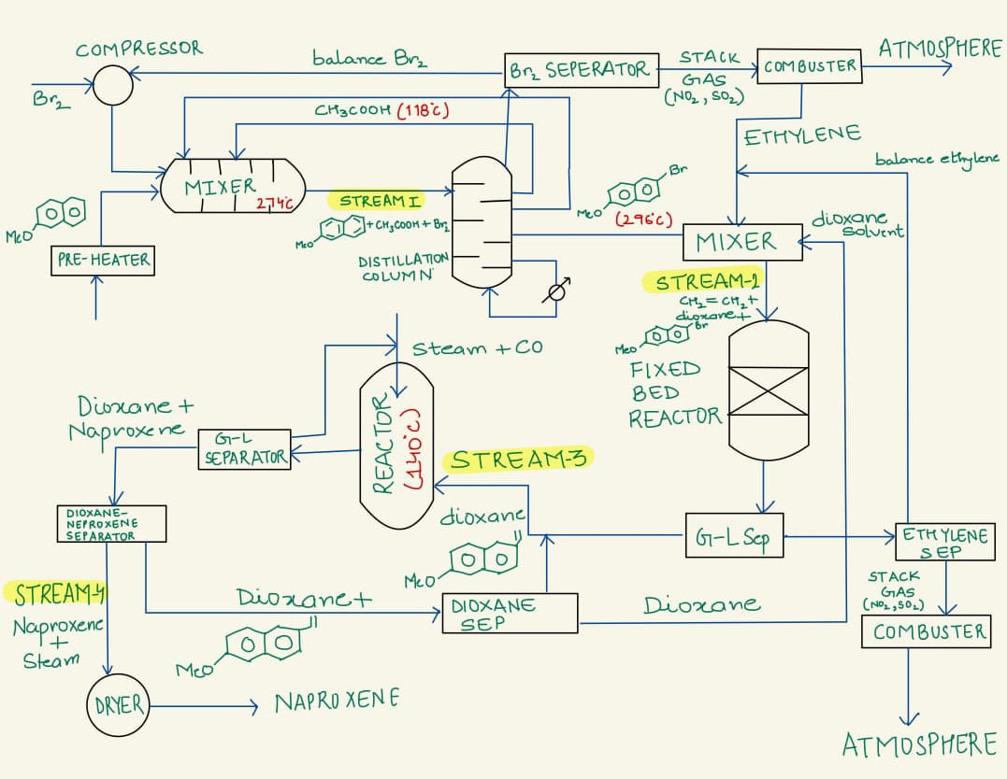

**Catalysts for Fixed Bed Reactor are: Pd(OAc)2 and PPh3**

1. **Material Balance:**

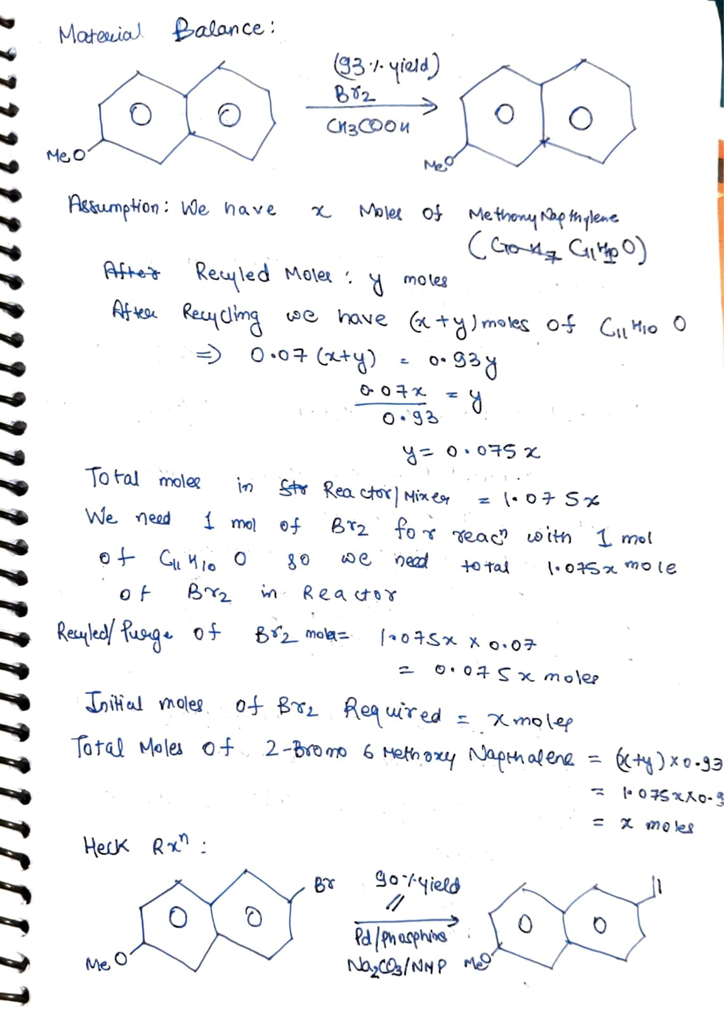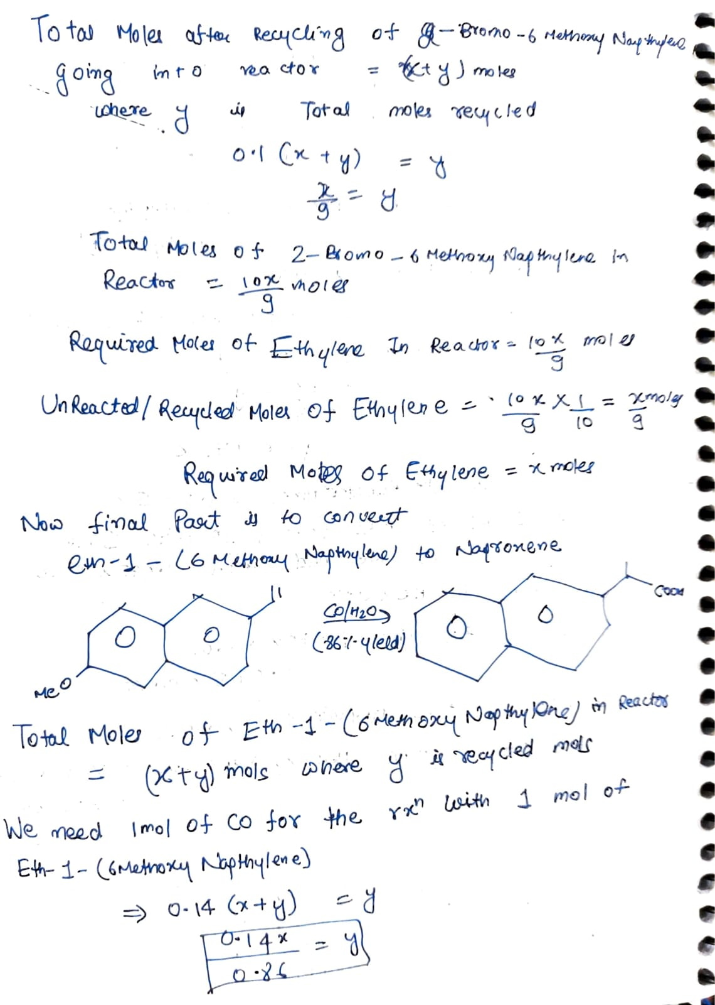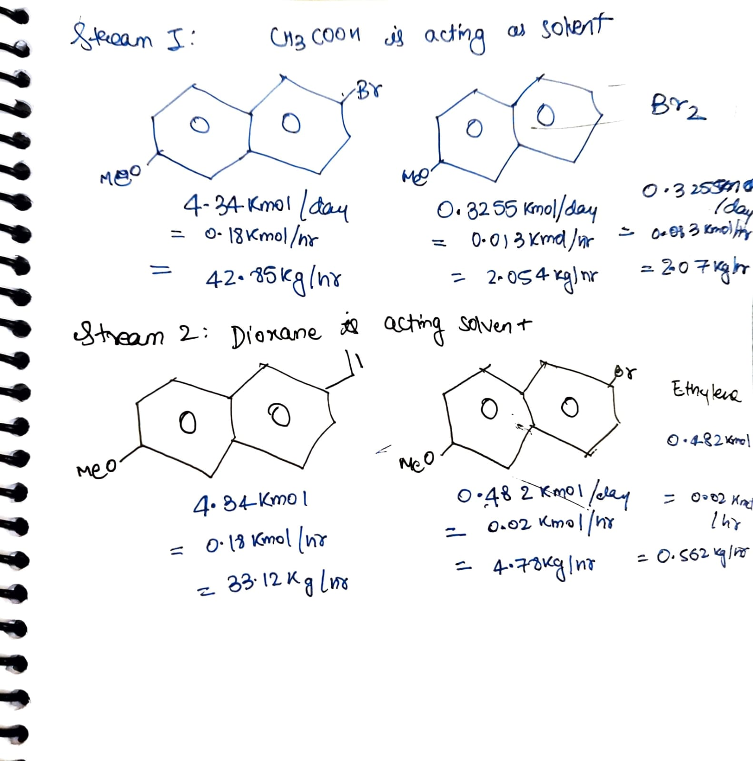

1. **Capital Cost**

**References:**.

1. <http://www.matche.com/equipcost/Reactor.html>
2. <https://www.sciencedirect.com/topics/engineering/fixed-bed-reactor>
3. <https://www.sciencedirect.com/topics/engineering/distillation-column>
4. <https://www.mdpi.com/2073-4344/7/9/267>

**List the contributions of each author:**

* Avi Gupta and Naman Goyal designed the Block Diagram
* Naman Goyal did the Material Balance
* Avi Gupta and Priyanka calculated Capital Cost

**Sign the pdf and upload.**

|  |  |  |
| --- | --- | --- |
| Name | Roll No | Signature |
| Abhinaba Mukherjee | 210028 |  |
| Naman Goyal | 210646 |  |
| Avi Gupta | 210235 |  |
| Priyanka | 210773 |  |