# VIRTUAL MOUSE

**Submitted in partial fulfilment of the requirements for the award of the degree of**

**Bachelor of Technology in Computer Science and Engineering**

## By:-

ANIMESH PRATAP SINGH 2100970100014

ANMOL AGARWAL 2100970100019

AKASH YADAV 2100970100009

Under the Supervision of

Dr. YOUDDHA BEER SINGH



**Galgotias College of Engineering & Technology**

## Greater Noida, Uttar Pradesh

**India-201310**

**Affiliated to**



**Dr. A.P.J. Abdul Kalam Technical University**

**Lucknow, Uttar Pradesh,**

**India-226031**

**TABLE OF CONTENTS**

* Certificate………………………………………………………….…2
* Declaration…………………………………………………………...3
* Acknowledgements…………………………………………………..4
* Abstract………………………………………………………………5
* Table of Contents…………………………………………………….6

# Introduction…………………………………………………………

* Motivation
* Goal and Objective
* Project Scope
* Problem Statement
* Impact, Significance and Contribution
* Discussions

# Systems Requirements…………………………………………………

* Hardware Requirements
* Software Requirements

1. **Design and Implementation…………………………………………...** 
   * System Design
   * Application Layout
   * Implementation
   * Methodology

1. **Conclusion …………………………………………………...………….** 
   * Limitation
   * Future Scope

# *CERTIFICATE*

This is to certify that Project Report entitled “***Virtual Mouse”*** which is submitted by ***Animesh pratap singh ,Anmol Agarwal ,Akash Yadav*** bearing in partial fulfilment of the requirement for the award of degree B. Tech. in Department of **Computer Science and Engineering** of **Galgotias college of engineering and technology ,** affiliated to **Dr. A.P.J. Abdul Kalam Technical University, Lucknow** is a record of the candidates own work carried out by them under my/our supervision. The project embodies result of original work and studies carried out by the students themselves and the contents of the project do not form the basis for the award of any other degree to the candidate or to anybody else.

Signature: Signature:

**Dr. Vishnu Sharma Dr. Youddha Beer Singh**

Head of Department

CSE CSE Department

GCET ,Greater noida GCET,Greater noida

Date

# DECLARATION

We hereby declare that this submission is our own work and that, to the best of my knowledge and belief, it contains no material previously published or written by another person nor material which to a substantial extent has been accepted for the award of any other degree or diploma of the university or other institute of higher learning, except where due acknowledgment has been made in the text.

Signature

Name: Animesh pratap singh,Anmol Agarwal ,Akash Yadav

Roll No.: 2100970100014,2100970100019,2100970100009

Date

# ACKNOWLEDGEMENT

It gives us a great sense of pleasure to present the report of the B.Tech. Project undertaken during

B.Tech. Third Year. We owe special debt of gratitude to our project supervisor **Youddha Beer Singh**, Department of Computer Science and Engineering, **Galgotias college of engineering and technology, Greater noida** for his constant support and guidance throughout the course of our work. His sincerely, thoroughness and perseverance have been a constant source of inspiration for us. It is only his cognizant efforts that our endeavours have seen light of the day.

We also take the opportunity to acknowledge the contribution of **Professor Dr. Vishnu sharma sir**, HOD, Department of Computer Science & Engineering**, Galgotias college of engineering and technology , Greater noida** for his full support and assistance during the development of the project.

We also do not like to miss the opportunity to acknowledge the contribution of all faculty members of the department for their kind assistance and cooperation during the development of our project. Last but not the least, we acknowledge our friends for their contribution in the completion of the project.

Signature

Animesh Pratap Singh - 2100970100014

Anmol Agarwal - 2100970100019

Akash Yadav - 2100970100009

*.:*

**ABSTRACT**

This project promotes an approach for the Human Computer Interaction (HCI) where cursor movement can be controlled using a real-time camera, it is an alternative to the current methods including manual input of buttons or changing the positions of a physical computer mouse. Instead, it utilizes a camera and computer vision technology to control various mouse events and is capable of performing every task that the physical computer mouse can.

The Virtual Mouse colour recognition program will constantly acquiring real-time images where the images will undergone a series of filtration and conversion. Whenever the process is complete, the program will apply the image processing technique to obtain the coordinates of the targeted colours position from the converted frames. After that, it will proceed to compare the existing colours within the frames with a list of colour combinations, where different combinations consists of different mouse functions. If the current colours combination found a match, the program will execute the mouse function, which will be translated into an actual mouse function to the users' machine.

**CHAPTER 1**

# Introduction

A mouse, in computing terms is a pointing device that detects two-dimensional movements relative to a surface. This movement is converted into the movement of a pointer on a display that allows to control the Graphical User Interface (GUI) on a computer platform. There are a lot of different types of mouse that have already existed in the modern days technology, there's the mechanical mouse that determines the movements by a hard rubber ball that rolls around as the mouse is moved. Years later, the optical mouse was introduced that replace the hard rubber ball to a LED sensor to detects table top movement and then sends off the information to the computer for processing. On the year 2004, the laser mouse was then introduced to improve the accuracy movement with the slightest hand movement, it overcome the limitations of the optical mouse which is the difficulties to track high-gloss surfaces. However, no matter how accurate can it be, there are still limitations exist within the mouse itself in both physical and technical terms. For example, a computer mouse is a consumable hardware device as it requires replacement in the long run, either the mouse buttons were degraded that causes inappropriate clicks, or the whole mouse was no longer detected by the computer itself.

## Motivation

It is fair to say that the Virtual Mouse will soon to be substituting the traditional physical mouse in the near future, as people are aiming towards the lifestyle where that every technological devices can be controlled and interacted remotely without using any peripheral devices such as the remote, keyboards, etc. it doesn't just provides convenience, but it's cost effective as well.

## Goals and Objectives

The purpose of this project is to develop a Virtual Mouse application that targets a few aspects of significant development. For starters, this project aims to eliminate the needs of having a physical mouse while able to interact with the computer system through webcam by using various image processing techniques. Other than that, this project aims to develop a Virtual Mouse application that can be operational on all kind of surfaces and environment.

The following describes the overall objectives of this project:

* To design to operate with the help of a webcam. The Virtual Mouse application will be operational with the help of a webcam, as the webcam are responsible to capture the images in real time. The application would not work if there are no webcam detected.
* To design a virtual input that can operate on all surface. The Virtual Mouse application will be operational on all surface and indoor environment, as long the users are facing the webcam while doing the motion gesture.
* To program the camera to continuously capturing the images, which the images will be analysed, by using various image processing techniques. As stated above, the Virtual Mouse application will be continuously capturing the images in real time, where the images will be undergo a series of process, this includes HSV conversion, Binary Image conversion, salt and pepper noise filtering, and more.
* To convert hand gesture/motion into mouse input that will be set to a particular screen position. The Virtual Mouse application will be programmed to detect the position of the defined colours where it will be set as the position of the mouse pointers.

## Project Scope

Virtual Mouse that will soon to be introduced to replace the physical computer mouse to promote convenience while still able to accurately interact and control the computer system. To do that, the software requires to be fast enough to capture and process every image, in order to successfully track the user's gesture. Therefore, this project will develop a software application with the aid of the latest software coding technique and the open-source computer vision library also known as the OpenCV.

The scope of the project is as below:

* Real time application.
* User friendly application.
* Removes the requirement of having a physical mouse.

## Problem Statement

It's no surprised that every technological devices have its own limitations, especially when it comes to computer devices. After the review of various type of the physical mouse, the problems are identified and generalized. The following describes the general problem that the current physical mouse suffers:

* Physical mouse is subjected to mechanical wear and tear.
* Physical mouse requires special hardware and surface to operate.
* Physical mouse is not easily adaptable to different environments and itsperformance varies depending on the environment.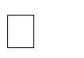
* Mouse has limited functions even in present operational environments.
* All wired mouse and wireless mouse have its own lifespan.

## Impact, Significance and Contribution

The Virtual Mouse application is expected to replace the current methods of utilizing a physical computer mouse where the mouse inputs and positions are done manually. This application offers a more effortless way to interact with the computer system, where every task can be done by gestures. Furthermore, the Virtual Mouse application could assist the motor-impaired users where he/she could interact with the computer system by just showing the correct combination of colours to the webcam.

## Discussions

There are abundance of methods for computer interaction besides the traditional physical mouse interaction. With the evolutions of modern technology and programming, so does the Human Computer Interaction (HCI) methods, as it allows unlimited ways to access the computers. This approach allows the developers to design specific/unique system that suit the needs of the users, from gesture movement tracking to coloured tracking, it's no surprise that in near future, physical mouse will no longer be needed and be replaced by video cameras that tracks gestures.

***CHAPTER 2***

***System Requirements***

## Hardware Requirements

The following describes the hardware needed in order to execute and develop the Virtual Mouse application:

* **Computer Desktop or Laptop**

The computer desktop or a laptop will be utilized to run the visual software in order to display what webcam had captured. A notebook which is a small, lightweight and inexpensive laptop computer is proposed to increase mobility.

System will be using

Processor : Core2

Duo Main Memory : 4GB RAM

Hard Disk : 320GB

Display : 14" Monitor

* **Webcam**

Webcam is utilized for image processing, the webcam will continuously taking image in order for the program to process the image and find pixel position.

## Software Requirement

The following describes the software needed in-order to develop the Virtual Mouse application:

**Python Language:**

**Python** is an [interprete](https://en.wikipedia.org/wiki/Interpreted_language)[d high-leve](https://en.wikipedia.org/wiki/High-level_programming_language)[l general-purpose programming language.](https://en.wikipedia.org/wiki/General-purpose_programming_language) Its design philosophy emphasizes [code readability w](https://en.wikipedia.org/wiki/Code_readability)ith its use of [significant indentation.](https://en.wikipedia.org/wiki/Off-side_rule) Its [language constructs a](https://en.wikipedia.org/wiki/Language_construct)s well as its [object-oriented a](https://en.wikipedia.org/wiki/Object-oriented_programming)pproach aim to help [programmers w](https://en.wikipedia.org/wiki/Programmers)rite clear, logical code for small and large-scale projects.

Python is [dynamically-typed a](https://en.wikipedia.org/wiki/Type_system#DYNAMIC)nd [garbage-collected.](https://en.wikipedia.org/wiki/Garbage_collection_(computer_science)) It supports multiple [programming paradigms,](https://en.wikipedia.org/wiki/Programming_paradigm) including [structured (](https://en.wikipedia.org/wiki/Structured_programming)particularly, [procedural),](https://en.wikipedia.org/wiki/Procedural_programming) object-oriented and [functional programming.](https://en.wikipedia.org/wiki/Functional_programming) It is often described as a "batteries included" language due to its comprehensive [standard library.](https://en.wikipedia.org/wiki/Standard_library)

### Open CV Library

OpenCV are also included in the making of this program. OpenCV (Open Source Computer Vision) is a library of programming functions for real time computer vision. OpenCV have the utility that can read image pixels value, it also have the ability to create real time eye tracking and blink detection.

Software will be using:

OS : Window 7 Ultimate 64-bit

Language : Python+

Tool Used : Open CV and CMak

***CHAPTER 3***

## Design and Implementation System Design

During the process of colour recognition, it contains 2 major phases which are the calibration phase and recognition phase. The purpose of the calibration phase is to allow the system to recognize the Hue Saturation Values of the colours chosen by the users, where it will store the values and settings into text documents, which will be used later on during the recognition phase. While on the recognition phase, the system will start to capture frames and search for colour input with based on the values that are recorded during the calibration phase. The phases of the virtual mouse is as shown in figure below.

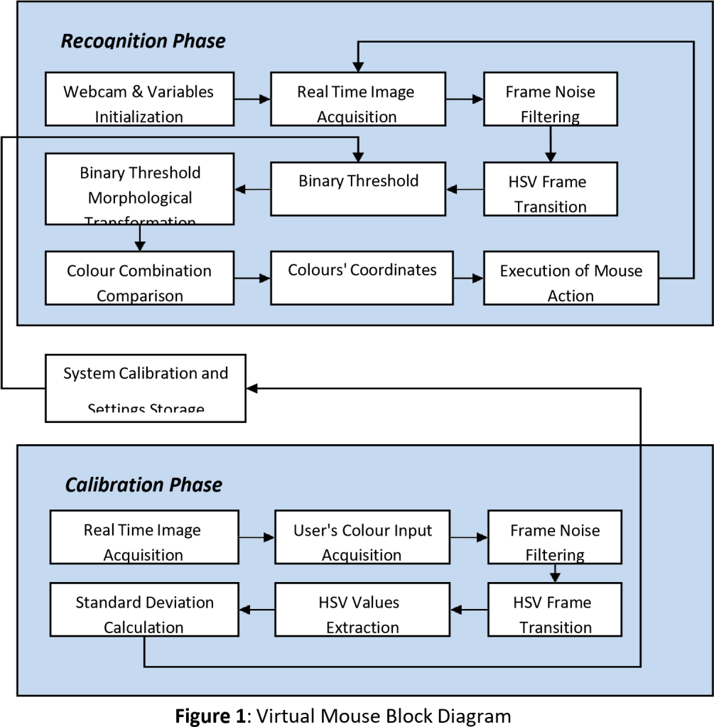

# Calibration Phase

1. Real Time Image Acquisition

The program will start of by capturing real-time images via a webcam where it will await for users' colour input. The size of the acquired image will be compressed to a reasonable size to reduce the processing loads of processing the pixels within the captured frame.

1. User's Colour Input Acquisition

The program acquires the frames that consist of input colours submitted by the users, the captured frame will be sent for process where it will undergone a series of transition and calculation to acquire the calibrated HSV values.

1. Frame Noise Filtering

Every captured frame consists of noises that will affect the performance and the accuracy of the program, therefore the frame require to be noise free. To do that, filters need to be applied on the captured frames to cancel out the unwanted noise. For the current project, Gaussian filter will be used, which is a common smoothing method to eliminate noise in a frame. This can be done by using GaussianBlur(InputArray src, OutputArray dst, Size ksize, double sigmaX, double sigmaY=0, intborderType = BORDER_DEFAULT

).

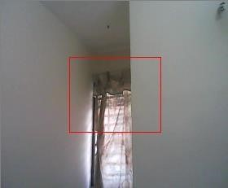

**Figure 2:** The comparison between un-filtered and filtered frame

1. HSV Frame Transition

The captured frame require to be converted from a BGR format to a HSV format. Which can be done by using cvtColor(src, dst,

CV_BGR2HSV).



Before After

**Figure 3**: The comparison between un-filtered and filtered frame

1. HSV Values Extraction

In order to acquire the HSV values, the converted frame require to be split into 3 single different planes, to do that the frame needs to be divided from a multi-channel array into a single channel array, which can be done by using split(const Mat& src, Mat* mvbegin).

1. Standard Deviation Calculation

To obtain the maximum and the minimum of the HSV values, it requires to gone through the Standard Deviation calculation, a measurement used to quantify the amount of variation / dispersion among other HSV values. Furthermore, to obtain an accurate range of values, three-sigma rule are required in the calculation, so that chances of the captured values have a very high possibility to fall within the three-sigma intervals.

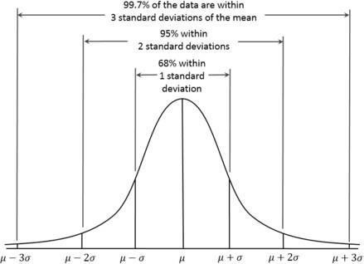

**Figure 4**: The distribution of three-sigma rule



**Figure 5**: User's colour input and the result of the binary threshold after standard deviation calculation

## Application Layout

The application will start of by displaying a console window; users are required to select the options available in the main menu as different options leads to different functions of the program. If the users somehow select an incorrect options (e.g. fourth option), the result will be the display of error message and re-direct users back to the main menu. The second option allows the user to choose and calibrate the desired colours in order to achieve optimal accuracy and performance during the recognition phase. Other than that, the third option allows the user to modify the settings of the program, this includes the height and width of the feedback windows, choices of webcams, and more.

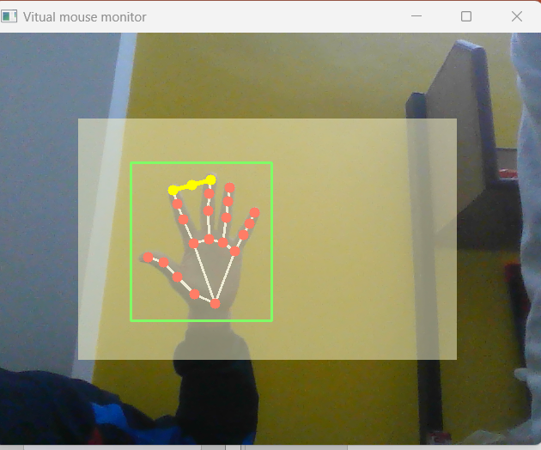

**Figure 6**: The general representation of feedback window

## Implementation

Throughout the development of the application, there are several implementation issues occurred. The following describes the issues and challenges that will likely to be encountered throughout the development phase:

* **The interruptions of salt and pepper noises within the captured frames** Salt and pepper noises occurred when the captured frame contains required HSV values that are too small, but still underwent a series of process even though it’s not large enough to be considered an input. To overcome this issue, the unwanted HSV pixels within the frame must first be filtered off, this

includes the area of the pixels that are too large and small. With this method, the likelihood of interruptions of similar pixels will reduce greatly.

* **Performance degradation due to high process load for low-tier system.** Since the application is required to undergo several of process to filter, process and execute the mouse functions in real time, the application can be CPU intensive for most of the low-tier system. If the size of the captured frames is too large, the time-taken for the application to process the entire frame are increase drastically. Therefore, to overcome this issue, the application is required to process only the essential part of the frames, and reduces the redundant filtering process that could potentially slow the application down.
* **The difficulties of calibrating the brightness and the contrast of the frames to get the required HSV values.**

The intensity of brightness and contrast matters greatly when it comes to acquiring the required colour pixels. In order for the application to execute the

entire mouse functions provided, all of the required HSV values to execute the specific mouse functions must be satisfied, meaning that the overall HSV values must be satisfied with the brightness and contrast as well.

## Methodology

For this project we'll be using the Agile Software Development methodology approach in developing the application. The stated approach is an alternative to the traditional waterfall model that helps the project team respond to unpredictability through incremental and iterative work. It promotes adaptive planning, evolutionary development, early delivery, continuous improvement, and encourages rapid and flexible respond to change. The following describes the principles of the Agile Software Development methodology:

* Satisfy the customer by early and continuous delivery of workable software.
* Encourage changes of requirement.
* Workable software is delivered frequently.
* Continuous collaboration between the stakeholders and the developers.
* Project are developed around motivated individuals.
* Operational software is the principle measure of progress.
* Sustainable development, able to maintain a constant pace.
* Continuous attention to technical excellence and good design.
* Simplicity
* Self-organizing teams
* Regular adaption to changing circumstances

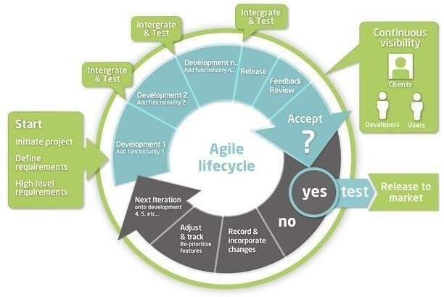

**Figure 7**: Agile method overview

The reason for choosing this methodology is due to the fact that the Virtual Mouse are still considered to be at the introduction stage, which means it still requires a great deal of extensive research and development before it could actually make it into the market. Therefore, this project requires a thorough yet iterative planning and requirements gathering where the lifecycle will be continually revisited to reevaluates the direction of the project and to eliminate the ambiguities in the process of the development, and at the same time welcome changes of requirements, which promotes adaptability and flexibility. Furthermore, due to the Virtual Mouse application are more towards serving the users, this project requires continuous customer collaboration, as they're essential for gathering the proper requirements in all aspects.

This is why that the agile methodology is the ideal approach for developing the project.

## Conclusion

In conclusion, it’s no surprised that the physical mouse will be replaced by a virtual nonphysical mouse in the Human-Computer Interactions (HCI), where every mouse movements can be executed with a swift of your fingers everywhere and anytime without any environmental restrictions. This project had develop a colour recognition program with the purpose of replacing the generic physical mouse without sacrificing the accuracy and efficiency, it is able to recognize colour movements, combinations, and translate them into actual mouse functions. Due to accuracy and efficiency plays an important role in making the program as useful as an actual physical mouse, a few techniques had to be implemented.

## Limitation

In this project, there are several existing problems that may hinder the results of colour recognitions. One of the problems is the environmental factor during the recognition phase takes place. The recognition process are highly sensitive on the intensity of brightness, as immense brightness or darkness may cause the targeted colours to be undetected within the captured frames. Besides that, distance is also the one of the problem that may affect the colour recognition results, as the current detection region can support up to 25cm radius, any display of colours exceed the mentioned distance will be considered as a noise and be filtered off. Furthermore, the performance of the program are highly dependent on the users' hardware, as processor speed and/or resolutions taken from the webcam could have an effect on performance load. Therefore, the slower the processing speed and/or the higher the resolutions, the longer time are required to process a single frame.

## Future Scope

There are several features and improvements needed in order for the program to be more user friendly, accurate, and flexible in various environments. The following describes the improvements and the features required:

1. Smart Recognition Algorithm

Due to the current recognition process are limited within 25cm radius, an adaptive zoom-in/out functions are required to improve the covered distance, where it can automatically adjust the focus rate based on the distance between the users and the webcam.

1. Better Performance

The response time are heavily rely on the hardware of the machine, this includes the processing speed of the processor, the size of the available RAM, and the available features of webcam. Therefore, the program may have better performance when it's running on a decent machines with a webcam that performs better in different types of lightings.

Mini-Project Title

## REFERENCES

Wikipedia

1. [https://en.wikipedia.org](https://en.wikipedia.org/)
2. [https://www.geeksforgeeks.org](https://www.geeksforgeeks.org/)
3. [https://www.youtube.com](https://www.youtube.com/)
4. [https://www.javatpoint.com](https://www.javatpoint.com/)
5. It includes various books, magazines, websites and other journals as well.

1