AIVI Career Intelligence Full Documentation

Investor-Grade Product Overview & Feature Walkthrough
Website: https://aivilabs.com
Version 1.0
Date: February 27, 2026

Executive Overview
AIVI is a premium, AI-powered Career Intelligence platform that converts generic resumes into highly ATS-optimized, mathematically quantified professional documents. This documentation breaks down the complete user journey, from the top-of-funnel landing page and signup flow to the core capabilities including Resume Intelligence, Resume Rebuild, Job Fit Analysis, Skill Roadmaps, Interview Prep, Promotion Readiness, Portfolio Analyzer, and LinkedIn Analyzer.

Table of Contents
Note: Please right-click here and select "Update Field" in Microsoft Word to generate the Table of Contents.

Contents
Executive Overview 2
Table of Contents 2
Technical Architecture Overview 3
Part 1: Landing Page Documentation 4
1.1 Hero Section 4
1.2 Value Proposition & Feature Highlights 4
1.3 CTA Buttons & Navigation Structure 5
1.4 Footer & SEO Structure 6
Part 2: Signup / Login Flow 6
2.1 Login Experience 6
2.2 Redirect Behavior & Error Handling 7
Part 3: Dashboard Overview 7
3.1 Main Dashboard View 7
3.2 Plan Gating & Usage Tracking 7
Part 4: Resume Intelligence Module 8
4.1 Score Breakdown & ATS Check 8
4.2 Technical Depth & Keyword Optimization 8
4.3 Weak Bullet Suggestions & Seniority Guidance 9
Part 5: Resume Rebuild / Resume Builder Module (CRITICAL) 9
5.1 Resume Builder Interface & Loading State 9
5.2 Fully Rebuilt Output & Quantified Impact 10
5.3 Version History & Paywall Friction 11
Part 6: Job Fit Analysis 11
6.1 Job Match Scoring 11
6.2 Missing & Matched Skills 12
Part 7: Skill Roadmap 12
7.1 Generated Career Roadmap 12
Part 8: Interview Intelligence 14
8.1 Categorized Interview Questions 14
Part 9: Promotion Readiness 15
9.1 Readiness Score & Gap Analysis 15
Part 10: Portfolio Analyzer 16
10.1 Portfolio Scoring Logic 16
Part 11: LinkedIn Analyzer 16
11.1 Profile Optimization 16
Part 12: Plan Gating & Paywall 17
12.1 Monetization Structure 17
Part 13: Admin Dashboard 18
13.1 Usage & Cost Tracking 18
Conclusion 20

Technical Architecture Overview
AIVI is built on a modern, scalable stack utilizing React/TypeScript for the frontend, Node.js and Google Cloud Functions for serverless backend processing, and Firebase/Firestore for real-time data synchronization and authentication. Core intelligence is powered by Google Gemini 1.5 APIs, leveraging deterministic scoring algorithms to provide deterministic and reliable career guidance.

Part 1: Landing Page Documentation

1.1 Hero Section
- Full hero section screenshot.
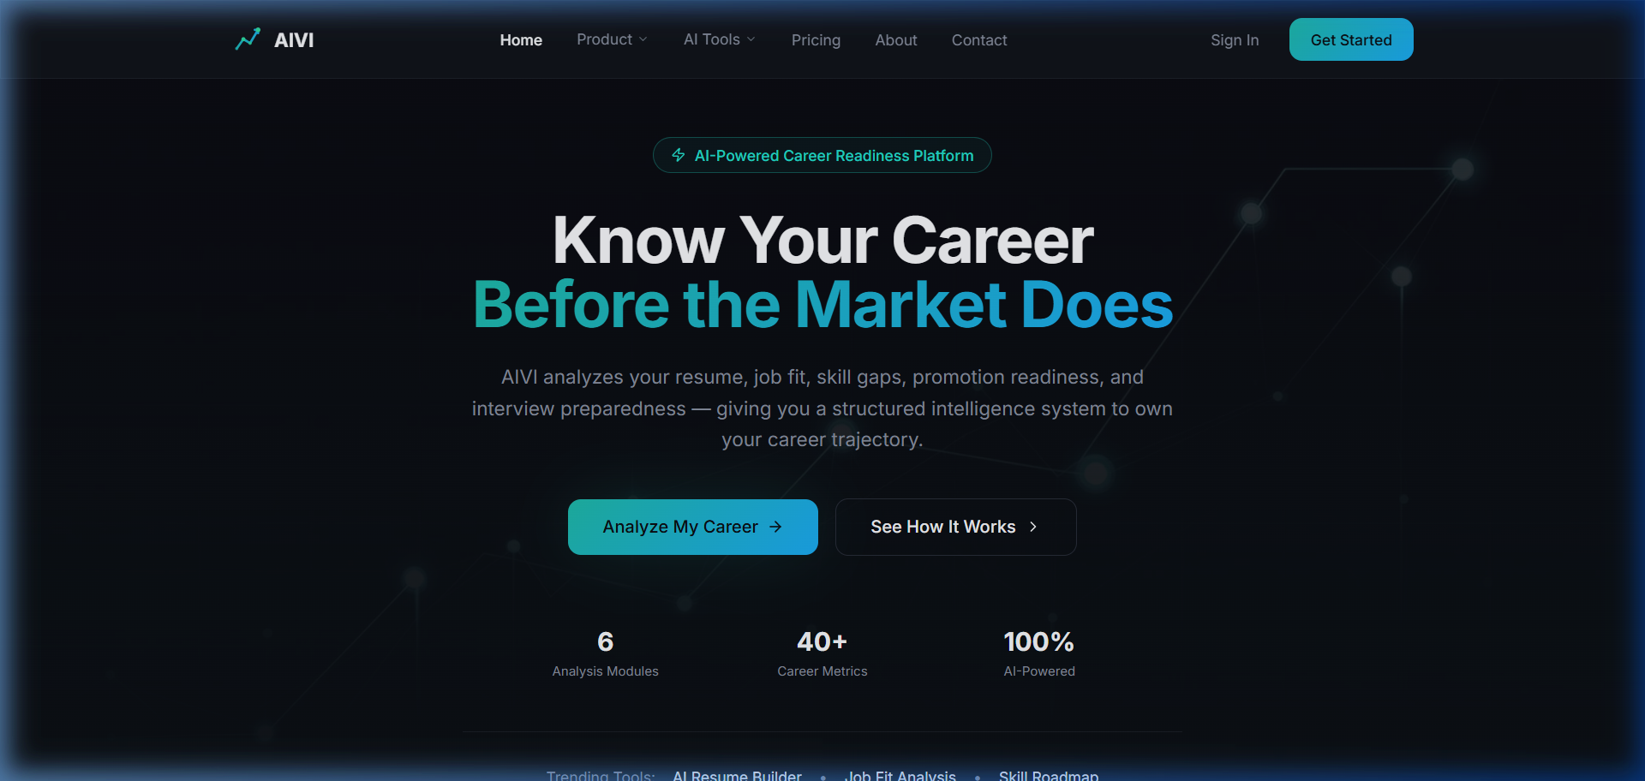
Figure 1 - Hero Section
- Description: Showcases the platform's core promise to job seekers with an immediate call to action to boost their career.
- User Intent: Hook the user immediately to understand value.

1.2 Value Proposition & Feature Highlights
- Screenshot of the feature highlights section.
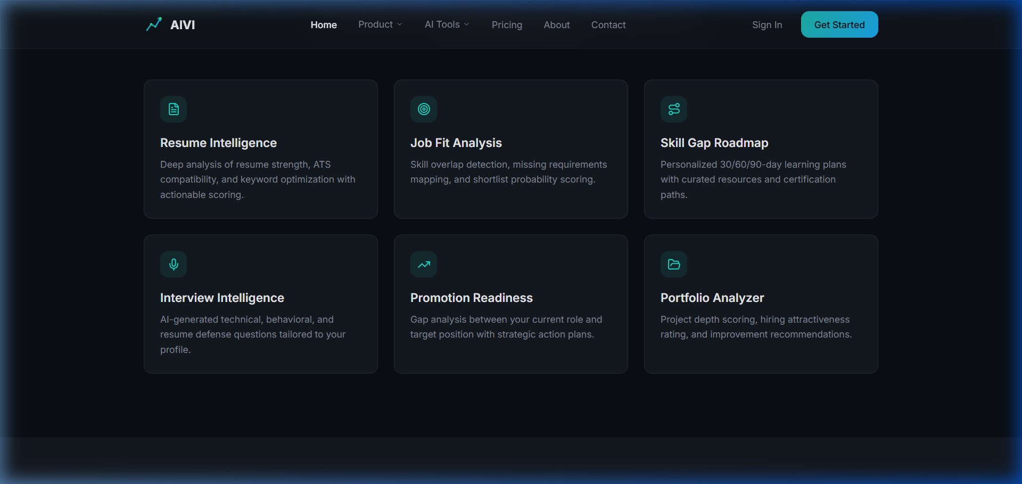
Figure 2 - Features Section
- Description: Clearly breaks down what tools are available.
- User Intent: Build trust and demonstrate comprehensive offering.

1.3 CTA Buttons & Navigation Structure
- Screenshot of Top Nav & secondary CTA.
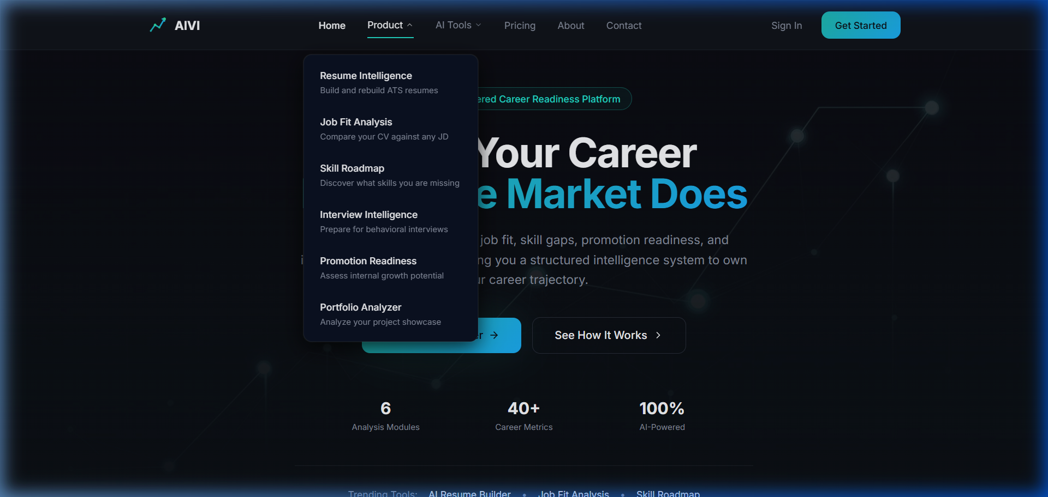
Figure 3 - Product Dropdown
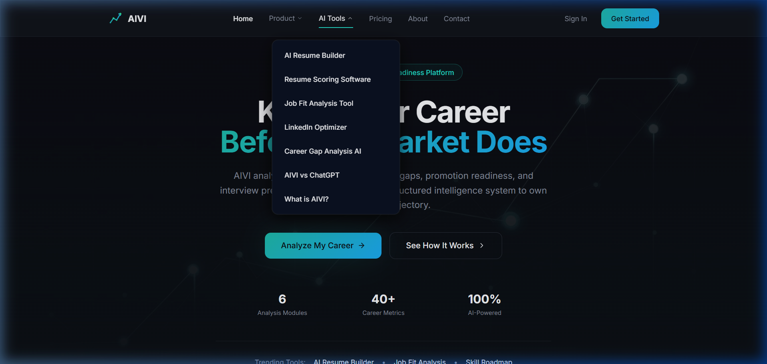
Figure 4 - AI Tools Dropdown
- Description: Enables easy discovery of CU pages for SEO and easy login for returning users.
- User Intent: Seamless navigation depending on whether user is top-of-funnel (exploring tools) or bottom-of-funnel (ready to log in).

1.4 Footer & SEO Structure
- Screenshot of the bottom footer containing links.
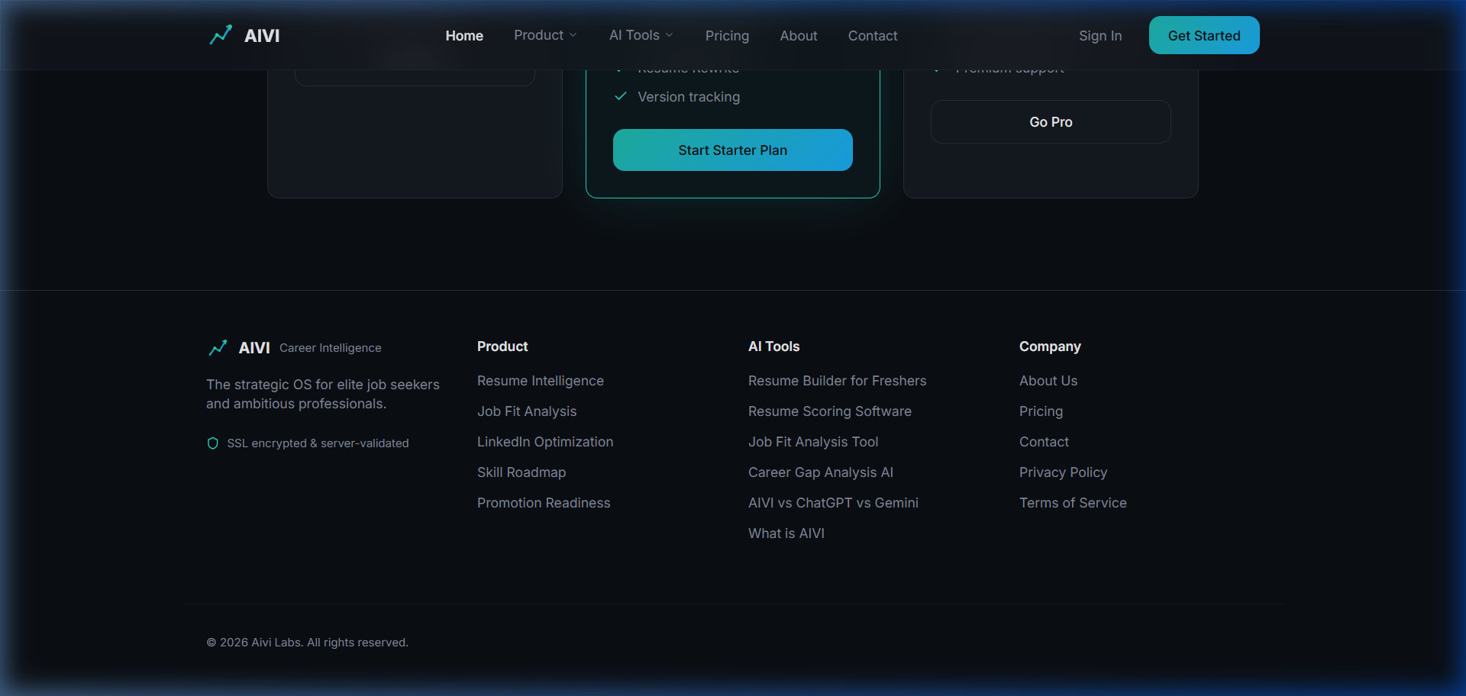
Figure 5 - Footer Section
- Description: Anchors the domain structure and distributes link equity across tool-specific bottom-of-funnel pages.
- User Intent: Deep dive into specific capabilities or verify company legitimacy.

Part 2: Signup / Login Flow

2.1 Login Experience
- Screenshot of the login page.
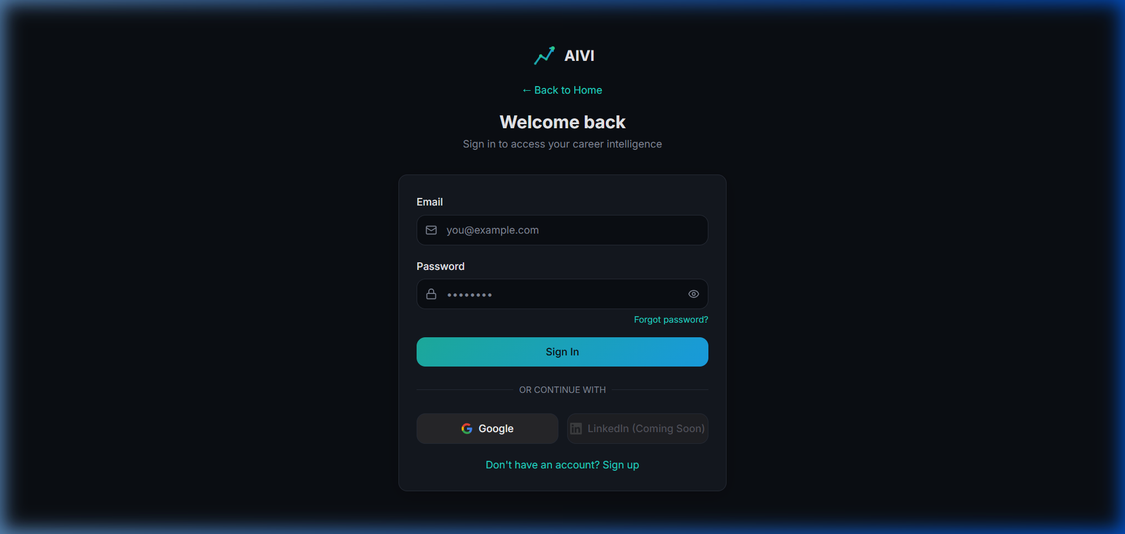
Figure 6 - Login Page
- Description: Secure, frictionless entry point to the platform.
- User Intent: Access account quickly without hassle.

2.2 Redirect Behavior & Error Handling
- Video/Screenshot showing post-login redirect.
- Description: Upon successful authentication, users are instantly guided to their localized dashboard to review past analysis and usage quota.
- User Intent: Confirm successful auth and land on the control center.

Part 3: Dashboard Overview

3.1 Main Dashboard View
- Screenshot of the main Career Intelligence Dashboard.
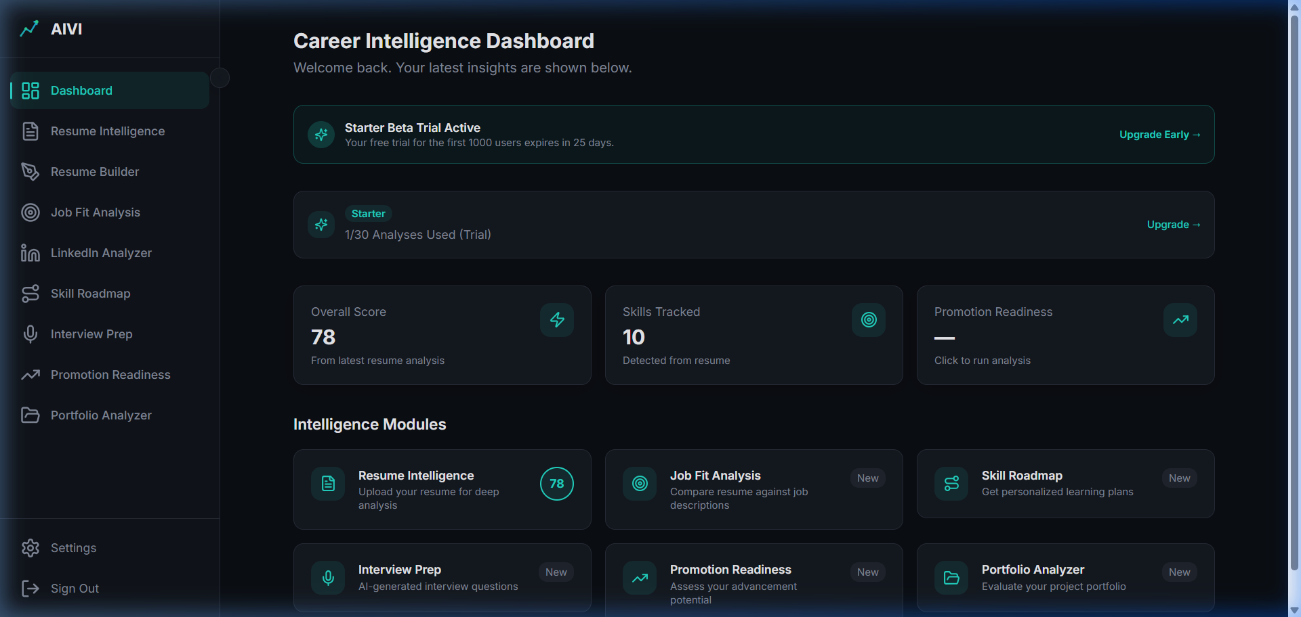
Figure 7 - Dashboard Overview
- Description: The central hub where all AI intelligence is aggregated. Users see their recent resume score, remaining trial/plan limits, and quick-links to all modules.
- User Intent: Get a quick pulse on current career standing and available quota.

3.2 Plan Gating & Usage Tracking
- Close-up screenshot of the Usage/Plan widget.
- Description: Clearly shows the user's current tier (Free vs Paid) and limits feature abuse. Free limits drive upgrades.
- User Intent: Check eligibility to run new scans and navigate to pricing.

Part 4: Resume Intelligence Module

4.1 Score Breakdown & ATS Check
- Screenshot of the completed Resume Analysis results page.
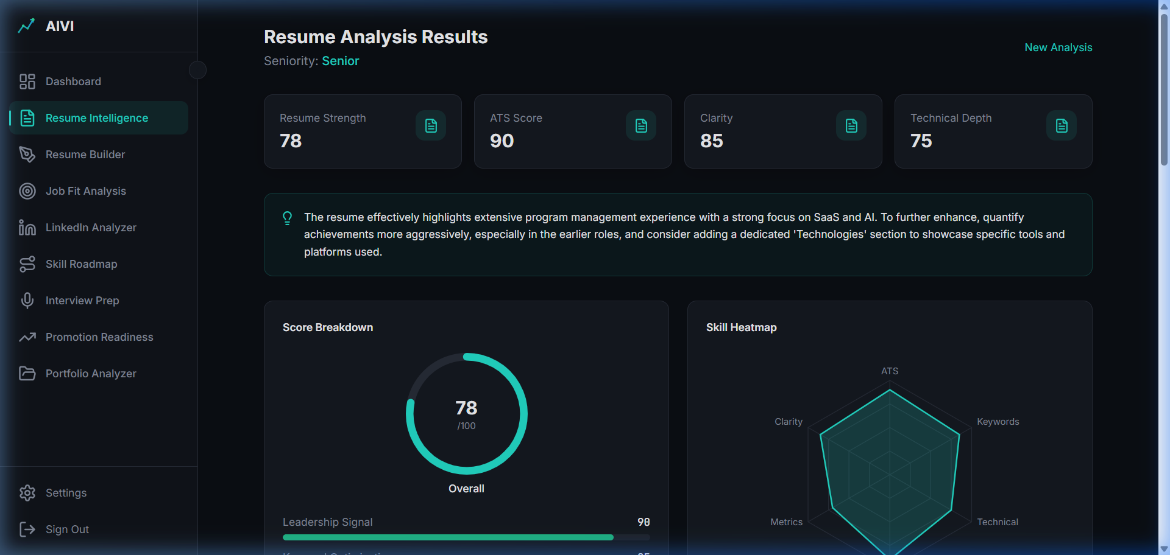
Figure 8 - Resume Score Breakdown
- Description: A deterministic rating engine providing immediate visual feedback on the resume's effectiveness.
- User Intent: Know exactly where the resume fails ATS scans and human review.

4.2 Technical Depth & Keyword Optimization
- Screenshot of the technical skills parsed and keyword suggestions in the Resume Analysis.
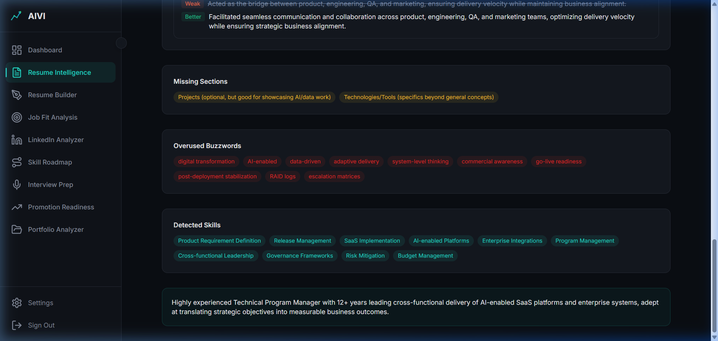
Figure 9 - Keyword Optimization
- Description: The system compares the resume against industry standards to find weak buzzwords and suggest high-value alternatives.
- User Intent: Ensure no critical hard skills are missing for their targeted seniority.

4.3 Weak Bullet Suggestions & Seniority Guidance
- Screenshot of the 'Areas for Improvement' or weak bullets section.
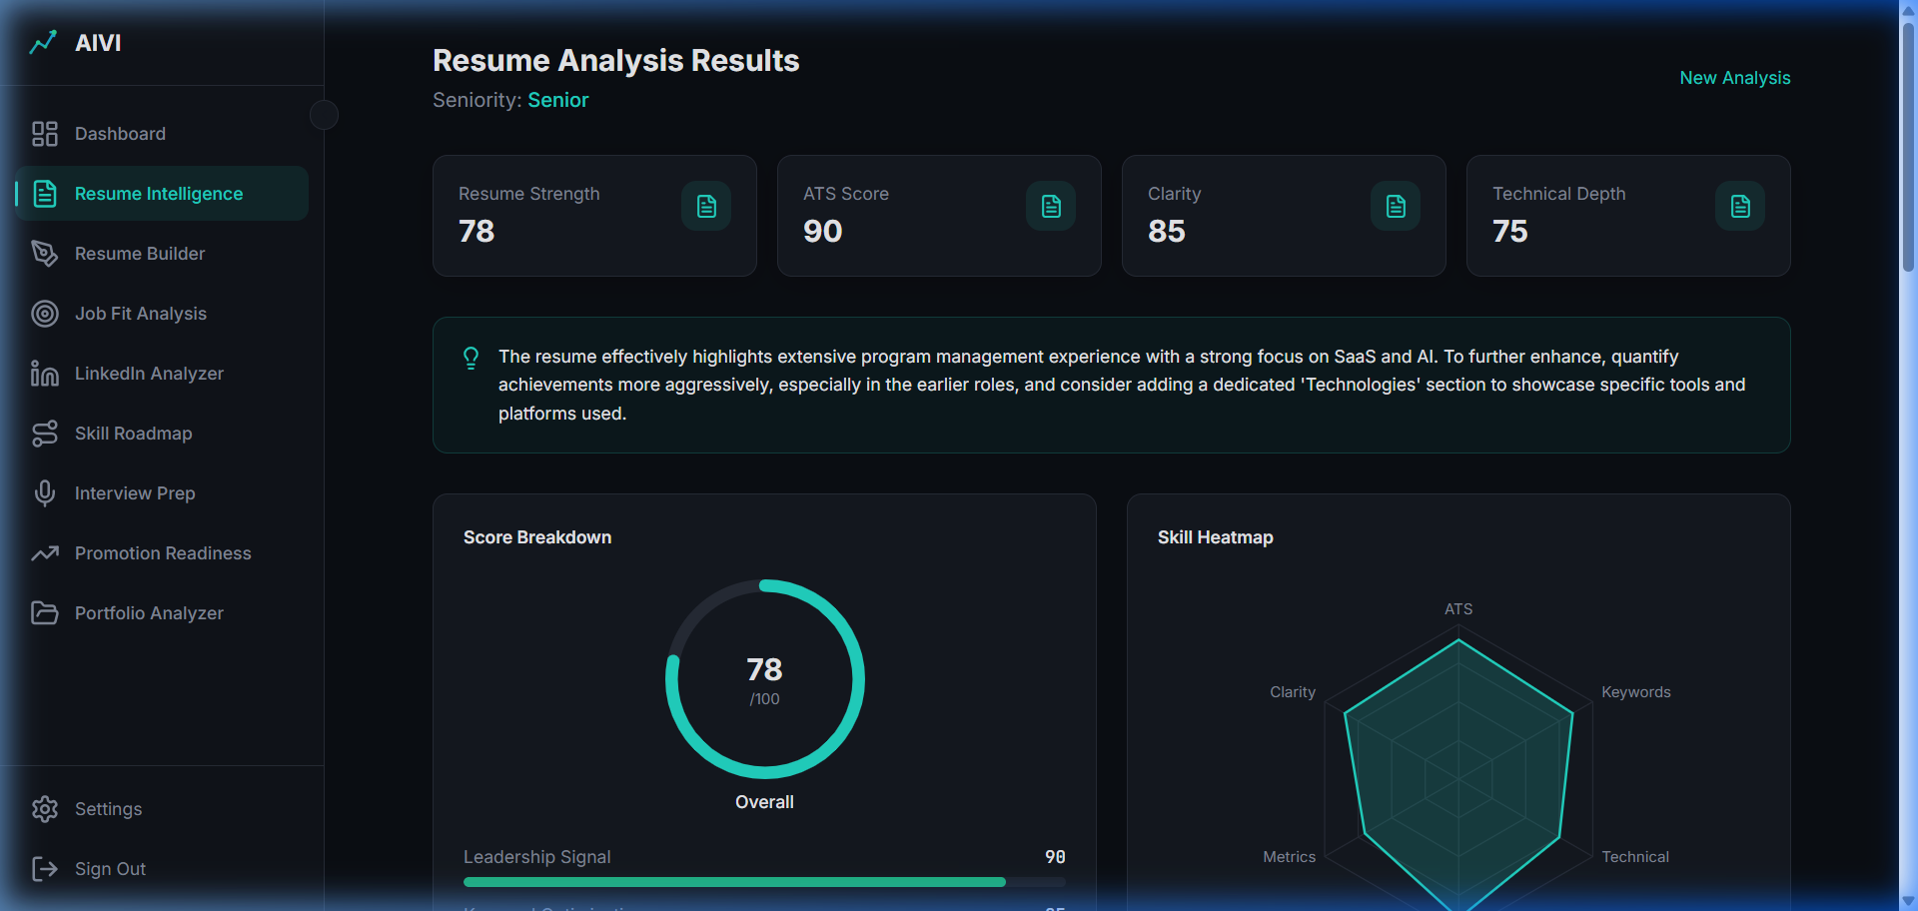
Figure 10 - Weak Bullet Suggestions
- Description: Pinpoints exactly which achievements lack quantification and what the detected seniority level is versus what it should be.
- User Intent: Get actionable advice on exactly what to rewrite.

Part 5: Resume Rebuild / Resume Builder Module (CRITICAL)

5.1 Resume Builder Interface & Loading State
- Full-page screenshot of the Resume Builder interface before generation.
- Screenshot of the 'Target Role' input field and loading state.
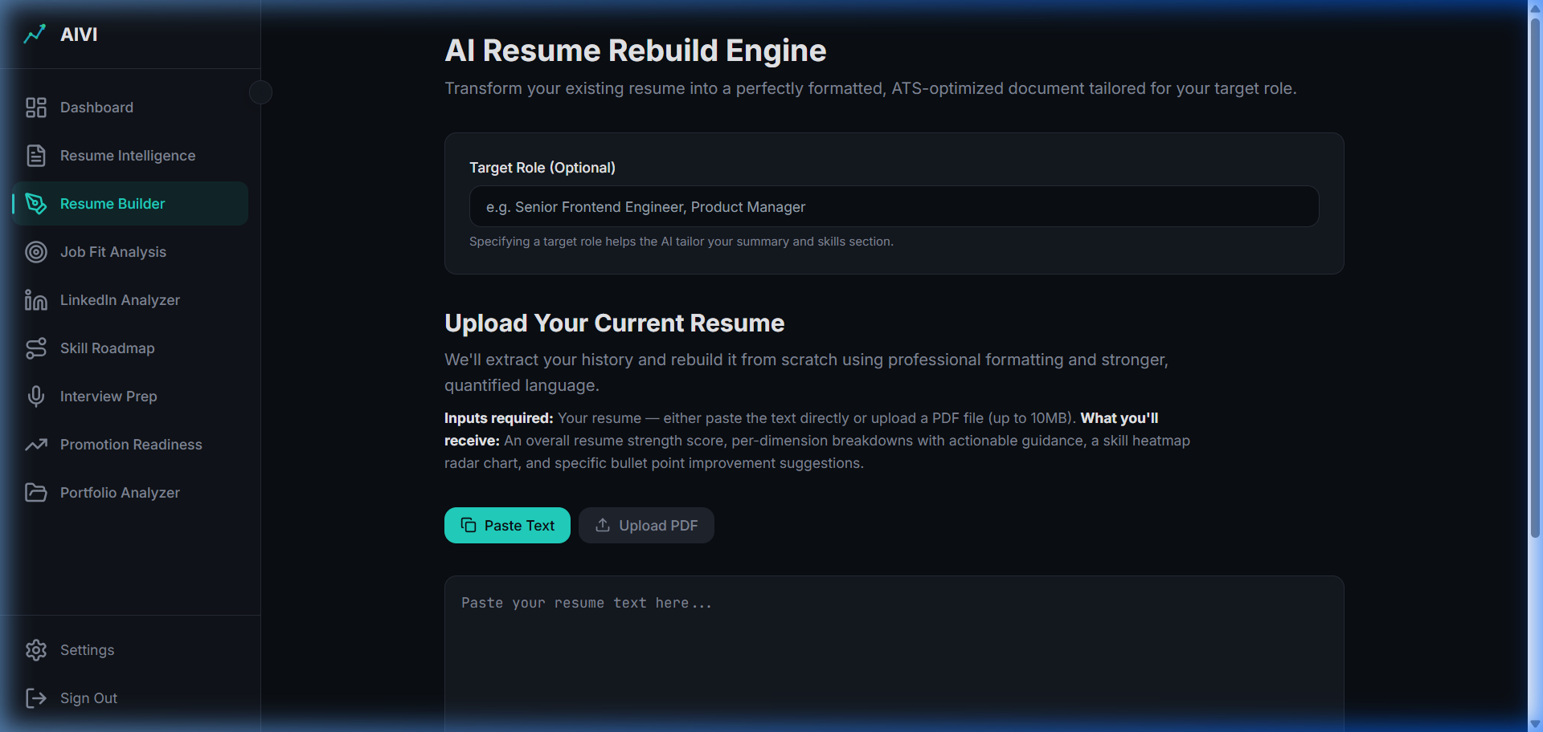
Figure 11 - Resume Builder Initial
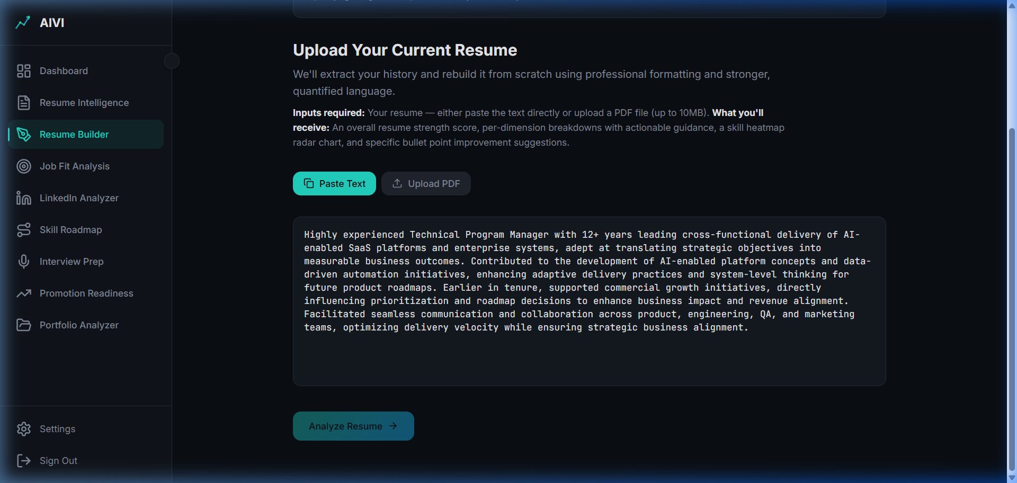
Figure 12 - Resume Builder Loading
- Description: A premium workflow where the user inputs their current resume and target job title. This initiates a deep regeneration phase instead of a simple review.
- User Intent: Transform an existing mediocre resume into a highly targeted, ATS-optimized version tailored to a specific job title.

5.2 Fully Rebuilt Output & Quantified Impact
- Screenshot of the fully rebuilt resume output.
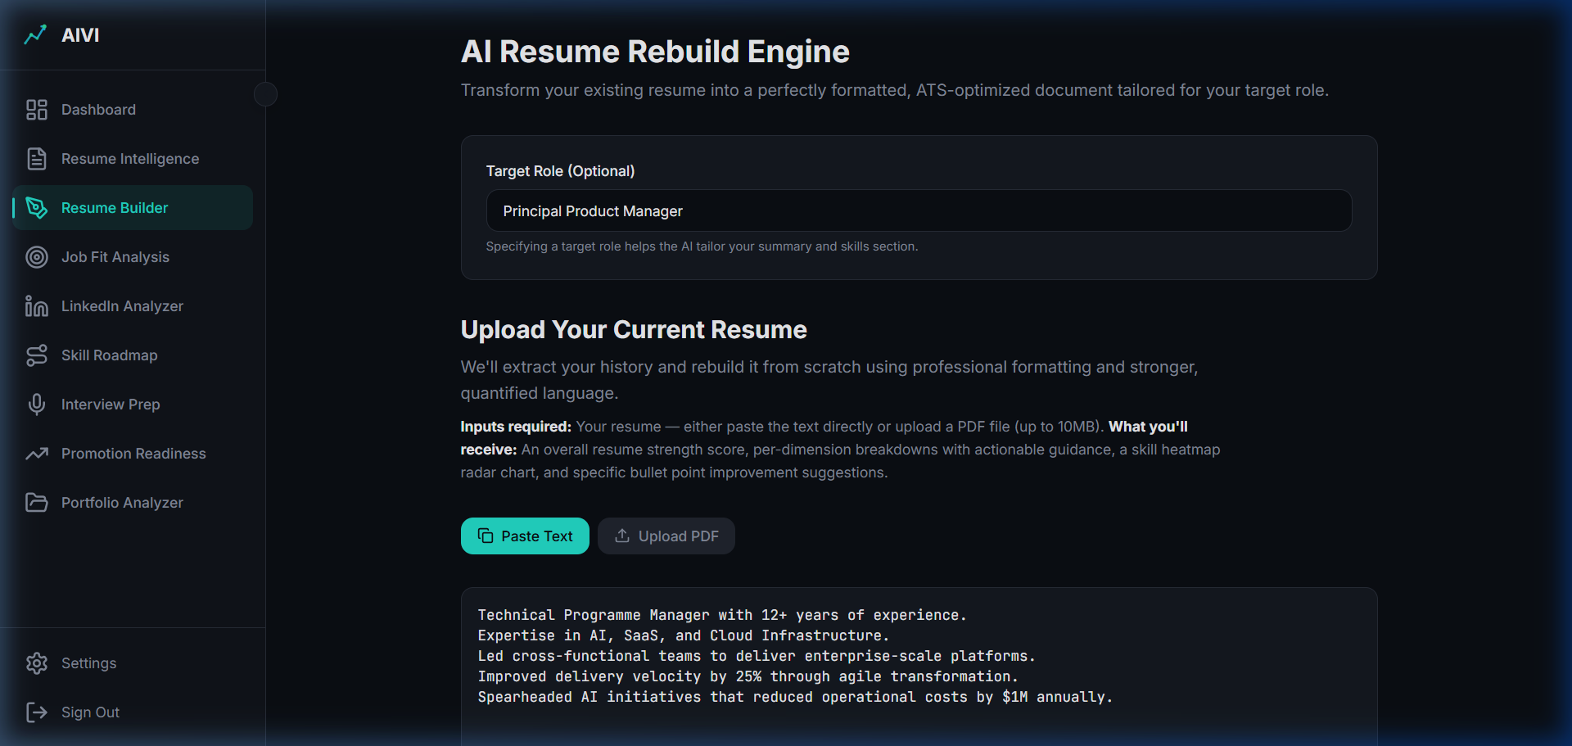
Figure 13 - Rebuilt Resume Output
- Description: This core paid feature does not merely rephrase text. It structurally improves bullet points by injecting context-aware keywords and expanding implied achievements into concrete numeric impacts.
- Strategic Use Case: Essential for users applying to specific high-competition roles where ATS keyword alignment is mandatory.

5.3 Version History & Paywall Friction
- Screenshot showing version saving and any regeneration paywall limitations.
- Description: Users can save different optimized versions for different job families. The ability to continually regenerate is gated behind the paid tier to sustain token costs and drive ROI up for premium users.
- How to Use Resume Builder:
- Upload current resume or select an existing one.
- Enter the specific Target Role.
- Review the newly quantified and ATS-optimized bullet improvements.
- Download or Save the version for direct application submission.

Part 6: Job Fit Analysis

6.1 Job Match Scoring
- Screenshot of the Job Fit Analysis result showing the Job Match %.
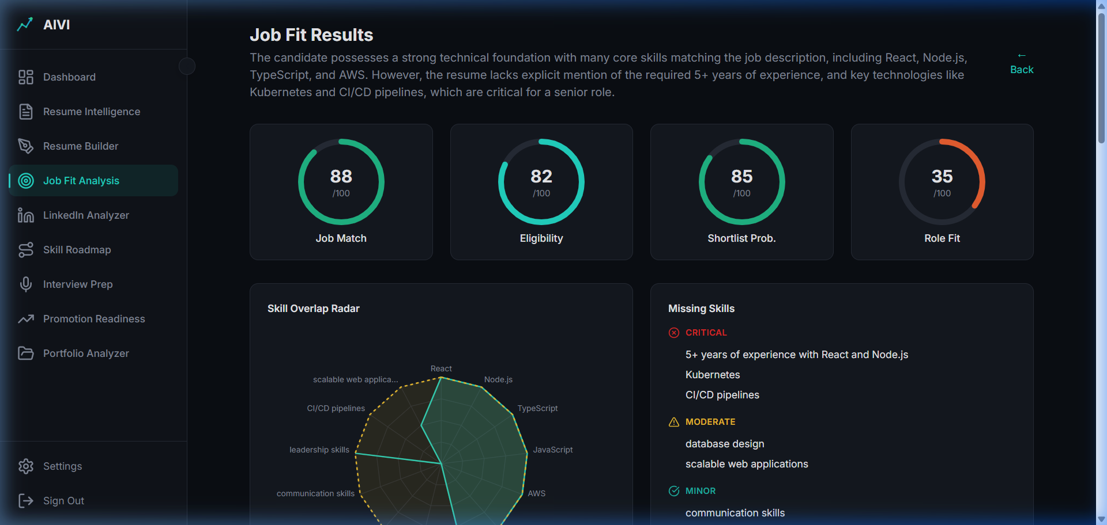
Figure 14 - Job Match Scoring
- Description: A deterministic engine comparing the parsed resume directly against a target Job Description.
- User Intent: Evaluate chances of getting an interview before spending time applying.

6.2 Missing & Matched Skills
- Screenshot of the Missing Skills and Tool Gaps comparison.
- Description: Clearly delineates which keywords the ATS will flag as missing, and any experience gaps identified.
- Strategic Usage: Use this gap list to either update the resume via Rebuild or pursue rapid upskilling.

Part 7: Skill Roadmap

7.1 Generated Career Roadmap
- Screenshot of the 30/60/90 day Skill Roadmap generated.
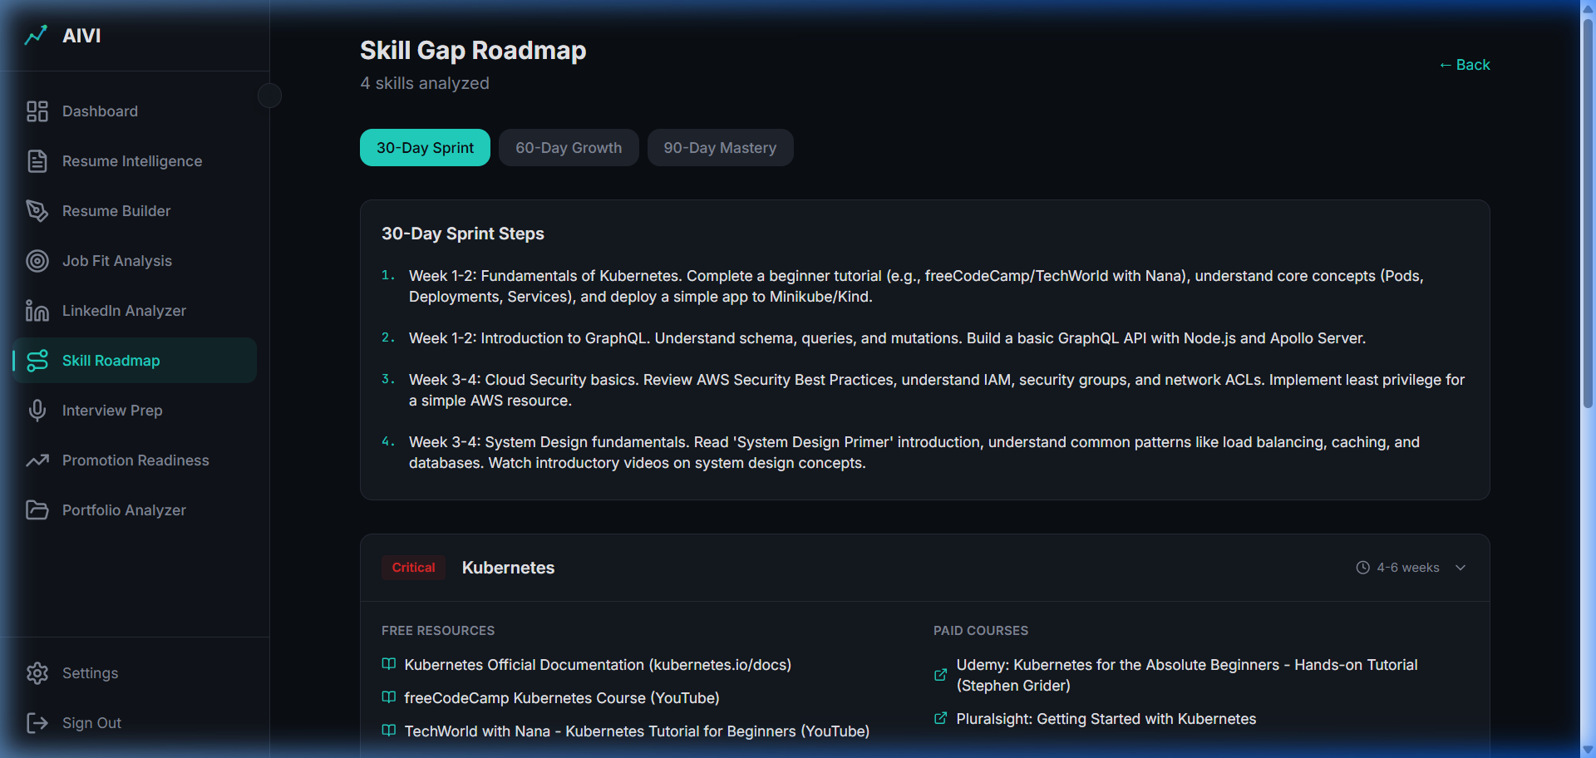
Figure 15 - 30 Day Roadmap
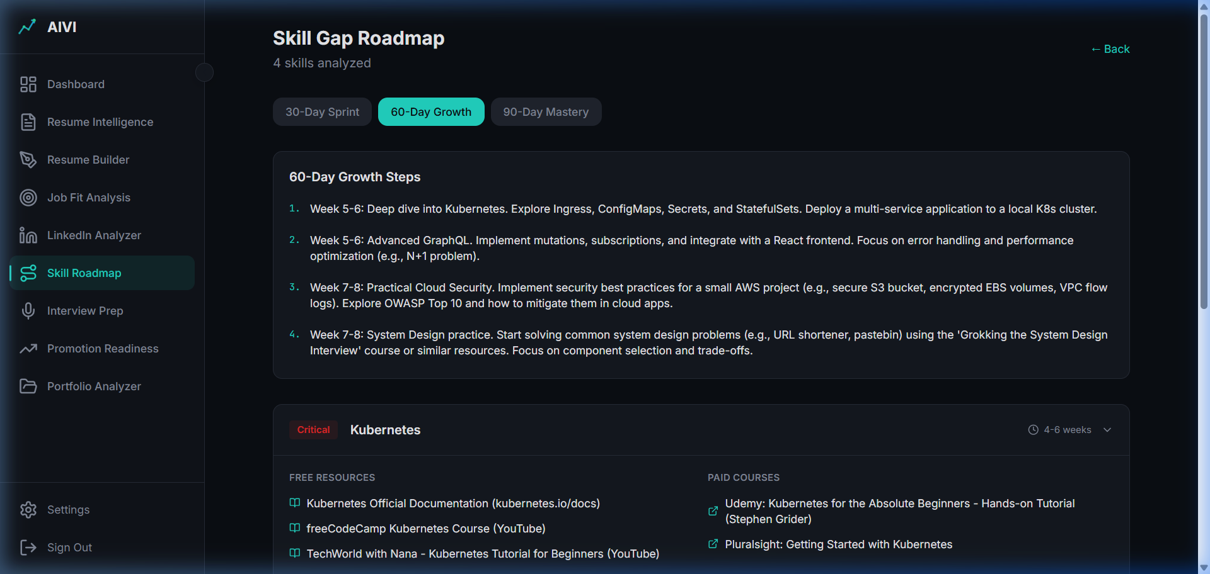
Figure 16 - 60 Day Roadmap
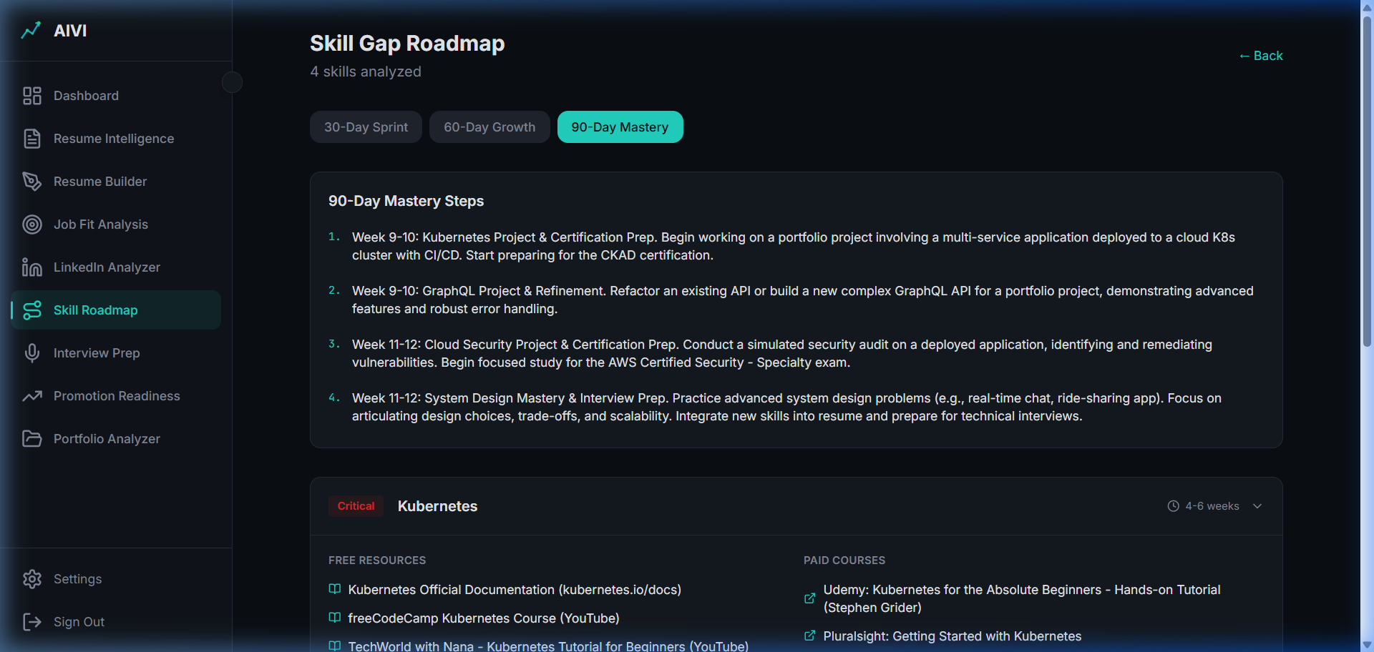
Figure 17 - 90 Day Roadmap
- Description: AI generates a personalized curriculum to bridge the exact gaps identified in the Job Fit Analysis.
- Practical Application: Users transition from identifying their weaknesses to actively fixing them via actionable timelines.

Part 8: Interview Intelligence

8.1 Categorized Interview Questions
- Screenshot of the Interview Intelligence module showing Categorized Questions.
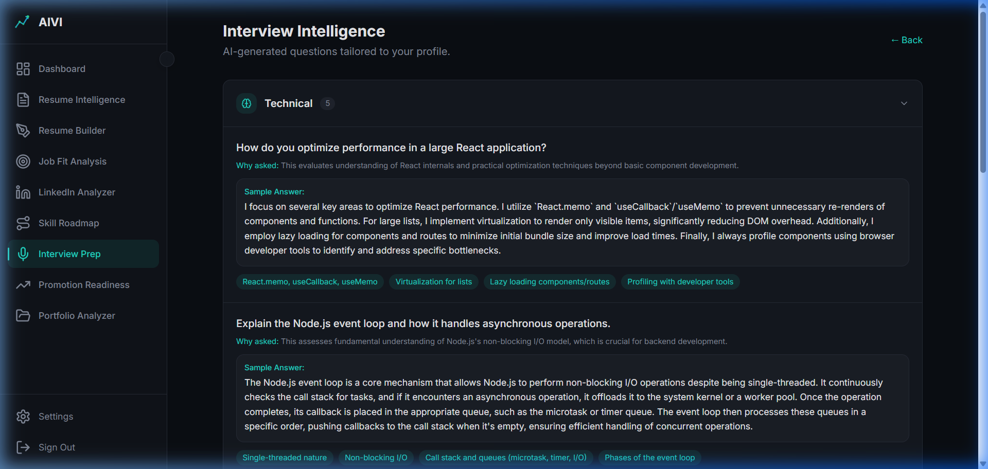
Figure 18 - Categorized Questions 1
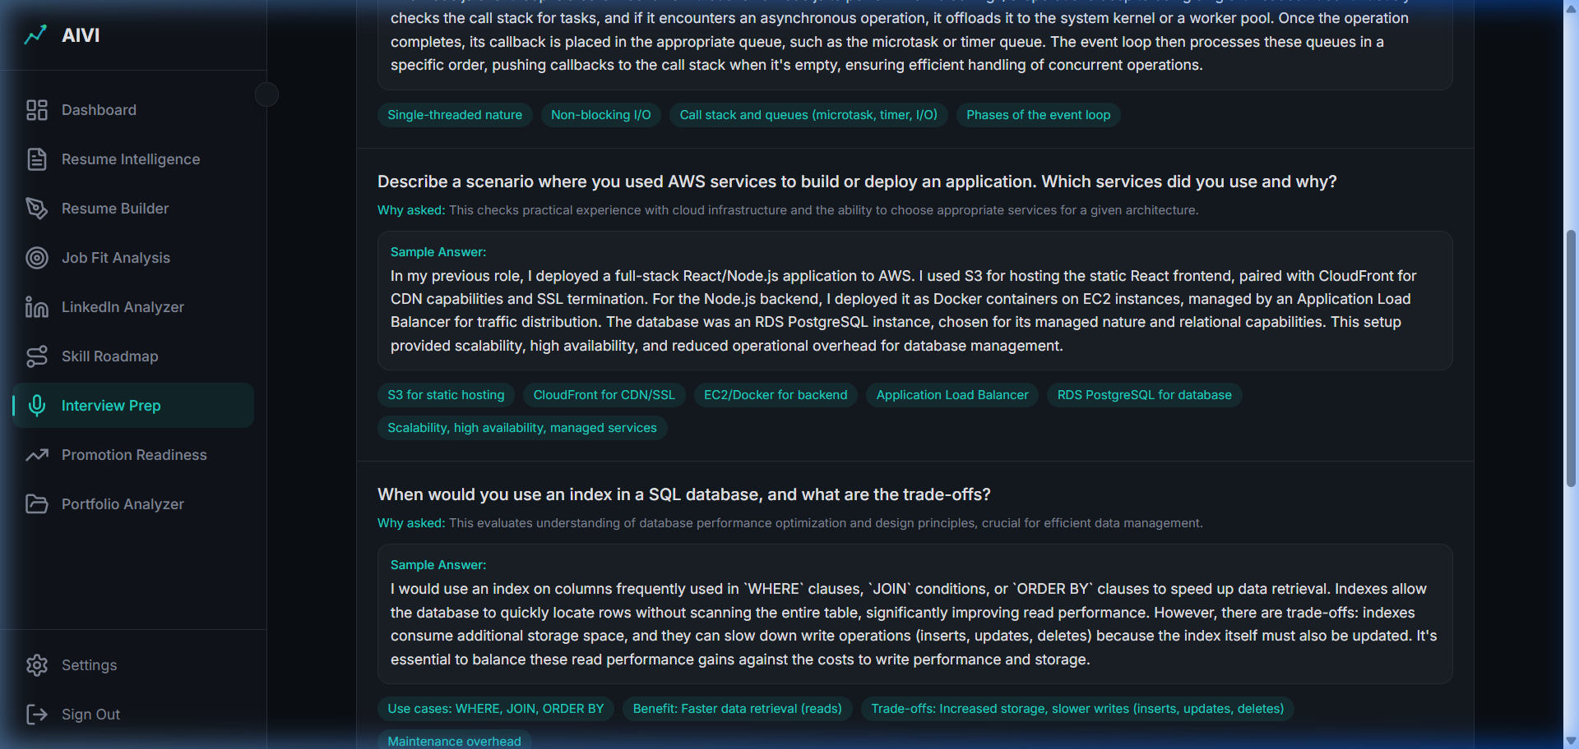
Figure 19 - Categorized Questions 2
- Description: Generates structured, role-specific behavioral and technical interview questions based on the resume and target role.
- User Preparation: Moves beyond generic AI chat to structured interview drilling.

Part 9: Promotion Readiness

9.1 Readiness Score & Gap Analysis
- Full section screenshot of Promotion Readiness.
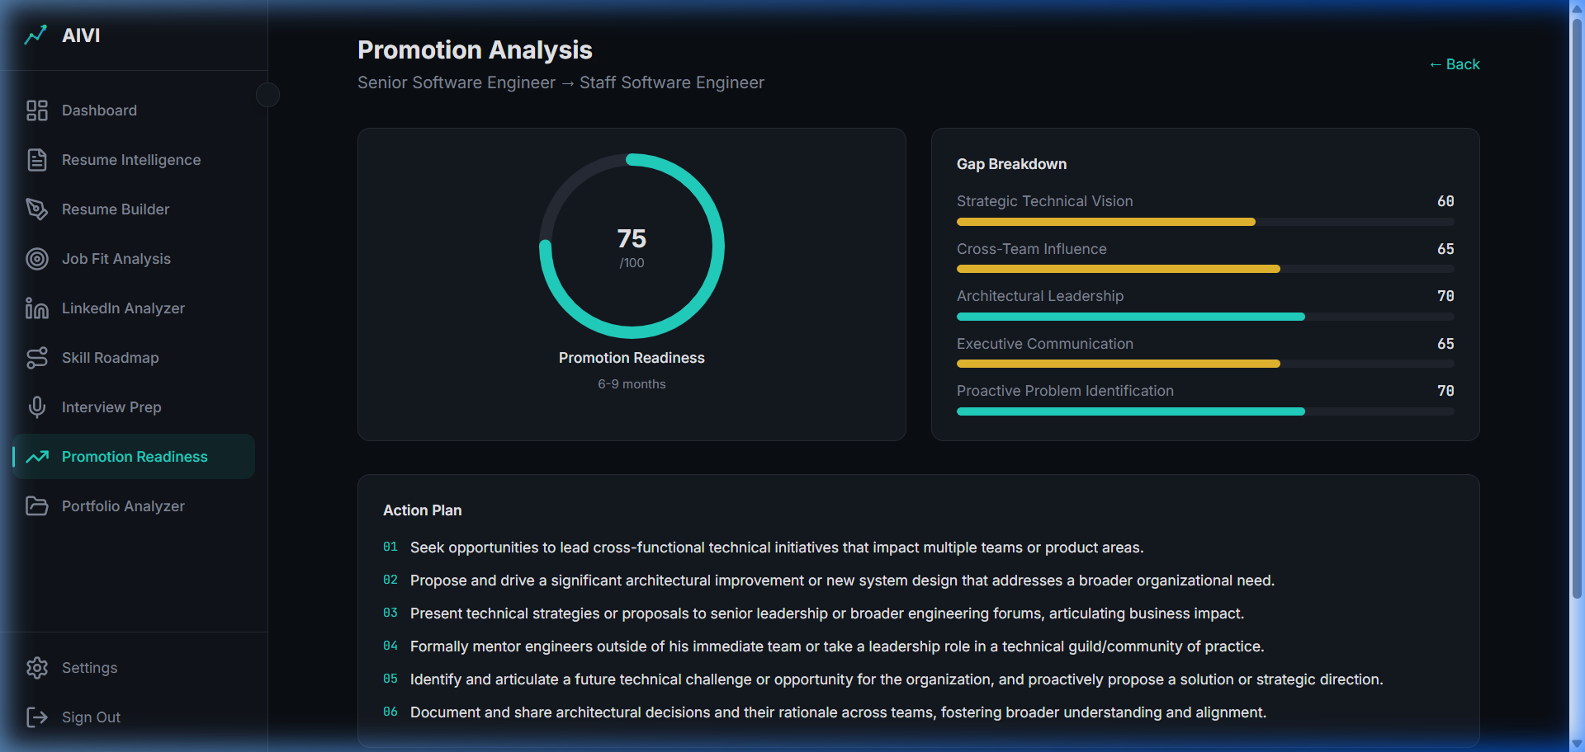
Figure 20 - Promotion Readiness
- Description: Positions the user for internal advancement by analyzing current impact versus next-level requirements.
- Positioning Strategy: Helps employed users negotiate titles and salary bumps internally.

Part 10: Portfolio Analyzer

10.1 Portfolio Scoring Logic
- Screenshot of the Portfolio Analyzer results.
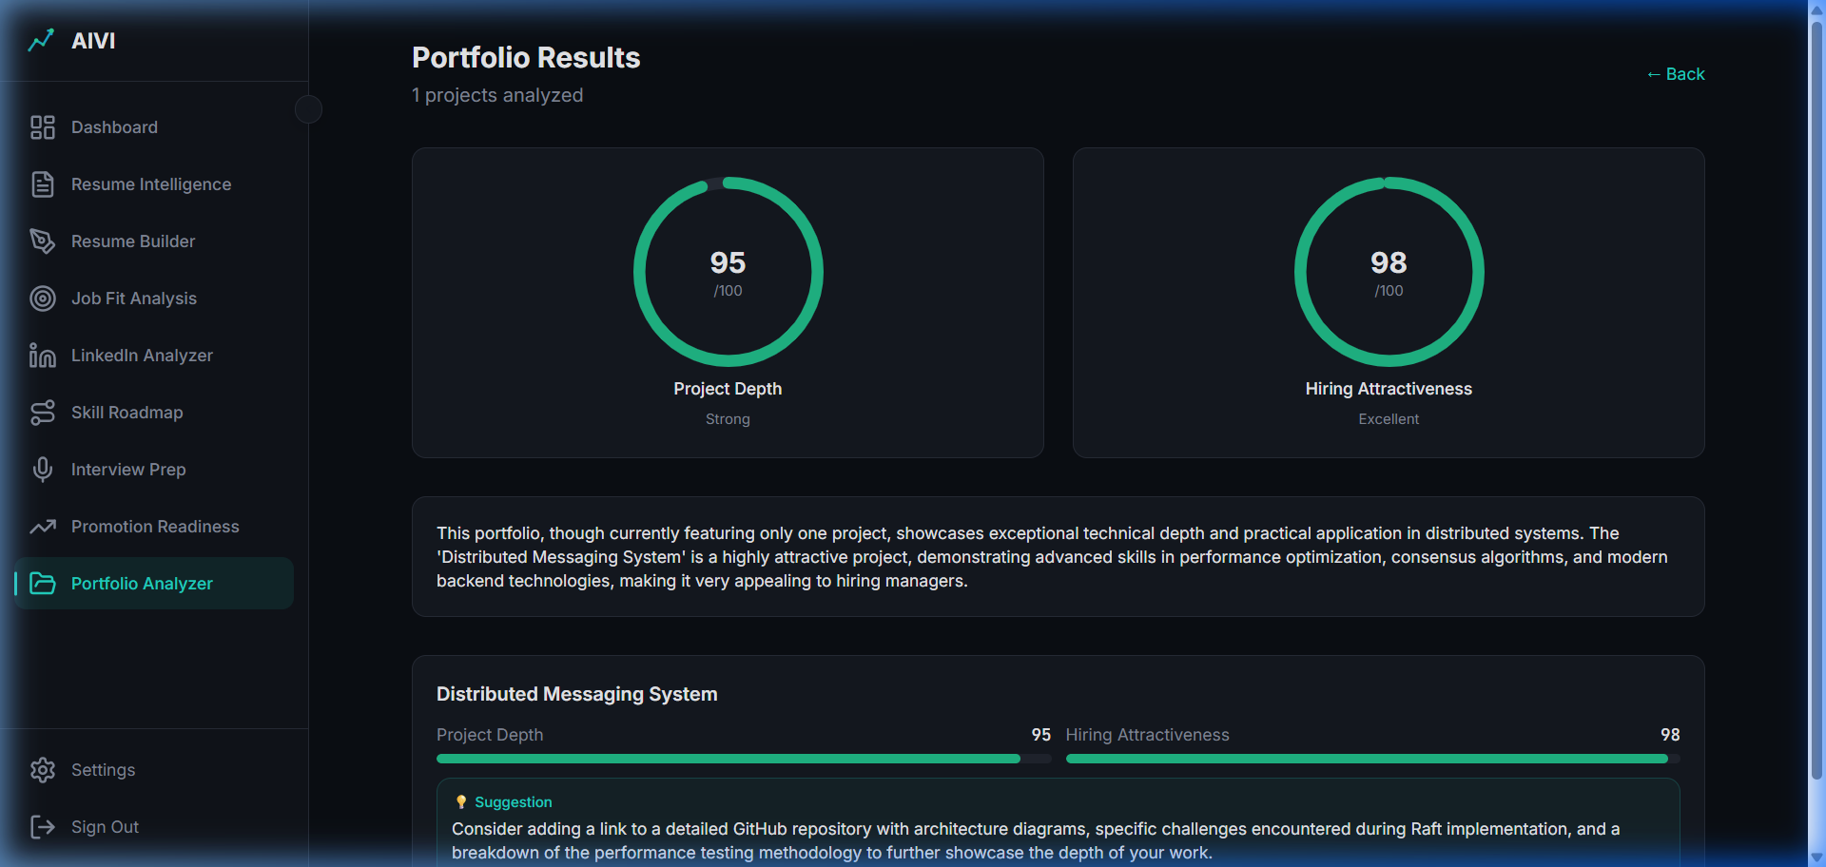
Figure 21 - Portfolio Analyzer
- Description: Reads project repositories or portfolio links to grade the visible proof of work.
- Scoring Logic: Grades based on technical complexity (Depth) and presentation (Attractiveness).

Part 11: LinkedIn Analyzer

11.1 Profile Optimization
- Screenshot of LinkedIn input and Optimization Output.
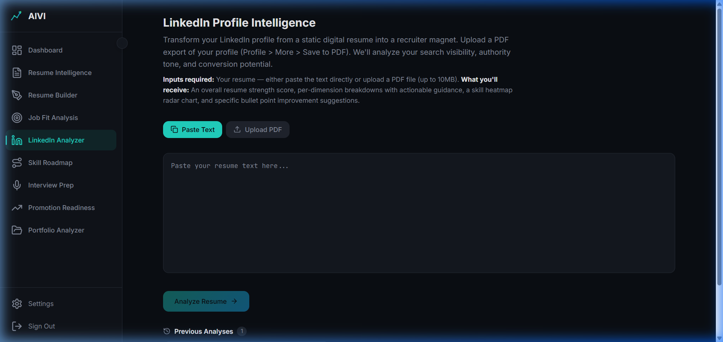
Figure 22 - LinkedIn Input
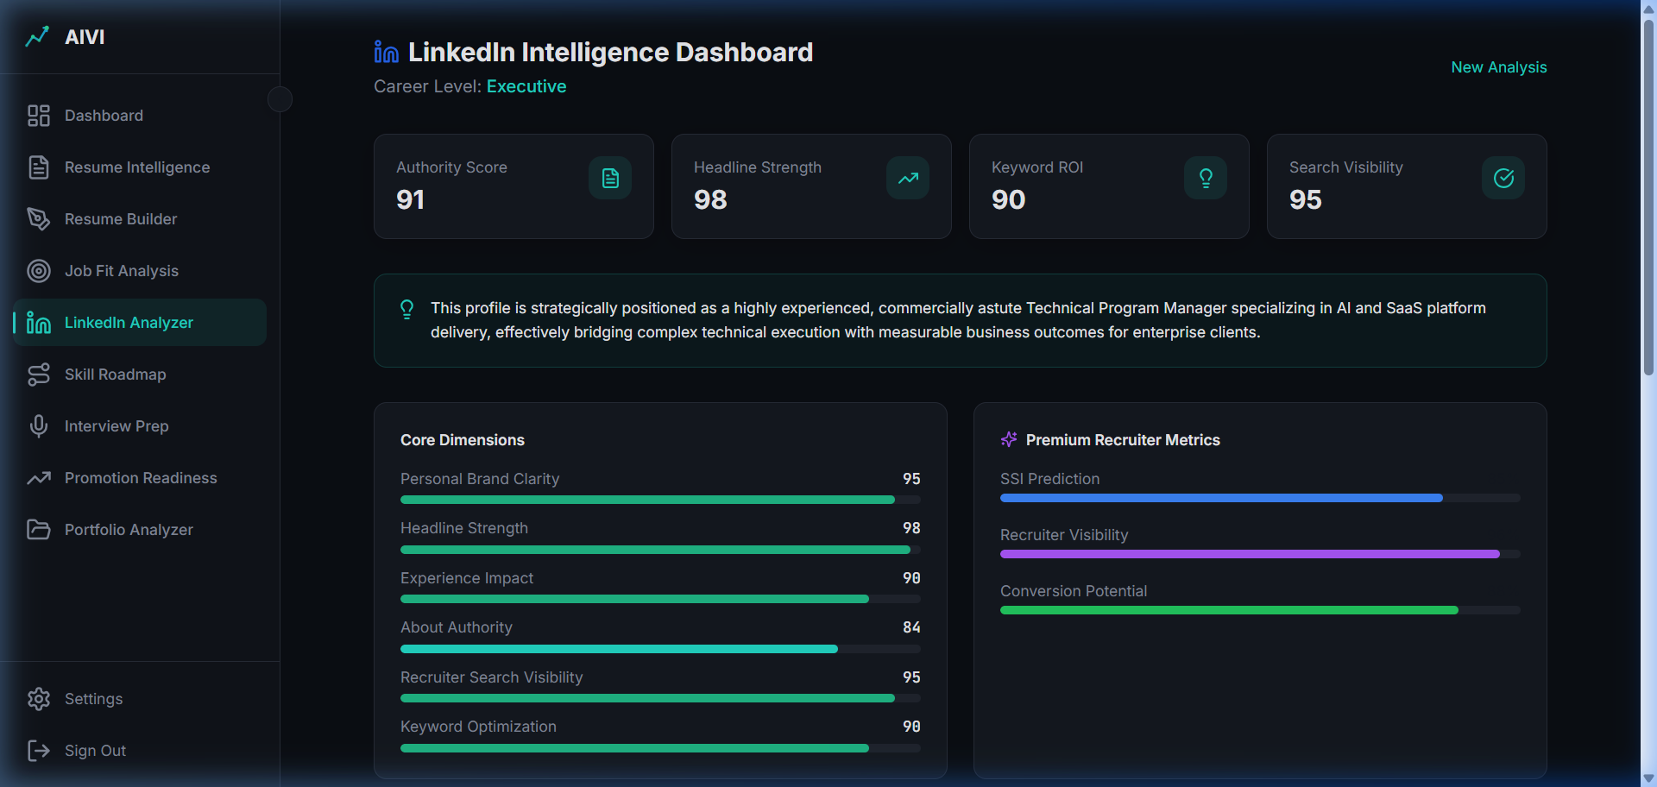
Figure 23 - LinkedIn Output
- Description: Extends resume intelligence to the public LinkedIn profile to increase inbound recruiter traffic.

Part 12: Plan Gating & Paywall

12.1 Monetization Structure
- Screenshot of the Upgrade Modal or Regenerate Restriction for free-tier users.
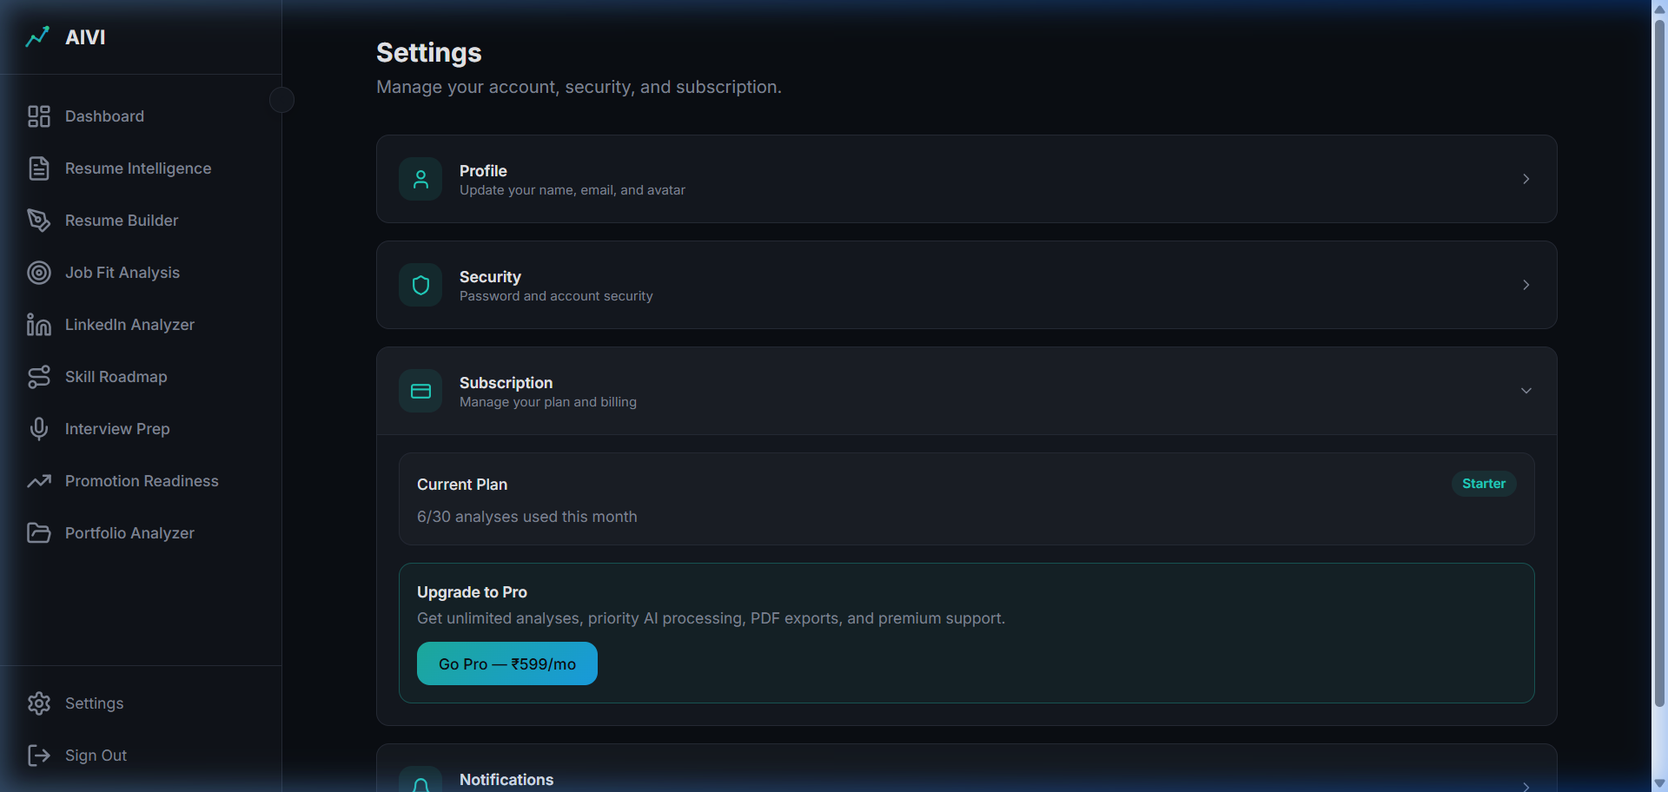
Figure 24 - Subscription Status
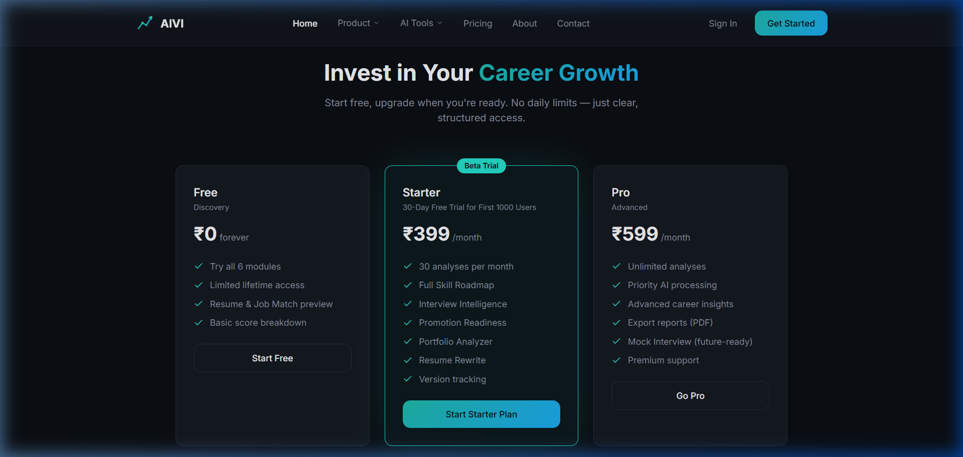
Figure 25 - Pricing Comparison
- Description: Demonstrates the freemium token model, how free runs exhaust, and the conversion funnel to the paid plan.

Part 13: Admin Dashboard

13.1 Usage & Cost Tracking
- Screenshot of the Admin Dashboard.
> *Note: Admin dashboard was inaccessible with the provided credentials. The route `/admin` returned a 404.*
- Description: Internal control center for monitoring token spend against Gemini APIs and managing trial statuses.

Conclusion
The AIVI Career Intelligence platform demonstrates a highly robust, feature-complete suite of tools designed to optimize the job-seeking process. The core value loop from Resume Builder to Job Fit, coupled with intelligence features like Interview Prep and Skill Roadmaps, positions AIVI as an essential, premium utility for career growth.

