CHAPTER 1

INTRODUCTION
  - Motivation
In today’s digital era, managing daily financial expenses has become a challenging task for individuals, families, and groups. Many people still depend on manual methods such as notebooks or simple mobile notes to record their expenses, which often results in inaccurate records and difficulty in tracking shared expenses. These traditional methods lack structured reporting, proper expense splitting mechanisms, and clear tracking of given and received amounts between individuals. As a result, financial transparency decreases and budgeting becomes less effective and inefficient.
The main objective of this document is to present the requirements and overall structure of the project TrackMyMoney – The Complete Expense Tracker. This document describes the Software Requirements Specification (SRS) of the system and outlines its key features and functionalities. It is intended for project managers, developers, testers, and end users. The reader is expected to have basic knowledge of mobile applications and financial management concepts.

  - Project Scope
This project aims to develop a mobile-based expense tracking application that digitizes and simplifies personal and shared expense management. The system provides three major modules: Personal Expense, Dual Expense, and Group Expense management. Users can record daily expenses, generate monthly and yearly reports, track shared expenses between two individuals, and split group expenses among multiple participants accurately.

  - Project Stakeholders
The project stakeholders for this document are:
- Software Project Managers
- Software Engineers
- Software Developers
- End Users (Individuals and Groups using the application)

  - Project Scheduling
Phase | Tasks | Duration
Week 1-2 | Requirement Analysis & Feasibility Study | 2 Weeks
Week 3 | System Design (ERD, DFD, UML Diagrams) | 1 Week
Week 4-6 | Database Design & Setup (SQLite) | 3 Weeks
Week 7-10 | Frontend Development (Flutter UI Design) | 4 Weeks
Week 11-14 | Backend Logic Implementation & State Management | 4 Weeks
Week 15-16 | Integration & Testing | 2 Weeks
Week 17 | Deployment & Documentation | 1 Week
Week 18 | Final Review & Submission | 1 Week

CHAPTER 2

SYSTEM ANALYSIS

  - Introduction
TrackMyMoney – The Complete Expense Tracker is a mobile-based application developed to replace traditional manual expense tracking methods with a structured digital system. The application enables users to record, monitor, and analyze personal, dual, and group expenses efficiently. It is designed as a lightweight mobile application suitable for individuals, friends, families, and small groups. The system stores financial data locally and provides organized reports to help users understand their spending behavior and manage their budget effectively.

  - Requirement Analysis
    - Functional Requirement
End User

- Personal Expense Module:
  - Add Personal Expense: User can add daily expense entries.
  - Update Expense: User can edit existing expense records.
  - Delete Expense: User can remove incorrect entries.
  - View Expense: User can see daily expense list.
  - View Reports: User can see and generate monthly and yearly expense reports.
- Dual Expense Module:
  - Add Dual Expense: User can record shared expenses between two individuals.
  - Track Given/Received Amount: System maintains balance between two users.
  - Update/Delete Dual Records: User can modify or remove entries.
  - View Dual Summary: User can see total balance status.
- Group Expense Module:
  - Create Group: User can create a group and add participants.
  - Add Group Expense: User can record group transactions.
  - Split Expense: System automatically splits expenses among participants.
  - View Group Summary: User can view total group balance and individual shares.

    - Non-Functional Requirement
Performance Requirements
- The system should respond quickly while adding, updating, or deleting expense records.
- Report generation (monthly and yearly) should take minimal time.
- The application should run smoothly on standard Android devices without lag.

Scalability
- The system should support an increasing number of expense records without affecting performance.
- The local database should efficiently handle large amounts of transaction data.

Usability
- The application should provide a simple and user-friendly interface.
- Navigation between Personal, Dual, and Group modules should be easy and intuitive.
- Users should be able to access reports and summaries without complex steps.

Reliability
- The system should store expense data accurately in the local database.
- The application should prevent data loss during normal usage.

    - Software & Hardware Requirements
User | Particulars | Client System | Server System
End User  (Mobile App) | Operating System | Android 5.0 and above
End User  (Mobile App) | Processor | Octa Core (Minimum)
End User  (Mobile App) | Enteral Memory | 100 MB (Minimum)
End User  (Mobile App) | RAM | 2 GB (Minimum)

  - Design and Implementation Constraints
The system is designed to work offline using local database storage.
The application uses setState for state management, which limits scalability for very large applications.
Users must maintain the confidentiality of their login credentials.
The system currently supports Android platform only.

  - Assumptions and Dependencies
- The user has a compatible Android device.
- The application depends on proper local database functioning.
- Each user maintains individual login credentials.
- The system assumes that users enter correct and accurate expense data.

CHAPTER 3

SYSTEM DESIGN

  - UML Diagram
    - Data-Flow Diagram
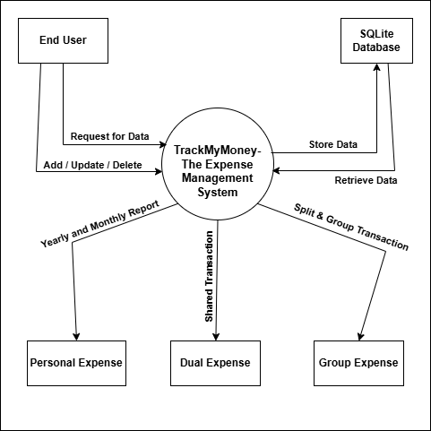
Figure 3.1.1.1 context diagram of expense management system

    - Use-case Diagram
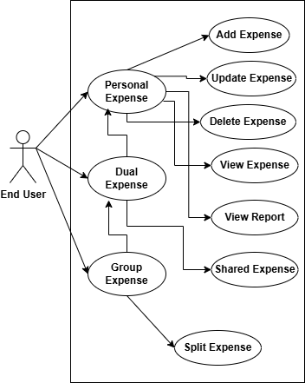
Figure 3.1.2.1 Use case diagram of expense management

    - Use-case Scenarios

Add Personal Expense
Abbreviated Title | Add Personal Expense
Actors | Personal User
Description | Allows user to add and categorize personal expenses.
Pre-Conditions | User must have select personal expense.
Task Sequence | - User selects "Add Expense".  - System displays expense entry form.  - User enters amount, category, date, description.  - User clicks Save.  - System stores expense details.
Post Conditions | Expense is added to personal expense list and updated in dashboard summary.
Exception | If required fields are empty, system displays validation error.

Give / Receive Money (Dual Account)
Abbreviated Title | Transfer / Settle Money
Actors | Primary User, Secondary User
Description | This use case allows one user in a Dual Account to give or receive money from the other user to settle shared expenses. The system updates balances automatically.
Pre-Conditions | Both users must be connected.  There must be an outstanding balance between users.
Task Sequence | - System displays current balance (who owes whom).  - User clicks "Settle / Transfer Money".  - User enters amount paid.  - User confirms transaction.  - System validates amount.  - System updates balance and transaction history.
Post Conditions | - Balance between both users is updated.  - Transaction is recorded in settlement history.  - If full payment is made, status changes to "Settled".
Exception | If entered amount is greater than outstanding balance, system displays validation error.  If no outstanding balance exists, system displays "No pending amount to settle".

Create Group
Abbreviated Title | Create Group
Actors | Group Admin
Description | Allows user to create a group for managing expenses among multiple participants.
Pre-Conditions | -
Task Sequence | - User selects "Create Group".  - Enters group name.  - Adds participants via email.  - System sends invitations.  - Members accept invitation.
Post Conditions | Group is created and visible in dashboard.
Exception | If participant email is invalid, system displays error message.

Add Group Expense (Split Among Participants)
Abbreviated Title | Add Group Expense
Actors | Group Admin,Group Members
Description | Allows adding expense in a group and splitting among selected participants.
Pre-Conditions | Group must exist and user must be a member.
Task Sequence | - User selects group.  • Clicks "Add Expense".  • Enters amount and description.  • Selects participants involved.  • Chooses split type (Equal/Percentage/Custom).  • System calculates share for each participant.  • User confirms and saves.
Post Conditions | Expense recorded and individual balances updated automatically.
Exception | If no participants selected, system displays error message.

View Expense Summary / Reports
Abbreviated Title | View Reports
Actors | User
Description | Allows user to view expense summary, monthly reports, and balance details.
Pre-Conditions | User must be have expense records.
Task Sequence | - User selects "Reports" or "Dashboard".  - System generates summary (Total spent, Category-wise, Group balances).  - User filters by date/category/group.
Post Conditions | User can analyze expenses and download report (optional).
Exception | if no data available, system displays "No records found".

Settle Balance (Group/Dual)
Abbreviated Title | Settle Balance
Actors | Group Member / Dual User
Description | Allows users to mark payments as settled between participants.
Pre-Conditions | Outstanding balance must exist.
Task Sequence | - User selects "Settle Up".  - Enters amount paid.  - Confirms settlement.  - System updates balance records.
Post Conditions | Balance updated and marked as settled.
Exception | If amount exceeds pending balance, system shows validation error.

    - Activity Diagram
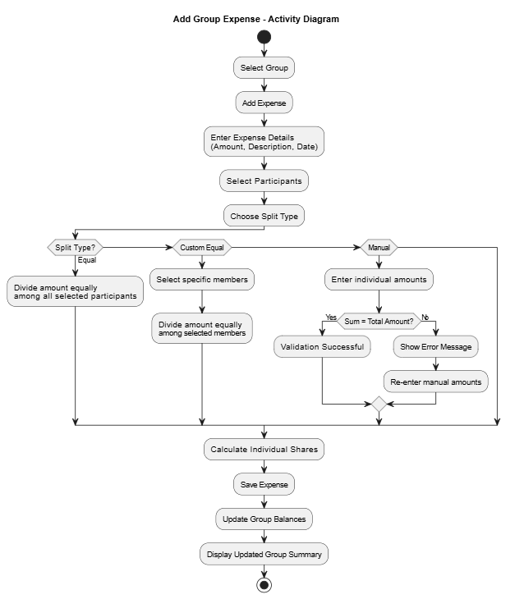
Figure 3.1.4.1 Activity diagram for Add group expense
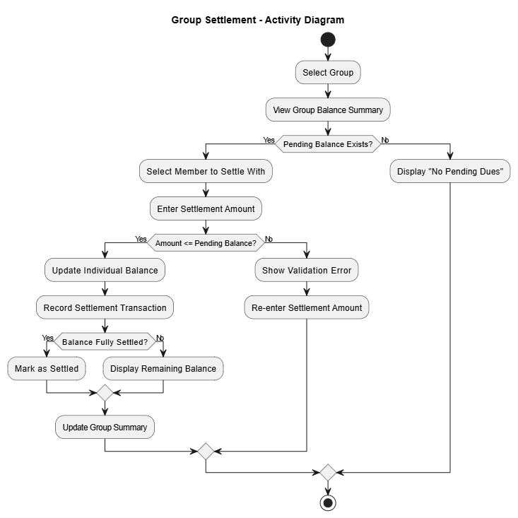
Figure 3.1.4.2 Activity diagram for settelment

    - Sequence Diagram
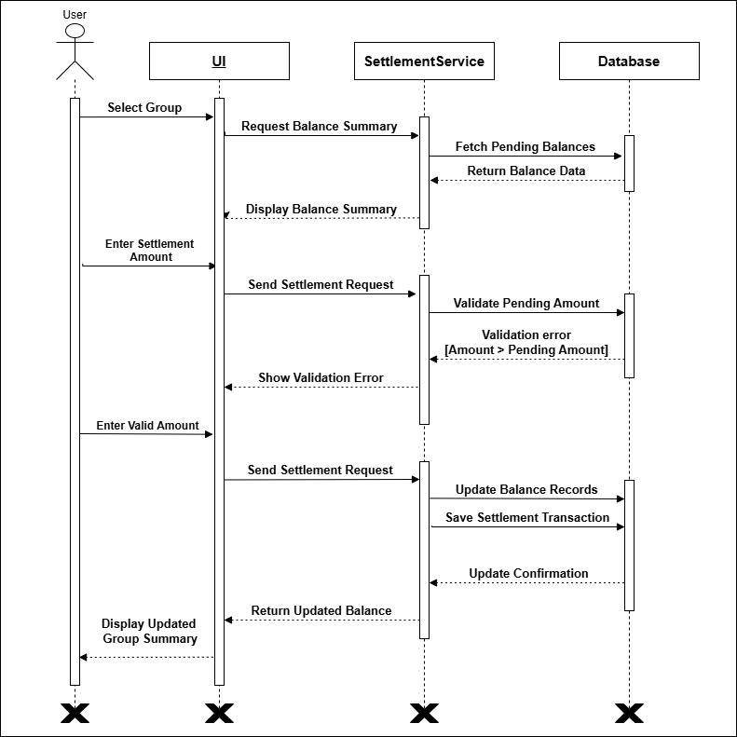
Figure 3.1.5.1 Sequence diagram for group diagram
    - State Diagram
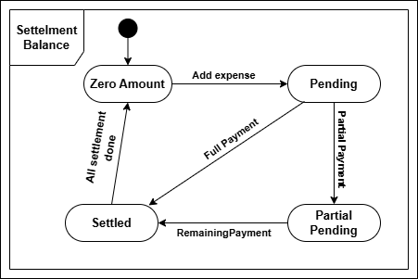
Figure 3.1.6.1 State diagram of Balance
    - Class Diagram
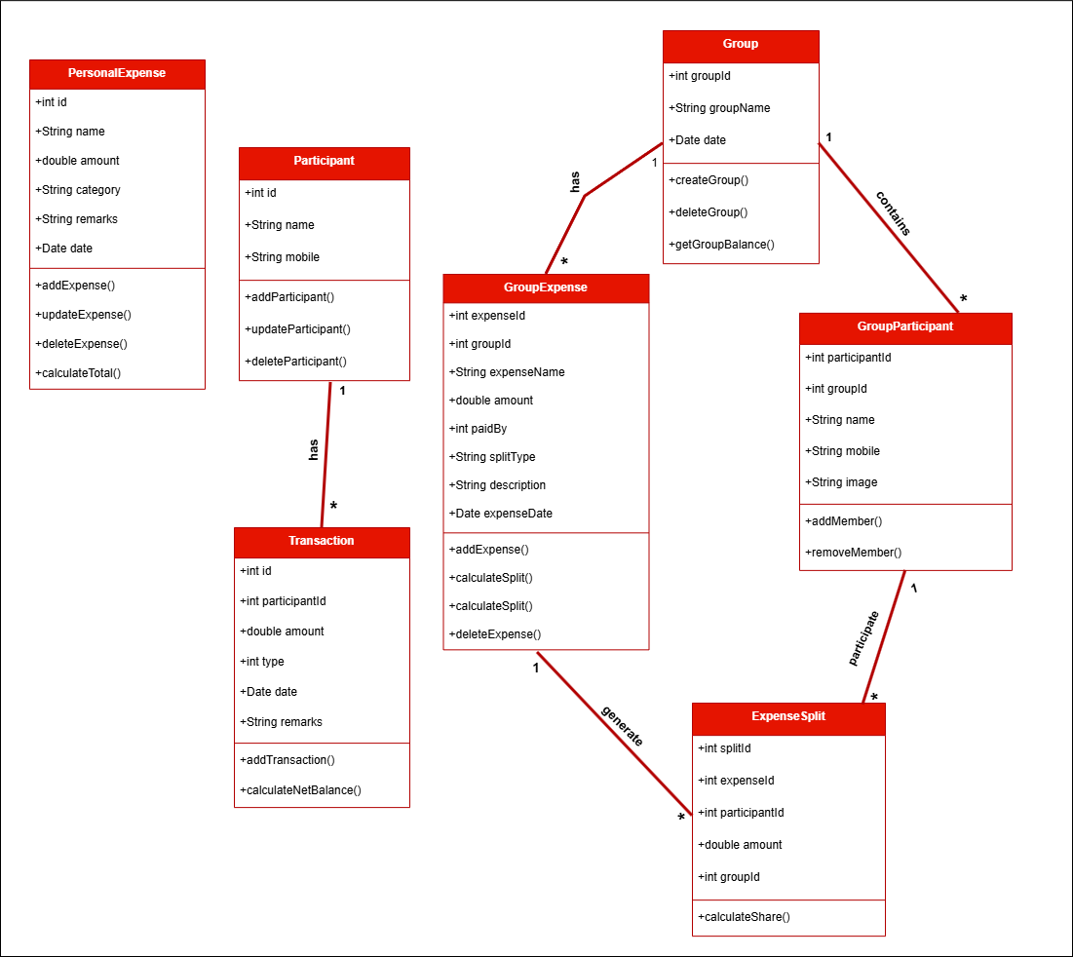
Figure 3.1.7.1 Class diagram of Expense Management System

  - Database Design
    - Database Schema

      - Database 1: Personal Expense Database
Table 1: Expenses
Column | Data Type | Null | Keys & Constrains | Default Value & Description
Id | INTEGER | NN | PK (Auto Increment) | Unique expense ID
Name | TEXT | AN | — | Name of expense
Amount | REAL | AN | — | Expense amount
Category | TEXT | AN | — | Expense category (Food, Travel, etc.)
Remarks | TEXT | AN | — | Additional notes
Date | TEXT | AN | — | Date of expense (ISO Format)
Table 3.9.1 Table: Expenses
      - Database 2: Dual Transaction Database
Table 2: Participants
Column | Data Type | Null | Keys & Constrains | Default Value & Description
Id | INTEGER | NN | PK (Auto Increment) | Unique participant ID
Name | TEXT | NN |  | Participant name
Mobile | TEXT | AN |  | Contact number
Table 3.9.2 Table: Participants
Table 3: Transactions

Column | Data Type | Null | Keys & Constrains | Default Value & Description
Id | INTEGER | NN | PK (Auto Increment) | Unique transaction ID
ParticipantId | INTEGER | NN | FK → Participants(id) | Reference to participant
Amount | REAL | AN |  | Transaction amount
Type | INTEGER | AN |  | 1 = Given, -1 = Received
Date | TEXT | AN |  | Transaction date (ISO 8601)
Remarks | TEXT | NN |  | Additional notes
Table 3.9.3 Table: Transactions

      - Database 3: Group Expense Database
Table 4: Groups
Column | Data Type | Null | Keys & Constraints | Default Value & Description
Group_Id | INTEGER | NN | PK (Auto Increment) | Unique group ID
Group_Name | TEXT | NN | — | Name of group
Date | TEXT | AN | — | Group creation date
Table 3.9.4 Table: Groups
Table 5: Group_Participants

Column | Data Type | Null | Keys & Constraints | Default Value & Description
Participant_Id | INTEGER | NN | PK (Auto Increment) | Unique participant ID
Group_Id | INTEGER | AN | FK | Associated group
Participant_Name | TEXT | NN | — | Participant name
Image | TEXT | AN | — | Profile image path
Mobile | TEXT | AN | — | Contact number
Table 3.9.5 Table: Group_Participants
Table 6: Group_Expenses
Column | Data Type | Null | Keys & Constraints | Default Value & Description
Expense_Id | INTEGER | NN | PK (Auto Increment) | Unique expense ID
Group_Id | INTEGER | NN | FK | Associated group
Expense_Name | TEXT | NN | — | Expense title
Amount | REAL | NN | — | Total expense amount
Paid_By | INTEGER | NN | FK | Person who paid
Split_Type | TEXT | NN | — | Equal / Custom / Manual
Description | TEXT | AN | — | Additional details
Expense_Date | TEXT | NN | — | Expense date
Table 3.9.6 Table: Group_Expenses

Table 7: Group_Expense_Splits
Column | Data Type | Null | Keys & Constraints | Default Value & Description
Split_Id | INTEGER | NN | PK (Auto Increment) | Unique split ID
Expense_Id | INTEGER | NN | FK | Related expense
Participant_Id | INTEGER | NN | FK | Participant involved
Amount | REAL | NN | — | Split amount
Group_Id | INTEGER | NN | FK | Associated group
Table 3.9.7 Table: Group_Expense_Splits

    - E-R Diagram
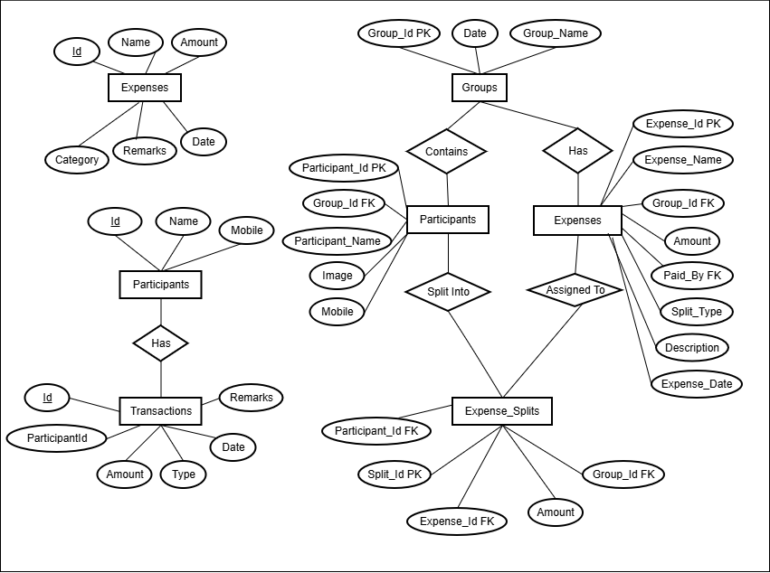
Figure 3.2.2.1 e-r diagram of expense management system

CHAPTER 4

IMPLEMENTATION

  - Module Design and Specification
    - Screen-1: Dashboard

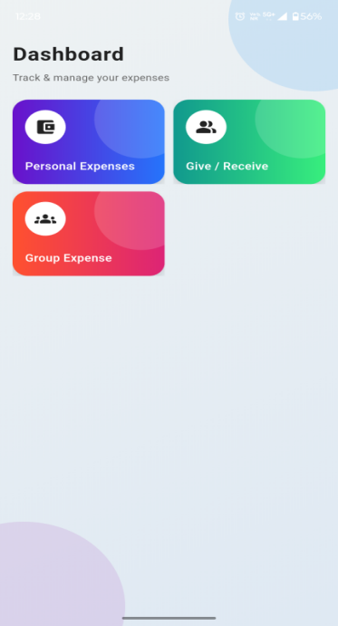
Figure 4.1.1 Screen-1: Dashboard

Purpose: This screen acts as the main dashboard of the TrackMyMoney system.
It allows the user to navigate to different expense management modules:Personal Expense, Dual Expense, Group Expense . The user selects a module by clicking the respective card.

Sr. | Screen Element | Input Type | O/M | Description
1 | Personal Expense Card | Card (Clickable) | M | Navigates user to Personal Expense module for managing personal expenses.
2 | Dual Expense Card | Card (Clickable) | M | Navigates user to Dual Expense module for tracking give/receive transactions between two users.
3 | Group Expense Card | Card (Clickable) | M | Navigates user to Group Expense module for managing shared expenses among multiple participants.

Table 4.1.1 Screen element of Dashboard

    - Screen-2: Personal Expense Screen

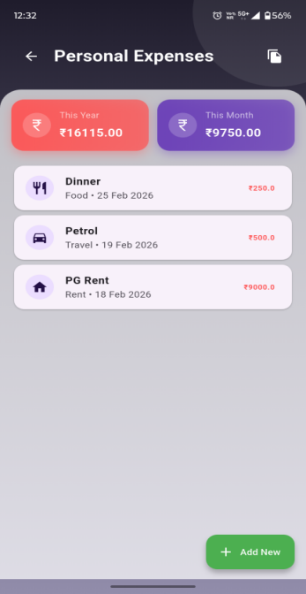
Figure 4.1.2 Screen-2: personal expenses screen

Purpose: This screen allows the user to manage personal expenses.
Sr. | Screen Element | Input Type | O/M | Description
1 | Title: Personal Expense | Label | -- | Displays screen title at the top.
2 | Report Icon | Icon / Button | O | Clicking navigates to Yearly Report page.
3 | Dashboard Card – This Month | Card | M | Shows total expense of the current month.
4 | Dashboard Card – This Year | Card | M | Shows total expense of the current year.
5 | Expense List | List / Table | M | Displays all expense records of the current month
6 | Add New | Button | M | Opens the Add Personal Expense Form for new expense entry.
7 | Back | Icon / Button | O | Navigates back to Dashboard (Module Selection) screen.

Table 4.1.2 Screen element of personal expenses screen

    - Screen-3: Add Personal Expense Form

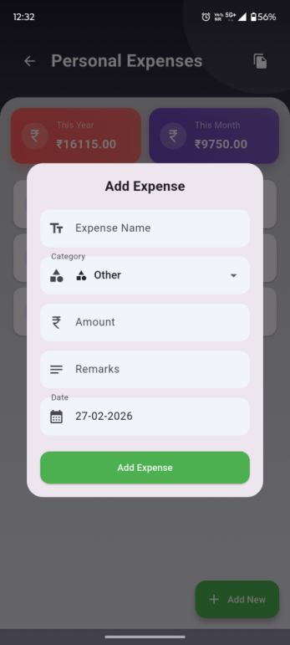
Figure 4.1.3 Screen-3: add personal expenses form

Purpose: Allows user to add personal expenses into the system.
Sr. | Screen Element | Input Type | O/M | Description
1 | Expense Name | Textbox | M | Enter title of expense.
2 | Amount | Number | M | Enter expense amount.
3 | Category | Dropdown | M | Select expense category (Food, Travel, etc.).
4 | Date | Date Picker | M | Select expense date.
5 | Remarks | Textarea | O | Additional notes about expense.
6 | Add Expense | Button | ------ | Stores expense in database.

Table 4.1.3 Screen element of add personal expenses form

    - Screen-4: Dual Expenses Screen
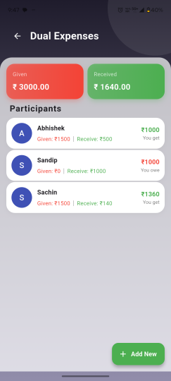
Figure 4.1.4 Screen-4: dual expense screen

Purpose: This screen allows the user to manage dual expenses.
Sr. | Screen Element | Input Type | O/M | Description
1 | Title: Dual Expense | Label | -- | Displays screen title at the top.
2 | Dashboard Card – Given | Card | M | Displays the total amount given to participants.
3 | Dashboard Card – Recieve | Card | M | Displays the total amount received from participants.
4 | Participants List | List / Table | M | Displays the list of all participants involved in dual expenses along with their expense details.naviagte through click.
5 | Add New | Button | M | Opens the Add Partcipants Form for new particpant entry.
6 | Back | Icon / Button | O | Navigates back to Dashboard (Module Selection) screen.

Table 4.1.4 Screen element of dual expense screen

    - Screen-5: Dual Expense Participant Details
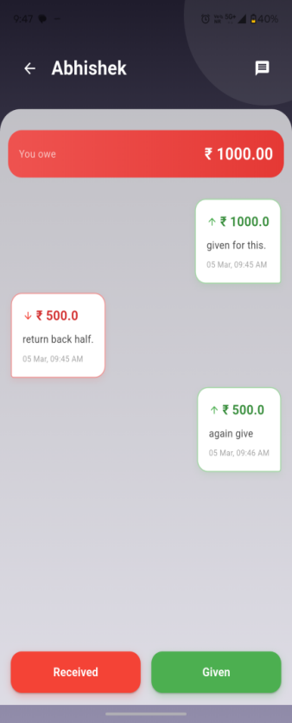
Figure 4.1.5 Screen-5: Dual Expense Participant Details

Purpose: To view and manage transactions with a specific participant, including balance status (given or received), transaction history, and options to add new transactions or send payment reminders.
Sr. | Screen Element | Input Type | O/M | Description
1 | Title:Participant Name | Label | M | Displays the selected participant’s name at the top of the screen.
2 | Message Button | Icon / Button | M | Sends a reminder message to the participant for the pending amount.
3 | Dashboard Tile – Balance | Card / Tile | O | Displays whether the user owes money or needs to receive money from the participant.
4 | Transaction History | Card List | M | Displays all transactions between the user and the participant in card format.
5 | Given Button | Button | M | Opens the form to record a new amount given to the participant.
6 | Receive Button | Button | M | Opens the form to record a new amount received from the participant

Table 4.1.5 Screen element of Dual Expense Participant Details

    - Screen-6: Group Expense
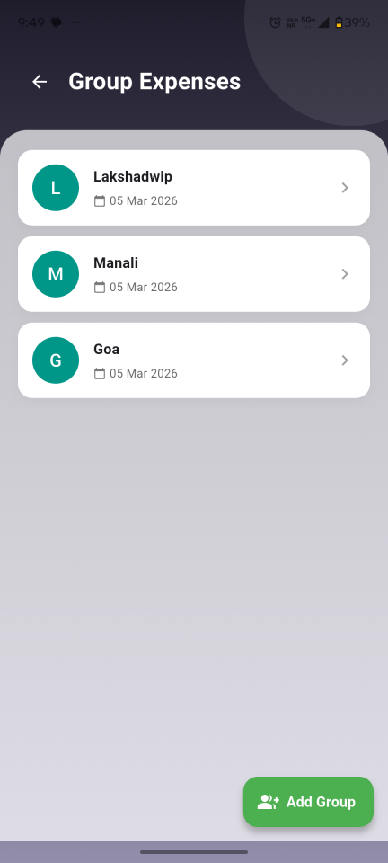
Figure 4.1.6 Screen-6: Group Expense

Purpose: To display the list of all groups created by the user and allow the user to create a new group for managing shared expenses.
Sr. | Screen Element | Input Type | O/M | Description
1 | Title: Group Expense | Label | -- | Displays screen title at the top.
2 | Group List | List / Table | M | Displays all created groups. The user can select a group to view its expense
3 | Add Group | Button | M | Opens the Create Group Form to add a new group for expense tracking.
4 | Back | Icon / Button | O | Navigates back to Dashboard (Module Selection) screen.

Table 4.1.6 Screen element of Group Expense

    - Screen-7: Group Expense – Expense Screen
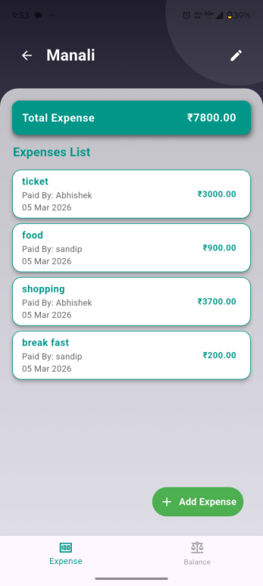
Figure 4.1.7 Screen-7: expense screen

Purpose: To display all expenses of the selected group, show the total group expense, and allow the user to add new group expenses.
Sr. | Screen Element | Input Type | O/M | Description
1 | Title: Group Name | Label | M | Displays the name of the selected group at the top of the screen.
2 | Dashboard Tile – Total Expense | Card / Tile | M | Displays the total expense amount of the group.
3 | Tab Bar (Expense / Balance) | Tab Navigation | M | Allows switching between Expense screen and Balance screen.
4 | Expense List | List / Card List | M | Displays all expenses added in the group with amount, payer, and date.
5 | Add Expense | Button / Floating Button | O | Opens the Add Group Expense Form to add a new group expense.
6 | Back | Icon / Button | O | Navigates back to the Group List screen.

Table 4.1.7 Screen element of expense screen

    - Screen-8: Group Expense – Balance Screen
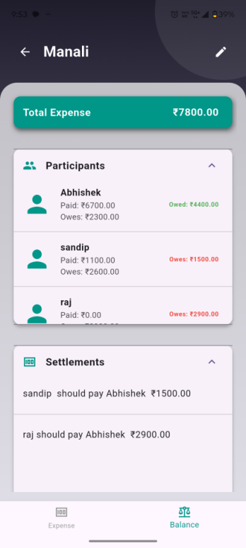
Figure 4.1.8 Screen-8: balance screen

Purpose: To show each participant’s balance in the group and display settlement transactions between participants.
Sr. | Screen Element | Input Type | O/M | Description
1 | Title: Group Name | Label | M | Displays the name of the selected group at the top of the screen.
2 | Dashboard Tile – Total Expense | Card / Tile | M | Displays the total expense amount of the group.
3 | Tab Bar (Expense / Balance) | Tab Navigation | M | Allows switching between Expense screen and Balance screen.
4 | Participants Balance List | List | M | Displays all participants and their balance status (Paid, Owes, Owed). Clicking a participant expands to show detailed balances.
5 | Settlement Transaction List | List | O | Displays settlement transactions showing who paid whom and the amount paid. Clicking shows detailed transaction history.
6 | Back | Icon / Button | O | Navigates back to the Group List screen.

Table 4.1.8 Screen element of balance screen

  - Testing
    - Functional Testing
Test Case ID | Test Scenario | Test Steps | Expected Result | Status
TC001 | Create New Group | - Open application  - Click "Create Group"  - Enter group name  - Click "Save" | Group is created successfully | Pass
TC002 | Add Member to Group | - Open group  - Click "Add Member"  - Enter member name  - Click "Save" | Member is added to group | Pass
TC003 | Add Expense (Equal Split) | - Open group  - Click "Add Expense"  - Enter amount  - Select Equal split  - Click "Save" | Expense is saved and amount split equally among members | Pass
TC004 | Add Expense (Custom Split) | - 1. Add expense  - Select Custom split  - Enter custom amounts  - Click "Save" | Expense is saved with correct custom split | Pass
TC005 | Add Expense (Manual Split) | - 1. Add expense  - Select Manual split  - Enter manual split  - Save | Expense saved with correct manual distribution | Pass
TC006 | Validate Split Calculation | - 1. Add expense with decimal value  - Verify total split | Sum of split amounts equals total expense | Pass
TC007 | View Group Balance | 1. Open group dashboard | Correct pending balances displayed | Pass
TC008 | Settlement | - Select member  - Enter payment amount  - Confirm settlement | Balance updates to "Fully Settled" | Pass
TC009 | Invalid Amount Entry | - Enter negative/zero amount  - Save | Error message displayed | Pass

    - Non-Functional Testing
Test Case ID | Test Scenario | Test Steps | Expected Result | Status
TC010 | Load Testing | - Add 1000+ expenses  - Perform settlements | System should not crash, response time ≤ 2s | Pass
TC011 | Performance Testing | Perform multiple expense & settlement operations | System should prevent SQL Injection | Pass
TC012 | Usability Testing | - Test UI for ease of use  - Check accessibility for users | Users can navigate easily, UI is clear | Pass
TC013 | Validation Testing | Enter invalid data in fields | Proper validation messages displayed | Pass

CHAPTER 5

CONCLUSION AND FUTURE ENHANCEMENT

  - Conclusion
The TrackMyMoney – The Complete Expense Tracker application successfully digitizes the process of managing personal and shared expenses. The system provides a simple and efficient platform for users to record daily expenses, manage dual (shared) transactions, and track group expenses with automatic expense splitting. By replacing traditional manual expense tracking methods such as notebooks or simple notes, the application improves financial transparency and budgeting efficiency.
The system includes features such as expense addition, update, deletion, monthly and yearly report generation, balance tracking for dual expenses, and automatic split calculation for group expenses. The use of Flutter ensures a smooth and responsive mobile interface, while SQLite provides secure and efficient local data storage. Overall, the project demonstrates how mobile technology can simplify financial management and help users develop better money management habits.

  - Future Enhancement
Although the current system fulfills the fundamental requirements of expense tracking, several enhancements can further improve its functionality and usability:

- Cloud Backup Integration
Implement cloud storage support to allow users to back up and restore their expense data across devices.
- Data Visualization & Graph Reports
Enhance reporting features by adding pie charts and bar graphs to visualize monthly and yearly expense trends.
- Export Report Feature
Provide functionality to export reports in PDF or Excel format for record keeping.

APPENDICES

Appendix A: Acronyms and Abbreviations
Acronym | Full Form
EMS | Expense Management System
DBMS | Database Management System
UI | User Interface
SQLite | Structured Query Language Lite
Context | A broad level diagram of the project showing a basic overview
Use Case | summarizes some of the relationships between Cases, user, and systems.
UML | Unified Modelling Language

REFERENCES
[1] Kapil B. Patil, Software Requirement Specification Document, LinkedIn Corporation, Sunnyvale USA,2018, www.slideshare.net /ANASNAIN/17337071 srslibrarymanagementsystem
[2] Karl E. Wiegers, IEEE Standard Of SRS Document, IEEE, web.cs.dal.ca/~hawkey/3130/srs_template-ieee.doc
[3] Roger S. Pressman, Software Engineering, McGraw-Hill, IA New York,2010. www.processimpact.com/process_assets/srs_template.doc.
[4]Flutter Official Documentation, Google, https://docs.flutter.dev

