# Model Overview Application

## Steps to build the application

*Prerequisites*: jdk 11 or above installed on the system, maven installed on the system.

To build runnable jar open command prompt/terminal and execute below command from the project directory

* mvn clean package

jar file with name **bikeee-0.0.1-SNAPSHOT.jar** is generated inside the target directory

### To run the jar file

open command prompt/ terminal and navigate to the project's target directory and run the below command

* java -jar bikeee-0.0.1-SNAPSHOT.jar

Application server should run on **http://localhost:8080**

### Endpoints

To get the list of top 3 models:

**http://localhost:8080/topthree**

# Screenshots

Application Running on localhost:

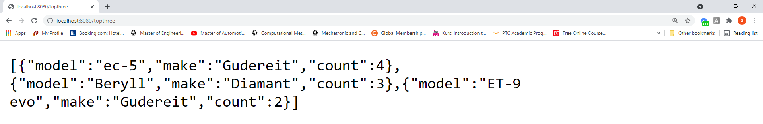

mvn clean package:

