Manual GUI test plan with description

The GUI can be tested by checking if every button present in the GUI does what it is supposed to do, checking different game ending conditions, checking if pieces moves are properly detected, checking if the user is prompted about the error messages and game conditions.

The tests will start from the game start to an ending condition.

1. Start

The game starts by asking the player names

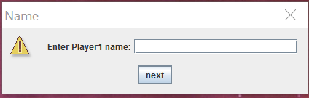 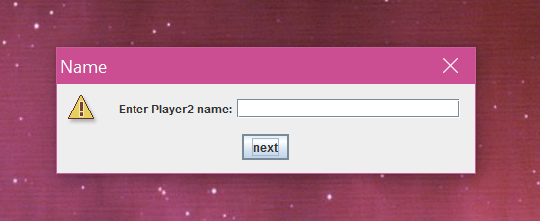

1. The initial Game Screen displays the player names, and options menu and the current score  
   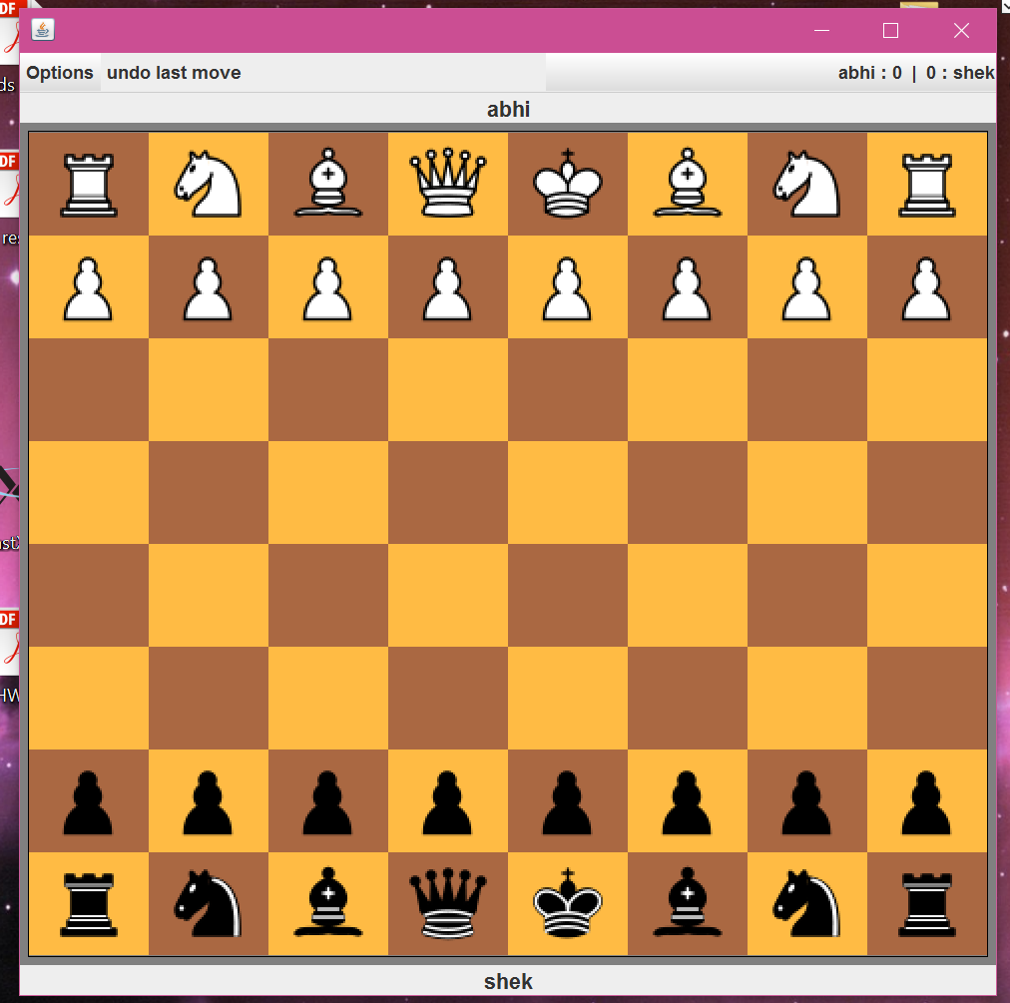

3) We can now check moving some pawns. The movement happens by first clicking the piece to move then pressing the final destination. If at any point the player wants to cancel his/her selection, they can press the right mouse button.

Basic White Piece Move

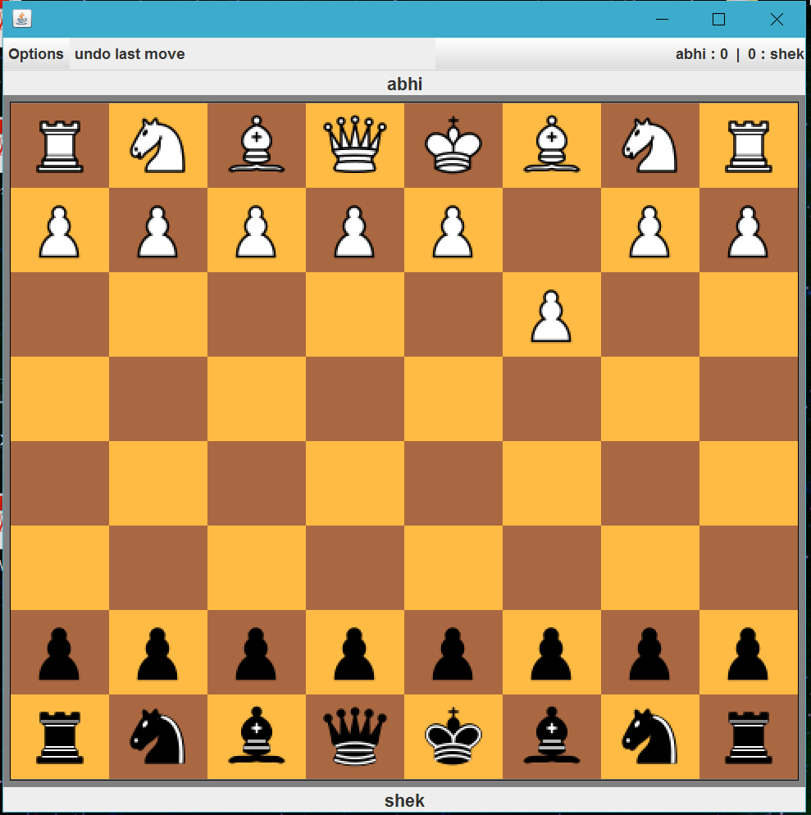

Basic black piece move

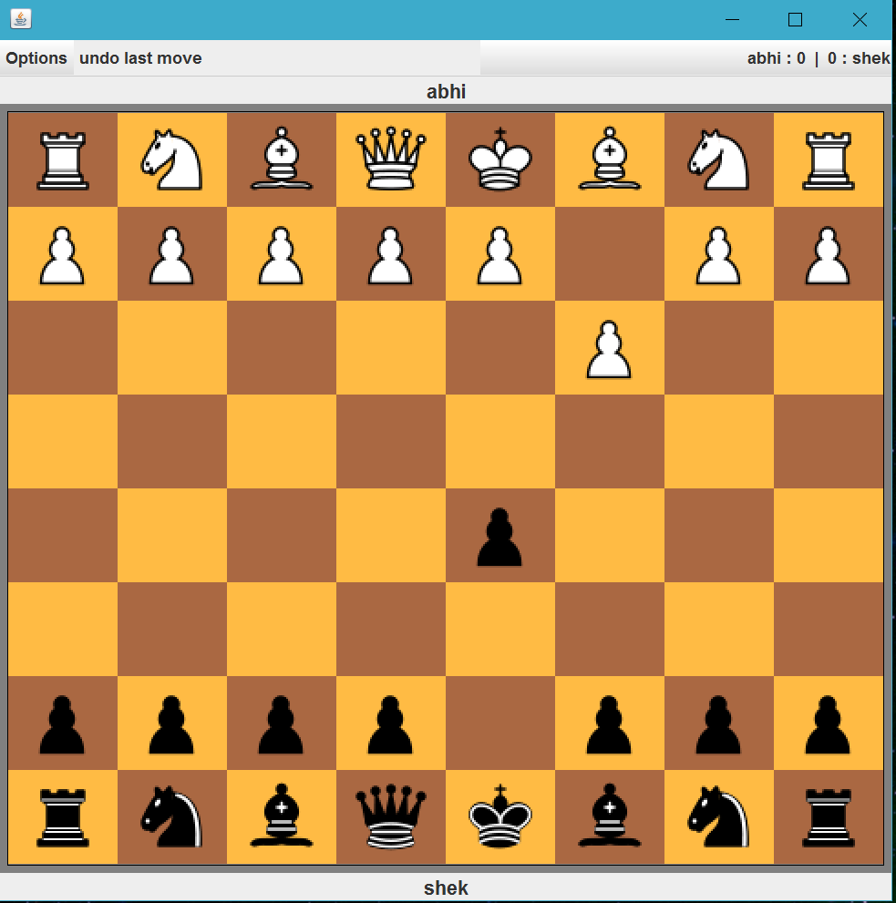

1. The board would popup a warning message if the wrong player tries to move a piece  
   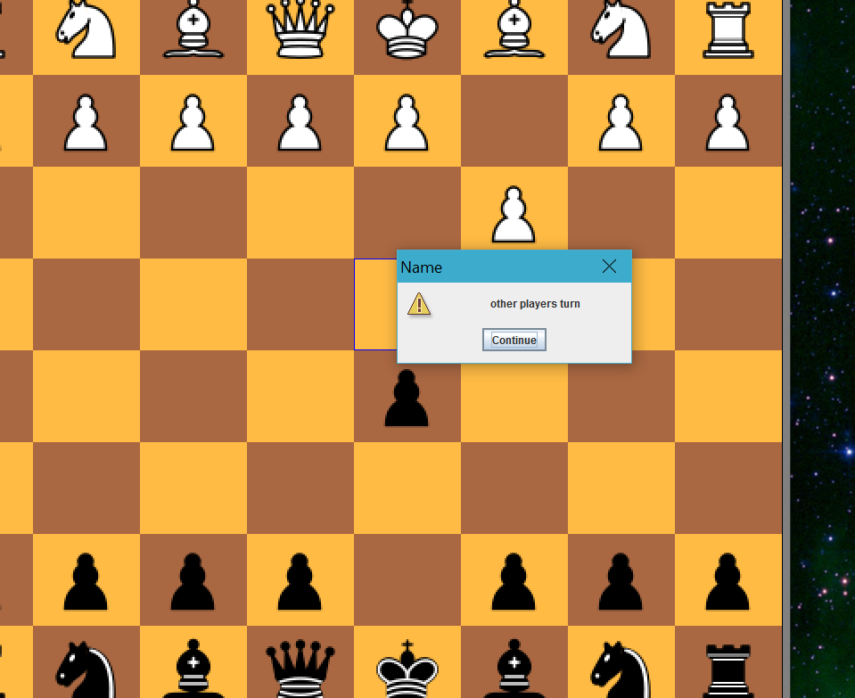
2. The board also give a warning if the user tries to move the piece to an invalid position  
   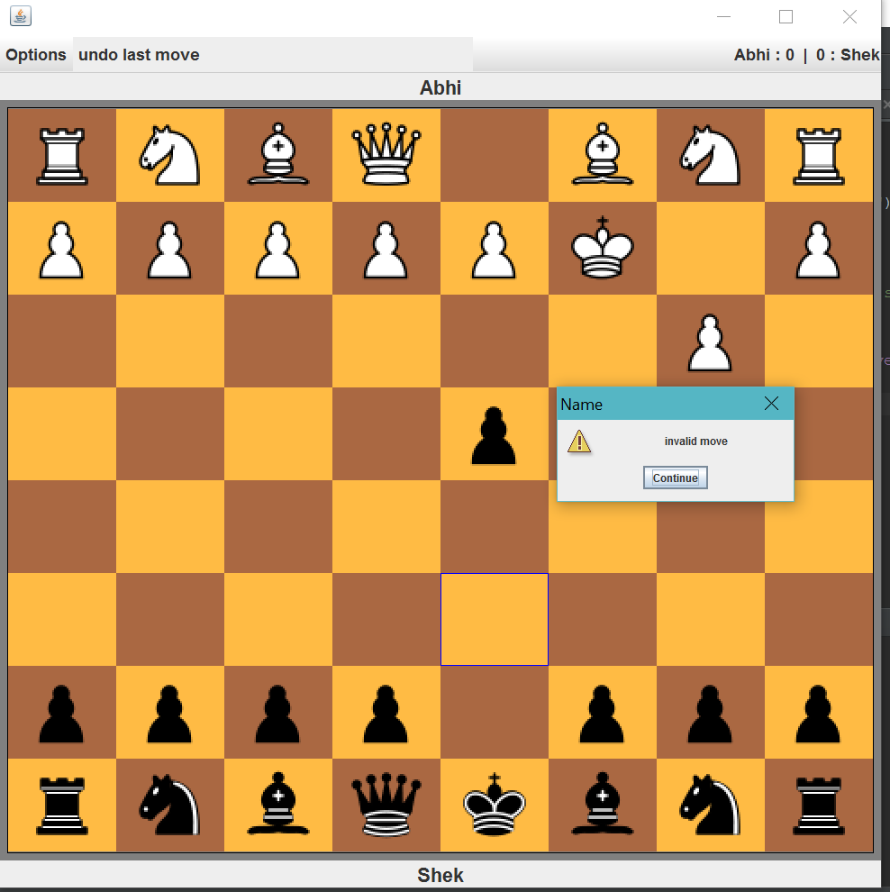
3. In addition, it also prompts the user if his/her move is putting their king in check. It allows them to undo their move or voluntarily die if they want to.  
     
     
     
   Here the king is trying to move to the blue highlighted box, but that is putting itself in check  
   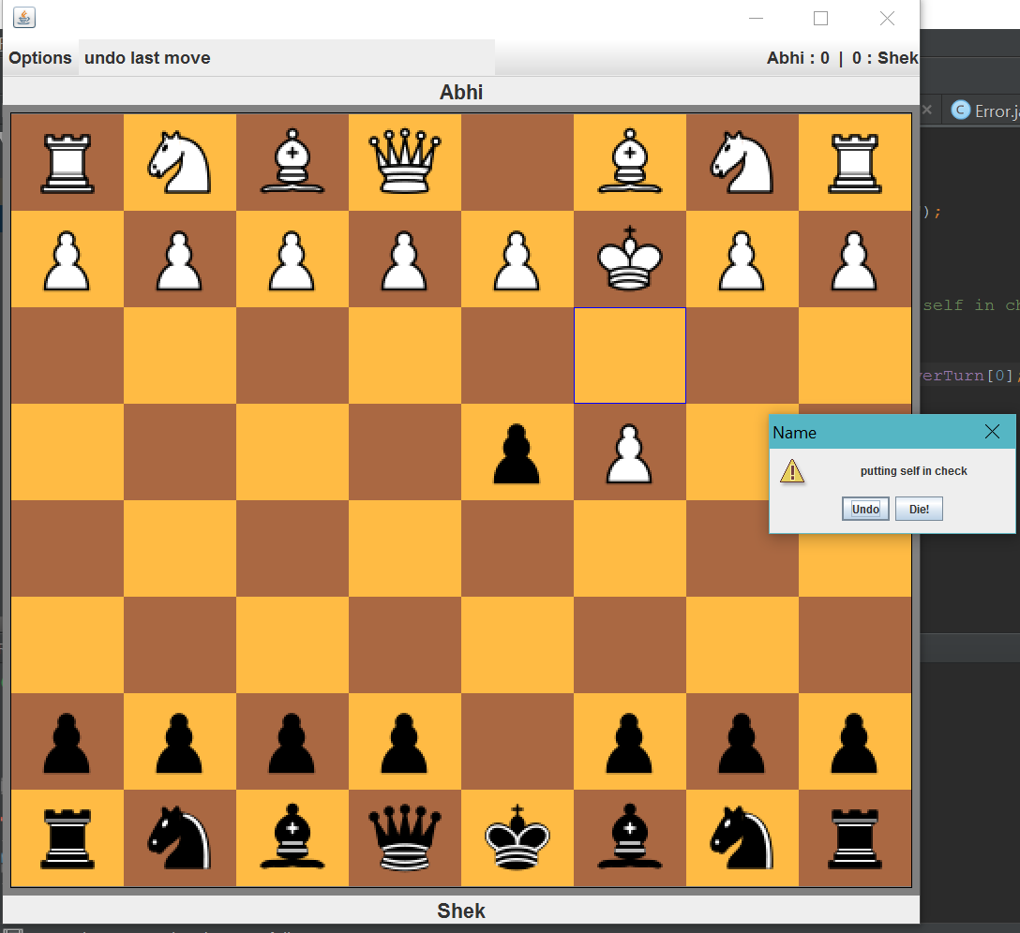
4. The game also prompts the players of a check situation. Here the black pawn is moving to the green step, and that would put the white king in check.  
   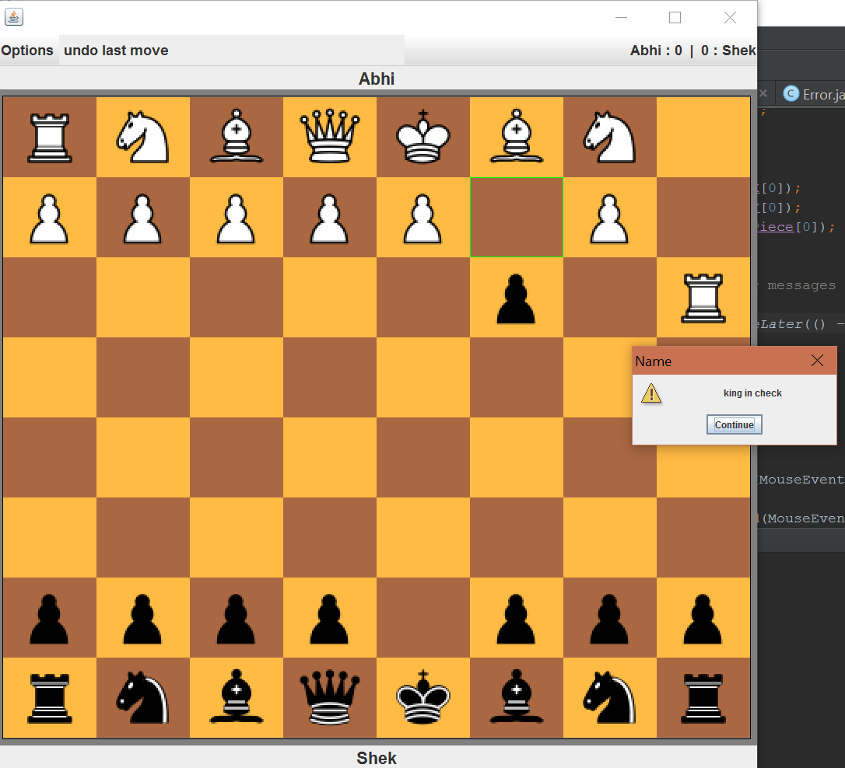
5. The steps for a checkmate are shown below. The game prompts the user that the game is over and he/she can restart the game. This would update the points on the top right. The one shown below is the quickest checkmate an is called fools mate

White pawn moves two down

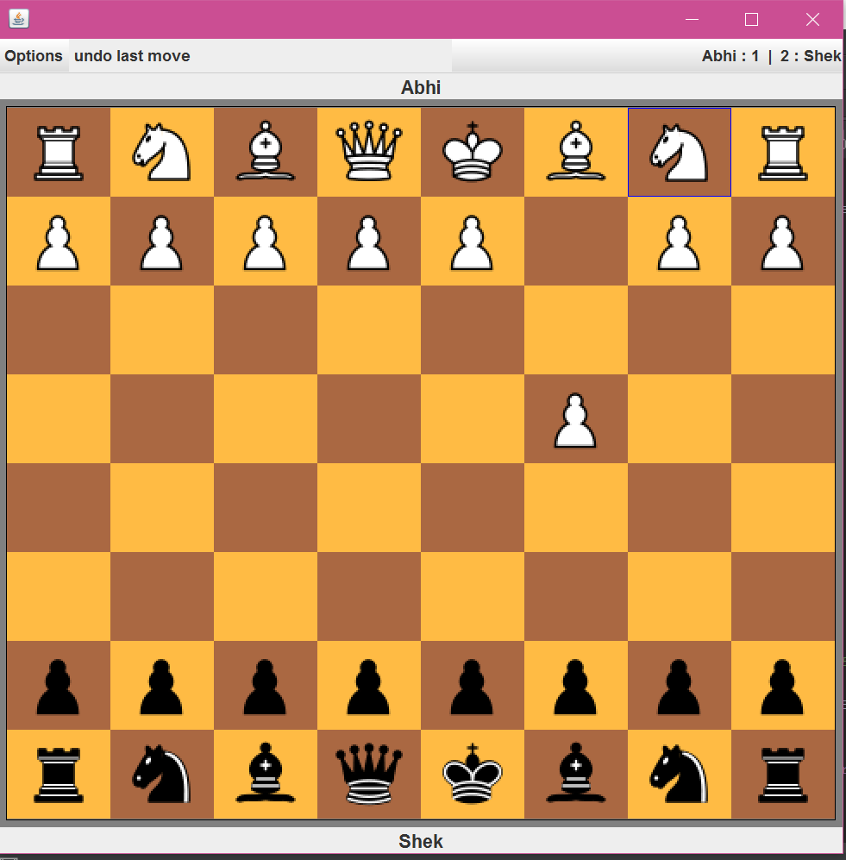

Black pawn moves two up

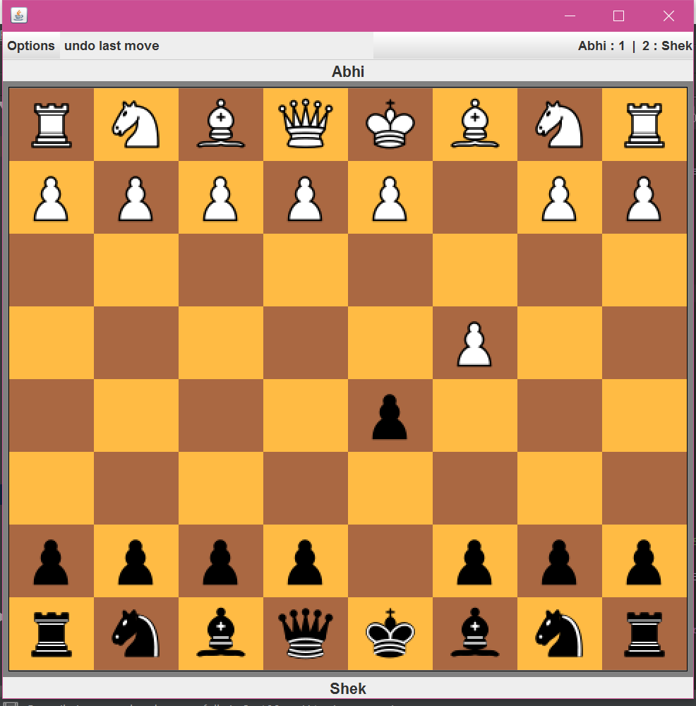  
  
  
  
  
White pawn away from the king moves one down

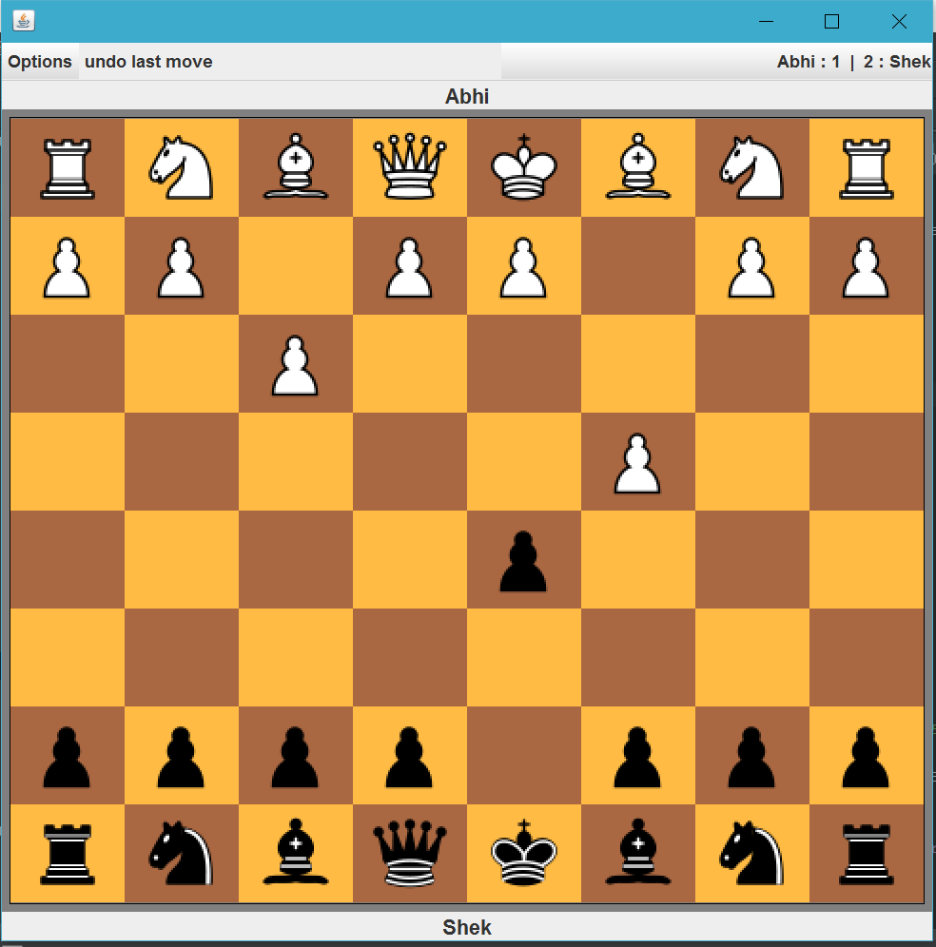

Black Queen puts king in checkmate when it moves to the green step

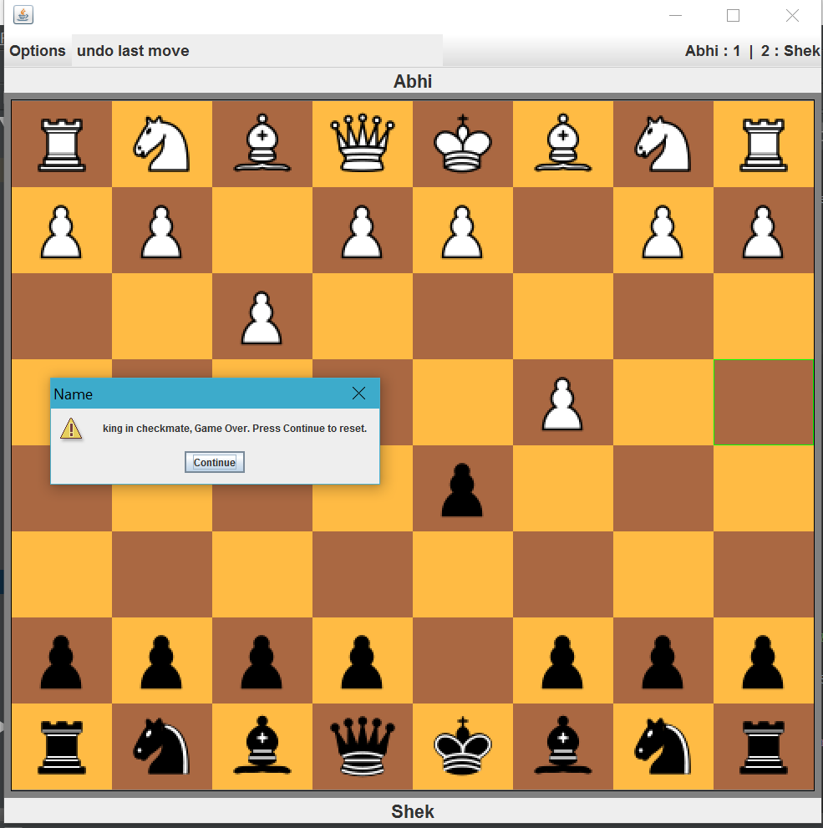

1. The player can restart the game after a checkmate to give the winning player a +1.  
   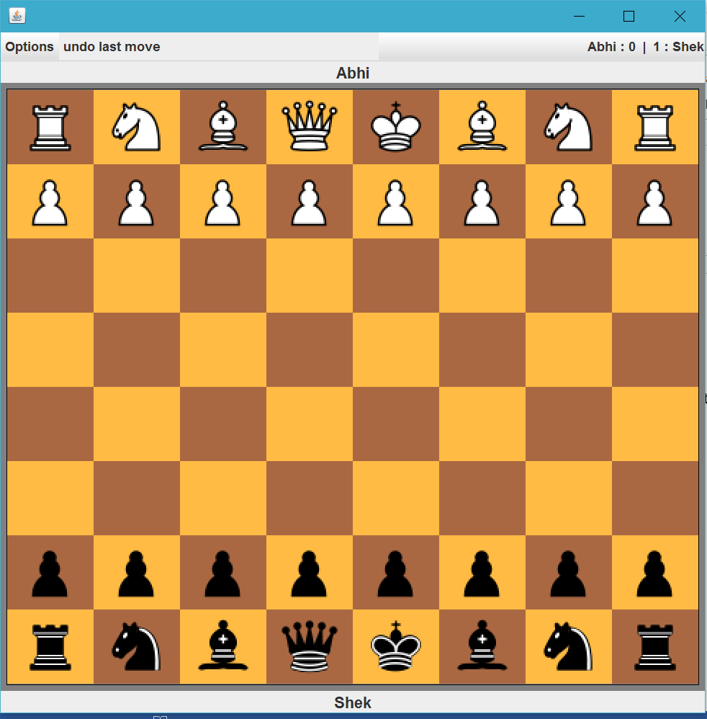
2. There is also an options bar with an option to Restart, Give up or play with Fairy Pieces  
   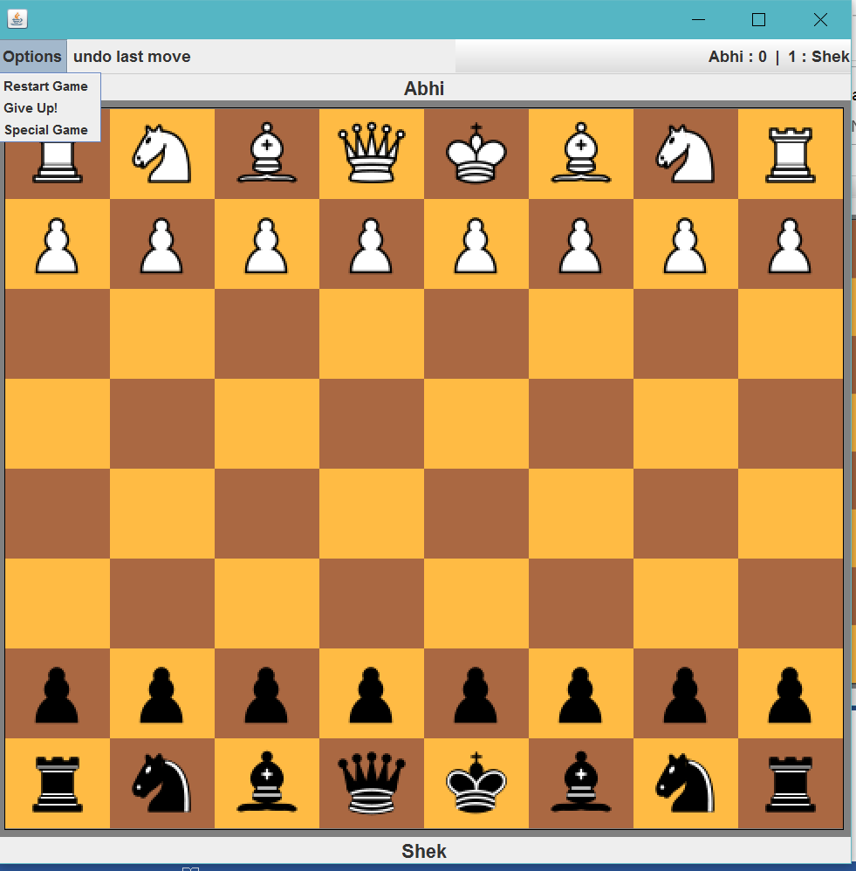  
     
     
   11) Pressing each gives a different prompt and tells the user about the action which is going to take place.  
   When restart Pressed

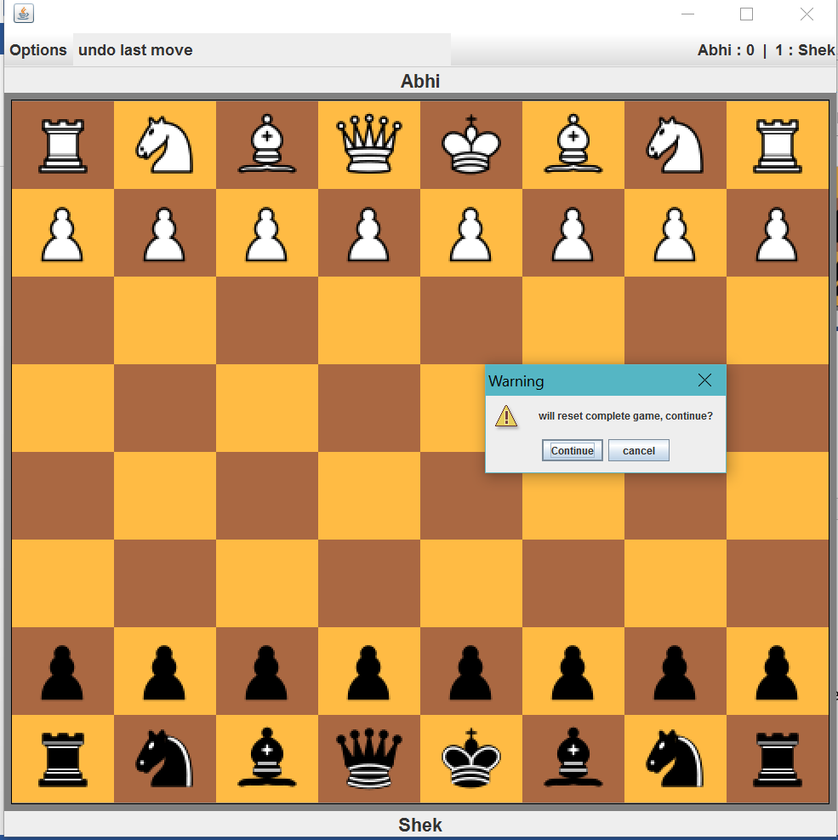

When Give Up Pressed  
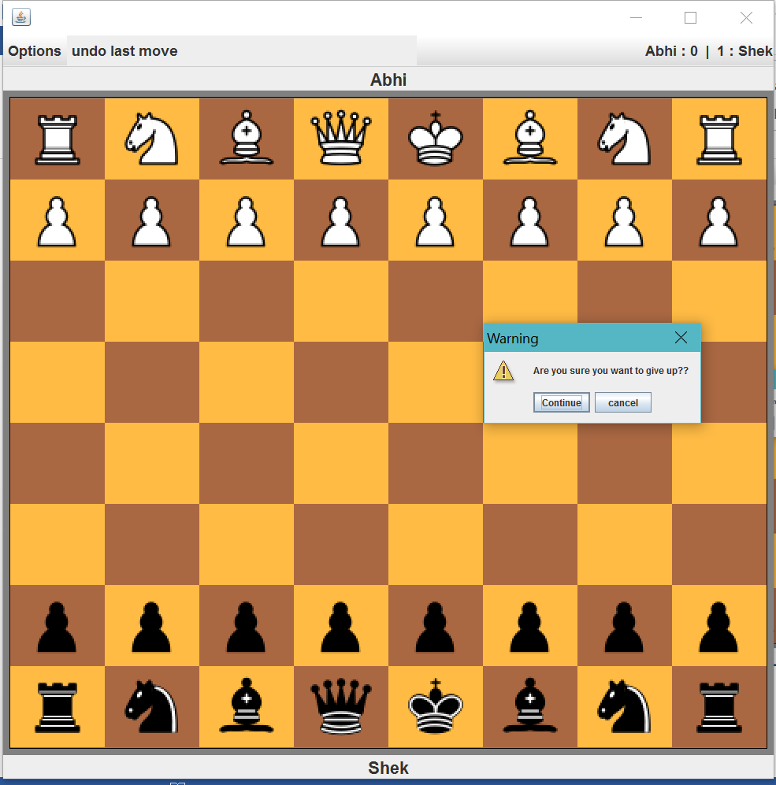

When Special game is pressed  
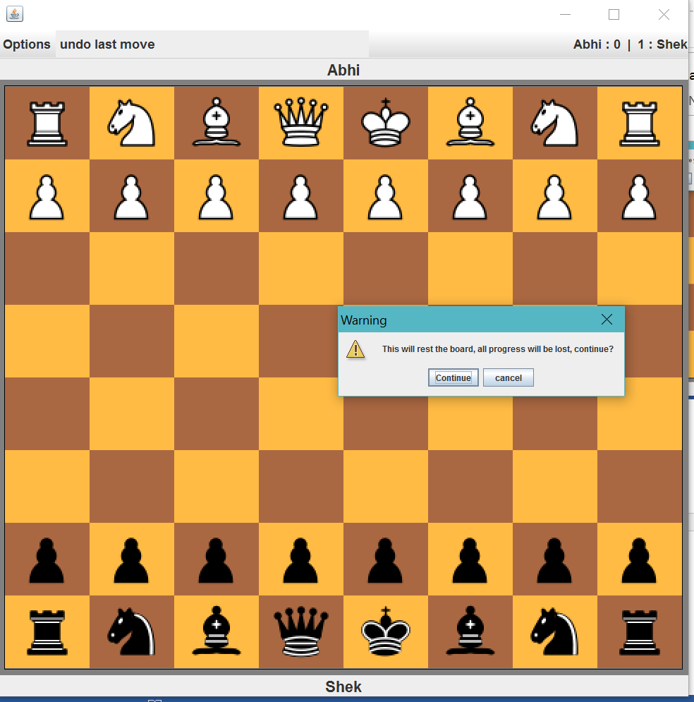

12) When Give up is pressed and use presses continue after the prompt, the winning player gets one point. The board automatically resets.  
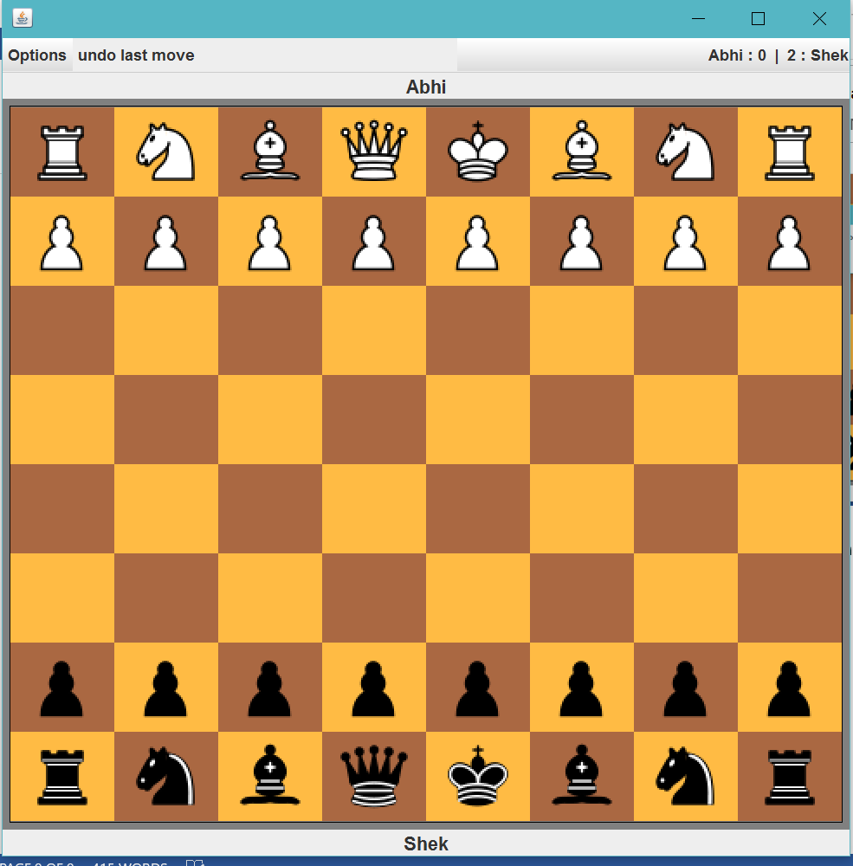  
  
  
13) When the user presses the special game button, the game resets, with the same points but fairy pieces.

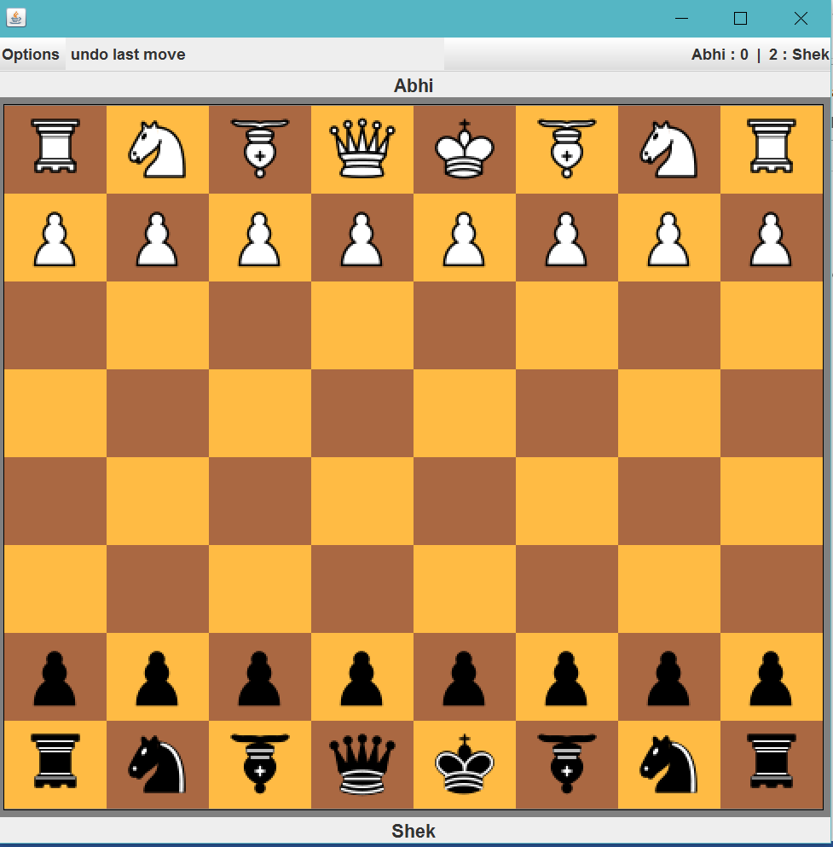

14) The use can also restart the game, which asks for the names again. This also resets the points.

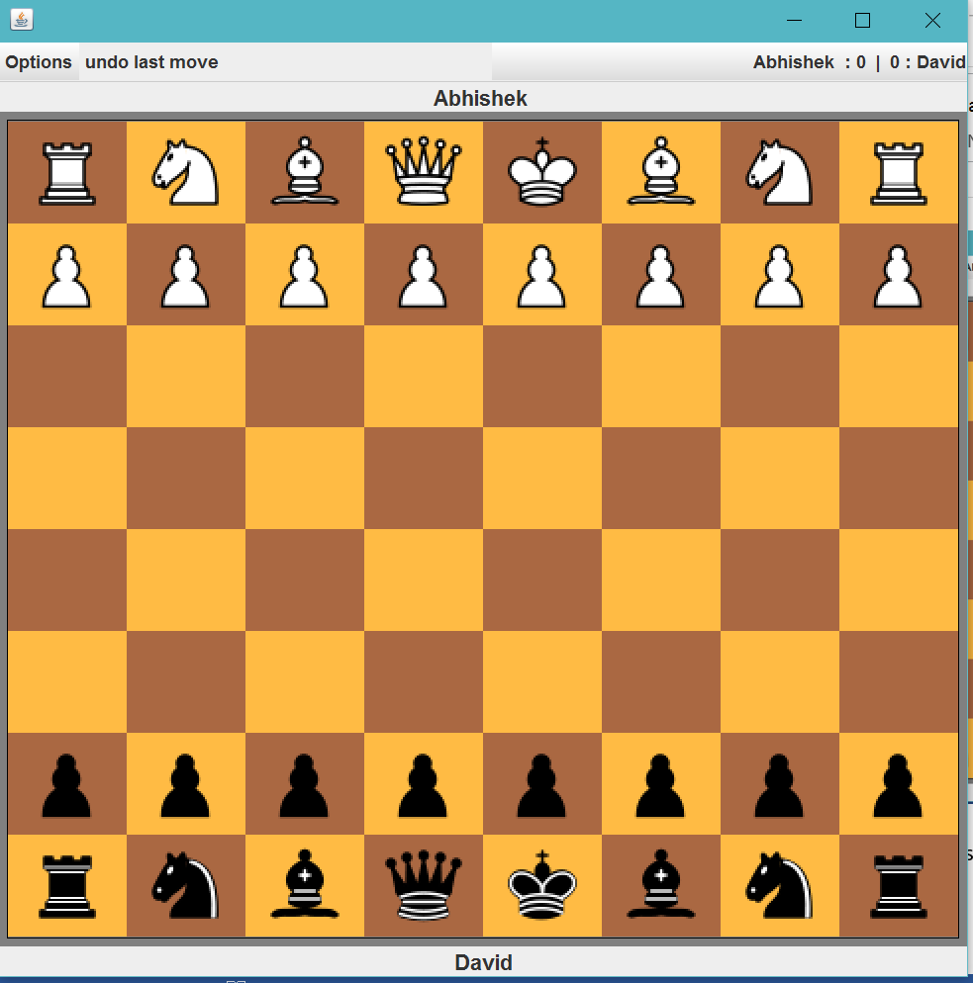

15) Here’s a sample chess game

