**Title:** **A Nationwide Comparison of the Provision of Ambulatory Care Services in Cancer and Non-Cancer Patients, 2016-2018.**

Running title: Ambulatory Care, Cancer and Non-Cancer Populations

Authors: Knowlton H1*, Wang CP2*, Kee D1, Vang S4, Mazumdar M3, and Agarwal P3

*Co-first authors

Institutional affiliations:

1Icahn School of Medicine at Mount Sinai

2Dr. Henry D. Janowitz Division of Gastroenterology, Icahn School of Medicine at Mount Sinai

3 Tisch Cancer Institute, Institute for Healthcare Delivery Science and Department of Population Health Science and Policy, Icahn School of Medicine at Mount Sinai

4 Center for Behavioral Oncology, Department of Population Health Science and Policy, Icahn School of Medicine at Mount Sinai

Corresponding author:

Parul Agarwal, PhD MPH

Assistant Professor

Institute for Healthcare Delivery Science

Tisch Cancer Institute

Department of Population Health Science and Policy

Icahn School of Medicine at Mount Sinai

1425 @ East 98th Street L2-37, 2nd Floor

New York, NY 10029, USA

Email: parul.agarwal@mountsinai.org

Target Journal: JGIM

References: 6/7

Tables: 1/1

Figures: 1/1

Appendices: 0/0

Word length: 696/700

Key words: ambulatory care, cancer survivors, preventative health services, cancer care

**INTRODUCTION**

As of 2022, almost 18 million Americans were living with cancer, and this number is expected to increase to 26 million by 2040.1 Cancer survivors require multi-disciplinary care to mitigate cancer and treatment-related side effects and morbidity in addition to preventative care.2 Prior studies, however, suggest differences in physicians’ knowledge and practice of care for cancer survivors.3 Thus, we aimed to extend the literature by performing a nationwide, comparative analysis of the provision of ambulatory care services in cancer and non-cancer patients.

**METHODS**

We evaluated data from the 2016-2018 National Ambulatory Medical Care Survey (NAMCS), an annually administered, nationally representative survey of ambulatory visits made to nonfederal office-based physician practices conducted by the National Center for Health Statistics of the Centers for Disease Control and Prevention. The NAMCS uses a multistage sample design for data collection on patient demographics, visit indications, prior diagnoses, medications, and services (e.g., examinations, laboratory tests, diagnostic imaging, counseling, and procedures). Our analyses included preventive services using US Preventive Services Task Force Grade A or B recommendations as well as pertinent, ancillary cancer care services.2,4,5 We performed bivariate analyses and multivariable-adjusted logistic regression to examine the relationships between cancer status and type of service rendered. All analyses were conducted using SAS Enterprise Guide 7.1 (SAS, Inc., Cary, NC).

**RESULTS**

We identified 1,744,110,764 patient visits between 2016 and 2018 (Table 1) and 125,294,620 visits associated with a cancer diagnosis (7.2%). Across all visits, 69.4% of patients were non-Hispanic white, 15.7% of patients were Hispanic, 8.6% of patients were non-Hispanic black, and 6.2% of patients were other race/ethnicity. The mean age of cancer patients was 66.2 years + 1.2 and 43.6% of cancer patients were male. The mean age of non-cancer patients was 45.6 years + 2.4 and 41.4% of non-cancer patients were male. Cancer patients experienced more mean number of chronic conditions and were on average seen more frequently over the past year (2.7 conditions + 0.1; 4.8 visits + 0.6) than non-cancer patients (1.3 conditions + 0.1; 4.6 visits + 0.2). On bivariate analyses (Table 1) of services rendered, as compared to non-cancer patients cancer patients were less likely to be offered dietary or mental health counseling or psychotherapy.

In multivariable logistic regression analyses adjusting for age, race/ethnicity, sex, and insurance status (Figure 1) and number of chronic conditions, cancer patients experienced significantly lower odds of receiving any health service (OR: 0.53; 95% CI, 0.46-0.61) compared to non-cancer patients. Cancer patients experienced lower odds of depression screening (OR: 0.69; 95% CI, 0.53-0.91), mental health counseling (OR: 0.23; 95% CI, 0.11-0.48), stress management (OR: 0.42; 95% CI, 0.20-0.87), physical therapy (OR: 0.38; 95% CI, 0.22-0.65), exercise education (OR: 0.46; 95% CI, 0.36-0.59), dietary counseling (OR: 0.48; 95% CI, 0.38-0.59), or smoking cessation counseling (OR: 0.68; 95% CI, 0.48-0.96). While cancer patients experienced greater odds of mammography referrals (OR: 1.57; 95% CI, 1.10-2.23) compared to non-cancer patients, there were no significant differences in the provision of cervical cancer screening, colonoscopy, or bone density scans. There were no significant differences in hepatitis testing, HIV testing and substance abuse screening between cancer and non-cancer patients.

**DISCUSSION**

Due to significant advances in cancer detection and treatment, the number of cancer survivors has grown exponentially and is expected to increase by 25% over the next decade.1 As more people live longer with cancer, there are also a growing number of cancer survivors living with multiple comorbid illnesses. Comorbidities also negatively impact cancer survivors’ overall physical and mental health, resulting in increased morbidity and poorer quality of life.6 Thus, there is a critical need for comprehensive, multi-disciplinary efforts to effectively manage the consequences of cancer, cancer-related treatment, and other comorbid conditions, in addition to monitoring for cancer recurrence and screening for secondary cancers.

Our study is not without limitations. Data are missing on certain patient (e.g., education level, income, marital status) and provider (e.g., years in clinical practice) factors, which may influence the rendering of health services. Despite these limitations, the strengths of our study are reflected in the use of a robust and nationally representative survey to provide a contemporary analysis of health services utilization in cancer and non-cancer populations and whose insights will inform future cancer survivorship care practices.

**ACKNOWLEDGEMENTS**

Funding:

No direct funding was received for this study, nor for writing support. The authors declare the following grant support: CPW receives research salary support from the National Cancer Institute of the National Institutes of Health under Award Number T32CA225617.

Conflicts of interest:

Data availability: The datasets during and/or analyzed during the current study available from the corresponding author on reasonable request.

Study exemption: As these databases are de-identified and publicly available, the study was exempt from review by the Mount Sinai Institutional Review Board.

**REFERENCES**

1. National Cancer Institute Division of Cancer Control & Population Sciences. Statistics and Graphs. National Institutes of Health. Accessed March 21, 2023, <https://cancercontrol.cancer.gov/ocs/statistics#:~:text=As%20of%20January%202022%2C%20it,approximately%205.4%25%20of%20the%20population.&text=The%20number%20of%20cancer%20survivors%20is%20projected%20to%20increase%20by,to%2022.5%20million%2C%20by%202032>.

2. Naughton MJ, Weaver KE. Physical and mental health among cancer survivors: considerations for long-term care and quality of life. *N C Med J*. Jul-Aug 2014;75(4):283-6. doi:10.18043/ncm.75.4.283

3. Potosky AL, Han PK, Rowland J, et al. Differences between primary care physicians' and oncologists' knowledge, attitudes and practices regarding the care of cancer survivors. *J Gen Intern Med*. Dec 2011;26(12):1403-10. doi:10.1007/s11606-011-1808-4

4. U.S. Preventive Services Task Force A & B Recommendations. Accessed 13 February 2023, <https://www.uspreventiveservicestaskforce.org/uspstf/recommendation-topics/uspstf-a-and-b-recommendations>.

5. Gospodarowicz M, Trypuc J, D’Cruz A, et al. Cancer Services and the Comprehensive Cancer Center. In: Gelband H, Jha P, Sankaranarayanan R, et al., editors. Cancer: Disease Control Priorities, Third Edition (Volume 3). Washington (DC): The International Bank for Reconstruction and Development / The World Bank; 2015 Nov 1. Chapter 11. doi: 10.1596/978-1-4648-0349-9_ch11.

6. Gallicchio L, Kalesan B, Hoffman SC, Helzlsouer KJ. Non-cancer adverse health conditions and perceived health and function among cancer survivors participating in a community-based cohort study in Washington County, Maryland. *J Cancer Surviv*. Mar 2008;2(1):12-9. doi:10.1007/s11764-008-0046-1

**Figure 1**. Forrest plot of adjusted odds ratios for the provision of ambulatory care services between cancer and non-cancer patients.

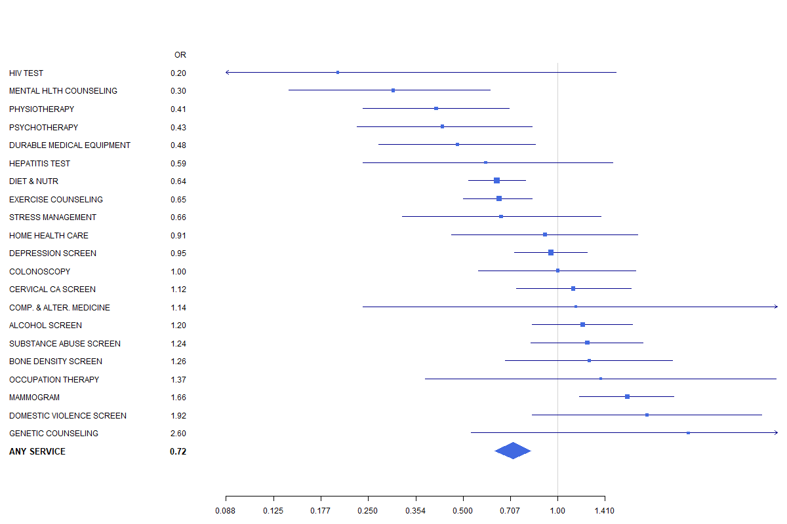

**Table 1.** Comparison of demographics and health services provision between cancer and non-cancer patients.

|  |  |  |  |  |
| --- | --- | --- | --- | --- |
|  | **Overall** | **Patients without cancer** | **Patients with cancer** | **p** |
| **No.** | 1,744,110,764.30 | 1,618,816,143.70 | 125,294,620.60 |  |
| **Age** | 47.1 (25.1) | 45.6 (25.1) | 66.2 (15.7) | **<0.001** |
| **Male sex** | 724,796,622.1 (41.6) | 670,174,918.2 (41.4) | 54,621,704.0 (43.6) | 0.348 |
| **Race/ethnicity** |  |  |  | **<0.001** |
| White, non-Hispanic | 1,210,740,753.7 (69.4) | 1,108,924,626.2 (68.5) | 101,816,127.5 (81.3) |  |
| Black, non-Hispanic | 150,457,289.4 (8.6) | 143,908,722.5 (8.9) | 6,548,567.0 (5.2) |  |
| Hispanic | 274,675,311.3 (15.7) | 263,891,839.2 (16.3) | 10,783,472.1 (8.6) |  |
| Other | 108,237,409.9 (6.2) | 102,090,955.8 (6.3) | 6,146,454.1 (4.9) |  |
| **Major reason for visit** |  |  |  | **<0.001** |
| Left blank | 41,981,396.6 (2.4) | 39,677,268.9 (2.5) | 2,304,127.7 (1.8) |  |
| New problem | 495,841,944.2 (28.4) | 467,184,631.2 (28.9) | 28,657,312.9 (22.9) |  |
| Chronic prob., routine | 549,837,591.1 (31.5) | 497,437,732.0 (30.7) | 52,399,859.1 (41.8) |  |
| Chronic prob., flare-up | 127,037,679.5 (7.3) | 116,025,348.3 (7.2) | 11,012,331.2 (8.8) |  |
| Pre-surgery | 34,912,159.8 (2.0) | 30,818,590.4 (1.9) | 4,093,569.4 (3.3) |  |
| Post-surgery | 94,127,492.9 (5.4) | 83,157,236.9 (5.1) | 10,970,256.0 (8.8) |  |
| Preventive care | 400,372,500.2 (23.0) | 384,515,335.9 (23.8) | 15,857,164.3 (12.7) |  |
| **Physician Specialty** |  |  |  | **<0.001** |
| Primary Care | 922,117,770.4 (52.9) | 887,480,657.8 (54.8) | 34,637,112.5 (27.6) |  |
| Surgical Care | 371,209,895.4 (21.3) | 336,601,057.6 (20.8) | 34,608,837.8 (27.6) |  |
| Medical Care | 450,783,098.5 (25.8) | 394,734,428.2 (24.4) | 56,048,670.3 (44.7) |  |
| **Pay Type** |  |  |  | **<0.001** |
| Blank | 45,013,689.8 (2.6) | 41,446,382.4 (2.6) | 3,567,307.4 (2.8) |  |
| Unknown | 55,357,936.7 (3.2) | 50,176,644.7 (3.1) | 5,181,292.0 (4.1) |  |
| Private insurance | 855,657,534.6 (49.1) | 813,340,729.3 (50.2) | 42,316,805.3 (33.8) |  |
| Medicare | 456,013,468.5 (26.1) | 390,633,410.6 (24.1) | 65,380,057.9 (52.2) |  |
| Medicaid or CHIP | 223,151,377.7 (12.8) | 216,600,237.7 (13.4) | 6,551,140.0 (5.2) |  |
| Worker’s Compensation | 7,975,149.1 (0.5) | 7,940,274.9 (0.5) | 34,874.3 (0.0) |  |
| Self-pay | 77,834,610.3 (4.5) | 76,775,032.5 (4.7) | 1,059,577.8 (0.8) |  |
| No change/charity | 4,906,329.5 (0.3) | 4,906,329.5 (0.3) | 0.0 (0.0) |  |
| Other | 18,200,668.2 (1.0) | 16,997,102.3 (1.0) | 1,203,565.9 (1.0) |  |
| **# of Chronic Conditions** | 1.1 (2.2) | 1.0 (2.2) | 2.7 (1.7) | **<0.001** |
| **Past visits in last 12 months** | 2.9 (6.8) | 2.8 (6.8) | 3.2 (6.7) | 0.406 |
| **Services provided** |  |  |  |  |
| Any service | 1,744,110,764 (28.2) | 1,618,816,144 (28.7) | 125,294,620.6 (21.5) | 0.001 |
| Alcohol abuse counseling | 8,991,905.6 (0.5) | 8,704,616.5 (0.5) | 287,289.1 (0.2) | 0.100 |
| Bone Mineral Density | 9,185,182.9 (0.5) | 8,358,653.8 (0.5) | 826,529.0 (0.7) | 0.587 |
| Breast Exam | 55,578,254.2 (3.2) | 50,562,923.1 (3.1) | 5,015,331.1 (4.0) | 0.247 |
| Cervical Cancer Screening | 38,628,828.4 (2.2) | 36,814,931.3 (2.3) | 1,813,897.1 (1.4) | 0.248 |
| Colonoscopy | 22,776,808.5 (1.3) | 21,115,403.2 (1.3) | 1,661,405.3 (1.3) | 0.972 |
| Complimentary and Alternative Medicine | 1,373,350.1 (0.1) | 1,344,268.1 (0.1) | 29,082.0 (0.0) | 0.102 |
| Depression Screening | 75,227,618.3 (4.3) | 68,481,463.8 (4.2) | 6,746,154.6 (5.4) | 0.295 |
| Diet/Nutrition Counseling | 216,890,076.6 (12.4) | 206,683,059.2 (12.8) | 10,207,017.3 (8.1) | **0.004** |
| Durable Medical Equipment | 17,835,579.4 (1.0) | 17,286,279.3 (1.1) | 549,300.1 (0.4) | **0.020** |
| Exercise counseling | 141,100,033.2 (8.1) | 133,247,031.3 (8.2) | 7,853,001.9 (6.3) | 0.055 |
| Genetic Counseling | 1,112,895.7 (0.1) | 652,108.1 (0.0) | 460,787.6 (0.4) | **0.005** |
| Hepatitis Test | 15,632,650.4 (0.9) | 15,171,073.1 (0.9) | 461,577.2 (0.4) | 0.114 |
| HIV test | 3,262,653.8 (0.2) | 3,095,472.9 (0.2) | 167,180.9 (0.1) | 0.569 |
| Home Health Care | 7,903,741.7 (0.5) | 7,451,179.5 (0.5) | 452,562.2 (0.4) | 0.697 |
| Mammography | 30,813,184.8 (1.8) | 27,365,932.2 (1.7) | 3,447,252.6 (2.8) | 0.212 |
| Mental Health Counseling | 29,007,475.1 (1.7) | 28,647,258.6 (1.8) | 360,216.4 (0.3) | **<0.001** |
| Occupational Therapy | 1,659,054.1 (0.1) | 1,530,125.7 (0.1) | 128,928.4 (0.1) | 0.905 |
| Psychotherapy | 27,233,950.1 (1.6) | 26,548,693.9 (1.6) | 685,256.3 (0.5) | **0.019** |
| Physical Therapy | 36,999,632.0 (2.1) | 35,449,392.9 (2.2) | 1,550,239.2 (1.2) | 0.114 |
| Skin exam | 335,206,570.0 (19.2) | 298,738,617.5 (18.5) | 36,467,952.5 (29.1) | **<0.001** |
| Stress Management | 17,603,370.1 (1.0) | 16,577,517.2 (1.0) | 1,025,852.8 (0.8) | 0.651 |
| Substance Abuse Screening | 22,950,527.4 (1.3) | 20,662,088.7 (1.3) | 2,288,438.8 (1.8) |  |
| Tobacco use/exposure counseling | 51,581,723.6 (3.0) | 48,499,123.2 (3.0) | 3,082,600.3 (2.5) | 0.478 |
| Legend: Numbers are No. (%) unless otherwise noted. | | | |  |