**Title:** **A Nationwide Comparison of the Provision of Ambulatory Care Services in Cancer Survivors and Non-Cancer Patients, 2016-2018.**

Running title: Ambulatory Care, Cancer and Non-Cancer Populations

Authors: Knowlton H1*, Wang CP2*, Kee D1, Vang S4, Mazumdar M3, and Agarwal P3

*Co-first authors

Institutional affiliations:

1Icahn School of Medicine at Mount Sinai

2Dr. Henry D. Janowitz Division of Gastroenterology, Icahn School of Medicine at Mount Sinai

3 Tisch Cancer Institute, Institute for Healthcare Delivery Science and Department of Population Health Science and Policy, Icahn School of Medicine at Mount Sinai

4 Department of Population Health, , NYU Grossman School of Medicine

Corresponding author:

Parul Agarwal, PhD MPH

Assistant Professor

Institute for Healthcare Delivery Science

Tisch Cancer Institute

Department of Population Health Science and Policy

Icahn School of Medicine at Mount Sinai

1425 @ East 98th Street L2-37, 2nd Floor

New York, NY 10029, USA

Email: parul.agarwal@mountsinai.org

Target Journal: JGIM

References: 7/7

Tables: 1/1

Figures: 1/1

Appendices: 0/0

Word length: 700/700

Key words: ambulatory care, cancer survivors, preventative health services, cancer care

**INTRODUCTION**

As of 2022, almost 18 million Americans were living with cancer, and this number is expected to increase to 26 million by 2040.1 In addition to preventive care, cancer survivors require multi-disciplinary efforts to mitigate their cancer and treatment-related side effects and morbidity.2 Despite the importance of integrating survivorship care and primary care, many cancer survivors do not receive appropriate ancillary support.3,4 Thus, we aimed to extend the literature by performing a nationwide, comparative analysis of the provision of ambulatory care services in cancer survivors and non-cancer patients.

**METHODS**

We evaluated data from the 2016-2018 National Ambulatory Medical Care Survey (NAMCS), an annually administered, nationally representative survey of ambulatory visits made to nonfederal office-based physician practices conducted by the National Center for Health Statistics of the Centers for Disease Control and Prevention. The NAMCS uses a multistage sample design for data collection on patient demographics, visit indications, prior diagnoses, medications, and ancillary services. Our analyses included preventive services using US Preventive Services Task Force Grade A or B recommendations as well as supportive cancer care services.2,5 We performed bivariate analyses using standardized mean differences (<https://www.tandfonline.com/doi/abs/10.1080/03610910902859574?journalCode=lssp20>; read this for avoiding to use p-value; refer if you change it) and multivariable logistic regression to examine the relationships between cancer status and type of service rendered. All analyses were conducted using SAS Enterprise Guide 7.1 (SAS, Inc., Cary, NC).

**RESULTS**

We identified 1,744,110,764 patient visits between 2016 and 2018 (Table 1) and 125,294,620 visits associated with a cancer diagnosis (7.2%). Across all visits, 69.4% of patients were non-Hispanic White, 15.7% of patients were Hispanic, 8.6% of patients were non-Hispanic Black, and 6.2% of patients were ‘other’ race/ethnicity. Cancer patients were older (mean age 66.2 years vs 45.6 years) than patients without cancer. Most cancer patients were insured with Medicare (52.2%), while their counterparts held private insurance (50.2%). Cancer patients experienced more chronic conditions (2.7 vs 1.0 conditions) and were seen more frequently over the past year (3.2 vs 2.8 visits) than patients without cancer. Cancer patients mainly received specialty care (72.3%), while their counterparts received primary care (54.8%). On bivariate analyses (Table 1) of services rendered, cancer patients were less likely to receive any service, such as dietary counseling, mental health counseling, psychotherapy, or durable medical equipment.

In multivariable logistic regression analyses (Figure 1) adjusting for age, race/ethnicity, sex, and insurance status and number of chronic conditions, cancer patients experienced significantly lower odds of receiving any health service (OR: 0.7; 95% CI, ) compared to non-cancer patients. Cancer patients experienced lower odds of receipt of mental health counseling (OR: 0.30; 95% CI, ), physical therapy (OR: 0.41; 95% CI, ), psychotherapy (OR: 0.43; 95% CI, ), durable medical equipment (OR 0.48; 95% CI, ), dietary counseling (OR: 0.64; 95% CI, ), and exercise education (OR: 0.65; 95% CI, ). While cancer patients experienced greater odds of mammography referrals (OR: 1.66; 95% CI, ________) compared to non-cancer patients, there were no significant differences in the provision of cervical cancer screening, colonoscopy, or bone density scans. There were no significant differences in hepatitis testing, HIV testing, and alcohol or substance abuse screening between cancer and non-cancer patients.

**DISCUSSION**

Due to significant advances in cancer diagnosis and treatment, the number of cancer survivors is expected to increase by 25% over the next decade.1 In our study, cancer care delivery was suboptimal, and has likely worsened since the COVID-19 pandemic.6 Cancer survivorship care is immensely complex due to the vast presentation of cancer- and treatment-related effects, presence of comorbid illnesses, and need for surveillance and preventative care. Management frequently occurs across multiple clinical disciplines and health systems, resulting in fragmented decision-making and coordination that can lead to serious gaps in cancer care delivery.7

c.

Our study is not without limitations. Data are missing on certain patient (e.g., education level, income, marital status) and provider (e.g., years in clinical practice) factors, which may influence the rendering of health services. However, the strengths of our study is in the use of a robust and nationally representative survey to provide a contemporary analysis of health services utilization in cancer and non-cancer populations. These insights should inform future cancer survivorship care practices.

**ACKNOWLEDGEMENTS**

Funding:

No direct funding was received for this study, nor for writing support. The authors declare the following grant support: CPW receives research salary support from the National Cancer Institute of the National Institutes of Health under Award Number T32CA225617. SV receives support from the National Cancer Institute of the National Institutes of Health under Award Number K01CA255411. The content is solely the responsibility of the authors and does not necessarily represent the official views of the National Institutes of Health.

Conflicts of interest: The authors have no conflicts of interest to report.

Data availability: The datasets during and/or analyzed during the current study are available from the corresponding author on reasonable request.

Study exemption: As these databases are de-identified and publicly available, the study was exempt from review by the Mount Sinai Institutional Review Board.

**REFERENCES**

1. National Cancer Institute Division of Cancer Control & Population Sciences. Statistics and Graphs. National Institutes of Health. Accessed March 21, 2023, <https://cancercontrol.cancer.gov/ocs/statistics#:~:text=As%20of%20January%202022%2C%20it,approximately%205.4%25%20of%20the%20population.&text=The%20number%20of%20cancer%20survivors%20is%20projected%20to%20increase%20by,to%2022.5%20million%2C%20by%202032>.

2. Naughton MJ, Weaver KE. Physical and mental health among cancer survivors: considerations for long-term care and quality of life. *N C Med J*. Jul-Aug 2014;75(4):283-6. doi:10.18043/ncm.75.4.283

3. Nekhlyudov L. Integrating primary care in cancer survivorship programs: models of care for a growing patient population. *Oncologist*. Jun 2014;19(6):579-82. doi:10.1634/theoncologist.2013-0384

4. Jacobsen PB. New Challenges in Psycho-Oncology Research II: A health care delivery, dissemination, and implementation research model to promote psychosocial care in routine cancer care. *Psychooncology*. Apr 2017;26(4):419-423. doi:10.1002/pon.4428

5. U.S. Preventive Services Task Force A & B Recommendations. Accessed 13 February 2023, <https://www.uspreventiveservicestaskforce.org/uspstf/recommendation-topics/uspstf-a-and-b-recommendations>.

6. Bellizzi KM, Ligus K, Fritzson E, Salafia C, Sanft T, Park CL. Disruption in Cancer Care During Early Survivorship due to the COVID-19 Pandemic and Patient Satisfaction with Telemedicine. *Support Care Cancer*. Apr 21 2023;31(5):291. doi:10.1007/s00520-023-07767-7

7. Kline RM, Temple LKF, Nekhlyudov L. Implementing Quality Colon Cancer Survivorship Care: A Practical Proposal for a Path Forward. *JCO Oncol Pract*. Feb 2021;17(2):77-84. doi:10.1200/op.20.00290

**Figure 1**. Forrest plot of adjusted odds ratios* for the provision of ambulatory care services in cancer and non-cancer patients.

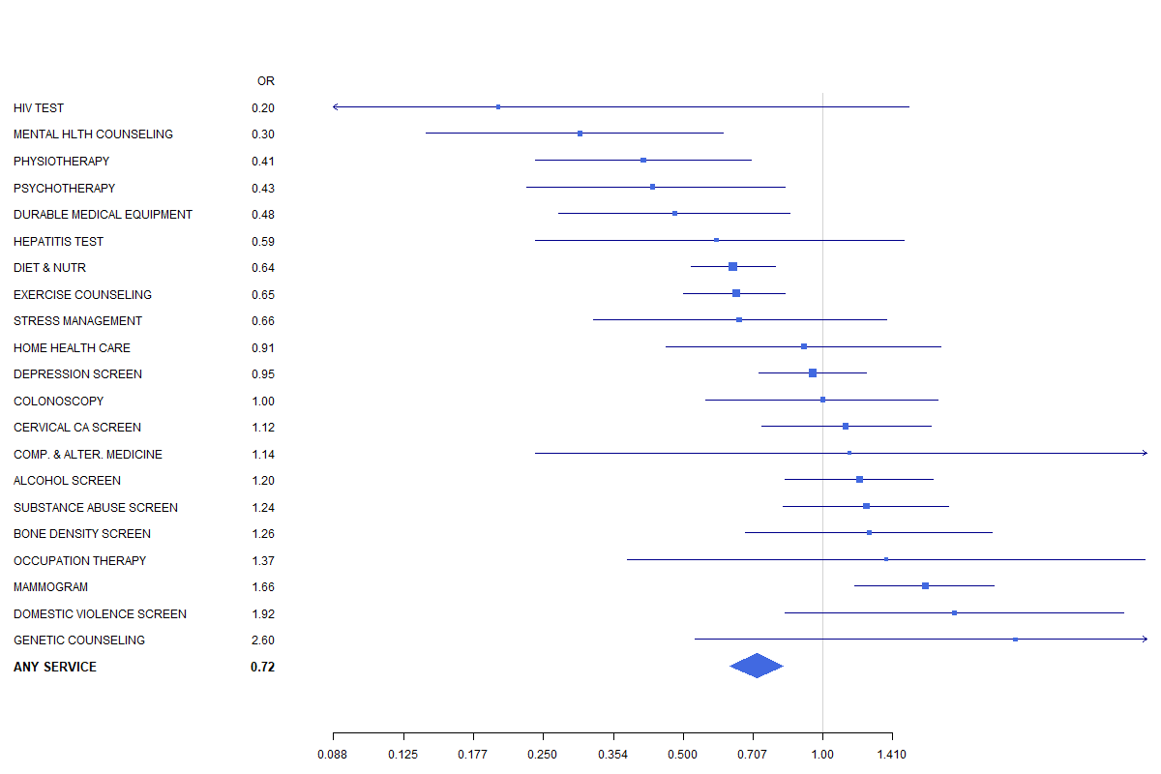

*Adjusted for: age, race/ethnicity, sex, and insurance status

**Table 1.** Comparison of demographics and health services rendered in cancer and non-cancer patients.

|  |  |  |  |  |
| --- | --- | --- | --- | --- |
|  | **Overall** | **Patients without cancer** | **Patients with cancer** | **p** |
| **No.** | 1,744,110,764.30 | 1,618,816,143.70 | 125,294,620.60 |  |
| **Age** | 47.1 (25.1) | 45.6 (25.1) | 66.2 (15.7) | **<0.001** |
| **Male sex** | 724,796,622.1 (41.6) | 670,174,918.2 (41.4) | 54,621,704.0 (43.6) | 0.348 |
| **Race/ethnicity** |  |  |  | **<0.001** |
| White, non-Hispanic | 1,210,740,753.7 (69.4) | 1,108,924,626.2 (68.5) | 101,816,127.5 (81.3) |  |
| Black, non-Hispanic | 150,457,289.4 (8.6) | 143,908,722.5 (8.9) | 6,548,567.0 (5.2) |  |
| Hispanic | 274,675,311.3 (15.7) | 263,891,839.2 (16.3) | 10,783,472.1 (8.6) |  |
| Other | 108,237,409.9 (6.2) | 102,090,955.8 (6.3) | 6,146,454.1 (4.9) |  |
| **Physician Specialty** |  |  |  | **<0.001** |
| Primary Care | 922,117,770.4 (52.9) | 887,480,657.8 (54.8) | 34,637,112.5 (27.6) |  |
| Surgical Care | 371,209,895.4 (21.3) | 336,601,057.6 (20.8) | 34,608,837.8 (27.6) |  |
| Medical Care | 450,783,098.5 (25.8) | 394,734,428.2 (24.4) | 56,048,670.3 (44.7) |  |
| **Pay Type** |  |  |  | **<0.001** |
| Blank | 45,013,689.8 (2.6) | 41,446,382.4 (2.6) | 3,567,307.4 (2.8) |  |
| Unknown | 55,357,936.7 (3.2) | 50,176,644.7 (3.1) | 5,181,292.0 (4.1) |  |
| Private insurance | 855,657,534.6 (49.1) | 813,340,729.3 (50.2) | 42,316,805.3 (33.8) |  |
| Medicare | 456,013,468.5 (26.1) | 390,633,410.6 (24.1) | 65,380,057.9 (52.2) |  |
| Medicaid or CHIP | 223,151,377.7 (12.8) | 216,600,237.7 (13.4) | 6,551,140.0 (5.2) |  |
| Worker’s Compensation | 7,975,149.1 (0.5) | 7,940,274.9 (0.5) | 34,874.3 (0.0) |  |
| Self-pay | 77,834,610.3 (4.5) | 76,775,032.5 (4.7) | 1,059,577.8 (0.8) |  |
| No change/charity | 4,906,329.5 (0.3) | 4,906,329.5 (0.3) | 0.0 (0.0) |  |
| Other | 18,200,668.2 (1.0) | 16,997,102.3 (1.0) | 1,203,565.9 (1.0) |  |
| **# of Chronic Conditions** | 1.1 (2.2) | 1.0 (2.2) | 2.7 (1.7) | **<0.001** |
| **Past visits in last 12 months** | 2.9 (6.8) | 2.8 (6.8) | 3.2 (6.7) | 0.406 |
| **Services provided** |  |  |  |  |
| Any service | 1,744,110,764 (28.2) | 1,618,816,144 (28.7) | 125,294,620.6 (21.5) | **0.001** |
| Alcohol abuse counseling | 8,991,905.6 (0.5) | 8,704,616.5 (0.5) | 287,289.1 (0.2) | 0.100 |
| Bone Mineral Density | 9,185,182.9 (0.5) | 8,358,653.8 (0.5) | 826,529.0 (0.7) | 0.587 |
| Breast Exam | 55,578,254.2 (3.2) | 50,562,923.1 (3.1) | 5,015,331.1 (4.0) | 0.247 |
| Cervical Cancer Screening | 38,628,828.4 (2.2) | 36,814,931.3 (2.3) | 1,813,897.1 (1.4) | 0.248 |
| Colonoscopy | 22,776,808.5 (1.3) | 21,115,403.2 (1.3) | 1,661,405.3 (1.3) | 0.972 |
| Complimentary and Alternative Medicine | 1,373,350.1 (0.1) | 1,344,268.1 (0.1) | 29,082.0 (0.0) | 0.102 |
| Depression Screening | 75,227,618.3 (4.3) | 68,481,463.8 (4.2) | 6,746,154.6 (5.4) | 0.295 |
| Diet/Nutrition Counseling | 216,890,076.6 (12.4) | 206,683,059.2 (12.8) | 10,207,017.3 (8.1) | **0.004** |
| Durable Medical Equipment | 17,835,579.4 (1.0) | 17,286,279.3 (1.1) | 549,300.1 (0.4) | **0.020** |
| Exercise counseling | 141,100,033.2 (8.1) | 133,247,031.3 (8.2) | 7,853,001.9 (6.3) | 0.055 |
| Genetic Counseling | 1,112,895.7 (0.1) | 652,108.1 (0.0) | 460,787.6 (0.4) | **0.005** |
| Hepatitis Test | 15,632,650.4 (0.9) | 15,171,073.1 (0.9) | 461,577.2 (0.4) | 0.114 |
| HIV test | 3,262,653.8 (0.2) | 3,095,472.9 (0.2) | 167,180.9 (0.1) | 0.569 |
| Home Health Care | 7,903,741.7 (0.5) | 7,451,179.5 (0.5) | 452,562.2 (0.4) | 0.697 |
| Mammography | 30,813,184.8 (1.8) | 27,365,932.2 (1.7) | 3,447,252.6 (2.8) | 0.212 |
| Mental Health Counseling | 29,007,475.1 (1.7) | 28,647,258.6 (1.8) | 360,216.4 (0.3) | **<0.001** |
| Occupational Therapy | 1,659,054.1 (0.1) | 1,530,125.7 (0.1) | 128,928.4 (0.1) | 0.905 |
| Psychotherapy | 27,233,950.1 (1.6) | 26,548,693.9 (1.6) | 685,256.3 (0.5) | **0.019** |
| Physical Therapy | 36,999,632.0 (2.1) | 35,449,392.9 (2.2) | 1,550,239.2 (1.2) | 0.114 |
| Skin exam | 335,206,570.0 (19.2) | 298,738,617.5 (18.5) | 36,467,952.5 (29.1) | **<0.001** |
| Stress Management | 17,603,370.1 (1.0) | 16,577,517.2 (1.0) | 1,025,852.8 (0.8) | 0.651 |
| Substance Abuse Screening | 22,950,527.4 (1.3) | 20,662,088.7 (1.3) | 2,288,438.8 (1.8) |  |
| Tobacco use/exposure counseling | 51,581,723.6 (3.0) | 48,499,123.2 (3.0) | 3,082,600.3 (2.5) | 0.478 |
| Legend: Numbers are No. (%) unless otherwise noted. | | | |  |