PROGRAM-2

Q. Develop a program to demonstrate the concept of recursion.

- Binary Search:

- Theory:

Binary search can be achieved by two ways:
- By Iteration method
- By Recursive method

The recursive method follows the divide and conquer approach. A sorted array can be searched using the binary search algorithm by continually halving the search interval.

//-----------------------------------------------------------------------------------

- Algorithm:

In order to execute a binary search, you must follow the following steps:

Step-1: Start your search using the middle member in the entire array.
Step-2: Return an index of the search key if the value of the search key equals the item.
Step-3: Alternately, if the search key's value is smaller than the item in the interval's midpoint, limit the interval to its lower half.
Step-4: If not, restrict it to the upper half.
Step-5: Check the interval from the second point again until the value is discovered or it is empty.

//-----------------------------------------------------------------------------------

- Code:

#include<stdio.h> // header files are included
#include<stdlib.h>

int bs(int array[],int x,int low,int high) // function for binary search
{
if (high>=low) // condition is checked if high is greater than or equal to low
{
int mid =(low+high)/2; //mid=(high+low)/2
if(array[mid]==x) //searching the middle part of the array.
{
return mid; // the middle value found is returned.
}
if(array[mid]>x) //searching the left half
{
return bs(array,x,low,mid-1); //high=mid-1
}
else // searching the right half
{
return bs(array,x,mid+1,high); //low=mid+1
}
return -1;
}
}

int main(void) //main function
{
int array[]={1,2,3,4,5,6,7,8,9}; //enter the elements in a sorted order as binary search works only for sorted elements
int n;
int x; //x is the element to be searched
int result; //result to store the index
n=sizeof(array)/sizeof (array[0]);
printf("Enter the element to be searched:\n");
scanf("%d",&x); // element is entered as an input by the user
result = bs(array,x,0,n-1); //function binary search is called.
if(result==-1)
{
printf("element is not found\n"); //if result=-1 then element is not found
}
else
{
printf("Element is found at index %d\n",result); //element is found
}
}

// END OF THE PROGRAM

//-----------------------------------------------------------------------------------

“Screenshot of the output”

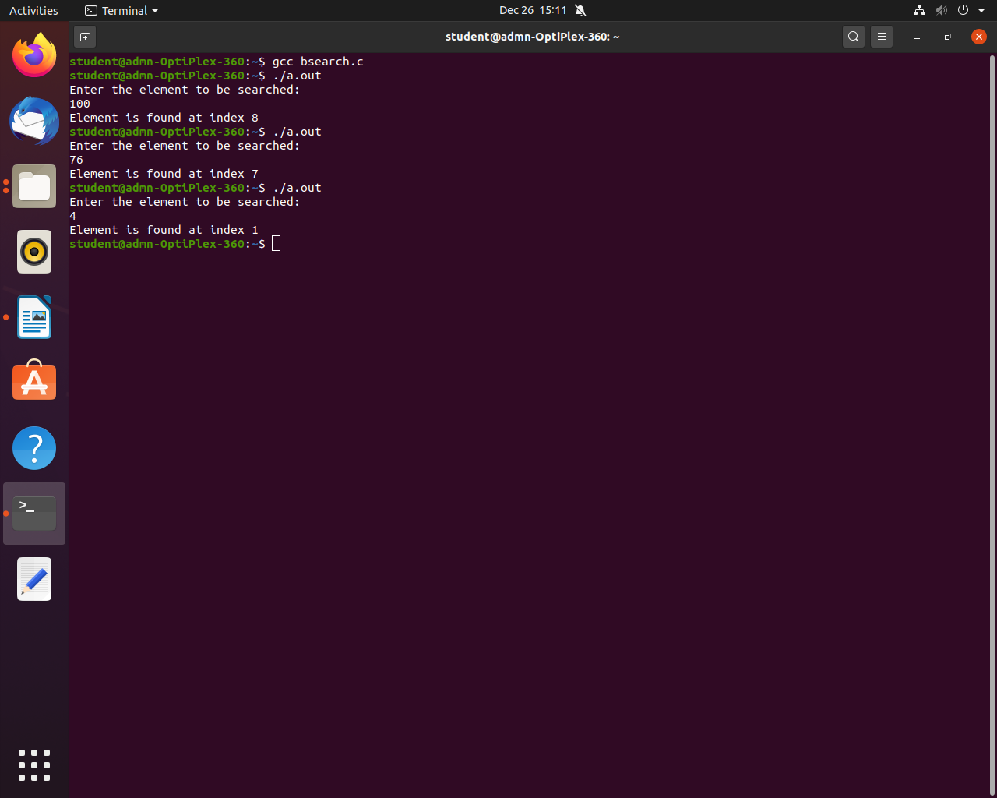

- Factorial of a given number:

- Theory:

A positive integer's factorial is the result of multiplying all the negative integers by the positive integer. For instance, the factorial of 5 is 120, which is equal to 5 * 4 * 3 * 2 * 1.

For instance, the factorial of 6 is 720, which is equal to 6*5*4*3*2*1.

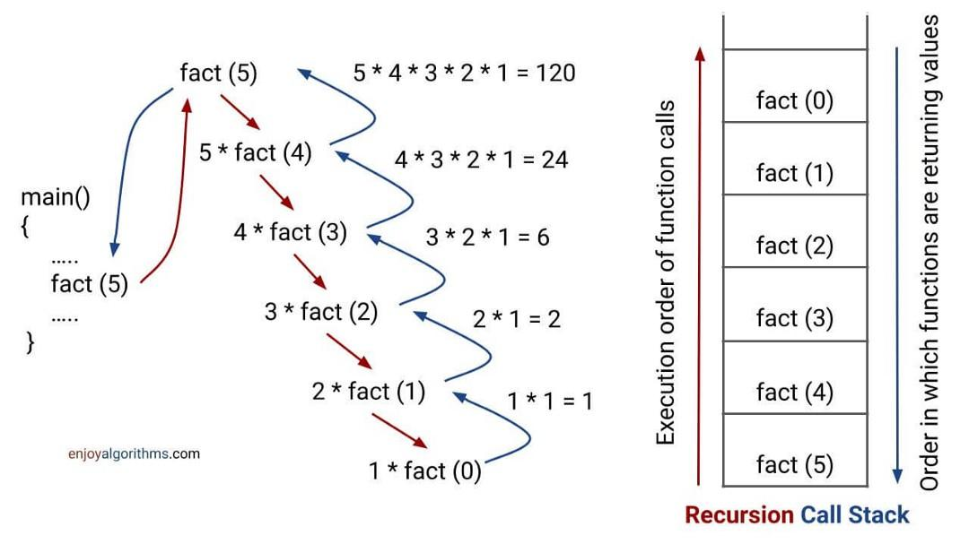

“Tracing of the factorial of a given number”

//----------------------------------------------------------------------------

- Algorithm:

Step-1: To find the factorial, request the user to enter an integer.
Step-2: Assign the integer to a variable after reading it.
Step-3: The final value is updated by multiplying each digit from the integer's value up to 1.
Step-4: The factorial is the final result after all multiplications up to one.

//-----------------------------------------------------------------------------

- Code:

#include<stdio.h> // header file is included
int fact(int); // function prototype for factorial.
int main() //main function
{
int n,f; // n and f are declared
printf("Enter the number:\n"); // user is asked to enter the value of which he wants to determine the factorial.
scanf("%d",&n); //user input is received
f=fact(n);
printf("The factorial of %d is %d\n",n,f); // factorial of the entered number is printed.

int fact(int n) // function definition of fact
{
if (n==0)
{
return 0; // if n=0 then 0 is returned.
}
else if(n==1)
{
return 1; // if n=1 then 1 is returned.
}
else
{
return n*fact(n-1); // else, fact function is called by itself i.e, RECURSIVE FUNCTION CALL
}
}

// END OF THE PROGRAM

//-------------------------------------------------------------------------------

“SCREENSHOT OF THE OUTPUT”

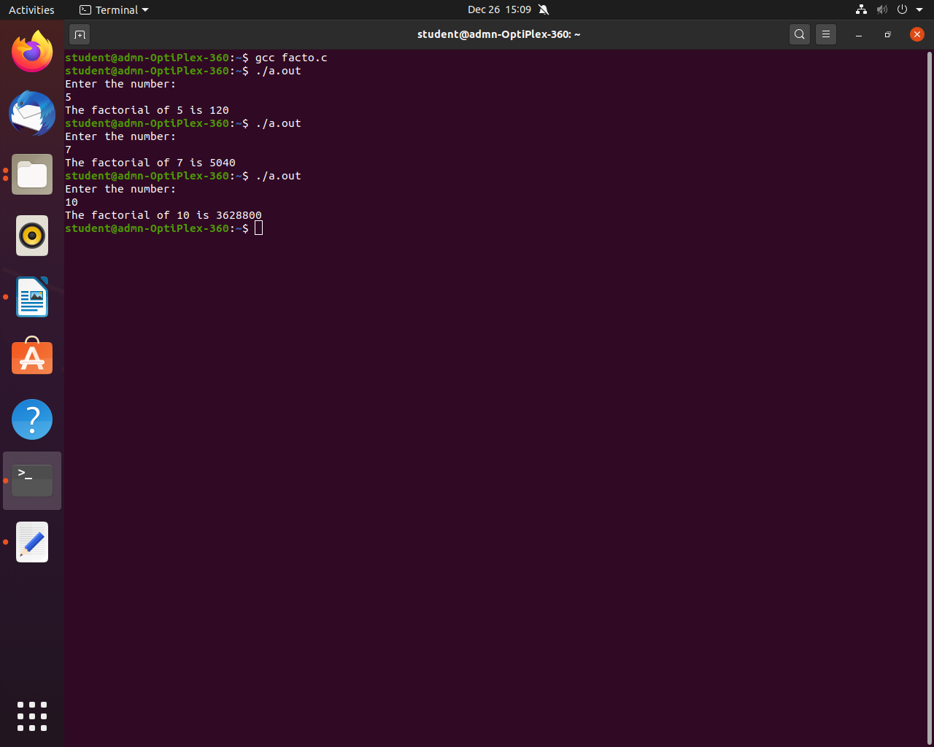

- Tower of Hanoi:

- Theory:

Three rods (A, B, and C) and N discs make up the mathematical puzzle known as the Tower of Hanoi. All of the discs are initially piled on rod A in decreasing order of diameter, with the smallest disc at the top. The goal of the puzzle is to transfer the complete stack to another rod (here referred to as C), while adhering to the following straightforward rules:

1. One disc at a time can only be relocated.
2. A disc may only be moved if it is the highest disc on a stack. Each move entails taking the upper disc from one of the stacks and placing it on top of another stack.
3. A larger disc cannot be stacked on a smaller disc.

//--------------------------------------------------------------------------------

- Algorithm:

Step-1: Recursively move discs 1, 2, and 3 from peg A to peg C to solve the puzzle.
Step-2: Translocate disc 4 from A to C.
Step-3: Recursively move discs 1, 2, and 3 from peg C to peg B to solve the problem.
You eventually realise that the problem has a pattern, and that the pattern might be repeated with each increase in the number of discs.
Step-4: Create the function Tower with the parameters int "a" for the number of discs, char "from" for the source peg, char "aux" for an additional peg, and char "to" for the destination peg.
Step-5: Add a "if" loop.
Step-6: Transfer the disc from the "starting peg" to the "destination peg" if (a=1), or if the number of discs is 1.
Step-7: If not, call the function tower for "a-1," which is the number of the first disc, then recall the function tower for the next disc and shift it "from" to "to."
Step-8: Repeat the recall function using recursion up until the disk's or number equals 1.

//------------------------------------------------------------------------------

For instance, the tower of Hanoi for 3 disks is as follows:

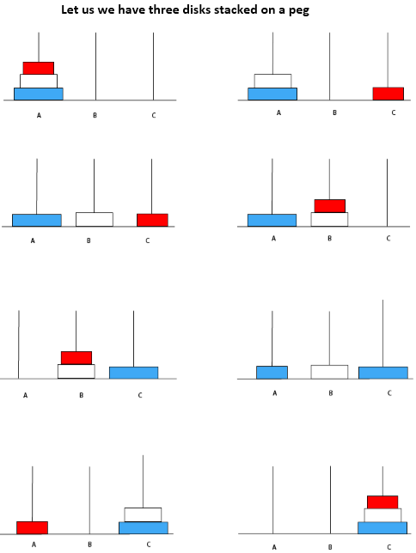

//-----------------------------------------------------------------------------

- Code:

#include<stdio.h> // header files are included
#include<stdlib.h>

//tIn ower of hanoi function rods from,to and auxillary has been declared.
int toh(int n, char from_rod, char to_rod, char aux_rod)
{
if(n==1) // condition n=1 is checked
{
printf("Move disk 1 from rod %c to rod %c\n",from_rod,to_rod);
// if n=1 then move disk 1 from the present rod to TO ROD
return 1;
}
toh(n-1,from_rod,aux_rod,to_rod); // function toh is called and parameters n,from,to and auxillary rods are passed.
printf("Move disk %d from rod %c to rod %c\n",n,from_rod,to_rod);
toh(n-1,aux_rod,to_rod,from_rod);
}

int main()
{
int n; // n is declared.
printf("Enter the number of disks:\n"); //user is asked to enter the number of disks
scanf("%d",&n);
// no.of disks is taken as an input parameters n,A,B,C
return 0;
}

// END OF THE PROGRAM

//-----------------------------------------------------------------------------

“SCREENSHOT OF THE OUTPUT”

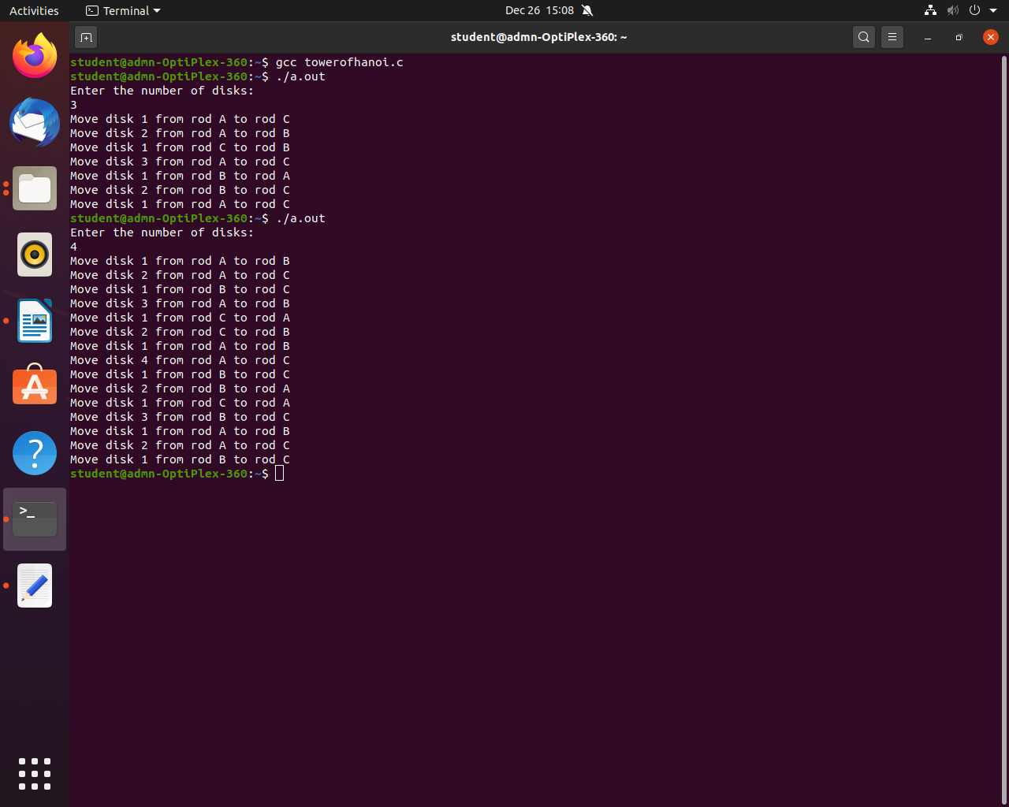

***********************************END***********************************

