**Section 2: Project-Related Excel Questions**

1. **You have a sales report with monthly sales data. How would you create a chart to display this data?**

Solution-

Before creating the chart directly, we have to know the following steps or we have to go through the following steps.

1. Understand the goal
2. Collect and connect the data.
3. Data cleaning and preprocessing
   * Missing values
   * Outliers
   * Duplicate values
4. Understand the Data
   * Rows
   * Columns
5. Analysis the data like pivot tables
6. Now we can go for plotting the Charts

**Steps for Creating Charts-**

**Step 1 - Highlight or select important Data we want to include in our chart.**

**Step 2 – Insert Chart (**go to 🡪 “insert tab” 🡪 “Charts” 🡪 )

* Select the chart that is related to your Data
* Like if we selected two columns’ sales and region 🡪 So we can go with pie or doughnut chart or Histogram 🡪 it will give data summary (percentage) in visual way
* Like in which region the count of sales or average of sales

**Step 3 – We can customize chart**

* By changing title adding Title
* Customize appearance of charts

1. **Describe how you would use Excel to identify outliers in a dataset.**

Solution-

Before creating the chart directly, we have to know What is Outlier

Outliers are the data point that is significantly changed from Overall Data point.

**Technique 1 – Scatter Plot**

* Visually scatter plot will tell us about data points are significantly different from the overall pattern
* In this outlier are the points who are away from the main cluster in a scatter plot

**Technique 2 – Box Plot**

* In this outlier are the points who are away from the Box

**Technique 3 – IQR (interquartile range)**

* In this the values outside the bond are outlier

1. **If given a large dataset, how would you use Excel to find and remove duplicates?**

Solution-

**Step 1** – Load the Data in Excel

**Step 2** – Select the entire range of data.

**Step 3** – Go to 🡪 “Data” tab on Excel

**Step 4** – Click on “Remove Duplicates” from “Data Tools” Group.

**Step 5** – excel will open a dialog box where all the columns are selected, then unselect the unwanted columns and hit OK

1. **Explain how you would use Excel to consolidate data from multiple worksheets into one summary sheet.**

Solution-

Let’s Understand this by taking an example.

Suppose we have 4 sheets in a workbook west, east, north and south. We want to append all the sheets in a single sheet to generate some insights from it.

We will follow the Following Steps

**Step 1** – Load the Data in Excel workbook

**Step 2** - Go to 🡪 “Data” Tab 🡪 Select the first table from sheet 1 i.e., West region data transform the data using power query editor and save as only connection

**Step 3** – Do the same for All sheets or Tables (East, north and south)

**Step 4** – select “Get Data” from “Data” tab scroll it down select “Combine Queries” And use “Append”

**Step 5** - It will look like pic Below

**Step 6** – Select the connections and hit ok

**Step 7** – transform data if necessary and save and load

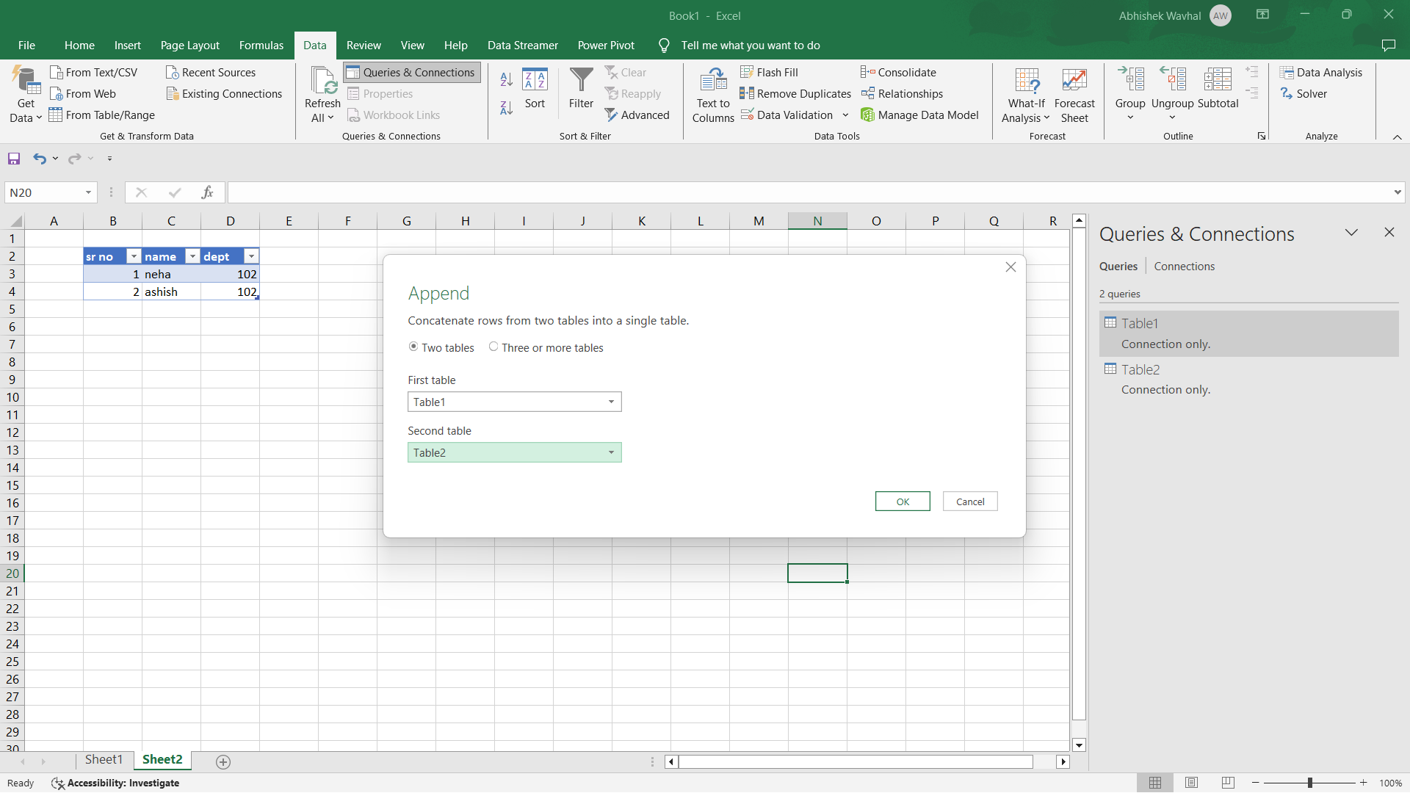

1. **Describe a scenario where you would use the IF function in project management.**

Solution-

**1** – For Tast tracking

* For Checking if Everyone in the project is completing their task
* EOD check with if function the count of task they have completed are close to mean and then decide their Attendance Mark them absent present or Half Day.

**2** – Understanding Project Deadline

3 – To Crete Automatic Notification

* Alter for completing daily target