Landscape of Acetylene Synthesis: Challenges and Perspectives
Zihao Zhang, Abhinandan Nabera, Gonzalo Guillén-Gosálbez, Javier Pérez-Ramírez*
Institute for Chemical and Bioengineering, Department of Chemistry and Applied Biosciences, ETH Zurich, Vladimir-Prelog-Weg 1, 8093 Zurich, Switzerland.
*Corresponding author. E-mail: jpr@chem.ethz.ch
Abstract (ca. 214 words)
Acetylene (C₂H₂), produced from coal or natural gas and known for its rich chemistry due to the triple bond, was a cornerstone of the organic chemical industry until the 1960s. The global availability of inexpensive petroleum around the 1950s accelerated ethylene (C₂H₄) synthesis technologies, thus diminishing C₂H₂’s market prominence due to their similar range of downstream chemicals production. Fossil-based C₂H₄ and C₂H₂ synthesis are energy-intensive and raise significant environmental concerns. While alternative C₂H₄ synthesis has been the focus due to its larger market share (225 vs 11 million tons in 2022), new C₂H₂ synthesis deserves equal attention for its potential to produce C₂H₄-derived chemicals and its unique applications, such as oxyacetylene welding, butanediol and acetylenic chemicals synthesis, etc. This review provides a holistic overview of C₂H₂ synthesis technologies, including indirect calcium carbide route, and direct routes via partial combustion, electric arc, (catalytic-)cold/warm plasma, (catalytic-)thermal pyrolysis. In addition to traditional fossil-based routes, we also discuss sustainable resources like biomass, plastic, CO₂, and biomethane as carbon feedstocks. We aim to elucidate the status and challenges of each method and encourage alternative C₂H₂ synthesis derived from sustainable resources by evaluating their potential through life cycle assessments. By highlighting novel synthesis approaches, we seek to renew interest in C₂H₂ chemistry and foster collaborative efforts for its technological advancement.

Keywords: Acetylene synthesis; Calcium carbide; Plasma; Methane coupling; Sustainable carbon resources; Life cycle assessment.
- Introduction (ca. 695 words)
Acetylene (C₂H₂) was accidentally discovered in 1836 in Ireland by Edmund Davy through the reaction of water with potassium carbide (K₂C₂), obtained by heating a mixture of tartar (potassium hydrogen tartrate, KC₄H₅O₆) and charcoal powder (Figure 1).¹ Significant study only began after French chemist Marcellin Berthelot coined the name “acetylene” in 1860 and reported the C₂H₂ synthesis via electric arc in 1862.² The first commercial calcium carbide (CaC₂) plant for C₂H₂ production was established in 1894 due to accident production of CaC₂ by the electrothermal reduction of lime (CaO) with carbon sources and its simple reaction with water to form C₂H₂ by Thomas Willson.³ Early applications of C₂H₂ were mainly in lighting and oxyacetylene welding and cutting due to the brightness and high temperature of C₂H₂ flame.^{2,4} The importance of C₂H₂ was reflected by its triple bond, which makes the molecule reactive and provides rich chemistry. The start of the industrial acetaldehyde production via C₂H₂ hydration in 1916, along with studies on C₂H₂ chemistry by Walter Reppe to produce various commodity chemicals, positioned C₂H₂ as a pillar of the organic chemical industry.^{5,6} Coal-based CaC₂ was the sole source for C₂H₂ production until the development of commercial light hydrocarbons cracking methods, including the electric arc (Hüls) process in 1940, and the partial combustion and thermal pyrolysis (Wulff) processes in 1950.^{7,8}
The blossoming of the petrochemical industry in the USA during the 1940s and in Europe during the 1950s, combined with the safer handling of olefins compared to C₂H₂, led to the development of cheaper steam cracking technology for the production of ethylene (C₂H₄) and propylene (C₃H₆), gradually displacing the C₂H₂ market primarily with C₂H₄.^{9,10} C₂H₂ is the sole pillar for chemical industry before 1940, but by 1960, global production of C₂H₂ and C₂H₄ reached 3 and 3.5 million metric tons per year (Mt y⁻¹) respectively,^{11–13} and these figures shifted to 11 Mt y⁻¹ for C₂H₂ and 214 Mt y⁻¹ for C₂H₄ by 2021.^{14–16} Between 1970s to 1980s, partial combustion became the dominant technologies for C₂H₂ production, as other methods were mostly abandoned. In recent years, China saw a resurgence in CaC₂ route, with CaC₂ production rising from over 2 Mt y⁻¹ in 1990 to 25 Mt y⁻¹ in 2014¹⁷, where nearly 3 tons of CaC₂ produce 1 ton of C₂H₂ depending on the CaC₂ purity. China currently leads in C₂H₂ production, with about 90% derived from the CaC₂ method due to its abundant coal reserves, while non-Chinses C₂H₂ production is less than 3 Mt y⁻¹ mostly through partial combustion.^{15,16,18} The historical transition from C₂H₂ to C₂H₄ resulted from cheaper C₂H₄ production technology due to the long-term availability of cheap oil before 1973.^{19,20} Afterwards, C₂H₂ production became more economical in some regions.²¹ Both C₂H₄ and C₂H₂ production are energy-intensity and have significant environmental impacts, producing 1-2 tons of CO₂ per ton of C₂H₄ depending on the feedstocks and 0.8 and 3.6 ton of CO₂ per ton of C₂H₂ via partial combustion and CaC₂ routes, respectively.^{15,22–24} This highlights the need for alternative production routes for both C₂H₂ and C₂H₄. While alternative C₂H₄ production has been extensively studied,^{25,26} research on C₂H₂ alternatives has lagged possibly due to its smaller market size.
Although C₂H₂ chemistry has largely been replaced since 1960s, it is important to remember that C₂H₂ is more reactive, and its derived processes often show streamlined synthesis pathways compared to C₂H₄-derived processes.⁵ Additionally, some applications of C₂H₂, such as oxyacetylene welding and the production of acetylene black, polyacetylene, and Reppe chemicals like 1,4-butanediol are difficult to replace.^{27–30} In the pursuit of a sustainable chemical industry using non-fossil carbon and renewable energy, research on C₂H₂ and C₂H₄ should start afresh, and it seems that C₂H₂ can play a vital role towards sustainability.³¹ For example, methane (CH₄), possibly sourced from biogas, has been widely explored for C₂H₄ production but remains unindustrialized.²⁶ In contrast, CH₄ to C₂H₂ via partial combustion and electric arc was commercialized nearly 70 years ago, despite its high energy consumption.³² Therefore, the shift towards sustainability presents an opportunity for revitalizing C₂H₂ production, warranting increased attention. In this review, we provide a holistic summary of C₂H₂ production methods, sustainable initiatives, and the challenges and opportunities. Our aim is to guide sustainable technology development and advocate for greater focus on alternative C₂H₂ routes.
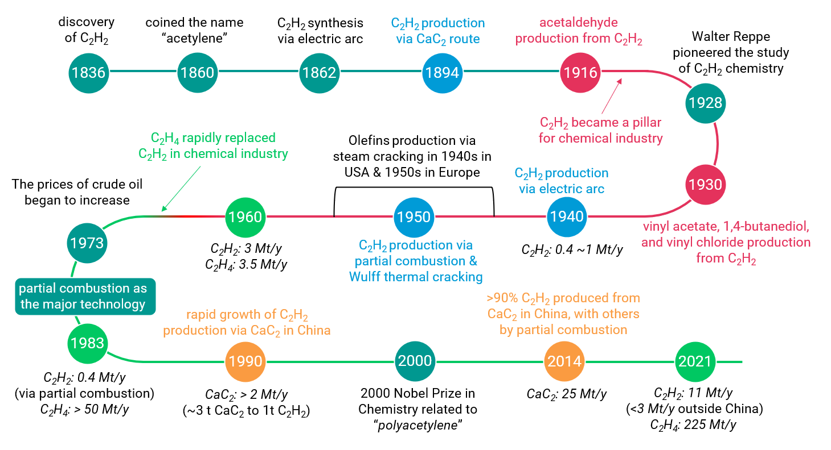
Fig. 1. History of C₂H₂ manufacture. The timeline illustrates the discovery of C₂H₂, the evolution of various industrial C₂H₂ production technologies, C₂H₂ chemistry, global production changes at key historical points, and the gradual market transition from C₂H₂ to C₂H₄.

- Production of acetylene (ca. 2770 words)
2.1. Summary of acetylene production routes and its applications (ca. 789 words)
Acetylene (C₂H₂) can be produced from fossil-derived feedstocks such as coal, natural gas and oil using four primary technologies: CaC₂, partial combustion, plasma, and thermal pyrolysis routes (Figure 2). Among these, oil-based routes have been explored but never reached commercial viability. Plasma technology includes thermal plasma, where all generated species reach thermal equilibrium, and non-thermal plasma, where energy is preferentially channeled to electrons, leading to a significantly higher electron temperature.³³ Thermal plasma, particularly the electric arc method, was first commercialized for C₂H₂ production from natural gas by Hüls, Germany in 1940, and Dupont later developed a rotating arc in 1963.^{7,34} However, the electric arc process was eventually replaced by partial combustion due to its extremely high energy consumption (Hüls arc process: 12.1 kW h kg⁻¹ C₂H₂).⁷ Plasma technology for converting coal and natural gas to C₂H₂ continues in pilot-scale operations in China. The natural gas plasma method, which is expected to be commercialized, uses one-third of the methane required for partial combustion, while specific details of the plasma technology and energy consumption has not been reported.^{15,35} Thermal pyrolysis of hydrocarbons was commercialized by the Wulff process in 1950, which involved preheating bricks to 1300 °C followed by feeding hydrocarbons for cracking to produce C₂H₂.⁸ Due to significant soot formation, most Wulff plants have been closed.¹¹ Currently, coal-derived CaC₂ and natural gas-derived partial combustion technologies dominate industrial C₂H₂ production. Production is region-dependent, with China producing over 8 Mt y⁻¹ primarily from the CaC₂ route (~90%) due to its large coal reserves, while production outside China is less than 3 Mt y⁻¹, mainly via partial combustion.^{11,15}
The first commercial application of C₂H₂ after 1894 was for lighting, followed by its use in oxyacetylene welding and cutting developed in 1903.² In the late 19th and early 20th centuries, acetylene lighting was widely used for illumination in mining, vehicles, street lighting, lighthouses, aviation beacons, but it was gradually replaced by electric lighting after 1920.¹¹ Oxyacetylene welding and cutting remain widely used, offering a flame temperature of approximate 3150 °C, and it is one of the cheapest and most accessible methods for metalworking.²⁷ The most significant application of C₂H₂ is as a feedstock in chemical industry,³¹ with key downstream products summarized in Figure 2. The industrial production of acetaldehyde, acetic acid, vinyl acetate, acrylic acid, and acrylonitrile from C₂H₂ has been largely replaced by routes using C₂H₄, C₃H₆, and methanol. Acetaldehyde and vinyl acetate are now primarily produced from C₂H₄, with annual productions of 1.5 and 6.2 Mt, respectively^{36,37}, but it should be noted that vinyl acetate production in China still primarily relies on C₂H₂ route. Acrylic acid and acrylonitrile are produced by from C₃H₆, with annual productions of 8.8 and 7 Mt, respectively.^{38–40} Acrylic acid has the highest annual global market size at approximately $22.6 billion,³⁸ while acetaldehyde has the lowest at around $1.5 billion. Acetic acid, previously produced via acetaldehyde oxidation, is now mainly produced by methanol carbonylation, with a high production of 18 Mt y⁻¹ and a global annual market size of about $15 billion.^{41,42}
Currently, major applications of C₂H₂ in chemical synthesis are the production of vinyl chloride, 1,4-butanediol, vinyl acetate, and acetylene black. Vinyl chloride production volume is the highest, reaching approximately 50 Mt y⁻¹,⁴³ predominantly used to produce poly(vinyl chloride) (PVC). While the C₂H₄-based PVC route dominates globally, accounting for about 65% of PVC output,⁴⁴ approximately 78% of PVC production in China uses the C₂H₂ route, with the remaining using the C₂H₄ route.²¹ This significant production from C₂H₂ and C₂H₄ contributes to a global PVC market size of $68 billion. In contrast, acetylene black has the smallest market size of approximately $0.3 billion.⁴⁵ It is a high-purity, highly crystalline form of carbon black produced from thermal decomposition of C₂H₂, with a unique structure making it an excellent conductive additive for electrodes.^{11,45} Therefore, the market for acetylene black is expected to grow with the global shift towards electric vehicles.⁴⁵
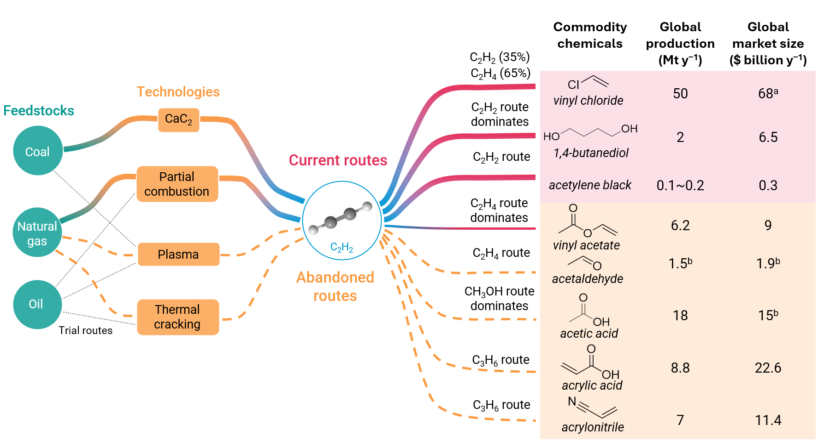
Fig. 2. C₂H₂ production routes, past and current applications. The figure introduces various C₂H₂ production routes using fossil-derived feedstocks including coal, natural gas and oil, and various technologies including CaC₂, partial combustion, plasma, and thermal pyrolysis routes. It also highlights major industrial applications of C₂H₂ and provides data on approximate global annual production (Mt/y) and market size (USD billion). Current routes: commercial processes that are in use; Abandoned routes: past commercial processes that were replaced via other methods; Trial routes: the processes with research interest in the past but never commercialized. ªSince almost all VCM demand is consumed for PVC production, this number reflects the global market size of PVC. ^{a,b}Data from Statista.
Another critical application of C₂H₂ is the production of 1,4-butanediol via the classical Reppe process, involving the reaction of C₂H₂ with formaldehyde. This process still dominates, accounting for 40% of total production (2~2.5 Mt y⁻¹).^{46,47} Despite its advantages, several complex and multi-step alternative routes have been developed to address the scarcity of C₂H₂ in some regions, including i) the production of maleic anhydride from benzene or n-butane oxidation, followed by esterification and hydrogenolysis, ii) the reaction of butadiene with acetic acid to form 1,4-diacetoxy-2-butene, followed by hydrogenation and hydrolysis and iii) the chlorination of butadiene and subsequent reaction with sodium acetate to give 1,4-diacetoxy-2-butene, followed by hydrogenation and hydrolysis.⁴⁶ 1,4-butanediol production exemplifies the advantage of C₂H₂ as a chemical synthesis feedstock. However, research on production of C₂H₂-based chemicals has not attracted sufficient attention since being largely replaced by olefin routes.

2.2. Indirect acetylene production route via calcium carbide (ca. 509 words)
Calcium carbide (CaC₂), also known as calcium acetylide, is a salt of the C₂²⁻ anion. Unique among all C₂H₂ synthesis routes, the CaC₂ method allows easy reaction with water at room temperature to release the C₂²⁻ anion as C₂H₂. The production process of C₂H₂ via CaC₂ route involves two reaction steps:
3 C + CaO → CaC₂ + CO ΔH = 465 kJ mol⁻¹
CaC₂ + 2 H₂O → C₂H₂ + Ca(OH)₂ ΔH = −127 kJ mol⁻¹
The formation of CaC₂ from coke and lime (CaO) is highly endothermic, while the conversion of CaC₂ to C₂H₂ is highly exothermic.⁴⁸ Due to its simplicity and high selectivity to C₂H₂, the CaC₂ route was first commercialized in 1896.³ This C₂H₂ manufacturing process (Figure 3a) has the low equipment investment but several disadvantages:⁴⁹ 1) the CaC₂ formation reaction requires temperatures of 2000–2300 °C in an electric arc furnace to overcome the high endothermicity; 2) large amounts of coal are consumed, with one-third of carbon resources converted to CO; 3) significant CO₂ emissions result from decomposition of limestone (CaCO₃) and combustion of byproduct CO to provide heat for the arc furnace; 4) large amounts of solid slag waste, mostly Ca(OH)₂, are produced. Due to these disadvantages and the transition of C₂H₂ to C₂H₄ as a key chemical industry feedstock, most CaC₂ plants in western countries have closed. However, in China, where coal reserves are abundant and imported oil for olefin production is costly, CaC₂-based C₂H₂ production remains significant. After a rapid growth in 21st century (Figure 3b),¹⁷ the annual CaC₂ production reached approximately 28 Mt, accounting for more than 96% of the world’s production.⁵⁰ Besides C₂H₂ production, CaC₂ is also used to produce calcium cyanamide.⁵¹
In the CaC₂ route (Figure 3a,3c), producing 1 kg of C₂H₂ consumes approximately 3.1 kg of 80% pure CaC₂ and 2 kg of coal, while generating 2.8 kg of Ca(OH)₂ slag waste and 3.6 kg of CO₂ (excluding the impact of electricity input).^{11,15} Electricity consumption is primarily associated with the CaC₂ production process, requiring about 3 to 3.5 kW h kg⁻¹ CaC₂,⁵² and total electricity consumption of at about 10.6 kW h kg⁻¹ C₂H₂.¹³ Several process improvements have been proposed over the years, such as reusing Ca(OH)₂ slag waste as building materials or for lime production via dehydration,^{18,53,54} CO₂ capture by Ca(OH)₂ to form limestone through mineralization,⁴⁸ CO recovery,¹¹ and the use of renewable electricity,⁵⁵ and the use of biochar to replace coal.^{16,54,56,57} These methods could reduce slag waste, CO₂ emission, and coal consumption to some extents (Figure 3c). Nevertheless, high electricity consumption remains inevitable due to the endothermic nature of CaC₂ formation reaction, so CaC₂ plants are usually located near sources of inexpensive electricity. An oxythermal method, which heats a mixture of CaO, coke, and O₂, can produce CaC₂ with a lower energy requirement. However, significant energy consumption is still necessary, provided by coke combustion. Although other metal carbides (e.g., BaC₂ and Li₂C₂) can be produced at relatively lower reaction temperatures, however, they have not been commercialized due to the more complex reaction processes compared to the CaC₂ route.^{49,58}
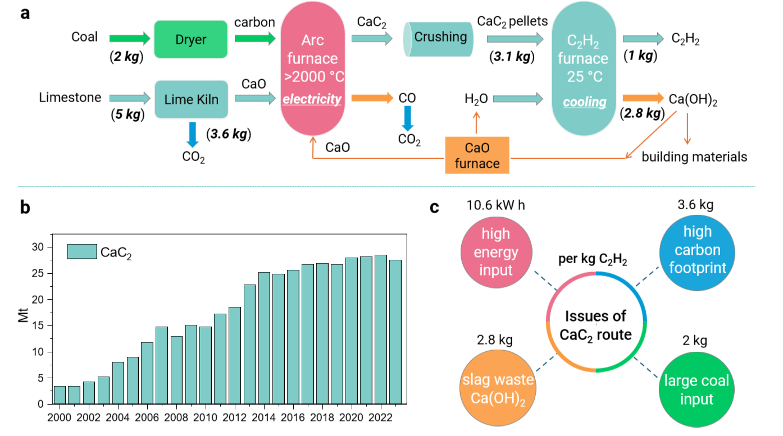
Fig. 3. CaC₂-based route. a. The process for CaC₂-based C₂H₂ manufacturing. b. annual production of CaC₂ in million metric tons (Mt) from 2000 to 2023 in China. c. four major issues associated with the CaC₂ route including high energy consumption, high carbon footprint, production of slag waste, and consumption of large coal resource.

2.3. Direct acetylene production routes (ca. 640 words)
Direct conversion of CH₄ to C₂ hydrocarbons (C₂H₂, C₂H₄, C₂H₆) are highly endothermic, with CH₄ to C₂H₂ is the most endothermic reaction with a standard enthalpy of 376 kJ mol⁻¹.³² For CH₄ to C₂H₂ process, the theoretical limit for the energy input is 189 kJ mol⁻¹ CH₄ and energy requirement is 4.03 kW h kg⁻¹ C₂H₂.^{59,60}
2 CH₄ → C₂H₂ + 3 H₂ ΔH = 376 kJ mol⁻¹
2 CH₄ → C₂H₄ + 2 H₂ ΔH = 202 kJ mol⁻¹
2 CH₄ → C₂H₆ + H₂ ΔH = 65 kJ mol⁻¹
Thermodynamic data show that CH₄ is the most stable hydrocarbon at normal temperatures, while C₂H₂ is least stable (Figure 4a) tending to decompose into carbon and hydrogen at high temperature.³² As temperature increases, the free energy of C₂H₂ decrease, making its formation more favorable above approximately 1230 °C, when the free energy of formation of C₂H₂ becomes lower than that of all other hydrocarbons.^{32,61} Among various hydrocarbons, producing C₂H₂ from CH₄ requires higher temperatures (Figure 4a).^{32,61} As seen in Figure 4b, CH₄ conversion to C₂H₂ and C₂H₄ is thermodynamically limited at low temperatures, but these limitations can be alleviated at higher temperatures.²⁶ C₂H₂ production becomes more thermodynamically favorable than C₂H₄ production under high temperatures, that otherwise also promote C₂H₂ decomposition. Thus, achieving reasonable C₂H₂ yields from CH₄ necessitates high reaction temperatures and rapid quenching of the C₂H₂ stream.
Two primary commercial technologies for direct C₂H₂ production are partial combustion, developed by BASF in 1950, and the electric or Hüls arc (known as thermal plasma), developed by Hüls in 1940. These technologies have explored various carbon resources, including crude oil, naphtha, and coal, but natural gas remains the only used industrial feedstock now. The reactor structures for CH₄ conversion by partial combustion and thermal plasma are illustrated in Figure 4c. In the partial combustion process, natural gas and O₂ are preheated separately (to 600 °C when CH₄ is used) before mixing in the diffuser and passing through the burner and reaction chamber.⁷ Approximately 60% of CH₄ combusts with O₂ in the burner to stabilize the flame at the temperature above 1500 °C, facilitating the conversion of the remaining CH₄.⁶² The reaction gas exists the reaction chamber within milliseconds, followed by rapid quenching with water or oil sprays. This process results in a C₂H₂ concentration of around 8 vol.% in the cracked gas.⁶² Unlike partial combustion, where chemical energy from combustion provides the necessary heat, thermal plasma relies on direct heat transfer from an electric arc to the reactants.⁶³ For natural gas feedstock, the arc burns directly in the gas, with a vortex chamber between the cathode and anode stabilizing the arc by injecting gas tangentially (Figure 4c). The arc’s center can reach temperature of 20000 °C, while the electrode walls remain around 600 °C.⁷ Similar to partial combustion reactor, the residence time in the arc furnace is brief, necessitating rapid quenching. Figure 4d compares two technologies.^{7,11,15,32} The thermal plasma method yields higher C₂H₂ concentration in the cracked gas, lower natural gas consumption, and reduced CO₂ emissions (excluding the impact of electricity input). Despite these advantages, thermal plasma has largely been replaced by partial combustion due to high soot formation, and particularly extremely high electricity consumption (12.1 kW h kg⁻¹ C₂H₂).^{7,64} Another type of thermal plasma plant operated by DuPont between 1963-1968 showed a higher C₂H₂ yield and lower electricity consumption of 8.8 kW h kg⁻¹ C₂H₂ using a rotating arc.⁶⁵ However, the equipment design was complex, and H₂ was co-fed as the plasma gas instead of the reactant CH₄.⁶⁵ With the increasing availability of green electricity, thermal plasma of natural gas and even coal has garnered attention in China and is likely to be commercialized soon.^{15,21,66} Additionally, C₂H₂ is produced as an impurity in the steam cracking of hydrocarbons to olefins, typically removed by catalytic selective hydrogenation or solvent extraction.²⁴
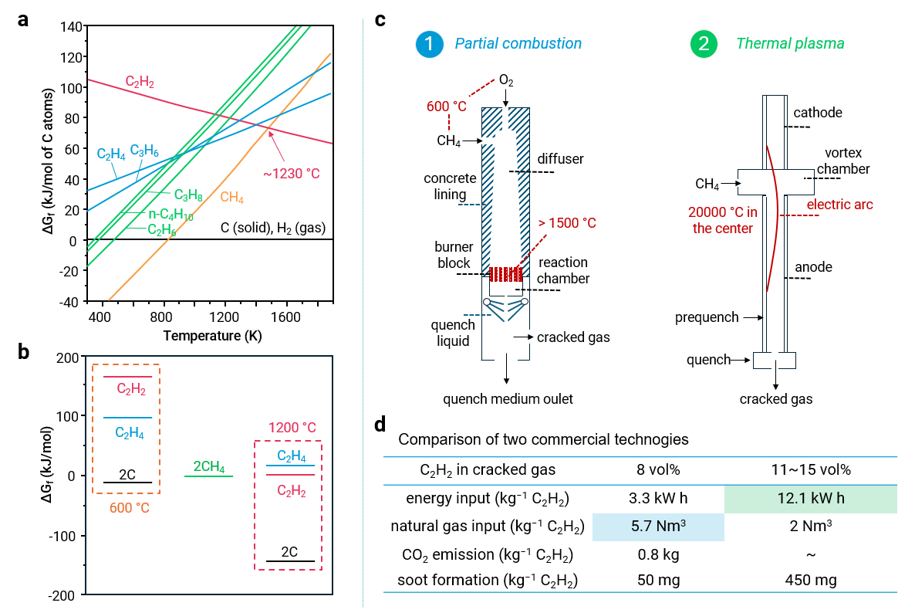
Fig. 4. Direct CH₄ to C₂H₂ production routes. a. Gibbs free energy of formation per carbon atom of several hydrocarbons from the elements as a function of temperature (K). b. Gibbs free energy of formation of C₂H₂, C₂H₄, carbon from CH₄ conversion at 600 and 1200 °C. c. Simplified reactor structure for C₂H₂ production via partial combustion and thermal plasma (electric arc), and d. comparison of these two technologies.

2.4. Tentative acetylene synthesis routes and catalytic applications (ca. 832 words)
Thermal pyrolysis of CH₄ in reactor tubes, heated either by electricity or combustion gas, can produce C₂H₂, though this method often leads to lower energy utilization efficiency and significant soot formation due to slow feed heating compared to partial combustion technology. Adding H₂ can shift the equilibrium to inhibit C₂H₂ decomposition but also reduces CH₄ conversion rate, making this approach less energy-efficient and commercially unviable.³² Recent advancements have explored non-thermal plasma technologies, including electrode-based plasma (dielectric barrier discharge (DBD), corona, pulsed, and spark) and electrodeless microwave plasma for C₂H₂ synthesis.³³ Non-thermal plasmas channel energy preferentially to electrons, creating a much higher electron temperature than the temperature of ions and neutrals. When the neutral temperature is close to room temperature, the plasma is termed “cold plasma” (e.g., DBD, corona and pulsed plasma), whereas microwave and spark plasma can heat neutrals to several thousand kelvins, making thermal activation significant; these are known as “warm plasma” (Figure 5a).³³ Electrode-based plasmas require electrodes for gas ionization to form plasma, while microwave plasma induces ionization via microwave irradiation, avoiding soot deposition issues on electrodes that affect plasma stability.⁷
Comparison of representative results of thermal pyrolysis, thermal and non-thermal (cold and warm) plasma processes are summarized in Figure 5b (Supplementary Table S1, S2). Overall performance based on CH₄ conversion and C₂H₂ selectivity shows that thermal plasma (electric arc) outperforms non-thermal plasma, which in turn outperforms thermal pyrolysis routes (Figure 5b). For the non-thermal plasma, cold plasma’s main advantage is eliminating the need for quenching since C₂H₂ is produced at low temperatures, whereas warm plasma typically achieves higher CH₄ conversion due to higher neutral temperatures (Supplementary Table S1). Feedstocks typically include pure CH₄ or CH₄ diluted in inert gas, with some attempts on co-feeds such as O₂,^{67,68} H₂,⁶⁹ and CO₂.⁷⁰ However, both cold and warm plasmas require substantial energy input to ensure the plasma formation, often exceeding commercial Hüls arc plasma processes with energy requirement of 12.1 kW h kg⁻¹ C₂H₂ (Figure 5c). Moreover, promising non-thermal results (Supplementary Table S1) mostly derive from microwave or pulsed plasma, which typically operates at low pressures or high frequency, that necessities complex requirement and limits commercial viability.³³ Catalytic attempts on non-thermal plasma have been widely explored, with DBD and microwave reactors being the most commonly used (Supplementary Table S1). For instance, in dielectric barrier plasma, adding the MFM-300(Fe) catalyst increased C₂H₂ selectivity from 17 to 38% at CH₄ conversion < 3%.⁷¹ In contrast, in microwave plasma, catalysts appear to have limited effect, with microwave irradiation being essential for significant C₂H₂ production. For example, microwave irradiation increased C₂H₂ selectivity from 0% to 35% at 700 °C with around 10% CH₄ conversion over Mo/ZSM-5@SiC catalyst.⁷² However, similar C₂H₂ selectivity was obtained with (33.7%) and without (38.4%) Ni powder catalyst at 31% CH₄ conversion.⁷³ It is essential to consider thermal activation in warm plasma due to high neutral temperatures, as its role cannot be overlooked. While extensive literature highlights the significance of non-thermal plasma on product yield, detailed energy requirements are sometimes not provided.
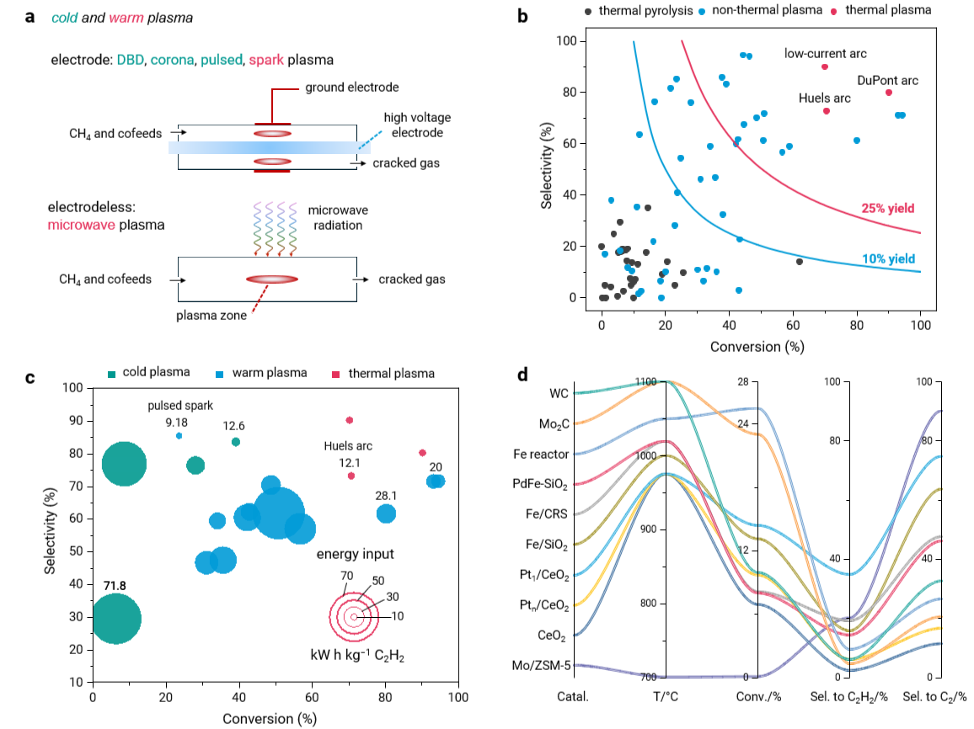
Fig. 5. Tentative acetylene synthesis routes. a. Structure of electrode-based and electrodeless plasma reactors among non-thermal (cold and warm) plasma. b. Conversion-selectivity trend from thermal pyrolysis, non-thermal and thermal plasma. c. Conversion-selectivity trend and energy requirement (kW h kg⁻¹ C₂H₂) for representative non-thermal and thermal pyrolysis routes. d. Representative catalyst type, reaction temperature (°C), CH₄ conversion, C₂H₂ and C₂ selectivity in non-oxidative CH₄ conversion.

For thermal pyrolysis, the oxidative (OCM) and non-oxidative (NCM) coupling of CH₄ could produce C₂ species, including C₂H₂, C₂H₄, and C₂H₆.²⁶ The slower heat transfer in thermal pyrolysis compared to partial combustion technology (> 1500 °C) limits commercial process like the Wulff process.³² Thus, thermal pyrolysis could be competitive only if reaction temperatures are lowered (≤ 1100 °C) using catalysts. OCM is thermodynamically more favorable than NCM but challenging to avoid overoxidation to CO_{x}, requiring lower reaction temperature (450~1000 °C).⁷⁴ However, at low temperatures, the reaction of CH₄ to C₂H₂ becomes less thermodynamically favorable compared to the formation of other hydrocarbons (Figure 4a,4b). As a result, C₂H₂ production from thermal pyrolysis primarily comes from NCM rather than OCM (Supplementary Table S2). The highest C₂H₂ selectivity reported is 35% at 14.4% CH₄ conversion at 975 °C on Pt₁/CeO₂ catalyst⁷⁵, outperforming pristine CeO₂, Pt_{n}/CeO₂, metal carbides, and Fe/Ni-based catalysts (Figure 5d),^{76–78} though CH₄ conversion is typically below 30% at temperature ≤ 1100 °C. CH₄ conversion of 63% is obtained on Pt on α-Al₂O₃ monolith, but a huge temperature gradient in monolith from 200 to 1500 °C is observed, already closer to the temperature in partial combustion (Figure 5b).⁷⁹ Additionally, coke deposition is significant due to thermodynamically favorable coke formation (Figure 4a). Advanced reactor designs, including membrane or millisecond reactors, have been explored for enhanced CH₄ conversion due to the shift of reaction equilibrium to product side and improved stability due to shortened contact time.^{80,81} However, achieving high CH₄ conversion and high C₂H₂ selectivity simultaneously via thermal pyrolysis remains challenging. As seen in Figure 5d, other C₂ products, especially C₂H₄, are always present in a large amount, that significantly affects C₂H₂ selectivity. Additionally, the presence of other byproducts such as C₃-C₅ hydrocarbons, aromatics, and coke further limits the C₂H₂ formation.^{77,82} Therefore, converting CH₄ to a broader product distribution, such as C₂ (C₂H₂, C₂H₄, C₂H₆) or even C₂₊ hydrocarbons mixture, should be more practical route for future CH₄ utilization by catalytic thermal pyrolysis route.

- Sustainable carbon resources for acetylene synthesis (ca. 734 words)
Fossil fuel-based C₂H₂ synthesis relies on four primary technologies: CaC₂, partial combustion (PC), thermal pyrolysis (TP), and plasma (Figure 6a). Currently, coal-based CaC₂, particularly prevalent in China, and natural gas-based PC dominates the market for CaC₂ production. While these methods require relatively lower energy input compared to thermal plasma route, they demand significant coal or natural gas input and have substantial environmental impacts, making them unsustainable for future chemical processes (Figure 3c,4d). Thus, developing C₂H₂ synthesis approaches using sustainable carbon resources (e.g., biochar, biogas, CO₂, plastic) and green electricity (e.g., wind, solar) is imminent. Figure 6b illustrates potential combinations of sustainable carbon resources and relevant technologies for C₂H₂ synthesis. Biochar, derived from biomass pyrolysis, has been proposed for C₂H₂ synthesis via the CaC₂ route with a lower carbon footprint, though it typically exhibits lower carbon and energy efficiency due to the lower energy density of biomass and the generation of volatile components during pyrolysis.^{16,54,56} Additionally, direct thermal pyrolysis of various biomass feedstocks to C₂H₂ has been widely studied, but, C₂H₂ selectivity remains limited.⁶³ Recently, the coal-based plasma route has gained attention in China as a greener alternative to the coal-based CaC₂ route.²¹ Biomass as a substitute for coal in the plasma route has also been explored, such as lignin and hemicellulose cracking in a hydrogen plasma, further reducing the carbon footprint.⁸³
Moreover, the pyrolysis of polyolefins and polyethylene terephthalate (PET) using rotating arc plasma technology has proven feasible for C₂H₂ production, achieving full carbon conversion and C₂H₂ selectivities of 55% for PET and 80% for polyolefins.^{84,85} However, the specific energy requirement is approximately 20 kW h kg⁻¹ C₂H₂, significantly higher than the commercial Hüls arc plasma process using natural gas feedstock (12.1 kW h kg⁻¹ C₂H₂). Biogas, as a renewable carbon feedstock composed mainly of CH₄ and CO₂, could replace natural gas for C₂H₂ synthesis with a lower carbon footprint. For instance, conversion of biogas-like mixtures CH₄ and CO₂ into C₂ products (C₂H₆, C₂H₄, C₂H₂) can be achieved using DBD cold plasma, with C₂H₆ as the dominant product.⁸⁶ Moreover, the addition of a catalyst (Ni–K/Al₂O₃) and increasing the reaction temperature above 220 °C can enhance C₂H₂ production from biogas in DBD cold plasma.⁸⁷ Direct conversion of biogas via TC and PC is challenging and has not been extensively studied, despite natural gas and CH₄ being common feedbacks for direct C₂H₂ production. However, the abundant availability of CH₄ in biogas or as a byproduct of CO₂ hydrogenation in biogas presents an opportunity to utilize biogas-derived CH₄ for C₂H₂ production using similar technologies (plasma, TP, PC) as those used for natural gas or CH₄.³¹ Therefore, biogas is a potential sustainable carbon resource alternative to natural gas.
CO₂ in biogas can be integrated into the C₂H₂ production process via CO₂-CO or CO₂-C₂H₂ cycles. A sustainable route for C₂H₂ production, coupled with CO₂ capture and conversion to CO (CO₂-CO cycle), based on the BaCO₃-BaC₂-Ba(OH)₂-BaCO₃ cycle, has been reported (Figure 6c).⁴⁹ Unlike the CaC₂ route, where CaO is obtained from CaCO₃ decomposition with significant CO₂ emissions, the CO₂-CO cycle does not directly emit CO₂. If Ca replaces Ba in this cycle, a large amount of CO₂ would be released before reacting with carbon due to similar thermodynamic reaction temperatures between CaCO₃ decomposition and the Boudouard reaction (CO₂ + C = 2 CO).⁴⁹ Additionally, BaC₂ synthesis requires lower temperatures and less energy input compared to CaC₂. Notably, the carbon source in CO₂ and half of the carbon sources in carbon (coal or biochar) convert to CO instead of C₂H₂ (Figure 6c). In contrast, the CO₂-C₂H₂ concept cycle directly transforms CO₂ into C₂H₂ through a cyclic electrochemical-assisted strategy (Figure 6d).⁵⁸ This cycle involves three steps: 1) LiOH electrolysis to produce an metallic Li⁰ with H₂O and O₂ as byproducts; 2) the active Li⁰ reacting with CO₂ to form Li₂C₂ with Li₂O or LiCO₃ as byproducts; 3) hydrolysis of Li₂C₂ to form C₂H₂ and the regeneration of LiOH. This cycle uses CO₂ and H₂O without additional carbon input, presenting a greener route than the CO₂-CO cycle. However, the recycling of Li₂O or LiCO₃ byproduct was not addressed, limiting the viability of the electrochemical-assisted CO₂-C₂H₂ cycle. CO₂-mediated concept cycle for C₂H₂ production shows promise for sustainability, but the research is still in its early stage. Given the current foundation of coal- and natural gas-derived technologies, incorporating biochar or biogas as potential green alternatives for C₂H₂ production is more practical at this stage.

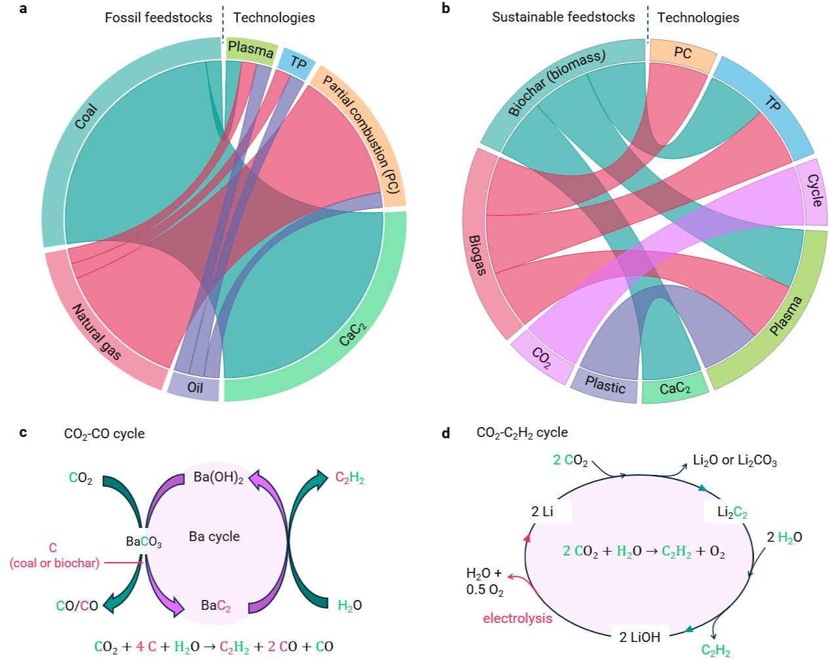
Fig. 6. Potential green C₂H₂ synthesis routes. a. Coal, natural gas, and oil-based technologies, including CaC₂, partial combustion (PC), thermal pyrolysis (TP), and plasma. b. Biochar, biogas, CO₂, plastic-based technologies, including CaC₂, plasma, cycle, TP, and PC. CO₂-based concept cycle includes c. BaC₂-based route coupling CO₂ capture and CO production (CO₂-CO cycle) and d. Li₂C₂-based electrochemical-assisted three-step cycle from LiOH to Li, Li reacting with CO₂ to Li₂C₂, followed by reaction with H₂O to produce C₂H₂ (CO₂-C₂H₂ cycle).

- Comparison of commercial and green acetylene synthesis routes (800 words)
Recently, we proposed a triple E priorities (Environmental, Economic, and Equity pillars) to guide the development of sustainable chemical processes.⁸⁸ This section will focus on the environmental impact and economic viability of various C₂H₂ synthesis technologies. We will compare these technologies using fossil and sustainable carbon resources, as well as traditional and green (wind) electricity through a life cycle assessment method.

- Mention that C₂H₂ must compete with C₂H₄ to produce bulk chemicals like vinyl chloride and acetic acid for the advanced position of C₂H₂ in the chemical industry.
- Comparison of vinyl chloride monomer (VCM) synthesis from C₂H₂ and C₂H₄, highlighting that C₂H₂-driven VCM synthesis is more economical regardless of the environmental impact in the current market.
- Envision a more sustainable C₂H₂ synthesis route from low-carbon or renewable feedstocks, such as biomethane.
- Conduct a life cycle assessment (LCA) and production cost comparison for the different C₂H₂ synthesis routes: the CaC₂-based route (coal vs. biochar), and the direct thermal or plasma routes (methane vs. biomethane).
- Propose a benchmark for the C₂H₂ yield or cost derived from methane or biomethane in the proposed alternative synthesis routes that can potentially compete with commercial routes.

Fig. 7. Environmental and economic comparison of processes for C₂H₂ manufacture. a. Climate change impacts and b. Production costs per kg of C₂H₂ via the CaC₂-based route (utilizing coal or biochar), and the direct thermal or plasma routes (methane vs. biomethane).

- Perspective and outlook (ca. 800 words)

C₂H₂ production relies on three mature technologies: CaC₂, thermal plasma, and partial combustion, utilizing coal and natural gas as feedstocks. Non-thermal plasma and thermal pyrolysis are emerging as alternative methods for C₂H₂ production. Non-thermal plasma shows performance closer to commercial thermal plasma, yet the C₂H₂ yield through thermal pyrolysis remains limited to less than 10% (Figure 5 b). While non-thermal plasma can achieve high C₂H₂ yields meeting industrial standards, it typically requires higher energy and more complex equipment than thermal plasma. Future direction should focus on increasing the energy utilization efficiency to reduce energy requirements to the theoretical limit (4.03 kW h kg⁻¹ C₂H₂) and designing durable equipment. Although warm plasma shows higher CH₄ conversion due to high neutral temperatures, C₂H₂ formation in cold plasma at room temperature avoids C₂H₂ decomposition into carbon and eliminates costly cooling processes. Thermal pyrolysis of CH₄ to C₂H₂ faces thermodynamic limitations at low temperatures. At high temperature (> 1500 °C), thermal pyrolysis is less competitive than partial combustion due to lower energy efficiency and significant soot formation. At lower temperatures (≤ 1100 °C), catalysts are critical for improving activity and C₂H₂ selectivity. Despite decades of effort, C₂H₂ selectivity remains below 40% (Figure 5b), with byproducts including other C₂ (C₂H₄, C₂H₆), C₃-C₅, aromatics, and coke. Given that C₂H₂ is not thermodynamically favorable at low temperatures, formation of other hydrocarbons is inevitable. Therefore, it might be more practical to focus thermal pyrolysis on selective CH₄ conversion to C₂ products or mixtures of C₂ and other hydrocarbons with enhanced C₂H₂ selectivity.
Without significant advancements in alternative technologies, three mature technologies, particularly coal-derived CaC₂ (prevalent in China) and natural gas-derived partial combustion, will continue to dominate C₂H₂ production from an economic perspective (Figure 7b). However, these routes have high climate change impacts (Figure 7a), particularly the CaC₂ route (> 12 kg CO₂-eq kg⁻¹). Incorporating sustainable carbon feedstocks (biochar or biogas) and renewable electricity into these technologies can lower the carbon footprint, albeit with increased production cost. Replacing natural gas with more expensive biogas is not suitable for the partial combustion route, as it consumes almost three times more biogas than plasma technology. Consequently, biochar-based CaC₂ and biogas-based plasma routes may become more prominent in the future. Additionally, exploring innovative methods, such as catalytic thermal pyrolysis for C₂ production with enhanced C₂H₂ selectivity and (catalytic) cold/warm plasma for efficient C₂H₂ production with lower energy consumption, should be also considered. Electrocatalytic, and photocatalytic CH₄ coupling have been widely studied, but dominant products are C₂H₆ or C₂H₄ instead of C₂H₂.^{89–91} Understanding why C₂H₂ production is inhibited in these process is crucial for future research. Plasma-assisted plastic upgrading to C₂H₂ is promising but requires significant energy requirement (20 kW h kg⁻¹ C₂H₂), that is unsuitable for practical applications without further development.^{84,85} Transforming CO₂ and H₂O into C₂H₂ and O₂ via CO₂-C₂H₂ concept cycle represents an ideal but nascent approach, necessitating further academic research on Li recycles, safety, C₂H₂ yield, and reactor design.⁵⁸
To revive C₂H₂ chemistry, C₂H₂ must compete with olefins in producing downstream bulk chemicals, such as VCM, acrylic acid, and 1,4-butanediol (Figure 2). The C₂H₂ route typically involves fewer steps due to its high reactivity. For instance, VCM production via direct C₂H₂ hydrochlorination is more straightforward than C₂H₄-based methods.⁴³ The main challenge lies in producing VCM from C₂H₂ in an environmentally friendly manner without the use of mercury catalysts. The recent commercialization of an Au/C catalyst in China for C₂H₂ hydrochlorination addresses some environmental concerns associated with mercury catalysts.^{92,93} Additionally, many applications of C₂H₂ were only studied by Reppe in the mid-20th century but have not attracted sufficient attention in the past decades. In the future, more research on efficient C₂H₂ conversion is needed prior to the revival of C₂H₂ chemistry. Given the explosive potentials of C₂H₂, on-site generation for applications is advantageous.³² For the CaC₂ route, shipping solid CaC₂ instead of C₂H₂ presents a significant advantage despite the high climate impact associated with this route using coal feedstock.
For mature technologies, transitioning C₂H₂ production from fossil resources (coal and natural gas) and grid electricity to sustainable carbon resources (biochar and biogas) and green electricity is essential to reduce the carbon footprint. Due to the high cost of sustainable carbon sources, partial combustion should be abandoned. The future of biochar-derived CaC₂ and biogas-derived plasma routes appear promising, contingent on the availability and cost of biochar and biogas. Other emerging technologies, such as (catalytic) non-thermal plasma, catalytic thermal pyrolysis, plasma-assisted plastic upgrading, and CO₂-derived cycle, face commercialization challenges without significant technological breakthroughs.
References
Introduction
1. Pässler, P., et al. Acetylene. Ullmann's Encyclopedia of Industrial Chemistry (2012). The most comprehensive introduction of C₂H₂, covering its physical and chemical properties, industrial applications, synthesis routes, safety precautions, transportation, and storage.
2. Schobert, H. Production of acetylene and acetylene-based chemicals from coal. Chem. Rev. 114, 1743-1760 (2014). Systematic review of coal-based C₂H₂ synthesis, encompassing commercial calcium carbide route and all related attempts.
3. Cruchade, H., et al. Catalytic routes for direct methane conversion to hydrocarbons and hydrogen: current state and opportunities. ACS Catal. 12, 14533-14558 (2022).
4. Kaiser, S.K., et al. Performance descriptors of nanostructured metal catalysts for acetylene hydrochlorination. Nat. Nanotechnol. 17, 606-612 (2022).
5. Trotus, I.T., Zimmermann, T. & Schuth, F. Catalytic reactions of acetylene: a feedstock for the chemical industry revisited. Chem. Rev. 114, 1761-1782 (2014). Systematic review of catalytic C₂H₂ applications.
6. Gao, Y., et al. Recent advances in intensified ethylene production-a review. ACS Catal. 9, 8592-8621 (2019).
7. Bedenko, S.P., Dement’ev, K.I. & Maximov, A.L. Modern processes for petrochemistry based on acetylene (A Review). Pet. Chem. 62, 989-1026 (2022).
8. Yan, B., Lu, W. & Cheng, Y. China goes green: cleaner production of chemicals. Green Process Synth. 1, 33-47 (2012).
9. An, J. Actuality and thoughts of natural gas to acetylene technology. Modern Chem. Ind. 33, 5-8 (2013).
10. Travis, A.S. & Center, E. Unintended technology transfer: acetylene chemistry in the United States. Bull. Hist. Chem. 32, 27-34 (2007).
11. Gyrdymova, Y., Lebedev, A., Du, Y.J. & Rodygin, K. Production of acetylene from viable feedstock: promising recent approaches. ChemPlusChem, in press (2024).

Production of acetylene
12. Jiang, C. & Hu, J. Conversion of methane to acetylene. Methane Conversion Routes: Status and Prospects, 76, 93 (2023). The most comprehensive book chapter on methane-to-C₂H₂ routes, covering calcium carbide, partial combustion, hot plasma, warm/cold plasma, and thermal pyrolysis.
13. Ma, Y., et al. Direct conversion of methane to ethylene and acetylene over an iron-based metal–organic framework. J. Am. Chem. Soc. 145, 20792-20800 (2023).
14. Guo, X., et al. Direct, nonoxidative conversion of methane to ethylene, aromatics, and hydrogen. Science 344, 616-619 (2014).
15. Han, S.J., Lee, S.W., Kim, H.W., Kim, S.K. & Kim, Y.T. Nonoxidative direct conversion of methane on silica-based iron catalysts: effect of catalytic surface. ACS Catal. 9, 7984-7997 (2019).
16. Xie, P., et al. Nanoceria-supported single-atom platinum catalysts for direct methane conversion. ACS Catal. 8, 4044-4048 (2018).
17. Zhang, S.B., et al. Lithium promotes acetylide formation on MgO during methane coupling under non‐oxidative conditions. Angew. Chem. Int. Ed. 62, e202307814 (2023).
18. Yan, B., Xu, P., Guo, C.Y., Jin, Y. & Cheng, Y. Experimental study on coal pyrolysis to acetylene in thermal plasma reactors. Chem. Eng. J. 207, 109-116 (2012).
19. Kang, H.S., et al. Methane to acetylene conversion by employing cost-effective low-temperature arc. Fuel Process. Technol. 148, 209-216 (2016).
20. Scapinello, M., Delikonstantis, E. & Stefanidis, G.D. The panorama of plasma-assisted non-oxidative methane reforming. Chem. Eng. Process.: Process Intensif. 117, 120-140 (2017).
21. Heintze, M. & Magureanu, M. Methane conversion into acetylene in a microwave plasma: Optimization of the operating parameters. J. Appl. Phys. 92, 2276-2283 (2002).
22. Radoiu, M.T., Chen, Y. & Depew, M.C. Catalytic conversion of methane to acetylene induced by microwave irradiation. Appl. Catal. B: Environ. 43, 187-193 (2003).
23. Oh, S.C., et al. Direct non‐oxidative methane conversion in a millisecond catalytic wall reactor. Angew. Chem. Int. Ed. 58, 7083-7086 (2019).
24. Sakbodin, M., Wu, Y., Oh, S.C., Wachsman, E.D. & Liu, D. Hydrogen‐permeable tubular membrane reactor: Promoting conversion and product selectivity for non‐oxidative activation of methane over an Fe©SiO₂ catalyst. Angew. Chem. Int. Ed. 55, 16149-1616152 (2016).
25. Zhang, S.B., et al. Role and dynamics of transition metal carbides in methane coupling. Chem. Sci. 14, 5899-5905 (2023).
26. Li, H.F., et al. Formation of acetylene in the reaction of methane with iron carbide cluster anions FeC₃⁻ under high‐temperature conditions. Angew. Chem. Int. Ed. 57, 2662-2666 (2018).
27. Zhang, X., Dai, B., Zhu, A., Gong, W. & Liu, C. The simultaneous activation of methane and carbon dioxide to C₂ hydrocarbons under pulse corona plasma over La₂O₃/γ-Al₂O₃ catalyst. Catal. Today 72, 223-227 (2002).
28. Zhang, Q., Wang, J. & Wang, T. Effect of ethane and propane addition on acetylene production in the partial oxidation process of methane. Ind. Eng. Chem. Res. 56, 5174-5184 (2017).
29. Li, M., et al. Reengineering of the carbon-to-acetylene process featuring negative carbon emission. Green Chem. 25, 8584-8592 (2023).

Sustainable carbon resources beyond fossil resources
30. Shlyapin, D.A., et al. Acetylene production technologies in the 21st century: main trends of their development in the paradigm of low-carbon economy of the future. Catal. Ind. 14, 251-267 (2022). Prediction on potential transition of carbide and partial combustions routes to plasma processes using renewable energy sources (wind or solar).
31. Jiang, P., et al. Towards carbon neutrality of calcium carbide-based acetylene production with sustainable biomass resources. Green Energy Environ. 9, 1068-1078 (2024).
32. Zhang, M., et al. Pyrolysis of polyolefins using rotating arc plasma technology for production of acetylene. Energies 10, 513 (2017).
33. Zhang, M., et al. Gas production from polyethylene terephthalate using rotating arc plasma. Chem. Eng. Process.: Process Intensif. 128, 257-262 (2018).
34. McEnaney, J.M., et al. A cyclic electrochemical strategy to produce acetylene from CO₂, CH₄, or alternative carbon sources. Sustain. Energy Fuels 4, 2752-2759 (2020).
35. Pääkkönen, A., Tolvanen, H. & Kokko, L. The economics of renewable CaC₂ and C₂H₂ production from biomass and CaO. Biomass Bioenergy 120, 40-48 (2019).
36. Bowker, M., et al. Advancing critical chemical processes for a sustainable future: challenges for industry and the Max Planck–Cardiff Centre on the fundamentals of heterogeneous catalysis (FUNCAT). Angew. Chem. Int. Ed. 61, e202209016 (2022).
37. Avenell, C.S., Sainz-Diaz, C.I. & Griffiths, A.J. Solid waste pyrolysis in a pilot-scale batch pyrolyser. Fuel, 75,1167-1174 (1996).

Comparison of commercial and green C₂H₂ synthesis routes
38. Zhang, S. et al. Life cycle assessment of acetylene production from calcium carbide and methane in China. J. Clean. Prod. 322, 129055 (2021). Comparison of three commercial C₂H₂ synthesis routes—calcium carbide, partial combustion, and hot plasma—via life cycle assessment.
39. Huo, H., et al. Life cycle assessment and sustainable production evaluation of calcium carbide industry in China. J. Clean. Prod. 360, 132176 (2022).
40. Huang, K., Miller, J.B., Huber, G.W., Dumesic, J.A. & Maravelias, C.T. A general framework for the evaluation of direct nonoxidative methane conversion strategies. Joule, 2, 349-365 (2018).

Perspective and outlook
41. Yu, X., et al. Stoichiometric methane conversion to ethane using photochemical looping at ambient temperature. Nat. Energy 5, 511-519 (2020).
42. Wu, S., et al. Ga-doped and Pt-loaded porous TiO₂–SiO₂ for photocatalytic nonoxidative coupling of methane. J. Am. Chem Soc. 141, 6592-6600 (2019).
43. Zhu, C., et al. Electrochemical conversion of methane to ethylene in a solid oxide electrolyzer. Nat. Commun. 10, 1173 (2019).
44. Johnston, P., Carthey, N. & Hutchings, G.J. Discovery, development, and commercialization of gold catalysts for acetylene hydrochlorination. J. Am. Chem Soc. 137, 14548-14557 (2015).
45. Malta, G., et al. Identification of single-site gold catalysis in acetylene hydrochlorination. Science, 355, 1399-1403 (2017).
46. Wang, L., Yi, Y., Wu, C., Guo, H. & Tu, X. One-step reforming of CO₂ and CH₄ into high-value liquid chemicals and fuels at room temperature by plasma-driven catalysis. Angew. Chem. Int. Ed. 56, 13679-13683 (2017).
47. Abdelsayed, V., Shekhawat, D. & Tempke, R.S. Zeolites interactions with microwaves during methane non-oxidative coupling. Catal. Today 365, 88-102 (2021).
48. Dipu, A.L., et al. Direct nonoxidative conversion of methane to higher hydrocarbons over silica-supported nickel phosphide catalyst. ACS Catal. 10, 375-379 (2019).

