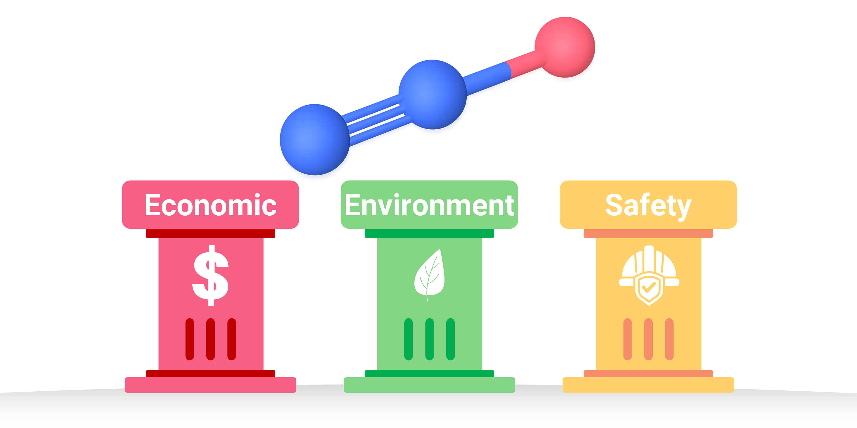
Using economic, environmental, and safety metrics, we demonstrate that the one-step direct ammonia oxidation synthesis outperforms the conventional five-step route for nitrous oxide production and hydrogen peroxide as a mono-oxygen donor, enabling key applications such as phenol production.

