Zurich, 03.11.25
Dr. Charley James
Publishing Editor, Green Chemistry

Revised GC-ART-09-2025-004863

Dear Dr. James, dear Charley,
Thank you for your decision on our manuscript, now titled Nitrous oxide as a green oxidant: a holistic evaluation based on economic, environmental, and safety metrics by A. Nabera, G.-M. Beshara, G. Guillén-Gosálbez, and J. Pérez-Ramírez, and for the opportunity to submit a revised version to Green Chemistry. We are delighted by the positive feedback from the peers and have thoroughly addressed all the points raised during the review process.
In response to Reviewer #1, we have revised the introduction and conclusions to better highlight the scope and significance of our work. The introduction now provides clearer context for nitrous oxide, N₂O, within the field of green and sustainable chemistry, emphasising recent advancements in organic synthesis. Furthermore, these sections have been explicitly amended to emphasise the holistic framework of economic, environmental, and safety metrics. Additionally, in this context, the title of our work has been updated to clearly reflect its novelty. Finally, the methods section has been streamlined in the main manuscript, with its bulk moved to the electronic supplementary information.
Regarding Reviewer #2, we have extended the safety analysis to include the storage, transportation, and application stages, using Dow’s Fire and Explosion Index calculations, and have accounted for preventive and mitigative strategies. Moreover, a regional sensitivity analysis has been incorporated into the life cycle assessment, and the comparison of N₂O has been broadened to include other green oxidants, such as molecular oxygen (O₂), in addition to hydrogen peroxide (H₂O₂). The discussion on industrial relevance and scalability has also been expanded, highlighting potential pathways for pilot- and industrial-scale implementation.
We are convinced that this Article underscores the promise of N₂O in green and sustainable chemistry and demonstrates the value of our novel multi-dimensional, integrated sustainability framework as a model for assessing emerging technologies. Please find attached detailed responses to the reviewers, along with the revised manuscript and supplementary information, both in clean and marked versions, as well as the green foundation box and the table of contents graphic.
We look forward to your positive decision.
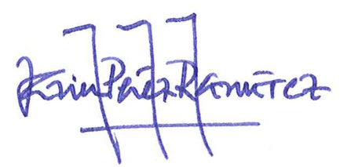
Best wishes,

Javier Pérez-Ramírez

