Electronic Supplementary Information
Analysis of nitrous oxide as a green oxidant based on safety, economic, and environmental metrics
Abhinandan Nabera,^{a,b} Gian Marco Beshara,^{a,b} Gonzalo Guillén-Gosálbez*^{a,b} and Javier Pérez-Ramírez*^{a,b}
ªInstitute for Chemical and Bioengineering, Department of Chemistry and Applied Biosciences, ETH Zurich, Vladimir Prelog Weg 1, Zurich 8093, Switzerland.
^{b}NCCR Catalysis, Zurich 8093, Switzerland.
*Corresponding authors. Email: gonzalo.guillen.gosalbez@chem.ethz.ch; jpr@chem.ethz.ch

Table of contents
- Process modelling methodology | 3
- Techno-economic analysis methodology | 12
- Life cycle assessment methodology | 15
- Assessment of safety metrics | 19
- Assumptions and limitations of the study | 22
- Breakdown of cost and climate change impacts in 2050 | 23
- Additional impact categories | 26

- Process modelling methodology
The process flow diagrams for nitrous oxide (N₂O, Fig. S1–S2), hydrogen peroxide (H₂O₂, Fig. S3), and phenol (Fig. S4–S5) production were developed using standard process models in Aspen Plus v12.1. Simulation results, including input-output data for mass and energy flows and process unit sizes, were used for economic, environmental, and safety assessments. Table S1 provides the mass and energy balances for N₂O production via the one-step direct ammonia oxidation and the five-step ammonium nitrate decomposition pathways. For the one-step route, we assume 100% conversion and selectivity towards N₂O. For the five-step route, the simulation was performed using literature data on temperature, pressure, conversion, and selectivity.^{1–4}
Similarly, for H₂O₂, we consider the anthraquinone autoxidation (AO) process, which produces H₂O₂ from hydrogen and oxygen using 2-ethyl anthraquinone as the working solution. This simulation was also based on literature data on temperature, pressure, conversion, and selectivity.⁵ Table S2 presents the mass and energy balances for the H₂O₂ production route via the AO process.
For phenol production, we analysed the traditional cumene oxidation route and compared it to emerging methods involving the direct oxidation of benzene using either N₂O or H₂O₂.^{6,7} Table S3 provides the mass and energy balances for the phenol production routes. The mass and energy balances for the traditional cumene oxidation-based phenol production route, were sourced from ecoinvent v3.10 database.⁸ For more detailed information, please refer to the techno-economic assessment (Section 2 of the ESI) and life cycle assessment (Section 3 of the ESI) sections.


Fig. S1 Process block diagram for production of N₂O via the multi-step ammonium nitrate thermal decomposition. An annual production of 130 kt of N₂O was considered. All process models were simulated using Aspen Plus v12.1, employing the NRTL fluid package. For simplicity, compressors, pumps, valves, heaters, and coolers are omitted from the process block diagram. Heat integration was performed using the Aspen Energy Analyzer v12.1.


Fig. S2 Process block diagram for production of N₂O via the one-step direct ammonia oxidation. An annual production of 130 kt of N₂O was considered. All process models were simulated using Aspen Plus v12.1, employing the NRTL fluid package. For simplicity, compressors, pumps, valves, heaters, and coolers are omitted from the process block diagram. Heat integration was performed using the Aspen Energy Analyzer v12.1.


Fig. S3 Process block diagram for production of H₂O₂ via the anthraquinone autoxidation (AO) process. An annual production of 130 kt of H₂O₂ was considered. All process models were simulated using Aspen Plus v12.1, employing the NRTL fluid package. For simplicity, compressors, pumps, valves, heaters, and coolers are omitted from the process block diagram. Heat integration was performed using the Aspen Energy Analyzer v12.1.


Fig. S4 Process block diagram for production of phenol via the one-step oxidation of benzene using N₂O. An annual production of 130 kt of phenol was considered. All process models were simulated using Aspen Plus v12.1, employing the NRTL fluid package. For simplicity, compressors, pumps, valves, heaters, and coolers are omitted from the process block diagram. Heat integration was performed using the Aspen Energy Analyzer v12.1.


Fig. S5 Process block diagram for production of phenol via the one-step oxidation of benzene using H₂O₂. An annual production of 130 kt of phenol was considered. All process models were simulated using Aspen Plus v12.1, employing the NRTL fluid package. For simplicity, compressors, pumps, valves, heaters, and coolers are omitted from the process block diagram. Heat integration was performed using the Aspen Energy Analyzer v12.1.

Table S1 Inputs and outputs of the one-step and five-step production routes per kg of N₂O produced. For both pathways, these values were extracted from the Aspen Plus v12.1 simulation (Fig. S1–S2).
Stream | One-step | Five-step
Feedstock
Ammonia / kg | 0.818 | 0.894
Utilities
Electricity / kWh | 0.050 | 0.547
Cooling water / MJ | 4.521 | 12.943
Heating (natural gas) / MJ | - | 0.281
Emissions to air
Nitrogen / kg | - | 5.581
Nitrogen oxides / kg | - | 0.068
Nitric acid / kg | - | 0.001

Table S2 Inputs and outputs of the anthraquinone autoxidation (AO) production route per kg of H₂O₂ produced. These values were extracted from the Aspen Plus v12.1 simulation (Fig. S3).
Stream | AO process
Feedstock
Hydrogen / kg | 0.066
2-Ethyl anthraquinone / kg | 0.003
Benzene / kg | 0.002
Utilities
Electricity / kWh | 0.089
Cooling water / MJ | 2.800
Heating (natural gas) / MJ | 1.925
Emissions to air
Hydrogen / kg | 0.007
Carbon dioxide, fossil / kg | 0.009
Water / kg | 0.001

Table S3 Inputs and outputs of the direct benzene oxidation routes per kg of phenol produced using N₂O or H₂O₂. For both pathways, these values were extracted from the Aspen Plus v12.1 simulation (Fig. S4–S5).
Stream | Using N₂O | Using H₂O₂
Feedstock
Benzene / kg | 0.829 | 0.922
Nitrous oxide / kg | 0.475 | -
Hydrogen peroxide / kg | - | 0.479
Utilities
Cooling water / MJ | 0.979 | 4.947
Heating (natural gas) / MJ | 12.784 | 6.923
Emissions to air
Benzene / kg | 0.001 | -
Nitrogen / kg | 0.302 | -

- Techno-economic analysis methodology
The process flowsheet for the N₂O, H₂O₂, and phenol production technologies (Fig. S1–S5) was developed using standard process models in Aspen Plus v12.1. Simulation results, including input-output data for the mass and energy flows and process unit sizes, were utilized for the techno-economic analysis. Table S1–S3 presents the mass and energy balance in the process simulations. The techno-economic assessment considers operational and capital expenditures (OPEX and CAPEX, respectively) for the reference year 2022. For all the routes, the OPEX was calculated following Ioannou et al.,⁹ while the CAPEX was estimated using correlations from Sinnott and Towler,¹⁰ accounting for installation factors of each equipment unit, and the annual capital charge ratio was used to annualise the CAPEX. Table S4 provides feedstock and utility prices used in the OPEX calculations for all the production pathways.
Furthermore, to estimate the costs for the year 2050, we performed a prospective techno-economic analysis. Such an analysis is inherently challenging due to the significant uncertainty and volatility of future prices, which are influenced by geopolitical factors and technological advancements. Table S5 outlines the feedstock and utility prices used in the OPEX calculations for all production pathways. Only the costs of ammonia (for N₂O), hydrogen (for H₂O₂), and N₂O or H₂O₂ (for phenol) was assumed to change by 2050, as these were identified as the main cost drivers. The costs of fossil-derived ammonia and hydrogen in 2022 were projected to 2050 using the average historical inflation rate, based on estimates from 2010 to 2020.

Table S4 Cost parameters used to calculate the unitary production cost of N₂O, H₂O₂, and phenol, with all costs reported using 2022 as the reference year.
Flow | Average | Low | High | Source
Fossil ammonia / USD kg^{–1} | 0.728 | 0.668 | 0.790 | ¹¹
Green ammonia (wind-based electrolysis) / USD kg^{–1} | 1.366 | 1.025 | 1.742 | ¹¹
Fossil hydrogen / USD kg^{–1} | 1.847 | 1.509 | 3.166 | ¹²
Green hydrogen (wind-based electrolysis) / USD kg^{–1} | 6.210 | 5.190 | 7.290 | ¹¹
2-Ethyl anthraquinone / USD kg^{–1} | 472.000 | - | - | Merck
Benzene / USD kg^{–1} | 0.800 | - | - | -
Fossil nitrous oxide / USD kg^{–1} | 0.636 | 0.587 | 0.686 | This work
Green nitrous oxide / USD kg^{–1} | 1.158 | 0.879 | 1.465 | This work
Fossil hydrogen peroxide / USD kg^{–1} | 1.639 | 1.617 | 1.726 | This work
Fossil hydrogen peroxide / USD kg^{–1} | 1.926 | 1.859 | 1.997 | This work
Heating (natural gas) / USD GJ^{–1} | 6.120 | - | - | ¹³
Cooling water / USD GJ^{–1} | 0.510 | - | - | ⁹
Grid electricity / USD kWh^{–1} | 0.093 | - | - | ⁹

Table S5 Cost parameters used to calculate the unitary production cost of N₂O, H₂O₂, and phenol in 2050.
Flow | Average | Low | High | Source
Fossil ammonia / USD kg^{–1} | 0.923 | 0.785 | 1.062 | -
Green ammonia (wind-based electrolysis) / USD kg^{–1} | 0.925 | 0.659 | 1.192 | ¹⁴
Fossil hydrogen / USD kg^{–1} | 2.342 | 1.914 | 4.015 | -
Green hydrogen (wind-based electrolysis) / USD kg^{–1} | 3.500 | 2.400 | 4.600 | ¹⁴
Fossil nitrous oxide / USD kg^{–1} | 0.795 | 0.682 | 0.909 | This work
Green nitrous oxide / USD kg^{–1} | 0.797 | 0.579 | 1.015 | This work
Fossil hydrogen peroxide / USD kg^{–1} | 1.672 | 1.643 | 1.782 | This work
Fossil hydrogen peroxide / USD kg^{–1} | 1.748 | 1.675 | 1.820 | This work

- Life cycle assessment methodology
For the life cycle assessment (LCA), the global average climate change impacts are quantified using an attributional LCA in accordance with ISO 14044/14040 standards.^{15,16} We consider 1 kg of N₂O, H₂O₂, or phenol produced as the functional unit, following a cradle-to-gate approach that encompasses all activities from raw material acquisition to the production of the chemical. The end-use phase is assumed to remain consistent across all cases, regardless of the production route. The mass and energy flows for the chemical production routes (Table S1–3) were obtained from simulations (Fig. S1–S5). These data enable us to model the foreground system (N₂O or H₂O₂ or phenol production), while data for the background system (activities supplying inputs to the production facility) were primarily sourced from the ecoinvent v3.10 database.⁸ The 100-year average global warming potentials (GWPs) as outlined by the IPCC in 2021 were used to calculate the climate change impacts.¹⁷ Additionally, the ReCiPe 2016 v1.03 method was employed to assess human health, ecosystem quality, and natural resources endpoints.¹⁸ The inventories used to calculate impacts for all production technologies and chemicals are presented in Table S6 for N₂O, Table S7 for H₂O₂, and Table S8 for phenol production technologies. An uncertainty assessment for all production scenarios was conducted using Monte Carlo sampling with 1000 iterations. This was generated from the ecoinvent pedigree matrix, using a normal distribution for the foreground system with a standard deviation of 10% from the mean to estimate uncertainty levels for life cycle inventory parameters. Normalization was also performed for all production routes.
Furthermore, to calculate the impacts for the year 2050, we conducted a prospective LCA. In this context, we considered an optimistic future scenario aligned with the 2 °C climate target. To update the background system, we utilized future projections derived from Integrated Assessment Models (IAMs). IAMs, such as IMAGE (Integrated Model to Assess the Global Environment), provide a comprehensive understanding of the interactions among the biosphere, society, and climate.¹⁹ We used the premise v2.1.1²⁰ framework to construct future background data consistent with the results from the IMAGE model. Additionally, the IMAGE model assumes specific Shared Socioeconomic Pathways (SSPs) that describe the relationship between challenges for adaptation and mitigation. In our study, we assumed the SSP2 scenario (“middle-of-the-road”). For the mitigation scenario, we considered the Representative Concentration Pathway (RCP) aimed at limiting the global mean surface temperature to 2 °C (RCP26 from premise). All calculations for the environmental assessment were conducted using the Brightway2.5 framework.²¹ Notably, we did not perform an uncertainty assessment for the prospective 2050 scenarios due to lack of available uncertainty data, i.e., the corresponding pedigree matrix.

Table S6 Inventories used in the life cycle assessment (LCA) to calculate the impacts of all N₂O production technologies.
Flow | Activity | Source
Fossil ammonia | market for ammonia, anhydrous, liquid | Ecoinvent v3.10
Green ammonia | ammonia production, from nitrogen and hydrogen, green | D’Angelo et al.²²
Green hydrogen (wind-based electrolysis) | hydrogen production, PEM electrolysis, green | D’Angelo et al.²²
Wastewater treatment | market for wastewater, average | Ecoinvent v3.10
Grid electricity | market group for electricity, high voltage | Ecoinvent v3.10
Wind electricity | electricity production, wind, >3MW turbine, onshore | Ecoinvent v3.10
Cooling water | cooling water | Ioannou et al.⁹
Heating (natural gas) | heat production, natural gas, at boiler condensing modulating >100kW | Ecoinvent v3.10

Table S7 Inventories used in the life cycle assessment (LCA) to calculate the impacts of all H₂O₂ production technologies.
Flow | Activity | Source
Fossil hydrogen | market for hydrogen, gaseous, medium pressure, merchant | Ecoinvent v3.10
Green hydrogen (wind-based electrolysis) | hydrogen production, PEM electrolysis, green | D’Angelo et al.²²
2-Ethyl anthraquinone | market for anthraquinone | Ecoinvent v3.10
Benzene | market for benzene | Ecoinvent v3.10
Wastewater treatment | market for wastewater, average | Ecoinvent v3.10
Grid electricity | market group for electricity, high voltage | Ecoinvent v3.10
Wind electricity | electricity production, wind, >3MW turbine, onshore | Ecoinvent v3.10
Cooling water | cooling water | Ioannou et al.⁹
Heating (natural gas) | heat production, natural gas, at boiler condensing modulating >100kW | Ecoinvent v3.10

Table S8 Inventories used in the life cycle assessment (LCA) to calculate the impacts of all phenol production technologies.
Flow | Activity | Source
Phenol from cumene oxidation | phenol production, cumene oxidation | Ecoinvent v3.10
Benzene | market for benzene | Ecoinvent v3.10
Fossil nitrous oxide | Nitrous oxide production using fossil ammonia | This work
Green nitrous oxide | Nitrous oxide production using green ammonia | This work
Fossil hydrogen peroxide | Hydrogen peroxide production using fossil hydrogen | This work
Green hydrogen peroxide | Hydrogen peroxide production using green hydrogen | This work
Grid electricity | market group for electricity, high voltage | Ecoinvent v3.10
Cooling water | cooling water | Ioannou et al.⁹
Heating (natural gas) | heat production, natural gas, at boiler condensing modulating >100kW | Ecoinvent v3.10

- Assessment of safety metrics
First, we evaluate the Dow Fire and Explosion Index (F&EI)²³ for all N₂O and H₂O₂ production technologies. The Dow F&EI is a widely used hazard analysis tool to quantify the potential fire and explosion risks in chemical process units. The methodology involves a step-by-step evaluation of process units, focusing on material properties, process conditions, and equipment characteristics. Table S9 shows the various parameters calculated using these guidelines. The final F&EI value categorizes the hazard level (e.g., light, moderate, severe) and informs safety management and insurance decisions. Next, another set of safety metrics is evaluated using the trinitrotoluene (TNT) equivalency framework proposed by Crowl.²⁴ This framework simplifies the comparison by equating the energy of a combustible fuel to the equivalent mass of TNT.

Table S9 Safety metrics calculated for all N₂O and H₂O₂ production technologies using the Dow Fire and Explosion Index framework.²³
Metric | One-step N₂O | Five-step N₂O | H₂O₂
Material factor | 29.00 | 10.00 | 21.00
General process hazards
Base factor | 1.00 | 1.00 | 1.00
Exothermic chemical reactions | 1.00 | 0.50 | 0.50
Endothermic processes | 0.40 | 0.00 | 0.00
Material handling and transfer | 0.00 | 0.00 | 0.00
Enclosed or indoor process units | 0.00 | 0.00 | 0.00
Access | 0.00 | 0.00 | 0.00
Drainage and spill control | 0.00 | 0.00 | 0.00
Total | 2.40 | 2.40 | 1.50
Special process hazards
Base factor | 1.00 | 1.00 | 1.00
Toxic materials | 0.00 | 0.60 | 0.00
Sub-atmospheric pressure | 0.00 | 0.00 | 0.00
Operation in or near flammable range | 0.00 | 0.00 | 0.00
Dust explosion | 0.00 | 0.00 | 0.00
Pressure | 0.00 | 0.00 | 0.00
Low temperature | 0.00 | 0.00 | 0.00
Quantity of flammable/unstable material | 1.92 | 1.06 | 2.03
Corrosion and erosion | 0.00 | 0.00 | 0.00
Leakage–joints and packing | 0.00 | 0.00 | 0.00
Use of fired equipment | 0.00 | 0.00 | 0.00
Hot oil heat exchange system | 0.00 | 0.00 | 0.00
Rotating equipment | 0.50 | 0.50 | 0.50
Total | 3.42 | 3.16 | 3.53
Process unit hazards factor | 8.21 | 4.75 | 5.29
Fire & Explosion Index | 238.13 | 47.47 | 111.19
Radius of Exposure (m) | 60.97 | 12.15 | 28.47
Area of Exposure (m²) | 11678.40 | 464.07 | 2546.18
Original Cost (MM$) | 41.71 | 9.83 | 10.94
Replacement Value (MM$) | 34.21 | 8.06 | 8.97
Damage Factor | 0.95 | 0.20 | 0.20
Base Maximum Probable Property Damage (MM$) | 32.50 | 1.61 | 1.79
Loss control credit factor | 1.00 | 1.00 | 1.00
Actual Maximum Probable Property Damage (MM$) | 32.50 | 1.61 | 1.79
Maximum Probable Days Outage | 166.28 | 28.05 | 29.90
Business Interruption (MM$) | 88.62 | 11.23 | 11.97

Table S10 Safety metrics calculated for all N₂O and H₂O₂ production technologies based on the TNT equivalency framework.²⁴
Parameter | Description | Unit | One-step N₂O | Five-step N₂O | H₂O₂
η | TNT equivalency of ammonium nitrate | - | 0.05 | 0.40 | 0.05
M | Molar mass of ammonium nitrate | kg/kmol | 17.03 | 80.04 | 2.02
m | Mass of fuel used | kg/hr | 30690.50 | 76816.99 | 2469.37
ΔHc | Heat of combustion of reaction | kJ/kg | 18346.00 | 1447.70 | 4008.82
E_{TNT} | Energy of explosion of TNT | kJ/kg | 4686.00 | 4686.00 | 4686.00
m_{TNT} | Equivalent mass of TNT | kg/hr | 6007.77 | 30727.80 | 70747.59
r | Distance from ground-zero point of the explosion | m | 100.00 | 100.00 | 100.00
Ze | Scaled distance | m/kg^{1/3} | 5.50 | 3.19 | 2.42
Po | Overpressure | kPa | 48.68 | 141.85 | 264.39
Y_{deaths} | Number of deaths due to lung haemorrhage | - | 0 | 5 | 9
Y_{eardrums} | Number of eardrum ruptures | - | 1 | 3 | 4
D_{pr} | Maximum distance at which projectiles can land | m | 1920.48 | 2736.66 | 3279.57

- Assumptions and limitations of the study
- The findings in this study are influenced by the assumptions embedded within the IMAGE IAM, which generated the background inventories. Our study uses the premise²⁰ Python package to generate prospective background inventories.
- For onshore wind turbines, no improvement in efficiency is assumed in the automatically generated and utilized inventories for 2050. However, data trends indicate that most reductions in carbon intensity will result from the production and recycling of wind turbines at the end of their life cycle. As a result, improvements in load factors and efficiencies are projected to be insignificant.²⁵
- Inventory data were sourced from Ecoinvent v3.10, utilizing a cut-off system model.⁸ Global or rest of the world-based inventories were selected to align with the regional scope of our analysis.
- Life cycle assessments were conducted for the production of 1 kg of the products, namely nitrous oxide, hydrogen peroxide, and phenol, employing various impact assessment methods. A cradle-to-gate assessment was performed for all categories, avoiding assumptions about the use phase of these platform chemicals and thereby reducing uncertainties.
- In the analysis of all production pathways, we assumed the continuous operation of compressors and pumps powered by grid electricity. In contrast, hydrogen production via the water electrolysis process was assumed to be powered by onshore wind electricity. The study does not account for potential energy storage requirements for wind electricity. Additionally, all environmental burdens are allocated to hydrogen, as the current market cannot absorb the excess oxygen generated as a by-product of water electrolysis.²²
- For green hydrogen production, we considered only proton exchange membrane (PEM) water electrolysis powered by onshore wind electricity due to its high potential for large-scale deployment.
- Conducting a prospective LCA based on IAMs has certain limitations. First, premise is currently focused on power generation, cement and steel production, transport, and fuels. Second, the outcomes of IAM scenarios are constrained by the assumptions employed within the IAM framework.

- Breakdown of costs and climate change impacts in 2050
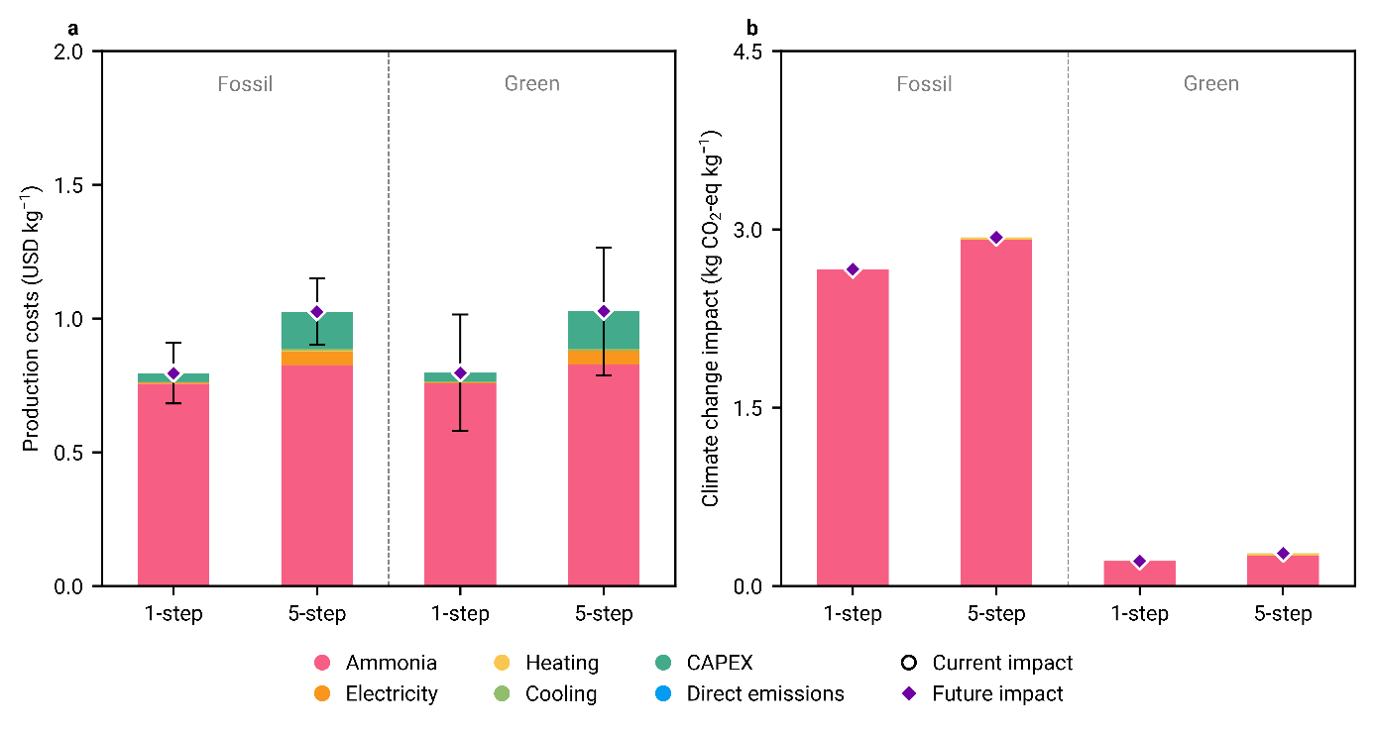
Fig. S6 (a) Production costs and (b) climate change impacts by 2050, per kg of N₂O produced, using two technologies: one-step NH₃ oxidation and five-step thermal decomposition of NH₄NO₃. The analysis includes N₂O production via both fossil-based NH₃ (derived from natural gas) and green NH₃ (produced via the electrolytic H₂-based Haber-Bosch process). Error bars for the climate change impacts are omitted due to insufficient data points in the premise database (see Section 3 of the ESI).

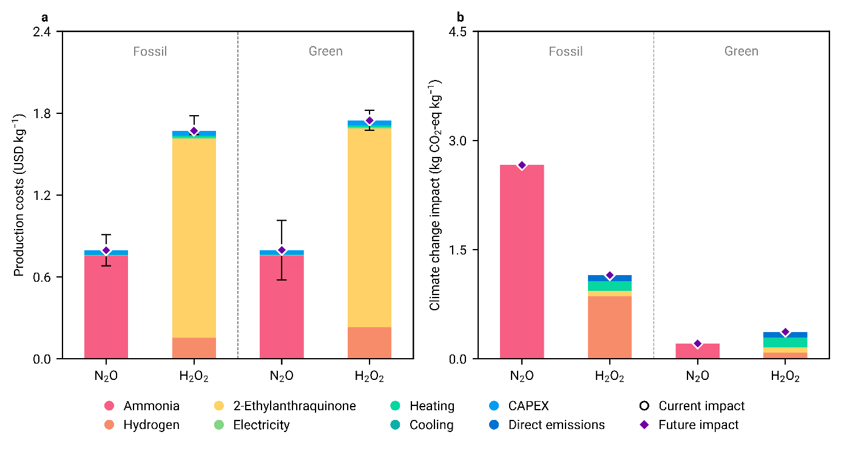
Fig. S7 (a) Production costs and (b) climate change impacts by 2050, per kg of N₂O and H₂O₂. For N₂O production, the one-step process using NH₃ derived from either natural gas (fossil-based) or the electrolytic H₂-based Haber-Bosch process (green) is shown. Similarly, the anthraquinone process for H₂O₂ production, utilizing H₂ from either natural gas reforming or electrolytic sources, is presented. Error bars for climate change impacts are not included due to a lack of sufficient data points in the premise database (refer to Section 3 of the ESI).

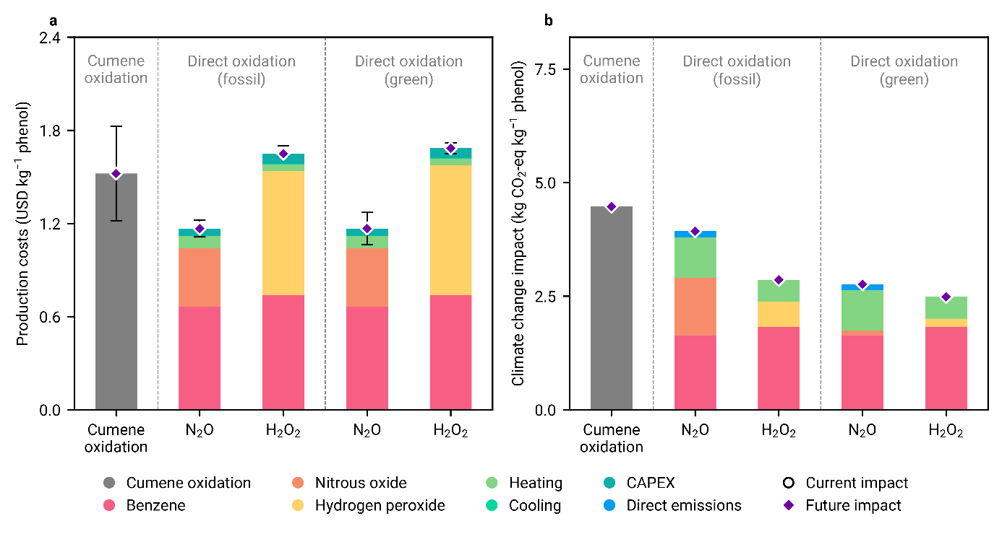
Fig. S8 (a) Production costs and (b) climate change impacts by 2050, per kg of phenol production using the business-as-usual cumene oxidation process, and the direct oxidation of benzene to phenol using N₂O and H₂O₂. For N₂O contributions, the one-step process using NH₃ derived from either natural gas (fossil-based) or the electrolytic H₂-based Haber-Bosch process (green) is shown. Similarly, the anthraquinone process for H₂O₂ contributions, utilizing H₂ from either natural gas reforming or electrolytic sources, is presented. Error bars for climate change impacts are omitted because the premise database lacks sufficient data points (see Section 3 of the ESI).

- Additional impact categories
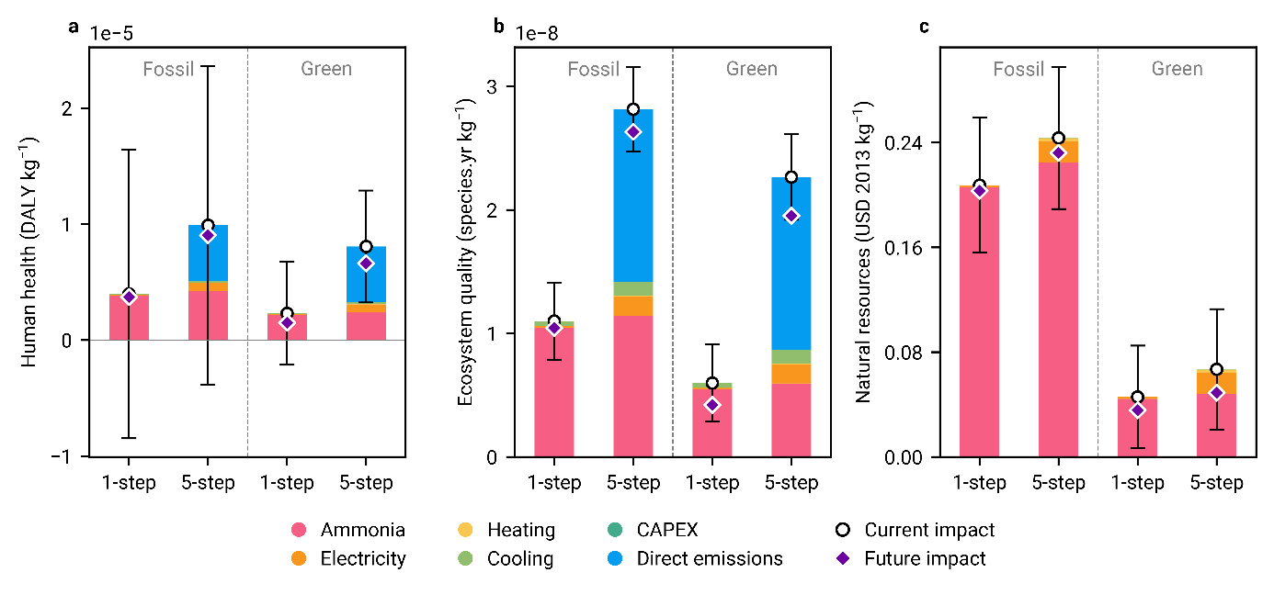
Fig. S9 (a) Human health, (b) ecosystems quality, and (c) natural resource impacts per kg of N₂O produced using two technologies: one-step NH₃ oxidation and five-step thermal decomposition of NH₄NO₃. The analysis includes N₂O production via both fossil-based NH₃ (derived from natural gas) and green NH₃ (produced via the electrolytic H₂-based Haber-Bosch process). Future projections for 2050 are highlighted for all impact categories across all technologies.

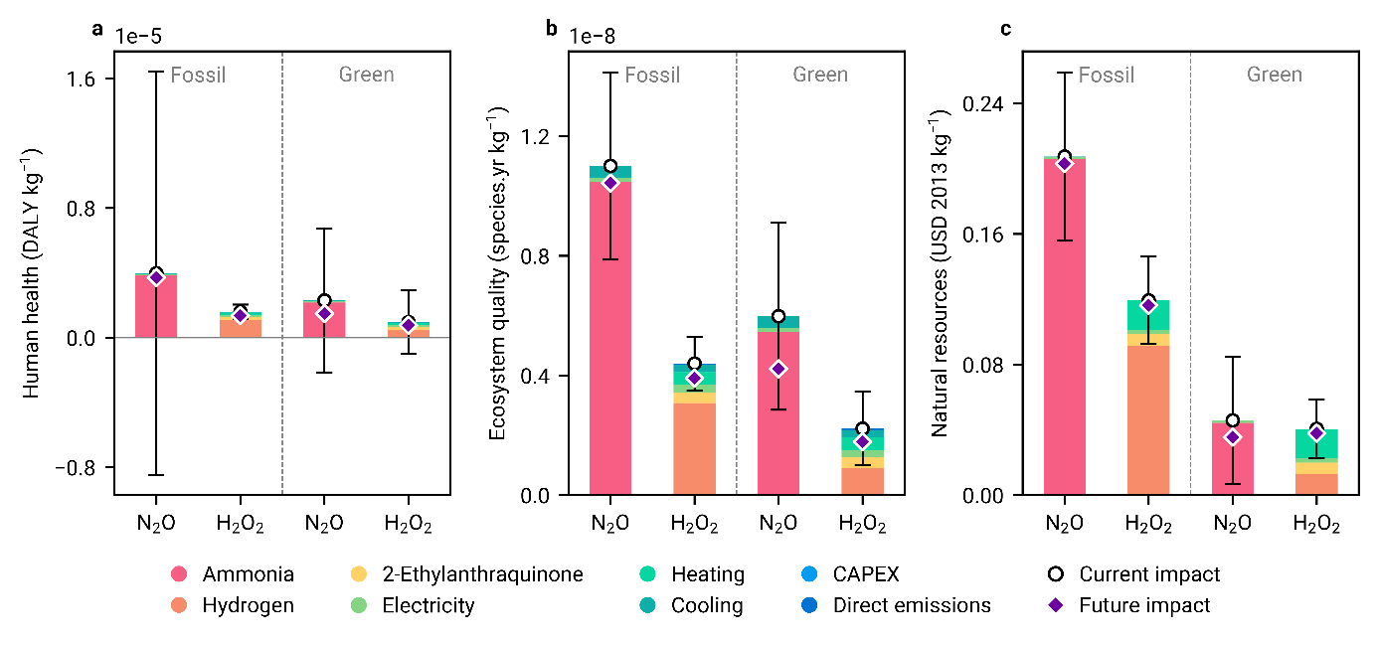
Fig. S10 (a) Human health, (b) ecosystems quality, and (c) natural resource impacts per kg of N₂O and H₂O₂. For N₂O production, the one-step process using NH₃ derived from either natural gas (fossil-based) or the electrolytic H₂-based Haber-Bosch process (green) is shown. Similarly, the anthraquinone process for H₂O₂ production, utilizing H₂ from either natural gas reforming or electrolytic sources, is presented. Future projections by 2050 for all impact categories across all technologies are highlighted.

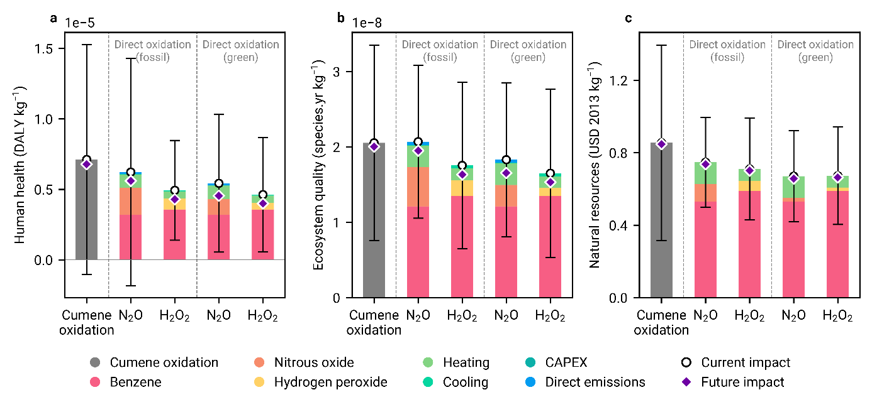
Fig. S11 (a) Human health, (b) ecosystems quality, and (c) natural resource impacts per kg of phenol production using the business-as-usual cumene oxidation process, and the direct oxidation of benzene to phenol using N₂O and H₂O₂. For N₂O contributions, the one-step process using NH₃ derived from either natural gas (fossil-based) or the electrolytic H₂-based Haber-Bosch process (green) is shown. Similarly, the anthraquinone process for H₂O₂ contributions, utilizing H₂ from either natural gas reforming or electrolytic sources, is presented. Projections for 2050 highlight potential reductions in all impact categories across all technologies.

References
1 M. D. Karaseva, M. M. Trubyanov, A. A. Atlaskin, I. V. Vorotyntsev, N. I. Laguntsov and P. N. Drozdov, Membr. Membr. Technol., 2019, 1, 72–80.
2 V. N. Parmon, G. I. Panov, A. Uriarte and A. S. Noskov, Catal. Today, 2005, 100, 115–131.
3 K. Severin, Chem. Soc. Rev., 2015, 44, 6375–6386.
4 M. Thiemann, E. Scheibler and K. W. Wiegand, in Ullmann’s Encyclopedia of Industrial Chemistry, ed. Wiley-VCH, Wiley, 1st edn., 2000.
5 G. Goor, J. Glenneberg and S. Jacobi, in Ullmann’s Encyclopedia of Industrial Chemistry, ed. Wiley-VCH, Wiley, 1st edn., 2007.
6 U. S. Ozkan, K. Ding, Y. Uozumi, G. Ertl, H. Knözinger, F. Schüth, J. Weitkamp, I. Chorkendorff, J. W. Niemantsverdriet, R. A. Sheldon, I. Arends, U. Hanefeld, B. Cornils, W. A. Herrmann, M. Muhler, R. A. van Santen and M. Neurock, .
7 Y. Morimoto, S. Bunno, N. Fujieda, H. Sugimoto and S. Itoh, J. Am. Chem. Soc., 2015, 137, 5867–5870.
8 G. Wernet, C. Bauer, B. Steubing, J. Reinhard, E. Moreno-Ruiz and B. Weidema, Int. J. Life Cycle Assess., 2016, 21, 1218–1230.
9 I. Ioannou, S. C. D’Angelo, A. J. Martín, J. Pérez-Ramírez and G. Guillén-Gosálbez, ChemSusChem, 2020, 13, 6370–6380.
10 G. P. Towler and R. K. Sinnott, Sinnott & Towler, Butterworth-Heinemann, 2013.
11 A. Nabera, I.-R. Istrate, A. J. Martín, J. Pérez-Ramírez and G. Guillén-Gosálbez, Green Chem., 2023, 25, 6603–6611.
12 B. Parkinson, P. Balcombe, J. F. Speirs, A. D. Hawkes and K. Hellgardt, Energy Environ. Sci., 2019, 12, 19–40.
13 World Bank, Monthly Prices, Commodity Markets.
14 A. Nabera, A. José Martín, R. Istrate, J. Pérez-Ramírez and G. Guillén-Gosálbez, Green Chem., 2024, 26, 6461–6469.
15 International Standards Organization, In ISO 14040:2006 Environmental Management--Life Cycle Assessment--Principles and Framework, 2006.
16 International StandardsOrganization, In ISO 14044:2006 Environmental Management--Life Cycle Assessment--Requirements and Guidelines, 2006.
17 Intergovernmental Panel on Climate Change (IPCC), Ed., in Climate Change 2022 - Mitigation of Climate Change, Cambridge University Press, 1st edn., 2023, pp. 1727–1790.
18 M. A. J. Huijbregts, Z. J. N. Steinmann, P. M. F. Elshout, G. Stam, F. Verones, M. Vieira, M. Zijp, A. Hollander and R. van Zelm, Int. J. Life Cycle Assess., 2017, 22, 138–147.
19 Integrated Assessment of Global Environmental Change with IMAGE 3.0, PBL Netherlands Environmental Assessment Agency, 2014.
20 R. Sacchi, T. Terlouw, K. Siala, A. Dirnaichner, C. Bauer, B. Cox, C. Mutel, V. Daioglou and G. Luderer, Renew. Sustain. Energy Rev., 2022, 160, 112311.
21 C. Mutel, J. Open Source Softw., 2017, 2, 236.
22 S. C. D’Angelo, S. Cobo, V. Tulus, A. Nabera, A. J. Martín, J. Pérez-Ramírez and G. Guillén-Gosálbez, ACS Sustain. Chem. Eng., 2021, 9, 9740–9749.
23 American Institute of Chemical Engineers, Dow’s Fire & Explosion Index Hazard Classification Guide, John Wiley & Sons, Inc, Hoboken, 7th ed., 2010.
24 D. A. Crowl and J. F. Louvar, Chemical process safety: fundamentals with applications, Prentice Hall, Upper Saddle River, NJ, 3rd ed., 2011.
25 R. Besseau, R. Sacchi, I. Blanc and P. Pérez-López, Renew. Sustain. Energy Rev., 2019, 108, 274–288.

