Reimagining industrial oxidants with nitrous oxide from direct ammonia oxidation
Abstract
Nitrous oxide, N₂O, is increasingly recognized as a selective oxidant in heterogeneous catalysis. However, its conventional multi-step production depends on the decomposition of ammonium nitrate, which poses significant risks due to the explosive nature of nitrate salts, as tragically exemplified by the 2020 Beirut explosion. The revolutionary one-step synthesis of N₂O from direct ammonia oxidation using heterogeneous catalysts offers a transformative opportunity to streamline production, potentially lowering costs and safety risks to meet the growing demand in the oxidant industry. In this work, we assess both the traditional multi-step and the one-step N₂O production routes utilizing fossil or electrolytic hydrogen-based ammonia as feedstock. Our results indicate that the one-step route outperforms the traditional route in production costs, climate change impacts, and safety metrics. Additionally, we compare the production costs and climate change impacts of the one-step N₂O and hydrogen peroxide (H₂O₂) routes, with H₂O₂ being the main alternative oxidant currently used in the industry. A blended scenario of 28% fossil and 72% green ammonia to produce N₂O matches the climate change impacts of H₂O₂, while reducing costs by approximately 40%. Lastly, the direct oxidation of benzene to phenol using N₂O shows at least 10% lower costs than the existing cumene oxidation process and similar climate change impacts. Overall, our findings provide a comprehensive evaluation of innovative N₂O production routes, offering scientists actionable insights to drive the development of safer, more cost-effective, and sustainable oxidants for industrial applications.

Introduction
Nitrous oxide, N₂O, is emerging as a promising and versatile oxidant in heterogeneous catalysis, primarily due to its ability to selectively deliver oxygen atoms during oxidation reactions.^{1,2} This unique feature minimizes overoxidation and by-product formation, making N₂O an attractive alternative to conventional oxidants like hydrogen peroxide (H₂O₂).³ Moreover, N₂O’s benign by-product—nitrogen gas—and its favourable properties, such as high solubility in non-polar media⁴ and thermal stability,⁵ further enhance its industrial appeal. Early breakthroughs, such as the one-step oxidation of benzene to phenol using N₂O over Fe-ZSM-5 catalysts, have demonstrated its potential for highly selective transformations.^{6–9} However, the broader application of N₂O has been hindered by the risks associated with its conventional production route, i.e., the thermal decomposition of ammonium nitrate (Fig. 1). This method is not only expensive but also rife with safety concerns due to the explosive nature of nitrate salts.^{10,11} These dangers have been tragically highlighted by recent global events such as the 2015 Port of Tianjin explosion, which claimed 173 lives,^{12,13} and the 2020 Beirut explosion, which resulted in 218 fatalities and significant property damage.^{14–16}
To address these limitations, the direct catalytic oxidation of ammonia to N₂O has gained attention as a safer and more economically viable alternative. This innovative approach eliminates reliance on hazardous nitrate intermediates and aligns with advancements in the sustainable production of chemicals. Recent developments in catalytic design have achieved over 90% N₂O selectivity and a 100-fold increase in productivity, with stability exceeding 70 hours.^{17–19} These catalysts effectively minimize by-products such as NO and N₂, making N₂O production more sustainable.
Building on this foundation, herein, for the first time and to the best of the authors’ knowledge, we evaluate the traditional multi-step and emerging one-step N₂O production pathways, examining their techno-economic feasibility, environmental impacts through life cycle assessments (LCAs), and safety metrics such as the Dow Fire & Explosion Index (F&EI)²⁰ and TNT equivalency.²¹ Additionally, we explore the potential of the one-step route to outperform H₂O₂ as the leading industrial oxidant, highlighting its advantages in cost and carbon footprint. Next, we assess the direct application of N₂O in the selective oxidation of benzene to phenol, making a case for its adoption in high-value chemical production processes. Furthermore, we perform prospective techno-economic assessments and LCAs for 2050, across all the routes evaluated, illustrating potential reductions in production costs and carbon footprint, respectively, mainly due to the decarbonization of the future electricity mix.
Our analysis reveals that the one-step direct ammonia oxidation to N₂O is more cost-effective and has a lower carbon footprint than the conventional multi-step ammonium nitrate decomposition process. Moreover, the one-step N₂O production route poses significantly lower F&EI, TNT equivalency, and associated financial and operational impacts compared to the conventional route. When comparing the N₂O production route with the conventional industrial oxidation of H₂O₂, we find that blending fossil natural gas-based and electrolytic hydrogen-based ammonia in a 28%/72% ratio can match the carbon footprint of conventional H₂O₂ production via the anthraquinone (AO) process, at a 40% lower cost. The direct oxidation of benzene to phenol using N₂O is the most cost-effective option, outperforming both the traditional cumene oxidation and the direct oxidation using H₂O₂ routes, while demonstrating a lower carbon footprint than the traditional cumene oxidation process. Overall, our findings offer a thorough assessment of novel N₂O production pathways, delivering valuable insights to guide researchers in advancing safer, more affordable, and sustainable oxidants for industrial use.

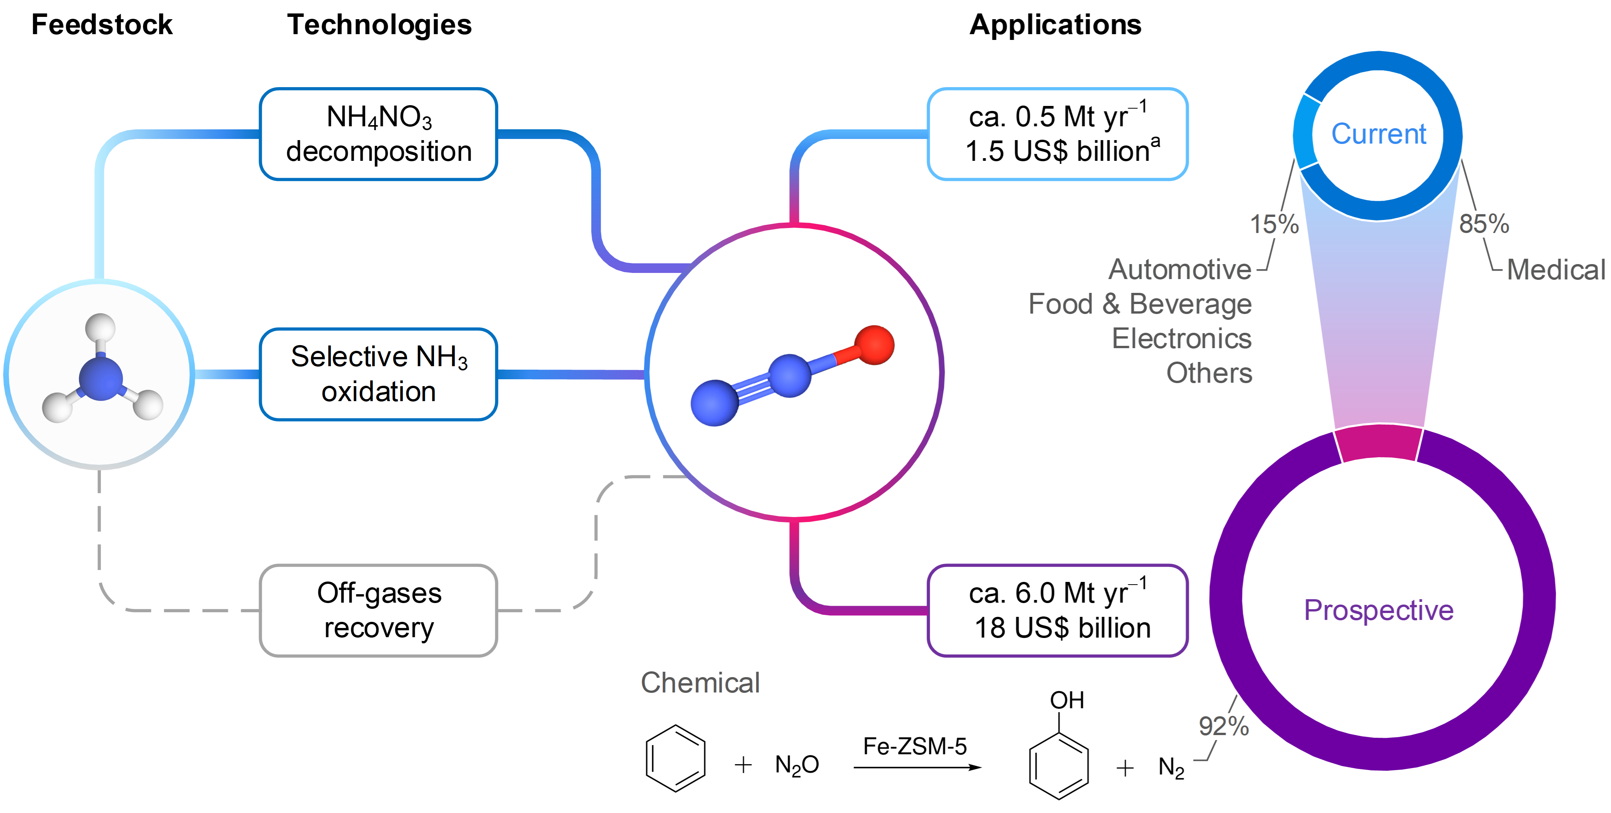
Fig. 1 Nitrous oxide (N₂O) production routes and current and future applications. Shown are various N₂O production routes, all relying on the use of ammonia, along with technologies such as ammonium nitrate decomposition, selective ammonia oxidation and recovery from off-gases (nitric and adipic acid production). The figure highlights the potential change in the global market of N₂O considering the direct hydroxylation of benzene to phenol (11.8 Mt yr^{–1} in 2023) as its main industrial applications. ªData are from Statista.
- Ammonia serves as the universal feedstock for all major N₂O production routes, including conventional ammonium nitrate decomposition, selective ammonia oxidation, and off-gas recovery.
- Current N₂O use is limited (ca. 0.5 Mt yr⁻¹) and dominated by the medical sector, with the remaining 13-15% split among automotive, food & beverage, electronics, and other sectors, though exact percentages for these are not publicly detailed.
- Projections suggest that global demand could increase by more than an order of magnitude (ca. 6.0 Mt yr⁻¹) should N₂O be adopted as a primary oxidant in large-scale processes such as the direct oxidation of benzene to phenol.

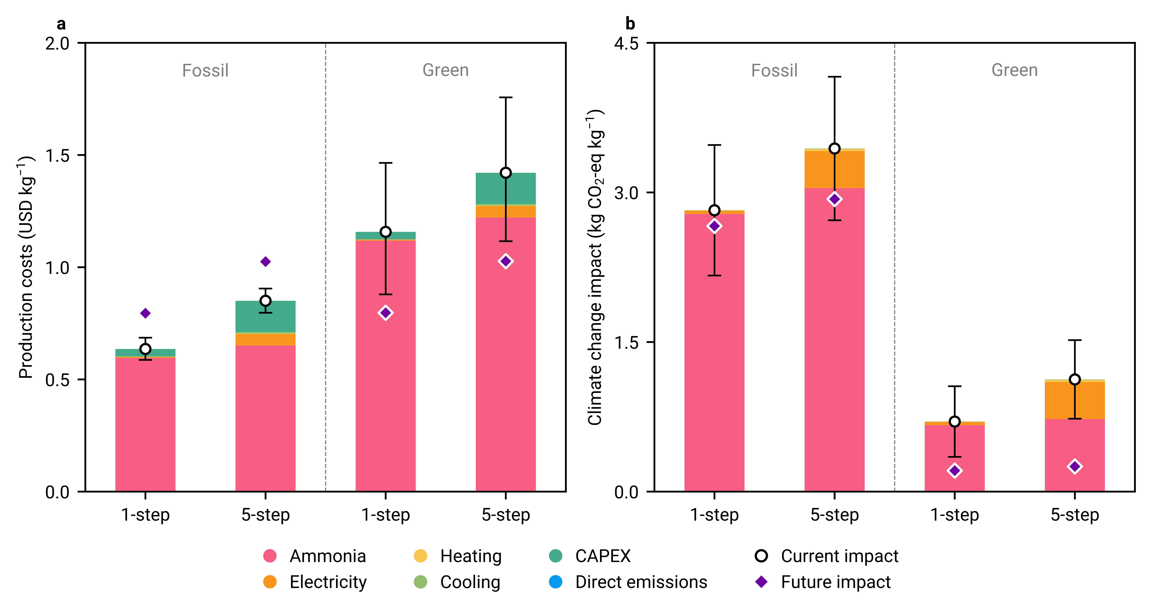
Fig. 2 (a) Production costs and (b) climate change impacts per kg of N₂O produced using two technologies: 1-step ammonia oxidation and 5-step thermal decomposition of ammonium nitrate. The analysis includes N₂O production via both fossil-based ammonia (derived from natural gas) and green ammonia (produced via the electrolytic hydrogen-based Haber-Bosch process). Future projections for 2050 are provided to highlight potential reductions in production costs and climate change impacts across all technologies.
- The 1-step direct oxidation of ammonia to N₂O performs better than the conventional 5-step process of ammonia to N₂O via ammonia nitrate decomposition in terms of both production costs and climate change impacts.
- Ammonia is the main contributing factor to both production costs and climate change impacts. However, CAPEX contributes more to production costs, and electricity contributes more to climate change impacts in the 5-step process compared to the 1-step direct oxidation technology.

Table 1 Risk assessment metrics for the 1-step and 5-step N₂O production routes are evaluated using the Dow fire and explosion index framework, highlighting estimated financial and operational impacts.
Metric | 1-step | 5-step
Fire and explosion index | 47 | 238
Degree of hazard | Light | Severe
Radius of exposure (m) | 12 | 61
Area of exposure (m²) | 464 | 11678
Maximum probable property damage (million USD) | 2 | 32
Maximum probable days outage | 28 | 166
Business interruption (million USD) | 11 | 89

Table 2 Safety metrics for evaluating explosion impacts and trinitrotoluene (TNT) equivalency in 1-step and 5-step N₂O production routes.
Metric | 1-step | 5-step
Equivalent mass of TNT (kg) | 6008 | 30727
Overpressure (kPa) | 49 | 142
Number of deaths due to lung haemorrhage | 0 | 5
Number of eardrum ruptures | 1 | 3
Maximum distance at which projectiles can land (m) | 1920 | 2737

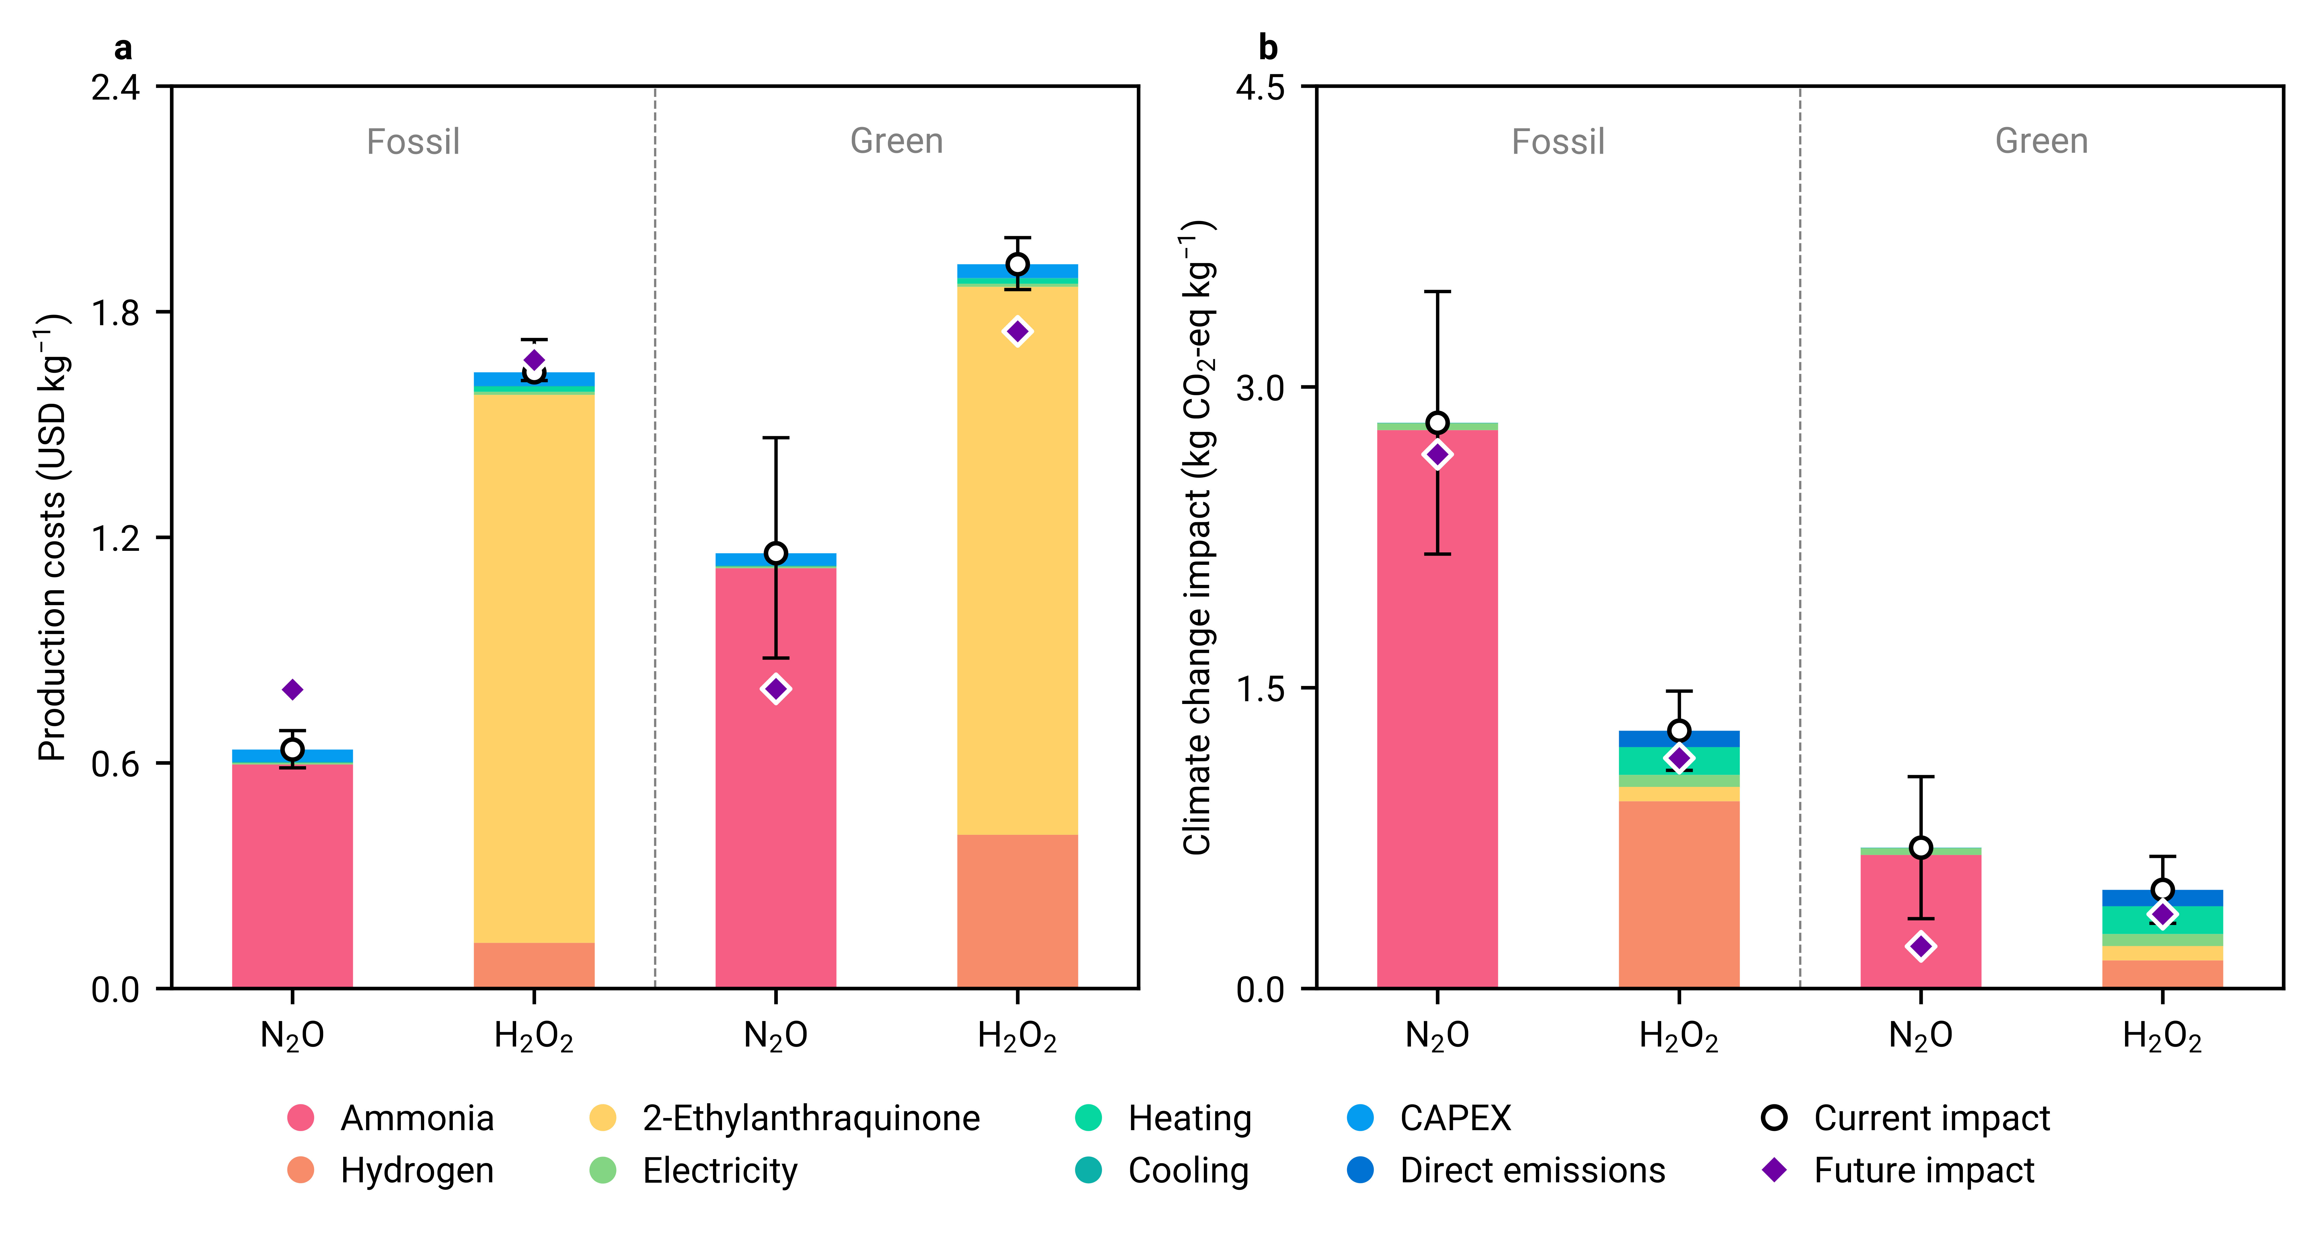
Fig. 3 (a) Production costs and (b) climate change impacts per kg of N₂O and H₂O₂. For N₂O production, the 1-step process using ammonia derived from either natural gas (fossil-based) or the electrolytic hydrogen-based Haber-Bosch process (green) is shown. Similarly, the anthraquinone process for H₂O₂ production, utilizing hydrogen from either natural gas reforming or electrolytic sources, is presented. Future projections for 2050 of production costs and climate change impacts for all technologies are indicated to illustrate potential reductions.
- H₂O₂ is significantly more expensive than N₂O alternatives (2.6 times in the fossil scenario and 1.7 times in the green scenario) due to the costly anthraquinone working solution required for the process.
- Regarding climate change impacts, in the fossil scenario, N₂O has an impact of
2.8 kg CO₂-eq kg^{–1}, compared to H₂O₂’s impact of 1.3 kg CO₂-eq kg^{–1}. In the green scenario, these impacts decrease to 0.7 kg CO₂-eq kg^{–1} for N₂O and 0.5 kg CO₂-eq kg^{–1} for H₂O₂. The N₂O production process exhibits significantly higher impacts than H₂O₂ production, primarily due to the hydrogen required (2.3 times more in the case of N₂O than in H₂O₂).
- In the future, as electricity becomes highly decarbonized, the impacts of N₂O in the green scenario decrease to 0.3 kg CO₂-eq kg^{–1}, while H₂O₂ remains at 0.4 kg CO₂-eq kg^{–1}.

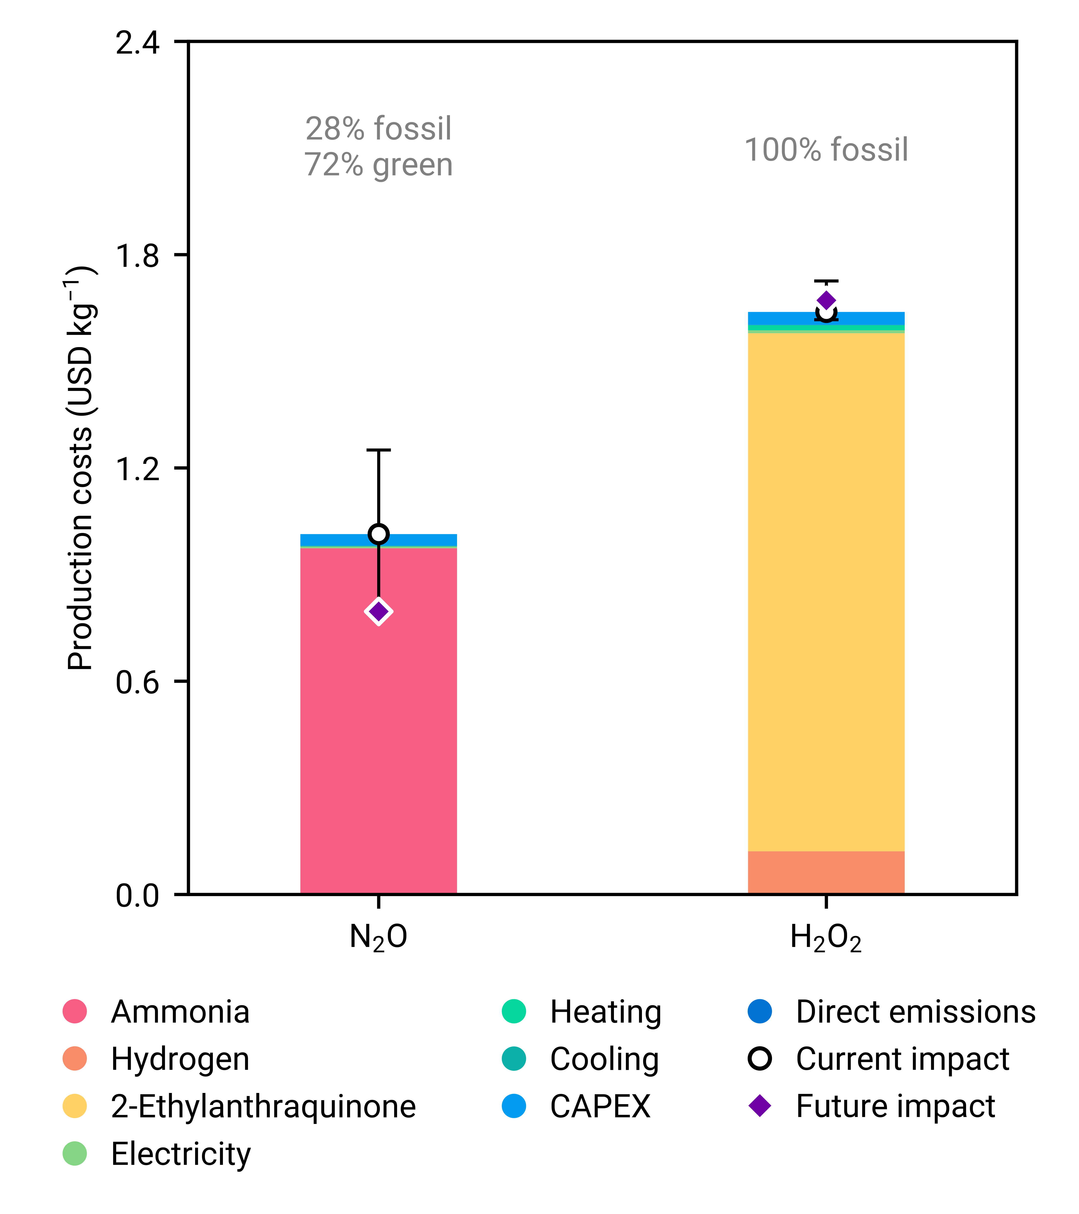
Fig. 4 Production costs of N₂O and H₂O₂ are compared under the condition of having the same carbon footprint. To match the climate change impact of fossil-based H₂O₂, a blend of N₂O—comprising 28% fossil-derived and 72% green N₂O (see Fig. 3)—is utilized. By 2050, projections illustrate potential reductions in production costs and climate change impacts across various technologies.
- A blending scenario between fossil and green ammonia for N₂O production suggests that, at a blend ratio of 28% fossil and 72% green ammonia, the carbon footprint of N₂O production can match that of fossil-based H₂O₂ production at a 38% lower production cost.

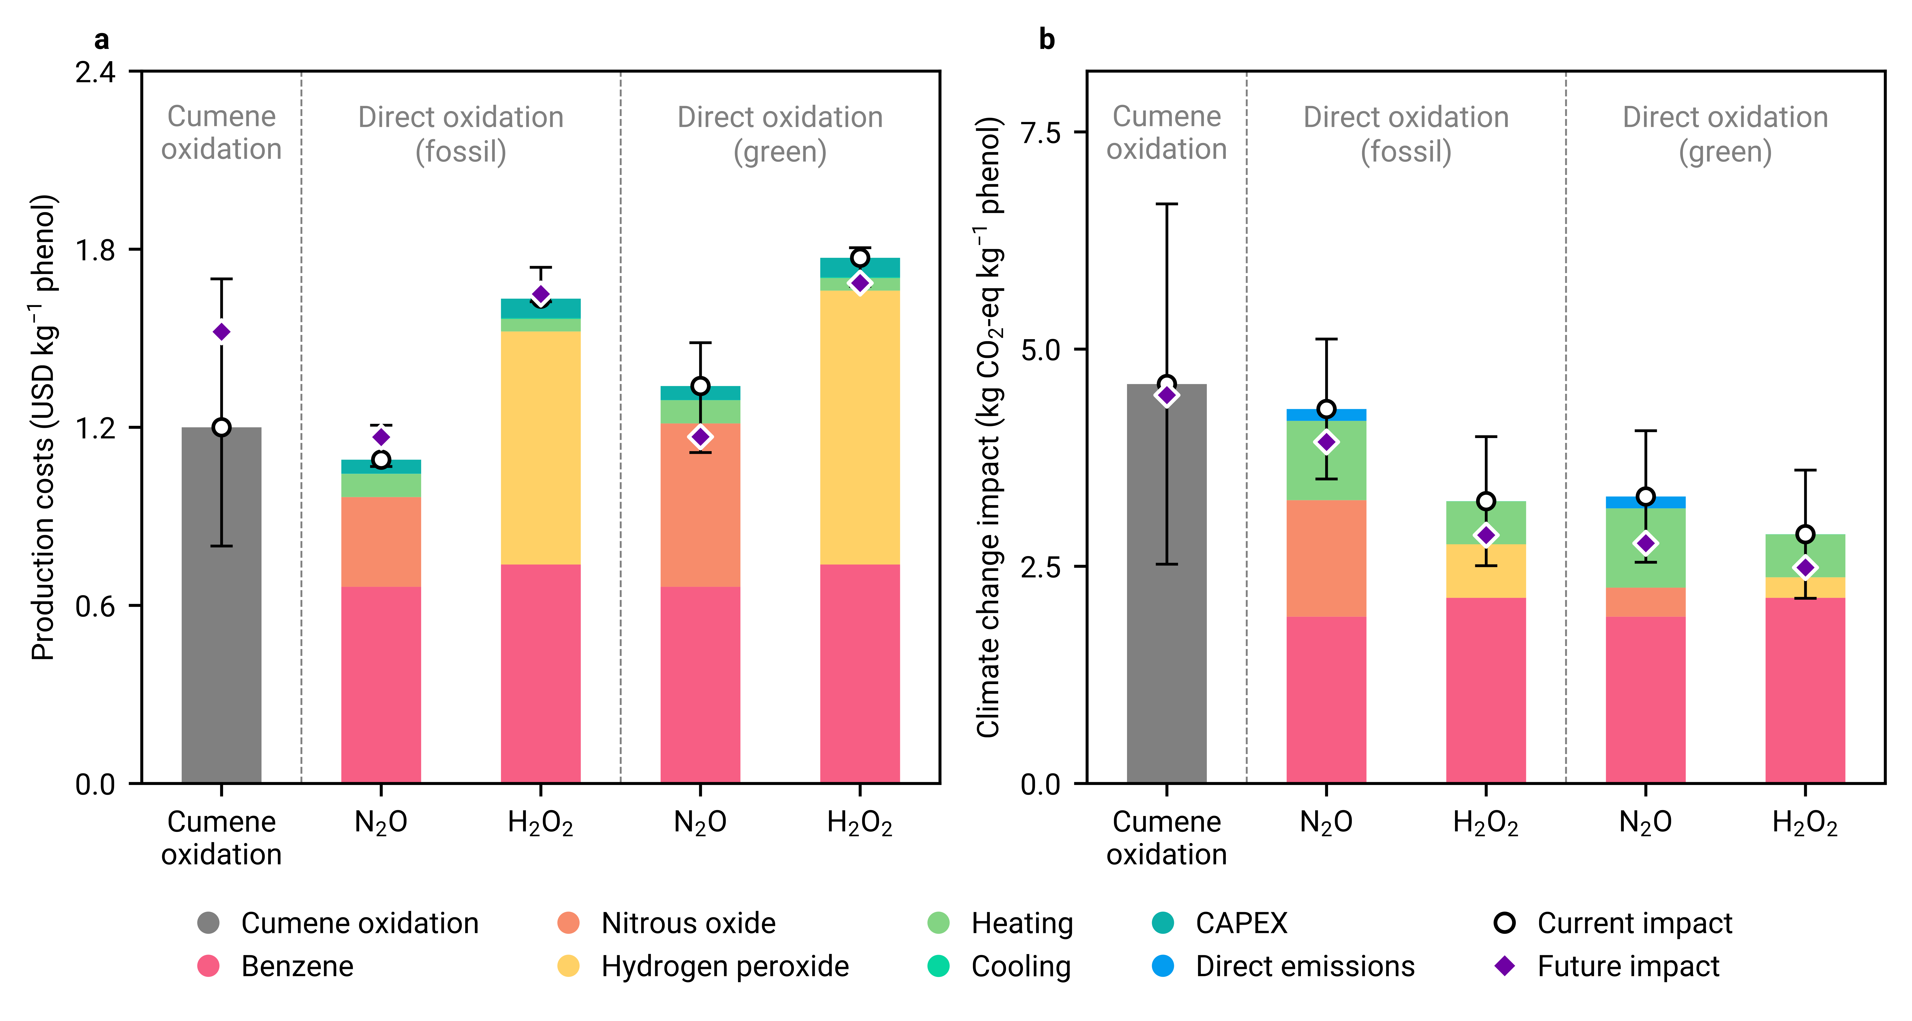
Fig. 5 (a) Production costs and (b) climate change impacts per kg of phenol production using the business-as-usual cumene oxidation process, and the direct oxidation of benzene to phenol using N₂O and H₂O₂. For N₂O contributions, the 1-step process using ammonia derived from either natural gas (fossil-based) or the electrolytic hydrogen-based Haber-Bosch process (green) is shown. Similarly, the anthraquinone process for H₂O₂ contributions, utilizing hydrogen from either natural gas reforming or electrolytic sources, is presented. Projections for 2050 highlight potential reductions in production costs and the climate change impacts across all technologies.
- The direct oxidation of benzene to phenol using N₂O is the most cost-effective route, outperforming the traditional cumene oxidation process for phenol production by reducing costs by 10%.
- In terms of climate change impacts, all direct oxidation routes have lower impacts than the traditional cumene oxidation process. Among these, the H₂O₂-based direct oxidation routes exhibit the lowest impacts for phenol production.

References
1 S. Lee, S. Park and J. Lee, ChemSusChem, 2025, e202402728.
2 K. Severin, Chem. Soc. Rev., 2015, 44, 6375–6386.
3 I. Gokce, M. O. Ozbek and B. Ipek, J. Catal., 2023, 427, 115113.
4 L. C. Yen and J. J. McKetta, J. Chem. Eng. Data, 1962, 7, 288–289.
5 M. Galle, D. W. Agar and O. Watzenberger, Chem. Eng. Sci., 2001, 56, 1587–1595.
6 G. Mi, J. Li, J. Zhang and B. Chen, Korean J. Chem. Eng., 2010, 27, 1700–1706.
7 A. Mancuso, O. Sacco, D. Sannino, V. Venditto and V. Vaiano, Catalysts, 2020, 10, 1424.
8 G. I. Panov, G. A. Sheveleva, A. S. Kharitonov, V. N. Romannikov and L. A. Vostrikova, Appl. Catal. Gen., 1992, 82, 31–36.
9 A. A. Ivanov, V. S. Chernyavsky, M. J. Gross, A. S. Kharitonov, A. K. Uriarte and G. I. Panov, Appl. Catal. Gen., 2003, 249, 327–343.
10 K. D. Shah, .
11 I. Surin, Z. Tang, J. Geiger, S. Damir, H. Eliasson, M. Agrachev, F. Krumeich, S. Mitchell, V. A. Kondratenko, E. V. Kondratenko, G. Jeschke, R. Erni, N. López and J. Pérez-Ramírez, Adv. Mater., 2023, 35, 2211260.
12 M. Bloor, T. Boyle and T. Chintapatla, .
13 G. Yu, Y.-S. Duh, X. Yang, Y. Li, Y. Chen, Y. Li, J. Li, R. Chen, L. Gong, B. Yang and J. Huang, Sustainability, 2022, 14, 3429.
14 T. El Zahran, M. Geha, F. Sakr, R. Bachir and M. El Sayed, Eur. J. Trauma Emerg. Surg., 2022, 48, 4919–4926.
15 S. Al-Hajj, H. R. Dhaini, S. Mondello, H. Kaafarani, F. Kobeissy and R. G. DePalma, Front. Public Health, 2021, 9, 657996.
16 K. Yammine, J. Daher, J. Otayek, A. Jardaly, J. Mansour, K. Boulos, A. E. Alam, J. Ghanimeh, G. Abou Orm, M. Berberi, E. Daccache, M. Helou, M. Estephan, C. Assi and F. Hayek, Injury, 2023, 54, 448–452.
17 I. Surin, Q. Yang, F. Krumeich, M. Agrachev, T. Otroshchenko, V. A. Kondratenko, E. V. Kondratenko and J. Pérez-Ramírez, Chem Catal., 2025, 5, 101165.
18 Q. Yang, I. Surin, J. Geiger, H. Eliasson, M. Agrachev, V. A. Kondratenko, A. Zanina, F. Krumeich, G. Jeschke, R. Erni, E. V. Kondratenko, N. López and J. Pérez-Ramírez, ACS Catal., 2023, 13, 15977–15990.
19 Z. Tang, I. Surin, A. Rasmussen, F. Krumeich, E. V. Kondratenko, V. A. Kondratenko and J. Pérez-Ramírez, Angew. Chem. Int. Ed., 2022, 61, e202200772.
20 American Institute of Chemical Engineers, Dow’s Fire & Explosion Index Hazard Classification Guide, John Wiley & Sons, Inc, Hoboken, 7th ed., 2010.
21 D. A. Crowl and J. F. Louvar, Chemical process safety: fundamentals with applications, Prentice Hall, Upper Saddle River, NJ, 3rd ed., 2011.

