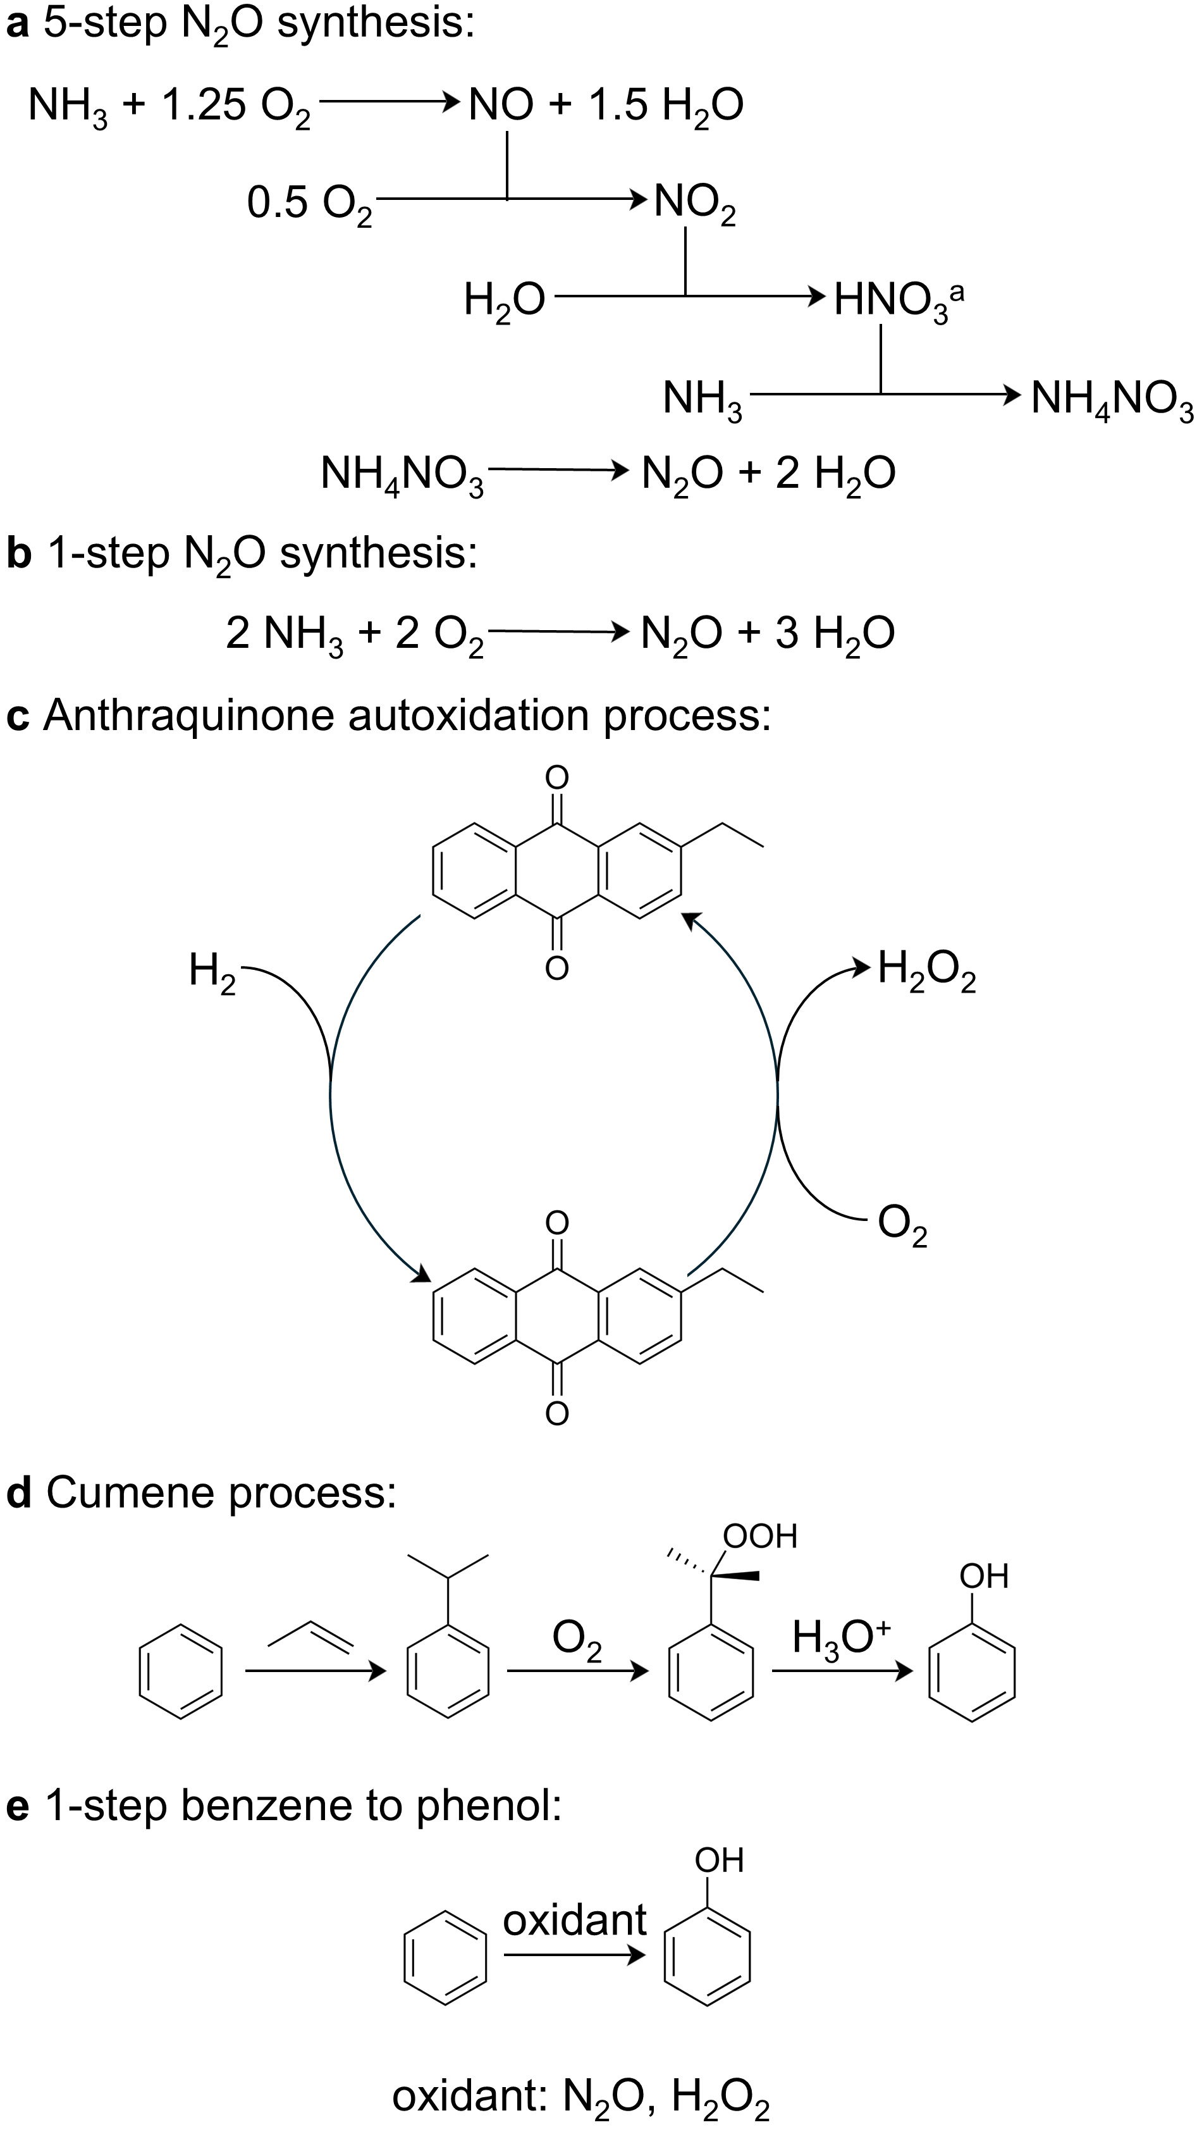
Fig. 1 Outline of the analysis. First, we compare the five-step and one-step N₂O production routes using economic, environmental, and safety metrics (Fig. 2 and Table 1). In the same analysis, we show how emissions can be further reduced using green NH₃, i.e., NH₃ produced via water electrolysis powered by clean electricity. Next, we extend our analysis to compare N₂O with H₂O₂, another mono-oxygen donor with benign by-products, again in terms of cost, environmental impact, and safety metrics (Figs. 3 and 4, and Table 2). Finally, we explore key applications for N₂O, such as the direct production of phenol from benzene oxidation, and compare this route with both the direct oxidation of benzene using H₂O₂ and the traditional cumene-based process for phenol production (Fig. 5). ªThe reaction of NO₂ with water to produce HNO₃ is depicted here as a simplified representation of nitrogen oxides absorption; in reality, NO₂ forms N₂O₄, which hydrolyses to HNO₃ and NO.
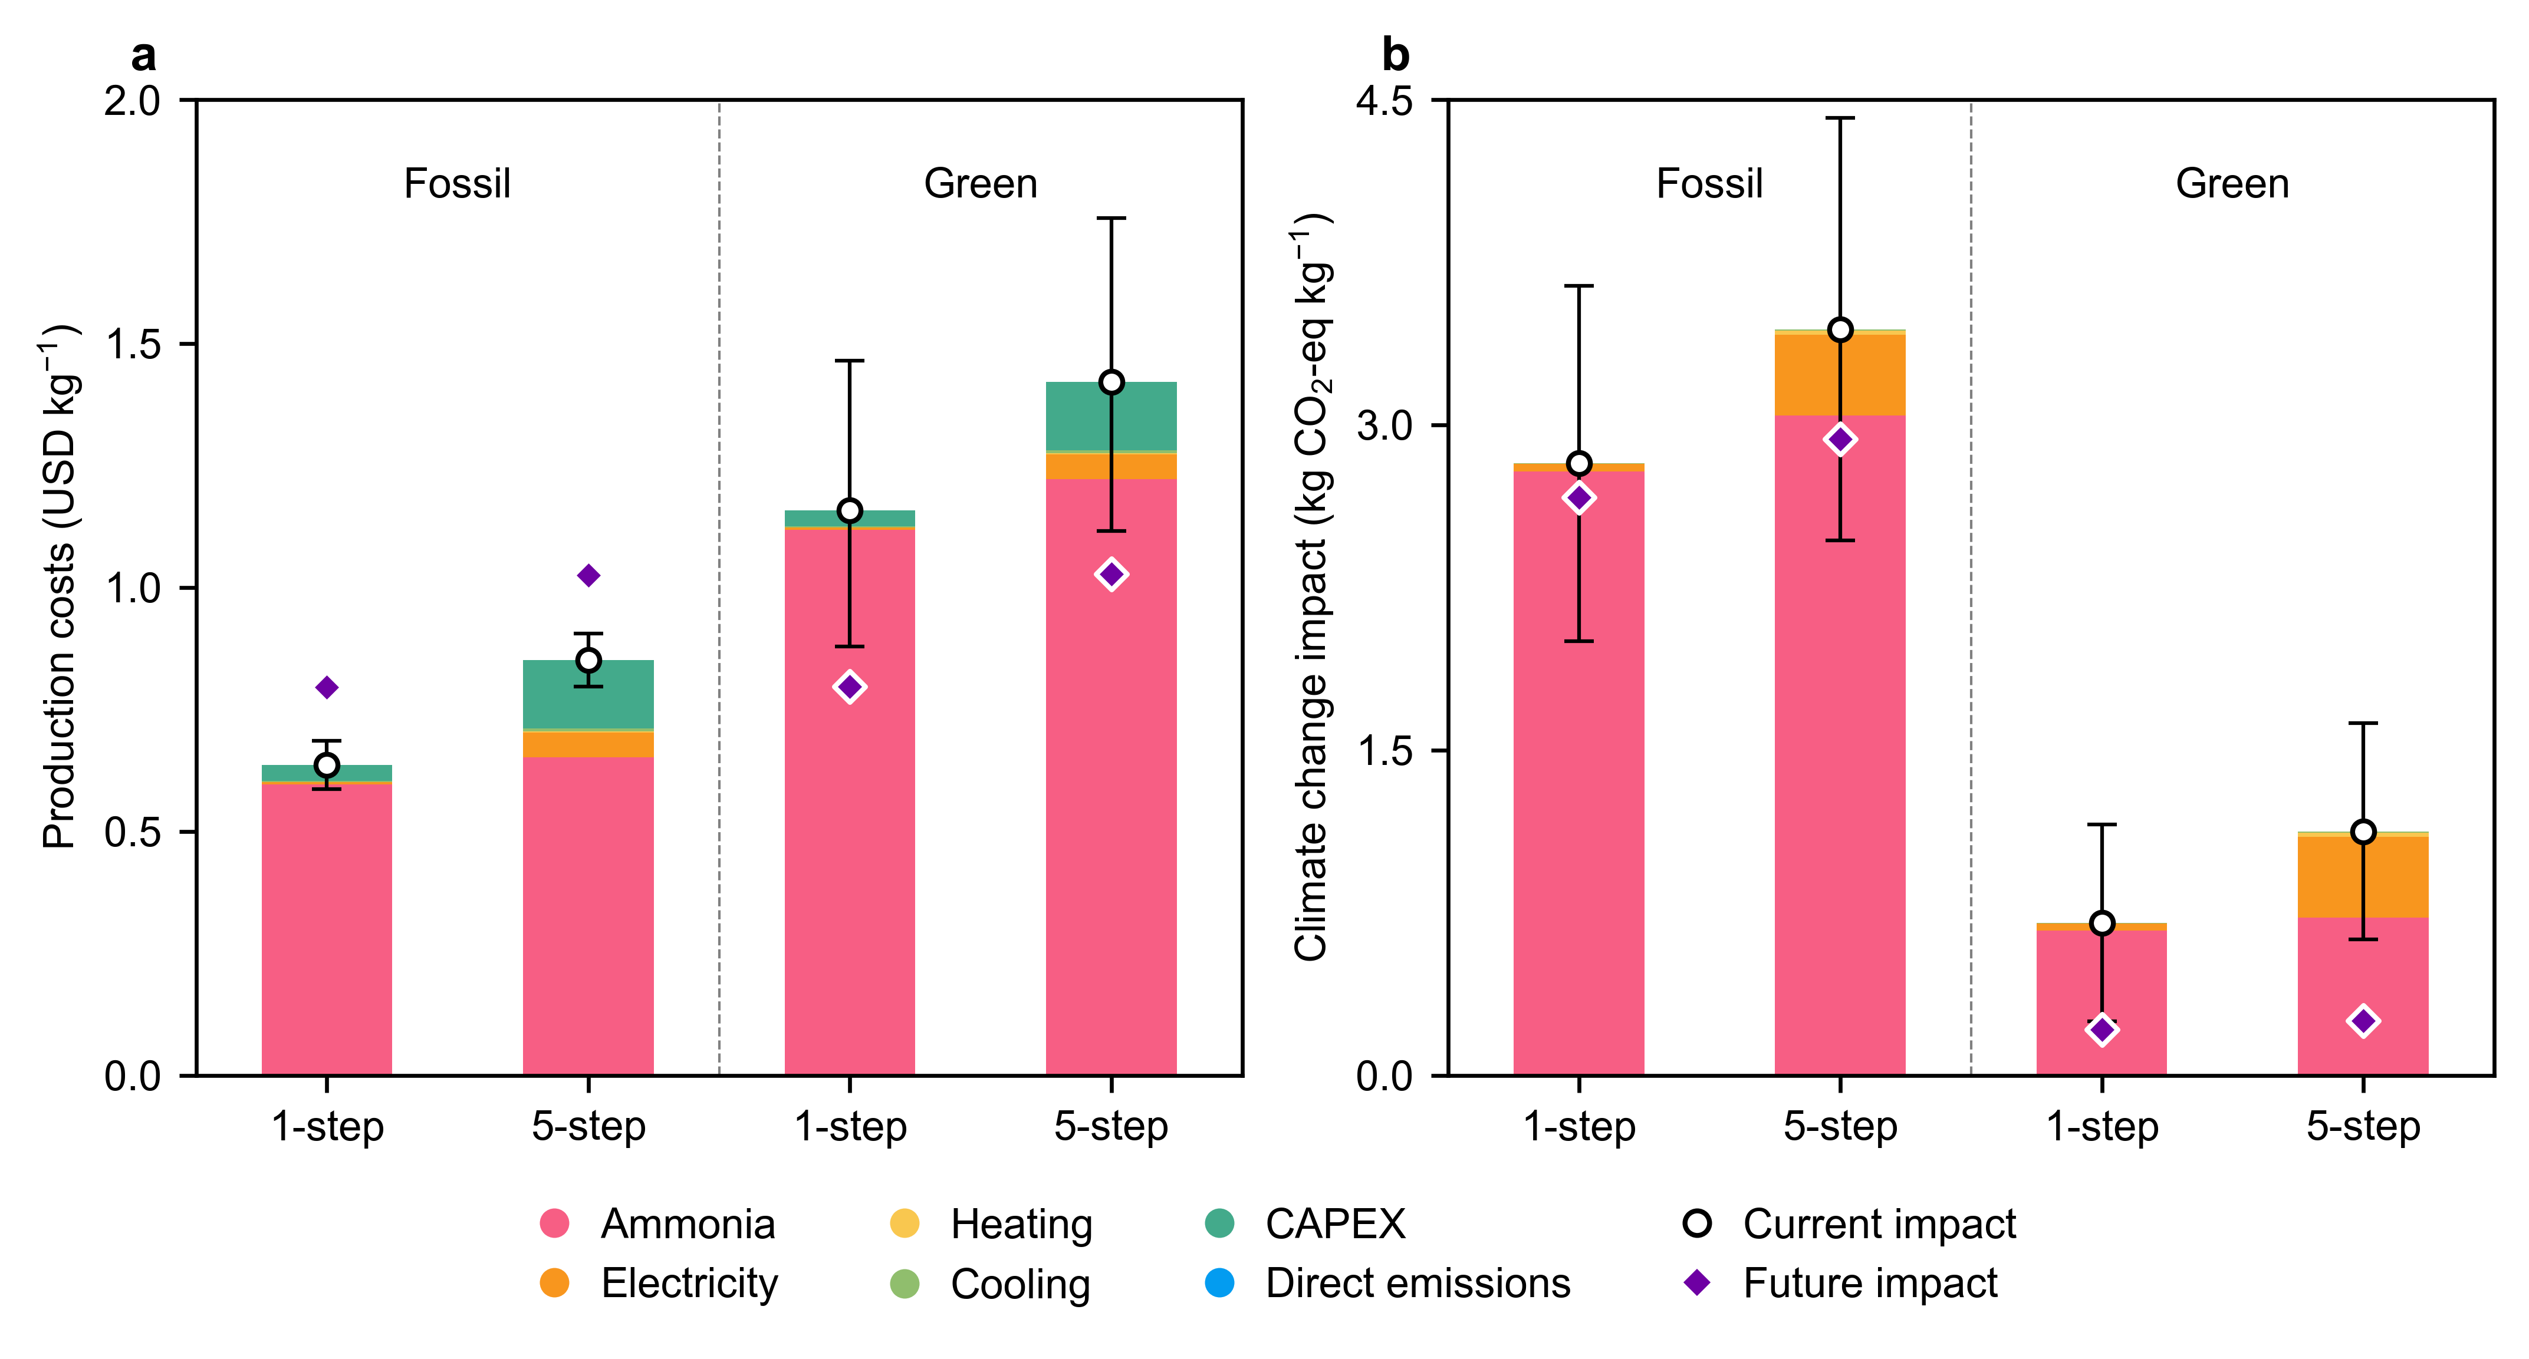
Fig. 2 (a) Production costs and (b) climate change impacts per kg of N₂O produced using two technologies: one-step NH₃ oxidation and five-step thermal decomposition of NH₄NO₃. The analysis includes N₂O production via both fossil-based NH₃ (derived from natural gas) and green NH₃ (produced via the electrolytic H₂-based Haber-Bosch process). Future projections for 2050 are highlighted for both the production costs and climate change impacts across all technologies.
- The one-step direct oxidation of NH₃ to N₂O performs better than the conventional five-step process of NH₃ to N₂O via NH₄NO₃ decomposition in terms of both production costs and climate change impacts.
- NH₃ is the main contributing factor to both production costs and climate change impacts. However, CAPEX contributes more to production costs, and electricity contributes more to climate change impacts in the five-step process compared to the one-step direct oxidation technology.

Table 1 Risk assessment metrics for the one-step and five-step N₂O production routes are evaluated using the Dow Fire and Explosion Index and the TNT equivalency framework, highlighting the estimate financial and operational impacts.
Metric | 1-step | 5-step
Dow Fire and Explosion Index
Fire and explosion index | 47 | 238
Degree of hazard | Light | Severe
Radius of exposure (m) | 12 | 61
Area of exposure (m²) | 464 | 11678
Maximum probable property damage (million USD) | 2 | 32
Maximum probable days outage | 28 | 166
Business interruption (million USD) | 11 | 89
Trinitrotoluene (TNT) equivalency
Equivalent mass of TNT (kg) | 6008 | 30727
Overpressure (kPa) | 49 | 142
Number of deaths due to lung haemorrhage | 0 | 5
Number of eardrum ruptures | 1 | 3
Maximum distance at which projectiles can land (m) | 1920 | 2737

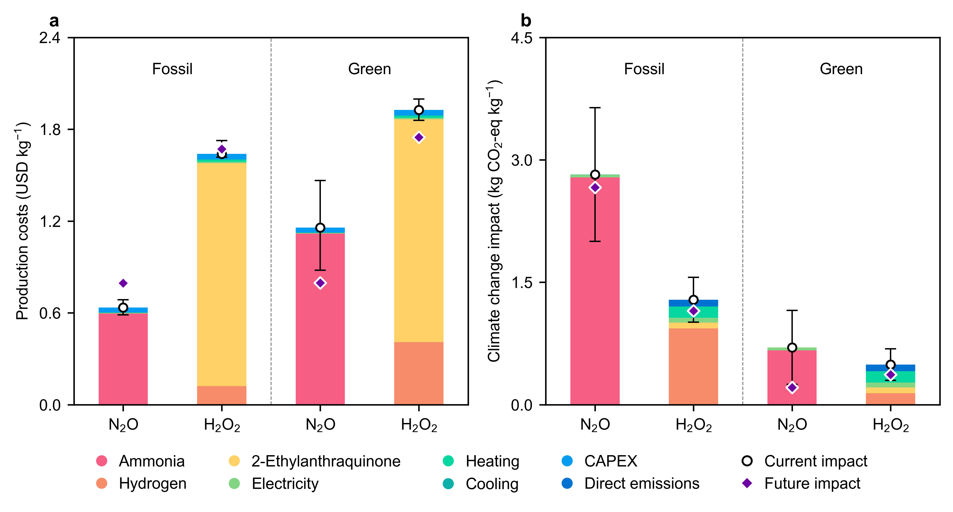
Fig. 3 (a) Production costs and (b) climate change impacts per kg of N₂O and H₂O₂. For N₂O production, the one-step process using NH₃ derived from either natural gas (fossil-based) or the electrolytic H₂-based Haber-Bosch process (green) is shown. Similarly, the anthraquinone process for H₂O₂ production, utilizing H₂ from either natural gas reforming or electrolytic sources, is presented. Future projections by 2050 for production costs and climate change impacts across all technologies are indicated.
- Hydrogen peroxide (H₂O₂) is significantly more expensive than N₂O alternatives (2.6 times in the fossil scenario and 1.7 times in the green scenario) due to the costly anthraquinone working solution required for the process.
- Regarding climate change impacts, in the fossil scenario, N₂O has an impact of
2.8 kg CO₂-eq kg^{–1}, compared to H₂O₂’s impact of 1.3 kg CO₂-eq kg^{–1}. In the green scenario, these impacts decrease to 0.7 kg CO₂-eq kg^{–1} for N₂O and 0.5 kg CO₂-eq kg^{–1} for H₂O₂. The fossil N₂O production process exhibits significantly higher impacts than H₂O₂ production, primarily due to the hydrogen (H₂) required (2.3 times more in the case of N₂O than in H₂O₂).
- In the future, as electricity becomes highly decarbonized, the impacts of N₂O in the green scenario decrease to 0.3 kg CO₂-eq kg^{–1}, while H₂O₂ remains at 0.4 kg CO₂-eq kg^{–1}.

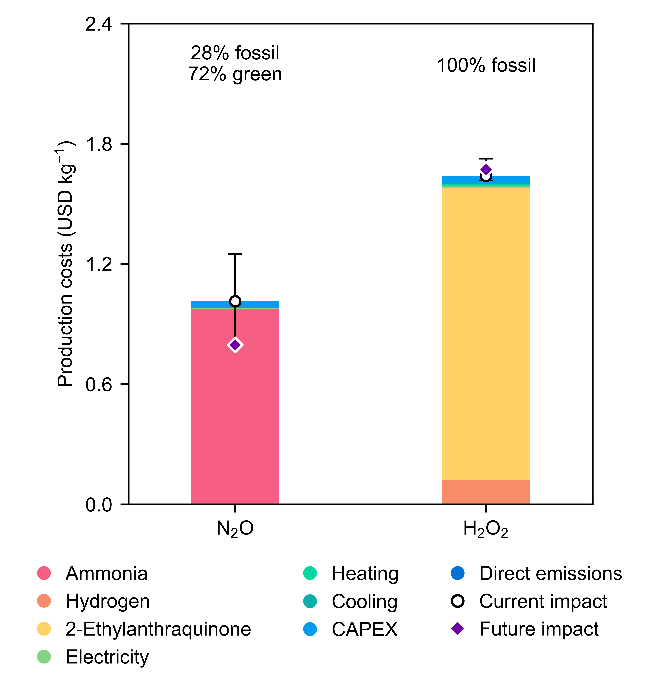
Fig. 4 Production costs of N₂O and H₂O₂ are compared under the condition of having the same carbon footprint. To match the climate change impact of fossil-based H₂O₂, a blend of N₂O—comprising 28% fossil-derived and 72% green NH₃ (see Fig. 3)—is utilized. By 2050, projections indicate potential reductions in production costs for N₂O.
- A blending scenario between fossil and green NH₃ for N₂O production suggests that, at a blend ratio of 28% fossil and 72% green NH₃, the carbon footprint of N₂O production can match that of fossil-based H₂O₂ production at a 38% lower production cost.

Table 2 Risk assessment metrics for one-step N₂O production compared to H₂O₂ production via the conventional anthraquinone process are evaluated using the Dow Fire and Explosion Index and the TNT equivalency framework, highlighting the estimate financial and operational impacts.
Metric | N₂O | H₂O₂
Dow Fire and Explosion Index
Fire and explosion index | 47 | 111
Degree of hazard | Light | Intermediate
Radius of exposure (m) | 12 | 28
Area of exposure (m²) | 464 | 2546
Maximum probable property damage (million USD) | 2 | 2
Maximum probable days outage | 28 | 30
Business interruption (million USD) | 11 | 12
Trinitrotoluene (TNT) equivalency
Equivalent mass of TNT (kg) | 6008 | 70748
Overpressure (kPa) | 49 | 264
Number of deaths due to lung haemorrhage | 0 | 9
Number of eardrum ruptures | 1 | 4
Maximum distance at which projectiles can land (m) | 1920 | 3280

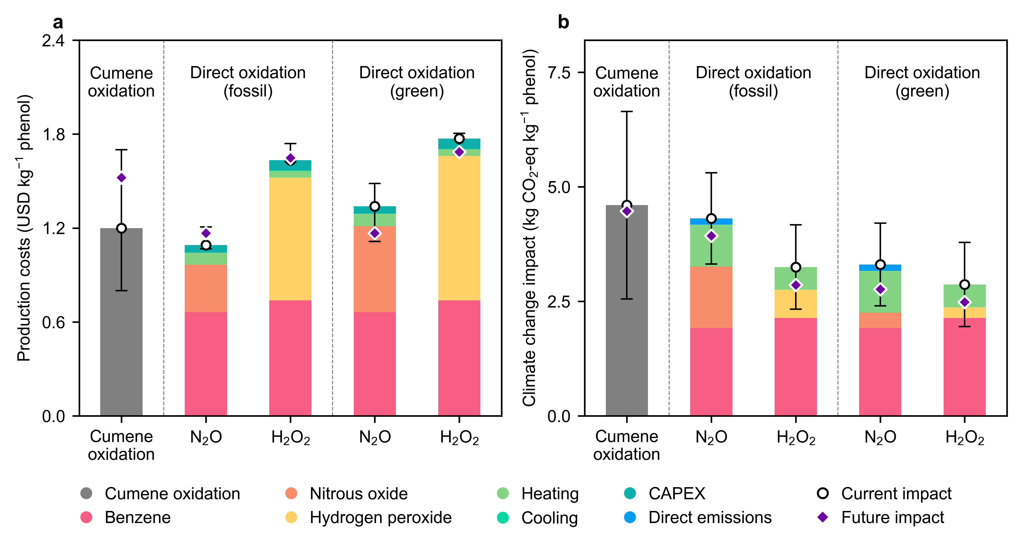
Fig. 5 (a) Production costs and (b) climate change impacts per kg of phenol produced using the business-as-usual cumene oxidation process, and the direct oxidation of benzene to phenol using N₂O and H₂O₂. For N₂O contributions, the one-step process using NH₃ derived from either natural gas (fossil-based) or the electrolytic H₂-based Haber-Bosch process (green) is shown. Similarly, the anthraquinone process for H₂O₂ contributions, utilizing H₂ from either natural gas reforming or electrolytic sources, is presented. Projections for 2050 highlight potential reductions in production costs and climate change impacts across all technologies.
- The direct oxidation of benzene to phenol using N₂O is the most cost-effective route, reducing costs by 10% compared to the traditional cumene oxidation process for phenol production.
- In terms of climate change impacts, all direct oxidation routes have lower impacts than the traditional cumene oxidation process. Among these, the H₂O₂-based direct oxidation routes exhibit the lowest impacts for phenol production.

