Received 00th January 20xx,
- Institute for Chemical and Bioengineering, Department of Chemistry and Applied Biosciences, ETH Zürich, Vladimir Prelog Weg 1, Zürich 8093, Switzerland.
Email: jpr@chem.ethz.ch; gonzalo.guillen.gosalbez@chem.ethz.ch
- Institute of Environmental Sciences (CML), Leiden University, Einsteinweg 2, 2333 CC Leiden, The Netherlands.
†Electronic Supplementary Information (ESI) available. See DOI: https://doi.org/
10.1039/x0xx00000x
Accepted 00th January 20xx
DOI: 10.1039/x0xx00000x

The nexus of climate policies and environmental sustainability in platform chemical production
Abhinandan Nabera,ª Ioan-Robert Istrate,^{b} Antonio José Martín,ª Javier Pérez-Ramírez*ª and Gonzalo Guillén-Gosálbez*ª
Platform chemicals form the basis of the chemical industry but are linked to significant environmental impacts due to their large volumes and predominant fossil origin. Achieving the grand transition towards low-carbon production of these chemicals necessitates the implementation of climate policies. Hydrogen, ammonia, and methanol account for 53% of global CO₂ emissions associated with primary chemicals and are therefore excellent case studies to analyse how future regulations, market dynamics, and technological advancements will affect sustainable production methods. In this study, we perform a prospective life cycle assessment until 2050 for various production technologies across 26 regions worldwide within the climate policies framework, limiting global temperature rise to 1.5 °C or 2 °C. Our findings indicate that, in contrast to fossil-based production, green pathways demonstrate substantial environmental impact reduction by 2050, with solar-based routes displaying predominant advantages for these chemicals. Furthermore, the global-scale regional assessment reveals that green hydrogen routes exhibit low variation in impact reduction across regions, offering no distinct location-based benefit. However, for green ammonia and methanol pathways, strategic planning is crucial to maximise global benefits. Overall, this work provides valuable insights for informed and sustainable manufacturing of key platform chemicals.

Introduction
The chemical industry plays a crucial role in our modern society, contributing significantly to various sectors such as manufacturing, agriculture, and healthcare. However, it is known as one of the hardest-to-abate sectors as it faces a critical challenge towards decarbonisation due to its high energy-intensive nature and heavy reliance on fossil fuels. This dependence further leads to 2 Gt CO₂ per year, accounting for 5% of the global CO₂ emissions.¹ Moreover, fossil fuels not only contribute to environmental concerns but also expose the industry to price volatility and supply chain disruptions.^{2,3} Amidst the array of chemicals produced today, platform chemicals are an important subset that serve as key intermediates in the production of a myriad of other products.
Hydrogen, ammonia, and methanol are three of the most important platform chemicals due to their versatility.^{4–6} Hydrogen, in particular, can be utilised across various sectors, from fuel cells in transportation to industrial processes and energy storage.^{4,7} As of 2020, the annual demand for hydrogen is around 89 Mt per year, and is projected to increase fivefold by 2050.⁸ Ammonia, on the other hand, is critical for the production of fertilisers, ensuring global food security⁹ and could also serve as energy carrier in electricity generation and transportation applications. These needs have led to an estimated demand of approximately 355 Mt per year in 2050, compared to its current demand of 185 Mt.¹⁰ Similarly, the demand of methanol (100 Mt per year), is projected to increase fivefold by 2050.^{11,12} Methanol is primarily used as a fuel or fuel additive owing to its cleaner combustion and lower emissions compared to other carbon fuels.¹³
Currently, 96% of hydrogen originates from fossil feedstocks, leading to 457 Mt CO₂ emissions per year (Fig 1).⁸ These emissions account only for hydrogen produced for refining processes to avoid double counting from ammonia and methanol production. In fact, around 43% of hydrogen is utilised for refining, 52% for ammonia and methanol production, and the rest for other applications.⁸ Conventionally, hydrogen is produced from steam methane reforming (SMR) at high temperatures of around 700–800 °C.⁷ Green hydrogen production is achievable through the electrolysis of water powered by renewable electricity sources, such as wind or solar.⁷ This alternative pathway is currently the most feasible low-carbon scheme. On the other hand, hydrogen can also be produced from renewable feedstock, such as biomass, via gasification.¹⁴
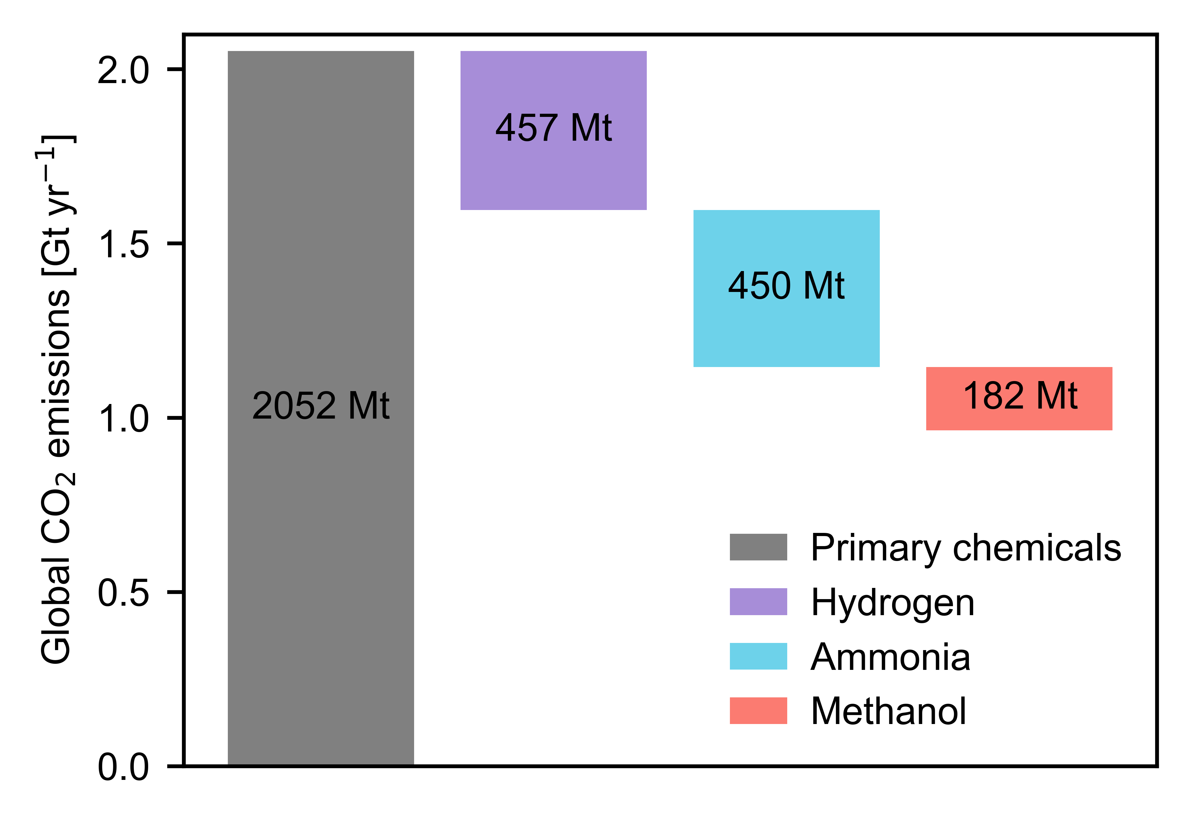
Fig. 1 Global CO₂ emissions associated with primary chemicals. Only emissions related to refining are displayed for hydrogen, as it is used in the production of ammonia and methanol.
Similarly, conventional ammonia production requires steam reforming of natural gas to produce hydrogen. This fossil hydrogen is then combined with nitrogen in the Haber-Bosch process over iron-based catalysts to produce ammonia.¹⁵ Approximately 60 to 70% of ammonia is produced via this energy-intensive route at high pressures (150–250 bar) and temperatures (350–550 °C).^{10,15} Ammonia production is responsible for approximately 450 Mt CO₂ emissions (Fig 1), accounting for 22% of the total primary chemical emissions due to heavy reliance on fossil fuels.¹ With regard to the production of green ammonia, the current Haber-Bosch process can incorporate low-carbon hydrogen sources, such as those obtained from water electrolysis or biomass gasification, in addition to nitrogen.^{6,16} The direct electrocatalytic reduction of nitrogen has recently gained considerable interest, due to its association with renewable electricity sources. However, the early-stage development of this technology currently renders its industrial implementation impractical.¹⁷
Between 60 and 65% of methanol is produced from syngas obtained from steam reforming of natural gas¹², which requires further hydrogenation over a Cu-Zn-Al catalyst under demanding conditions (35–100 bar and 200–300 °C).¹⁸ The corresponding CO₂ emissions from global methanol production are around 182 Mt CO₂ per year (Fig 1), accounting for 9% of total emissions related to primary chemicals.¹ The production of low-carbon or green methanol is achievable through the optimised reverse water-gas shift reaction. This pathway incorporates captured CO₂ as feedstock, combined with low-carbon hydrogen sources.⁵ Another alternative is the utilisation of biomass as a feedstock, achieved via a gasification process. Furthermore, co-electrolysis is a promising technology that involves the conversion of CO₂ and water into syngas, necessary for methanol synthesis.¹⁹ This process employs solid oxide electrolysers that operate at high temperatures (800–1000 °C) and are powered by renewable electricity sources. Nevertheless, significant advancements are still necessary to make the co-electrolysis process commercially viable.²⁰
This brief overview discusses various pathways for hydrogen, ammonia, and methanol production and their large contributions to CO₂ emissions, making them excellent case studies for conducting techno-economic and life cycle assessments (LCAs). Previous studies in the literature have assessed multiple impact categories for the production technologies of all three chemicals. Regarding hydrogen, Parkinson et al.⁷ focussed on large-scale production routes and evaluated 12 technologies to assess their economic and environmental potential. Further, Dincer et al.²¹ compared 19 different hydrogen production technologies considering both renewable and fossil sources for their economic and environmental impacts. Similar to hydrogen, previous works have also conducted comprehensive evaluations of the economic and environmental impacts of various ammonia production technologies. For example, D’Angelo et al. evaluated both the centralised (fossil, blue, and green)⁶ and decentralised (direct electro-reduction of nitrogen)²² ammonia production pathways. Furthermore, these studies also assessed the absolute sustainability of production technologies in terms of planetary boundaries, which refer to a set of biophysical limits on primary Earth system processes defining a safe operating space (SOS).^{23,24} Breaching these boundaries could potentially lead to instability on our planet.²⁵ Similarly, various studies evaluating established and emerging methanol production technologies exist in literature.^{5,19}
In previous techno-economic and LCA studies, the standard approach involved creating a process model to quantify mass and energy flows within the primary plant (i.e., the foreground system).²⁶ Subsequently, this data was integrated with life cycle emissions related to these material and energy inputs, considering a wide range of technologies within the associated chemical supply chains (i.e., the background system).²⁶ Historically, LCAs for chemicals frequently assumed a fixed background system, representing the existing state of the technosphere.^{27,28} However, the current landscape is swiftly evolving in response to decarbonisation challenges, as demonstrated by various climate policies proposed in alignment with the goals of the Paris Agreement. Achieving the objectives set by these policies will necessitate significant changes in our economic structure, involving the decarbonisation of energy generation and transportation. These transformations are likely to have a substantial impact on all industrial sectors. Therefore, disregarding these forthcoming technological shifts when assessing environmental impacts of chemicals could result in spurious and misguided conclusions.
Hence, in this work, we aim to explore the extent to which forthcoming economic developments might impact the environmental consequences associated with emerging chemical production pathways. To achieve this, we assess the environmental impact of fossil and green hydrogen, ammonia, and methanol while considering future economic projections derived with Integrated Assessment Models (IAMs). IAMs, such as IMAGE, provide a comprehensive understanding of the interlinked relationships among society, the biosphere, and the climate system.²⁹ This enables us to evaluate the current and future global environmental impacts based on anticipated socio-economic and technological advancements. In this regard, we utilise the premise framework to construct future background data that aligns with the results derived from the IMAGE model.²⁹ More specifically, we conduct a prospective life cycle assessment (pLCA) spanning from 2020 to 2050, with 2020 as our reference year for analysis. Additionally, we extend the temporal dimension of platform chemical production to a regional level, encompassing 26 different regions worldwide.
Overall, our results provide a broader perspective on the environmental performance of various chemical production methods, shedding light on the true potential of both fossil and renewable carbon-based chemicals under plausible future socio-economic and technological scenarios.
Methods
xxx
Results and discussion
xxx
Conclusions
xxx
Author Contributions
AN: conceptualisation, methodology, visualisation, formal analysis, writing – original draft, writing – review and editing; IRI: conceptualisation, methodology, validation, writing – original draft, writing – review and editing; AM: conceptualisation, methodology, visualisation, writing – original draft, writing – review and editing; JPR: conceptualisation, writing – review and editing, supervision, and project administration; GGG: conceptualisation, validation, writing – original draft, writing – review and editing, supervision, and project administration.
Conflicts of interest
There are no conflicts to declare.
Acknowledgements
This publication was created as part of NCCR Catalysis (grant number 180544), a National Centre of Competence in Research funded by the Swiss National Science Foundation.
References
1 P. Gabrielli, L. Rosa, M. Gazzani, R. Meys, A. Bardow, M. Mazzotti and G. Sansavini, One Earth, 2023, 6, 682–704.
2 A. Nabera, I.-R. Istrate, A. J. Martín, J. Pérez-Ramírez and G. Guillén-Gosálbez, Green Chem., 2023, 25, 6603–6611.
3 World Bank, Monthly Prices, Commodity Markets.
4 T. Terlouw, C. Bauer, R. McKenna and M. Mazzotti, Energy Environ. Sci., 2022, 15, 3583–3602.
5 A. González-Garay, M. S. Frei, A. Al-Qahtani, C. Mondelli, G. Guillén-Gosálbez and J. Pérez-Ramírez, Energy and Environmental Science, 2019, 12, 3425–3436.
6 S. C. D’Angelo, S. Cobo, V. Tulus, A. Nabera, A. J. Martín, J. Pérez-Ramírez and G. Guillén-Gosálbez, ACS Sustainable Chem. Eng., 2021, 9, 9740–9749.
7 B. Parkinson, P. Balcombe, J. F. Speirs, A. D. Hawkes and K. Hellgardt, Energy and Environmental Science, 2019, 12, 19–40.
8 IEA, Net Zero Roadmap: A Global Pathway to Keep the 1.5 °C Goal in Reach - 2023 Update, International Energy Agency, 2023.
9 C. A. Ramírez and E. Worrell, Resources, Conservation and Recycling, 2006, 46, 75–93.
10 IEA, Ammonia Technology Roadmap: Towards more sustainable nitrogen fertiliser production, International Energy Agency, 2021.
11 IRENA, Global Renewables Outlook: Energy transformation 2050, International Renewable Energy Agency, 2020.
12 IRENA, Innovation Outlook: Renewable Methanol, International Renewable Energy Agency, 2021.
13 T. J. Deka, A. I. Osman, D. C. Baruah and D. W. Rooney, Environ Chem Lett, 2022, 20, 3525–3554.
14 B. Pandey, Y. K. Prajapati and P. N. Sheth, International Journal of Hydrogen Energy, 2019, 44, 25384–25415.
15 J. Humphreys, R. Lan and S. Tao, Adv Energy and Sustain Res, 2021, 2, 2000043.
16 L. Wang, M. Xia, H. Wang, K. Huang, C. Qian, C. T. Maravelias and G. A. Ozin, Joule, 2018, 2, 1055–1074.
17 A. J. Martín, T. Shinagawa and J. Pérez-Ramírez, Chem, 2019, 5, 263–283.
18 O. Martin and J. Pérez-Ramírez, Catal. Sci. Technol., 2013, 3, 3343.
19 M. Pérez-Fortes, J. C. Schöneberger, A. Boulamanti and E. Tzimas, Applied Energy, 2016, 161, 718–732.
20 H. Al-Kalbani, J. Xuan, S. García and H. Wang, Applied Energy, 2016, 165, 1–13.
21 M. Granovskii, I. Dincer and M. A. Rosen, Journal of Power Sources, 2006, 157, 411–421.
22 S. C. D’Angelo, A. J. Martín, S. Cobo, D. F. Ordóñez, G. Guillén-Gosálbez and J. Pérez-Ramírez, Energy Environ. Sci., 2023, 16, 3314–3330.
23 J. Rockström, W. Steffen, K. Noone, Å. Persson, F. S. Chapin, E. F. Lambin, T. M. Lenton, M. Scheffer, C. Folke, H. J. Schellnhuber, B. Nykvist, C. A. de Wit, T. Hughes, S. van der Leeuw, H. Rodhe, S. Sörlin, P. K. Snyder, R. Costanza, U. Svedin, M. Falkenmark, L. Karlberg, R. W. Corell, V. J. Fabry, J. Hansen, B. Walker, D. Liverman, K. Richardson, P. Crutzen and J. A. Foley, Nature, 2009, 461, 472–475.
24 W. Steffen, K. Richardson, J. Rockström, S. E. Cornell, I. Fetzer, E. M. Bennett, R. Biggs, S. R. Carpenter, W. De Vries, C. A. De Wit, C. Folke, D. Gerten, J. Heinke, G. M. Mace, L. M. Persson, V. Ramanathan, B. Reyers and S. Sörlin, Science, 2015, 347, 1259855.
25 V. Tulus, J. Pérez-Ramírez and G. Guillén-Gosálbez, Green Chem., 2021, 23, 9881–9893.
26 J. Kleinekorte, L. Fleitmann, M. Bachmann, A. Kätelhön, A. Barbosa-Póvoa, N. Von Der Assen and A. Bardow, Annu. Rev. Chem. Biomol. Eng., 2020, 11, 203–233.
27 I. Ioannou, S. C. D’Angelo, A. J. Martín, J. Pérez-Ramírez and G. Guillén-Gosálbez, ChemSusChem, 2020, 13, 6370–6380.
28 Á. Galán-Martín, V. Tulus, I. Díaz, C. Pozo, J. Pérez-Ramírez and G. Guillén-Gosálbez, One Earth, 2021, 4, 565–583.
29 R. Sacchi, T. Terlouw, K. Siala, A. Dirnaichner, C. Bauer, B. Cox, C. Mutel, V. Daioglou and G. Luderer, Renewable and Sustainable Energy Reviews, 2022, 160, 112311.

