**1St test Result:- 64/65 (98.46)**

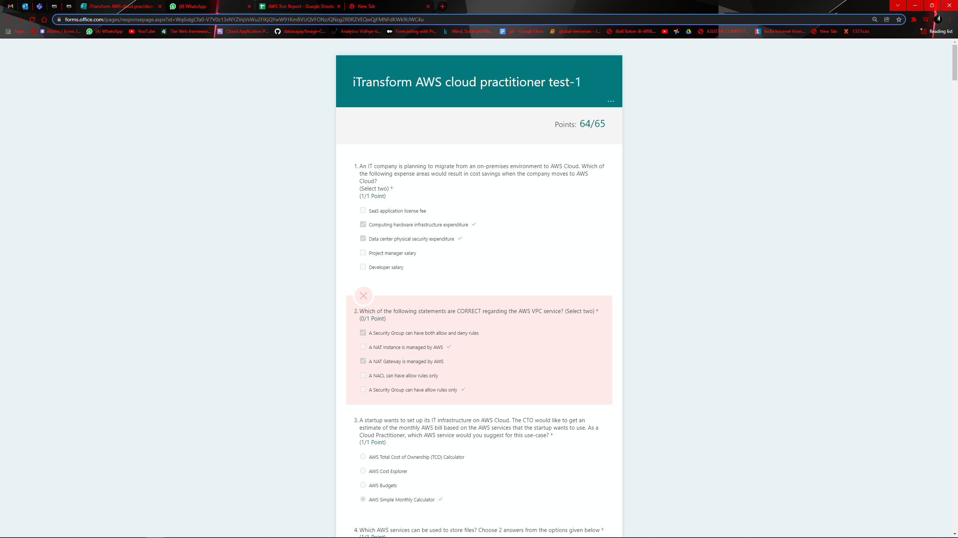

**2nd test Result:- 64/65 (98.46)**

