**Webmin in Ubantu**

[**Webmin**](http://www.webmin.com/index.html) is an open source, web based system administration tool for Unix/Linux. Using Webmin, you can setup and configure all services such as DNS, DHCP, Apache, NFS, and Samba etc via any modern web browsers. So, you don’t have to remember all commands or edit any configuration files manually.

1. Edit file **/etc/apt/sources.list**,

# sudo vi /etc/apt/sources.list

1. Add the following lines at the End of File:

# deb http://download.webmin.com/download/repository sarge contrib

# deb http://webmin.mirror.somersettechsolutions.co.uk/repository sarge contrib

1. Add the GPG key:

# sudo wget http://www.webmin.com/jcameron-key.asc

# sudo apt-key add jcameron-key.asc

1. Update the sources list:

# sudo apt-get update

1. Install webmin using the following command:

# sudo apt-get install webmin

1. Allow the webmin default port **“10000”** via firewall, if you want to access the webmin console from a remote system.

# sudo ufw allow 10000

1. Access Webmin console

Open up your browser and navigate to the URL

[**https://ip-address:10000/**](https://ip-address:10000/). (like. https://192.168.1.170:10000/)

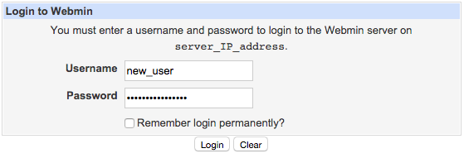

Enter the same login credentials that you used to log in to your server via SSH. This user must have **root privileges** via sudo.

**How to Change/Reset Webmin root Password**

In order to change webmin root account password use following command. ( Note: It will not change your systems root password )

# /usr/libexec/webmin/changepass.pl /etc/webmin root secretpassword

**How to Change Webmin default Port**

If you do not want to run webmin with default port, use below steps to change the default port.

Login Webmin as root >> Webmin >> Webmin Configuration >> Ports and Addresses… you can change port there