**make parathion on linux instance**

**first we have to attached secondary harddiks drive on your virtual machine.**

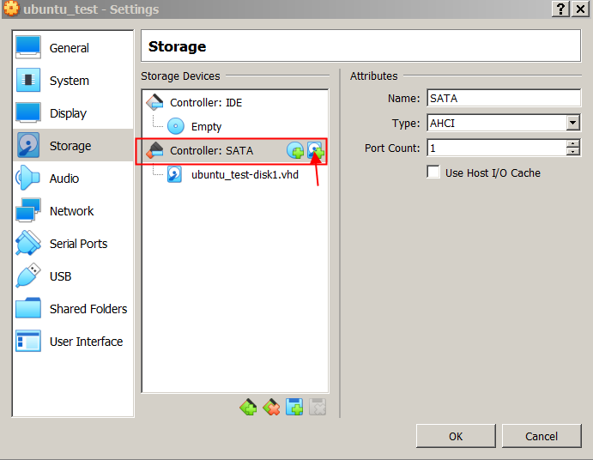

**add 20gb of storage**

**open the terminal of your linux**

**To show detailed overview of our block devices**

fdisk -l

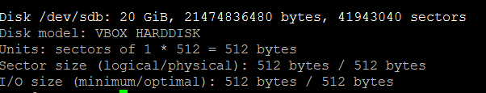

**fdisk main function is that it is an interactive tool to create/manage/delete partitions. So to start creating partitions from sdb**

fdisk /dev/sdb

**If we select the "m" option, we get list of option.**

**Now let's use option "n" start creating a new partition:**

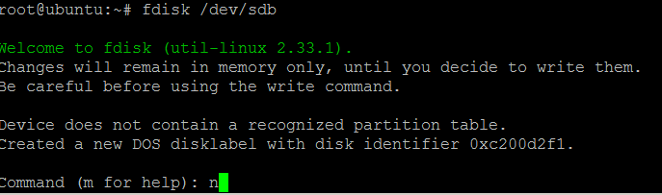

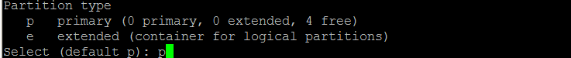

**I'll create my first primary partition which is going to be 5GB in size.:**



**Notice that that the first sector start at 2048 rather than 0. That's because the 0-2047 is reserved for setting up the MBR's special internal partition.**

**we have to use the "w" option to apply the changes.**

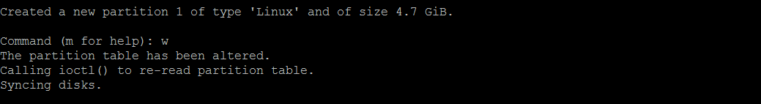

**Let's now repeat the process to create 2 5GB primary partitions in total.**

**Format the partition**

**Next we will format our partition using mkfs command**

mkfs.ext4 /dev/sdb1

mkfs.ext4 /dev/sdb2

**Mount the partition**

**done using the “mount” tool**

**we have to create mount point**

mkdir /mnt/deep

**then mount the partation**

mount -t ext4 /dev/sbd1 /mnt/deep

**after that check the mounted patation using**

df -h

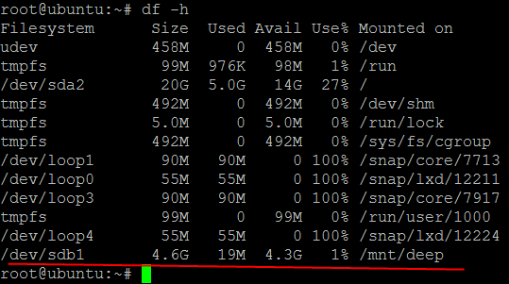

**But our partaion will not be mounted automatically after every reboot. To mount it permanently in our system, we need to append /etc/fstab file. Open /etc/fstab file & make an entry of the following line**

vi /etc/fstab

*/dev/sdb1 /mnt/deep ext4 defaults 0 0*

**/dev/sbd1** = device/file name

**/mnt/deep** = defines device mount point

**ext4** = specifies the file-system type

**defaults** = describes the mount options

**0** = specifies the option to be used by the dump program

**0** = specifies the fsck command option

**Creating SWAP partition using FDISK & FALLOCATE commands**

**Swap is a space on a disk that is used when the amount of physical RAM memory is full. When a Linux system runs out of RAM, inactive pages are moved from the RAM to the swap space.**

**Swap is a special area on your computer, which the operating system can use as additional RAM.**

**Firstly we will create a partition of our HHD that is sdb**

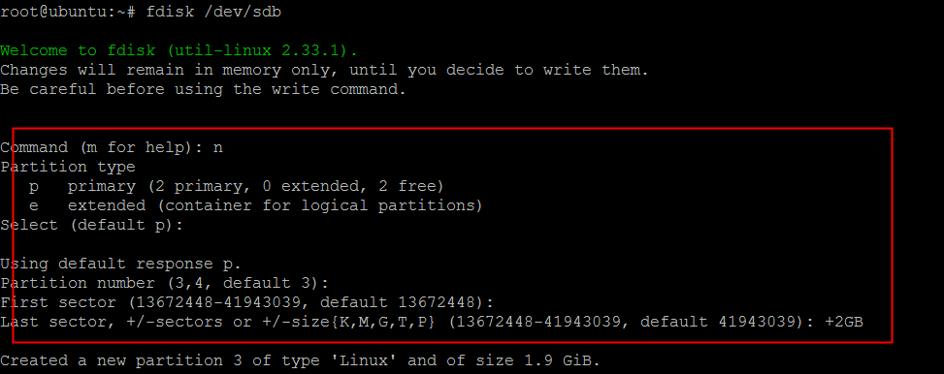

**We have now created a partition of size 2GB but we have not assigned it any partition type, so to assign a partition type, press “t” & press enter.**

**Now you will be first asked to enter partition number, which is 3 for our partition & then we will asked to enter partition id which for swap it’s 82 (to see list of all available partition types, press “l” ) & then press “w” to save the partition table.**

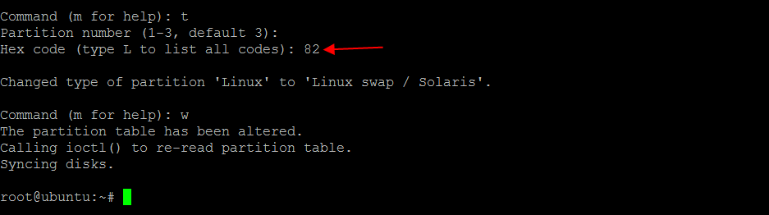

**Next we will format our swap partition using mkswap command**

mkswap /dev/sdb3

**will then activate our newly created swap**

swapon /dev/sda3

**But our swap will not be mounted automatically after every reboot. To mount it permanently in our system, we need to append /etc/fstab file. Open /etc/fstab file & make an entry of the following line**

vi /etc/fstab

*/dev/sdb3 swap swap default 0 0*

**Save & close the file. Our swap now will even work after a reboot.**

**Creating swap using fallocate command**

**this method is easiest & fastest way to create swap. Fallocate is one of the most underestimated & very less used command. Fallocate is used to pre-allocate blocks/size to a files.**

**To create a swap using fallocate, we will firstly create a file named swap_space in ‘/’. Next we will allocate 2GB to our file swap_space ,**

**fallocate –l 2G /swap_space**

**We will then verify the size of the file by running**

ls -lh /swap_space.

**Next, we will make our /swap_space more secure by changing the file permissions**

chmod 600 /swap_space

**Now only root will be able to read, write on this file. We will now format the swap partition,**

mkswap /swap_space

**& then will turn on our swap**

**swapon -s**

**This swap partition will need to be remounted after every reboot. So to make it permanent, edit the /etc/fstab, as we did above & enter the following line**

vi /etc/fstab

*/swap_space swap swap sw 0 0*

**Save & exit the file. Our swap will now be permanently mounted. We can check if your swap is working or not by running “free -m” on your terminal after rebooting the system.**

**links**

<https://codingbee.net/rhcsa/rhcsa-creating-partitions>

<https://linuxtechlab.com/create-swap-using-fdisk-fallocate/>