Q.1.) What is Linear Regression?

Ans: Linear Regression is a commonly used algorithm used in predictive analysis. Precisely, it is a statistical method that relates a dependent variable (say Y) to one or more independent variable(s) say, that shows a linear relationship, hence the name Linear Regression. It **shows the linear relationship**, which means it finds how the value of the **dependent variable** is changing according to the value of **the independent variable.** In case of **single one explanatory variable is known as the Simple Linear Regression** and that for **more than one, it is known as the Multiple Linear Regression**. It is mostly used for finding out the relationship between variables and forecasting.

Consider the below graph:

After plotting the data points, the relation between the dependent and the independent variable is found to be linear.

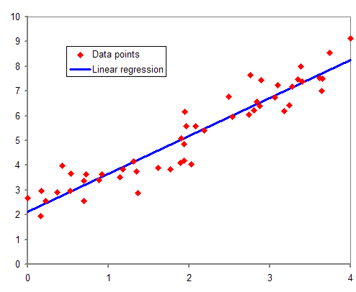

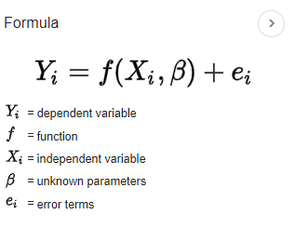The equation for the Linear Regression is given by:

Q.2.) How can we calculate the error in Linear Regression?

Ans : In Linear Regression, the error can be calculated by using various methods, most often used method is MSE ( Mean Squared Error) .

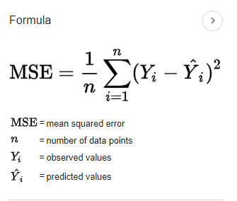In [statistics](https://en.wikipedia.org/wiki/Statistics), the mean squared error (MSE) or mean squared deviation (MSD) of an [estimator](https://en.wikipedia.org/wiki/Estimator) that measures the [average](https://en.wikipedia.org/wiki/Expected_value) of the squares of the [errors](https://en.wikipedia.org/wiki/Error_(statistics)), that is, the average squared difference between the estimated values and the actual value.

Q3. What is the difference between loss and cost function?

Ans: When calculating loss, we consider only a single data point, then we use the term loss function. Whereas, when calculating the sum of error for multiple data then we use the cost function.

Q.4.) What is the difference between MSE, MAE and RMSE?

Ans: **MAE:** Mean absolute error MAE represents the difference between the original and predicted values extracted by averaged the absolute difference over the data set.

