Image Parameters in R

par
From ?par:
Description:

'par' can be used to set or query graphical parameters. Parameters
can be set by specifying them as arguments to 'par' in 'tag =
value' form, or by passing them as a list of tagged values.

There are a very large number of settings in par. For the full documentation, read the par help. Common settings that would be changed are discussed here.

bg Set the background colour for the whole image. Can be set with colour names (bg=“red”) or hex values (bg=“#FF0000”)
fg Set the colour that the plot is drawn with (border, tick mark labels, points, etc)

cex This changes the size of the text for the labels on a plot as a magnification factor (default cex=1). If you wish to make them larger, set this as e.g. cex=3
cex.axis As for cex, but for tick mark labels on the axes
cex.lab … axis title (the 'label')
cex.main … title of plot

col.axis The colour of the axis tick mark labels
col.lab … axis titles (default col.axis=”black”)
col.main … title for the plot

font The font type to use (default font=1)
1 – Normal
2 – Bold
3 – Italic
4 – Bold italic
font.axis Font for tick mark labels
font.lab … axis title
font.main … plot title

lab The number of tick marks on the axes. Specified as lab=c(x,y,len) where len is unimplemented. The defaults are c(5,5,7) – 5 tick marks per axis
las Tick mark label orientation on axes. las=0 (default) is parallel to the axis, las=2 is perpendicular to the axis. las=1 gives horizontal labels, las=3 gives vertical labels
lty Line type. If specified as a character, the value is the length of mark followed by length of space, i.e. “82” would be 8 units long with a 2 unit gap. Integers 1-6 can be used instead, as shown below
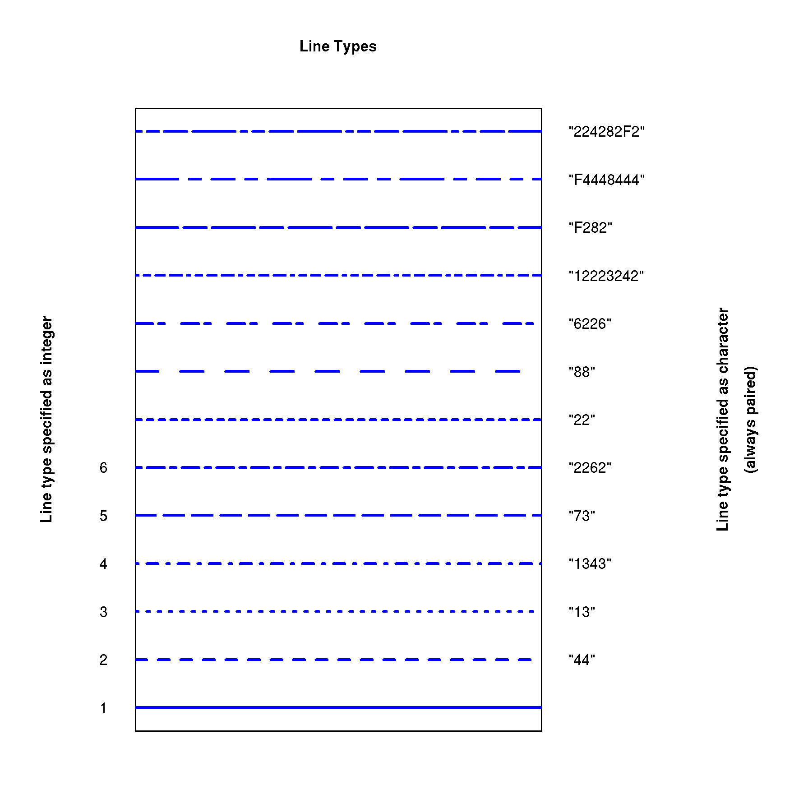
mar The number of (text) lines to use for the plot margins. Specified as c(bottom, left, top, right). Default is mar=c(5,4,4,2)
mgp The distance (in text lines) that the axis title, labels and line are displaced. Defaults to mgp=c(3,1,0)
oma The distance (in lines) around the outside of the plotting area. Good for inserting date/time stamps without affecting the figure itself
xlab, ylab Label for x-axis, y-axis
xaxt,yaxt Specify =”n” to suppress plotting of axis (use with axis())
main Label for plot
xpd Expand available

pch Character symbol to use as point symbol. 0-25 are specified as an integer value (i.e. pch=5), while the remaining characters are specified as characters (i.e. pch=”a”). Any (single) character may be used. For characters 21-25, the fill colour is specified by bg, i.e. bg=”880000” in this case. Colours are specified by col.
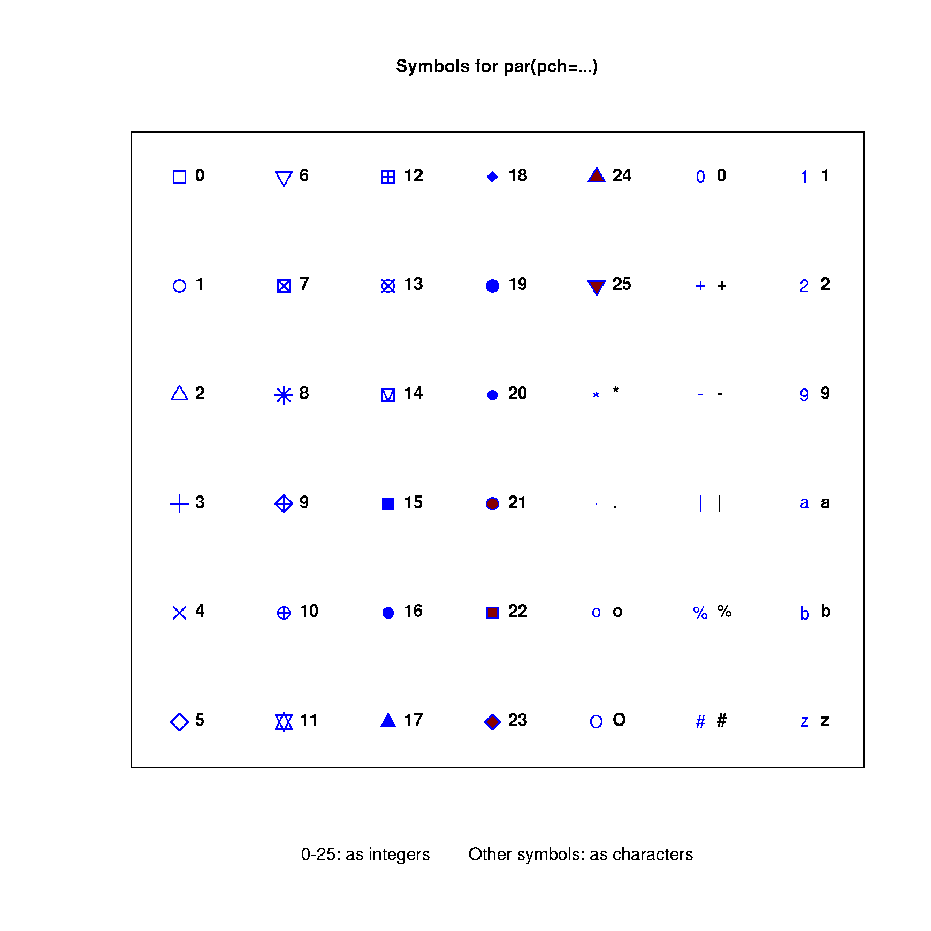

Example
# Reduce dataset to single replicates of runs 1 to 5
dnase<-DNase[seq(2,80,by=2),]
# Change the ordered levels to integers
dnase$Run<-as.integer(as.character(dnase$Run))
# Define line types to use
linetype<-c("44","13","1343","73","2262")
# Define colours to use
col_list<-c("#ee3333","#3366aa","#009973","#992288","#fba300")
# Define symbols to use
pch_list<-seq(0:5)
# Set margins and allow for objects outside plot area
par(xpd=TRUE,mar=par()$mar+c(0,0,0,5))
# Draw an empty plot window
plot(dnase$conc,dnase$density, # x- and y- values
type="n", # don't plot anything yet
xlab="Concentration",ylab="Density", # Axis titles
main="ELISA assay of DNase Activity", # Plot title
las=1, # Axis labels horizontal
)
# Plot each run as a separate line and create labels
legend_labels<-c()
for (ii in 1:5) {
lines(dnase$conc[which(dnase$Run==ii)],
dnase$density[which(dnase$Run==ii)],
col=col_list[ii],
pch=pch_list[ii],
lty=linetype[ii],
lwd=2,type="o"
)
legend_labels<-append(legend_labels,paste("Run",ii))
}
legend("left",inset=1.05,legend_labels,col=col_list,lty=linetype,lwd=2)

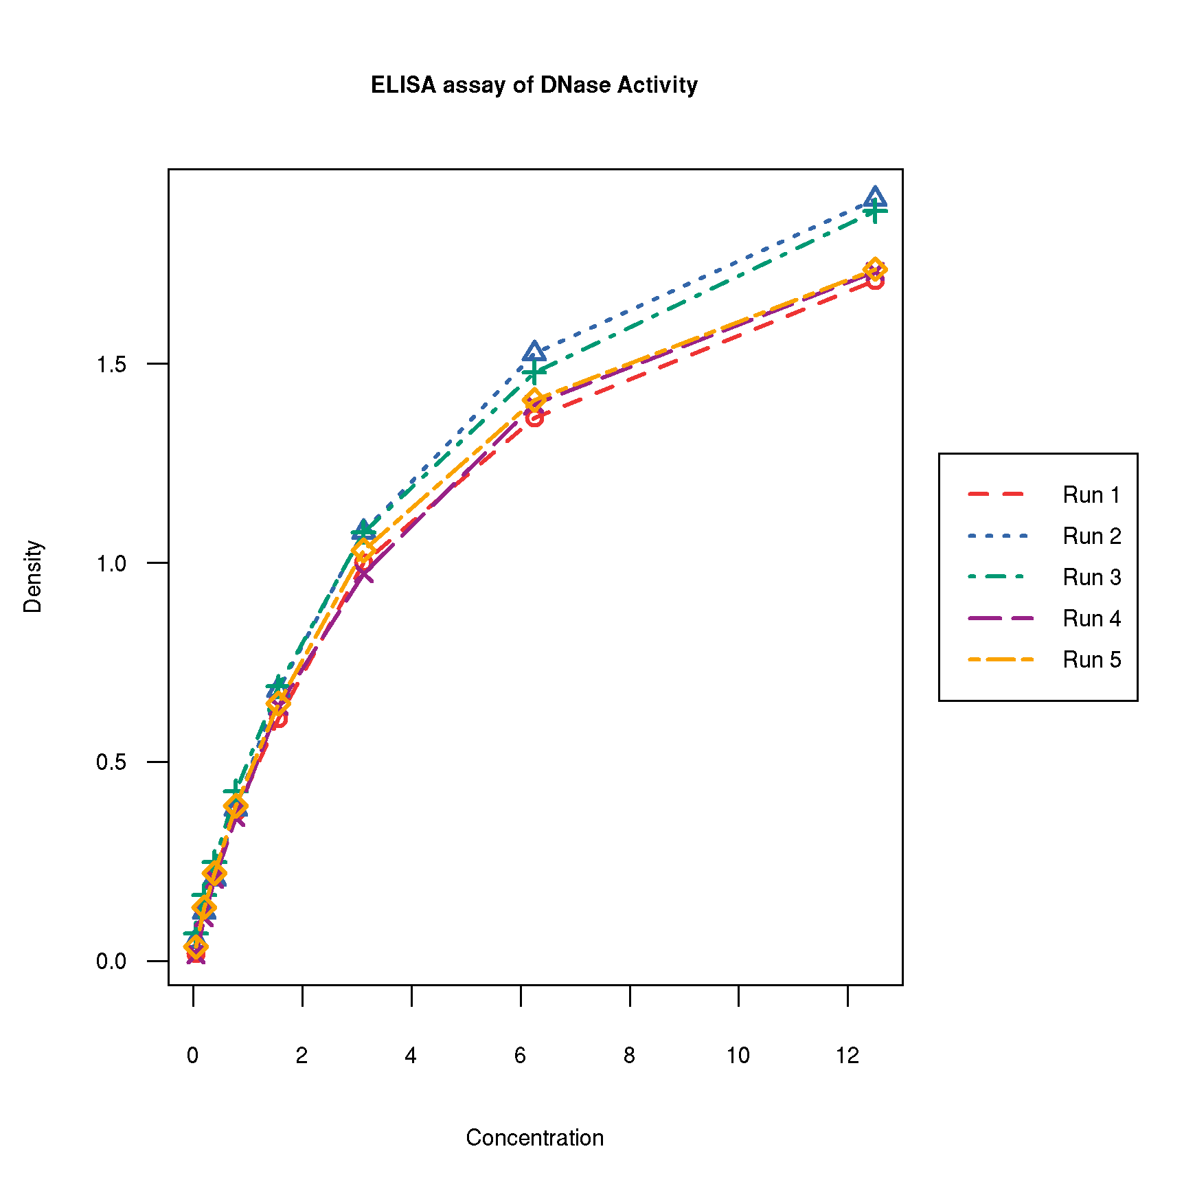

bg in this context is for the points. When as par(bg=”blue”), bg is the plot background. If called as plot(bg=”blue”), it is the background of the symbol (only applicable for pch=21:25)

