Image Parameters in R

par
From ?par:
Description:

'par' can be used to set or query graphical parameters. Parameters
can be set by specifying them as arguments to 'par' in 'tag =
value' form, or by passing them as a list of tagged values.

There are a very large number of settings in par. For the full documentation, read the par help. Common settings that would be changed are discussed here.

bg Set the background colour for the whole image. Can be set with colour names (bg=“red”) or hex values (bg=“#FF0000”)
fg Set the colour that the plot is drawn with (border, tick mark labels, points, etc)

cex This changes the size of the text for the labels on a plot as a magnification factor (default cex=1). If you wish to make them larger, set this as e.g. cex=3
cex.axis As for cex, but for tick mark labels on the axes
cex.lab As above, but for the axis title (the 'label')
cex.main As above, but for title of plot

col.axis The colour of the axis tick mark labels
col.lab The colour of the axis titles (default col.axis=”black”)
col.main The colour of the title for the plot

font The font type to use (default font=1)
1 – Normal
2 – Bold
3 – Italic
4 – Bold italic
font.axis Font for tick mark labels
font.lab … axis title
font.main … plot title

lab The number of tick marks on the axes. Specified as lab=c(x,y,len) where len is unimplemented. The defaults are c(5,5,7) – 5 tick marks per axis
las Tick mark label orientation on axes. las=0 (default) is parallel to the axis, las=2 is perpendicular to the axis. las=1 gives horizontal labels, las=3 gives vertical labels
lty Line type
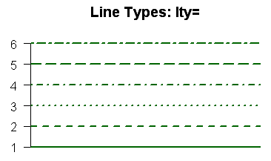
mar The number of (text) lines to use for the plot margins. Specified as c(bottom, left, top, right). Default is mar=c(5,4,4,2)
mgp The distance (in text lines) that the axis title, labels and line are displaced. Defaults to mgp=c(3,1,0)

pch Character symbol to use as points
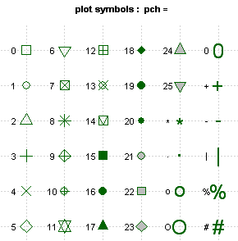

Example
par(fg=“blue”, font=2, las=1, lty=2, pch=c(15,16,17,18,0,1,2,5))
would cause the image to be drawn in blue on a white background, bold font, horizontal labels on the axes, a dashed line and using different symbols for each point.

Images reproduced from http://www.statmethods.net/advgraphs/parameters.html

