Software Requirements Specification
for
Online Internship Application Portal
Version 1.0 approved
Prepared by Abhraneel Dhar
Techno Main Salt Lake

30/07/2025
Table of Contents
1.Introduction 4
1.1 Purpose/Objective 4
1.2 Document Conventions (Definition, Acronyms, Abbreviations) 4
1.3 Scope 4
1.4 References 4
2. History/Background Study (Sources of Domain Knowledge) 4
2.1 Technical Literature 5
2.2 Existing Applications 5
2.3 Customer Surveys 5
2.4 Expert Advice 9
2.5 Current/Future requirements 10
3. Overall Description 10
3.1 Product Functions 10
3.1.1. Hardware Requirement 10
3.1.2. Software Requirement 10
3.2 . Functional Requirements 10
3.2.1 User Registration: 10
3.2.2 User Login: 10
3.2.3 Create Post: 11
3.2.4 Like/React to Post: 11
3.2.5 Comment on Post: 11
3.2.6 Follow/Unfollow Users: 11
3.2.7 View Feed: 11
3.2.8 Edit Profile: 12
3.2.9 Private Messaging: 12
3.2.10 Notifications: 12
3.2.11 Search Users/Posts: 12
3.2.12 Logout: 12
3.3. Non-Functional Requirements 13
3.3.1. Correctness Requirement 13
3.3.2.Portability requirement 13
3.3.3.Efficiency Requirement 13
3.3.4.Usability Requirement 13
3.3.5.Reusability Requirement 13
3.3.6. Reliability Requirement 14
3.3.7. Maintainability Requirement 14
3.4. User Characteristics 14
3.4.1. Design & Implementation Constraints 14
3.4.2. Assumptions & Dependencies 14
4. Interface Requirements 14
4.1. User Interfaces 15
4.2. Hardware Interfaces 15
4.3. Software Interfaces 15
4.4. Communication Interfaces 15
5. Conclusion 15

1.Introduction

1.1 Purpose/Objective

The purpose of this document is to outline the software requirements for the development of a Social Media Platform. It defines the functional and non-functional specifications, system interfaces, design constraints, and other essential requirements for building a scalable, secure, and user-friendly platform to connect people, share content, and communicate in real-time.

1.2 Document Conventions (Definition, Acronyms, Abbreviations)

This document follows standard SRS formatting. Terms like UI (User Interface), API (Application Programming Interface), DBMS (Database Management System), and UX (User Experience) are used frequently. The use of "shall" denotes a mandatory requirement, while "should" indicates a recommendation.

1.3 Scope

This platform will allow users to create profiles, post updates, like/comment/share content, chat privately or in groups, follow others, and receive notifications. Admin users will have moderation capabilities. The system will support both web and mobile interfaces, targeting global usage with multilingual and accessibility features.

1.4 References
- IEEE 830-1998 Software Requirements Specification Standard.
- RESTful API Design Guidelines.
- UX/UI Design Principles by Nielsen Norman Group.
- OWASP Security Guidelines.
- Documentation from existing platforms like Facebook , Twitter , and Instagram (publicly available resources).

2. History/Background Study (Sources of Domain Knowledge)

2.1 Technical Literature

Various academic journals, whitepapers, and developer blogs have been studied to understand best practices in social networking architecture, scalability, and security. Topics include real-time data streaming, serverless backends, and content recommendation engines.

2.2 Existing Applications

Current platforms such as Facebook, Instagram, and Twitter were analyzed for feature sets, UI/UX flows, and backend structures. Insights from their privacy policies and community guidelines also contributed to the requirement formulation.

2.3 Customer Surveys

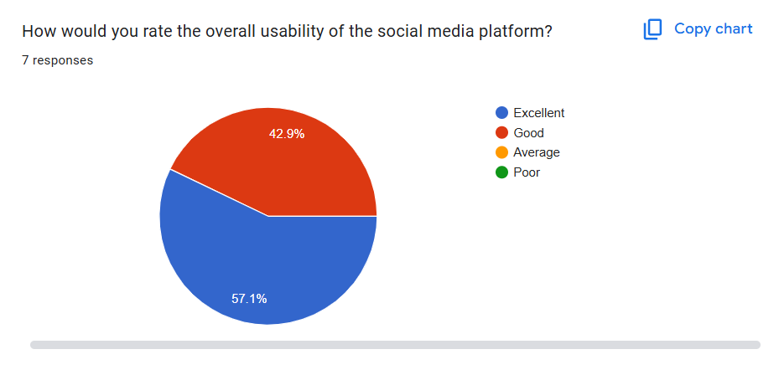

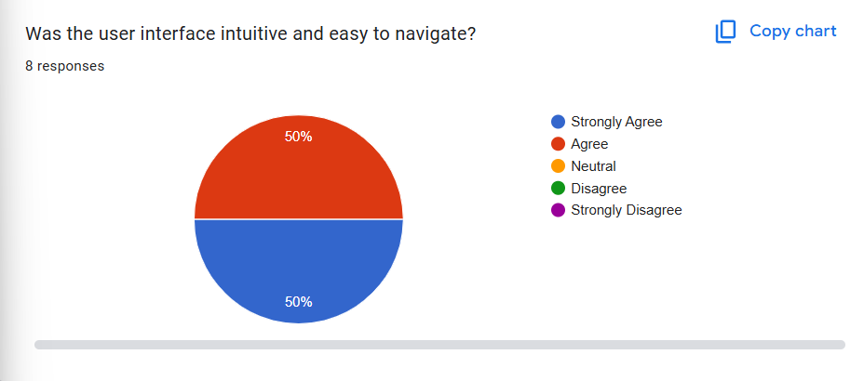

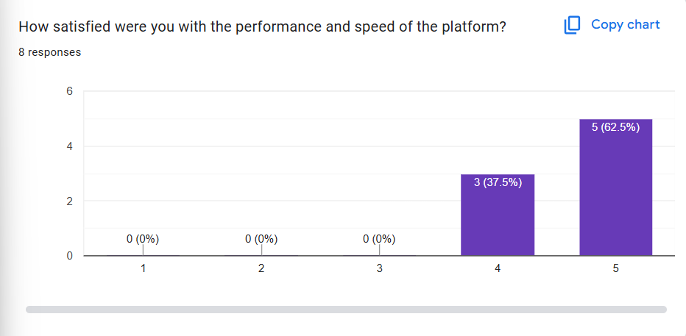

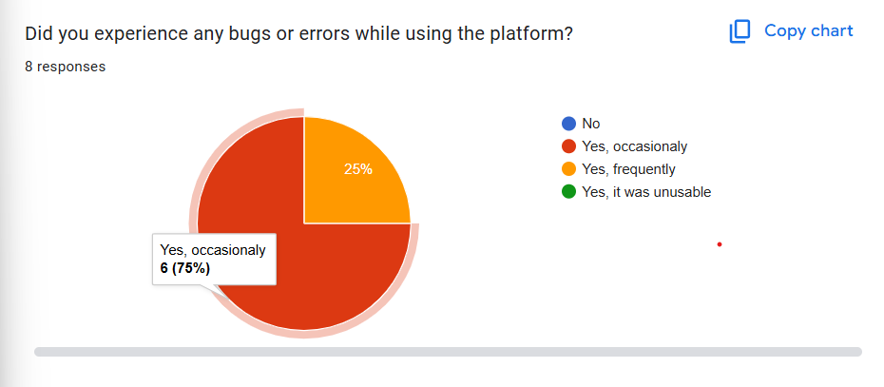

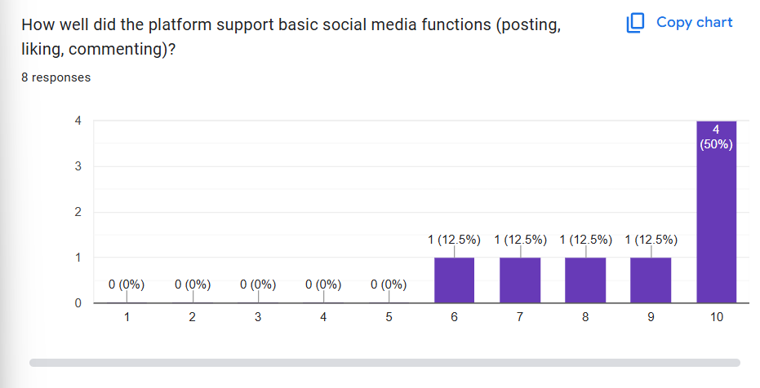

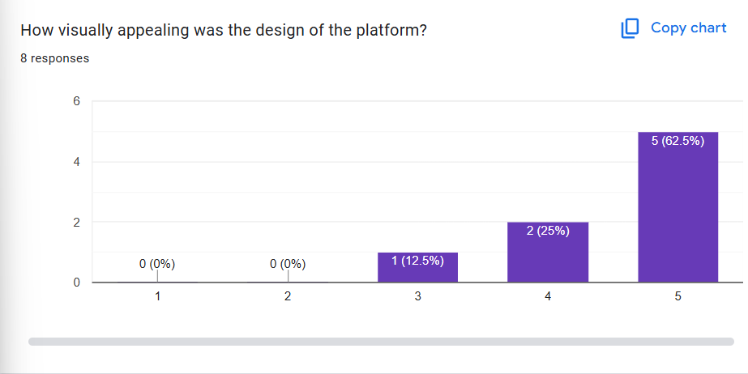

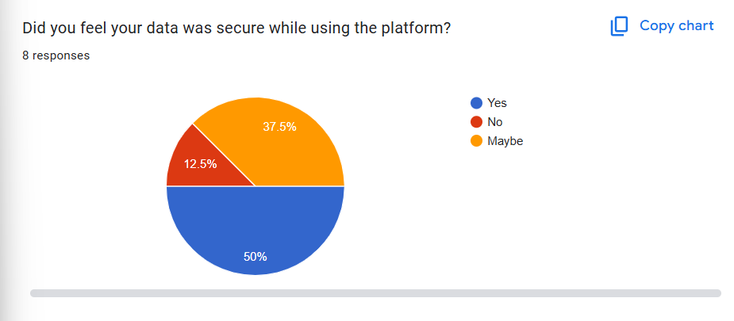
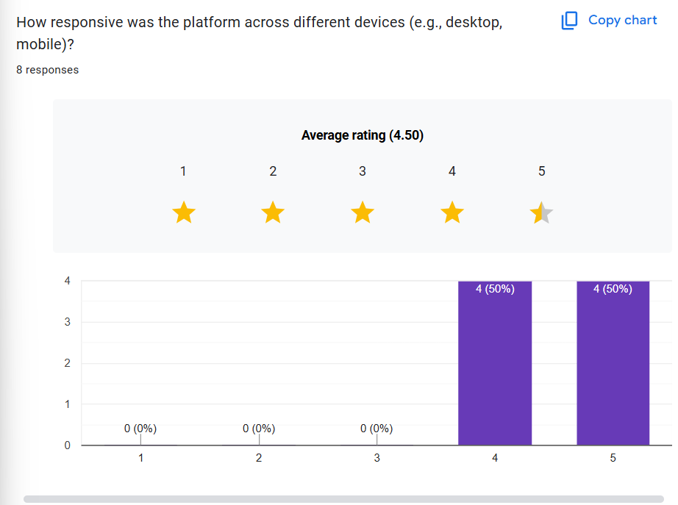

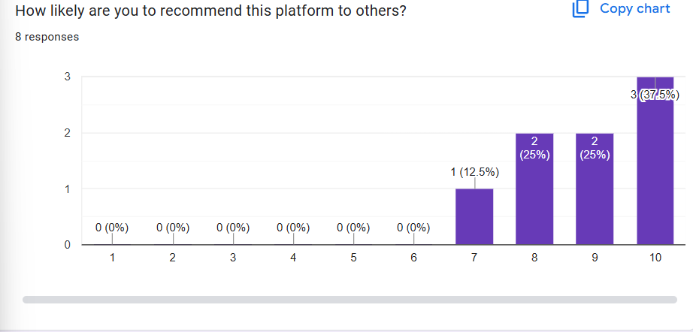

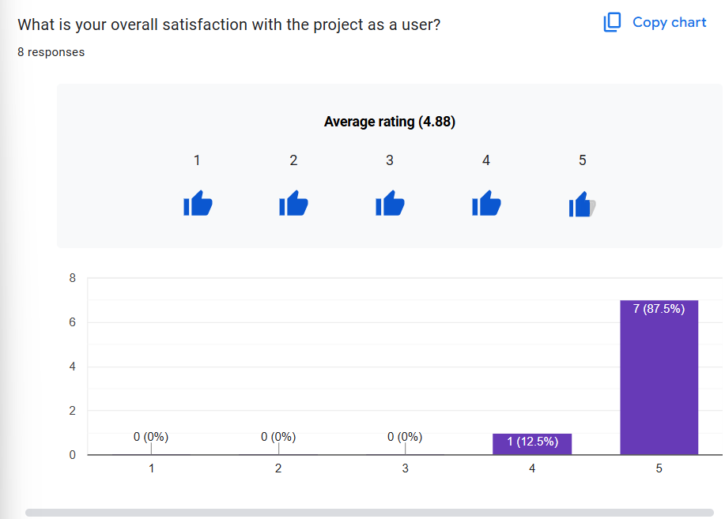

2.4 Expert Advice

Input was taken from full-stack developers, UI/UX designers, and cybersecurity experts to ensure the proposed system is technically feasible, secure, and user-centered.

2.5 Current/Future requirements

The current goal is to develop a core social media system with scalable microservices. Future versions will include AI-based content moderation, story-style updates, e-commerce integration, and video streaming features.

3. Overall Description

3.1 Product Functions

3.1.1. Hardware Requirement
- Client: Any smartphone, tablet, or PC with internet access.
- Server: Cloud-based Linux servers(e.g., AWS EC2) with minimum 8-core CPU, 32GB RAM, and scalable storage.

3.1.2. Software Requirement
- Frontend: HTML5, CSS3, JavaScript (React.js/flutter).
- Backend: Node.js , Express.js
- Database: MongoDB/PostgreSQL
- Deployment: Docker, Kubernetes, CI/CD (Github Actions), Nginx

. Functional Requirements

3.2.1 User Registration:
- Description: New users can create an account.
- Input: Name, email, password, DOB, gender.
- Output: Account successfully created.
- Error: Email already in use, weak password, missing required fields.

3.2.2 User Login:
- Description: Existing users can log in to their account.
- Input: Email/username and password.
- Output: Welcome back, redirected to home feed.
- Error: Invalid credentials, account not found, wrong password.

3.2.3 Create Post:
- Description: Users can share text, images, videos.
- Input: Post text, media (optional).
- Output: Post successfully created and displayed in feed.
- Error: Empty post, unsupported media format, failed upload.

3.2.4 Like/React to Post:
- Description: Users can like or react to others' posts.
- Input: Tap/click on reaction icon.
- Output: Reaction updated.
- Error: Network failure, post not found.

3.2.5 Comment on Post:
- Description: Users can comment on any public or followed post.
- Input: Comment text.
- Output: Comment added under the post.
- Error: Empty comment, network issue.

3.2.6 Follow/Unfollow Users:
- Description: Users can follow or unfollow other users.
- Input: Tap/click follow or unfollow button.
- Output: Updated follow status.
- Error: User not found, action failed.

3.2.7 View Feed:
- Description: Users see posts from followed accounts and suggestions.
- Input: None.
- Output: List of relevant posts displayed.
- Error: Feed not loading due to network/server issues.

3.2.8 Edit Profile:
- Description: Users can edit bio, profile photo, and basic details.
- Input: Updated profile info.
- Output: Profile updated successfully.
- Error: Invalid input, file upload failed.

3.2.9 Private Messaging:
- Description: Users can chat with other users in private.
- Input: Message text, optional media.
- Output: Message sent and shown in chat.
- Error: User not found, network error.

3.2.10 Notifications:
- Description: Users get alerts on likes, comments, messages, and follows.
- Input: None.
- Output: Real-time or queued notifications.
- Error: Notifications delayed or not shown.

3.2.11 Search Users/Posts:
- Description: Users can search for other users or public posts.
- Input: Search keyword.
- Output: List of matching results.
- Error: No results, connection error.

3.2.12 Logout:
- Description: User logs out from the session.
- Input: Click/tap logout.
- Output: Session ended, redirected to login.
- Error: Session not ended due to server error.

3.3. Non-Functional Requirements

3.3.1. Correctness Requirement
The platform must ensure accurate execution of all features as per the functional specifications and data integrity throughout.

3.3.2.Portability requirement

The software should run on all major browsers and be responsive across devices (desktop, mobile, tablet) and operating systems (Windows, iOS, Android, Linux).

3.3.3.Efficiency Requirement

The system must support up to 1 million concurrent users with minimal latency, using caching mechanisms and optimized database queries.

3.3.4.Usability Requirement

The UI should be intuitive and user-friendly. Accessibility features (screen reader support, high contrast mode) must be integrated to support all users.

3.3.5.Reusability Requirement

Code modules for login/authentication, media upload, and chat services must be modular and reusable in other projects.

3.3.6. Reliability Requirement

System uptime should be 99.9%. Failover systems and backup procedures must be in place to prevent data loss.

3.3.7. Maintainability Requirement

The codebase should follow clean architecture principles and be well-documented to ensure easy maintenance and onboarding of new developers.

3.4. User Characteristics

Users may range from tech-savvy teenagers to elderly individuals. The UI should cater to users with varying levels of technical knowledge. Admins and moderators will have special privileges and a separate dashboard with analytics and content control features.

3.4.1. Design & Implementation Constraints

The system must adhere to GDPR and data protection regulations. It should use open-source technologies to reduce costs and must be deployed in a cloud-based environment with support for horizontal scaling.

3.4.2. Assumptions & Dependencies

It is assumed that users have access to internet-connected devices. The platform depends on third-party APIs for messaging, email services, and analytics. Availability of cloud services is critical for scalability.

4. Interface Requirements

4.1. User Interfaces

The UI will include a news feed, profile pages, chat interface, settings, and notification panel. Admin dashboard will feature analytics and reporting tools.

4.2. Hardware Interfaces

Server hardware must support SSD storage, load balancers, and GPUs (optional for AI features). Client hardware interface is limited to browser/mobile app.

4.3. Software Interfaces

REST APIs will allow frontend-backend communication. Integration with OAuth 2.0 providers like Google/Facebook is required. WebSockets will be used for real-time messaging.

4.4. Communication Interfaces

Communication over HTTPS with TLS encryption is mandatory. Real-time data will be handled using WebSockets, while push notifications will use Firebase Cloud Messaging.

5. Conclusion

This Software Requirements Specification outlines a robust, scalable, and user-friendly social media platform. It sets the foundation for development and ensures that all stakeholders have a clear understanding of the project's goals, constraints, and deliverables.

