Quick Commerce Final project:
I have considered google cloud for the project implementation. Please find the below,
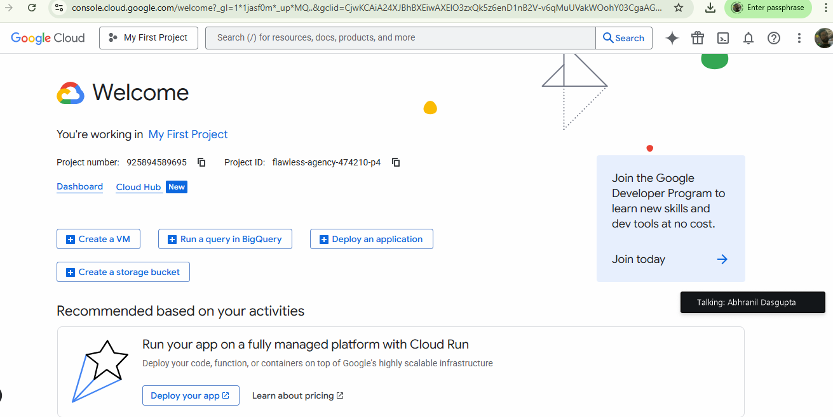
Data Collection :
● Batch Sources: Pull orders from MySQL (or RDS) and inventory documents from MongoDB/DynamoDB at regular intervals.

Order table is created in cloud sql DB. Created SQL instance in GCP
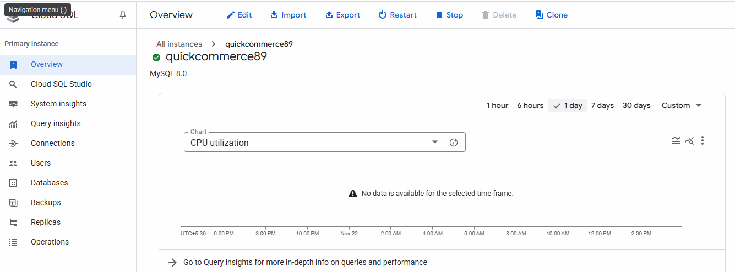
Configuration:
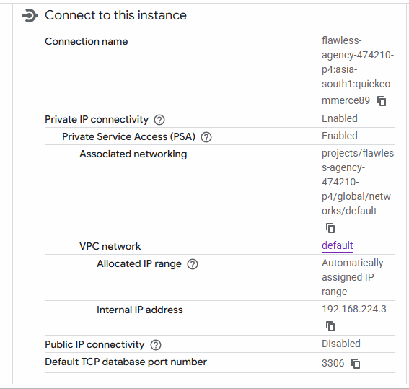
Order table in cloud SQL,
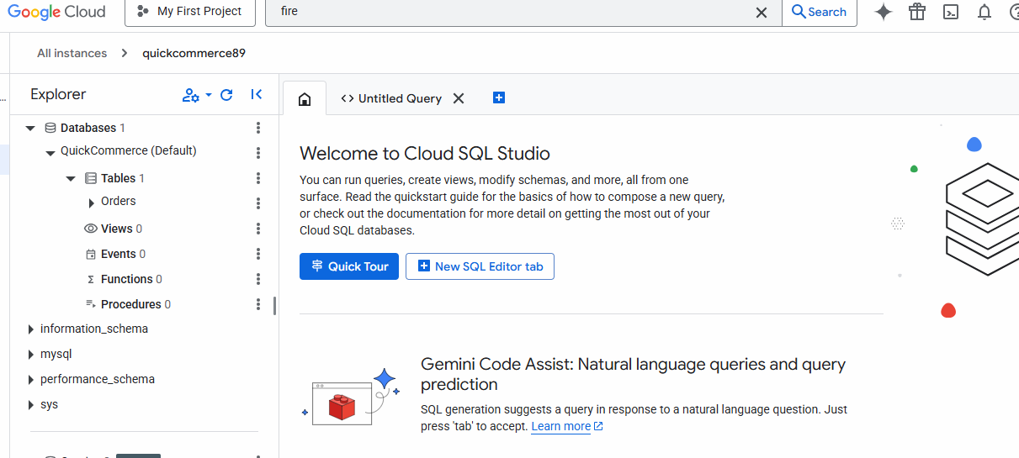

Order table with 1000 record,
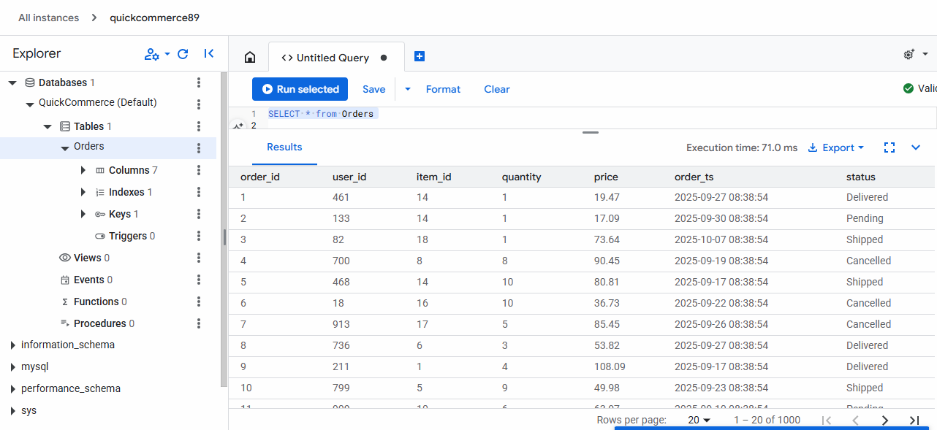

For MongoDB I have used firestore,
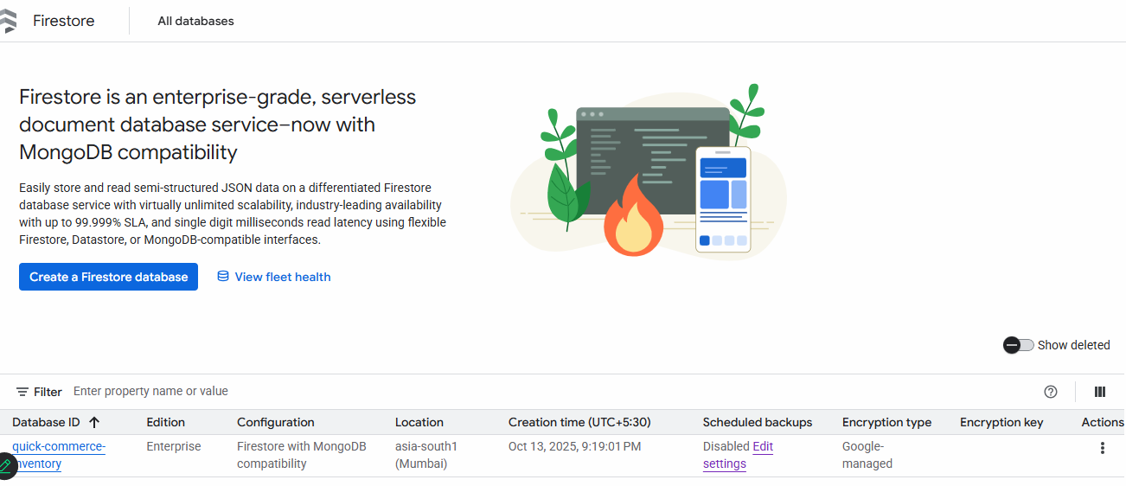

This is the 20 record. The data has taken from the https://mockaroo.com/ as mentioned in the project document,
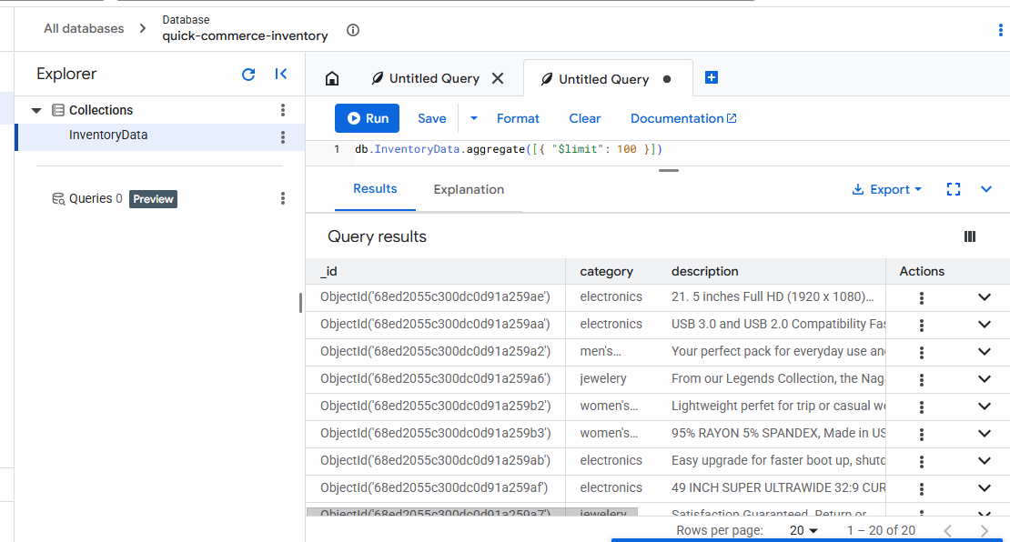

● Real-Time Streams: Simulate and ingest courier GPS and status events via Kafka topics (gps_stream, status_stream).
For streaming data I have used pub/sub module in GCP to generate real time GPS and status event data
Created below topics,
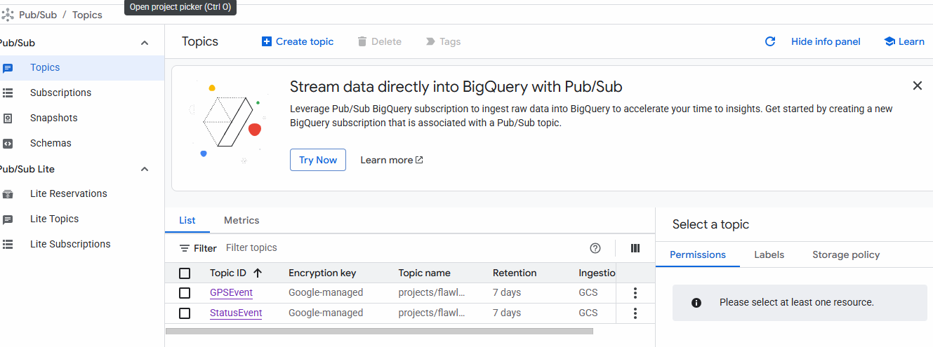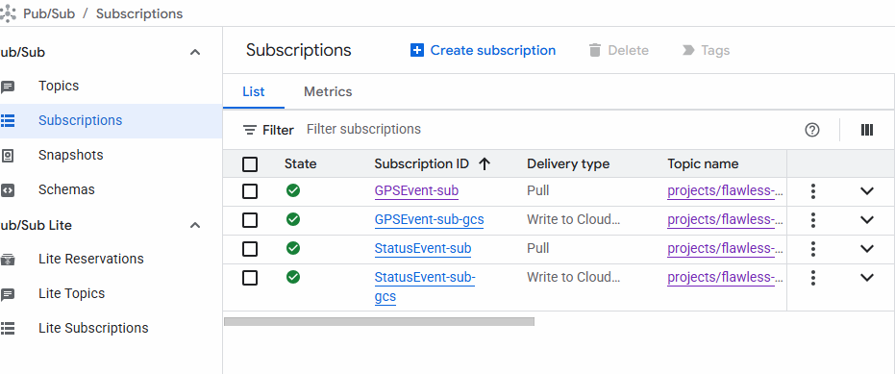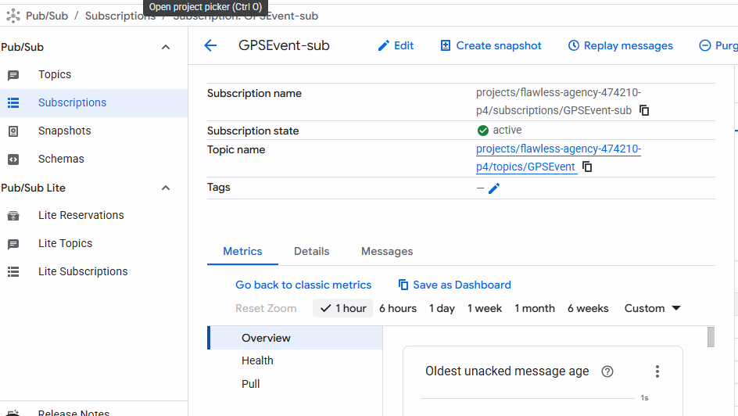
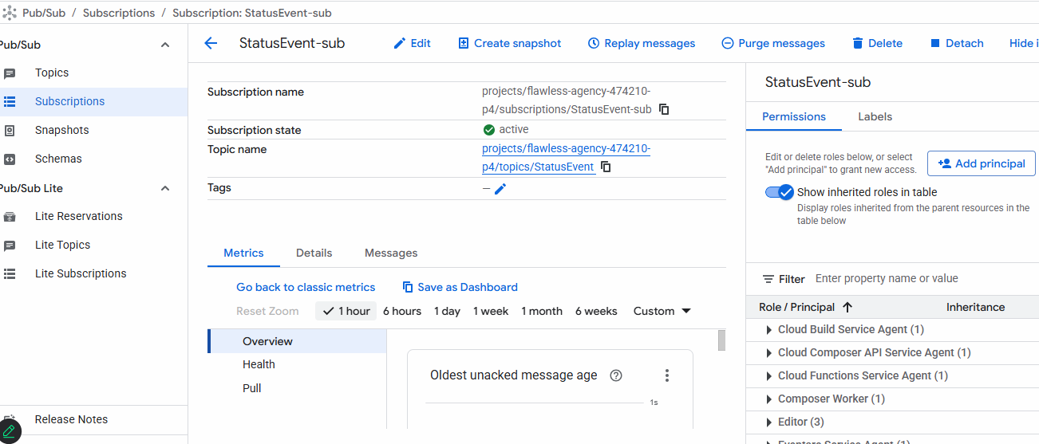

I am extracting below data set from the respective db to cloud storage which is nothing but a bucket so that we can transform the data set in dataproc using pyspark,
- order data(fom cloud SQL)
- inventory data(from firestore)
- Status Event(using pub/sub)
- GPS Event(using pub/sub)
Used corresponding scripts for the data extraction,
- order data(fom cloud SQL) >> newExtractOrderData.py
- inventory data(from firestore) >> extractFirestoreData.py
- Status Event(using pub/sub) >> Publishing data for 10sec - “gps_event_publisher.py” and subscribing and storing data in bucket – “gps_event_subscriber.py”
- GPS Event(using pub/sub) >> Publishing data for 10sec - “statusEvent_simulatorlimited.py” and subscribing and storing data in bucket – “statusEventDataExtractiontoGCSLimited.py”

Storing the above the in below buckets,
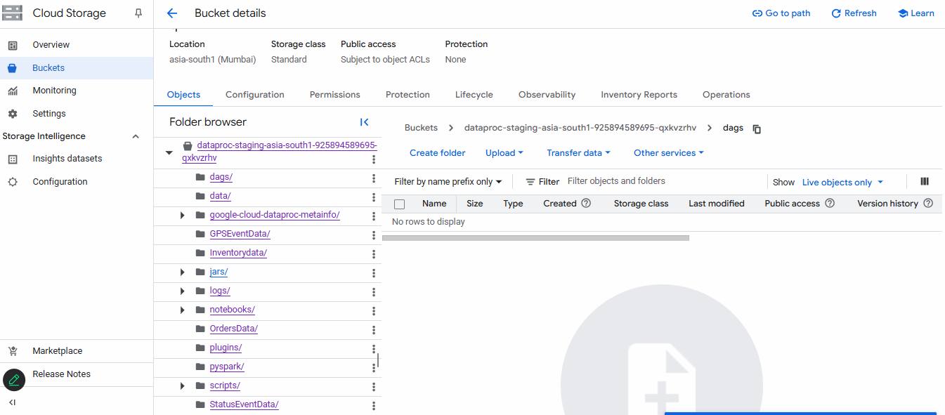
GPSData storing,

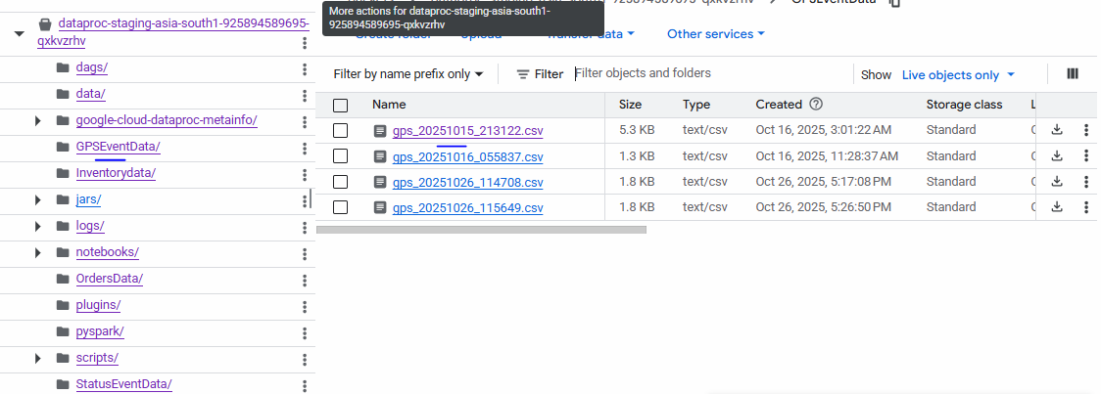
InventoryData Storing,

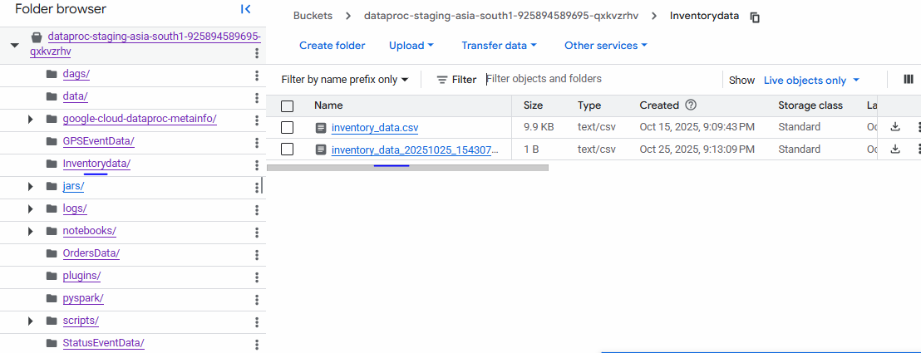
Order data storing,

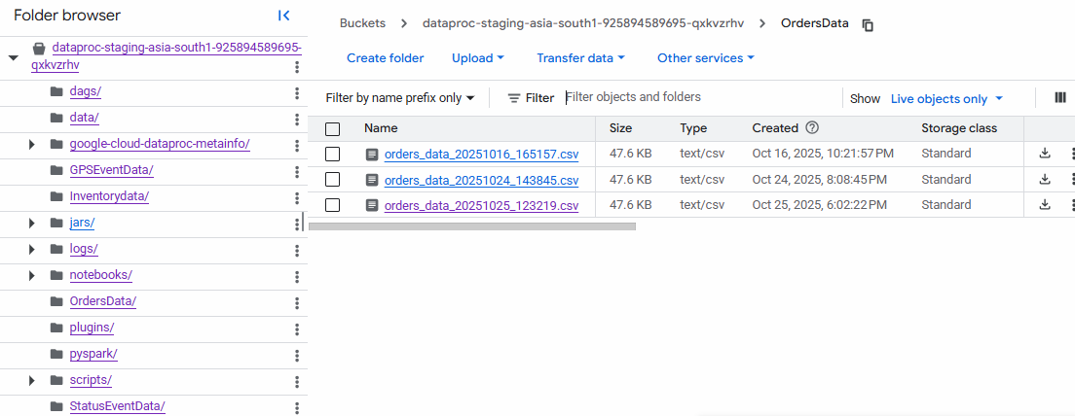

StatusEvent data storing,
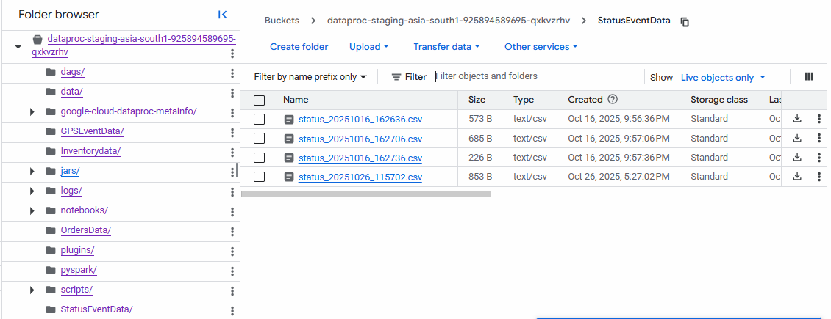

Data Transformation & Processing
Have used pyspark for transforming all the data as per the requirement and after transformation the transformed data is stored into bigquery.
The transformation is happening using dataproc cluster
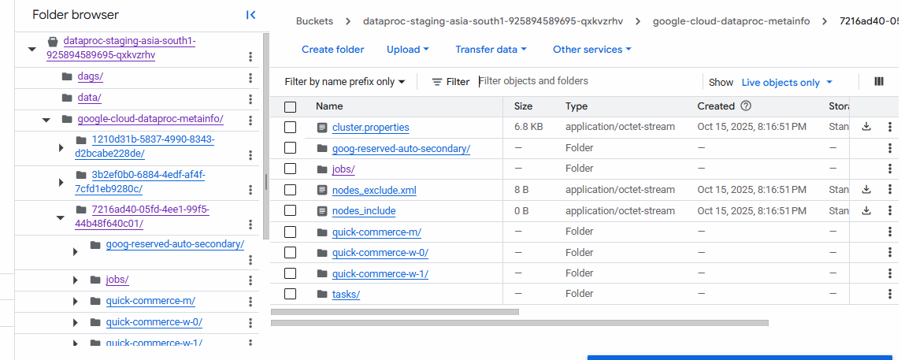
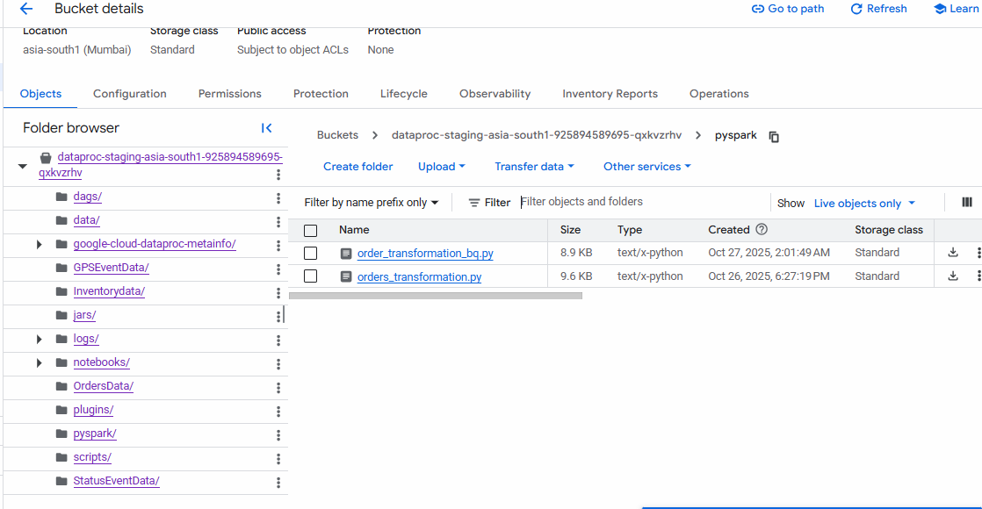
Script used for the same - all_data_transformation_load_to_bigQuery.py(named in GCP order_transformation_bq.py)
Used below spark as I have received compatibility issue
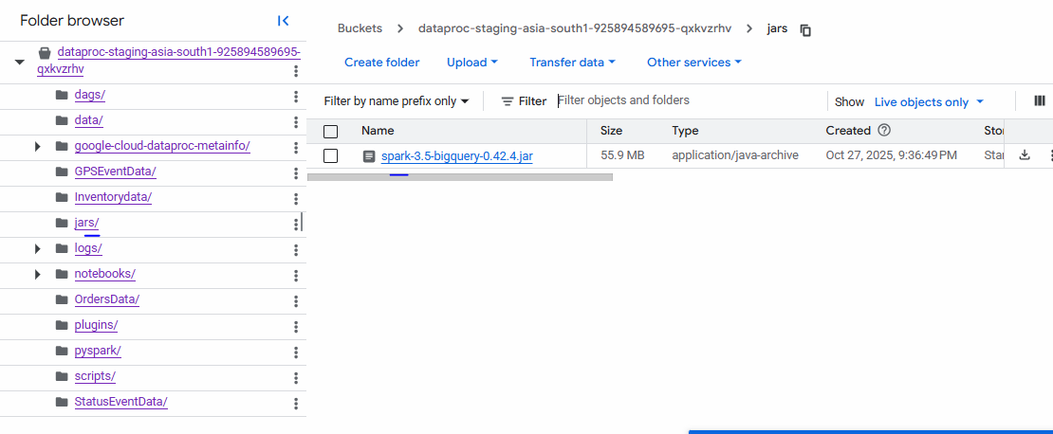
Storing transformed data in BigQuery
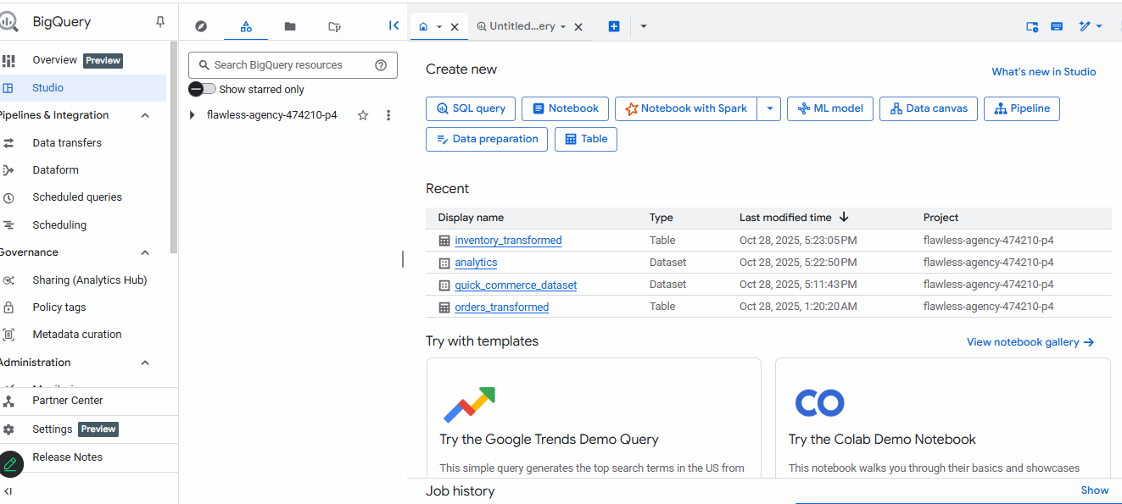
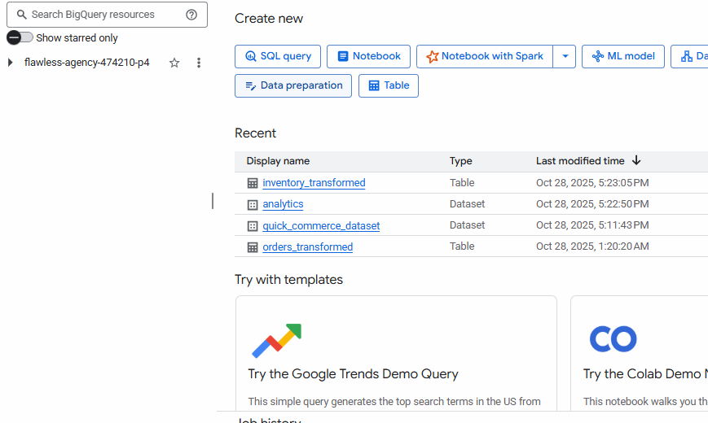

Querying data in bigQuery table to get the insight,
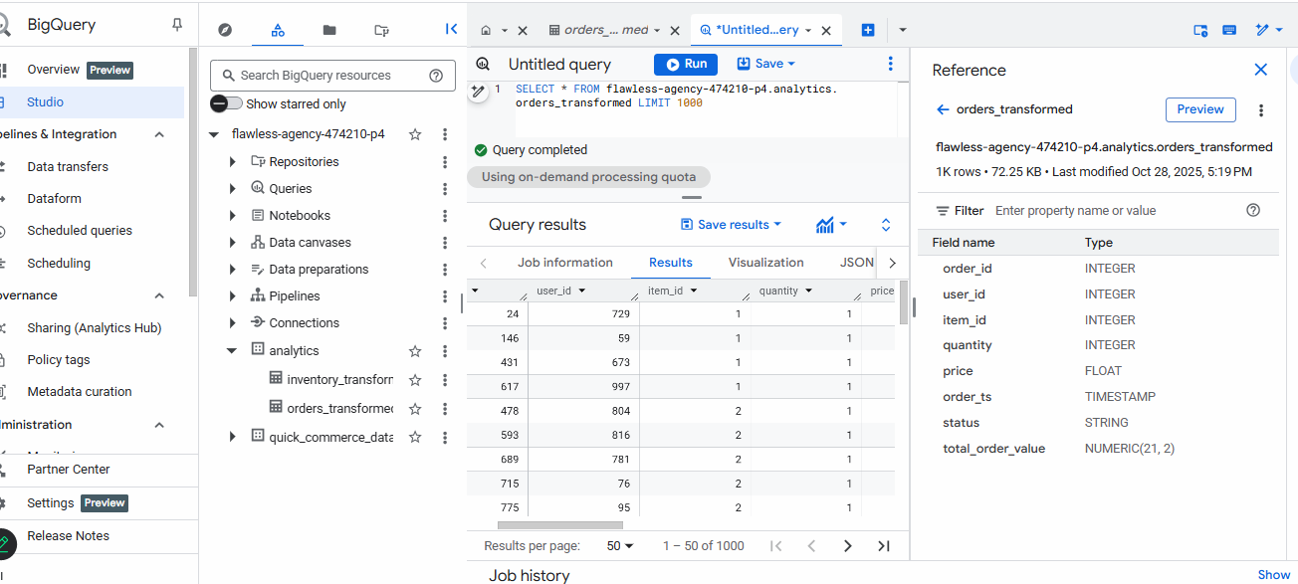

Orchestration & Automation :
Used airflow dag to automate the whole process and made in continuous,
For all the data extraction used below dag script,
airflow_orders_invetory_data_extraction_dag.py
For streaming data extraction used below dag script,
gps_event_status_dag_final.py
For data transformation used below dag script,
order_transformation_dataproc_dag.py

Right now no dags are running as I’m out of subscription, but this is the place where I used the dag scripts and automation the end to end pipeline
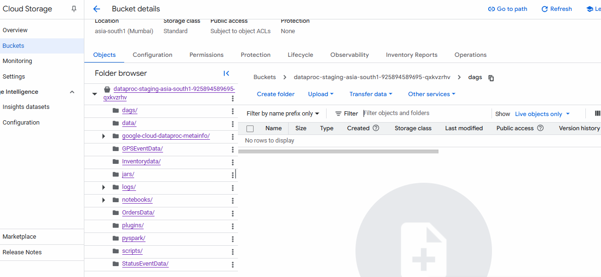

Storage for Analytics:
● Define fact and dimension tables for analytics Orchestration & Automation
● Write processed outputs as Parquet/CSV to HDFS/S3 or directly load into a data warehouse (Snowflake, Redshift, or Hive).

