**Create Storage Account(Resource)**

* Go to storage, select Storage Account
* Select suitable subscription, resource group(create new if needed)
* Give a relevant name to storage account

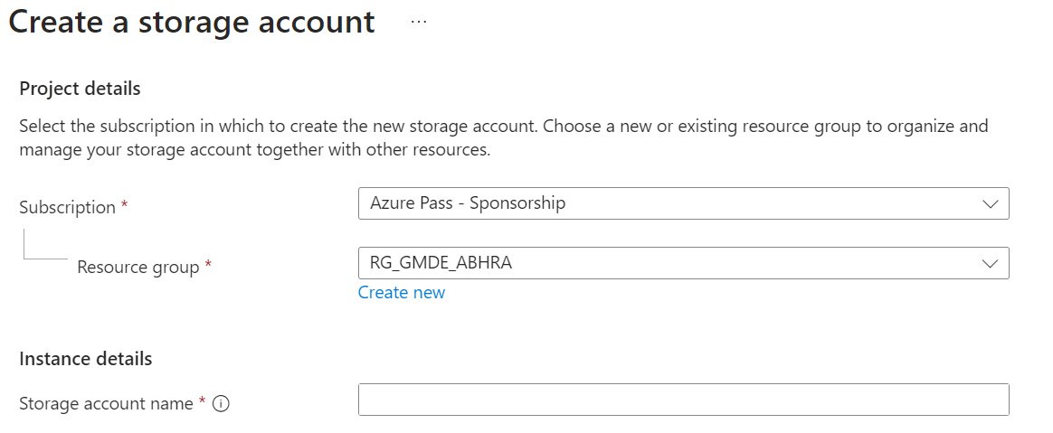

* Enable hierarchical namespace to create ADLS storage account(creates blob storage by default)



* Check other details and create

**Create Container**

* Select an existing storage account
* Create a new container by giving it a suitable name
* Here, we store data files(hierarchical manner in **ADLS** storage)

**Create Data Factory**

* Go to Data factory, create new
* Select suitable subscription, Resoure Group
* Give it a suitable name, select suitable region and version
* Check other details and create

**Prerequisites for creating a pipeline**

* **Launch an existing data factory**
* **Integration Runtime**
  + Go to **manage, select Integration Runtimes**
  + Create an IR if the type is **Self Hosted**
  + **AutoResolve** IR is already created when creating the data factory
* **Linked Service**
  + Select new, choose **Azure Data Lake Storage Gen2** for ADLS storage account
  + Give a suitable name, choose suitable IR connection
  + Select the necessary storage account name
* **Datasets**
  + Go to **author**, select datasets
  + Create new dataset, choose **Azure Data Lake Storage Gen2** for ADLS storage account
  + Select suitable file format
  + Give a suitable name, select required **linked service**
  + Mention the correct file path present in particular **storage container**
* **DataFlow**
  + Select **Data Flows**, create new giving suitable name
  + Add one or more **source node**, include one data set for each source node
  + Add new **operation node** to do a particular transformation
  + Send that transformed data to a destination dataset by creating a **sink node**

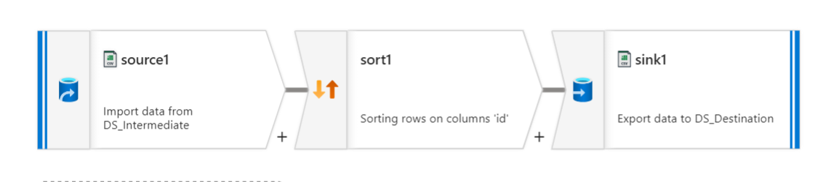

**Create a Pipeline**

* Create new pipeline, select required activities
* Link the activities with one of the four conditions:
  + On skip
  + On success
  + On failure
  + On completion

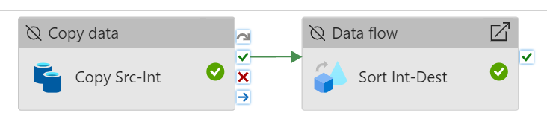

* Select each activity and configure as per requirements