**Creating a Server**

* Go to create SQL server
* Provide a server name, suitable location, credentials for respective authentication method

**Creating a Database**

* Go to SQL Databases, create new
* Select suitable Subscription, Resource Group and Server
* Customize **Compute+Storage** as per requirements
* Allow/Deny Azure services to access the server
* If sample database is needed, switch **Use existing data** to Sample

**Creating and Accessing Tables**

* Select an existing database
* Go to Query Editor to access the contents of database(tables, views, etc)
* Use the Query box to create and manipulate data

**DBMS in Azure Data Factory**

* **Creating DB Linked Service**
  + Create new Linked Service with Azure SQL Database
  + Give particular Server and database names and provide authentication credentials
* **Creating DB Dataset**
  + Create new dataset with Azure SQL Database
  + Select DB supporting Linked Service, and a table
* **Creating Pipeline**
  + Create new pipeline, include few activities (say Copy Data)
  + Select required source and sink datasets
  + To copy entire data, select **Use Query as Table**
  + To copy certain data, select **Use Query as Query** and give it a suitable query

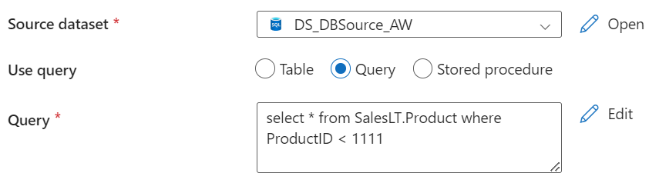

* + If the sink is a **DB**, make sure to create an empty table having structure same as the source table(s)
  + If the sink is a **delimiter(csv)** file, select particular Copy Behavior

**API in Azure Data Factory**

* **Creating API Linked Service**
  + Create new Linked Service with HTTP source
  + Give particular URL and provide authentication credentials
* **Creating API Dataset**
  + Create new dataset HTTP source
  + Give Relative URL
* **Creating Pipeline\***
  + Create new pipeline, include few activities (say Copy Data)
  + Select required API source and sink datasets