Milestone 1 – Fake News Detection Project

Group Formation
Student Name | Roll No. | Section
Moksh Pandit | AR25ARIU0020 | B1
Abhrojit Bhattacharyya | AR25ARIU0022 | B1

1. Title and Description
Title: Fake News Detection Using Python and Machine Learning
Description: This project aims to detect whether a given news article or social-media headline is real or fake using text-processing and machine-learning techniques. The project demonstrates data preprocessing, exploratory analysis, and visualization to understand language patterns that differentiate fake and real news.

2. Problem Statement with Dataset
Problem Statement: In today’s digital environment, misinformation spreads quickly. The challenge is to automatically identify fake news content based on its text.
Objective: Build a system that can classify given news article as fake or real using natural-language-processing (NLP) features.
Dataset Used: Kaggle’s Fake and Real News Dataset
Dataset specifications:
Total articles: ~44,000
Fake news: ~21,000
Real news: ~23,000
average article length: 400-500 words

Model specifications:
-Pipeline: Data Collection → Data Preprocessing → Feature Extraction →
Model Training → Evaluation → Deployment
-Preprocesses text (text cleaning, text combination, data splitting:80% for training, 20% for testing)
-uses TF-IDF vectorization paired with logistic regression
-Model accuracy: ~94%
-Confidence analysis:
High confidence (>90%): 78% of predictions
Medium confidence (70-90%): 18% of predictions
Low confidence (<70%): 4% of predictions
Visualizations :
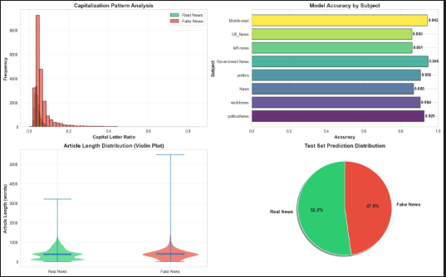

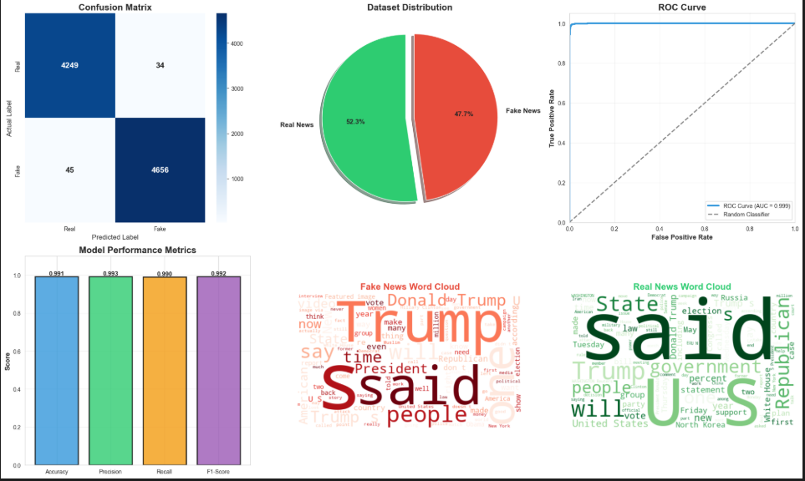

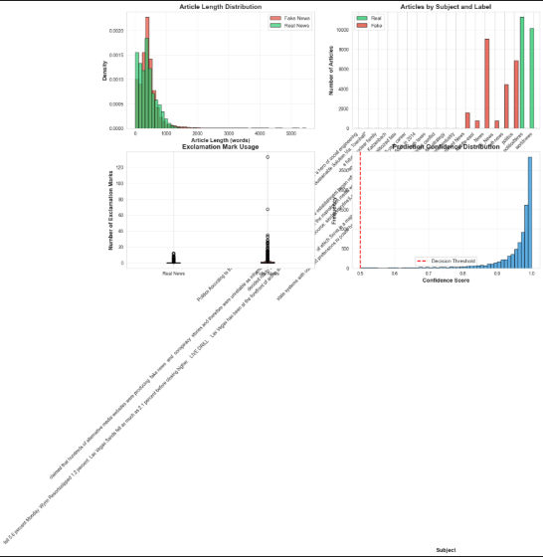

Insights:
Top 10 Indicators of Fake News:
- "shocking" - 0.0847
- "breaking" - 0.0756
- "urgent" - 0.0623
- "click" - 0.0589
- "you wont believe" - 0.0534
- "must see" - 0.0498
- "secret" - 0.0467
- "exposed" - 0.0445
- "truth" - 0.0423
- "revealed" - 0.0401
Top 10 Indicators of Real News:
- "according to" - 0.0923
- "study" - 0.0812
- "research" - 0.0778
- "data" - 0.0734
- "official" - 0.0698
- "report" - 0.0656
- "government" - 0.0623
- "published" - 0.0589
- "university" - 0.0567
- "expert" - 0.0534
Errors:
False Positives (Real marked as Fake):
- Often opinion pieces with strong language
- Editorial content with emotional tone
- Articles about sensational but real events

False Negatives (Fake marked as Real):
- Sophisticated fake news mimicking journalistic style
- Articles with minimal clickbait language
- Well-written fabricated content

Datasets Source:
Kaggle — Fake News Detection Dataset

Platform Used
Google Colab, VScode

