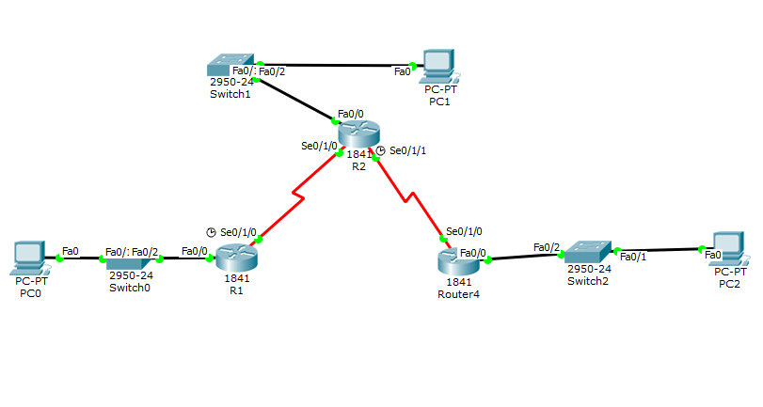

1. Take 3 routers
2. Take 3 switches
3. Take 3 PC's
4. connect everything pc, switch, router.
5. go to the router check for serial interface in the config.
6. if not available go to the physical turnoff the router and select the "HWIC-2T" on the left coulmn and draga nad drop it on the empty port available.
7. now turn on the router.
8. now select "Serial DCE" cable to connect the router R1,R2,R3.
9. no > ENTER >> type "enable" >> type "conf t" >> type "int Se0/1/0"
10. 10." ip address 172.16.1.1 255.255.255.252" >> "no shutdown" >> type "exit"
11. 11.type "interface Fa0/0" >> "ip address 192.168.10.1 255.255.255.0" >> "no shutdown" >> "exit" >> "write memory" >> error will come continue >> "exit" >> "write memory".

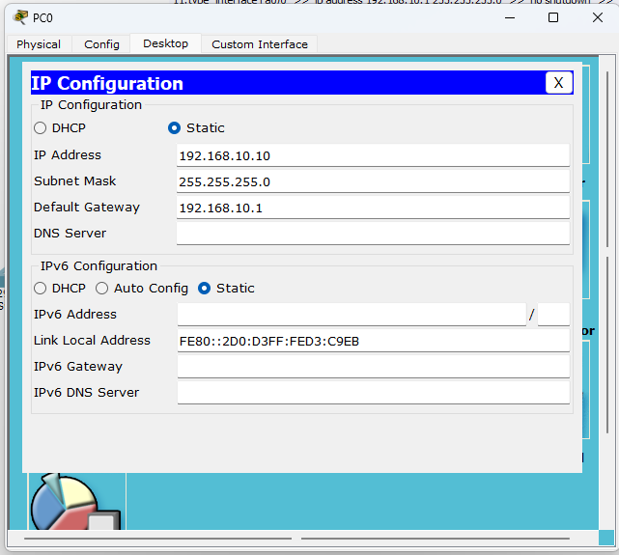

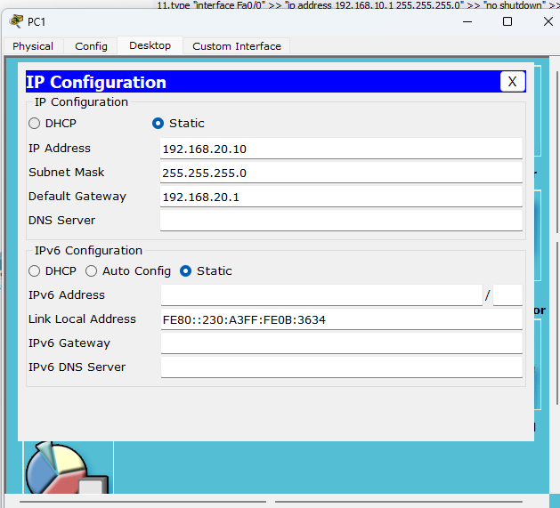

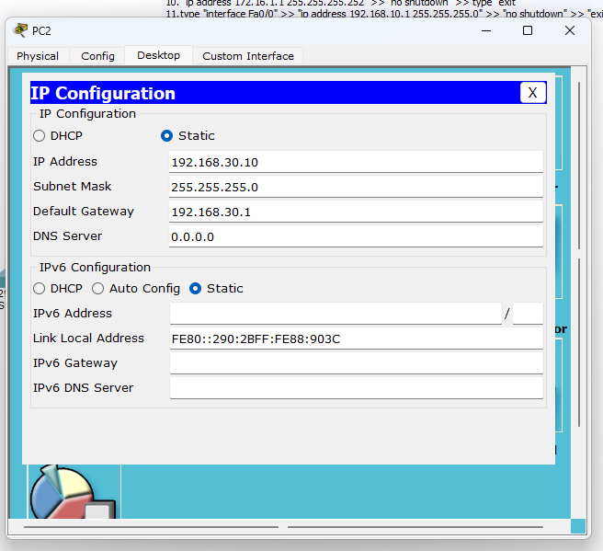

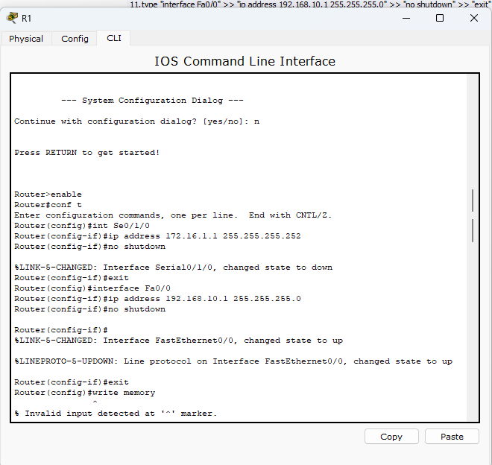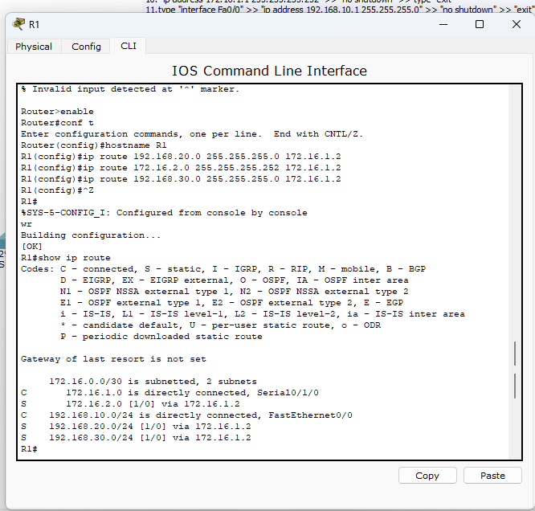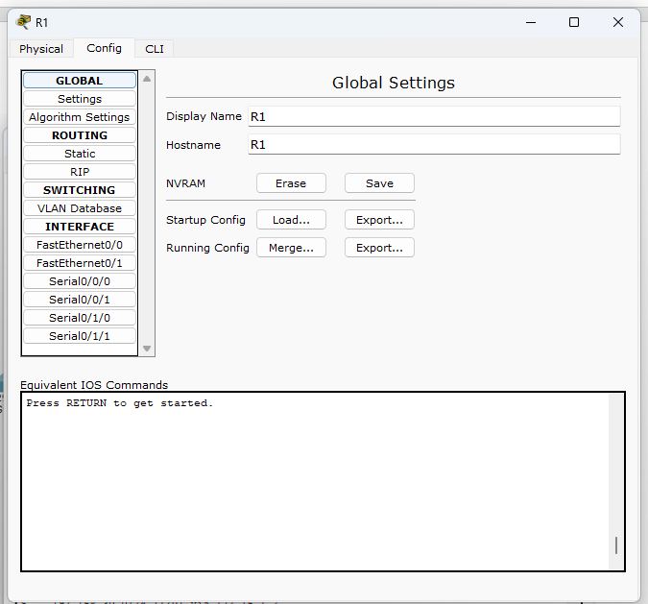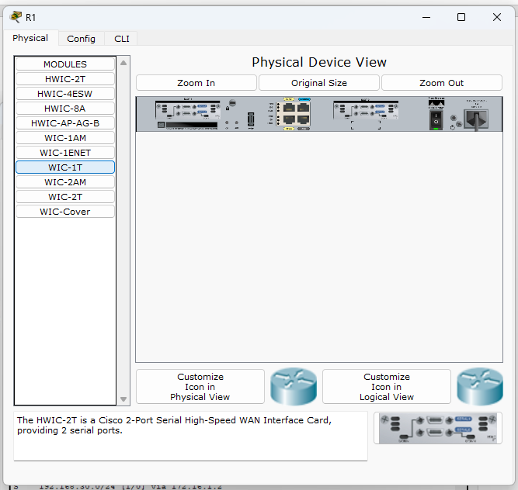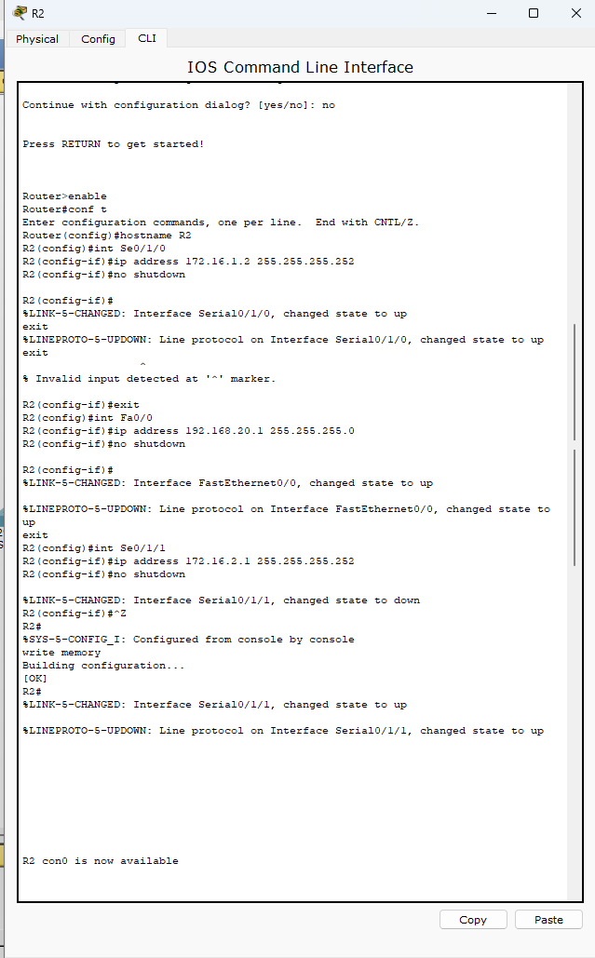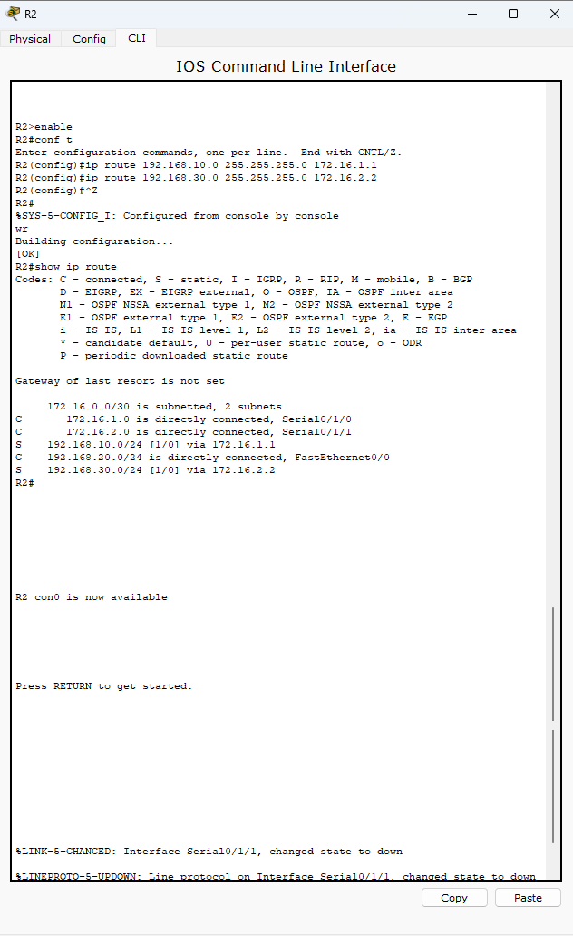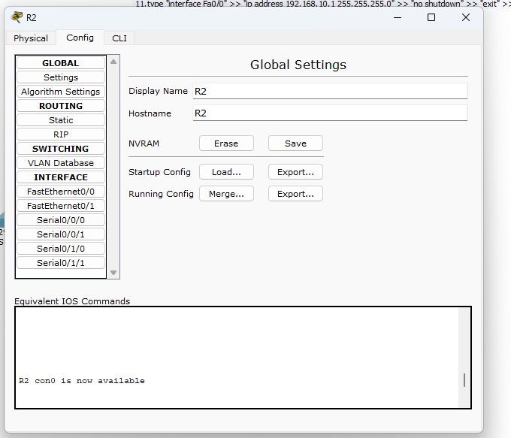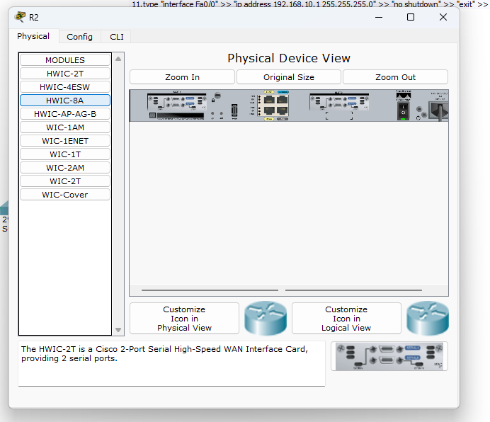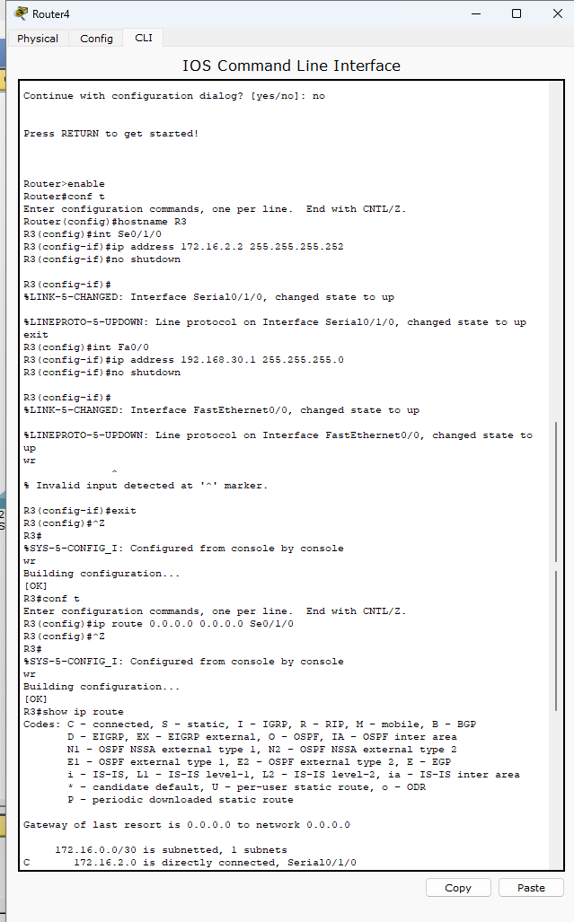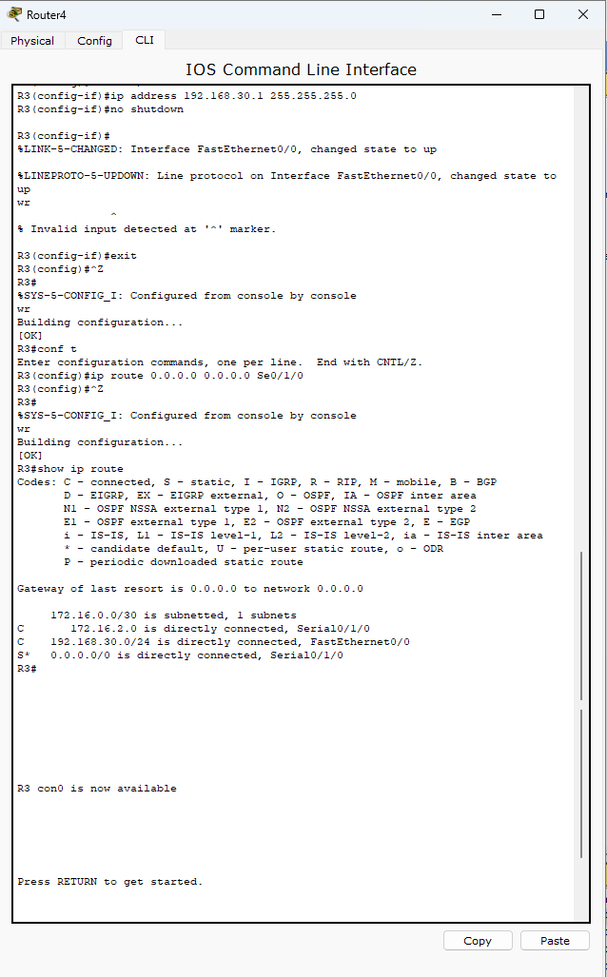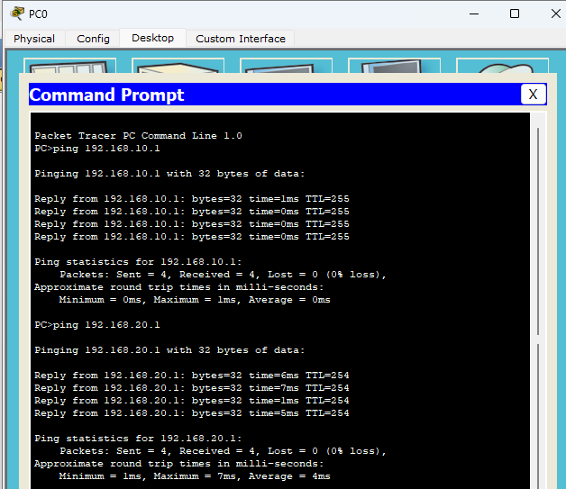

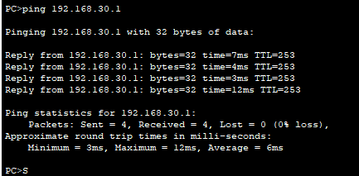

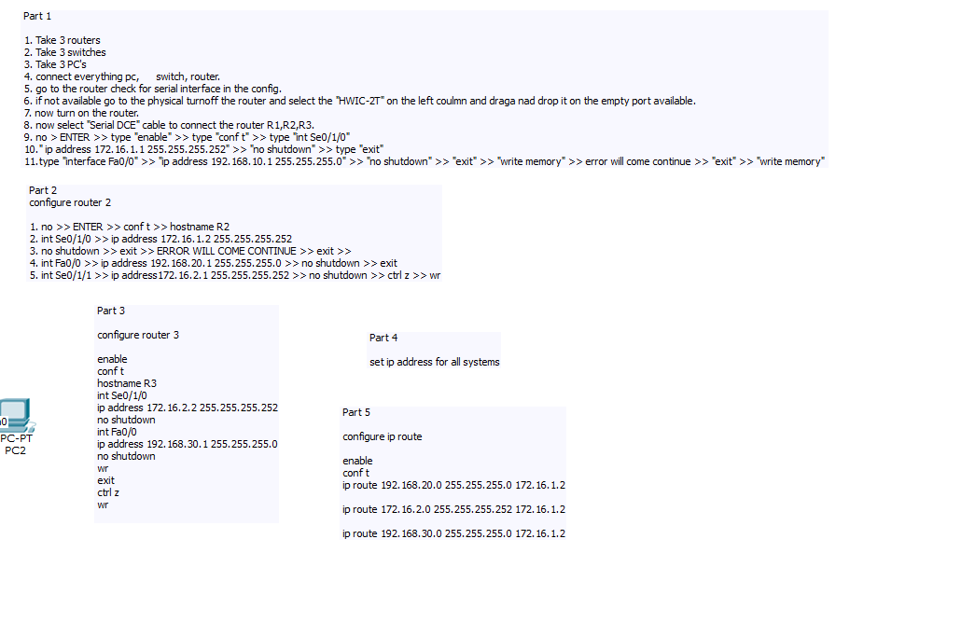

Part 2

configure router 2

1. no >> ENTER >> conf t >> hostname R2

2. int Se0/1/0 >> ip address 172.16.1.2 255.255.255.252

3. no shutdown >> exit >> ERROR WILL COME CONTINUE >> exit >>

4. int Fa0/0 >> ip address 192.168.20.1 255.255.255.0 >> no shutdown >> exit

5. int Se0/1/1 >> ip address172.16.2.1 255.255.255.252 >> no shutdown >> ctrl z >> wr

Part 3

configure router 3

enable

conf t

hostname R3

int Se0/1/0

ip address 172.16.2.2 255.255.255.252

no shutdown

int Fa0/0

ip address 192.168.30.1 255.255.255.0

no shutdown

wr

exit

ctrl z

wr

Part 4

set ip address for all systems

Part 5

configure ip route

enable

conf t

ip route 192.168.20.0 255.255.255.0 172.16.1.2

ip route 172.16.2.0 255.255.255.252 172.16.1.2

ip route 192.168.30.0 255.255.255.0 172.16.1.2