1. Create a topology as below

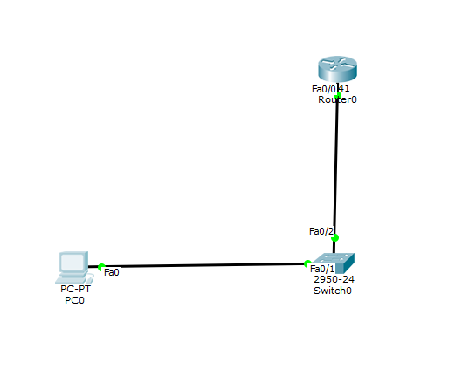

1. Go to pc and configure ip address for pc

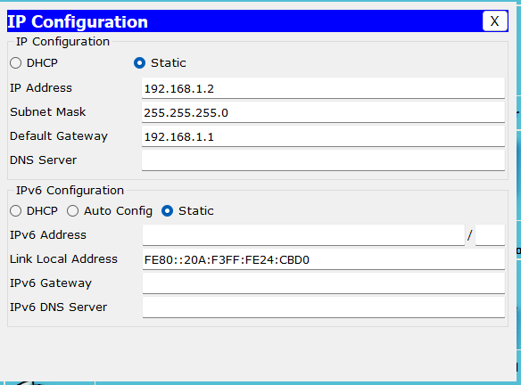

1. Go to router and configure router with telnet commands

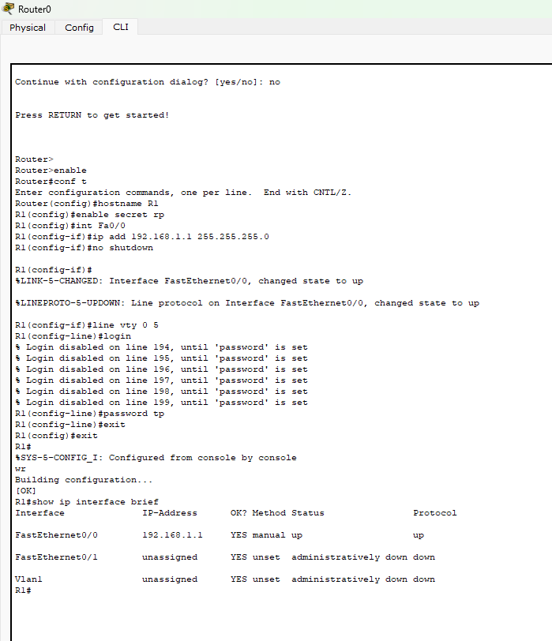

1. Now go the pc command line and access the router cli in the pc command line   
   1st Password is tp

2nd password is rp

