Week-06

1.Construct the network using routers ,switches and pc’s using approriate cable.

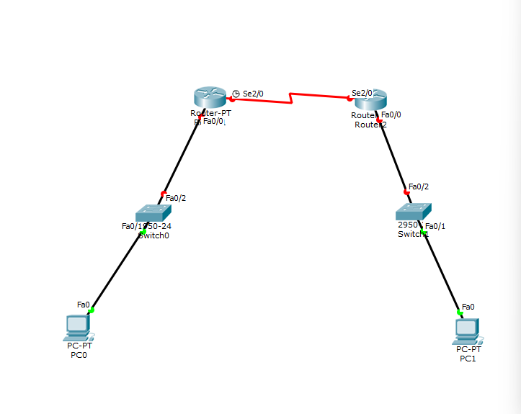

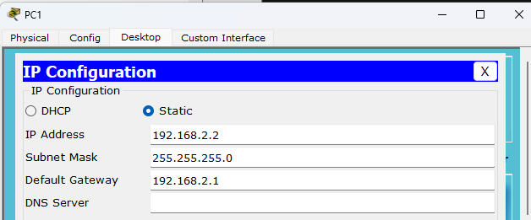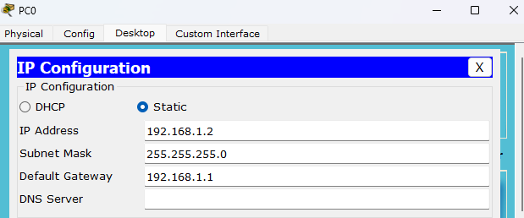2. Assign IP address for the PC’s

3. Configure the Routers by clicking on interface and assign the IP address in FA0/0 and turn on the port.

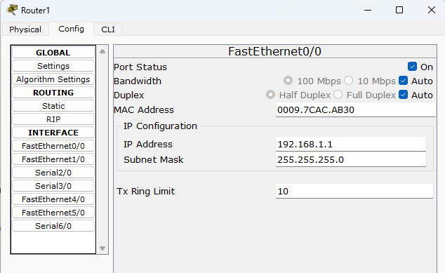

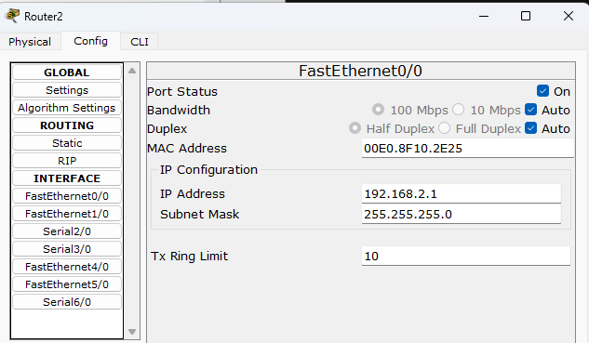

4. Configure the router by clicking on interface->serial2/0 and assign the IP address and set the clock rate turn on.

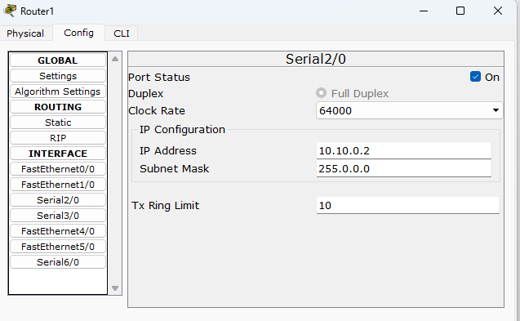

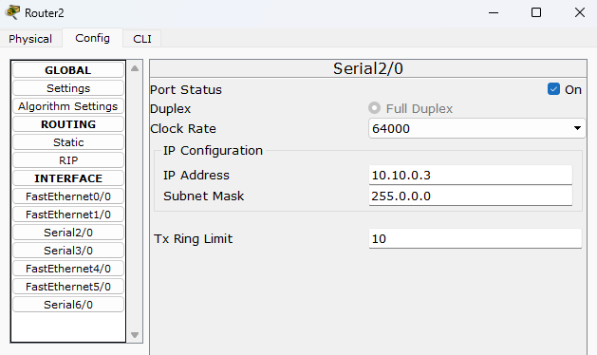

5. Configure the RIP Routing, config->routing->RIP and add the network address and click on add.

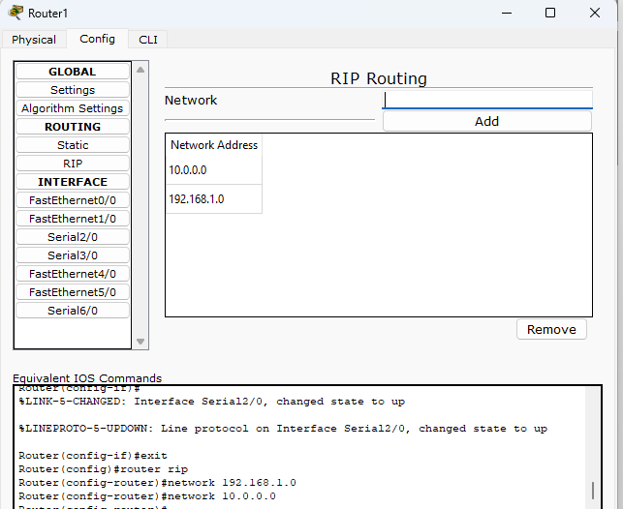

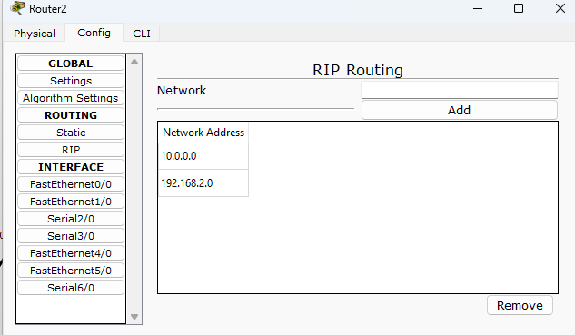

6. Click on the settings and click save.

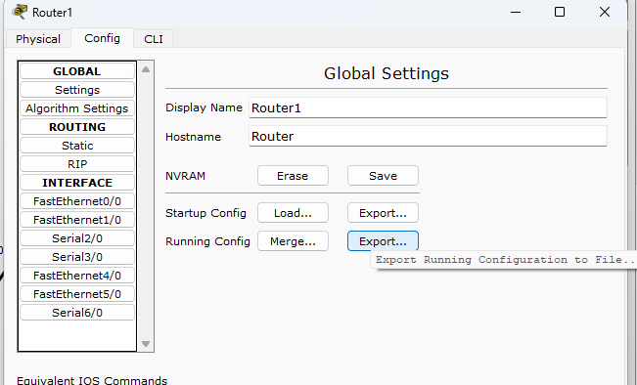

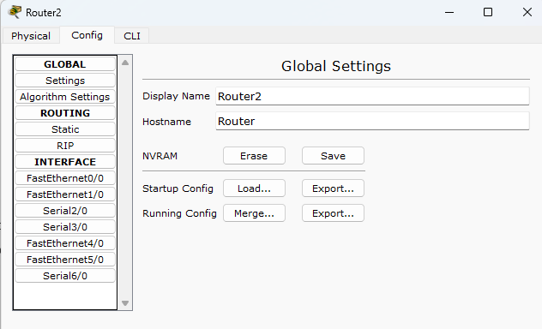

7. Transfer the packet from router to pc-1 and vice – versa the data packet will be shared.

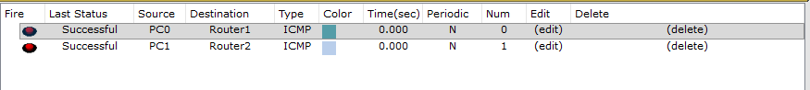

8. Transfer the packet from PC-0 to PC-1 now the data will be transferred quickly.

