**Budget Calculator Web App**

GitHub deployment link: <https://abhyakp.github.io/Budget_Calc/>

While opening the web app we could see the input field for the Income, expenses and place displaying the balance

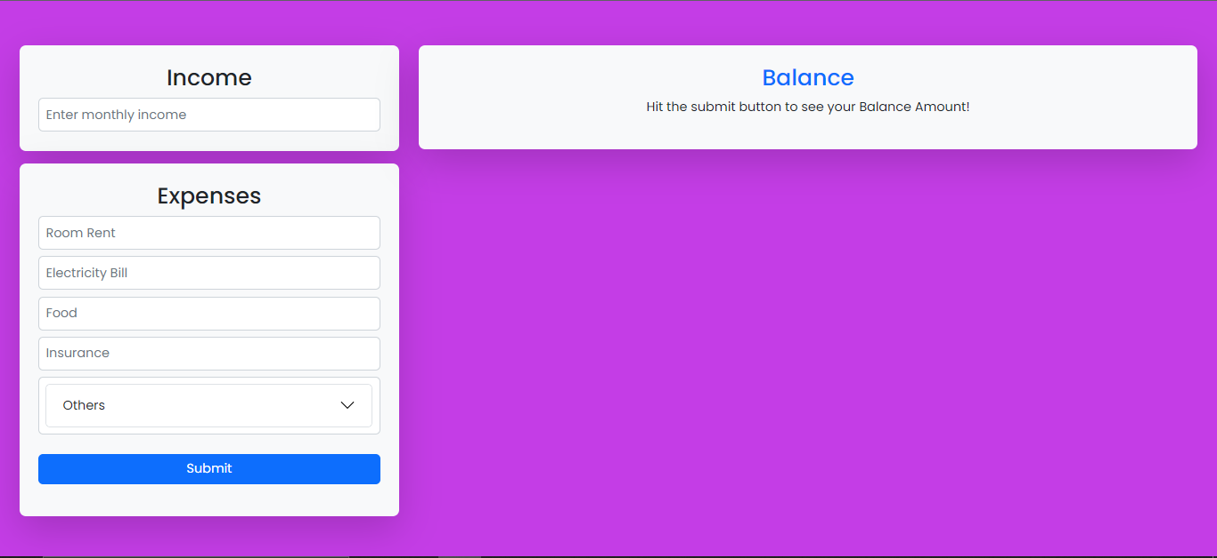

After entering the monthly income, need to fill the expenses. In expenses area, we made some predefined expenses such as, rent, Electricity, food etc. The user also has the option to enter other expenses by clicking the collapsible field “Others”

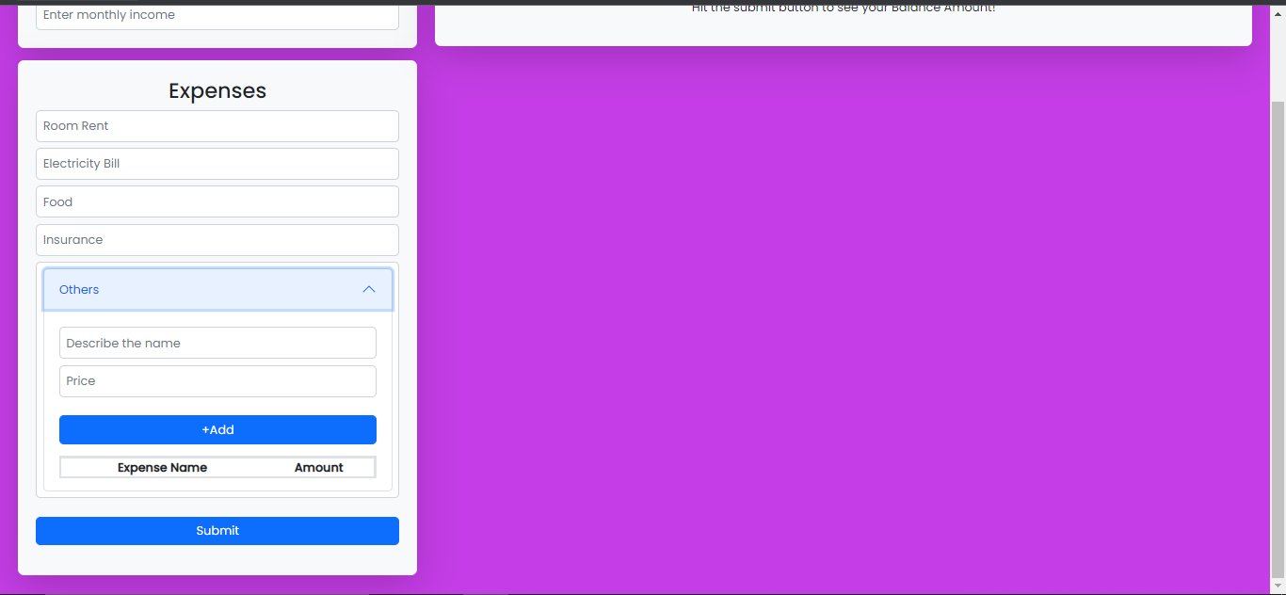

After entering the other expense, click “+Add” and it will show in below table

After entering all the expenses click the submit button to get the balance and expense overview.

Also if we click the button for breakdown, a modal will pop up showing the table of all expenses including the other expenses

Please have look on the below example for step by step illustration

1. Enter the Income

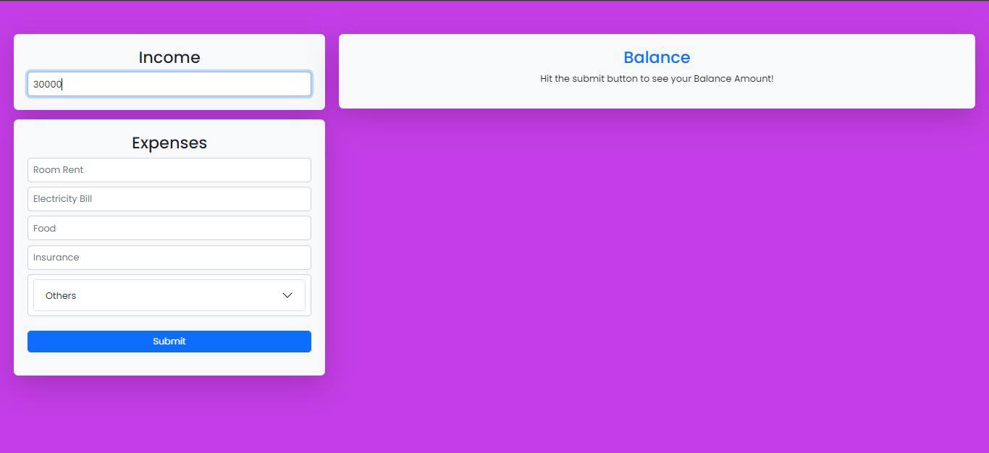

2. Enter the Expenses

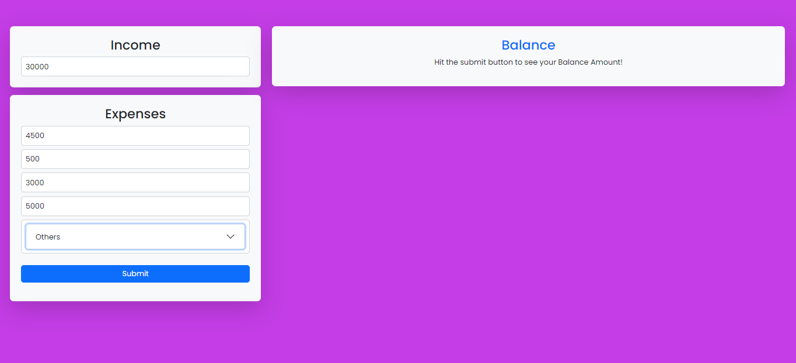

3. Enter other expenses, if any

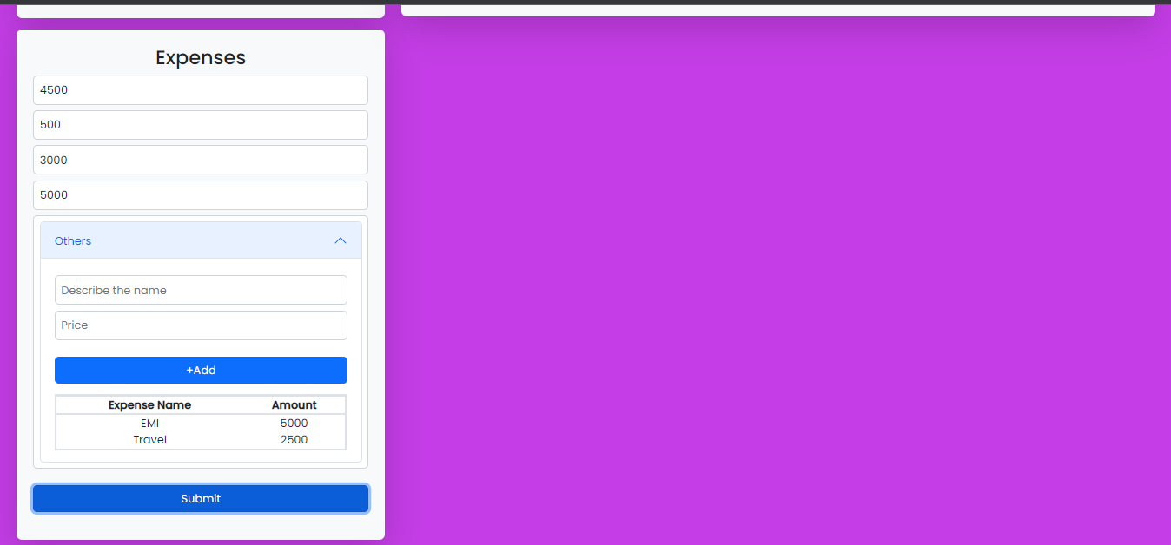

4. Click Submit for getting the balance

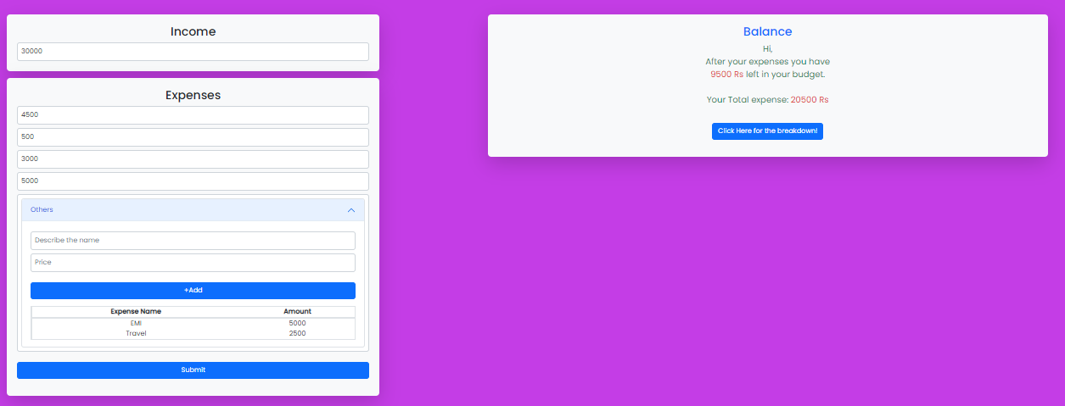

5. Click the button for getting the breakdown

