**Country Details App using REST API**

GitHub deployment link: <https://abhyakp.github.io/Country_app/>

In index page we can see an input field for entering the country name which we want to check the details.

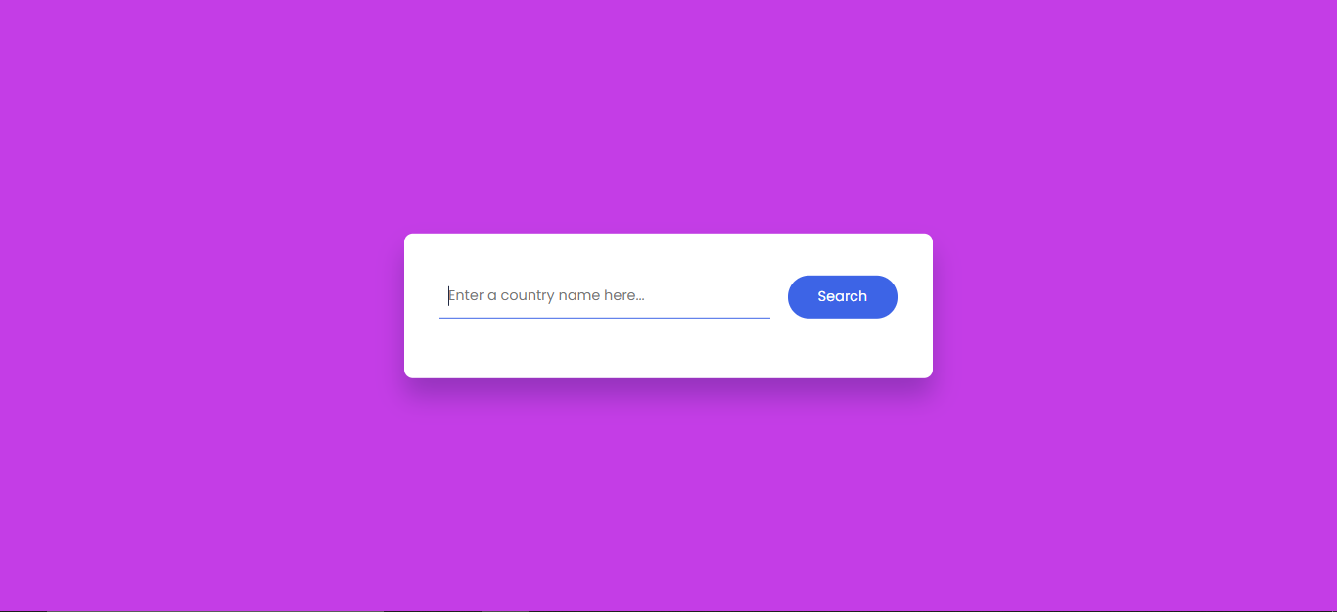

After entering Click on search Button. And the result is:

