**TITLE: AUTOMATED ROOM LIGHTING SYSYEM**

**GROUP NO: 18**

**TEAM MEMBERS:**

***1. Abhyanth.P***

***2. Rakshit R.K***

***3. Bharath N***

***4. Arun Kulkarni***

**INTRODUCTION:**

Now with increasing technology day by day all the work done by human is being automated to reduce errors, decrease the cost, high efficiency.

We prefer automation because the result quality increases labour decreases so that less money can be spent of labour and more on quality of the result .

Now what is home automation: Home automation or domotics is building automation for a home, called a smart home or smart house. A home automation system will control lighting, climate, entertainment systems, and appliances. It may also include home **security** such as access control and alarm systems,

Our project is an application of home automation which deals with automatic turning on the light when a person enters the room and turn off when the person leaves the room.

***Why this project:*** As per normal human behaviour 70-80% of us keep the light on after we leave the room and hence wasting electricity on a small scale its ok that one light wont consume much power so that wont effect anyone but when we see it on a larger scale as a whole city or state there is huge wastage of electricity overall so in order to avoid this we are doing this project

***Working*:** Consider we are using this project in a bedroom we keep 2 IR sensor

One outside the room just close to the door from the outside (Ir-1)

Second IR sensor inside the room close to door but from the inside

(Ir-2)

Now we program the Arduino such that at

First we initialize the IR sensor output to be 0

First stage we only concentrate on IR-1 sensor If it detects any movement we check IR-2 sensor if there also movement is detected then we turn on the lights as the person will go inside the room if only the IR-1 sensor detects the movement and not IR-2 then we don’t turn on the lights

Similarly during the second stage now the lights are on and the person is inside the room now we concentrate only on Ir-2 sensor If it detects any movement we check Ir-1 sensor if there also movement is detected then we turn off the lights as the person will go outside the room if only the

Ir-2 sensor detects the movement and not Ir-1 then we don’t turn off the lights

**What is an IR Sensor?**

IR sensor is an electronic device, that emits the light in order to sense some object of the surroundings. An [**IR sensor**](https://robu.in/product-category/sensor/ir-and-pir-sensor/) can measure the heat of an object as well as detects the motion. Usually, in the [**infrared spectrum**](https://en.wikipedia.org/wiki/Infrared_spectroscopy), all the objects radiate some form of thermal radiation. These types of radiations are invisible to our eyes, but infrared sensor can detect these radiations.

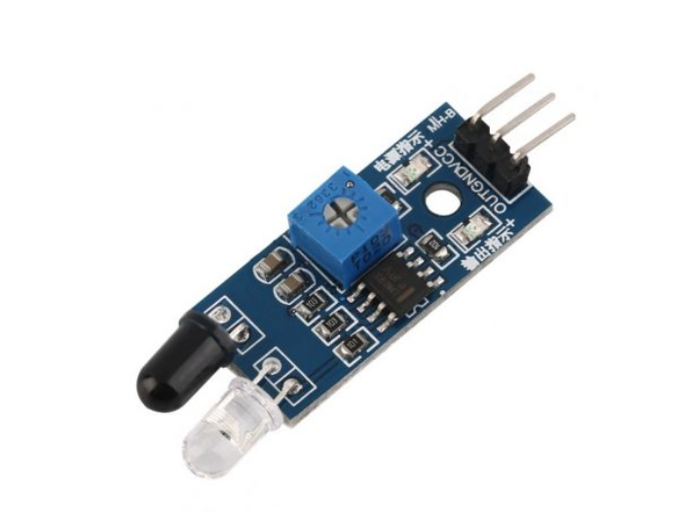

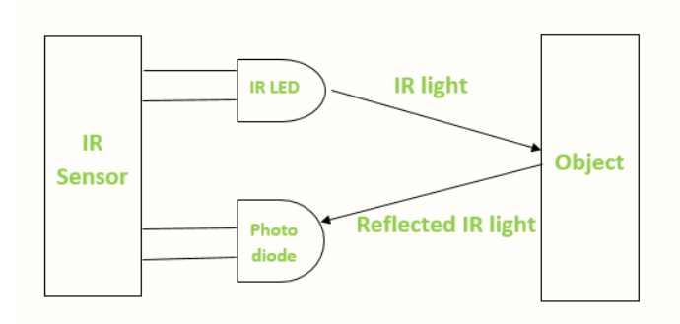The emitter is simply an IR LED [**(Light Emitting Diode**](https://robu.in/product-category/display-boards/led/)) and the detector is simply an IR photodiode . Photodiode is sensitive to IR light of the same wavelength which is emitted by the IR LED. When IR light falls on the photodiode, the resistances and the output voltages will change in proportion to the magnitude of the IR light received.

There are five basic elements used in a typical infrared detection system: an infrared source, a transmission medium, optical component, infrared detectors or receivers and signal processing. Infrared lasers and Infrared LED’s of specific wavelength used as infrared sources.

The three main types of media used for infrared transmission are vacuum, atmosphere and optical fibers. Optical components are used to focus the infrared radiation or to limit the spectral response.

***IR Sensor Working Principle***

There are different types of infrared transmitters depending on their wavelengths, output power and response time. An IR sensor consists of an IR LED and an IR Photodiode, together they are called as PhotoCoupler or OptoCoupler.

***IR Transmitter or IR LED***

Infrared Transmitter is a light emitting diode (LED) which emits infrared radiations called as IR LED’s. Even though an IR LED looks like a normal LED, the radiation emitted by it is invisible to the human eye.

The picture of an Infrared LED is shown below.

[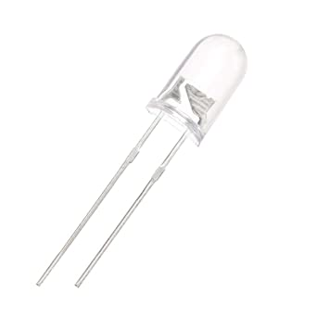](https://aws.robu.in/wp-content/uploads/2020/05/51fibl-5xL._SX342_.jpg)

***IR Receiver or Photodiode***

Infrared receivers or infrared sensors detect the radiation from an IR transmitter. IR receivers come in the form of photodiodes and phototransistors. Infrared Photodiodes are different from normal photo diodes as they detect only infrared radiation. Below image shows the picture of an IR receiver or a photodiode,

[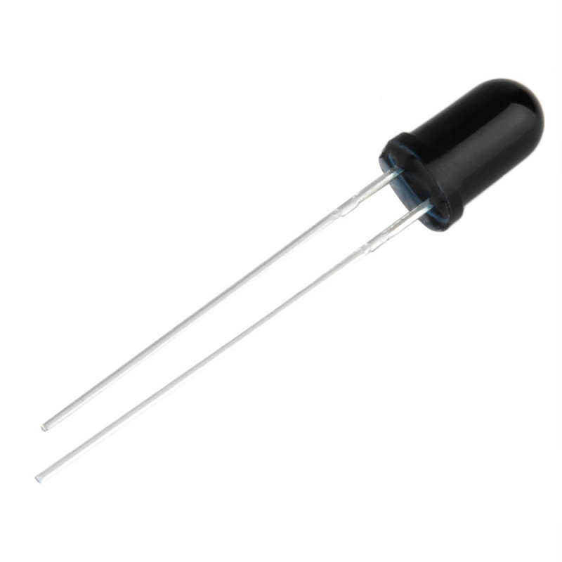](https://aws.robu.in/wp-content/uploads/2020/05/SN-IR-R-0-1-1-800x800-1.jpg)

Different types of IR receivers exist based on the wavelength, voltage, package, etc. When used in an infrared transmitter – receiver combination, the wavelength of the receiver should match with that of the transmitter.

The emitter is an IR LED and the detector is an IR photodiode. The IR photodiode is sensitive to the IR light emitted by an IR LED. The photo-diode’s resistance and output voltage change in proportion to the IR light received. This is the underlying working principle of the IR sensor.

When the IR transmitter emits radiation, it reaches the object and some of the radiation reflects back to the IR receiver. Based on the intensity of the reception by the IR receiver, the output of the [**sensor**](https://robu.in/product-category/sensor/) defines.

***IR Sensor (Components and Pins)***

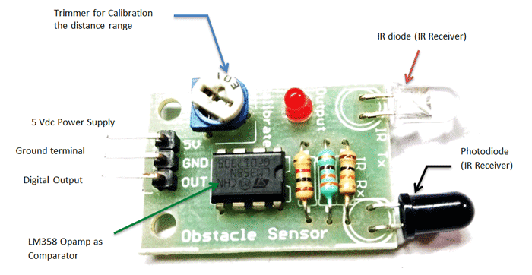

***Advantages of Infrared sensor***

Following are the **advantages of Infrared sensor**:  
➨It provides secured communication due to line of sight or point-to-point mode of communication.  
➨The battery used in infrared devices last for long duration due to lower power consumption.  
➨Infrared motion sensors detect motion in daytime and nighttime reliably.  
➨The sensor does not require any contact with the product to be sensed. The infrared devices are more appropriate for targets which are close than 10 mm.  
➨Infrared devices can measure distance to soft objects which may not be easily detected by ultrasound.  
➨They are physically smaller in size and are more affordable.  
➨It has response time faster than thermocouple.  
➨It provides good stability over time.  
➨No corrosion or oxidation can affect the accuracy of infrared sensor.  
➨It delivers high repeatability.

***Applications***

***Proximity Sensor***

These are used in smart phones to find distance of object. They use principle called Reflective Indirect Incidence. Radiation transmitted by transmitter is received by receiver after being reflected from object. Distance is calculated based on the intensity of radiation received.

***Item Counter***

This use direct incidence method to count the items. Constant radiation is maintained in between transmitter and receiver. As soon as object cuts the radiation, item is detected and count is increased. The same count is shown on display system.

***Burglar Alarm***

This is one of widely and commonly used sensor application. It is another example for direct incidence method.

It works similar to item counter, where transmitter and receiver are kept on both the sides of door frame. Constant radiation is maintained between transmitter and receiver, whenever object crosses path alarm starts off.

[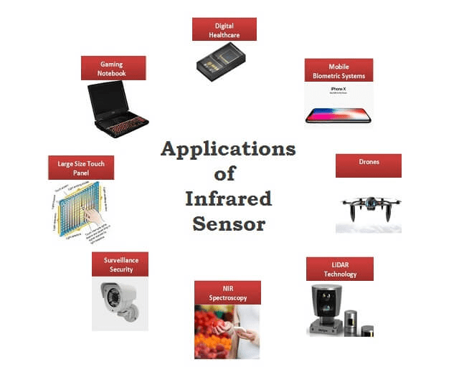](https://i2.wp.com/electricalfundablog.com/wp-content/uploads/2018/09/Applications-of-Infrared-Sensor.png?ssl=1)

**Fig. 6 – Applications of Infrared Sensor**

***Radiation Thermometers***

It is one of key application of Infrared sensors. Working of radiation thermometer depends on temperature and type of object.

These have faster response and easy pattern measurements. They can do measurement without direct contact of object.

**Human Body Detection**

This method is used in intrusion detection, auto light switches, etc. Intrusion alarm system sense temperature of human body.

If the temperature is more than threshold value, it sets on the alarms. It uses electromagnetic system which is suitable for human body in order to protect it from unwanted harmful radiations.

**Gas Analyzers**

Gas Analyzersare used to measure gas density by using absorption properties of gas in IR region. Dispersive and Non Dispersive types of gas analyzers are available.

**Arduino details**

The **Arduino Uno** is an [open-source](https://en.wikipedia.org/wiki/Open-source) [microcontroller board](https://en.wikipedia.org/wiki/Microcontroller_board) based on the [Microchip](https://en.wikipedia.org/wiki/Microchip_Technology) [ATmega328P](https://en.wikipedia.org/wiki/ATmega328P) microcontroller and developed by [Arduino.cc](https://en.wikipedia.org/wiki/Arduino). The board is equipped with sets of digital and analog [input/output](https://en.wikipedia.org/wiki/Input/output) (I/O) pins that may be interfaced to various [expansion boards](https://en.wikipedia.org/wiki/Expansion_board) (shields) and other circuits. The board has 14 digital I/O pins (six capable of [PWM](https://en.wikipedia.org/wiki/Pulse-width_modulation) output), 6 analog I/O pins, and is programmable with the [Arduino IDE](https://en.wikipedia.org/wiki/Arduino#Software) (Integrated Development Environment), via a type B [USB cable](https://en.wikipedia.org/wiki/USB_cable). It can be powered by the USB cable or by an external [9-volt battery](https://en.wikipedia.org/wiki/9-volt_battery), though it accepts voltages between 7 and 20 volts. It is similar to the [Arduino Nano](https://en.wikipedia.org/wiki/Arduino_Nano) and Leonardo. The hardware reference design is distributed under a [Creative Commons](https://en.wikipedia.org/wiki/Creative_Commons) Attribution Share-Alike 2.5 license and is available on the Arduino website. Layout and production files for some versions of the hardware are also available.

The word "[uno](https://en.wiktionary.org/wiki/uno" \o "wikt:uno)" means "one" in [Italian](https://en.wikipedia.org/wiki/Italian_language) and was chosen to mark the initial release of [Arduino Software](https://en.wikipedia.org/wiki/Arduino_Software). The Uno board is the first in a series of USB-based Arduino boards it and version 1.0 of the Arduino [IDE](https://en.wikipedia.org/wiki/Integrated_development_environment) were the reference versions of Arduino, which have now evolved to newer releases. The ATmega328 on the board comes preprogrammed with a [bootloader](https://en.wikipedia.org/wiki/Bootloader" \o "Bootloader) that allows uploading new code to it without the use of an external hardware programmer.

***Pin description used for our project:***

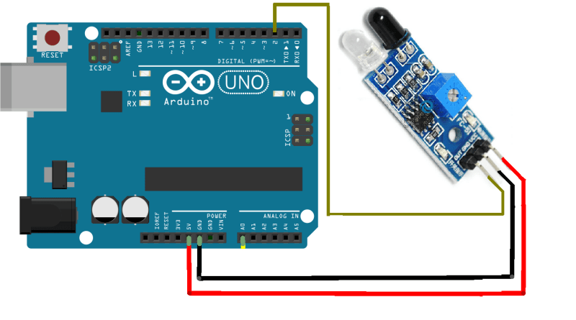

1. The vcc pin of the IR sensor is connected to 5v of the arduino

2. The ground pin of the IR sensor is connected to the gnd of the arduino

3. The digital output of the sensor is connected to the digital pin of the arduino