**TITLE: AUTOMATED ROOM LIGHTING SYSYEM**

**GROUP NO: 18**

**TEAM MEMBERS:**

***1. Abhyanth.P***

***2. Rakshit R.K***

***3. Bharath N***

***4. Arun Kulkarni***

**INTRODUCTION:**

Now with increasing technology day by day all the work done by human is being automated to reduce errors, decrease the cost, high efficiency.

We prefer automation because the result quality increases labour decreases so that less money can be spent of labour and more on quality of the result.

Now what is home automation: Home automation or domotics is building automation for a home, called a smart home or smart house? A home automation system will control lighting, climate, entertainment systems, and appliances. It may also include home **security** such as access control and alarm systems,

Our project is an application of home automation which deals with automatic turning on the light when a person enters the room and turn off when the person leaves the room.

**CONNECTIONS:**

We have divided our project into 2 one is the receiver E1and one more is the transmitter E2

The function of the receiver is to take the input from the IR sensor and update to the cloud using the read api keys we are using Things Speak cloud in our project whenever the sensor detects any movement its updates the cloud in the cloud I have created 2 fields 1.is for the sensor 1 2.for the second sensor

The function of the receiver is to read the date from the cloud and act accordingly as it was told earlier that are 2 fields in the cloud if field-1 is 1 thn the receiver turns on the light if the field-2 I 1 then the receiver turns off the light

**Cloud used:** [**https://thingspeak.com/**](https://thingspeak.com/)

**Our project channel:** [**https://thingspeak.com/channels/1223049**](https://thingspeak.com/channels/1223049)

**Transmitter:**

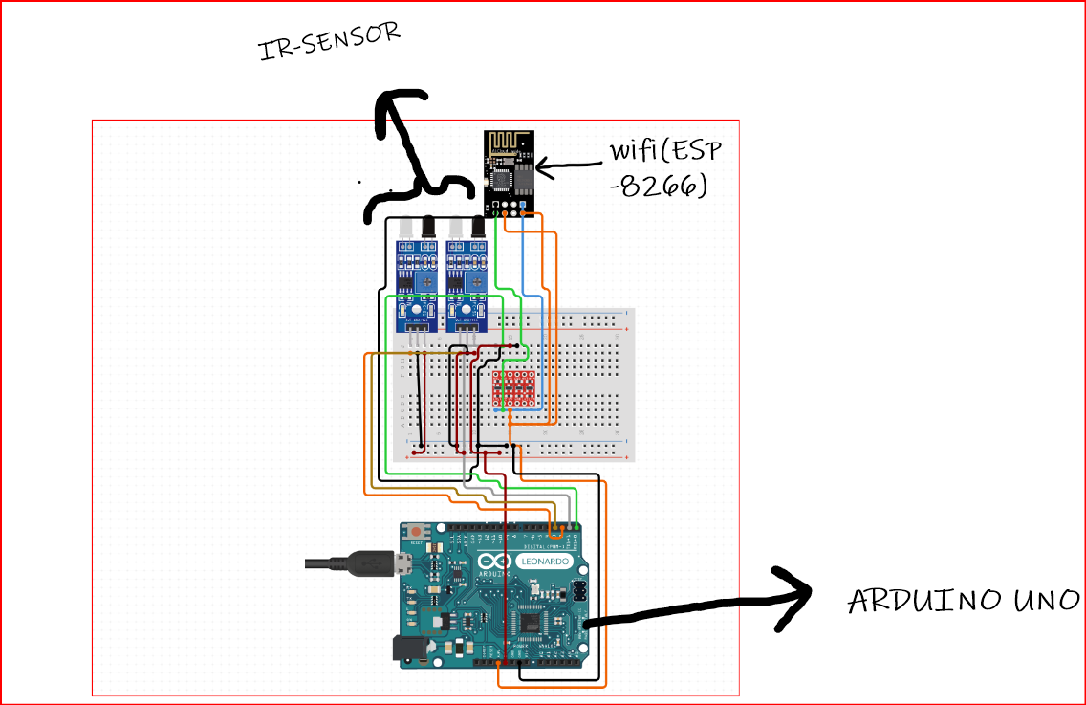

**Components used:**

1. 2x IR Sensors
2. Wi-Fi module(esp8266)
3. Arduino Uno
4. Breadboard

The IR sensors have 3 pin

1. The ground pin which is connected to the ground pin of the arduino
2. The vcc pin which is connected to the 5v in of the arduino
3. The digital output pin connected to a digital pin of the arduino

The Wi-Fi module has 8 pins

1. The vcc(3.3) is connected to the 3.3 volt of the arduino
2. The ground pin which is connected to the ground pin of the arduino
3. The TX pin is connected to the rx of the ardunio
4. The rx pin is connected to the TX of the ardunio

**RECIVER:**

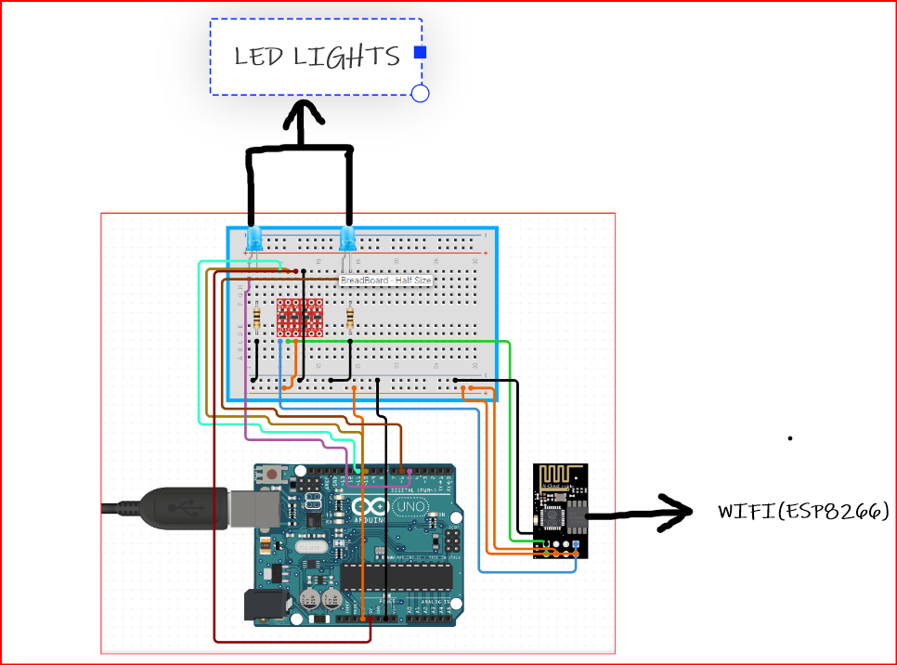

**Components used:**

1. Wi-Fi module(esp8266)
2. Arduino Uno
3. Breadboard
4. 2x LED’S

The Wi-Fi module has 8 pins

1. The vcc(3.3) is connected to the 3.3 volt of the arduino
2. The ground pin which is connected to the ground pin of the arduino
3. The TX pin is connected to the rx of the ardunio
4. The rx pin is connected to the TX of the ardunio

The led’s have 2 pins

One pin is connected to 5v of arduino and one more is connected to the ground

**PROGRAM:**

#include<SoftwareSerial.h>//for bluethooth and Wi-Fi module

#define ir_out1 6//ir sensor-1;

#define ir_out2 7//ir sensor-2

SoftwareSerial bt(2,3);//(Rx,Tx)//the bluetooth pins

SoftwareSerial Wi-Fi(4,5);//(Rx,Tx)//Wi-Fi pins

String wifiname="helloo";

String pass="bye";

String data;

int res1,res2;

void setup() {

// put your setup code here, to run once:

pinMode(ir_out1,INPUT);

pinMode(ir_out2,INPUT);

bt.begin(9600);

wifi.begin(9600);

Serial.begin(9600);

espcmd("AT+RST");//attention command to reset the Wi-Fi module

espcmd("AT+CWMODE=1");//Wi-Fi module acts as a client

espcmd("AT+CWJAP=\""+wifiname+"\",\""+pass+"\"");//attention command To connect to local Wi-Fi network

while(!wifi.find("OK")){

//becomes false and exits the loop only after the Wi-Fi module is connected

}

delay(1000);

}

void loop() {

// put your main code here, to run repeatedly:

res1=digitalRead(ir_out1);//reads output from the first ir sensor

res1=digitalRead(ir_out2);//reads output from the second ir sensor

if(res1==1){

light_on();//user defined function to turn on lights

}

else if(res2==1){

light_off();//user defined function to turn off lights

}

}

void light_on(){//user defined function to turn on lights

espcmd("AT+CIPMUX");//attention command to specify number of devises to be connected

espcmd("AT+CIPSTART=\"TCP\",\"api.thingspeak.com\",80");//adhress of the cloud we are using

String data="/update?api_key=EG23Y36D9LLC1KRJ&field1=1";//read api key given by the cloud

espcmd("AT+CIPSEND="+String(data.length()+2));//attention comman to send data

wifi.find(">");

wifi.println(data);

espcmd("AT+CIPCLOSE=0");

delay(1000);

}

void light_off(){//user defined function to turn off lights

espcmd("AT+CIPMUX");

espcmd("AT+CIPSTART=\"TCP\",\"api.thingspeak.com\",80");//adhress of the cloud we are using

data="/update?api_key=EG23Y36D9LLC1KRJ&field2=1";//read api key given by the cloud

espcmd("AT+CIPSEND="+String(data.length()+2));//attention comman to send data

wifi.find(">");

wifi.println(data);

espcmd("AT+CIPCLOSE=0");

delay(1000);

}

void espcmd(String cmd){//function to write in the esp monitor

wifi.println(cmd);//used to print in the esp monitor

delay(1000);

}