Zargux — Incident Detection in Linux Servers

USE-CASE DOCUMENTATION

A report submitted in partial fulfillment of the requirements
for the degree of Bachelor of Technology in
Computer Science & Engineering / Cyber Security

Submitted by
[Student Name] — [Roll / Enrollment No.]
[Team member 2 — Roll No.] (delete if solo)

Under the guidance of
[Internal Faculty Guide — Name & Designation]

Department of Computer Science & Engineering
ABES Engineering College, Ghaziabad
Dr. A.P.J. Abdul Kalam Technical University, Lucknow
Session 2025–26

1. Use-Case Diagram
» Draw in draw.io / Visual Paradigm and paste here. Conventions:
- Actors = stick figures OUTSIDE the system box (e.g. Analyst, Attacker, the Target System/Timer).
- System boundary = a labelled rectangle around all use cases.
- Use cases = ovals named with a verb phrase (Run Detection, Generate Alert, Respond to Incident).
- «include» = dashed arrow to an always-used sub-case; «extend» = optional behaviour; association = solid line.
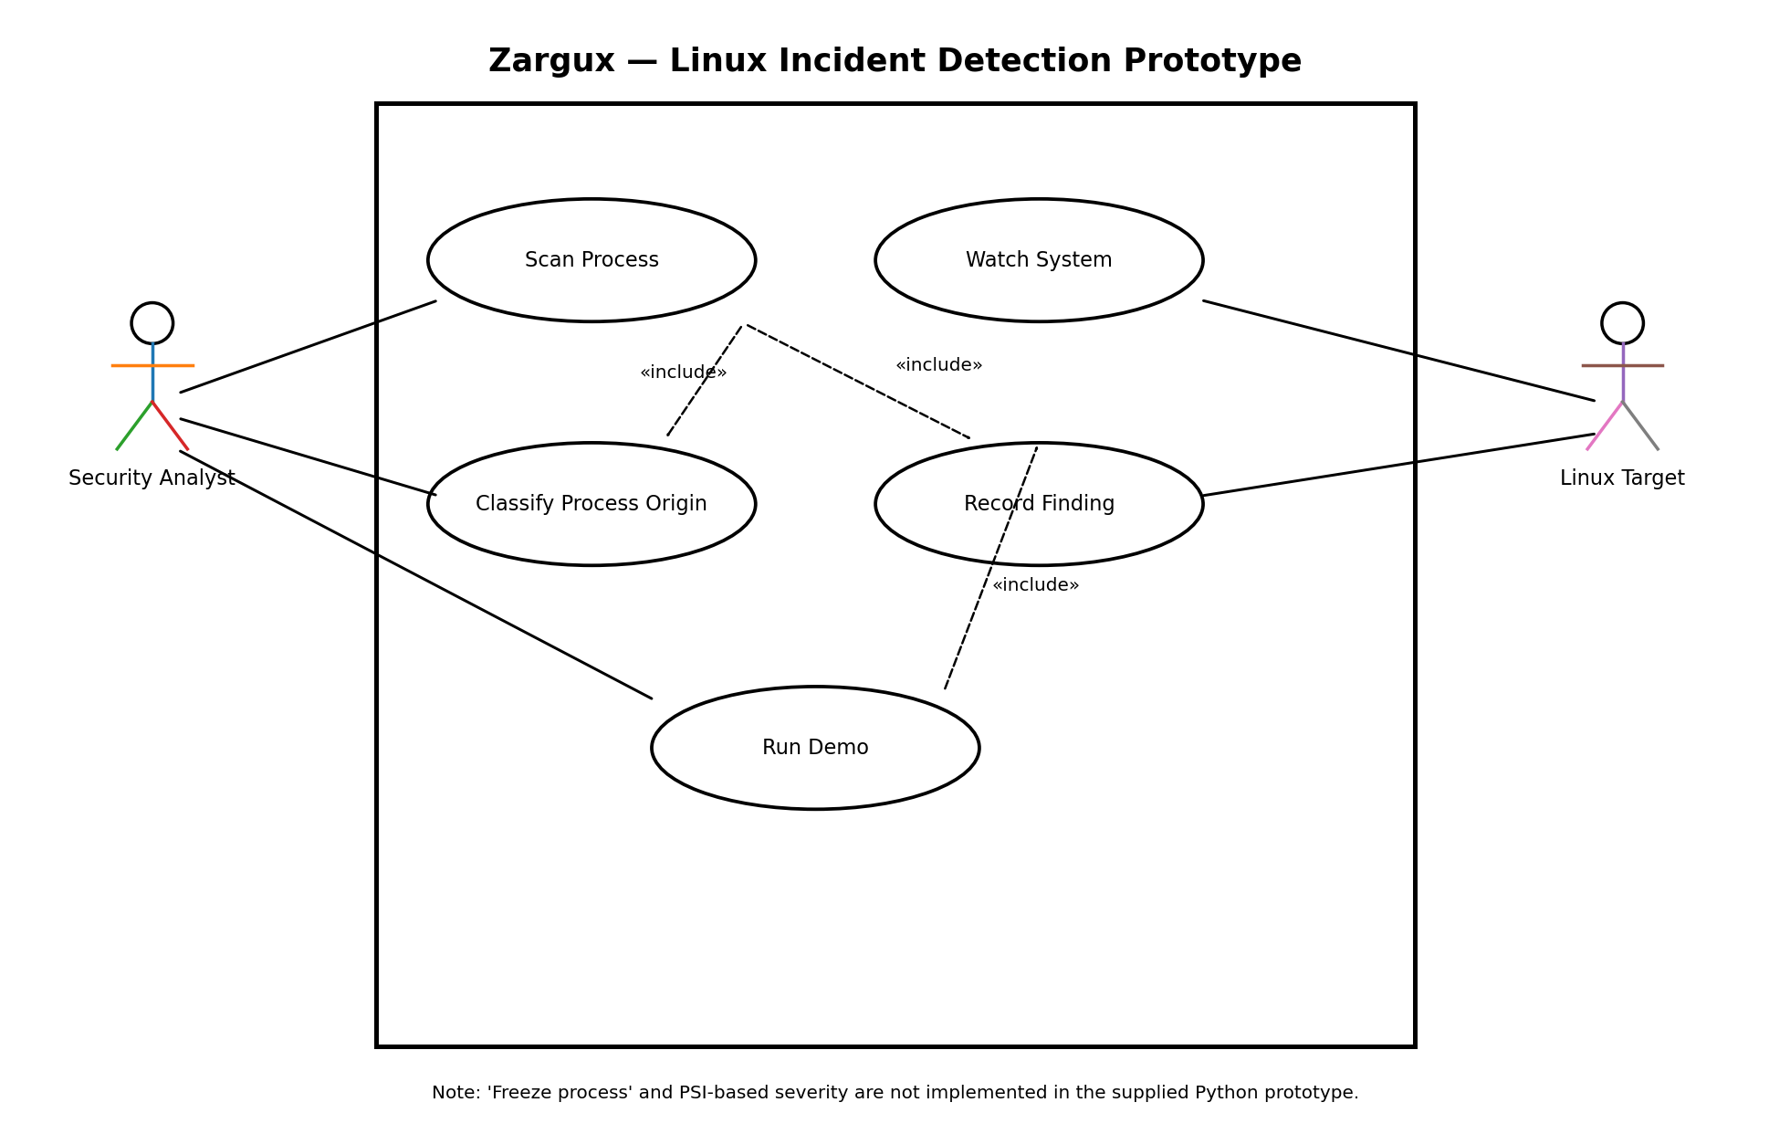

2. Use-Case Descriptions
» One table per use case. A filled example is below; copy the blank table for each of your use cases.

2.1 Example (filled) — Run Detection
Use Case ID | UC-01
Use Case Name | Run Detection
Actor(s) | Security Analyst (primary); Target System (secondary)
Description | The analyst starts the detector, which watches evidence and raises an alert when the rule fires.
Preconditions | Detector configured; evidence source (logs/events) available.
Trigger | Analyst runs the detector.
Main Flow | 1. Analyst starts detector. 2. System reads evidence. 3. System evaluates the rule. 4. On match, system raises an alert with the incident details.
Alternate Flow | 3a. No match within window → system keeps watching.
Exception Flow | 2a. Evidence source unavailable → system logs an error and retries.
Postconditions | An incident record exists; analyst is alerted.
Priority | High

2.2 Blank table — copy one per use case
Use Case ID | [UC-0x]
Use Case Name | [verb phrase]
Actor(s) | [primary; secondary]
Description | [one line]
Preconditions | […]
Trigger | […]
Main Flow | 1. … 2. … 3. …
Alternate Flow | […]
Exception Flow | […]
Postconditions | […]
Priority | [High/Medium/Low]

» Suggested use cases for a detection project: Run Detection, Simulate Attack, Generate Alert, Respond to Incident, View Dashboard.

Zargux — Use-Case Documentation (Python Prototype)
Project context. Zargux is an incident-detection prototype for Linux servers. The supplied project definition describes origin-based detection of programs executing from writable temporary locations such as /dev/shm, /tmp, and /var/tmp, with CPU pressure used as contextual evidence. The supplied Python prototype implements process-origin classification, live monitoring, persistence to findings.json, and a three-case demonstration.

1. Scope of the Current Prototype
- Runs inside an Ubuntu 24.04 LTS Multipass VM.
- Reads /proc/<pid>/exe to determine the executable origin of running processes.
- Treats /dev/shm/, /tmp/, /var/tmp/, and executables ending in ' (deleted)' as HIGH.
- Uses dpkg -S to identify package-managed executables and classifies them as CLEAR.
- Classifies other non-package-managed executables outside writable temporary locations as WATCH.
- Reads /proc/pressure/cpu and displays avg10, avg60, and avg300 in watch mode.
- Persists findings in findings.json, keeping the most recent 50 records.
- Provides scan, watch, and demo CLI commands.

2. Use-Case Descriptions
Use Case ID | UC-01
Use Case Name | Scan Process
Actor(s) | Security Analyst (primary); Linux Target (secondary)
Description | Perform a one-shot origin-based security verdict for a selected process ID.
Preconditions | Zargux is installed on the Ubuntu VM and the PID exists and is readable.
Trigger | Analyst runs sudo python3 zargux.py scan <pid>.
Main Flow | 1. Read /proc/<pid>/exe. 2. Classify the executable origin. 3. Print PID, executable path, verdict, and reason. 4. Save the finding to findings.json.
Alternate Flow | The process may exit between PID discovery and /proc lookup; Zargux reports that the PID was not found or permission was denied.
Exception Flow | Permission is insufficient or the process exits; the scan terminates with an error.
Postconditions | A verdict is displayed and a finding is persisted.
Priority | High

Use Case ID | UC-02
Use Case Name | Watch System
Actor(s) | Security Analyst (primary); Linux Target (secondary)
Description | Continuously monitor CPU pressure and process origins and display processes whose verdict is WATCH or HIGH.
Preconditions | Zargux has permission to inspect the target processes; /proc is available.
Trigger | Analyst runs sudo python3 zargux.py watch [--interval N].
Main Flow | 1. Read CPU PSI values. 2. Enumerate numeric PIDs under /proc. 3. Read each /proc/<pid>/exe link. 4. Classify each process. 5. Hide CLEAR processes. 6. Display WATCH/HIGH processes and CPU percentage. 7. Save a new finding when a PID's verdict changes. 8. Repeat after the configured interval.
Alternate Flow | No suspicious processes are present; the display reports that nothing is flagged.
Exception Flow | PSI cannot be read; Zargux displays that CPU pressure is unavailable but continues the process scan.
Postconditions | The terminal provides a live view and findings are persisted.
Priority | High

Use Case ID | UC-03
Use Case Name | Classify Process Origin
Actor(s) | Zargux Detection Engine (primary); Linux /proc; dpkg
Description | Determine whether a running executable is deleted, located in a writable temporary path, package-managed, or otherwise unpackaged.
Preconditions | An executable path has been obtained from /proc/<pid>/exe.
Trigger | The scan/watch logic calls classify(exe_path).
Main Flow | 1. Check whether the path ends with ' (deleted)'. 2. Check whether it begins with /dev/shm/, /tmp/, or /var/tmp/. 3. If not, query dpkg -S for package ownership. 4. Return HIGH, CLEAR, or WATCH with a reason.
Alternate Flow | A package lookup may return no match; the process becomes WATCH unless its path is suspicious.
Exception Flow | The executable path cannot be read; the caller skips or reports the process depending on the command.
Postconditions | A normalized verdict and human-readable reason are returned.
Priority | High

Use Case ID | UC-04
Use Case Name | Record Finding
Actor(s) | Zargux (primary); findings.json
Description | Persist security findings so that scan, watch, and demo results can be reviewed after detection.
Preconditions | The working directory is writable.
Trigger | A scan, watch transition, or demo case produces a finding.
Main Flow | 1. Load existing findings.json if present. 2. Append time, summary, and severity. 3. Keep the most recent 50 records. 4. Write the updated JSON file.
Alternate Flow | If findings.json contains invalid JSON, Zargux starts with an empty list and continues.
Exception Flow | The file cannot be written; persistence fails and the operating system reports the error.
Postconditions | The finding is stored with a timestamp, summary, and severity label.
Priority | Medium

Use Case ID | UC-05
Use Case Name | Run Three-Case Demo
Actor(s) | Security Analyst (primary); Linux Target (secondary)
Description | Run the presentation workflow that contrasts a legitimate stress-ng process, a copied stress-ng binary in /dev/shm, and a legitimate unpackaged control.
Preconditions | Ubuntu VM has stress-ng, systemd, sudo access, and the required paths available.
Trigger | Analyst runs sudo python3 zargux.py demo.
Main Flow | 1. Stop leftovers from previous demo runs. 2. Launch stress-ng from /usr/bin. 3. Copy stress-ng to /dev/shm and launch the copy. 4. Create ~/bin/my-legit-tool from /bin/sleep and launch it. 5. Classify all three processes and save findings. 6. Print a side-by-side results table. 7. Stop demo services and remove the /dev/shm copy.
Alternate Flow | A demo process may fail to start or disappear before classification; that case is omitted from the results.
Exception Flow | Required sudo/systemd/stress-ng operation fails; the demo stops with an error.
Postconditions | The terminal shows how executable origin changes the verdict even for the same stress-ng binary and similar CPU workload.
Priority | High

3. Activity Diagram
Current prototype flow for live monitoring.
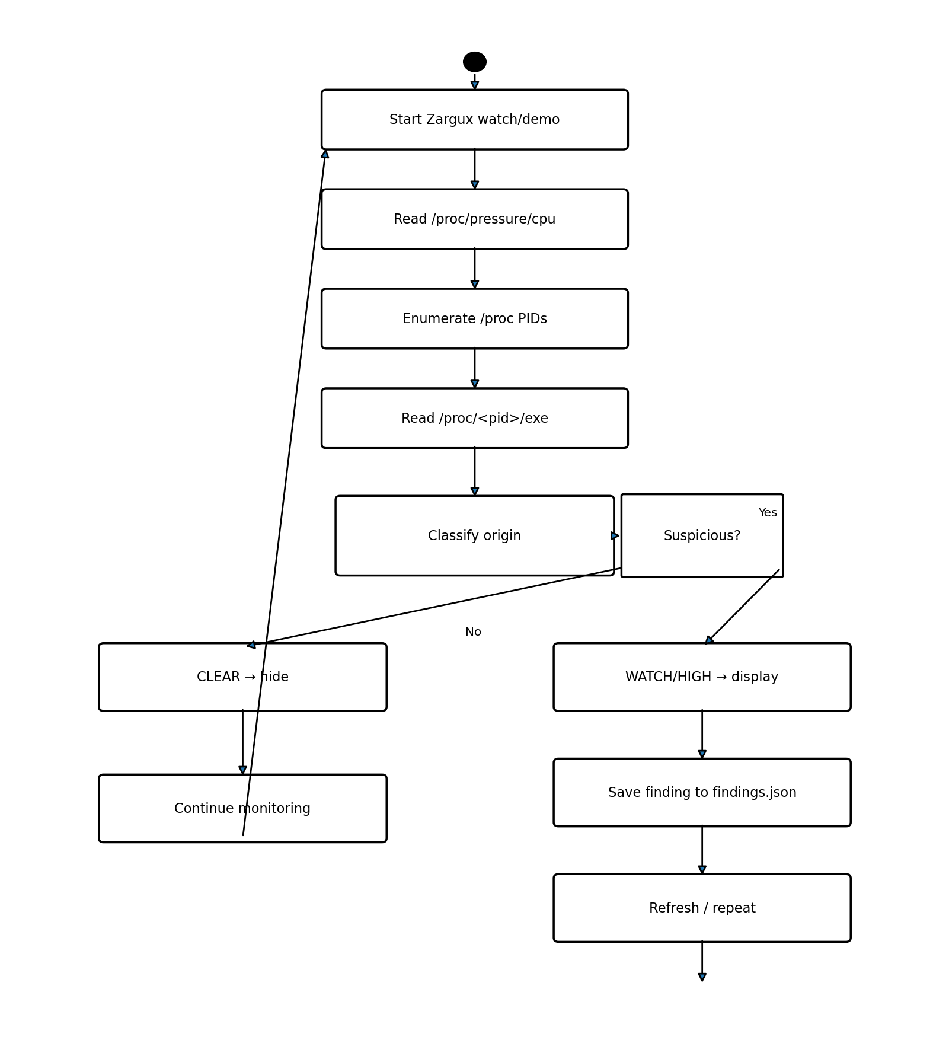

4. Sequence Diagram
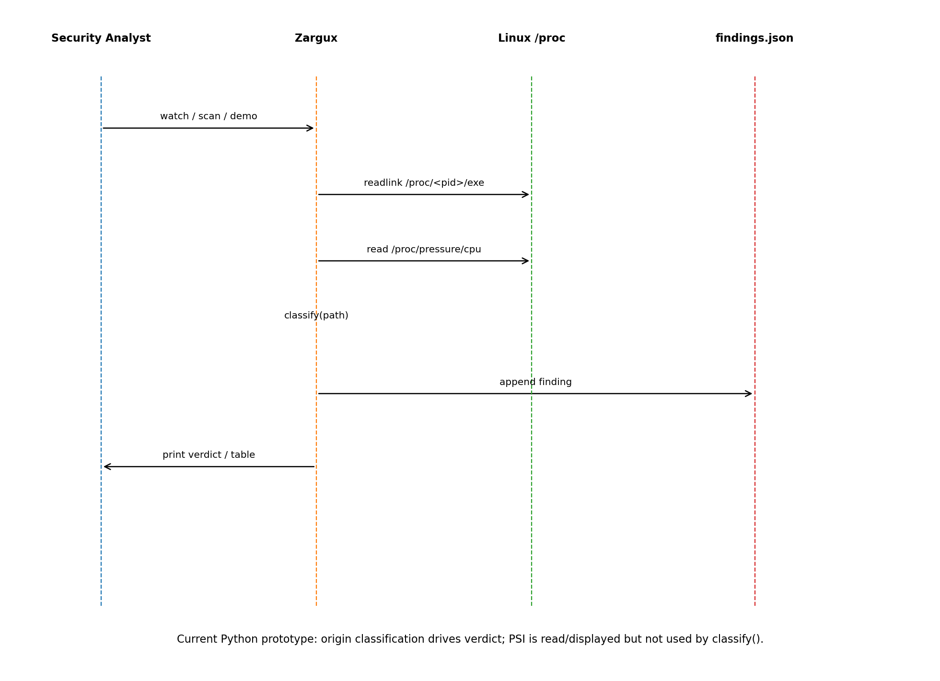

5. Component Diagram
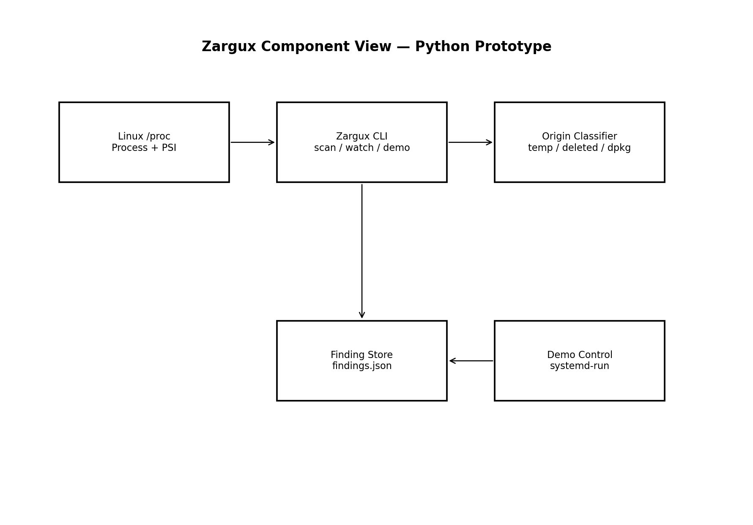

6. Deployment Diagram
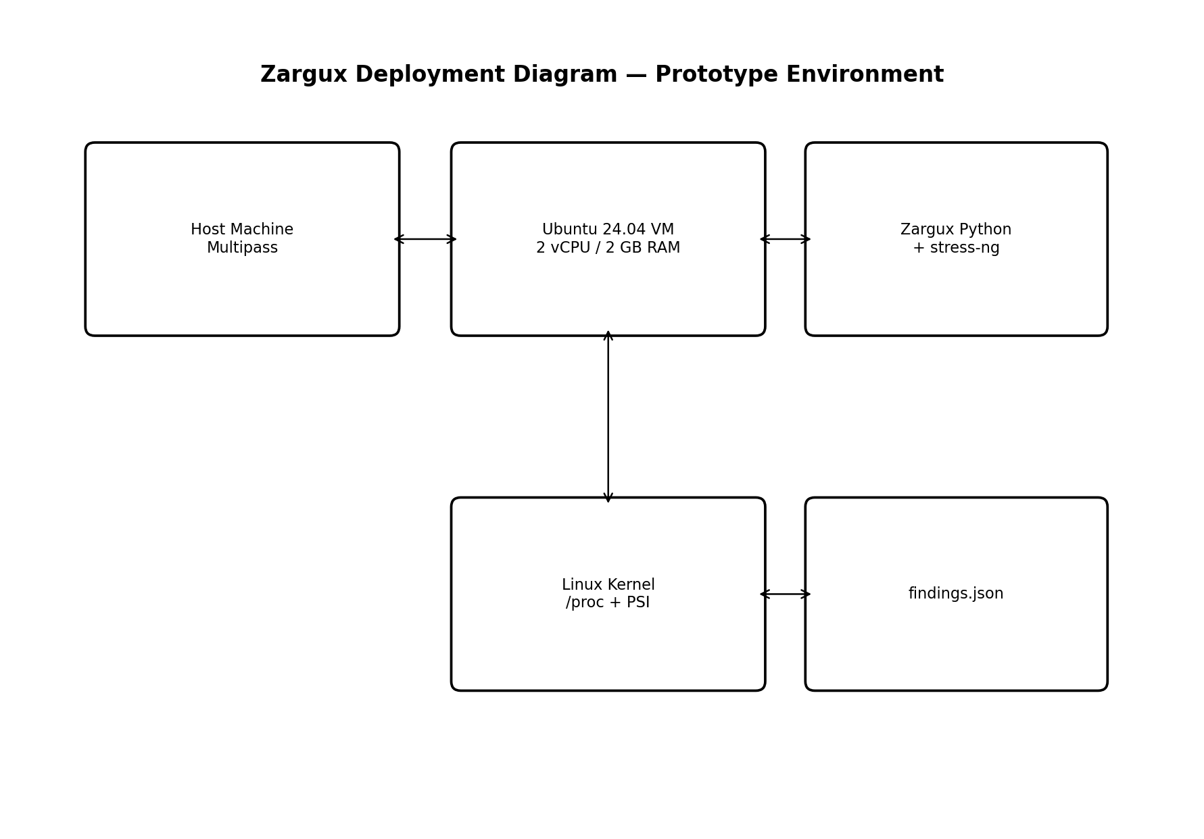

7. Implementation Notes and Prototype Gaps
The project-definition document and the supplied Python code are not fully identical. For academic accuracy, the current prototype should be described separately from planned/future Zargux behavior.
CPU PSI severity: Project definition: HIGH when CPU PSI avg10 is at/above 40 for 10 seconds. Supplied code: read_psi() displays PSI, but classify() does not use PSI to calculate the verdict or severity.
Response action: Project definition says the tool saves evidence and freezes the suspicious process. Supplied code saves a finding, but it does not freeze/stop the detected process. The demo stops its own systemd services only during cleanup.
Monitoring interval: Project definition states every 2 seconds. The supplied watch command defaults to a 3.0-second interval unless --interval is supplied.
Evidence file: The supplied code persists findings in findings.json containing time, summary, and severity. It does not currently create a separate executable/evidence copy of the suspicious process.
Language/runtime: The project definition describes the intended detector as Zig 0.13.0, while the supplied implementation is a Python 3 prototype executed inside the Ubuntu VM.

8. Suggested Final Wording for the Current Prototype
Zargux is a Linux incident-detection prototype that identifies suspicious running processes by inspecting the origin of their executable through /proc/<pid>/exe. Executables running from writable temporary locations such as /dev/shm, /tmp, and /var/tmp, or executables that have been deleted from disk while still running, are classified as HIGH. Package-managed executables are classified as CLEAR, while other unpackaged executables outside those locations are classified as WATCH. Zargux can scan a single PID, continuously watch the system, persist findings to findings.json, and run a controlled three-case demonstration in an Ubuntu 24.04 Multipass VM. The prototype also reads CPU pressure from /proc/pressure/cpu as contextual monitoring information.

9. Reference Environment
- Host VM manager: Multipass 1.16.4.
- Target: Ubuntu 24.04 LTS, 2 vCPU, 2 GB RAM.
- Attack/demo utility: stress-ng 0.20.01-1.
- Package ownership check: dpkg.
- Prototype implementation: Python 3 CLI.
- Intended implementation in the project definition: Zig 0.13.0.

