1. **The write() Predicate**

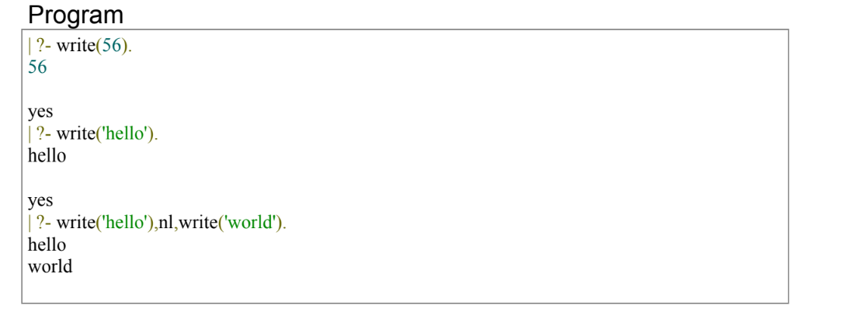

1. **The read() Predicate**

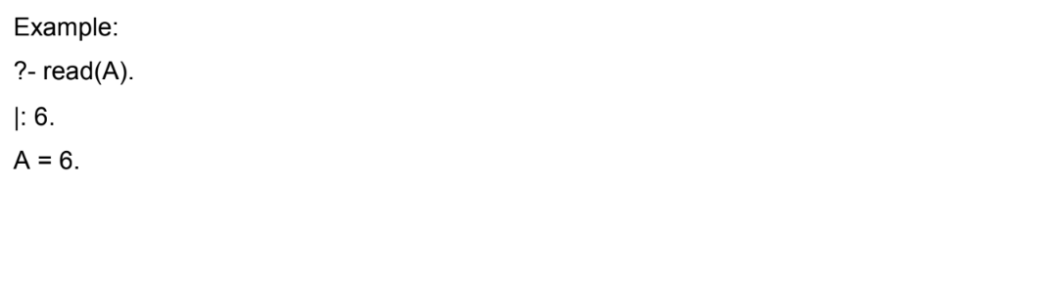

1. **Cube Of Number**

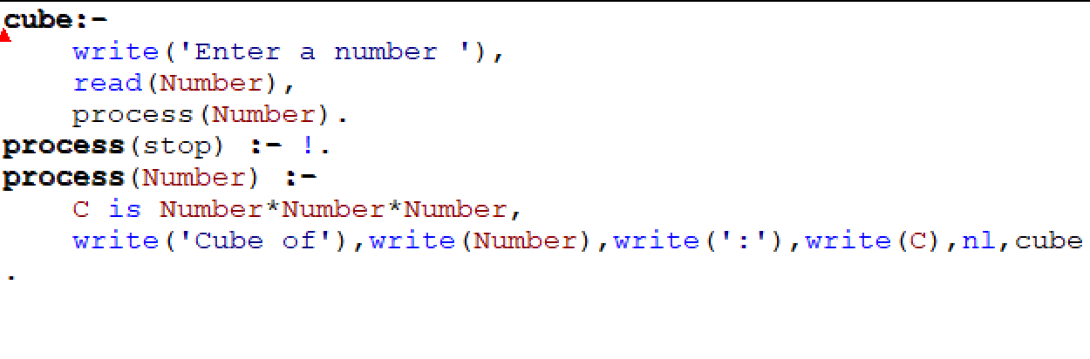

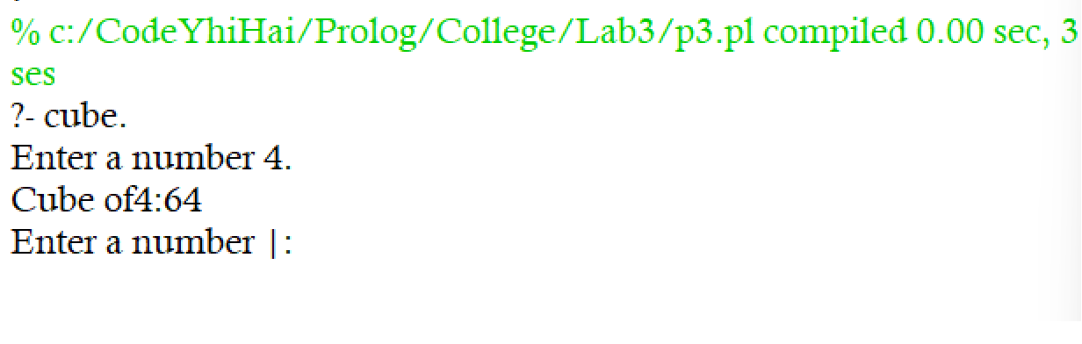

1. **The Tab() Predicate**

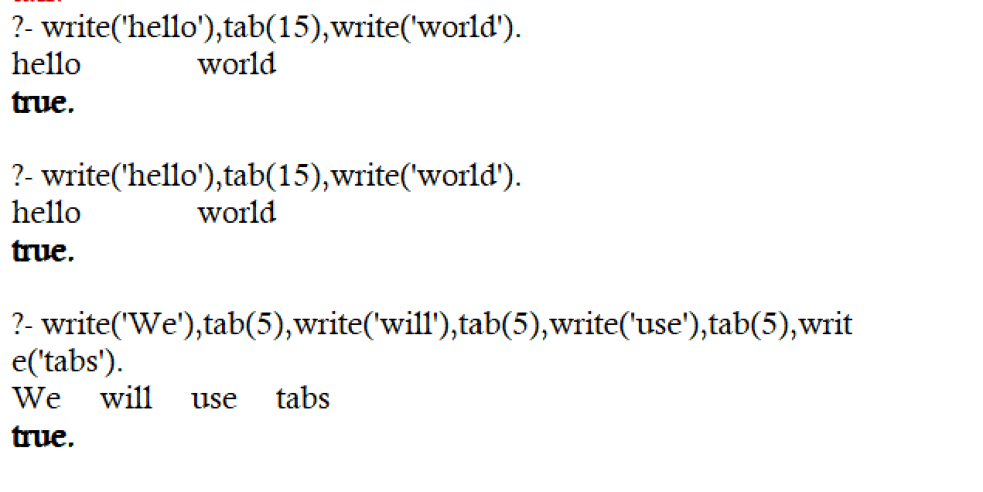

1. **The tell and told**

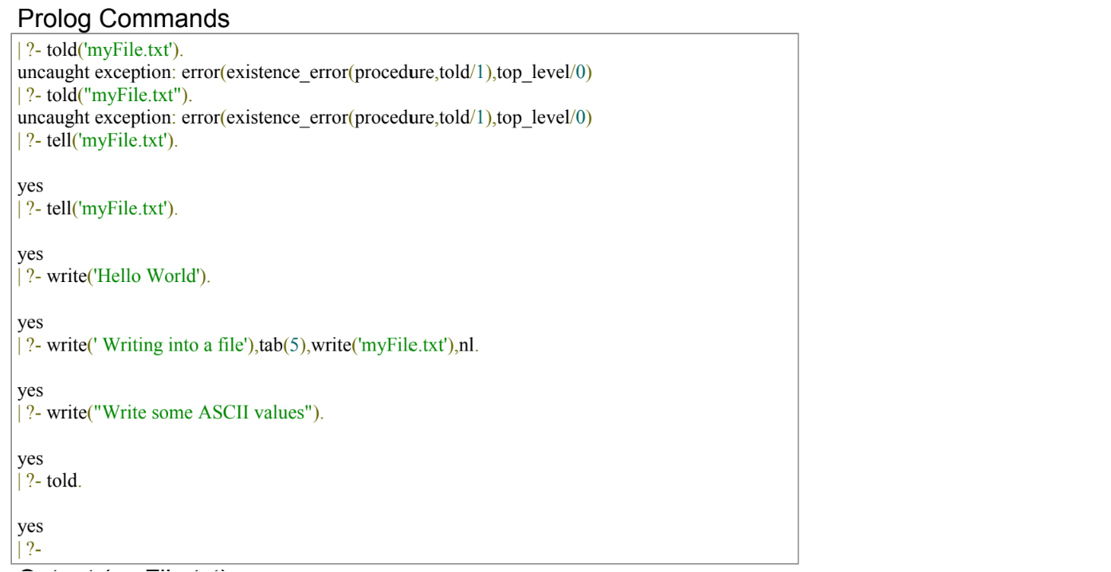

1. **The see and seen**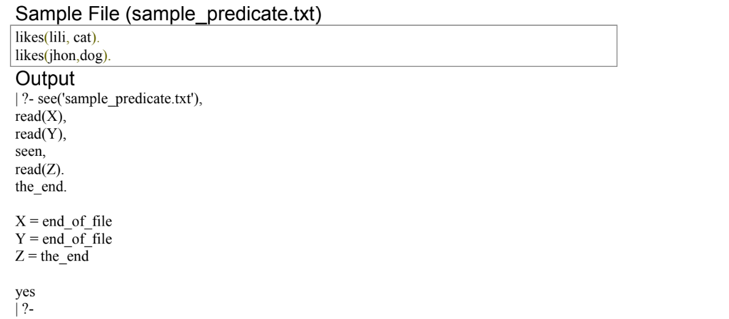
2. **The put(C) and put_char(C) predicates**

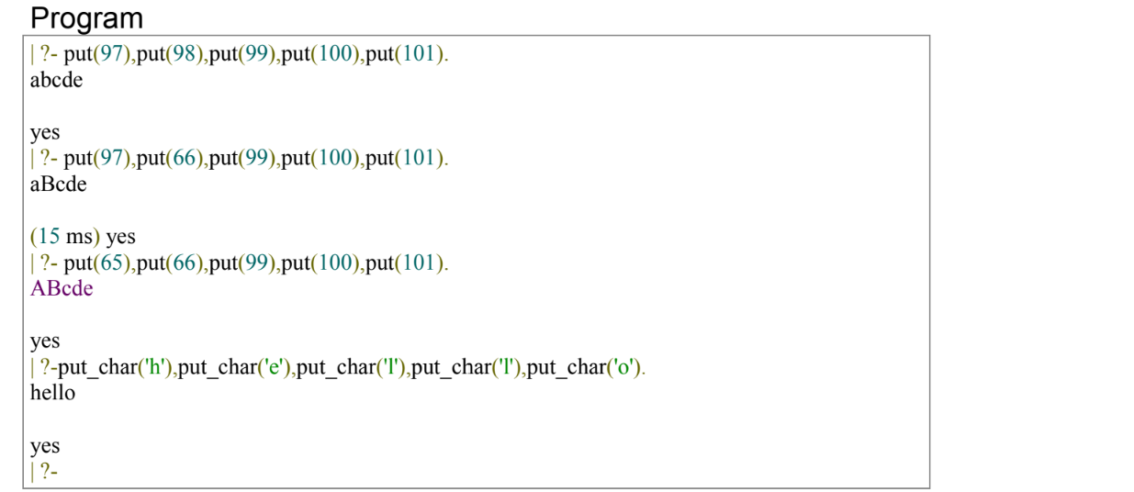

1. **The get_char(C) and get_code(C) predicates**

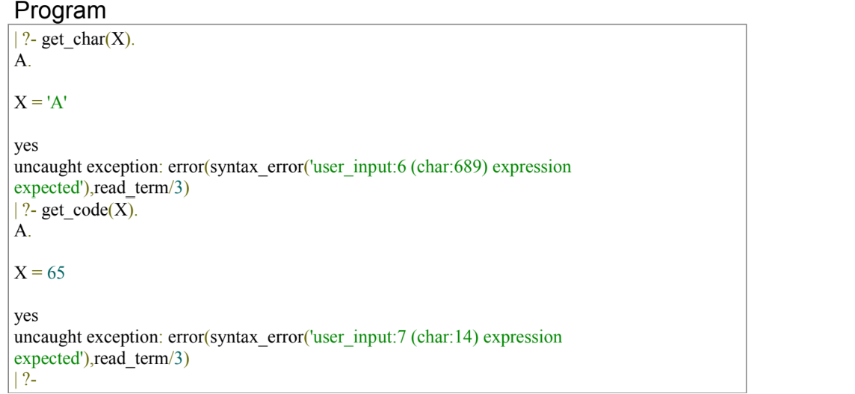

1. **Decomposing Atoms**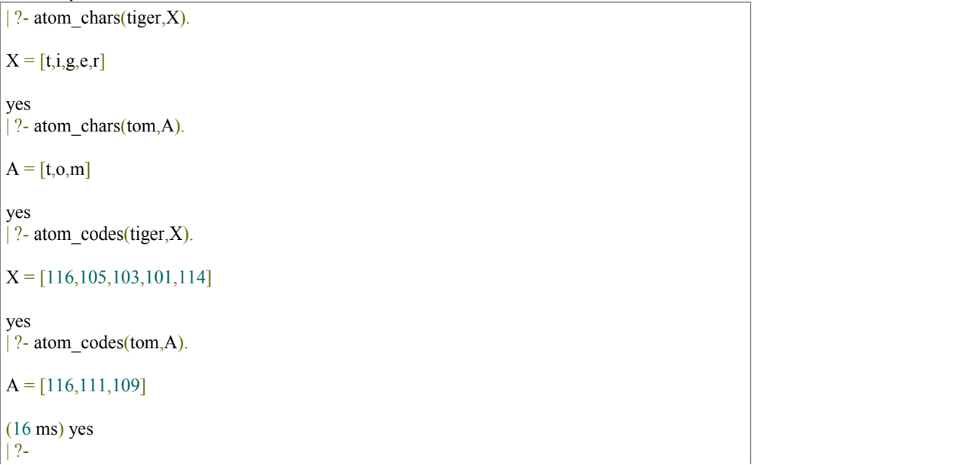
2. **The consult in Prolog**

