**Code :**

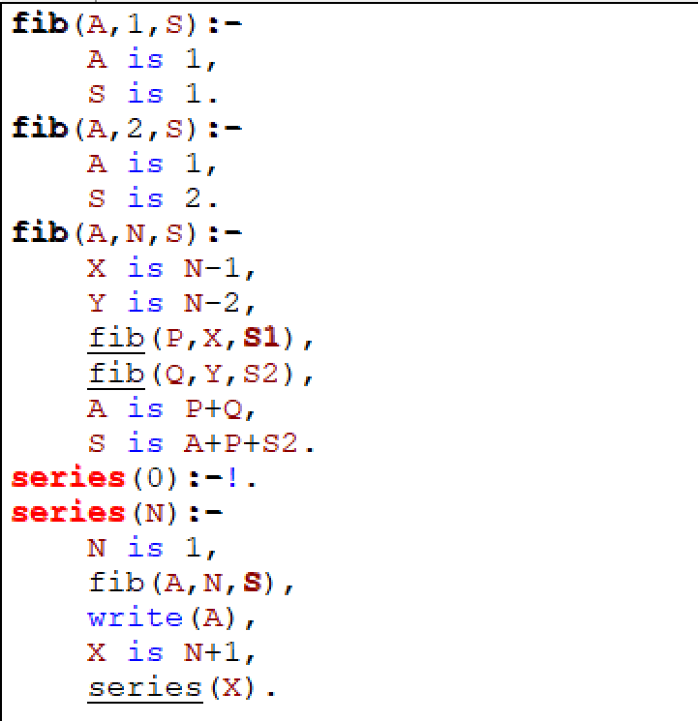

**Output:**

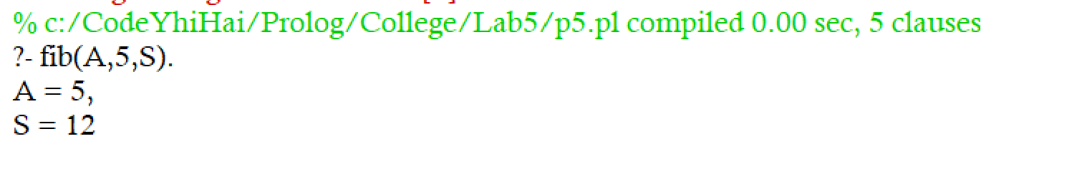

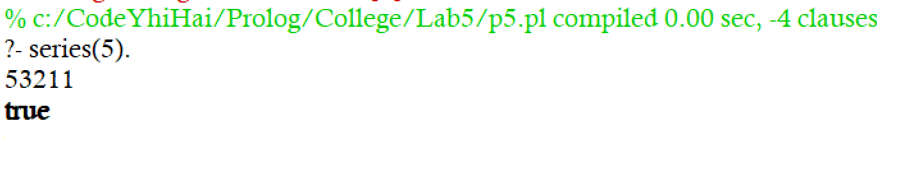

Here A is last number, S is Sum and series tells about the fibbonacci series in reverse order*