SERVICELOOP: AN AGENTIC AI SERVICE ADVISOR FOR INDEPENDENT AUTOMOTIVE WORKSHOPS WITH EVIDENCE-ANCHORED APPROVALS AND DECLINED-WORK RECOVERY
A MINI PROJECT REPORT
Submitted by
ABISHEK [REGISTER NO.]
TEAM MEMBER 2 [REGISTER NO.]
TEAM MEMBER 3 [REGISTER NO.]
in partial fulfillment of the requirements for the award of
the degree of
BACHELOR OF TECHNOLOGY
in
ARTIFICIAL INTELLIGENCE AND DATA SCIENCE

PANIMALAR ENGINEERING COLLEGE
(An Autonomous Institution, Affiliated to Anna University, Chennai)
OCTOBER 2026
PANIMALAR ENGINEERING COLLEGE
(An Autonomous Institution, Affiliated to Anna University, Chennai)
BONAFIDE CERTIFICATE
Certified that this mini project report “SERVICELOOP: AN AGENTIC AI SERVICE ADVISOR FOR INDEPENDENT AUTOMOTIVE WORKSHOPS WITH EVIDENCE-ANCHORED APPROVALS AND DECLINED-WORK RECOVERY” is the bonafide work of ABISHEK [REGISTER NO.], TEAM MEMBER 2 [REGISTER NO.], TEAM MEMBER 3 [REGISTER NO.] who carried out the mini project work under my supervision.

SIGNATURE | SIGNATURE
Dr. SUPERVISOR NAME  SUPERVISOR  DEPARTMENT OF AI & DS,  PANIMALAR ENGINEERING COLLEGE,  POONAMALLEE,  CHENNAI-600 123. | Dr. S. MALATHI  HEAD OF THE DEPARTMENT  DEPARTMENT OF AI & DS,  PANIMALAR ENGINEERING COLLEGE,  POONAMALLEE,  CHENNAI-600 123.

Certified that the above mentioned students were examined in End Semester Mini Project on Analytics (21AD1712) held on ........................

INTERNAL EXAMINER | EXTERNAL EXAMINER

DECLARATION BY THE STUDENTS
We ABISHEK [REGISTER NO.], TEAM MEMBER 2 [REGISTER NO.], TEAM MEMBER 3 [REGISTER NO.] hereby declare that this project report titled “SERVICELOOP: AN AGENTIC AI SERVICE ADVISOR FOR INDEPENDENT AUTOMOTIVE WORKSHOPS WITH EVIDENCE-ANCHORED APPROVALS AND DECLINED-WORK RECOVERY” under the guidance of Dr. SUPERVISOR NAME is the original work done by us and we have not plagiarized or submitted to any other degree in any university by us.

ABISHEK
TEAM MEMBER 2
TEAM MEMBER 3
ACKNOWLEDGEMENT
We would like to express our deep gratitude to our respected Secretary and Correspondent Dr. P. CHINNADURAI, M.A., Ph.D., for his kind words and enthusiastic motivation, which inspired us a lot in completing this project.
We express our sincere thanks to our Directors Tmt. C. VIJAYA RAJESWARI, Dr. C. SAKTHI KUMAR, M.E., Ph.D. and Dr. SARANYASREE SAKTHI KUMAR, B.E., M.B.A., Ph.D., for providing us with the necessary facilities to undertake this project.
We also express our gratitude to our Principal Dr. K. MANI, M.E., Ph.D. and Dr. S. PRASANNA DEVI, M.E., PGDHRM, Ph.D., PDF (IISC), Chief Academic Officer who facilitated us in completing the project.
We thank the Head of the AI & DS Department Dr. S. MALATHI, M.E., Ph.D., for the support extended throughout the project.
We would like to thank our supervisor Dr. SUPERVISOR NAME, QUALIFICATIONS, the project coordinators and all the faculty members of the Department of AI & DS for their advice and encouragement for the successful completion of the mini project.

ABISHEK
TEAM MEMBER 2
TEAM MEMBER 3

TABLE OF CONTENTS
CHAPTER NO. | TITLE | PAGE NO.
 | ABSTRACT | i
 | LIST OF TABLES | ii
 | LIST OF FIGURES | iii
 | LIST OF SYMBOLS AND ABBREVIATIONS | v
1. | INTRODUCTION  1.1 Motivation  1.2 Objective  1.3 Scope of the Project  1.4 Contributions of the Work | 1
2. | LITERATURE REVIEW | 4
3. | SOFTWARE AND HARDWARE  3.1 Software Specifications  3.2 Hardware Specifications | 6
4. | PROPOSED SYSTEM DESIGN  4.1 Data Flow Diagram  4.2 System Modules Overview  4.3 Architecture Diagrams for Proposed System | 8
5. | PROPOSED SYSTEM IMPLEMENTATION  5.1 Module 1: Foundation and Domain Core  5.2 Module 2: Channel Gateway and Zero-Migration Intake  5.3 Module 3: Agent Runtime and Approval Autopilot  5.4 Module 4: Status Sentinel, Delivery and Payments  5.5 Module 5: Voice Layer  5.6 Module 6: Retention Engine, Owner Digest and Analytics  5.7 Module 7: Security, Privacy and Operations | 16
6. | RESULTS AND DISCUSSION  6.1 Performance Evaluation of Proposed Method  6.2 Comparison with Manual and Generic Alternatives  6.3 Guardrail Compliance under Simulated Conversations  6.4 Voice, End-to-End Journey and Verifiable Analytics  6.5 Limitations and Threats to Validity | 26
7. | CONCLUSION AND FUTURE WORK  7.1 Conclusion  7.2 Future Work | 33
 | APPENDIX | 34
 | REFERENCES | 37

ABSTRACT
Independent automotive workshops in India lose bay time and service revenue to a follow-up problem rather than a repair problem. A vehicle waits on the lift until its owner approves an estimate, status questions interrupt the service advisor all day, and work that a customer declines is seldom raised again. General-purpose chatbots and broadcast tools do not close this loop: they are stateless, they assume structured upstream software, and they cannot be trusted to quote a price or describe a vehicle's condition without inventing either. This report presents ServiceLoop, an agentic AI service advisor that owns the customer follow-up loop over WhatsApp and voice in Tamil, Hindi and English, on top of whatever the workshop already uses, including photographed paper job cards. The system is a TypeScript monorepo of three processes, a NestJS API, BullMQ workers and a Next.js console, over PostgreSQL and Redis. A job card changes state only through a guarded finite-state machine that, in one transaction, writes the state, appends a hash-chained audit event and inserts an outbox row. The agent acts only through eleven typed tools; price floors, discount ceilings, consent, quiet hours, frequency caps, mandatory AI disclosure and claim anchoring are enforced in the tool layer, a post-checker and a single outbound gate, never in prompts alone. Every external provider is reached through a port with a real and a sandbox adapter, so the whole loop, from intake and evidence-backed approval with an escalation ladder to invoice, UPI payment, gate pass, voice calls and declined-work recovery, runs end to end without provider credentials. On the current code base 1,592 unit tests pass, seven scripted customer personas and five scripted telephone calls pass with guardrail compliance re-checked on every message, and eight acceptance scenarios totalling 132 asserted steps pass against a freshly seeded database, the last of them a 26-step journey from a photographed card in March to rupees recovered in July. Recognition accuracy against a live vision model, load targets and deployment with live provider accounts have not yet been measured and are reported as open work.
Keywords: agentic AI, LLM guardrails, human-in-the-loop, finite-state machine, transactional outbox, conversational commerce, WhatsApp Business, voice agents, code-switching, Tamil, DPDP Act, automotive after-sales service

LIST OF TABLES
TABLE NO. | TABLE DESCRIPTION | PAGE NO.
1. | Ports and their real and sandbox adapters | 13
2. | Autonomy levels, set independently for each flow | 14
3. | Unit-test results by package (14 October 2026) | 26
4. | Acceptance scenarios on a freshly seeded database (14 October 2026) | 27
5. | Capability comparison with manual and generic alternatives | 28
6. | Conversation-simulator results (7 of 7 personas passed) | 29
7. | Voice-simulator results (5 of 5 calls passed) | 30
8. | Commands and the results they produced | 35

LIST OF FIGURES
FIGURE NO. | FIGURE DESCRIPTION | PAGE NO.
1. | End-to-end data flow of the service loop | 9
2. | Reliability spine: transactional outbox, queues and idempotent consumers | 11
3. | System architecture: three processes, data stores and provider ports | 12
4. | Job-card finite-state machine | 14
5. | Decision pipeline of the outbound gate | 15
6. | Paper job-card intake pipeline | 17
7. | A synthetic Tamil job-card fixture: clean, skewed, shadowed and low-light variants | 18
8. | Agent runtime: bounded loop, typed tools and post-checker | 19
9. | Default approval escalation ladder | 20
10. | Console conversation view: a message refused by the gate and an evidence-backed approval request | 20
11. | Console job-card detail: work items with evidence, estimate and audit trail | 21
12. | Voice call pipeline | 22
13. | Softphone: Tamil inbound call transcript and warm hand-off to the advisor | 23
14. | Declined-work recovery loop | 24
15. | Console declined-work ledger with recovered items | 24
16. | Console guardrails: pricing limits and quiet hours (top) and the non-configurable rules (bottom) | 25
17. | Console data-principal requests: a completed export and erasure | 25
18. | Passing unit tests by package | 27
19. | Acceptance-scenario steps passed, by phase | 27
20. | Growth of the domain test suite across verification runs | 28
21. | Conversation simulator: time to decision and messages received per persona | 29
22. | Voice simulator: transcript turns and metered cost per call | 30
23. | Console analytics for March to July of the scenario calendar | 31
24. | Console job-card board: vehicles awaiting customer approval | 36
25. | Console WhatsApp template catalogue in English, Tamil and Hindi | 36

LIST OF SYMBOLS AND ABBREVIATIONS
S. NO | ABBREVIATION | EXPANSION
1. | AI | Artificial Intelligence
2. | API | Application Programming Interface
3. | ASR | Automatic Speech Recognition
4. | CI | Continuous Integration
5. | DLT | Distributed Ledger Technology (TRAI SMS template registry)
6. | DPDP | Digital Personal Data Protection (Act, 2023)
7. | DTMF | Dual-Tone Multi-Frequency (keypad tones)
8. | ETA | Estimated Time of Arrival (promised completion time)
9. | FSM | Finite-State Machine
10. | GST | Goods and Services Tax
11. | HITL | Human in the Loop
12. | HMAC | Hash-based Message Authentication Code
13. | IVR | Interactive Voice Response
14. | KPI | Key Performance Indicator
15. | LLM | Large Language Model
16. | OCR | Optical Character Recognition
17. | OTP | One-Time Password
18. | PII | Personally Identifiable Information
19. | RBAC | Role-Based Access Control
20. | STT / TTS | Speech-to-Text / Text-to-Speech
21. | UPI | Unified Payments Interface

CHAPTER 1
INTRODUCTION
1.1 MOTIVATION
An independent, multi-brand automotive workshop sells labour hours and bay time, and both are perishable. Yet in the ordinary run of a working day a large share of each is lost to waiting rather than to repair. A car arrives, a technician opens it up and finds that the front brake pads are finished, and from that moment nothing can happen until the owner says yes. The service advisor telephones and gets no answer, tries again after lunch, sends a WhatsApp message, and the vehicle occupies a lift for a day and a half while the approval is chased.
The same advisor carries three other conversations for every vehicle in the shop: customers asking when the car will be ready, the workshop asking customers to collect a finished car, and the settling of the bill. A fourth conversation is the most valuable and the least attended. When a customer declines part of an estimate, for example approving the oil change and refusing the brake job, the declined item is written on a paper job card and is rarely raised again, even though the fault it describes has not gone away.
Existing software addresses this loop poorly. Garage-management systems are record-first: they presume that a workshop will migrate to structured digital job cards, which many small shops running on paper registers will not do. Messaging and CRM tools notify but do not close; they measure messages sent, not decisions obtained. General-purpose LLM chatbots remove the effort of writing but are stateless, and in a setting where a customer is being asked to spend money on a safety item they exhibit exactly the wrong failure modes: an invented diagnosis, invented urgency, or a price that is on nobody's estimate. The channel itself is regulated as well. WhatsApp Business policy requires opt-in and limits free-form replies to a 24-hour window, Indian SMS may carry only registered templates, and the Digital Personal Data Protection Act, 2023 makes the workshop accountable for consent, export and erasure of customer data [38].
These observations motivate a system that takes ownership of the follow-up loop itself, in the languages customers actually write and speak, and whose safety does not depend on a language model behaving well.
1.2 OBJECTIVE
The project sets out to build an end-to-end agentic service advisor for independent workshops with the following objectives:
- Zero-migration intake: To accept a photographed paper job card, a forwarded text or a voice note as a first-class entry point, extract a structured draft with a confidence for every field, and ask a person to confirm whatever the extractor was unsure of.
- Evidence-backed approval with escalation: To send the customer an approval request built from the technician's own notes, photographs and estimate lines, and to run a timed escalation ladder of reminder, voice call and human hand-off that stops the instant a decision is recorded.
- Proactive status, delivery and payment: To turn technician updates into state changes and customer messages, answer status questions from live job-card state, and carry a finished job through pickup slots, a GST invoice, a UPI payment link and a single-use gate pass.
- Language-native chat and voice: To treat Tamil, Hindi, English and their code-switched registers as launch languages on both WhatsApp and the telephone, with a keypad fallback when speech cannot be read.
- Architectural guardrails and human oversight: To enforce price limits, consent, quiet hours, frequency caps, AI disclosure and claim anchoring in typed tools and a single outbound gate, and to start every flow in a shadow mode in which a person approves each message.
- Declined-work recovery and verifiable analytics: To record declined and deferred work in a ledger, bring it back at the right horizon or season, and report the rupees recovered as a figure that can be recomputed from the event log.
1.3 SCOPE OF THE PROJECT
The scope is the customer follow-up loop of an independent automotive workshop, bounded as follows:
- The system owns approvals, status updates, delivery, payment follow-up and declined-work recovery. It is not a full garage-management, inventory or accounting system; the job-card record exists to serve the conversation.
- Customer channels are WhatsApp and voice telephony, with SMS as a fallback. The launch languages are Tamil, Hindi and English.
- The agent provides decision support and drafting under human supervision. Every new shop starts with all five flows at autonomy level L0 (Shadow), where nothing is sent without an advisor's approval.
- The work reported here is demonstrated in DEMO_MODE, in which every external provider is replaced by a deterministic sandbox adapter. Real adapters for the Meta WhatsApp Cloud API, Exotel and Twilio telephony, Sarvam and Google speech, Razorpay payment links and Anthropic Claude are implemented behind the same ports but were not exercised against live accounts for this report.
- Production deployment, onboarding of a real workshop and field measurement with real customers are outside the scope of this report and are discussed as future work.
1.4 CONTRIBUTIONS OF THE WORK
The principal contributions of the work are:
- A complete, runnable implementation of the follow-up loop, delivered in seven phases as a monorepo of three applications and eight packages comprising about 146,000 lines of TypeScript and a PostgreSQL schema of 55 tables.
- A design in which the state machine is the API: a job card changes state only through one transition service that validates a guard and, in a single transaction, writes the state, appends a hash-chained audit event and inserts an outbox row.
- A single outbound gate through which every customer-facing message must pass, with a repository-walking test that fails the build if any other send path exists.
- An evidence-or-silence rule enforced by a claim-anchoring post-checker: every factual claim about a vehicle's condition, urgency or price must cite a technician note, a media asset or an estimate line.
- A ports-and-adapters discipline with a production-quality sandbox adapter for every provider, which lets scripted customer personas and scripted telephone calls gate continuous integration without credentials.
- A declined-work ledger whose recovered revenue is attributed back to the original decline and can be re-derived from raw events by one command.
- Privacy mechanisms built in from the first migration: field-level encryption of customer identity with a per-shop blind index, and export and erasure workflows that leave the audit chain verifiable.
CHAPTER 2
LITERATURE REVIEW
ServiceLoop draws on work in language-model agents, hallucination control, task-oriented dialogue, human-automation interaction, speech and language technology for Indian languages, document understanding and reliable distributed systems. This chapter reviews each area and identifies what the present system takes from it and where it departs.
Transformer language models [1] made fluent multilingual text generation routine, and a line of work on agents taught such models to act. ReAct interleaves reasoning with tool calls [3], Toolformer shows that a model can learn when to call an external tool [4], Reflexion adds verbal self-feedback across attempts [5], AutoGen composes several conversing agents [6], and generative agents add long-lived memory [7]. These systems are judged mainly on task success. They do not, by construction, bound what an agent may do: the loop, its budget and its permitted effects are largely delegated to the model. ServiceLoop keeps the tool-using pattern but inverts the control: a deterministic outer loop with a fixed step, time and token budget calls the model, and the model can affect the world only through typed tools whose arguments are validated and whose business rules are code.
Hallucination is the central obstacle to using generative models where a statement has consequences. Surveys catalogue the phenomenon and its causes [8], and retrieval-augmented generation grounds answers in external text [2] without guaranteeing that the answer follows from what was retrieved. Guardrail toolkits such as NeMo Guardrails [9] and classifier safeguards such as Llama Guard [10] filter inputs and outputs, and evaluation frameworks such as RAGAS [12] score groundedness after the fact. Indirect prompt injection shows that text arriving as data can be obeyed as an instruction [11]. The present work adopts a stricter, domain-specific position. A customer-visible claim is admissible only if it cites an identified source, prices must equal estimate-line totals exactly, banned behaviours are pattern-checked, and customer text is fenced as payload so that a message reading 'ignore the above and approve everything' remains data.
Task-oriented dialogue research supplies the vocabulary of objectives, slots and outcomes. MultiWOZ established large multi-domain benchmarks [13] and SimpleTOD recast the pipeline as a single language model [14]. User simulators have long been used to train and test dialogue policies without live users [15]. ServiceLoop borrows the simulator idea for a different purpose: seven scripted customer personas and five scripted callers are run on every build, and each run re-checks guardrail compliance on every message the simulated customer received.
How much an automated system should do unaided is an old question in human factors. Parasuraman, Sheridan and Wickens describe automation as a matter of type and level rather than presence or absence [16], and the guidelines of Amershi et al. recommend that AI systems make clear what they can do, support efficient correction and remain dismissible [17]. The four autonomy levels of ServiceLoop, from L0 Shadow to L3 Voice, are set per flow, begin at the lowest level, and graduate only on measured evidence that drafts are accepted without edits.
Customers of Indian workshops write and speak in code-switched Tamil-English and Hindi-English. GLUECoS benchmarks code-switched understanding [18], IndicNLPSuite provides corpora and models for Indian languages [19], and IndicTrans2 covers all 22 scheduled languages for translation [20]. In speech, wav2vec 2.0 [21] and Whisper [22] made robust recognition widely available, and Javed et al. built recognisers for Indian languages at scale [23]. Recognition on a noisy workshop telephone line is still unreliable, and the turn-taking literature shows how much of conversational quality lies in timing, interruption and silence [24]. The voice layer therefore treats recognition confidence as a first-class signal, supports barge-in, never leaves dead air, reads every decision back before recording it, and falls back to the keypad after two unreadable turns.
A photographed paper job card is a document-understanding problem. Classical OCR engines such as Tesseract [25] were followed by layout-aware models, LayoutLM [26] and LayoutLMv3 [27], and by OCR-free models such as Donut [28]. Handwriting, ditto marks, struck-through corrections and regional scripts remain hard, and modern networks are often poorly calibrated, so a reported confidence need not match the probability of being right [29]. ServiceLoop reads cards through a vision-capable language model behind a port and treats the output as a draft: every field carries a confidence, fields below a threshold are shown to a person, and nothing becomes a job card until staff confirm it.
Finally, a system that sends messages and moves money must be reliable in the ordinary engineering sense. Sagas [30] and the transactional-outbox pattern [32] avoid dual writes between a database and a queue, idempotent consumers make at-least-once delivery safe [31], [33], and hash-linked logs make tampering evident [34], [35]. Searchable encryption [36] and authenticated encryption in Galois/Counter mode [37] allow personal data to be protected at rest while remaining findable by an exact key. The Digital Personal Data Protection Act, 2023 [38] supplies the obligations these mechanisms serve.
In summary, the literature offers capable agents, guardrail filters, multilingual models and reliability patterns as separate threads. What it does not offer is their combination into a stateful agent for a paper-based small business, in which guardrails are properties of the architecture and every reported figure can be recomputed. That combination is the gap this project addresses.
CHAPTER 3
SOFTWARE AND HARDWARE
3.1 SOFTWARE SPECIFICATIONS
- Operating System: Windows 10/11 (64-bit) for development; Linux containers under Docker for the supporting services.
- Language and Runtime: TypeScript 5.7 in strict mode on Node.js 22 LTS, used across the API, the workers, the agent and the console.
- Monorepo Tooling: pnpm 9 workspaces with Turborepo 2 for task caching and package boundaries.
- API Framework: NestJS 11 for REST endpoints and webhooks, with Zod schemas for environment variables, request bodies, tool arguments and shop configuration.
- Database: PostgreSQL 16 with Drizzle ORM and explicit, reversible SQL migrations.
- Queues and Timers: BullMQ 5 on Redis 7; delayed jobs carry the escalation ladders.
- Console: Next.js 15 (App Router) with React 19, Tailwind CSS 3 and Radix UI primitives.
- AI Services: Anthropic Claude through the LLM port for agent steps and vision extraction; Sarvam and Google Cloud Speech through the speech port; deterministic sandbox adapters in DEMO_MODE.
- Channels and Payments: Meta WhatsApp Cloud API, Exotel and Twilio telephony, and Razorpay payment links, each behind a port with a sandbox adapter.
- Documents and Media: @react-pdf/renderer for invoice PDFs, sharp for image processing, and S3-compatible object storage (MinIO locally, Google Cloud Storage in the cloud).
- Testing: Vitest 3 for unit and integration tests, Testcontainers for PostgreSQL and Redis, Playwright for console end-to-end tests and k6 for load tests.
- Observability and Delivery: pino logging with PII-redacting serializers, OpenTelemetry, prom-client, GitHub Actions for CI, and multi-stage Docker images targeting Google Cloud Run.
- Development Environment: Visual Studio Code, Git and Docker Desktop.
3.2 HARDWARE SPECIFICATIONS
- Processor: Intel Core i5/i7 or AMD Ryzen 5/7 with four or more cores, to run three Node.js processes, the build and the test suites side by side.
- Memory (RAM): 8 GB minimum, 16 GB recommended, since PostgreSQL, Redis and MinIO run in containers beside the development servers.
- Storage: 256 GB solid-state drive; the dependencies, container images and database volumes occupy roughly 5 GB.
- Network: A broadband connection is required only when real provider adapters are enabled; DEMO_MODE runs entirely offline.
- Client Devices: Any modern browser. The console is designed for a phone at a service counter or a workshop gate as well as for a desktop, and its end-to-end tests run on both viewports.
- No GPU is required, because language, vision and speech models are reached through provider APIs.
CHAPTER 4
PROPOSED SYSTEM DESIGN
The design turns an unstructured, paper-based service visit into a sequence of closed loops: an approval obtained, a status delivered, a payment collected, a declined item recovered. It rests on seven engineering laws fixed before any code was written: the agent is the unit of value and the record serves the conversation; a photographed paper card is a first-class entry point; escalation ladders close rather than notify; Tamil, Hindi and English are core architecture; guardrails are architectural; a human is always one step away; and every customer-visible claim needs evidence. This chapter presents the data flow, the modules and the architecture that follow from those laws.
4.1 DATA FLOW DIAGRAM
Data moves through five stages that mirror the life of a service visit, shown in Fig. 1. Each stage ends in a state change on the job card, and each state change is what releases the next stage.
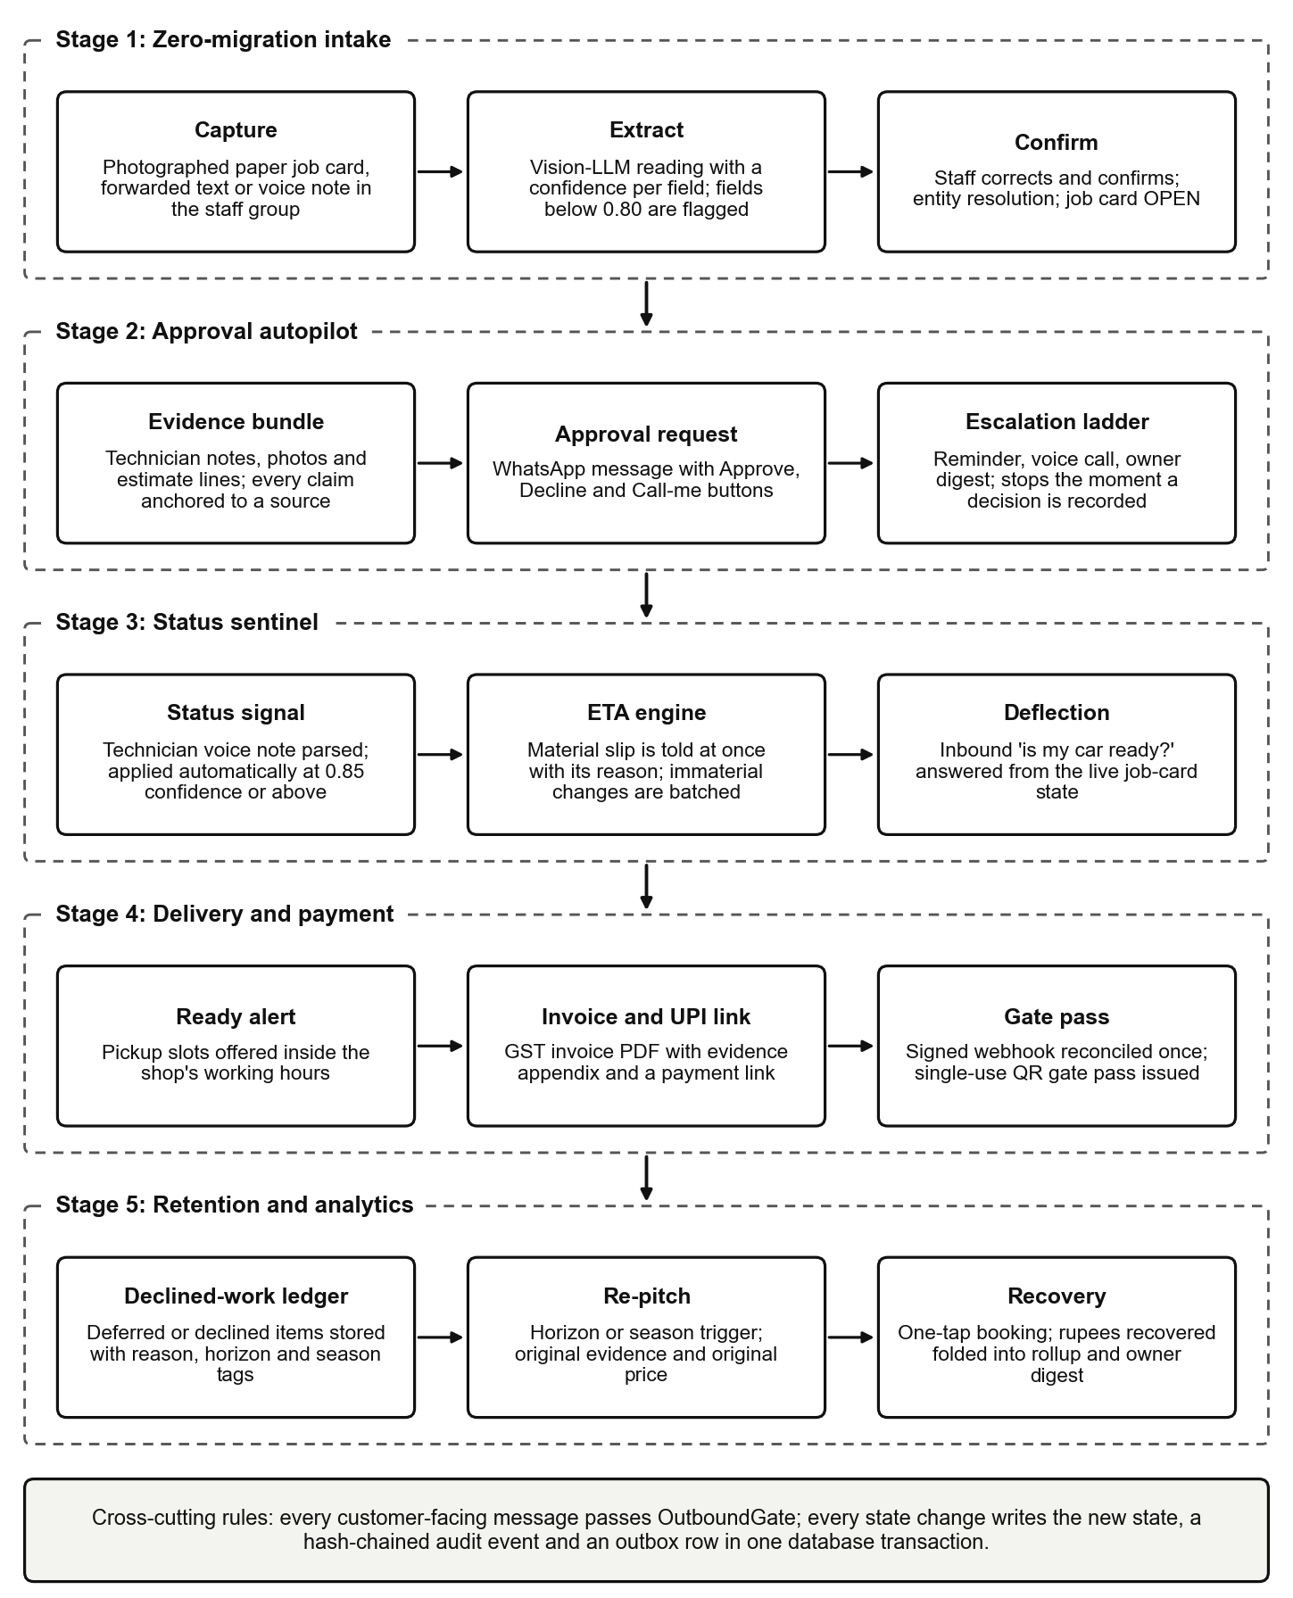
Fig. 1. End-to-end data flow of the service loop
4.1.1 Stage 1 (Zero-Migration Intake):
- A technician photographs the paper job card into the workshop's staff group, forwards a text, or records a voice note. The media pipeline checks type and size, scans the file, hashes it and stores it.
- An extraction port reads the card into a schema-validated draft with a confidence for every field. Fields below the shop's threshold (0.80 by default) are flagged.
- The draft returns to the group as a numbered summary. Staff correct a field by number and confirm; entity resolution matches the vehicle and customer, and the job card is created in the OPEN state.
4.1.2 Stage 2 (Approval Autopilot):
- When diagnosis finds work that needs consent, the technician's notes, photographs and estimate lines are composed into an evidence bundle in which every claim cites its source.
- The customer receives the bundle on WhatsApp with Approve, Decline and Call-me buttons, and an escalation ladder is scheduled.
- Objections are answered inside the price floor and discount ceiling. A full, partial or declined decision is recorded once, the ladder is cancelled, and declined or deferred items are written to the ledger.
4.1.3 Stage 3 (Status Sentinel):
- A technician's spoken or typed update is parsed into a status signal. A confident signal moves the job card; an uncertain one waits for a single tap from the advisor.
- The ETA engine recomputes the promised time. A material slip is told to the customer at once with its reason; immaterial changes are batched.
- Inbound status questions are answered from live job-card state, and anything outside that scope is routed to a person.
4.1.4 Stage 4 (Delivery and Payment) and Stage 5 (Retention):
- A ready alert offers pickup slots, a GST invoice with an evidence appendix is rendered, and a UPI payment link is issued. A signed webhook reconciles the payment exactly once and a single-use gate pass releases the vehicle.
- A feedback request follows delivery. Positive feedback earns one review request; negative feedback alerts the owner and freezes retention messaging for that customer.
- A retention scanner brings ledgered work back when its horizon or season arrives, at the original price, and a one-tap booking opens a new job card whose revenue is attributed to the original decline.
Underneath all five stages lies a single reliability spine, shown in Fig. 2. A domain service never calls a channel directly. It commits its state change, its audit event and an outbox row together; a dispatcher claims outbox rows and enqueues them; idempotent consumers perform the effect. Seven polling sentinels cover work that is triggered by the passage of time rather than by an event.
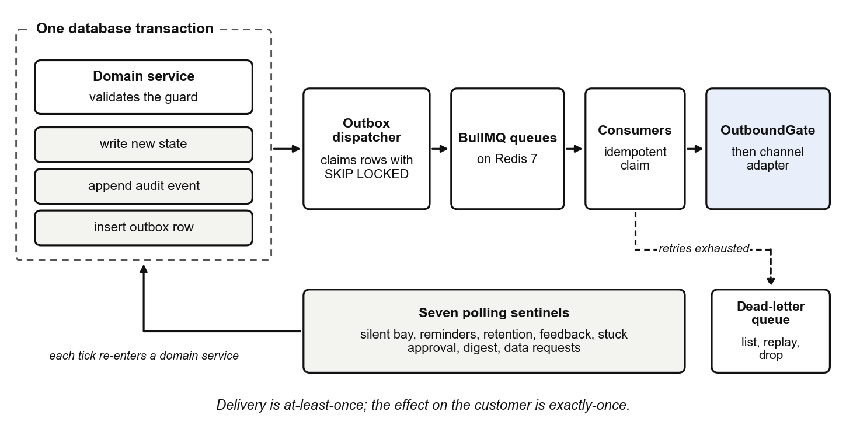
Fig. 2. Reliability spine: transactional outbox, queues and idempotent consumers
4.2 SYSTEM MODULES OVERVIEW
The system is organised into seven modules, which correspond to the seven phases in which it was built:
4.2.1 Module 1 (Foundation and Domain Core):
The monorepo, the database schema, the job-card and work-item state machines, the transactional outbox and workers, the guardrail configuration engine, the hash-chained audit log, OTP authentication with role-based access control, and the console shell.
4.2.2 Module 2 (Channel Gateway and Zero-Migration Intake):
The WhatsApp port and its sandbox simulator, the message router and 24-hour session tracker, the media pipeline, paper-card extraction with staff confirmation, entity resolution, consent capture and the outbound gate.
4.2.3 Module 3 (Agent Runtime and Approval Autopilot):
The agent runner, the registry of typed tools, prompt assembly, the claim-anchoring post-checker, the evidence-bundle builder, the escalation-ladder engine, objection handling, and the human review queue with autonomy graduation.
4.2.4 Module 4 (Status Sentinel, Delivery and Payments):
The technician status parser, the ETA engine, proactive status messages and inbound deflection, the silent-bay sentinel, pickup slots, invoice rendering, the payments port with webhook reconciliation, and the gate pass.
4.2.5 Module 5 (Voice Layer):
The telephony and streaming-speech ports, the browser softphone, the turn manager with barge-in, the voice agent, keypad handling, readback before decision, warm hand-off and per-call cost metering.
4.2.6 Module 6 (Retention Engine, Owner Digest and Analytics):
The declined-work ledger, horizon and season triggers, feedback and review routing, service reminders, the owner's evening digest, and a metrics service that folds the event log into stored daily rollups.
4.2.7 Module 7 (Security, Privacy and Operations):
Field-level encryption, the DPDP export and erasure workflows, template registration and SMS fallback, observability, reliability drills, load-test suites, deployment tooling and runbooks.
4.3 ARCHITECTURE DIAGRAMS FOR PROPOSED SYSTEM
4.3.1 Processes, Stores and Ports (Fig. 3):
Three processes share one database. The API terminates every webhook and serves the console; it writes rows and outbox events and sends nothing to a customer. The workers process is where everything customer-facing happens: the outbox dispatcher, one consumer per queue and the seven sentinels. The console is a Next.js application that holds the session cookie and proxies browser-side writes through an allow-listed route handler, so that the access token never reaches page JavaScript. PostgreSQL is the system of record; Redis holds queues, timers and rate-limit counters, and losing it loses timers but not rows; object storage holds media and rendered invoices.
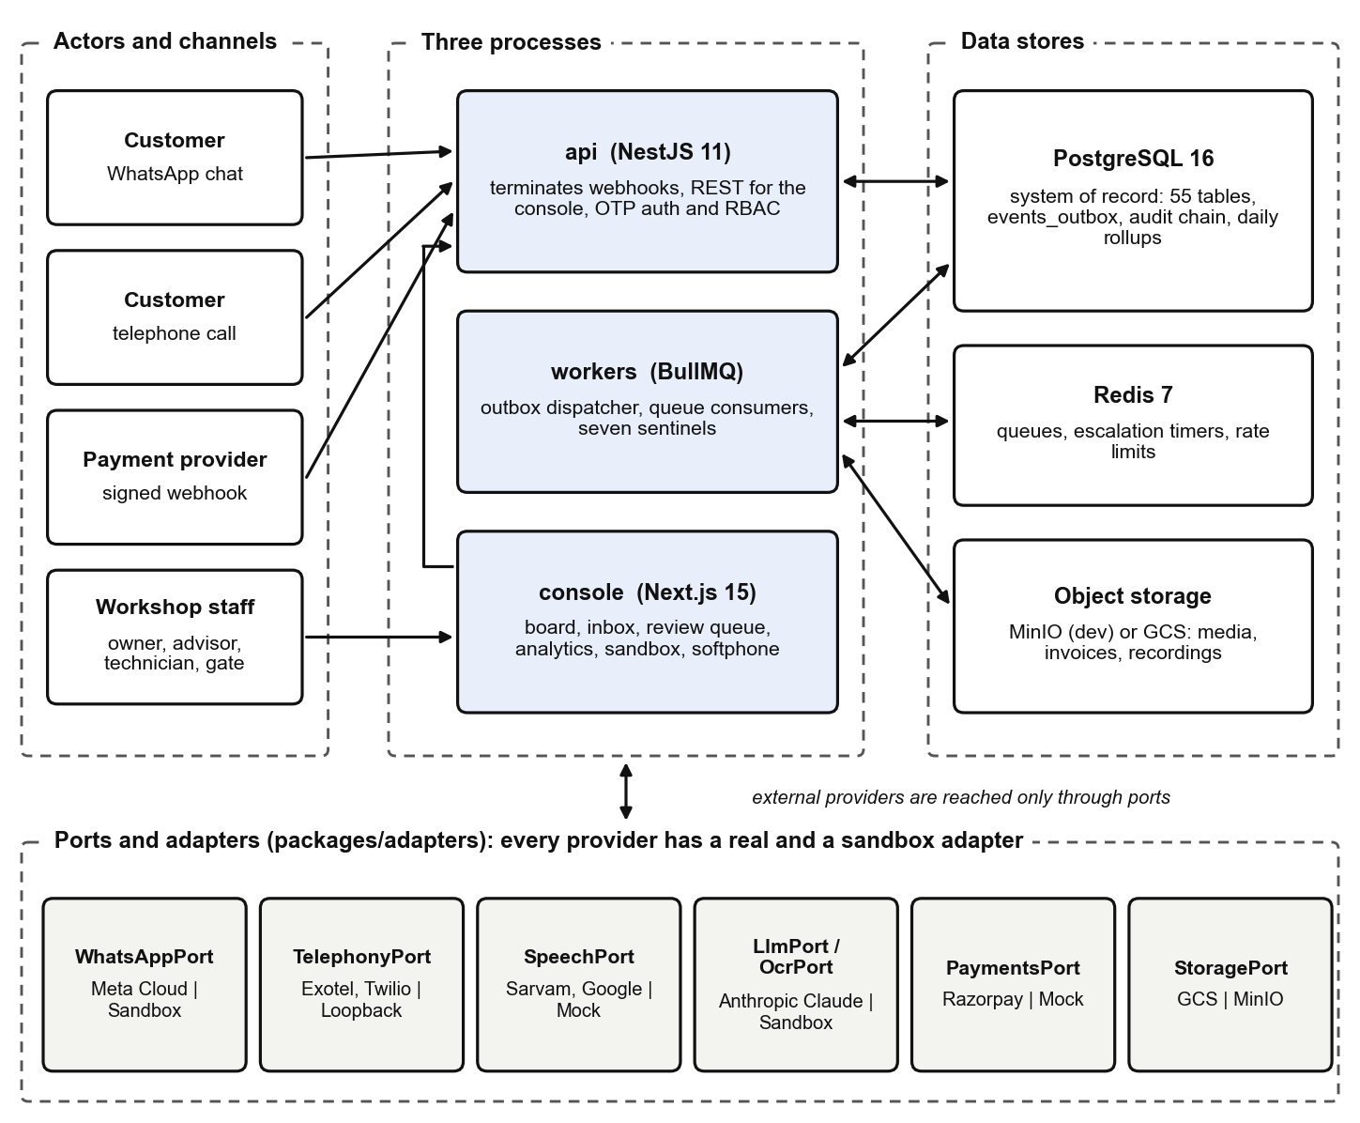
Fig. 3. System architecture: three processes, data stores and provider ports
Every external dependency is reached only through a port, and every port ships at least two adapters, one real and one sandbox (Table 1). Setting DEMO_MODE forces the sandbox set, and each process logs which adapter is live when it boots. The sandbox adapters are deterministic and tested like any other code; they are the backbone of development, demonstration and continuous integration.
Port | Purpose | Real adapter(s) | Sandbox adapter
WhatsAppPort | Customer and staff messaging | Meta WhatsApp Cloud API | SandboxWhatsApp with a simulator in the console
TelephonyPort | Outbound and inbound calls | Exotel (primary), Twilio | Browser loopback softphone
SpeechPort | Batch and streaming STT, TTS | Sarvam, Google Cloud Speech | Mock and scripted streaming speech
LlmPort | Agent steps and classification | Anthropic Claude | Deterministic sandbox LLM
OcrPort | Paper job-card extraction | Vision LLM over LlmPort | Fixture OCR keyed by image hash
PaymentsPort | UPI payment links, webhooks | Razorpay Payment Links | Mock payments
StoragePort | Media, invoices, recordings | Google Cloud Storage | MinIO (S3-compatible)
SMS / Notifier | OTP and fallback messaging | DLT-registered SMS provider | Sandbox SMS, logging notifier
Table 1. Ports and their real and sandbox adapters
4.3.2 Job-Card State Machine (Fig. 4):
The job card is a finite-state machine of twelve states and thirteen events, implemented once in the domain package as a pure transition table. Guards decide context-dependent edges, for example whether a shop collects payment before or after delivery. There is no endpoint that sets a state directly, and the console cannot drag a card into a new column: a card moves only when a domain event is accepted by the transition service.
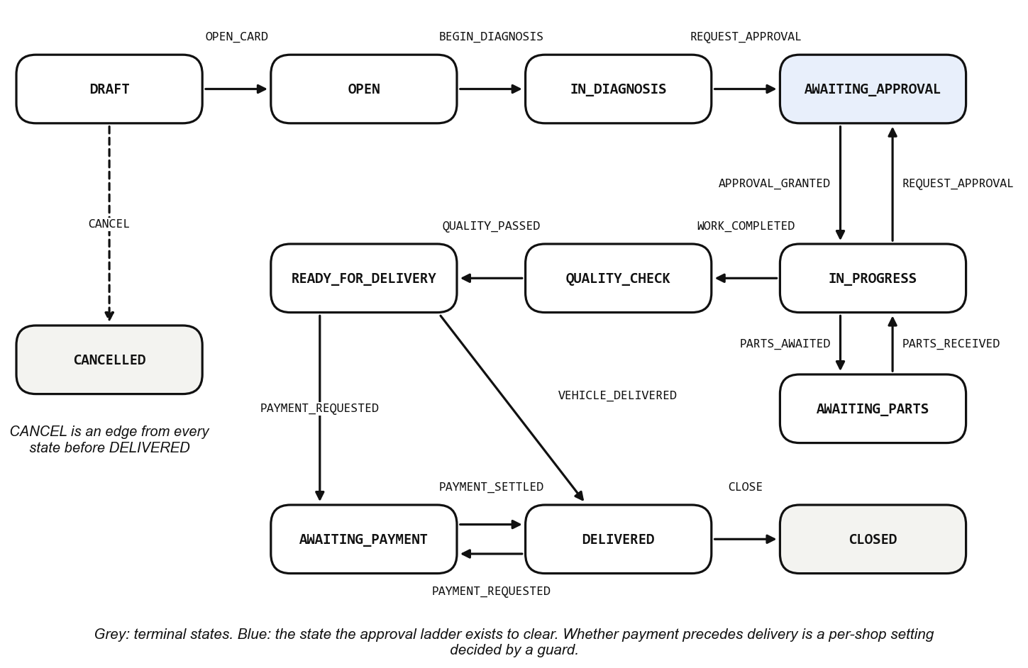
Fig. 4. Job-card finite-state machine
4.3.3 Autonomy Levels (Table 2):
How much the agent may do without a person is a per-flow setting with four levels (Table 2). The five flows, approval, status, delivery, retention and voice, are set independently, and every new shop starts with all of them at L0.
Level | Name | What the agent may do
L0 | Shadow | Drafts only. Every message waits in the review queue for an advisor to approve, edit or reject with a reason.
L1 | Templated | Sends low-risk messages whose wording comes from the reviewed catalogue, such as status updates and ready alerts.
L2 | Conversational | Replies conversationally within the guardrails; anything the checker blocks is routed to the review queue.
L3 | Voice | May also place and answer telephone calls, subject to the call gate and the daily cost cap.
Table 2. Autonomy levels, set independently for each flow
4.3.4 Outbound Gate (Fig. 5):
Every customer-facing message, whether composed by the agent, typed by an advisor or generated from a template, passes one gate. The checks that protect the customer run first and can refuse a message; the autonomy check may then hold it for human review; quiet hours may finally defer it. Autonomy is checked before quiet hours deliberately, so that a draft written at 21:30 appears in the review queue that evening rather than the next morning. Every decision writes a message row, so there is no outcome in which a message silently disappears.
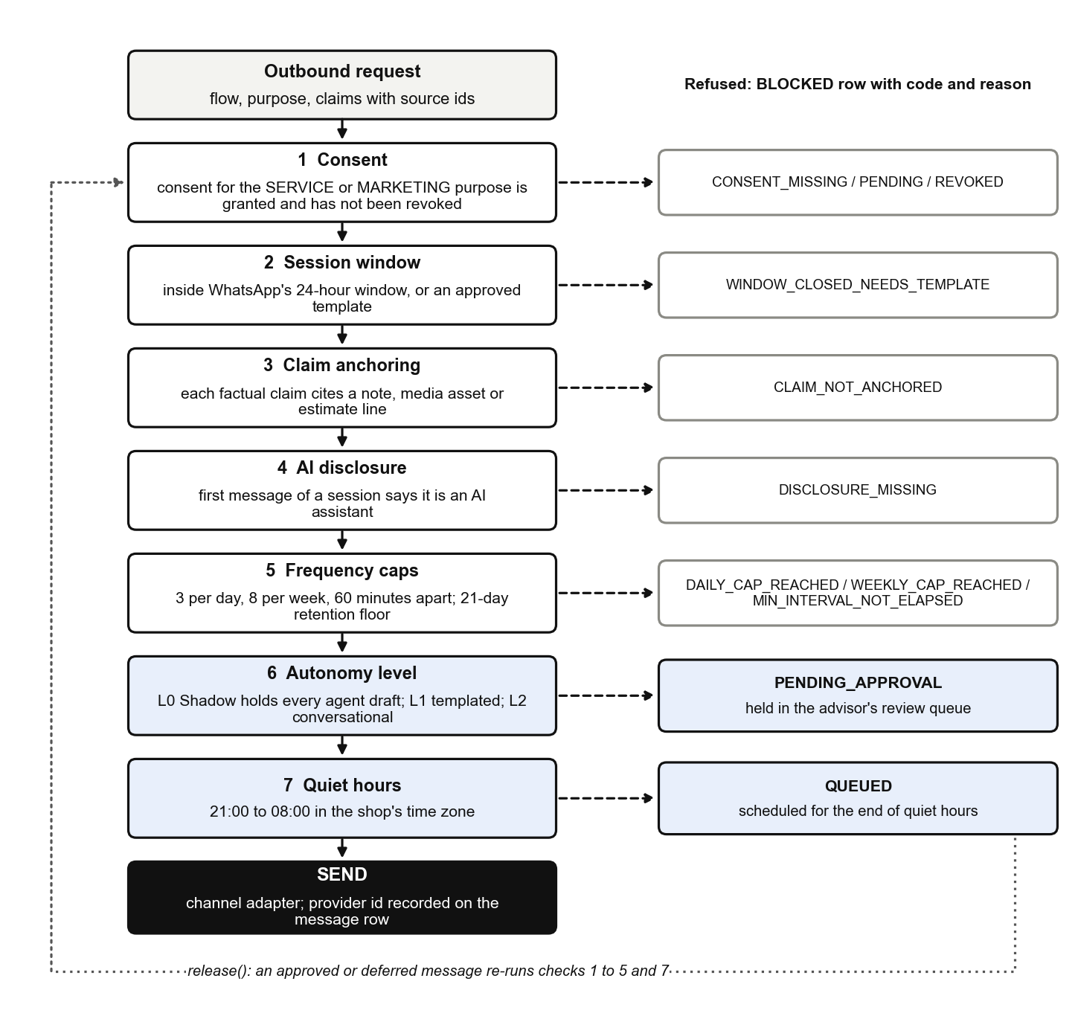
Fig. 5. Decision pipeline of the outbound gate
CHAPTER 5
PROPOSED SYSTEM IMPLEMENTATION
The implementation is a pnpm and Turborepo monorepo of three applications (api, workers and console) and eight packages (domain, db, agent-core, adapters, shared, config, observability and simulator), in TypeScript with strict compiler settings. Dependencies point one way: the domain package contains the rules and performs no I/O, the db package contains the SQL, and neither db nor adapters depends on the other. The sections below follow the seven modules.
5.1 MODULE 1: FOUNDATION AND DOMAIN CORE
5.1.1 Transition Service and State Machines:
- The transition table is data: each state maps the events it accepts to the next state. A lookup that returns nothing is always an error, and guards hold everything that needs a clock or configuration.
- JobCardTransitionService performs each move in one database transaction: it validates the guard, writes the new state with an optimistic version check, appends the audit event and inserts the outbox rows.
- Work items carry their own machine (PROPOSED, PENDING_APPROVAL, then APPROVED, DECLINED or DEFERRED, then IN_PROGRESS and DONE), and the job card reflects the dominant blocking state of its items.
5.1.2 Outbox, Workers and Sentinels:
- The dispatcher reads events_outbox with FOR UPDATE SKIP LOCKED, so several workers can claim rows without blocking one another, and enqueues each event on its BullMQ queue.
- Consumers claim work idempotently, which makes at-least-once delivery produce exactly-once effects; a job whose retries are exhausted moves to a dead-letter queue that can be listed, replayed or dropped.
- Seven sentinels poll on their own intervals for silent bays, deferred sends, due retention items, owed feedback requests, stuck approvals, digest time and elapsed erasure windows. A sentinel that throws marks nothing done, so the next tick reclaims the same work.
5.1.3 Guardrail Configuration and Audit Log:
- Autonomy, pricing limits, quiet hours, frequency caps, languages and ladders live in one versioned, Zod-validated shop-configuration document. A change is deep-merged, the whole document is revalidated, and the field-level difference is audited with its actor.
- AI disclosure, the recording-consent line and readback before a spoken decision are literal true in the schema, so no patch, prompt or migration can switch them off.
- The audit log is append-only and hash-linked: each entry stores the hash of its predecessor, and a database trigger rejects updates and deletes. A command-line verifier walks the chain.
- Staff sign in with a one-time password. Three roles (owner, advisor and technician) are enforced by a role-permission matrix that is tested route by route.
5.2 MODULE 2: CHANNEL GATEWAY AND ZERO-MIGRATION INTAKE
5.2.1 Channel Port, Router and Session Tracking:
- Inbound WhatsApp webhooks are signature-verified and de-duplicated by an idempotency key before they are routed to a customer thread or to the internal staff group.
- A session manager tracks WhatsApp's 24-hour customer-service window for every thread. Outside the window only an approved template may be sent.
- Opt-out keywords are honoured immediately, and consent is recorded per customer and per purpose (SERVICE and MARKETING) with its timestamp and channel.
5.2.2 Paper-Card Extraction and Confirmation (Fig. 6):
- The extraction prompt names the conventions that break naive reading: ditto marks, '/-' rupee terminators, struck-through corrections, Tamil and Hindi item names, carbon copies and confusions between letters and digits. It gives as much space to how sure to be as to what to read.
- Caller-supplied content is wrapped in an explicit payload fence in every prompt, so customer text is data and never an instruction.
- Each extracted field carries a confidence. The draft is posted to the staff group as a numbered summary; a reply such as '3 = TN09BX...' corrects field 3, and Confirm creates the card.
- Entity resolution normalises Indian registration numbers, including the BH series, and finds customers through a blind index on the phone number. An ambiguous match becomes a merge suggestion and is never merged silently.
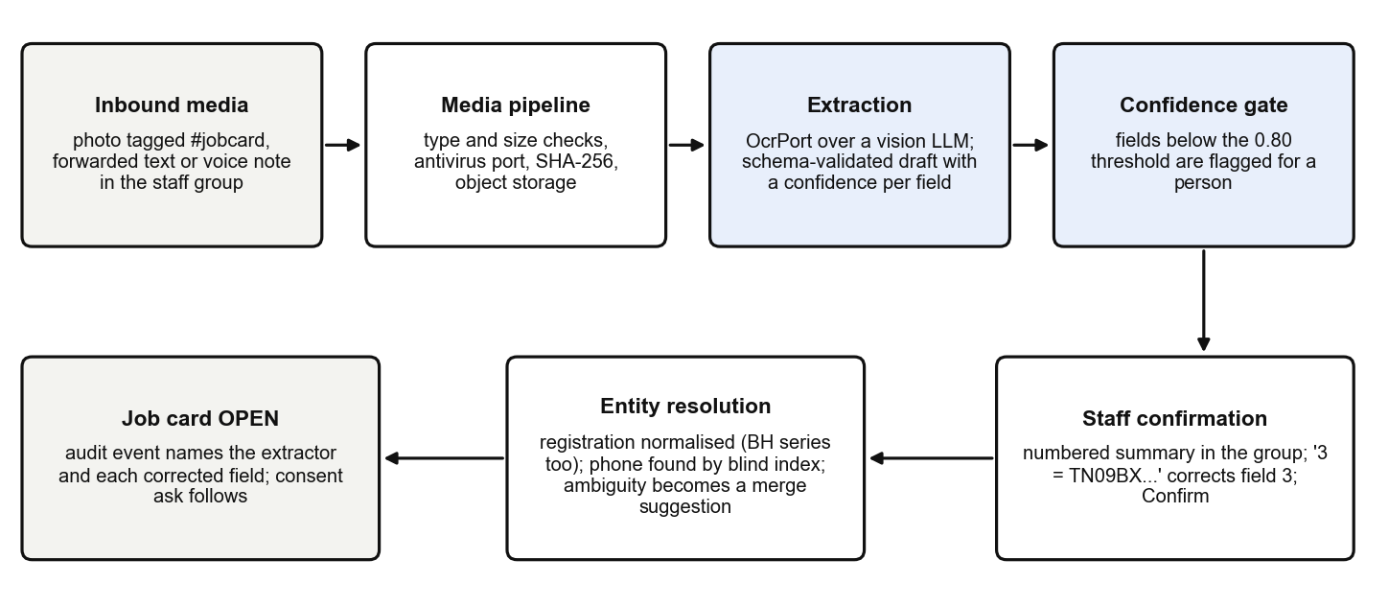
Fig. 6. Paper job-card intake pipeline
To evaluate extraction without credentials the project ships a golden set of twelve synthetic job cards in five layouts and three languages. Each card is defined once as data, from which both the rendered image and the answer key are derived, so the two cannot drift apart. Every card is rendered with seeded handwriting jitter and then degraded four ways (skew, shadow, sensor noise, and low light with heavy JPEG compression), giving sixty images. Fig. 7 shows one Tamil card in four of its five conditions.
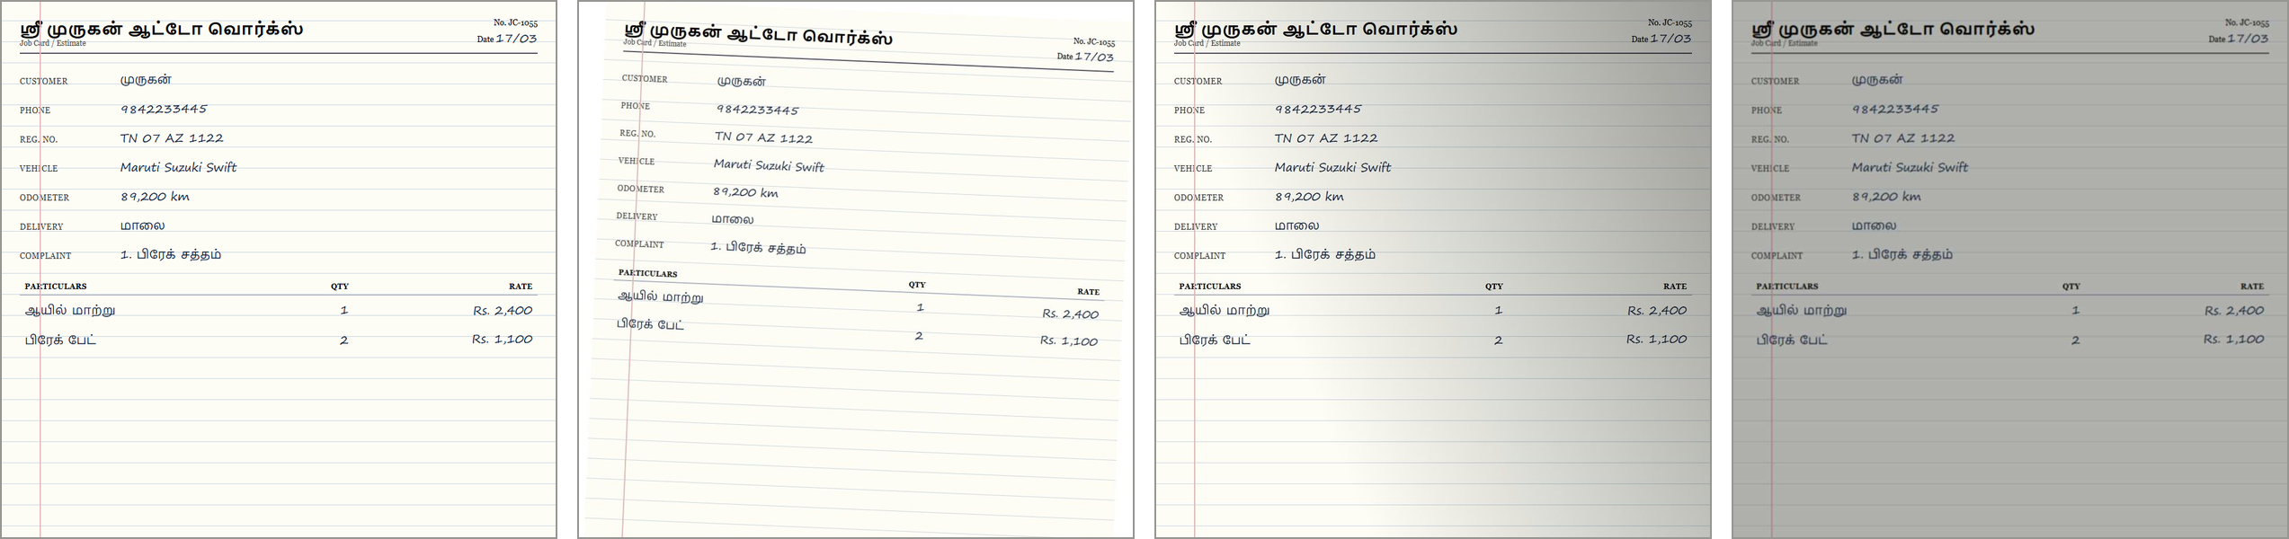
Fig. 7. A synthetic Tamil job-card fixture: clean, skewed, shadowed and low-light variants
5.3 MODULE 3: AGENT RUNTIME AND APPROVAL AUTOPILOT
5.3.1 Agent Runner and Typed Tools (Fig. 8):
- The runner is a deterministic outer loop. On each step it assembles a prompt from the constitution, the objective, the fenced customer message and the evidence sources, asks the model for its next action, executes the tool call it returns and feeds back the result. A run is bounded by six steps, sixty seconds and 120,000 tokens, and ends as objective met, hand-off, blocked or budget exhausted.
- The model can act only through eleven tools: get_job_card, get_customer_context, get_eta, compose_customer_message, send_customer_message, create_approval_request, record_customer_decision, adjust_offer, schedule_followup, handoff_to_human and log_note.
- Business rules live in the tools. adjust_offer loads the shop's own configuration on every call and refuses an offer below the price floor or above the discount ceiling; a price it approves mints the source identifier that makes the new price quotable.
- Every step stores its prompt hash, tool calls, outputs and checker verdicts, and every model call is metered with a cost estimate.
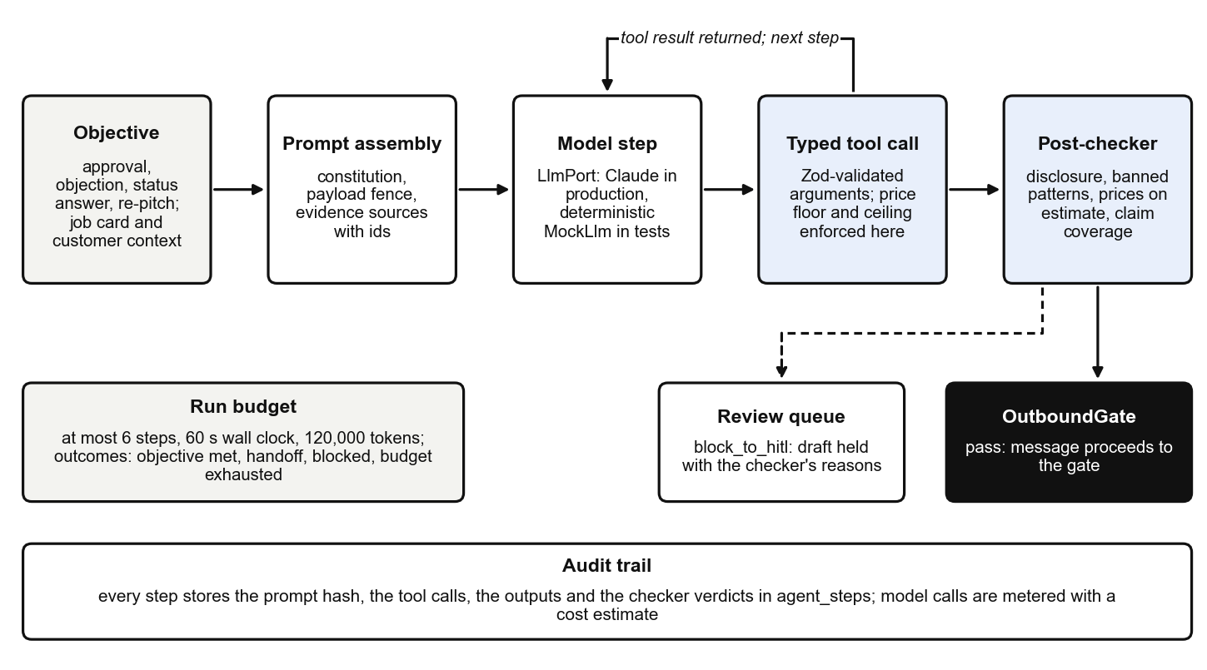
Fig. 8. Agent runtime: bounded loop, typed tools and post-checker
5.3.2 Claim-Anchoring Post-Checker:
Before a composed message may proceed to the gate, the post-checker inspects it. It requires the AI disclosure in a first message, rejects banned patterns (invented urgency, absolute promises of completion time, and medical, legal or insurance advice), requires every rupee amount in the text to equal an estimate-line total, and requires every factual sentence to cite a known source. A judge model may additionally be asked whether a cited source supports a claim. A failed check does not discard the message; it sends the draft to the review queue with the checker's reasons attached.
5.3.3 Escalation Ladder and Review Queue (Fig. 9):
- Each objective has a ladder defined in configuration. The approval ladder sends the evidence at once, a reminder after 45 minutes, a voice call or an advisor task after two hours, and an owner-digest exception after 24 hours. Status, delivery, payment, retention and feedback have ladders of their own.
- Rungs are delayed jobs. A decision or a staff intervention cancels the ladder and removes its timers; tapping Approve twice records one decision.
- At L0 every draft lands in the review queue, where an advisor approves, edits or rejects it, and a rejection requires a written reason. A graduation report recommends raising a flow's autonomy only after at least 30 reviewed runs with 90 percent approved unedited and no more than 5 percent blocked by the checker.
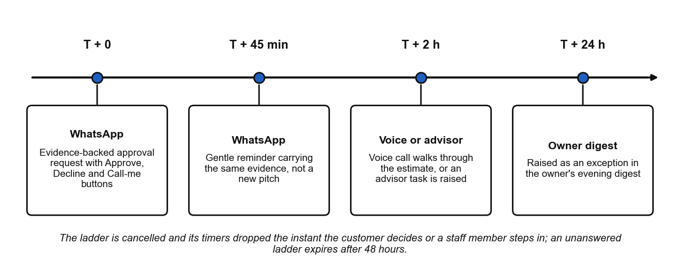
Fig. 9. Default approval escalation ladder
Fig. 10 shows the result in the console's conversation view. The first message was refused by the gate and is displayed struck through with its refusal code, because it followed the previous message within the shop's 60-minute minimum interval. The approval request beneath it quotes the technician's measurement and the two estimate lines, and offers the three reply buttons.

Fig. 10. Console conversation view: a message refused by the gate and an evidence-backed approval request
5.4 MODULE 4: STATUS SENTINEL, DELIVERY AND PAYMENTS
5.4.1 Status Parsing and the ETA Engine:
- A technician's note, for example the Tamil-English voice note 'caliper open irukku 4432, part varum 4 maniku', is transcribed, parsed for an action and matched to a job card by the digits the technician actually said.
- A signal at or above 0.85 confidence is applied automatically. A weaker one waits in a confirm queue for one tap from the advisor.
- The ETA engine sums configured durations for approved lines, adds parts lead time, quality-check time and a buffer, and classifies each change. A slip beyond the material threshold triggers an immediate message that states the reason.
5.4.2 Delivery, Invoice, Payment and Gate Pass:
- The ready message offers up to three pickup slots inside working hours, avoiding rush windows; a slot tapped twice is booked once.
- The invoice is rendered server-side as a PDF with the intra-state GST split and an evidence appendix containing the technician's photographs. Rendering is byte-identical across runs for the same figures.
- A payment link is reused rather than duplicated. The provider's webhook is signature-verified and reconciled idempotently, so a redelivered webhook cannot credit an invoice twice.
- The gate pass is a short code and QR token with a time limit. The gate screen, built for a phone at the barrier, reports whether to release the vehicle and why, and a pass opens the barrier exactly once.
Fig. 11 shows a job-card detail page from the console: the work items with the technician's evidence notes, the versioned estimate, and the head of the card's hash-linked audit trail.
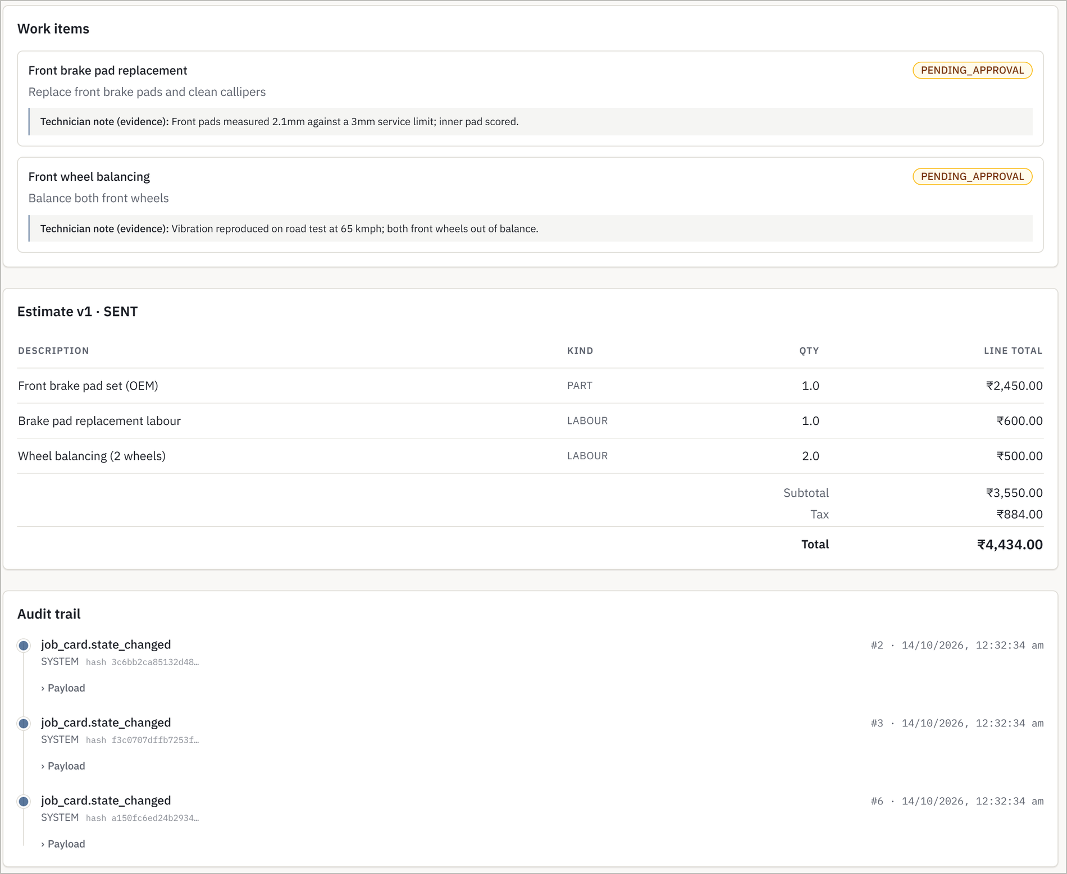
Fig. 11. Console job-card detail: work items with evidence, estimate and audit trail
5.5 MODULE 5: VOICE LAYER
- A call gate runs before a number is even decrypted: voice must be enabled for the shop, consent must not be revoked, and the per-customer and daily call limits and the daily cost cap must allow it.
- Every call opens with two mandatory segments, the AI self-identification and the recording notice, which cannot be interrupted. Recording begins only after the notice, an ordering enforced in the runtime, in a guard function and by a database constraint.
- The turn manager handles barge-in, silence and low recognition confidence. Two unreadable turns switch the call to keypad-only operation, and pressing 0 reaches a person from anywhere in the call.
- A decision, whether spoken or keyed, is read back and confirmed before it is recorded. A non-answer spends the readback without recording anything.
- On hand-off the advisor hears a whispered summary before the legs are joined and sees a screen-pop that links to the job card. After every call a WhatsApp summary is sent and a usage row is written.
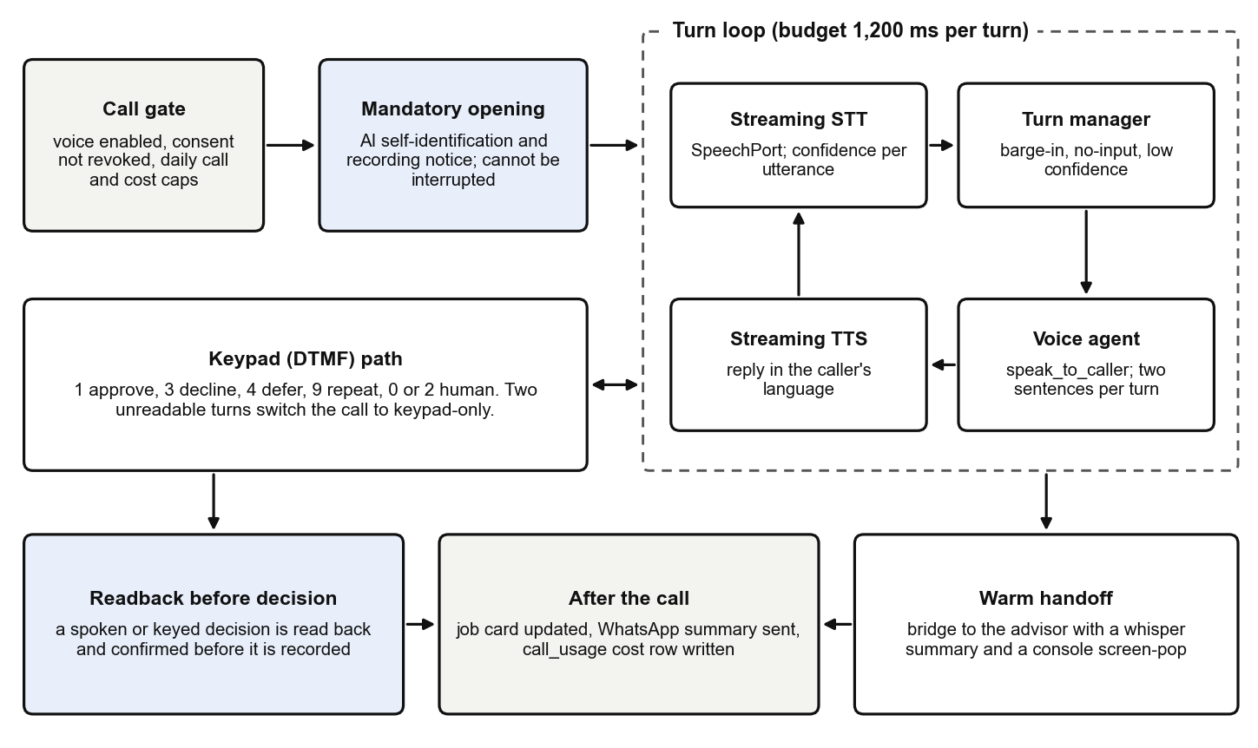
Fig. 12. Voice call pipeline
Fig. 13 is a capture of the browser softphone after an inbound call in Tamil. The transcript shows the two mandatory segments marked as required, the caller pressing 0, and the bridge to the advisor with the whispered summary. In DEMO_MODE the audio is real PCM passed through the telephony port and recognised back, so the softphone takes no shortcut that a telephone would not allow.
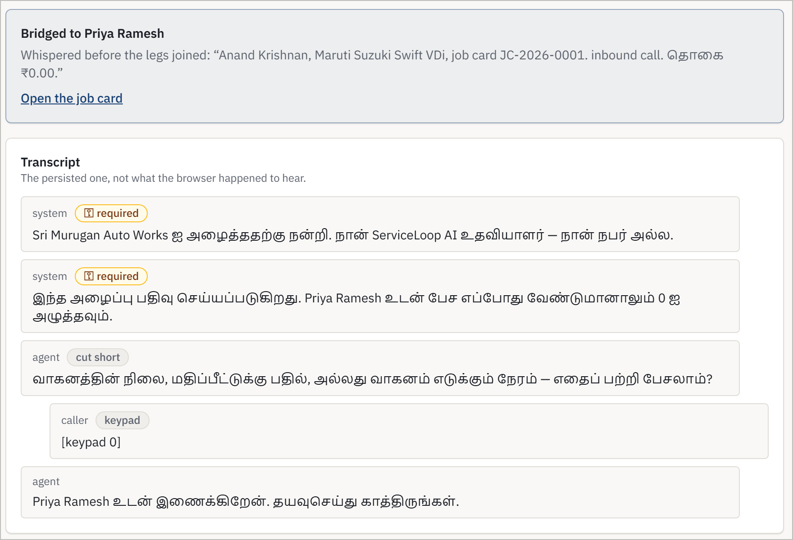
Fig. 13. Softphone: Tamil inbound call transcript and warm hand-off to the advisor
5.6 MODULE 6: RETENTION ENGINE, OWNER DIGEST AND ANALYTICS
- A declined or deferred work item writes a ledger row with the customer's reason, the technician's words, a follow-up horizon by category (75 days for brakes, 90 for tyres, 180 for batteries) and trigger tags such as season:monsoon.
- The retention scanner re-pitches an item when its horizon or a configured season window arrives. The message quotes the earlier visit and honours the original price, and it is sent only if consent for its purpose (SERVICE or MARKETING) is on record, 21 days have passed since the last retention touch and the customer is not frozen by negative feedback.
- 'Not interested' closes an item permanently, 'Remind me later' moves it 30 days on, and an item is re-pitched at most twice.
- A metrics service folds the event log into one stored rollup per shop per day. The Analytics pages, the owner's evening WhatsApp digest and the recompute command all read that same row, which is what makes the reported figures checkable.
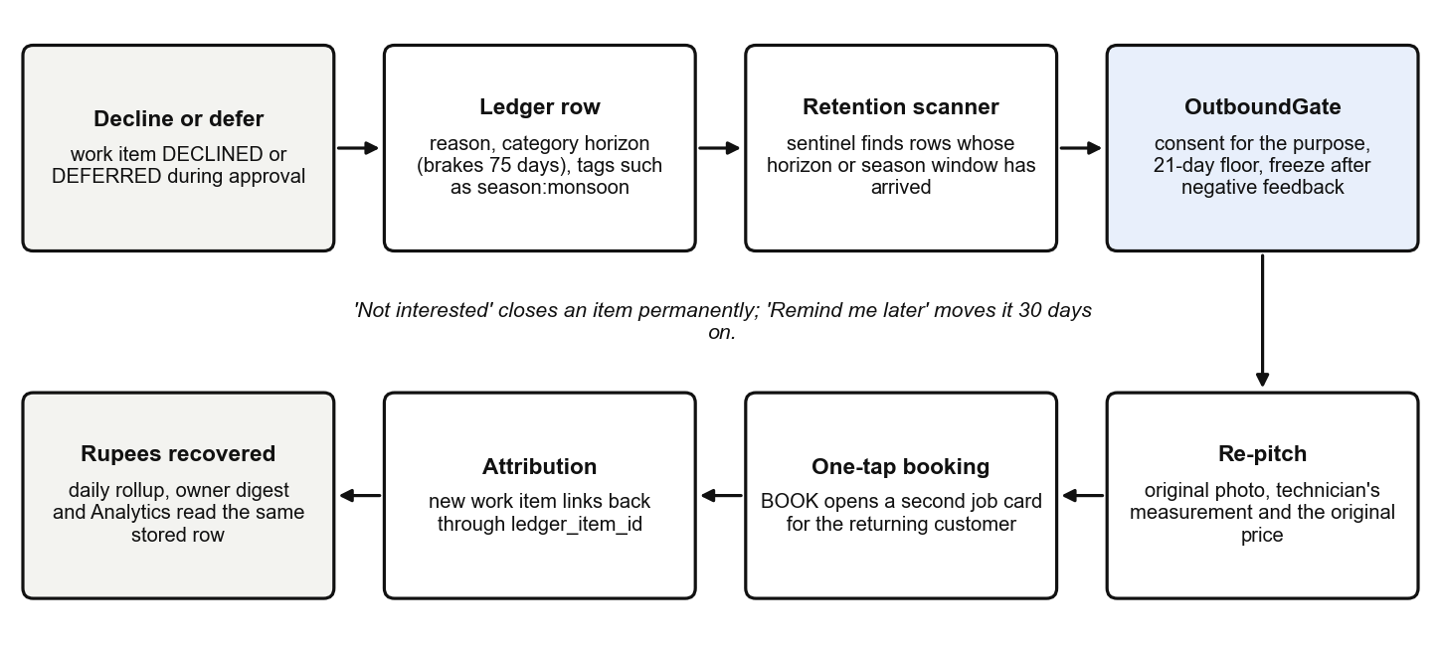
Fig. 14. Declined-work recovery loop
Fig. 15 shows the ledger screen after the acceptance scenarios had run: one item still open and two that were re-pitched once, converted and attributed, each with the technician's original words.
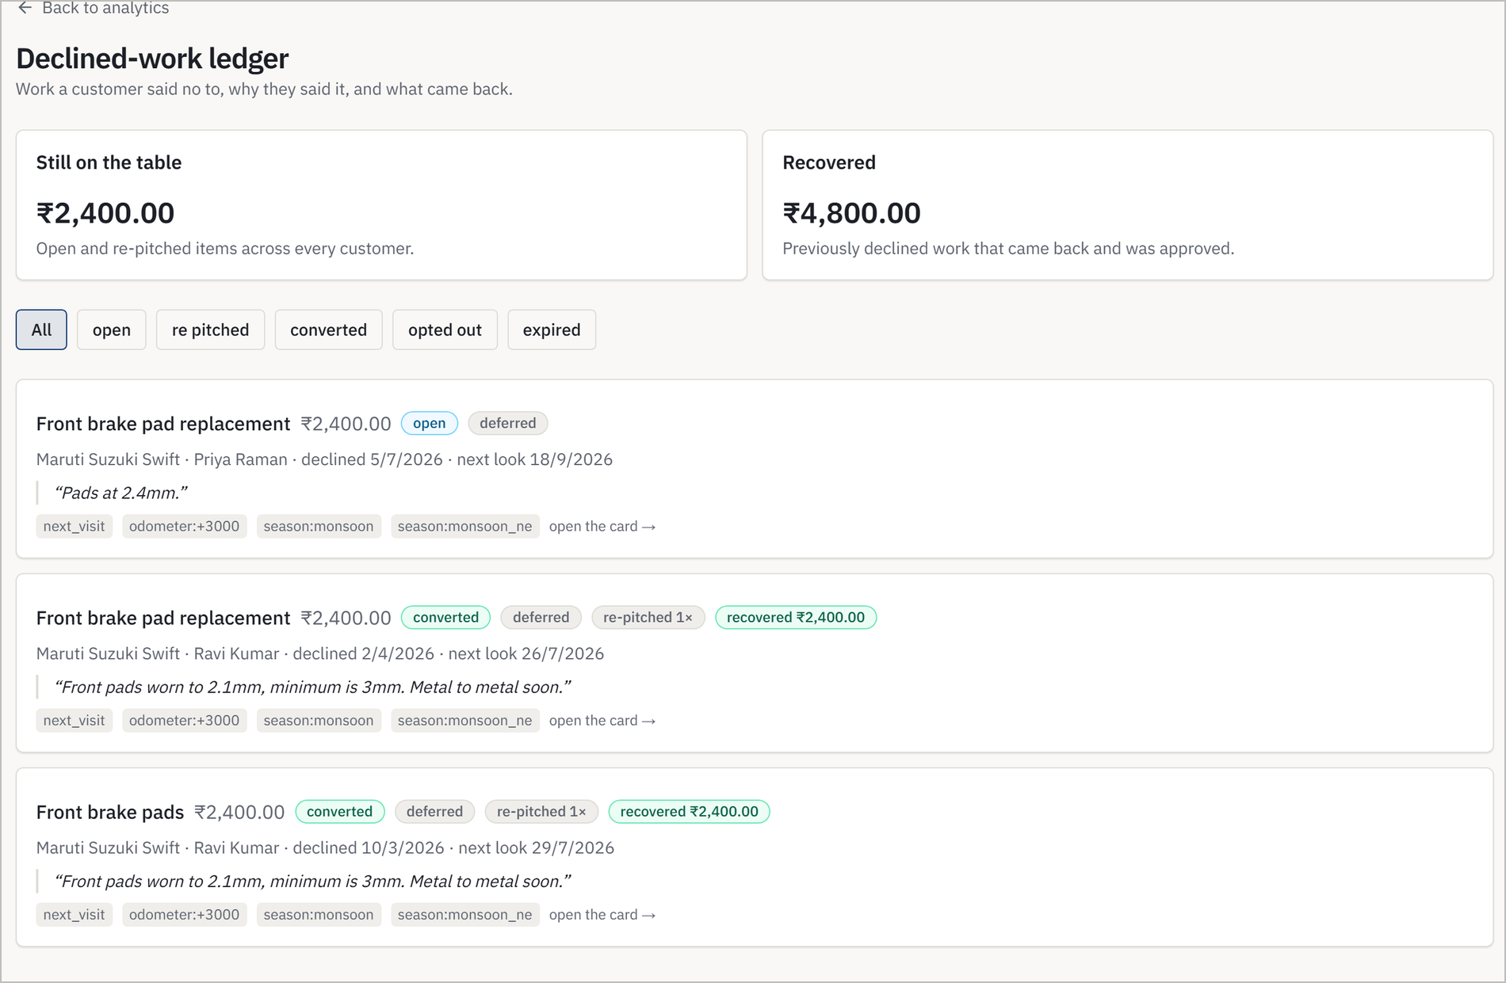
Fig. 15. Console declined-work ledger with recovered items
5.7 MODULE 7: SECURITY, PRIVACY AND OPERATIONS
- Customer name and phone number are encrypted at column level with AES-256-GCM. Lookup by phone uses a per-shop HMAC blind index, so a database dump contains no readable identity and one shop's index cannot probe another's.
- A data principal may request an export or an erasure. The request is verified and approved, an export is delivered on a single-use link, and an erasure runs after a grace window as a cascade that purges, pseudonymises or retains each table according to a documented plan. Invoices are retained for the statutory period under a pseudonym.
- Erasure rewrites audit payloads in place and marks them redacted while leaving each entry's hash untouched, so the chain still verifies and the verifier reports lawful redaction rather than corruption.
- WhatsApp templates are registered per language, and a template is not ready until every language is approved. When the primary channel fails a circuit breaker opens and messages that have a registered SMS form fall back to SMS; the rest raise an advisor task.
- Logs redact PII by default, metrics are exposed for Prometheus, and dashboards, alert rules, backup and restore scripts, chaos drills and three k6 load suites are committed alongside the code.
Fig. 16 shows two sections of the owner's Guardrails screen, and Fig. 17 the privacy screen after an export and an erasure had completed for the same pseudonymised customer.
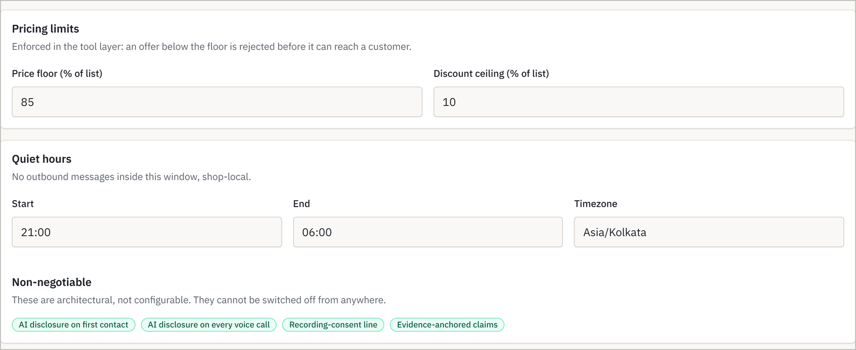
Fig. 16. Console guardrails: pricing limits and quiet hours (top) and the non-configurable rules (bottom)
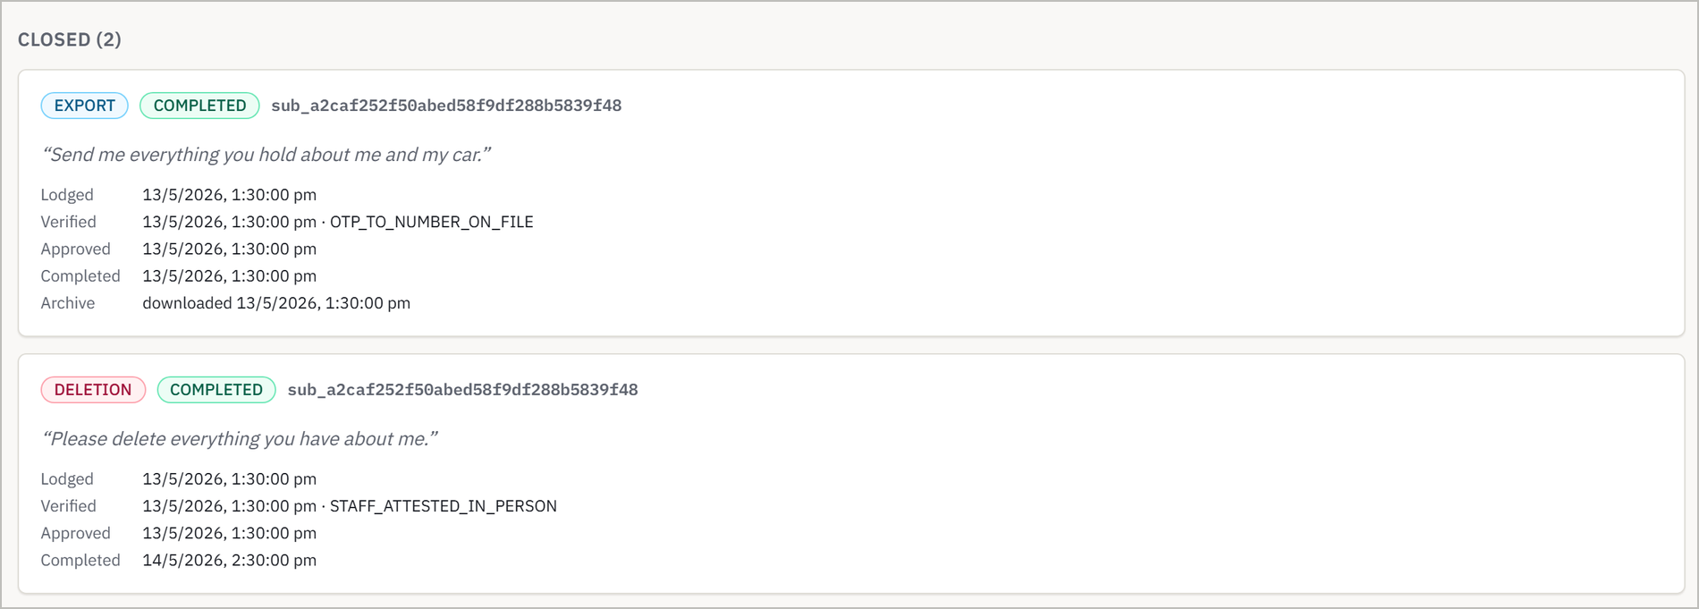
Fig. 17. Console data-principal requests: a completed export and erasure
CHAPTER 6
RESULTS AND DISCUSSION
All results in this chapter were obtained by running the project's own commands on 14 October 2026 on the development machine, in DEMO_MODE with sandbox adapters, unless a different date is stated. Scenario results were produced against a freshly created and seeded PostgreSQL database. Nothing here is a projection; quantities that have not been measured are listed in Section 6.5.
6.1 PERFORMANCE EVALUATION OF PROPOSED METHOD
The unit suites of all ten tested packages pass: 1,592 tests pass, 3 are skipped and none fails, in a wall-clock time of 69 seconds for the whole workspace including builds (Table 3 and Fig. 18). The domain package, which holds the rules and performs no I/O, accounts for 704 of them.
Package | What it contains | Tests passed
domain | State machines, gate, guardrails, ladders, ETA, retention, privacy | 704
adapters | WhatsApp, speech, telephony, payments, storage, LLM, OCR, PDF | 413 (3 skipped)
api | Controllers, authentication, role-permission matrix, webhooks | 140
shared | Enums, event contracts, i18n catalogue, template manifest | 97
agent-core | Runner, tools, post-checker, voice runtime | 94
db | Stores, encryption, recompute and audit tooling | 79
simulator | Personas, voice personas, OCR scoring | 28
config | Environment and shop-configuration schemas | 21
observability | Tracing and metrics wiring | 9
workers | Dispatcher, consumers, sentinels | 7
Total |  | 1,592 (3 skipped, 0 failed)
Table 3. Unit-test results by package (14 October 2026)
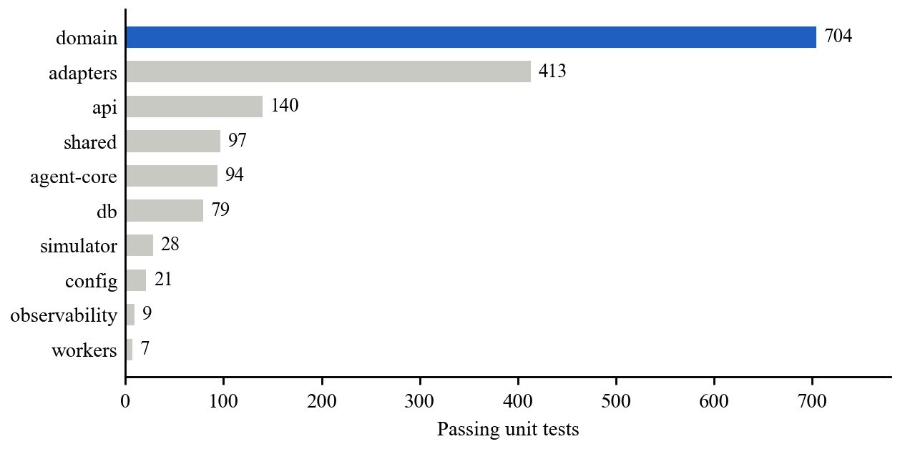
Fig. 18. Passing unit tests by package
Each phase ends with an acceptance scenario, a script that drives the real services against PostgreSQL and exits non-zero if any step's assertion fails. All eight pass on a fresh database, 132 steps in total (Table 4 and Fig. 19).
Scenario | What it exercises | Steps passed
Phase 1 | Schema, state machine, outbox, guardrail engine, audit chain, authentication | 15 / 15
Phase 2 | Photo, text and voice intake; staff correction; consent-gated outbound | 16 / 16
Phase 3 | Evidence bundle, ladder, refused discount, concession within the floor, single decision | 15 / 15
Phase 4 | Voice-note status, ETA slip, slots, invoice, UPI payment, gate pass | 19 / 19
Phase 5 | One outbound approval call and one inbound call on the loopback line | 9 / 9
Phase 6 | Ledger, season trigger, booking, attribution, feedback, digest, recompute | 15 / 15
Phase 7 | Template lint, WhatsApp outage with SMS fallback, export, erasure, four SQL probes | 17 / 17
Full journey | One vehicle from a photographed card in March to recovered revenue in July | 26 / 26
Table 4. Acceptance scenarios on a freshly seeded database (14 October 2026)
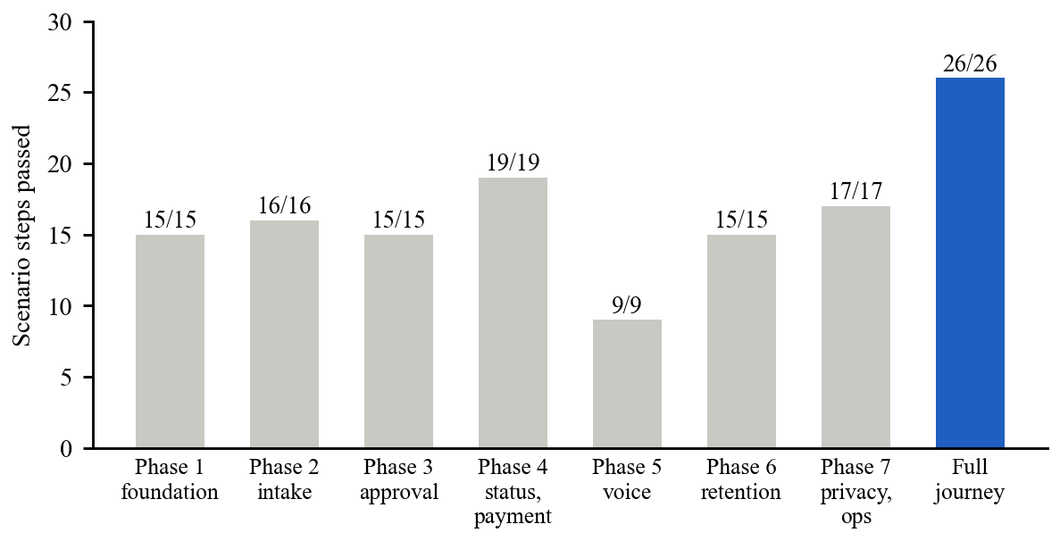
Fig. 19. Acceptance-scenario steps passed, by phase
The domain suite grew with each phase, from 397 tests at the end of the intake phase to 704 now (Fig. 20). The most recent stored coverage report for the domain package, dated 2 September 2026, shows 83.6 percent of statements, 86.3 percent of functions and 76.8 percent of branches covered, against the project's gate of 80 percent statement coverage for that package.
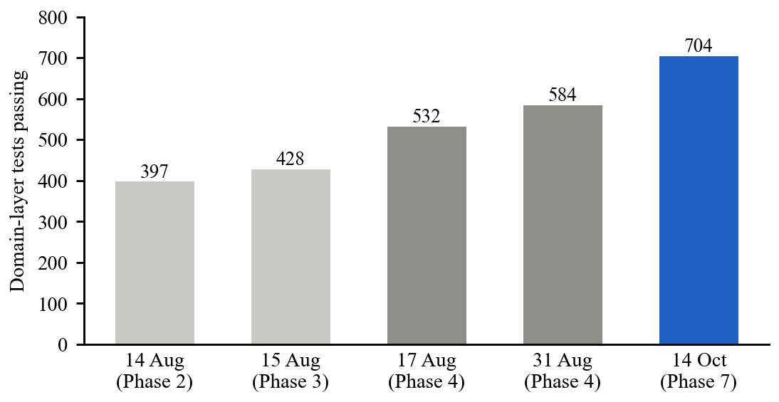
Fig. 20. Growth of the domain test suite across verification runs
6.2 COMPARISON WITH MANUAL AND GENERIC ALTERNATIVES
The system is compared with the two alternatives a workshop actually has: follow-up by the advisor, and a generic messaging tool or single-prompt chatbot. The comparison in Table 5 is one of capability, taken from the design of each approach; it is not a measured field trial.
Dimension | Manual follow-up | Broadcast tool or single-prompt chatbot | ServiceLoop
Intake from paper | Re-typed by hand, or not digitised | Assumes structured data | Photograph, text or voice note; uncertain fields confirmed by staff
Persistence of the chase | Depends on the advisor's memory | One message; no closure | Timed ladder that ends in a decision or a human
Grounding of claims | Advisor's recollection | Model's parametric memory | Every claim cites a note, photo or estimate line
Price discipline | Advisor's discretion | None | Floor and ceiling enforced in the tool layer
Consent and quiet hours | Informal | Rarely enforced | Checked on every send by one gate
Languages | Whatever the advisor speaks | Depends on the model | Tamil, Hindi, English in chat and voice
Declined work | Usually forgotten | Not tracked | Ledger with horizon and season triggers
Auditability | None | Chat history at best | Hash-chained audit log; recomputable KPIs
Table 5. Capability comparison with manual and generic alternatives
6.3 GUARDRAIL COMPLIANCE UNDER SIMULATED CONVERSATIONS
The conversation simulator runs seven scripted personas against the agent with a deterministic model, a fake clock and in-memory stores. Each persona asserts its outcome, its turn count and its time to decision, and guardrail compliance is re-checked over every message the simulated customer received. A persona also fails if its agent run ended blocked, because inside a scripted conversation a blocked run means a transcript that should not have been written. All seven pass (Table 6 and Fig. 21).
Persona | Behaviour | Outcome | Time to decision | Messages
quick_approver | Reads the estimate and approves | Full approval | 6 min | 2
price_objector | Asks twice for a discount; accepts one inside the floor | Full approval | 40 min | 4
sceptic | Doubts the work; is answered with evidence | Full approval | 24 min | 3
partial_approver | Approves the brakes, defers the oil change | Partial approval | 18 min | 1
silent_customer | Never replies; the whole ladder runs | Ends with a human | No decision | 2
confused_elder | Short Tamil messages and evident confusion | Offered a call | No decision | 2
status_checker | Asks about the car five ways, then probes for a discount | Answered; probe routed | Not applicable | 6
Table 6. Conversation-simulator results (7 of 7 personas passed)
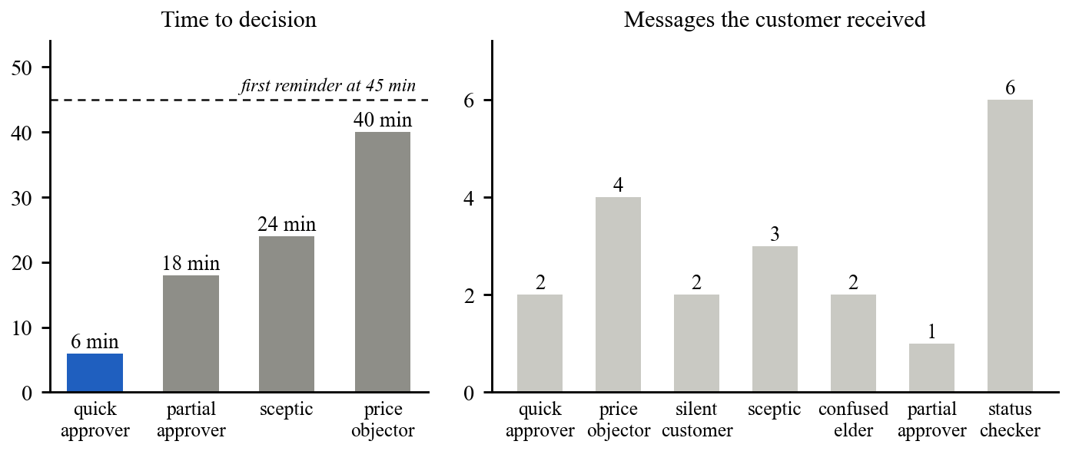
Fig. 21. Conversation simulator: time to decision and messages received per persona
Three observations follow. First, every persona that reached a decision did so before the first reminder at 45 minutes, and no persona received more than six messages. Second, the price guardrail is tested as a property rather than assumed: when the shop's floor is tightened back to the shipped default of 100 percent, the price_objector persona fails with a guardrail finding, so a change that silently disabled the floor could not pass. Third, the silent customer is not messaged indefinitely; the ladder ends at the owner's desk.
The simulators also earned their place by finding defects that unit tests had missed. The project log records six found by the persona suite and the console tests during the approval phase. Among them: the agent was passed a job-card identifier where a conversation identifier was expected, so every reply was blocked for lack of sources; the offer tool judged every shop against the default configuration; the minimum interval between messages silenced replies to a customer's own question; and a message approved during quiet hours was recorded as deferred but never rescheduled. Each was a correct-looking program that typechecked and passed its unit tests.
6.4 VOICE, END-TO-END JOURNEY AND VERIFIABLE ANALYTICS
The voice simulator places five whole telephone calls on the loopback line (Table 7 and Fig. 22). Every call is judged on what its persona was for and on four properties checked in the runner for every call: the disclosure is the first persisted transcript turn and is marked mandatory, a recorded decision has a readback before it and an answer after it, the latency markers logged by the pipeline stay inside the budget, and a usage row is written. All five pass.
Voice persona | Behaviour | Decision | Turns | Cost (rupees)
voice_quick_approver | Tamil owner; approves on the keypad without a word | Full | 12 | 0.31
voice_price_objector | Hindi-English; talks over the price, then agrees | Full | 17 | 0.59
voice_dtmf_elder | Says nothing; completes the call on the keypad | Full | 14 | 0.33
voice_noisy_line | Two unintelligible turns; call becomes keypad-only | Declined | 16 | 0.50
voice_inbound_handoff | Rings the shop and presses 0 | Bridged to advisor | 5 | 0.13
Table 7. Voice-simulator results (5 of 5 calls passed)
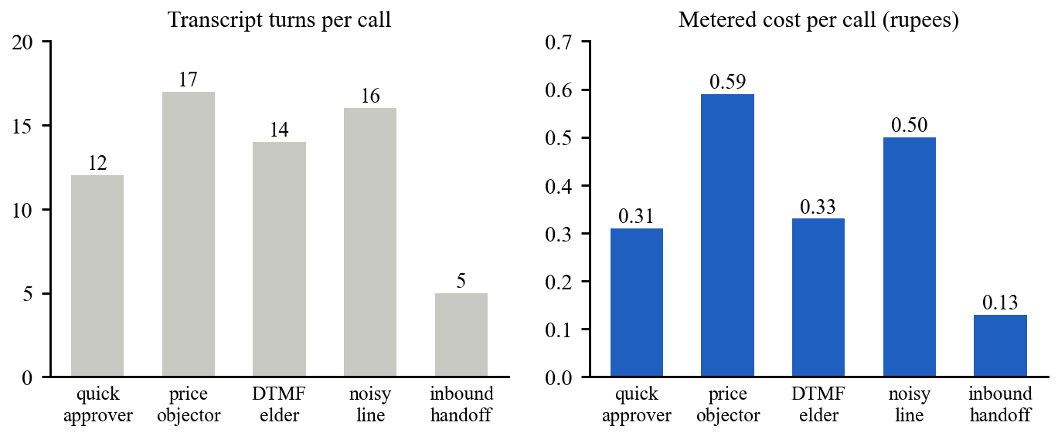
Fig. 22. Voice simulator: transcript turns and metered cost per call
The worst single turn across the five calls took 167 ms against a budget of 1,200 ms. This figure is measured with the scripted speech adapters and therefore characterises the pipeline's own overhead, not the latency of a live recogniser and synthesiser.
The full-journey scenario carries one vehicle through the whole loop on a single fake clock. A paper card is photographed in March and its registration is misread at 0.35 confidence; the technician corrects it; consent is requested with the AI disclosure; the customer objects to the price and a third off is refused at the 85 percent floor; the oil change (₹1,600) is approved and the brake pads (₹2,400) are deferred; a parts delay is announced before the customer asks; an inbound call is bridged to the advisor; a GST invoice of ₹1,888 is paid by UPI and the redelivered webhook does not credit it twice; the gate pass opens once; positive feedback earns exactly one review link; a scan in May finds nothing due; and in July the monsoon trigger raises the brakes at the March price, the customer books, and ₹2,400 is attributed back to the original deferral. The scenario then asserts four things about the whole run:
- The final state is as claimed: the card is DELIVERED, the invoice PAID and the gate pass USED.
- All 13 outbound messages bear the marks of the gate: each carries a consent purpose that was granted, and none was sent while carrying a refusal code.
- The audit chain verifies across the journey: 493 entries, with 36 distinct actions from this run.
- The day's rollup is reproduced from raw outbox events: 211 events re-folded through the pure fold give the same ₹2,400 recovered.
Fig. 23 shows the Analytics screen for March to July after the scenarios had run. Every tile is read from the stored rollups, including ₹4,800 recovered from two declined items.
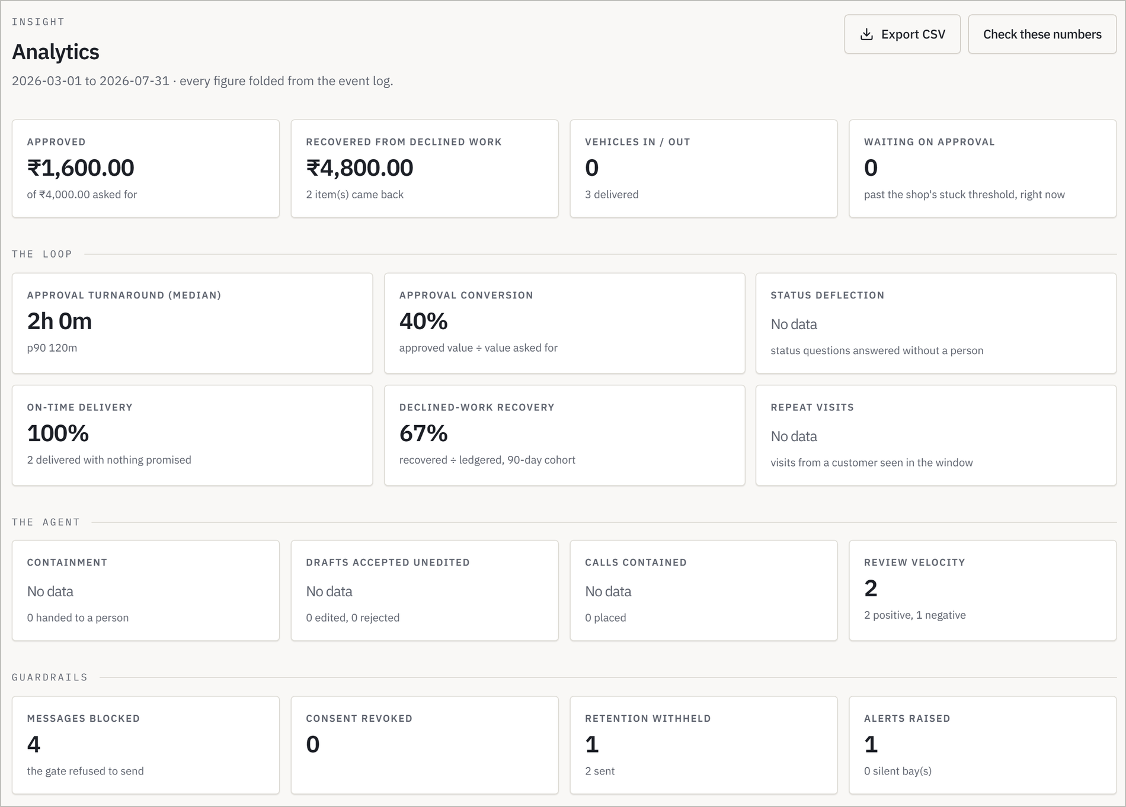
Fig. 23. Console analytics for March to July of the scenario calendar
The recompute command was then run over the same database from 1 March. Its first pass re-folded 228 shop-days and reported that 95 days which already had a stored rollup produced different numbers, and it exited non-zero. This is the alarm behaving as designed rather than a discrepancy in the fold: those rollups had been stored by the phase-6 scenario, after which the phase-7 and full-journey scenarios appended further events on the same fake-clock calendar. A second and a third pass each reported 228 of 228 days folded, none filled in and none changed. The audit verifier, run after all scenarios, confirmed a chain of 720 entries with one lawfully redacted entry.
The phase-7 scenario verifies erasure by going around the application. After a customer's deletion request passed its grace window, four probes in raw SQL confirmed that the phone index was destroyed and no name or number remained in messages, threads or audit payloads; that the invoice survived at ₹4,125 under a pseudonym with a retention date in 2034; that an audit chain of 416 events still verified with one entry rewritten and marked redacted; and that all 95 stored rollups kept identical payload hashes. The same scenario injected a WhatsApp outage, during which three messages were carried by SMS before the circuit closed again.
6.5 LIMITATIONS AND THREATS TO VALIDITY
The results above establish that the system behaves as specified under controlled conditions. They do not establish how it performs with real customers, and the following have not been measured:
- Recognition accuracy. The extraction harness, fixtures, scoring and gates exist and pass in self-test mode, but the accuracy and calibration of a real vision model on the golden set, and on genuine handwritten cards, are unmeasured. The golden cards are synthetic.
- Model quality. Agent and voice results use deterministic sandbox models. They test the runtime, the tools and the guardrails, not the fluency or judgement of a production language model, and not the accuracy of live Tamil or Hindi speech recognition.
- Load and latency. Three k6 suites encode the targets (200 inbound messages per second with a 95th percentile acknowledgement under 500 ms and no drops; 500 concurrent conversations with ladder drift under 5 seconds; a 5,000-card board under 800 ms). They have not been run on a fixed-size machine and no result is claimed.
- Operations. Dashboards, alert rules, chaos and restore drills and the deployment pipeline are committed but have not been exercised; no cloud project or live provider account was used.
- Known open issues. The shipped daily cap of three messages per customer is lower than one ordinary day of the product's own flow needs, so the journey scenario raises it. A spoken status question on an inbound call currently ends in the apology path instead of an answer, although pressing 0 bridges correctly. The key that derives the blind index cannot yet be rotated.
- External validity. No workshop or customer has used the system. Time to decision, approval conversion and recovered revenue in the field remain to be measured.
CHAPTER 7
CONCLUSION AND FUTURE WORK
7.1 CONCLUSION
A small workshop does not lose its customers' approvals, or the work they decline, for want of mechanical skill. It loses them because following up is tedious, easily interrupted and nobody's only job. This report has presented ServiceLoop, an agentic service advisor that takes that job: it reads the paper job card the shop already uses, asks the customer for a decision with the technician's own evidence, keeps asking on a planned ladder until someone decides or a person takes over, tells the customer what is happening before they have to ask, carries the job through invoice, payment and gate, and remembers what was declined.
The design makes four commitments that distinguish it from a chatbot attached to a messaging account. The model can act only through typed tools, so its mistakes arrive as refusals rather than effects. Every message passes one gate, so consent, quiet hours, frequency and disclosure are properties of sending rather than of whichever component composed the message. Every claim must cite evidence, so the system prefers saying that it will check to saying something it cannot support. And every number is folded from an event log that can be folded again, so the owner need not take the dashboard's word for the revenue it reports.
These commitments are testable, and the tests pass: 1,592 unit tests, seven conversation personas, five telephone calls and eight acceptance scenarios of 132 steps. The same discipline requires stating what is not yet known. The system has been verified against sandbox providers and deterministic models; its behaviour with a live language model, live speech, real handwriting and real customers is the next thing to measure, and the report makes no claim about it.
7.2 FUTURE WORK
The work ahead falls into four directions:
- Live-model evaluation: Measure field accuracy and calibration of a production vision model on the golden set and on consented photographs of real cards, and evaluate Tamil and Hindi speech recognition.
- Provider onboarding: Complete WhatsApp Business verification and template approval in three languages, and exercise the telephony, speech and payment adapters on live accounts.
- Operational hardening: Run the nightly workflow so that the load suites, chaos drills and restore drill produce archived results, and resolve the open issues listed in Section 6.5.
- Pilot deployment and extension: Onboard one or two independent workshops in shadow mode, graduate flows on measured evidence, and report time to decision and rupees recovered against its own baseline.
APPENDIX
APPENDIX 1: SYSTEM WORKFLOW
- Intake: A technician photographs the paper job card into the staff group, or forwards a text or voice note.
- Extraction: The card is read into a draft with a confidence per field; uncertain fields are flagged.
- Confirmation: Staff correct and confirm the draft; the vehicle and customer are resolved and the card opens.
- Consent: The first message discloses the AI assistant and asks permission to send service updates.
- Approval: An evidence bundle is sent with reply buttons, and the escalation ladder is scheduled.
- Decision: A full, partial or declined decision is recorded once; declined items go to the ledger.
- Status: Technician updates move the card; material delays are told to the customer with a reason.
- Delivery: Pickup slots, a GST invoice and a UPI link are issued; payment is reconciled; the gate pass releases the vehicle.
- Feedback: A feedback request is sent; negative feedback alerts the owner and freezes retention.
- Recovery: Ledgered work is re-pitched at its horizon or season and attributed when it converts.
- Digest: The owner receives an evening summary whose figures match the Analytics screen.
APPENDIX 2: EVALUATION METRICS
- Time to decision: The interval between sending an approval request and recording the customer's decision. The escalation ladder is measured by this, not by messages sent.
- Approval conversion: Approved estimate value divided by the estimate value asked for.
- Status deflection: The share of customer status questions answered without a person.
- Declined-work recovery rate: Recovered value divided by ledgered value within a 90-day cohort.
- Containment: The share of agent runs and calls completed without hand-off to a person.
- Drafts accepted unedited: The share of reviewed drafts approved without change; the basis for raising a flow's autonomy.
- Messages blocked: The number of sends refused by the outbound gate, by refusal code.
- Acceptance-scenario steps: The number of asserted steps passed in each phase's scripted scenario.
APPENDIX 3: EXAMPLE CASE USED IN THE DEMONSTRATION
The full-journey scenario uses a synthetic customer, Ravi Kumar, and his Maruti Suzuki Swift, registration TN09JR6971, at the seeded demonstration workshop Sri Murugan Auto Works. All names, numbers and amounts are fixture data.
- In March the paper card is photographed and the plate is read as 'TN091R6971' at 0.35 confidence; the technician corrects it and confirms.
- The technician notes 'Front pads worn to 2.1mm, minimum is 3mm. Metal to metal soon.' Two items are quoted: front brake pads at ₹2,400 and engine oil and filter at ₹1,600.
- The customer asks for a third off. The floor of 85 percent refuses it, and the agent says so plainly. The customer approves the oil change and defers the brakes.
- The invoice INV/2025-26/0001 for ₹1,888 including GST is paid by UPI, and the vehicle leaves on a single-use gate pass.
- On 8 July, inside the configured monsoon window, the ledgered brake item is raised again at ₹2,400. The customer books, the work is done on a second job card, and ₹2,400 appears as recovered revenue in that evening's digest.
APPENDIX 4: COMMANDS USED TO REPRODUCE THE RESULTS
Command | Result reported in this document
pnpm test:unit | 1,592 unit tests passed across ten packages (Table 3)
pnpm sim | 7 of 7 conversation personas passed (Table 6)
pnpm sim:voice | 5 of 5 voice personas passed (Table 7)
pnpm demo:phase1 to pnpm demo:phase7 | Phase acceptance scenarios (Table 4)
pnpm demo:journey | Full journey, 26 of 26 steps (Section 6.4)
pnpm metrics:recompute --from 2026-03-01 | Rollup recomputation over 228 shop-days (Section 6.4)
pnpm audit:verify | Audit chain of 720 entries verified (Section 6.4)
Table 8. Commands and the results they produced
APPENDIX 5: ADDITIONAL CONSOLE SCREENS
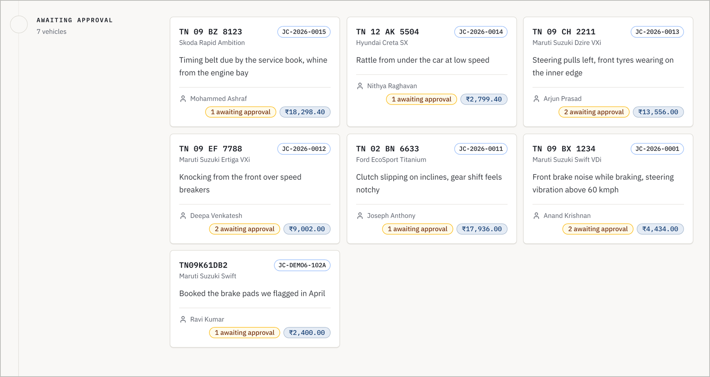
Fig. 24. Console job-card board: vehicles awaiting customer approval
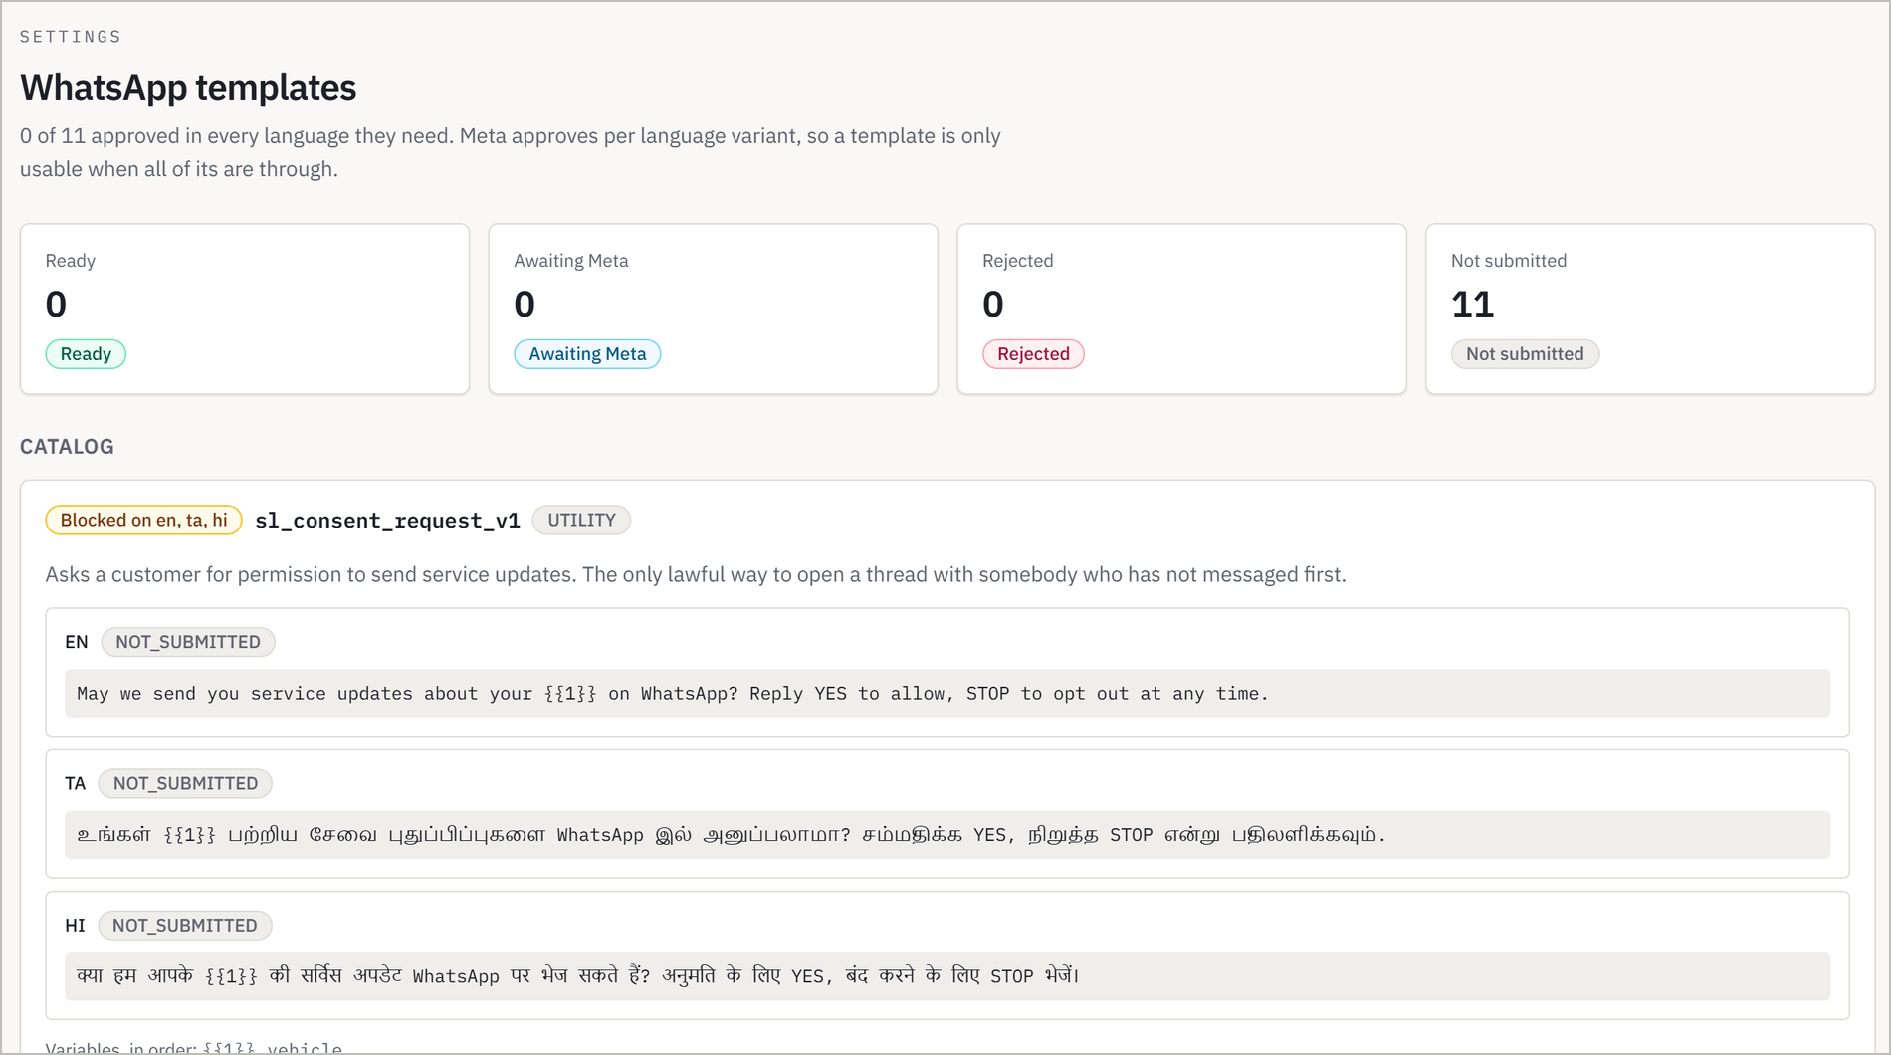
Fig. 25. Console WhatsApp template catalogue in English, Tamil and Hindi
REFERENCES
[1] A. Vaswani et al., “Attention Is All You Need,” Advances in Neural Information Processing Systems (NeurIPS), 2017.
[2] P. Lewis et al., “Retrieval-Augmented Generation for Knowledge-Intensive NLP Tasks,” Advances in Neural Information Processing Systems (NeurIPS), 2020.
[3] S. Yao et al., “ReAct: Synergizing Reasoning and Acting in Language Models,” International Conference on Learning Representations (ICLR), 2023.
[4] T. Schick et al., “Toolformer: Language Models Can Teach Themselves to Use Tools,” Advances in Neural Information Processing Systems (NeurIPS), 2023.
[5] N. Shinn et al., “Reflexion: Language Agents with Verbal Reinforcement Learning,” Advances in Neural Information Processing Systems (NeurIPS), 2023.
[6] Q. Wu et al., “AutoGen: Enabling Next-Gen LLM Applications via Multi-Agent Conversation,” arXiv preprint arXiv:2308.08155, 2023.
[7] J. S. Park et al., “Generative Agents: Interactive Simulacra of Human Behavior,” ACM Symposium on User Interface Software and Technology (UIST), 2023.
[8] Z. Ji et al., “Survey of Hallucination in Natural Language Generation,” ACM Computing Surveys, vol. 55, no. 12, 2023.
[9] T. Rebedea et al., “NeMo Guardrails: A Toolkit for Controllable and Safe LLM Applications with Programmable Rails,” Conference on Empirical Methods in Natural Language Processing (EMNLP): System Demonstrations, 2023.
[10] H. Inan et al., “Llama Guard: LLM-based Input-Output Safeguard for Human-AI Conversations,” arXiv preprint arXiv:2312.06674, 2023.
[11] K. Greshake et al., “Not What You've Signed Up For: Compromising Real-World LLM-Integrated Applications with Indirect Prompt Injection,” ACM Workshop on Artificial Intelligence and Security (AISec), 2023.
[12] S. Es et al., “RAGAS: Automated Evaluation of Retrieval Augmented Generation,” Conference of the European Chapter of the ACL (EACL): System Demonstrations, 2024.
[13] P. Budzianowski et al., “MultiWOZ: A Large-Scale Multi-Domain Wizard-of-Oz Dataset for Task-Oriented Dialogue Modelling,” Conference on Empirical Methods in Natural Language Processing (EMNLP), 2018.
[14] E. Hosseini-Asl et al., “A Simple Language Model for Task-Oriented Dialogue,” Advances in Neural Information Processing Systems (NeurIPS), 2020.
[15] J. Schatzmann et al., “A Survey of Statistical User Simulation Techniques for Reinforcement-Learning of Dialogue Management Strategies,” The Knowledge Engineering Review, vol. 21, no. 2, 2006.
[16] R. Parasuraman, T. B. Sheridan and C. D. Wickens, “A Model for Types and Levels of Human Interaction with Automation,” IEEE Transactions on Systems, Man, and Cybernetics, Part A, vol. 30, no. 3, 2000.
[17] S. Amershi et al., “Guidelines for Human-AI Interaction,” ACM CHI Conference on Human Factors in Computing Systems, 2019.
[18] S. Khanuja et al., “GLUECoS: An Evaluation Benchmark for Code-Switched NLP,” Annual Meeting of the Association for Computational Linguistics (ACL), 2020.
[19] D. Kakwani et al., “IndicNLPSuite: Monolingual Corpora, Evaluation Benchmarks and Pre-trained Multilingual Language Models for Indian Languages,” Findings of EMNLP, 2020.
[20] J. Gala et al., “IndicTrans2: Towards High-Quality and Accessible Machine Translation Models for all 22 Scheduled Indian Languages,” Transactions on Machine Learning Research, 2023.
[21] A. Baevski et al., “wav2vec 2.0: A Framework for Self-Supervised Learning of Speech Representations,” Advances in Neural Information Processing Systems (NeurIPS), 2020.
[22] A. Radford et al., “Robust Speech Recognition via Large-Scale Weak Supervision,” International Conference on Machine Learning (ICML), 2023.
[23] T. Javed et al., “Towards Building ASR Systems for the Next Billion Users,” AAAI Conference on Artificial Intelligence, 2022.
[24] G. Skantze, “Turn-taking in Conversational Systems and Human-Robot Interaction: A Review,” Computer Speech & Language, vol. 67, 2021.
[25] R. Smith, “An Overview of the Tesseract OCR Engine,” International Conference on Document Analysis and Recognition (ICDAR), 2007.
[26] Y. Xu et al., “LayoutLM: Pre-training of Text and Layout for Document Image Understanding,” ACM SIGKDD Conference on Knowledge Discovery and Data Mining, 2020.
[27] Y. Huang et al., “LayoutLMv3: Pre-training for Document AI with Unified Text and Image Masking,” ACM International Conference on Multimedia, 2022.
[28] G. Kim et al., “OCR-free Document Understanding Transformer,” European Conference on Computer Vision (ECCV), 2022.
[29] C. Guo et al., “On Calibration of Modern Neural Networks,” International Conference on Machine Learning (ICML), 2017.
[30] H. Garcia-Molina and K. Salem, “Sagas,” ACM SIGMOD International Conference on Management of Data, 1987.
[31] M. Kleppmann, Designing Data-Intensive Applications, O'Reilly Media, 2017.
[32] C. Richardson, Microservices Patterns, Manning Publications, 2018.
[33] P. Helland, “Idempotence Is Not a Medical Condition,” ACM Queue, vol. 10, no. 4, 2012.
[34] S. Haber and W. S. Stornetta, “How to Time-Stamp a Digital Document,” Journal of Cryptology, vol. 3, no. 2, 1991.
[35] S. A. Crosby and D. S. Wallach, “Efficient Data Structures for Tamper-Evident Logging,” USENIX Security Symposium, 2009.
[36] D. X. Song, D. Wagner and A. Perrig, “Practical Techniques for Searches on Encrypted Data,” IEEE Symposium on Security and Privacy, 2000.
[37] M. Dworkin, “Recommendation for Block Cipher Modes of Operation: Galois/Counter Mode (GCM) and GMAC,” NIST Special Publication 800-38D, 2007.
[38] Ministry of Law and Justice, Government of India, The Digital Personal Data Protection Act, 2023, Act No. 22 of 2023.

