TOURISM-SPARQL-EXPLORER

Step 1 — Make Sure Python is Installed
You already have Python 3.13 (seen in your logs). Verify by running:
python --version

Step 2 — Install All Required Packages
Open terminal in your project folder and run these one by one:
pip install flask
pip install rdflib
That's it — those are the only two packages your project needs.

Step 3 — Verify Installations
pip show flask
pip show rdflib
You should see version info for both.

Step 4 — Check Everything is Working
Run this to confirm no import errors:
python -c "from flask import Flask; from rdflib import Graph; print('All good!')"
You should see:
All good!

Step 5 — Run the Project
python app.py
Then open browser → http://127.0.0.1:5000

Quick Reference Table
Package | Why Needed | Install Command
flask | Web server & routing | pip install flask
rdflib | Parse JSON-LD & run SPARQL | pip install rdflib
d3.js | Graph visualization | Loaded from CDN (no install)
leaflet.js | Map display | Loaded from CDN (no install)
D3 and Leaflet are loaded directly in your HTML from the internet — no installation needed for those.

Do you want me to help you verify if they're already installed or troubleshoot any errors?

Step 1 — Fix Your Folder Structure
Your project should look like this:
Tourism-SPARQL-explorer/
│
├── app.py
├── data/
│ └── tourism.jsonld
├── templates/
│ └── index.html
└── static/
└── app.js
Open your file explorer and make sure these folders exist. If static/ or templates/ is missing, create them.

Step 2 — Fix tourism.jsonld (Add More Data)
Open data/tourism.jsonld and replace everything with this:
[
{
"@context": {
"schema": "http://schema.org/",
"geo": "http://www.w3.org/2003/01/geo/wgs84_pos#"
},
"@id": "http://example.org/tourism#MeenakshiTemple",
"@type": "schema:TouristAttraction",
"schema:name": "Meenakshi Amman Temple",
"schema:location": "Madurai",
"schema:price": "0.00",
"geo:lat": "9.9195",
"geo:long": "78.1195"
},
{
"@context": {
"schema": "http://schema.org/",
"geo": "http://www.w3.org/2003/01/geo/wgs84_pos#"
},
"@id": "http://example.org/tourism#BrihadeeswararTemple",
"@type": "schema:TouristAttraction",
"schema:name": "Brihadeeswara Temple",
"schema:location": "Thanjavur",
"schema:price": "0.00",
"geo:lat": "10.7828",
"geo:long": "79.1318"
},
{
"@context": {
"schema": "http://schema.org/",
"geo": "http://www.w3.org/2003/01/geo/wgs84_pos#"
},
"@id": "http://example.org/tourism#OotyLake",
"@type": "schema:TouristAttraction",
"schema:name": "Ooty Lake",
"schema:location": "Ooty",
"schema:price": "30.00",
"geo:lat": "11.4102",
"geo:long": "76.6950"
},
{
"@context": {
"schema": "http://schema.org/",
"geo": "http://www.w3.org/2003/01/geo/wgs84_pos#"
},
"@id": "http://example.org/tourism#HotelTajMadurai",
"@type": "schema:LodgingBusiness",
"schema:name": "Hotel Taj Madurai",
"schema:location": "Madurai",
"schema:price": "3500.00",
"geo:lat": "9.9252",
"geo:long": "78.1198"
},
{
"@context": {
"schema": "http://schema.org/",
"geo": "http://www.w3.org/2003/01/geo/wgs84_pos#"
},
"@id": "http://example.org/tourism#SterlingShantiniketan",
"@type": "schema:LodgingBusiness",
"schema:name": "Sterling Ooty Fern Hill",
"schema:location": "Ooty",
"schema:price": "5000.00",
"geo:lat": "11.4200",
"geo:long": "76.7050"
}
]

Step 3 — Fix app.py
Open app.py and replace everything with this:
from flask import Flask, render_template, request, jsonify
from rdflib import Graph

app = Flask(__name__)
g = Graph()
g.parse("data/tourism.jsonld", format="json-ld")

@app.route("/")
def index():
return render_template("index.html")

@app.route("/sparql", methods=["POST"])
def sparql_query():
query = request.json.get("query")
try:
results = g.query(query)
output = []
for row in results:
output.append([str(cell) for cell in row])
return jsonify({"success": True, "data": output, "columns": list(results.vars)})
except Exception as e:
return jsonify({"success": False, "error": str(e)}), 400

if __name__ == "__main__":
app.run(debug=True, use_reloader=False)
What changed:
- Added try/except so bad queries don't crash the app
- Returns column names alongside data
- use_reloader=False stops the infinite restart problem

Step 4 — Fix templates/index.html
Open templates/index.html and replace everything with this:
<!DOCTYPE html>
<html>
<head>
<title>Tourism SPARQL Explorer</title>
<script src="https://d3js.org/d3.v7.min.js"></script>
<link rel="stylesheet" href="https://unpkg.com/leaflet@1.9.4/dist/leaflet.css" />
<script src="https://unpkg.com/leaflet@1.9.4/dist/leaflet.js"></script>
<style>
body { font-family: Arial, sans-serif; margin: 20px; }
#map { height: 400px; margin-top: 20px; }
svg { border: 1px solid #ccc; margin-top: 20px; }
textarea { width: 100%; }
#error { color: red; }
table { border-collapse: collapse; width: 100%; margin-top: 10px; }
th, td { border: 1px solid #ccc; padding: 8px; text-align: left; }
th { background: #f0f0f0; }
</style>
</head>
<body>
<h2>🗺️ Tourism SPARQL Explorer</h2>

<label>Type:</label>
<select id="type">
<option value="TouristAttraction">Tourist Attraction</option>
<option value="LodgingBusiness">Lodging Business</option>
</select>
&nbsp;
<button onclick="buildQuery()">Build Query</button>
<button onclick="runQuery()">Run Query</button>

<br><br>
<textarea id="query" rows="8"></textarea>
<div id="error"></div>

<div id="tableContainer"></div>
<svg width="800" height="400"></svg>
<div id="map"></div>

<script src="/static/app.js"></script>
</body>
</html>

Step 5 — Fix static/app.js
Open static/app.js and replace everything with this:
let mapInstance = null;

function buildQuery() {
const type = document.getElementById("type").value;
const query = `PREFIX schema: <http://schema.org/>
PREFIX geo: <http://www.w3.org/2003/01/geo/wgs84_pos#>

SELECT ?name ?location ?lat ?long WHERE {
?s a schema:${type} ;
schema:name ?name ;
schema:location ?location ;
geo:lat ?lat ;
geo:long ?long .
}`;
document.getElementById("query").value = query;
}

function runQuery() {
const query = document.getElementById("query").value;
document.getElementById("error").textContent = "";

fetch("/sparql", {
method: "POST",
headers: { "Content-Type": "application/json" },
body: JSON.stringify({ query })
})
.then(res => res.json())
.then(result => {
if (!result.success) {
document.getElementById("error").textContent = "Error: " + result.error;
return;
}
drawTable(result.columns, result.data);
drawGraph(result.data);
drawMap(result.data);
});
}

function drawTable(columns, data) {
let html = "<table><tr>";
columns.forEach(c => html += `<th>${c}</th>`);
html += "</tr>";
data.forEach(row => {
html += "<tr>";
row.forEach(cell => html += `<td>${cell}</td>`);
html += "</tr>";
});
html += "</table>";
document.getElementById("tableContainer").innerHTML = html;
}

function drawGraph(data) {
const svg = d3.select("svg");
svg.selectAll("*").remove();

const nodes = [], links = [], seen = new Set();

data.forEach(([name, location]) => {
if (!seen.has(name)) { nodes.push({ id: name }); seen.add(name); }
if (!seen.has(location)) { nodes.push({ id: location }); seen.add(location); }
links.push({ source: name, target: location });
});

const simulation = d3.forceSimulation(nodes)
.force("link", d3.forceLink(links).id(d => d.id).distance(150))
.force("charge", d3.forceManyBody().strength(-300))
.force("center", d3.forceCenter(400, 200));

svg.selectAll("line").data(links).enter().append("line").attr("stroke", "#999");

const node = svg.selectAll("circle").data(nodes).enter().append("circle")
.attr("r", 10).attr("fill", "#69b3a2");

const label = svg.selectAll("text").data(nodes).enter().append("text")
.text(d => d.id).attr("font-size", 12);

simulation.on("tick", () => {
svg.selectAll("line")
.attr("x1", d => d.source.x).attr("y1", d => d.source.y)
.attr("x2", d => d.target.x).attr("y2", d => d.target.y);
node.attr("cx", d => d.x).attr("cy", d => d.y);
label.attr("x", d => d.x + 12).attr("y", d => d.y);
});
}

function drawMap(data) {
// Fix: destroy old map before creating new one
if (mapInstance) {
mapInstance.remove();
mapInstance = null;
}

mapInstance = L.map('map').setView([10.0, 78.0], 7);
L.tileLayer('https://{s}.tile.openstreetmap.org/{z}/{x}/{y}.png', {
attribution: '© OpenStreetMap contributors'
}).addTo(mapInstance);

data.forEach(([name, location, lat, lon]) => {
const parsedLat = parseFloat(lat);
const parsedLon = parseFloat(lon);
if (!isNaN(parsedLat) && !isNaN(parsedLon)) {
L.marker([parsedLat, parsedLon])
.addTo(mapInstance)
.bindPopup(`<b>${name}</b><br>${location}`);
}
});
}

// Auto build query on load
buildQuery();

Step 6 — Run the App
Open your terminal in the project folder and run:
python app.py
Then open your browser and go to:
http://127.0.0.1:5000

What You'll See Now
- Dropdown — choose Tourist Attraction or Lodging Business
- Click Build Query → it fills the SPARQL box automatically
- Click Run Query → shows a table, a graph, and map with pins

Do you want me to help with anything specific like adding search filters, more data, or styling?

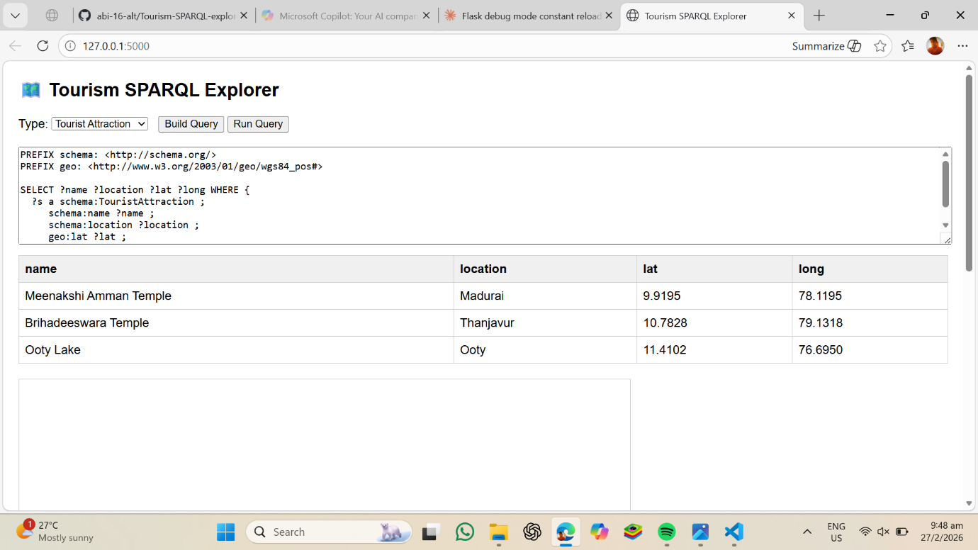
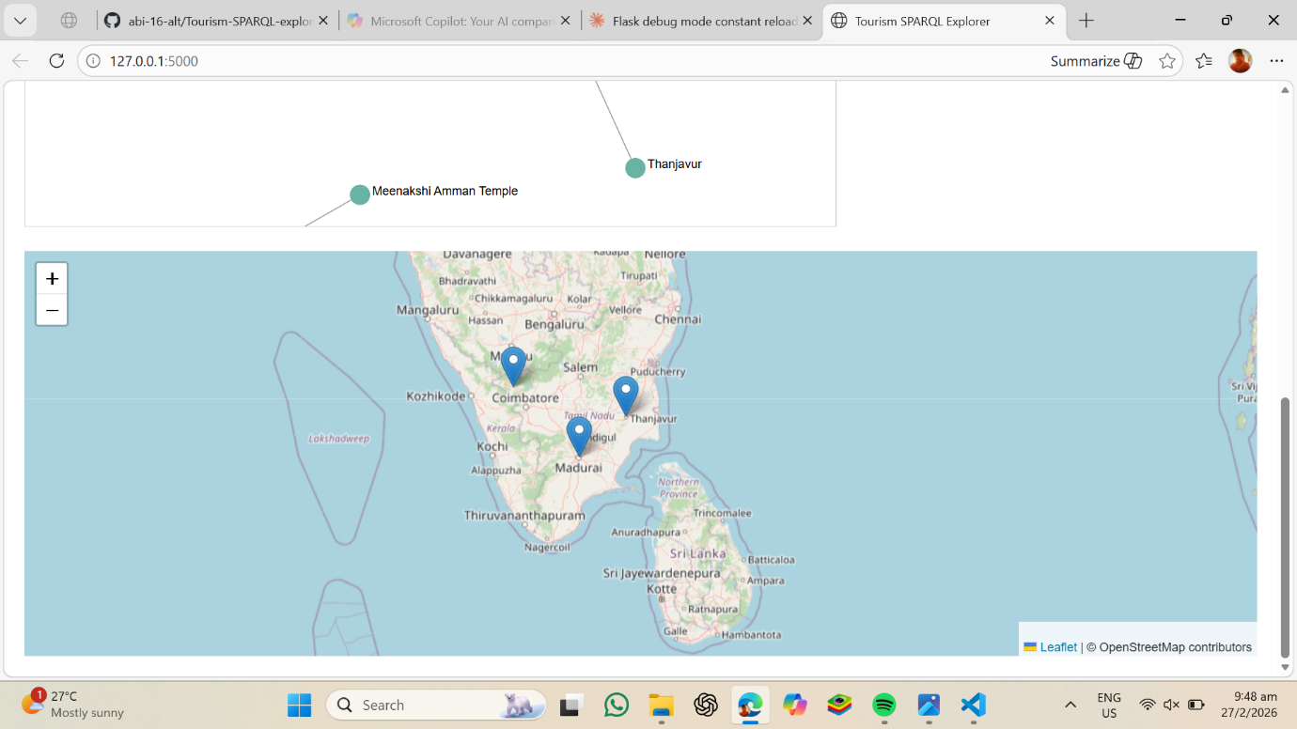

GITHUB: abi-16-alt/Tourism-SPARQL-explorer
End…..

