🗺️ Tourism SPARQL Explorer
Build It From Scratch — Complete Developer Guide

📌 What You Will Build
A full-stack web application that stores tourism data as Linked Data (JSON-LD),
lets users write SPARQL queries through a browser UI, and visualises results as
an interactive knowledge graph (D3.js) and a live map (Leaflet / OpenStreetMap).

Layer | Technology | Purpose
Data | JSON-LD + schema.org | Semantic, machine-readable tourism data
Backend | Python + Flask | Web server & SPARQL query engine
RDF Engine | RDFLib | Parse JSON-LD, execute SPARQL
Frontend | HTML + CSS + JS | Query builder & result viewer
Graph Viz | D3.js v7 | Force-directed knowledge graph
Map Viz | Leaflet + OpenStreetMap | Geo-pin map of attractions

Estimated Time: 2–3 hours | Difficulty: Beginner–Intermediate

1. Prerequisites & Setup

1.1 What You Need to Know
- Basic Python (variables, functions, dictionaries)
- Basic HTML / CSS / JavaScript
- Command-line / terminal usage
- No prior RDF or SPARQL knowledge needed — covered step by step

1.2 Software to Install
Software | Version | Install Command
Python | 3.9+ | https://python.org (or brew install python)
pip | Latest | Comes with Python
Code Editor | Any | VS Code recommended — https://code.visualstudio.com
Browser | Modern | Chrome, Firefox, or Edge

1.3 Create Your Project Folder
Open your terminal and run:
mkdir tourism-sparql-explorer
cd tourism-sparql-explorer
# Create the folder structure
mkdir data static templates

Your project will look like this when finished:
tourism-sparql-explorer/
├── app.py ← Flask backend
├── requirements.txt ← Python dependencies
├── data/
│ └── tourism.jsonld ← Your semantic dataset
├── static/
│ └── app.js ← Frontend JavaScript
└── templates/
└── index.html ← Browser UI

1.4 Install Python Dependencies
# Create requirements.txt
echo "Flask==2.3.3" > requirements.txt
echo "rdflib==7.0.0" >> requirements.txt
# Install them
pip install -r requirements.txt

2. Understanding the Key Concepts

🧠 Why Linked Data / RDF?
Normal databases store data in rows and columns. Linked Data stores data as
triples: Subject → Predicate → Object (e.g. MeenakshiTemple → hasName → 'Meenakshi Amman Temple').
This makes data self-describing and queryable with SPARQL — SQL for the web of data.

2.1 RDF Triples (Subject → Predicate → Object)
Every fact in your dataset is expressed as a triple:
Subject | Predicate | Object
MeenakshiTemple | rdf:type | schema:TouristAttraction
MeenakshiTemple | schema:name | "Meenakshi Amman Temple"
MeenakshiTemple | schema:location | "Madurai, Tamil Nadu"
MeenakshiTemple | geo:lat | "9.9195"

2.2 JSON-LD — Linked Data in JSON
JSON-LD is a JSON format that adds semantic meaning using a @context that maps keys to URIs:
{
"@context": {
"schema": "http://schema.org/",
"geo": "http://www.w3.org/2003/01/geo/wgs84_pos#"
},
"@id": "http://example.org/tourism#MeenakshiTemple",
"@type": "schema:TouristAttraction",
"schema:name": "Meenakshi Amman Temple",
"schema:location": "Madurai, Tamil Nadu",
"geo:lat": "9.9195",
"geo:long": "78.1195"
}

2.3 SPARQL — Querying RDF Data
SPARQL works like SQL but for triples. A basic SELECT query:
SELECT ?name ?location WHERE {
?s a <http://schema.org/TouristAttraction> ;
<http://schema.org/name> ?name ;
<http://schema.org/location> ?location .
}
Read it as: Find any subject (?s) that is a TouristAttraction, and return its name and location.

3. Building the Data Layer (data/tourism.jsonld)

STEP 1 | Create your JSON-LD data file  This is the heart of the project — your semantic dataset.

Open your editor, create data/tourism.jsonld and paste:
[
{
"@context": {
"schema": "http://schema.org/",
"geo": "http://www.w3.org/2003/01/geo/wgs84_pos#"
},
"@id": "http://example.org/tourism#MeenakshiTemple",
"@type": "schema:TouristAttraction",
"schema:name": "Meenakshi Amman Temple",
"schema:location": "Madurai, Tamil Nadu",
"schema:price": "0.00",
"geo:lat": "9.9195",
"geo:long": "78.1195"
},
{
"@context": {
"schema": "http://schema.org/",
"geo": "http://www.w3.org/2003/01/geo/wgs84_pos#"
},
"@id": "http://example.org/tourism#HotelSaravana",
"@type": "schema:LodgingBusiness",
"schema:name": "Hotel Saravana Bhavan",
"schema:location": "Chennai, Tamil Nadu",
"schema:price": "1500.00",
"geo:lat": "13.0827",
"geo:long": "80.2707"
}
]

💡 Tip — Add More Places
Each object in the array is one place. Just copy the block, change the @id,
and fill in new values. Use Google Maps to find lat/long coordinates.
Type: schema:TouristAttraction OR schema:LodgingBusiness

4. Building the Backend (app.py)

STEP 2 | Create the Flask web server  3 routes, ~20 lines of Python.

Create app.py in the root of your project:
from flask import Flask, render_template, request, jsonify
from rdflib import Graph
app = Flask(__name__)
# Load and parse the JSON-LD file into an in-memory RDF graph
g = Graph()
g.parse("data/tourism.jsonld", format="json-ld")
@app.route('/')
def index():
return render_template("index.html")
@app.route('/sparql', methods=['POST'])
def sparql_query():
query = request.json.get("query")
results = g.query(query)
output = []
for row in results:
output.append([str(cell) for cell in row])
return jsonify(output)
if __name__ == '__main__':
app.run(debug=True)

How It Works — Line by Line
Code | What It Does
g = Graph() | Creates an empty in-memory RDF graph (the triplestore)
g.parse(..., format='json-ld') | Reads tourism.jsonld and loads all triples into the graph
@app.route('/') | Serves the HTML page when someone visits localhost:5000
@app.route('/sparql', POST) | Receives SPARQL queries from the browser
g.query(query) | Runs the SPARQL against the in-memory graph
jsonify(output) | Returns results as JSON back to the browser

5. Building the Frontend

STEP 3 | Create the HTML template (templates/index.html)  The user interface — query builder + result containers.

<!DOCTYPE html>
<html>
<head>
<title>Tourism SPARQL Explorer</title>
<!-- D3.js for knowledge graph -->
<script src="https://d3js.org/d3.v7.min.js"></script>
<!-- Leaflet for map -->
<link rel="stylesheet" href="https://unpkg.com/leaflet@1.9.4/dist/leaflet.css" />
<script src="https://unpkg.com/leaflet@1.9.4/dist/leaflet.js"></script>
<style>
body { font-family: Arial, sans-serif; max-width: 960px; margin: 0 auto; padding: 20px; }
textarea { width: 100%; }
#map { height: 400px; margin-top: 20px; }
svg { border: 1px solid #ccc; display: block; margin-top: 20px; }
pre { background: #f4f4f4; padding: 10px; overflow: auto; }
</style>
</head>
<body>
<h1>Tourism SPARQL Explorer</h1>
<!-- Step 1: Choose entity type -->
<label>Select Type:</label>
<select id="type">
<option value="TouristAttraction">Tourist Attraction</option>
<option value="LodgingBusiness">Lodging Business</option>
</select>
<button onclick="buildQuery()">Build Query</button>
<!-- Step 2: Edit or write SPARQL -->
<textarea id="query" rows="6"></textarea><br>
<button onclick="runQuery()">Run Query</button>
<!-- Step 3: Results -->
<pre id="results">Results will appear here...</pre>
<svg width="800" height="400"></svg>
<div id="map"></div>
<script src="/static/app.js"></script>
</body>
</html>

STEP 4 | Create the JavaScript (static/app.js)  Query builder, SPARQL fetch, D3 graph, Leaflet map.

5.1 Query Builder Function
function buildQuery() {
const type = document.getElementById("type").value;
const query = `
SELECT ?name ?location WHERE {
?s a <http://schema.org/${type}> ;
<http://schema.org/name> ?name ;
<http://schema.org/location> ?location .
}`;
document.getElementById("query").value = query.trim();
}

5.2 Run Query & Fetch Results
function runQuery() {
const query = document.getElementById("query").value;
fetch("/sparql", {
method: "POST",
headers: { "Content-Type": "application/json" },
body: JSON.stringify({ query })
})
.then(res => res.json())
.then(data => {
document.getElementById("results").textContent = JSON.stringify(data, null, 2);
drawGraph(data);
drawMap(data);
});
}

5.3 D3.js Knowledge Graph
function drawGraph(data) {
const svg = d3.select("svg");
svg.selectAll('*').remove(); // Clear previous render
const nodes = [], links = [];
data.forEach(([name, location]) => {
nodes.push({ id: name });
nodes.push({ id: location });
links.push({ source: name, target: location });
});
const simulation = d3.forceSimulation(nodes)
.force('link', d3.forceLink(links).id(d => d.id).distance(150))
.force('charge', d3.forceManyBody().strength(-300))
.force('center', d3.forceCenter(400, 200));
svg.selectAll('line').data(links).enter().append('line')
.attr('stroke', '#999');
const node = svg.selectAll('circle').data(nodes).enter().append('circle')
.attr('r', 10).attr('fill', '#69b3a2');
const label = svg.selectAll('text').data(nodes).enter().append('text')
.text(d => d.id).attr('x', 12).attr('y', '.31em');
simulation.on('tick', () => {
svg.selectAll('line')
.attr('x1', d => d.source.x).attr('y1', d => d.source.y)
.attr('x2', d => d.target.x).attr('y2', d => d.target.y);
node.attr('cx', d => d.x).attr('cy', d => d.y);
label.attr('x', d => d.x + 12).attr('y', d => d.y);
});
}

5.4 Leaflet Map
let mapInstance = null; // Keep reference to avoid double-init
function drawMap(data) {
if (mapInstance) { mapInstance.remove(); }
mapInstance = L.map('map').setView([10.0, 78.0], 6);
L.tileLayer('https://{s}.tile.openstreetmap.org/{z}/{x}/{y}.png', {
attribution: '© OpenStreetMap contributors'
}).addTo(mapInstance);
data.forEach(row => {
const lat = parseFloat(row.find(v => v.includes('9.') || v.includes('13.')));
const lon = parseFloat(row.find(v => v.includes('78.') || v.includes('80.')));
const label = row.find(v => !v.includes('http') && isNaN(parseFloat(v)));
if (!isNaN(lat) && !isNaN(lon)) {
L.marker([lat, lon]).addTo(mapInstance).bindPopup(label);
}
});
}

6. Running the Project

STEP 5 | Start the Flask server  One command to launch everything.

# Make sure you're in the project root folder
cd tourism-sparql-explorer
# Run the app
python app.py
# You should see:
* Running on http://127.0.0.1:5000
* Debug mode: on

Open your browser and go to: http://localhost:5000

✅ How to Test It
1. Select 'Tourist Attraction' from the dropdown
2. Click 'Build Query' — a SPARQL query appears in the text area
3. Click 'Run Query'
4. You should see: raw JSON results, a D3 force graph, and a map marker for Madurai
5. Try selecting 'Lodging Business' and repeating — you'll see Chennai data

7. Complete Data Flow Diagram

Here is how data moves through the system end-to-end:

Stage | Component | What Happens
① Startup | app.py | Flask loads & parses tourism.jsonld into RDFLib Graph (in-memory triplestore)
② User Action | index.html | User picks entity type, clicks 'Build Query' → SPARQL appears in textarea
③ Query Edit | index.html | User can freely edit the SPARQL before running
④ HTTP POST | app.js → Flask | fetch('/sparql', POST) sends query JSON to backend
⑤ SPARQL Exec | app.py + RDFLib | g.query(sparql) runs against the in-memory graph
⑥ JSON Response | Flask → browser | Results returned as [[name, location], ...] array
⑦ Render ×3 | app.js | Raw JSON shown, D3 graph drawn, Leaflet map pins placed

8. Common Errors & Fixes

Error Message | Cause | Fix
ModuleNotFoundError: flask | Flask not installed | Run: pip install -r requirements.txt
ModuleNotFoundError: rdflib | RDFLib not installed | Run: pip install rdflib==7.0.0
Port 5000 already in use | Another app using port 5000 | Run: python app.py --port 5001 OR kill the other process
Map not showing / grey box | Leaflet CSS not loaded | Check the <link> tag for Leaflet CSS is in your HTML <head>
D3 graph is empty | No results from SPARQL query | Check your JSON-LD @type matches the query exactly
JSON parse error on startup | Malformed tourism.jsonld | Validate JSON at jsonlint.com — check commas & brackets
Results: [] (empty array) | SPARQL finds no matches | Make sure entity type in dropdown matches @type in JSON-LD

9. Extending the Project

9.1 Add More Data Entries
Simply add more objects to the array in tourism.jsonld. Each needs a unique @id.

9.2 Add More SPARQL Query Types
In app.js, add more options to the buildQuery function:
// Filter by price
SELECT ?name ?price WHERE {
?s a <http://schema.org/TouristAttraction> ;
<http://schema.org/name> ?name ;
<http://schema.org/price> ?price .
FILTER (xsd:float(?price) = 0.0)
}

9.3 Improve the Map (fix coordinate parsing)
The current map has a fragile coordinate parser. A cleaner approach:
// In tourism.jsonld, store lat & long explicitly:
// "geo:lat": "9.9195", "geo:long": "78.1195"
// In your SPARQL query, select them too:
SELECT ?name ?location ?lat ?long WHERE {
?s a <http://schema.org/TouristAttraction> ;
<http://schema.org/name> ?name ;
<http://schema.org/location> ?location ;
<http://www.w3.org/2003/01/geo/wgs84_pos#lat> ?lat ;
<http://www.w3.org/2003/01/geo/wgs84_pos#long> ?long .
}

9.4 Ideas for Further Features
- Add a search / filter bar above results
- Style the D3 nodes differently for Attractions vs Hotels (color-code by type)
- Add a sidebar listing all found places with click-to-zoom on the map
- Connect to a real SPARQL endpoint like Wikidata or DBpedia
- Deploy to the web using Render, Railway, or Heroku (free tiers available)

10. Quick-Start Checklist

🚀 Do These Steps in Order
□ Step 1 — Create folders: mkdir data static templates
□ Step 2 — Install deps: pip install flask rdflib
□ Step 3 — Create data/tourism.jsonld (at least 1 entry)
□ Step 4 — Create app.py (Flask server + /sparql endpoint)
□ Step 5 — Create templates/index.html (UI with textarea + SVG + map div)
□ Step 6 — Create static/app.js (buildQuery + runQuery + drawGraph + drawMap)
□ Step 7 — Run: python app.py
□ Step 8 — Open browser at http://localhost:5000 and test!

Output:
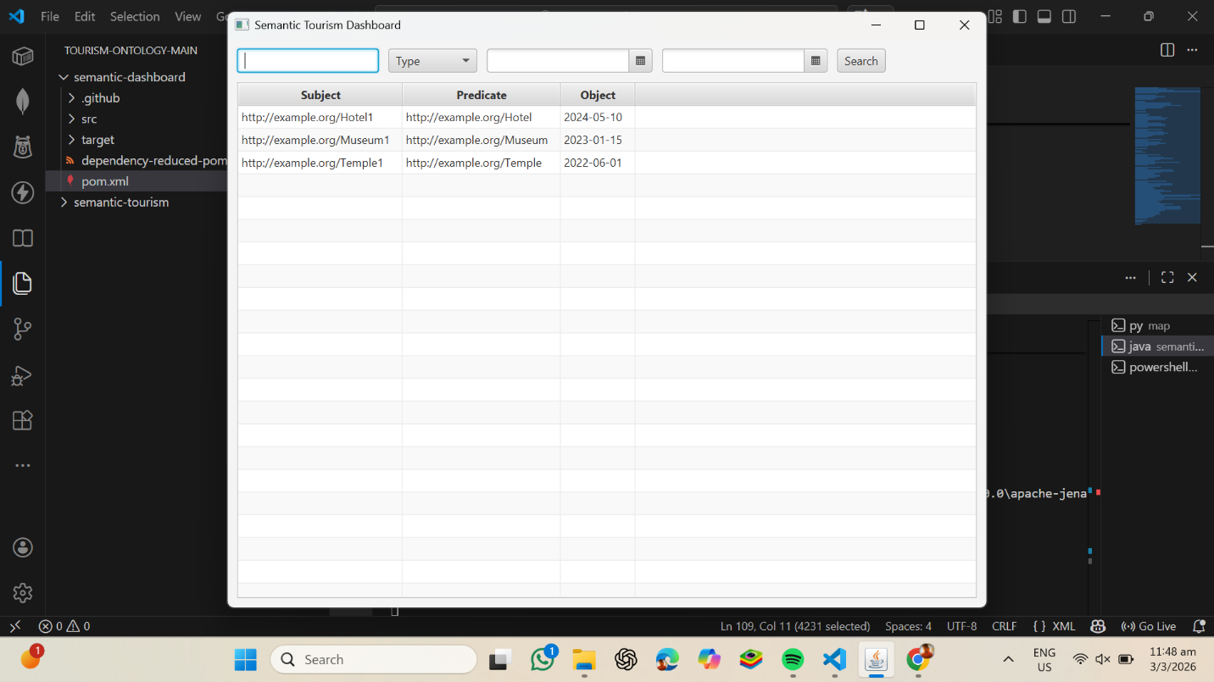

Vscode:
Terminal 1:
- PS D:\tourism-ontology-main\semantic-dashboard> mvn javafx:run
Terminal 2:
PS D:\tourism-ontology-main> cd D:\tourism-ontology-main\semantic-tourism\map
PS D:\tourism-ontology-main\semantic-tourism\map> py -m http.server 8000
Serving HTTP on :: port 8000 (http://[::]:8000/) ...

Terminal 3:
PS D:\tourism-ontology-main> cd D:\tourism-ontology-main\semantic-tourism\python
PS D:\tourism-ontology-main\semantic-tourism\python> py query.py
✅ GeoJSON exported to ../map/highly_rated.geojson
PS D:\tourism-ontology-main\semantic-tourism\python>

GITHUB: abi-16-alt/tourism-ontology

