Challenge 1: Sepsis

CW2, Systems Biology, 7BIOM037W, Omics Challenge, w2101020, Abioseh Kamara

2025

Table of Contents

*Introduction* Sepsis is a life-threatening condition defined by organ dysfunction resulting from the body’s dysregulated response to infection (Guarino et al., 2023). It can progress to septic shock, characterised by profound circulatory, cellular, and metabolic abnormalities, which significantly increase the risk of mortality compared to sepsis alone (Guarino et al., 2023; Martin-Loeches, Singer and Leone, 2024). According to the first global report on sepsis incidence and mortality, sepsis accounts for approximately 19.7% of all global deaths (Giamarellos-Bourboulis et al., 2024). Current treatments include antibiotics, supportive therapies (such as organ support), and co-adjuvants like steroids and immunoglobulins. However, the growing threat of antimicrobial resistance, along with diagnostic challenges caused by inconsistent definitions of sepsis and the presence of sepsis mimics (e.g., severe trauma or pancreatitis), contribute to overdiagnosis in 15–40% of cases (Martin-Loeches, Singer and Leone, 2024). These issues hinder efforts to reduce sepsis-related morbidity and mortality. This underscores the need for reliable biomarkers that can distinguish between sepsis and sepsis mimics and stratify patients based on disease severity. Such biomarkers could facilitate a precision medicine approach, directing specific therapies, such as immunotherapies, to the right patients, rather than relying on broad-spectrum interventions. Advances in omics technologies, particularly transcriptomics using RNA sequencing (RNA-seq), have enabled the discovery of host-derived biomarkers for sepsis (Giamarellos-Bourboulis et al., 2024; Martin-Loeches, Singer and Leone, 2024). This report aims to analyse RNA-seq data from healthy controls, sepsis patients, and septic shock cases to determine whether gene expression profiles can differentiate disease severity. It also investigates an unknown patient’s transcriptomic and microbial profile to predict clinical outcome and inform treatment decisions based on bacterial whole-genome sequencing.

summary(cars)

## speed dist   
## Min. : 4.0 Min. : 2.00   
## 1st Qu.:12.0 1st Qu.: 26.00   
## Median :15.0 Median : 36.00   
## Mean :15.4 Mean : 42.98   
## 3rd Qu.:19.0 3rd Qu.: 56.00   
## Max. :25.0 Max. :120.00

## 0.1 Including Plots

You can also embed plots, for example:

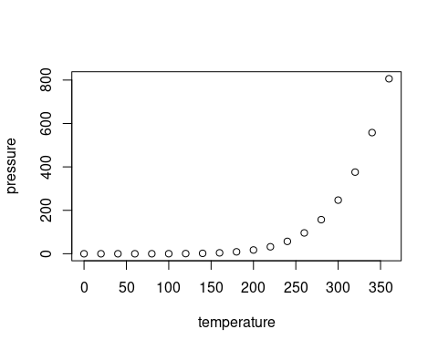

Note that the echo = FALSE parameter was added to the code chunk to prevent printing of the R code that generated the plot.